Assignment -8.3
Hall ticket No:2303A51557
Name: T.TEJASRI

Task-01-Email Validation using TDD

Task Description
You are developing a user registration system that requires reliable email input validation.
Prompt:
# Generate Python function for email validation
Code:
import re
def is_valid_email(email):
# Regular expression for validating an Email
regex = r'^[a-zA-Z0-9._%+-]+@[a-zA-Z0-9.-]+\.[a-zA-Z]{2,}$'

# If the string matches the regular expression, it's a valid email
if re.match(regex, email):
return True
else:
return False
# example inputs
print(is_valid_email("kumardakshinya25@gmailcom"))
print(is_valid_email("2303a51553@sru.edu.in"))
Output:
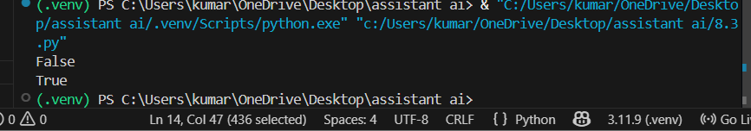
Explanation:
This program validates whether the given email address is in correct format or not.
It uses Python regular expression (re module) to compare the input email with a predefined pattern.
The pattern checks the presence of username, @ symbol, domain name and extension (.com, .in, .edu etc).If the email matches the pattern the function returns True, otherwise it returns False.
Thus the program ensures only valid email addresses are accepted during user registration

Task-02-Grade Assignment using Loops

Task Description
You are building an automated grading system for an online examination platform.
Prompt:
# write a python program to bulid an automated grading system for an online examination platform using loops and aslo include invalid input like -5,eighty
Code:
def calculate_grade(score):
if score < 0 or score > 100:
return "Invalid input"
elif score >= 90:
return "Grade: A"
elif score >= 80:
return "Grade: B"
elif score >= 70:
return "Grade: C"
elif score >= 60:
return "Grade: D"
else:
return "Grade: F"
# Test Cases
scores = [95, 85, 75, 65, 55, -5
, "eighty"]
for s in scores:
if isinstance(s, int):
print(f"Score: {s} - {calculate_grade(s)}")
else:
print(f"Score: {s} - Invalid input")
Output:
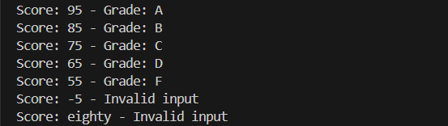
Explanation:
This program implements an automated grading system for student marks.
The function checks the score range using conditional statements and assigns grades A, B, C, D or F accordingly.It also handles invalid inputs such as negative numbers, values greater than 100 and non-numeric values like strings.
A loop is used to test multiple scores one by one and display the result.Hence the program automates evaluation of marks and avoids manual grading errors.

Task-03:-Sentence Palindrome Checker
• You are developing a text-processing utility to analyze sentences
Prompt:
#TASK-3:write a python program to check sentence palindrome checker to develop a text-processing utility to analyze sentences
Code:
def is_palindrome(sentence):
cleaned = ''.join(sentence.lower().split())
return cleaned == cleaned[::-1]
# Test Cases
sentences = ["Madam In Eden Im Adam",
"Hello World","A man a plan a canal Panama"]
for s in sentences:
if is_palindrome(s):
print(f'"{s}" is a palindrome.')
else:
print(f'"{s}" is not a palindrome.')
Output:
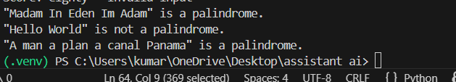
Explanation:
This program checks whether a given sentence is a palindrome.
The sentence is first converted to lowercase and spaces are removed so that comparison becomes uniform.Then the string is reversed and compared with the original processed string.
If both are equal the sentence is a palindrome, otherwise it is not.The program is useful in text processing applications where pattern symmetry needs to be identified.

Task-04: -ShoppingCart Class

Task Description #4:
You are designing a basic shopping cart module for an e-commerce application.
Prompt:
#TASK-4:Write a python program to design a basic shopping cart module for an e-commerce application.add item and remove item and total cost
Code:
class ShoppingCart:
def __init__(self):
self.cart = {}
def add_item(self, item, price):
self.cart[item] = price
print(f"Added {item} to cart at ₹{price}")
def remove_item(self, item):
if item in self.cart:
del self.cart[item]
print(f"Removed {item} from cart")
else:
print(f"{item} not found in cart")
def total_cost(self):
return sum(self.cart.values())
# Test Cases
cart = ShoppingCart()
cart.add_item("Laptop", 50000)
cart.add_item("Headphones", 2000)
cart.add_item("Mouse", 500)
print("Total Cost: ₹", cart.total_cost())
cart.remove_item("Headphones")
print("Total Cost after removal: ₹", cart.total_cost())
o that number: "))
print(f"The sum of integers from 1 to {number} is {sum_to_n(number)}")
Output:
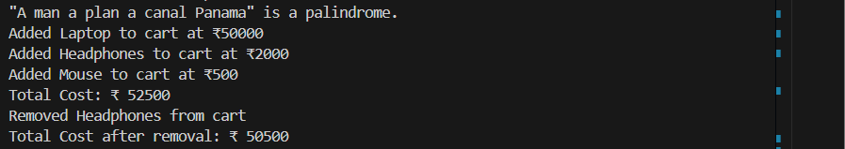
Explanation:
This program simulates a simple shopping cart using a Python class.
The cart stores items and their prices in a dictionary data structure.The class provides methods to:add items to the cart,remove items from the cart,calculate total cost of items.Whenever items are added or removed the total cost is updated automatically.
This demonstrates the concept of Object Oriented Programming and models basic e-commerce cart functionality

Task-05:

Task Description #5: Date Format Conversion
You are creating a utility function to convert date formats for reports
Prompt:
#TASK-5:write a python program to create a utility function to convert date formats for reports
Code:
from datetime import datetime
def convert_date_format(date_str, current_format, desired_format):
try:
date_obj = datetime.strptime(date_str, current_format)
return date_obj.strftime(desired_format)
except ValueError:
return "Invalid date format"
# Test Cases
dates = [("2024-06-15", "%Y-%m-%d", "%d/%m/%Y"),
("15/06/2024", "%d/%m/%Y", "%Y-%m-%d"),
("06-15-2024", "%m-%d-%Y", "%Y/%m/%d"),
("invalid-date", "%Y-%m-%d", "%d/%m/%Y")]
for date_str, current_fmt, desired_fmt in dates:
print(f"Original: {date_str} - Converted: {convert_date_format(date_str, current_fmt, desired_fmt)}")
Output:
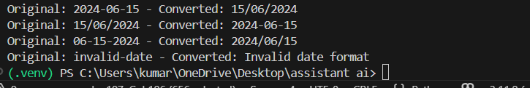
Explanation:
This program converts dates from one format to another using the datetime module.
The input date string is first converted into a date object using strptime() function.
Then it is formatted into the required output format using strftime() function.If the input date does not match the given format the program handles the error and returns an invalid message.
This program is useful in report generation and database applications where different date formats are required.

