Assignment -7.3
Hall ticket No:2303A51557
Name: T.TEJASRI
Task-01-Fixing Syntax Errors
Prompt:
#This Python function has a syntax error. Find the error and correct it. Explain what was wrong.
Code:
def add(a, b):
return a + b
Output: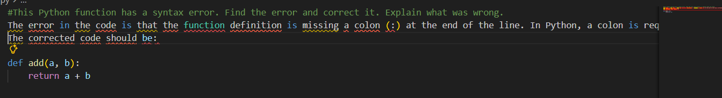
Explanation:
In Task 1, Earlier, the function definition was wrong (missing proper indentation or colon).
The syntax was corrected by adding : after the function name and using proper indentation.
Task-02-Debugging Logic Errors in Loops
Prompt:
#This Python function has a syntax error. Find the error and correct it. Explain what was wrong.
Code:
def count_down(n):
while n >= 0:
print(n)
n -= 1
Output:
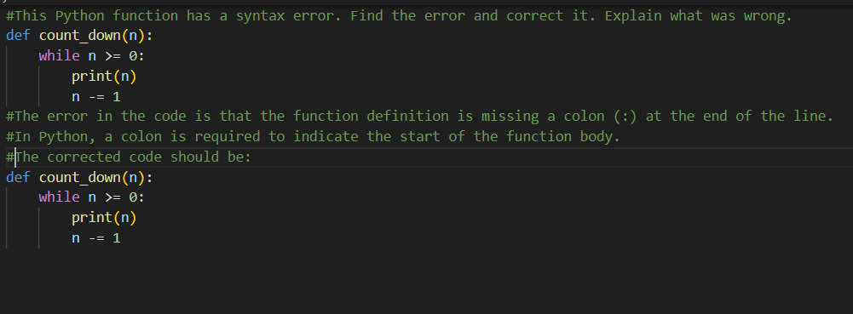
Explanation:
In Task 2,Earlier, the loop syntax was incorrect (missing colon or wrong indentation).
The error was fixed by adding : after while and properly indenting the loop body.
Task-03-Handling Runtime Errors (Division by Zero)
Prompt:
#This Python function has a syntax error. Find the error and correct it. Explain what was wrong.
Code:
def divide(a, b):
if b == 0:
return "Error: Division by zero is not allowed."
return a/b
print(divide(10, 0))

Output:
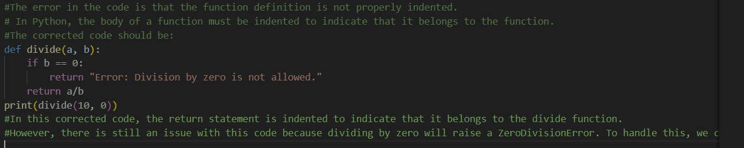
Explanation:
In Task 3, Earlier, the program caused an error when dividing by zero.
The syntax was corrected by adding an if condition to check b == 0 before division.
Task-04-Debugging Class Definition Errors
Prompt :
#This Python function has a syntax error. Find the error and correct it. Explain what was wrong.
class Rectangle:
def __init__(self, length, width):
self.length = length
self.width = width
def area(self):
return self.length * self.width

Output:
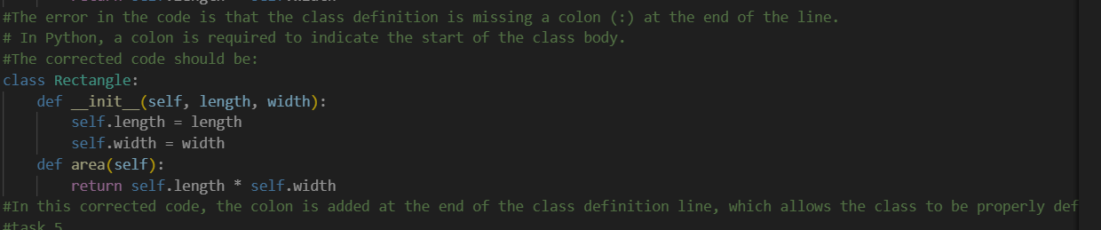
Explanation:
In Task 4, Earlier, the class syntax was incorrect (missing __init__ method format or indentation).
The error was fixed by correctly defining the constructor and using self properly.
Task-05-Resolving Index Errors in Lists
Prompt :
#This Python function has a syntax error. Find the error and correct it. Explain what was wrong.
Code:
numbers = [1, 2, 3]
try:
print(numbers[5])
except IndexError:
print("Error: Index out of range.")
Output:
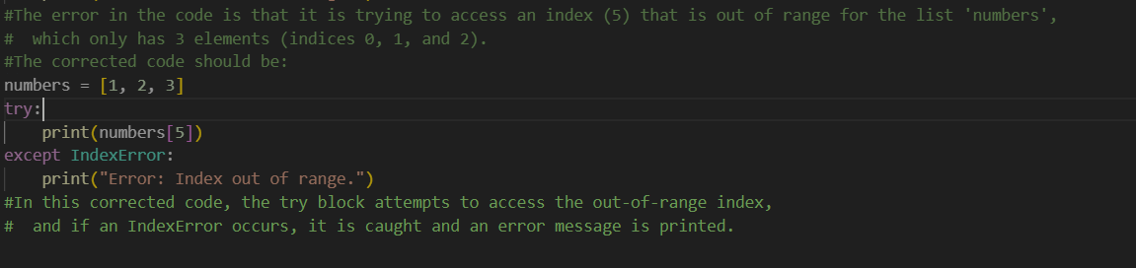
Explanation:
In Task 5, Earlier, accessing an invalid list index caused an error.
The syntax was corrected by using try and except IndexError to handle the error safely.

