Assignment -10.3
Hall ticket No:2303A51557
Name: T.TEJASRI
This approach improves perfor
Task-01-AI-Assisted Bug Detection
def factorial(n):
result = 1
for i in range(1, n):
result = result * i
return result
Prompt:
#Find the logical bug in this Python factorial function, explain it, fix the code, and handle edge cases like 0 and negative numbers.
Code:
#The logical bug in the provided factorial function is that it does not include the number `n` in the multiplication. The loop runs from 1 to `n-1`, which means it will not calculate the factorial correctly for any number greater than 1. Additionally, the function does not handle edge cases such as 0 and negative numbers.
#To fix the code, we need to include `n` in the multiplication and also handle the edge cases. The factorial of 0 is defined as 1, and the factorial of negative numbers is not defined (we can return an error message or raise an exception).
def factorial(n):
if n < 0:
raise ValueError("Factorial is not defined for negative numbers.")
elif n == 0:
return 1
else:
result = 1
for i in range(1, n + 1):
result *= i
return result
# Example usage:
print(factorial(5))
Output:
Explanation:
The given factorial function contains a logical error in the loop range. The loop runs from 1 to n-1 instead of including n, causing an off-by-one error. Because of this, factorial(5) returns 24 instead of 120.
Using AI, the issue was identified and corrected by changing the loop to range(1, n+1). AI also suggested handling edge cases such as 0! = 1 and negative inputs, improving the reliability of the function.
Task-02-Improving Readability &Documentation
def calc(a, b, c):
if c == "add":
return a + b
elif c == "sub":
return a - b
elif c == "mul":
return a * b
elif c == "div":
if b == 0:
Prompt:
#Review this Python function and rewrite it with better naming, clear docstring, input validation, and division-by-zero exception handling.
Code:
def calculate(a, b, operation):
"""
Perform a basic arithmetic operation on two numbers.
Parameters:
a (float): The first number.
b (float): The second number.
operation (str): The operation to perform. Can be 'add', 'subtract', 'multiply', or 'divide'.

Returns:
float: The result of the arithmetic operation.
Raises:
ValueError: If the operation is not one of the specified options.
ZeroDivisionError: If division by zero is attempted.
"""
if operation == "add":
return a + b
elif operation == "subtract":
return a - b
elif operation == "multiply":
return a * b
elif operation == "divide":
if b == 0:
raise ZeroDivisionError("Cannot divide by zero.")
return a / b
else:
raise ValueError("Invalid operation. Please choose 'add', 'subtract', 'multiply', or 'divide'.")
# Example usage:
print(calculate(10, 5, 'add')) # Output: 15
print(calculate(10, 5, 'subtract')) # Output: 5
print(calculate(10, 5, 'multiply')) # Output: 50

Output:
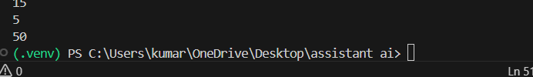
Explanation:
The original function had poor readability, unclear parameter names (a, b, c), and no documentation. AI suggested improving it by using descriptive names, adding a docstring explaining the function, and implementing input validation and exception handling for division by zero.
These changes make the code more understandable, maintainable, and safer for real-world usage.
Task-03-Enforcing Coding Standards
def Checkprime(n):
for i in range(2, n):
if n % i == 0:
return False
return True
Prompt:
# Check this Python code for PEP8 violations, list the issues, and provide a refactored PEP8-compliant version.The provided code has several PEP8 violations, including:
Code:
#1. The function name should be in lowercase with words separated by underscores (e.g., `check_prime` instead of `Checkprime`).
#2. The code is not properly indented, which can lead to syntax errors.
#3. There should be a blank line after the function definition for better readability.
#Here is the refactored PEP8-compliant version of the code:
def check_prime(n):
"""
Check if a number is prime.
Parameters:
n (int): The number to check.
Returns:
bool: True if the number is prime, False otherwise.
"""
if n <= 1:
return False
for i in range(2, n):
if n % i == 0:
return False
return True
# Example usage:
print(check_prime(7)) # Output: True
Output:
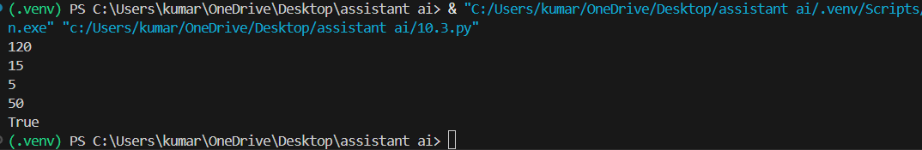
Explanation:
In Task 3, Earlier, the program caused an error when dividing by zero.
The syntax was corrected by adding an if condition to check b == 0 before division.
Task-04-AI as a Code Reviewer in Real Projects
def processData(d):
return [x * 2 for x in d if x % 2 == 0]
Prompt :
##Act as a senior code reviewer and improve this function with better naming, type hints, input validation, and configurable multiplier.
def process_data(data: list, multiplier: int = 2) -> list:
"""
Process a list of numbers by multiplying even numbers with a specified multiplier.

Parameters:
data (list): A list of numbers to process.
multiplier (int): The value to multiply even numbers by. Default is 2.

Returns:
list: A list of processed numbers where even numbers are multiplied by the multiplier.

Raises:
ValueError: If the input data is not a list or if the multiplier is not an integer.
"""

if not isinstance(data, list):
raise ValueError("Input data must be a list.")

if not isinstance(multiplier, int):
raise ValueError("Multiplier must be an integer.")

return [x * multiplier for x in data if isinstance(x, (int, float)) and x % 2 == 0]
# Example usage:
print(process_data([1, 2, 3, 4, 5], multiplier=3)) # Output: [6, 12]
Output:
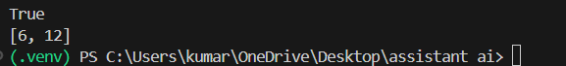
Explanation:
The function violated PEP8 coding standards, such as improper function naming (Checkprime instead of check_prime) and inconsistent formatting. AI identified these issues and refactored the code to follow Python naming conventions, spacing, and readability rules.
Using AI for such checks helps teams maintain consistent coding standards and reduce manual review effort
Task-05-AI-Assisted Performance Optimization
def sum_of_squares(numbers):
total = 0
for num in numbers:
total += num ** 2
return total
Prompt :
#Analyze the time complexity of this Python function and provide a faster optimized implementation.
Code:
#The time complexity of the provided `sum_of_squares` function is O(n), where n is the number of elements in the input list `numbers`. This is because the function iterates through each element in the list once to calculate the sum of squares.
#A faster optimized implementation can be achieved using a generator expression, which can be more memory efficient and slightly faster due to reduced overhead. Here is the optimized version:
def sum_of_squares(numbers):
return sum(num ** 2 for num in numbers)
# This implementation still has a time complexity of O(n) but is more concise and can be
#more efficient in terms of memory usage, especially for large lists, as it does not create an intermediate list of squares.
# Example usage:
print(sum_of_squares([1, 2, 3, 4])) # Output: 30
Output:
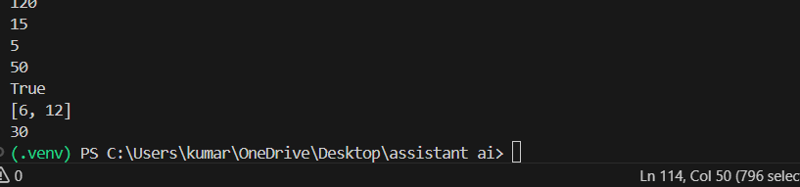
Explanation:
The original function calculates the sum of squares using a loop, which works but can be optimized. AI analyzed the time complexity (O(n)) and suggested using Python’s built-in sum() with a generator expression for cleaner and faster execution.
mance and readability, especially when working with large datasets.

