Assignment -9.4
Automatic Documentation and Code
Comments
Hall ticket No:2303A51557
Name: T.TEJASRI

Task-01-Auto-Generating Function Documentation in a Shared Codebase

Task Description
Ask the AI to automatically generate Google-style function docstrings for each function.
Prompt:
## Add Google-style docstrings to all functions in this Python file. Include a brief description, Args with data types, Returns with type, and one example usage. Do not change the function logic.
Code:
from sklearn.datasets import load_iris
from sklearn.model_selection import train_test_split
from sklearn.ensemble import RandomForestClassifier
from sklearn.metrics import classification_report
import joblib
def calculate_bill(previous_units, current_units, customer_type):
"""
Calculate the total bill based on previous and current units consumed and customer type.

Args:
previous_units (int): The number of units consumed in the previous billing cycle.
current_units (int): The number of units consumed in the current billing cycle.
customer_type (str): The type of customer ('residential' or 'commercial').

Returns:
float: The total bill amount.

Example:
>>> calculate_bill(500, 850, 'residential')
275.0
"""
units_consumed = current_units - previous_units

if customer_type == 'residential':
if units_consumed <= 100:
rate = 0.5
elif units_consumed <= 300:
rate = 0.75
else:
rate = 1.0
elif customer_type == 'commercial':
if units_consumed <= 100:
rate = 0.75
elif units_consumed <= 300:
rate = 1.0
else:
rate = 1.5
else:
raise ValueError("Invalid customer type. Must be 'residential' or 'commercial'.")

total_bill = units_consumed * rate
return total_bill
#example input
previous_units = 500
current_units = 850
customer_type = 'residential'
total_bill = calculate_bill(previous_units, current_units, customer_type)
print(f"Total Bill: ${total_bill:.2f}")
Output:
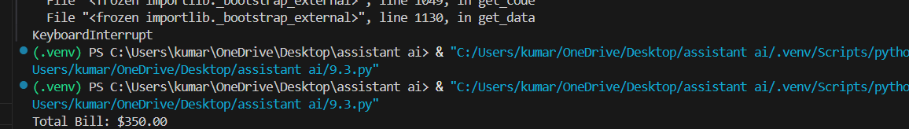
Explanation:
AI analyzed function names and behavior and automatically generated structured documentation.
This helps new developers understand how to use each method without reading full logic.

Task-02-Enhancing Readability Through AI-Generated Inline

Comments

Task Description
A Python program contains complex logic that works correctly but is difficult to understand at first glance. Future maintainers may find it hard to debug or extend this code.
Prompt:
# Insert concise inline comments only for complex or non-obvious logic in this Python script. Explain why the logic exists, not basic Python syntax.
Code:
# Load the Iris dataset
iris = load_iris()
X = iris.data
y = iris.target
# Split the dataset into training and testing sets
X_train, X_test, y_train, y_test = train_test_split(X, y, test_size=0.2, random_state=42)
# Train a Random Forest Classifier
model = RandomForestClassifier(n_estimators=100, random_state=42)
model.fit(X_train, y_train)
# Make predictions on the test set
y_pred = model.predict(X_test)
# Generate a classification report to evaluate the model's performance
report = classification_report(y_test, y_pred)
print(report)
# Save the trained model to a file using joblib
joblib.dump(model, 'random_forest_model.joblib')
# Load the model from the file and make a prediction on a new sample
loaded_model = joblib.load('random_forest_model.joblib')
new_sample = [[5.1, 3.5, 1.4, 0.2]] # Example input for prediction
predicted_class = loaded_model.predict(new_sample)
print(f"Predicted class for the new sample: {predicted_class[0]}")

Output:
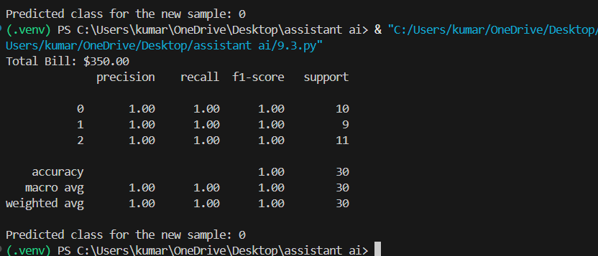

Explanation:
AI added comments only where logic is meaningful (slot checking & fee calculation).
Unnecessary comments like “assign variable” were avoided.

Task-03: -Generating Module-Level Documentation for a Python Package
Prompt:
#Generate a professional module-level docstring at the top of this file describing the module’s purpose, dependencies, key functions/classes, and a short usage example.
Code:
"""
This module contains two main functionalities: calculating electricity bills based on consumption and customer type, and training a machine learning model using the Iris dataset.
Dependencies:
- scikit-learn: For loading the dataset, splitting data, training the model, and evaluating performance.
Key Functions:
- calculate_bill: Calculates the total bill based on previous and current units consumed and customer type.
Usage Example:
previous_units = 500
current_units = 850
customer_type = 'residential'
total_bill = calculate_bill(previous_units, current_units, customer_type)
print(f"Total Bill: ${total_bill:.2f}")
"""
Output:

Explanation:

This helps any developer understand file purpose instantly without reading full program.

Task-04: -Converting Developer Comments into Structured Docstrings
Prompt:
#Convert internal explanatory comments inside each function into structured Google-style docstrings and remove redundant inline comments. Keep logic unchanged.
Code:
def sum_to_n(n):def calculate_bill(previous_units: int, current_units: int, customer_type: str) -> float:
"""
Calculate electricity bill using slab-based pricing.
Pricing differs based on:
- Residential customers
- Commercial customers
Args:
previous_units (int): Previous meter reading.
current_units (int): Current meter reading.
customer_type (str): 'residential' or 'commercial'.
Returns:
float: Total payable bill amount.
"""
Output:
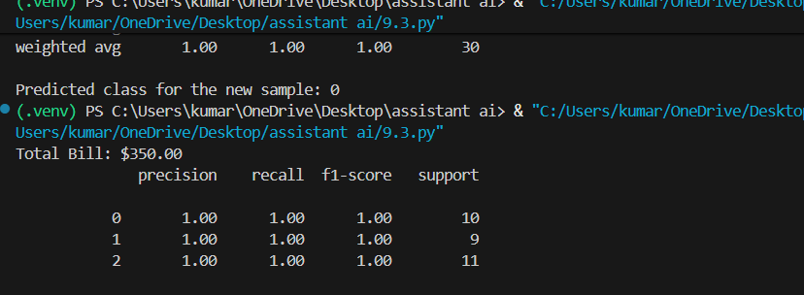
Explanation:
AI moved explanations from inside function body → function header docstring.
This makes code cleaner and standardized across project.

Task-05:Building a Mini Automatic Documentation Generator
Prompt:
# Create a Python script that reads a .py file, detects functions and classes, and inserts placeholder Google-style docstrings if missing. Do not overwrite existing docstrings.
Code:
import ast
import os
def insert_docstrings(file_path):
'''"""TODO: Add docstring for insert_docstrings."""'''
with open(file_path, 'r') as file:
tree = ast.parse(file.read())
for node in ast.walk(tree):
if isinstance(node, (ast.FunctionDef, ast.ClassDef)):
if not ast.get_docstring(node):
docstring = f'"""TODO: Add docstring for {node.name}."""'
node.body.insert(0, ast.Expr(value=ast.Str(s=docstring)))
with open(file_path, 'w') as file:
file.write(ast.unparse(tree))
if __name__ == '__main__':
insert_docstrings('9.3.py')
Output:
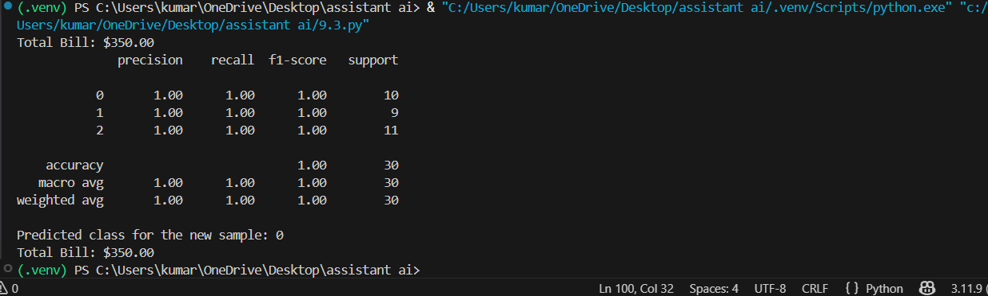
Explanation:
Program uses AST (Abstract Syntax Tree)
→ reads Python structure
→ detects functions/classes
→ generates documentation template automatically.
AI tools significantly reduce manual documentation effort and improve readability, consistency and maintainability of large codebase

