METRO TICKET BOOKING SYSTEM
Using ServiceNow
Project Documentation

Maddula Tejasri Lakshmi
23481A5497

1. Introduction
The Metro Ticket Booking System is a ServiceNow-based application developed to digitize the process of booking metro tickets. The system allows a user to select the starting station and destination station, choose the journey type, enter the number of passengers, automatically calculate the fare, select a payment mode, and submit the booking through the ServiceNow Service Catalog.
The project is designed as a practical ServiceNow application that combines Service Catalog, Catalog Variables, Catalog Client Scripts, Flow Designer, custom tables, Service Portal and a QR-code ticket concept.
Basic system flow:
User → Book A Metro Ticket → Fare Calculation → Order Now → RITM → Flow Designer → Metro Database → Digital/QR Ticket

2. Problem Statement
Traditional metro ticket booking may involve manual station selection, fare calculation, payment and ticket handling. The proposed system provides a digital approach in which the passenger enters the required information and ServiceNow automates the major processing steps.
The main problem addressed by this project is to develop a digital metro ticket booking system using ServiceNow that can automatically calculate fares, store booking information and provide a foundation for generating a digital QR-based ticket.

3. Objectives
- To develop a digital metro ticket booking system using ServiceNow.
- To allow users to select source and destination stations.
- To provide Single Journey and Return Journey options.
- To allow the user to specify the number of passengers.
- To calculate the ticket fare automatically.
- To provide payment mode selection.
- To store submitted booking information in a Metro Database.
- To automate booking data transfer using Flow Designer.
- To provide a foundation for digital QR ticket generation.
- To reduce manual work and make metro ticket booking easier.

4. Technologies and ServiceNow Components Used
- ServiceNow Service Catalog – used to create the metro booking form.
- Catalog Item – the main item named “Book A Metro Ticket”.
- Catalog Variables – used to collect booking information.
- Catalog Client Script – used for automatic fare calculation and client-side behavior.
- Flow Designer / Workflow Studio – used to automate the booking workflow.
- Custom Tables – used for station details and booking storage.
- Service Portal – used as the user-facing portal.
- Service Portal Widget – custom widget named metro_qr_widget for the QR-ticket concept.

5. Metro Station Details Table
A custom table named “Metro Station’s Details” was created to store the metro station records. Its technical name is u_metro_station_details. This table is used as the reference table for the Starting From and Going To variables.
Stations configured for the project:
- Ameerpet
- Madhapur
- LB Nagar
- Kukatpally
- Jubilee Hills
- Panjagutta
- Uppal Stadium
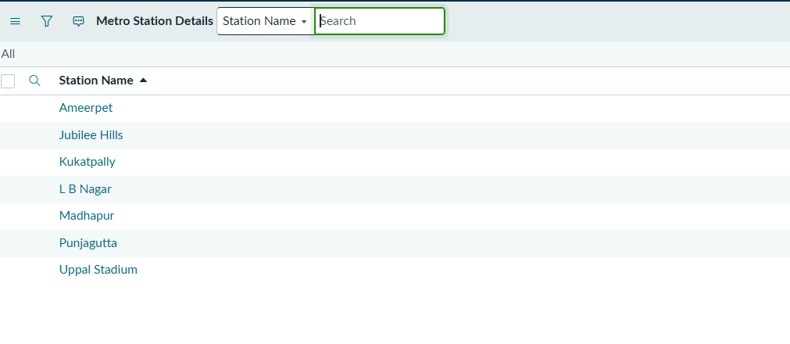
Metro Station’s Details table/list

6. Book A Metro Ticket Catalog Item
The main Service Catalog item is named “Book A Metro Ticket”. It provides the form through which the user enters the information required for a metro ticket booking.
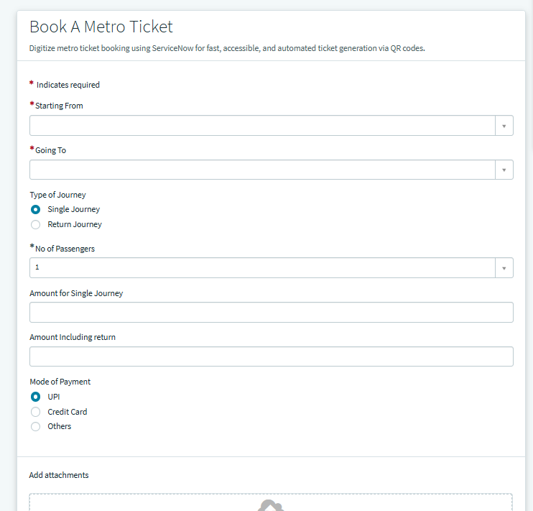
Book A Metro Ticket catalog item screenshot

7. Catalog Variables
S.No | Variable | Type | Variable Name
1 | Starting From | Reference | starting_from
2 | Going To | Reference | going_to
3 | Type of Journey | Multiple Choice | type_of_journey
4 | No of Passengers | Select Box | no_of_passengers
5 | Amount for Single Journey | Single Line Text | amount_for_single_journey
6 | Amount Including Return | Single Line Text | amount_including_return
7 | Mode of Payment | Multiple Choice | mode_of_payment
8 | Enter Payment Mode | Single Line Text | enter_payment_mode

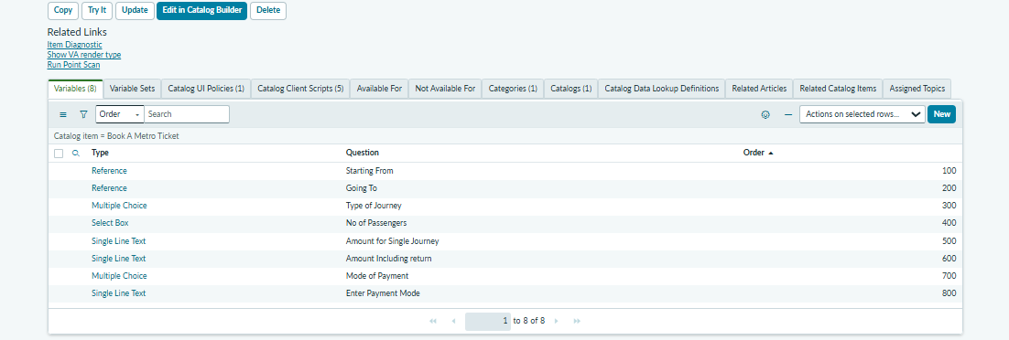

8. Starting From and Going To
Starting From and Going To are Reference variables. Both variables refer to the Metro Station’s Details table. This allows the user to select a station from the available records instead of typing station names manually.
Starting From variable: starting_from
Going To variable: going_to

9. Type of Journey
The Type of Journey variable is a Multiple Choice variable. It provides two choices:
Option | Value
Single Journey | 1
Return Journey | 2
For the project fare logic, a return journey is calculated as two times the single journey fare.

10. Number of Passengers
The No of Passengers variable is configured as a Select Box. The selected passenger count is used in the fare calculation and is also stored in the Metro Database.
Example: If the single fare is ₹30 and there are 2 passengers, the total single-journey amount is ₹30 × 2 = ₹60.

11. Automatic Fare Calculation
Automatic fare calculation is one of the main features of the project. The user does not have to calculate the ticket amount manually. The fare calculation uses the selected starting station, destination station, journey type and number of passengers.
The calculation is implemented using a Catalog Client Script. The existing fare-calculation script is working and is kept as part of the current project implementation.

12. Project Sample Fare Table
The following fares are project-defined sample fares used for the prototype. They should not be treated as official Hyderabad Metro fares.
Starting Station | Destination | Single Fare
Ameerpet | Madhapur | ₹30
Ameerpet | LB Nagar | ₹50
Ameerpet | Kukatpally | ₹30
Ameerpet | Jubilee Hills | ₹20
Ameerpet | Panjagutta | ₹20
Ameerpet | Uppal Stadium | ₹60
Madhapur | LB Nagar | ₹80
Madhapur | Kukatpally | ₹40
Madhapur | Jubilee Hills | ₹30
Madhapur | Panjagutta | ₹30
Madhapur | Uppal Stadium | ₹70
LB Nagar | Kukatpally | ₹60
LB Nagar | Jubilee Hills | ₹50
LB Nagar | Panjagutta | ₹60
LB Nagar | Uppal Stadium | ₹40
Kukatpally | Jubilee Hills | ₹30
Kukatpally | Panjagutta | ₹30
Kukatpally | Uppal Stadium | ₹70
Jubilee Hills | Panjagutta | ₹20
Jubilee Hills | Uppal Stadium | ₹60
Panjagutta | Uppal Stadium | ₹60

13. Fare Calculation Examples

Single Journey
Example:
Starting From: Ameerpet
Going To: Madhapur
Journey: Single Journey
Passengers: 2
Single Fare: ₹30
Total = ₹30 × 2 = ₹60

Return Journey
Example:
Starting From: Ameerpet
Going To: Madhapur
Journey: Return Journey
Passengers: 2
Single Fare: ₹30
Return fare per passenger = ₹30 × 2 = ₹60
Total = ₹60 × 2 passengers = ₹120
[ INSERT IMAGE HERE – Catalog form showing automatically calculated fare ]

14. Amount Fields
Two amount fields are included in the catalog item. Amount for Single Journey uses the variable name amount_for_single_journey. Amount Including Return uses the variable name amount_including_return. These fields are populated according to the fare calculation logic.

15. Payment Mode
The Mode of Payment variable is a Multiple Choice variable used to select the preferred payment method. The Enter Payment Mode variable is a Single Line Text field used to store additional payment-related information.
Mode of Payment variable: mode_of_payment
Enter Payment Mode variable: enter_payment_mode

16. Metro Database
A separate custom table named “Metro Database” was created to store booking information. The purpose of this table is to maintain the submitted metro ticket details in a centralized location.
Fields created in the Metro Database:
- Starting From – Reference to Metro Station’s Details
- Going To – Reference to Metro Station’s Details
- Type of Journey – Choice
- No of Passengers – Choice
- Amount for Single Journey – Currency
- Amount Including Return – Currency
- Mode of Payment – Choice
- Enter Payment Mode – String

17. Flow Designer – Metro Project
Flow Designer is used to automate the movement of booking information from the Service Catalog to the Metro Database. The flow created for the project is named “Metro Project”.
Current flow architecture:
Service Catalog Trigger → Get Catalog Variables → Create Metro Database Record

18. Service Catalog Trigger
The first step of the flow is the Service Catalog Trigger. It starts the flow when the relevant catalog item is submitted.
The flow is associated with the “Book A Metro Ticket” catalog item through the Catalog Item Process Engine configuration. The Flow field is set to “Metro Project”. Workflow and Execution Plan are not used in this implementation.

19. Get Catalog Variables
The second flow action is Get Catalog Variables. It retrieves the values entered by the user in the Book A Metro Ticket catalog item.
Submitted Request: Trigger → Requested Item
Template Catalog Item: Book A Metro Ticket
Variables selected:
- starting_from
- going_to
- type_of_journey
- no_of_passengers
- amount_for_single_journey
- amount_including_return
- mode_of_payment
- enter_payment_mode

20. Create Metro Database Record
The third flow action is Create Record. The target table is Metro Database. The values retrieved from Get Catalog Variables are mapped to the corresponding Metro Database fields.
Metro Database Field | Source Variable
Starting From | starting_from
Going To | going_to
Type of Journey | type_of_journey
No of Passengers | no_of_passengers
Amount for Single Journey | amount_for_single_journey
Amount Including Return | amount_including_return
Mode of Payment | mode_of_payment
Enter Payment Mode | enter_payment_mode

21. End-to-End Booking Process
1. The user opens the Book A Metro Ticket catalog item.
2. The user selects the starting station.
3. The user selects the destination station.
4. The user selects Single Journey or Return Journey.
5. The user selects the number of passengers.
6. The system automatically calculates the fare.
7. The user selects the payment mode.
8. The user clicks Order Now.
9. ServiceNow creates the catalog request/RITM.
10. The Metro Project flow is triggered.
11. Get Catalog Variables retrieves the submitted values.
12. Create Record stores the booking in the Metro Database.
13. The QR-ticket component is intended to be used on the post-order experience.

22. QR Code Ticket Concept
The project also includes a QR-code ticket concept. A custom Service Portal widget named metro_qr_widget has been prepared for displaying a digital metro ticket and QR code.
For the current prototype, the QR code can be associated with the RITM number. A ticket number can follow a format such as METRO-RITM0010006.
The current QR implementation is kept active as configured in the project. The existing QR-related code has been retained, and the widget code has not been changed from the version currently configured.
]

23. QR Code Widget – metro_qr_widget
A custom Service Portal widget named metro_qr_widget has been created for the QR-ticket functionality. The widget is intended to display the digital ticket after the booking process.
At the current stage, the widget code has been kept as previously configured and has not been modified. The final placement of the widget on the correct post-order/Order Status page is still pending.

24. QR Ticket Data Concept
The QR ticket concept uses a ticket identifier derived from the ServiceNow request item. This provides a simple way to connect the displayed QR ticket with the booking record.
Example:
RITM Number: RITM0010006
Ticket Number: METRO-RITM0010006
This is a prototype approach. In a production system, a secure unique ticket identifier and backend validation should be used.

25. Service Portal
The project uses Service Portal as the user-facing interface. The Service Portal provides access to the Service Catalog and the Book A Metro Ticket item.

26. Service Portal Designer
Service Portal Designer is used to manage the portal pages and widgets. The designer was opened through the Service Portal configuration area, and the Pages section was used to inspect the available pages.

27. Order Status Page – Current Status
The project currently contains multiple pages with Order Status-related names, including sw_order_status, va_order_status and me_order_status. The final correct Order Status page for placing the metro QR widget is still being identified.
One inspected page displayed an authorization/invalid-record message and showed Order Guide in the designer, so no changes were made to that page. The QR widget placement is therefore intentionally kept as a pending step.

28. Current Project Status
Module | Current Status
Metro Station table | Completed
Metro station records | Completed
Book A Metro Ticket catalog item | Completed
Catalog variables | Completed
Automatic fare calculation | Working
Payment fields | Completed
Metro Database | Completed
Metro Project Flow | Working
Get Catalog Variables | Configured
Create Metro Database Record | Configured
Catalog Item → Flow association | Completed
QR code client script | Kept active as currently configured
QR widget | Created; code unchanged
Final QR widget placement | Pending

29. Example Booking Record
An example booking can be:
Field | Example Value
Starting From | Ameerpet
Going To | Madhapur
Type of Journey | Single Journey
No of Passengers | 2
Single Fare | ₹30 per passenger
Total Single Journey Amount | ₹60
Mode of Payment | Online / selected option

30. Advantages
- Digital metro ticket booking.
- Automatic fare calculation.
- Reduced manual calculation errors.
- Centralized storage of booking information.
- Automated data processing through Flow Designer.
- Easy tracking and reporting of bookings.
- Foundation for digital QR ticket generation.
- Can be extended with additional stations and fare rules.
- Can be integrated with dashboards, payments and validation in future.

31. Future Enhancements
- Generate a unique Booking Number for every ticket.
- Add Booking Status such as Pending, Confirmed, Cancelled and Completed.
- Store QR Code / QR URL in the Metro Database.
- Add secure QR validation at the metro station gate.
- Integrate a real payment gateway.
- Add ticket cancellation and refund logic.
- Add booking history for users.
- Create analytics dashboards for routes, passengers and revenue.
- Create a dedicated fare table so administrators can change fares without editing scripts.
- Extend the system to mobile and conversational/WhatsApp-based booking.

32. Proposed Final Architecture
The proposed final architecture is:
User → Service Portal → Book A Metro Ticket → Station/Journey/Passenger Selection → Automatic Fare Calculation → Order Now → ServiceNow Request/RITM → Metro Project Flow → Metro Database → Booking/Ticket Identifier → QR Ticket → QR Validation

33. Conclusion
The Metro Ticket Booking System using ServiceNow demonstrates how ServiceNow can be used to build a practical digital ticketing application. The system combines Service Catalog, Catalog Variables, Catalog Client Scripts, custom tables, Flow Designer, Service Portal and a QR-ticket concept.
The booking form allows the user to select source and destination stations, choose the journey type, select the number of passengers and obtain an automatically calculated fare. After submission, the Metro Project flow retrieves the catalog variables and creates a corresponding record in the Metro Database.
The project also includes a QR-code ticket component. The current QR code script and widget configuration have been retained as currently implemented, while the final placement of the QR widget on the correct post-order page remains the next development step.
The system can be further enhanced with secure QR validation, real payment integration, dynamic fare management, ticket cancellation, booking history and analytics.

34. Recommended Screenshots for the Final Report
1. Book A Metro Ticket catalog item
2. Catalog Variables
3. Metro Station’s Details table
4. Fare calculation script
5. Catalog form showing calculated fare
6. Metro Database table
7. Metro Project Flow Designer
8. Get Catalog Variables configuration
9. Create Record mapping
10. Catalog Item Process Engine with Metro Project selected
11. Successful Flow Execution
12. Active QR code client script
13. metro_qr_widget configuration
14. Service Portal Designer
15. Order Status pages
16. Metro Database booking record
Screenshots:
Catalog Variables
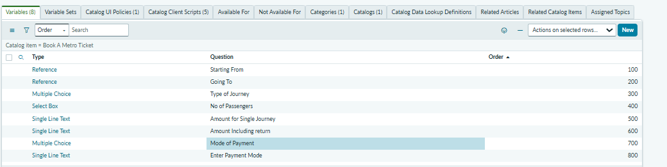

Client Scripts
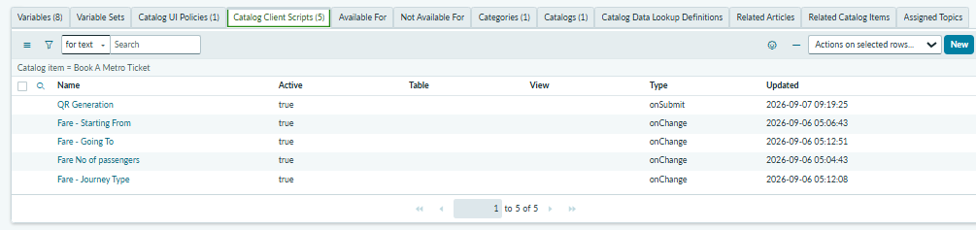

Book a metro Ticket Form


Fare Calculation:
for Single Journey & Return Journey
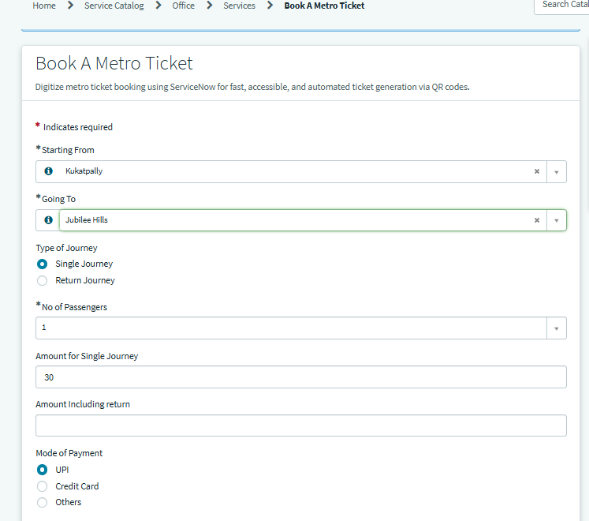
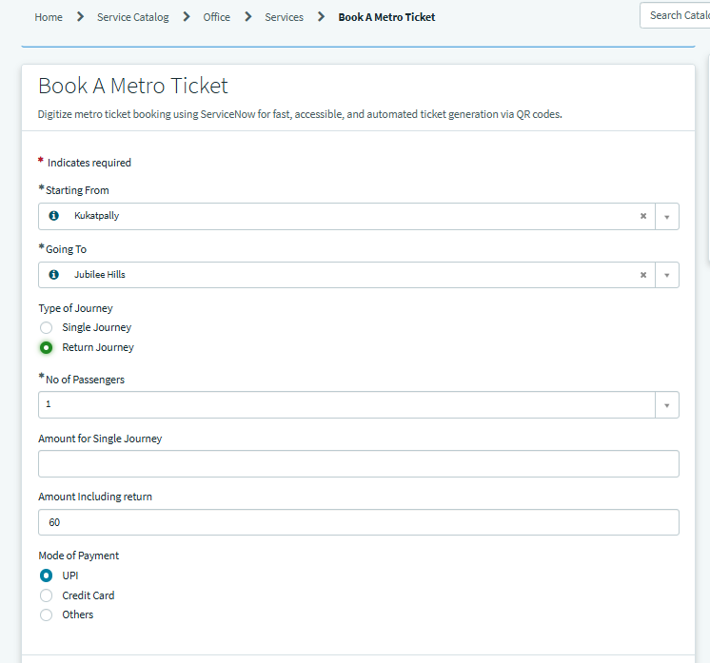
QR Generation:
