**PRACTISE TEST**

**2.07.2024**

Perform the Data Preprocessing Steps mentioned below for the above dataset:

Step 1: Importing Libraries and the Dataset. Analyse the data statistically.

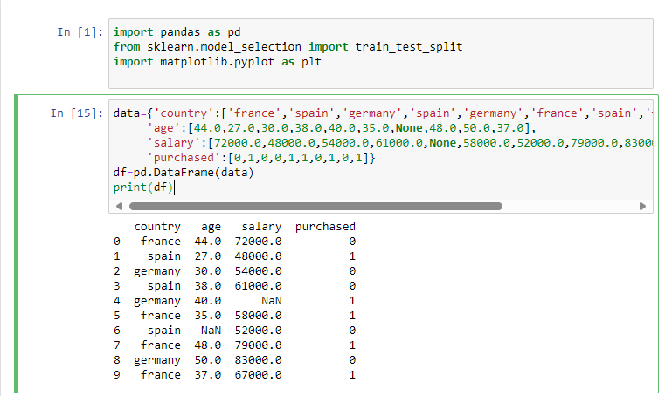

Step 2: Display the number of non-null values, datatype of each dataframe

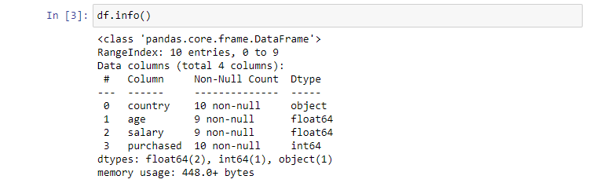

Step 3: Extracting the Independent Variable

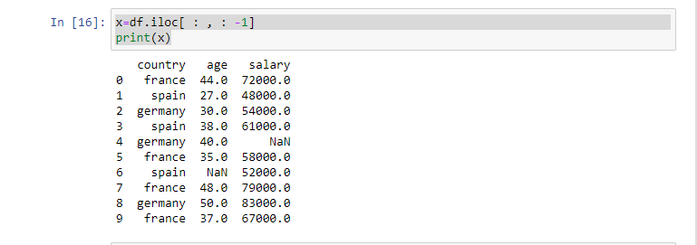

Step 4: Extracting the Dependent Variable

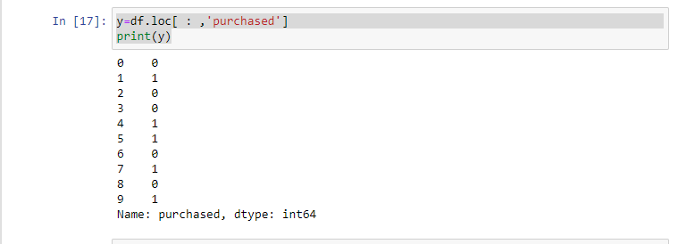

Step 5: Fill the null values in the Dataset with the Mean Value of the Attribute

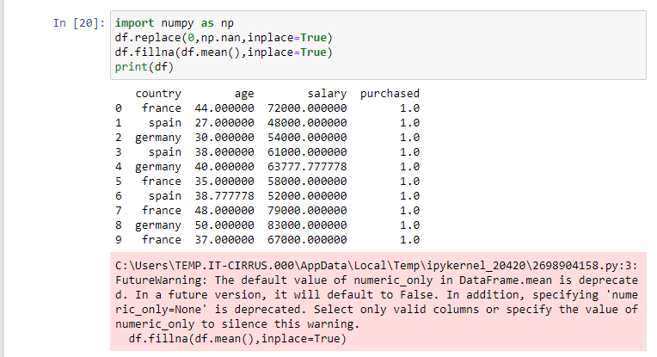

Step 6: One hot Encoding of the Country Variable

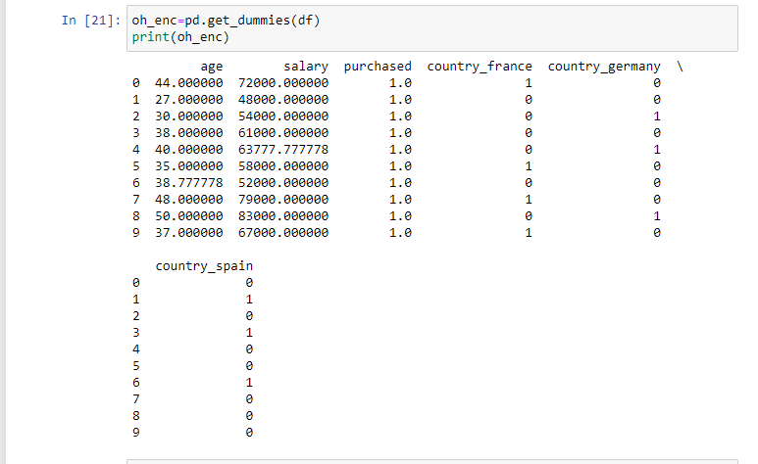

Step 7: Label Encoding of the Country variable in a new reference

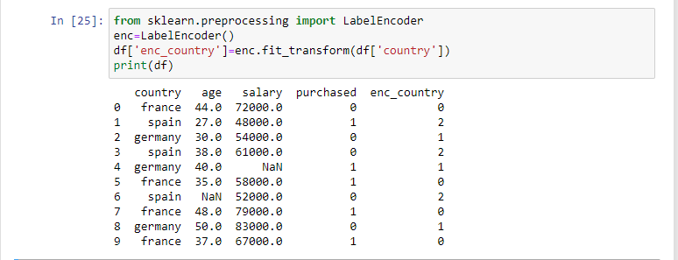

Step 8: Splitting the Dataset into Training and Test Sets

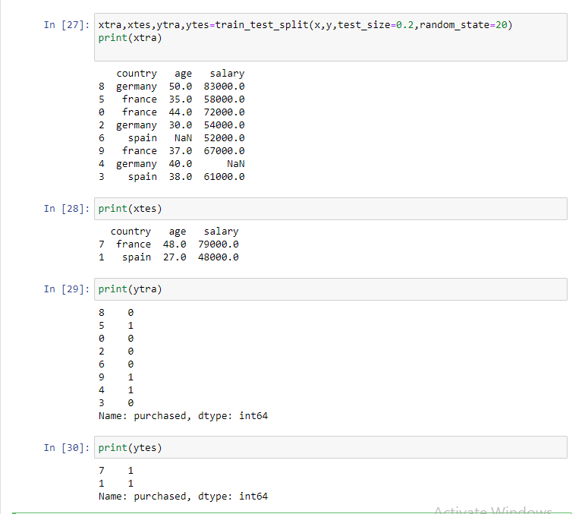

Step 9: Feature Scaling / Normalization – Z-score (Salary Attribute)

