CSCI 6560: Selected Topics in Database
Middle Tennessee State University
Instructor: Dr. Khem N. Poudel
HW2

1. What are the main components of the Google Cloud Computing Explain briefly.

Main Components of Google Cloud Computing
Google Cloud Platform is a complete cloud computing platform that offers Infrastructure, platforms, and analytics services to organizations of all sizes. The platform organizes its services into several major components, including compute, storage, networking, security, and data analytics. These components work together to deliver scalable, reliable, and secure cloud solutions. Google Cloud Platform (GCP) comprises several key elements that provide computing, storage, networking, security, and analytics services.

1. Compute Services
These services provide virtual machines and application hosting.
- Compute Engine – Infrastructure as a Service (IaaS) that provides virtual machines.
- App Engine – Platform as a Service (PaaS) for building and hosting applications.
- Google Kubernetes Engine (GKE) – Managed Kubernetes service.
- Cloud Functions – Serverless computing platform.

The compute layer in Google Cloud enables the processing power needed to execute applications and workloads. Compute Engine is an Infrastructure as a Service (IaaS) solution that lets users create and manage virtual machines while having complete control over the operating system and configurations. In contrast, App Engine is a Platform as a Service (PaaS) offering that allows developers to run and scale applications without worrying about managing the underlying Infrastructure. Google Kubernetes Engine (GKE) is an offering that supports containerized applications and automates their deployment, scaling, and management. Cloud Functions is an offering that supports server less computing by executing code in response to events without managing servers.

2. Storage Services
It is used to store both structured and unstructured data.
- Cloud Storage – Object storage for files, backups, and media.
- Cloud SQL – Managed relational database service.
- Cloud Bigtable – NoSQL wide-column database.
- Persistent Disk – Block storage for VMs.

The storage layer provides durable and scalable data storage solutions. Cloud Storage is an object storage service used to store unstructured data, such as files, backups, and media content. Cloud SQL is a fully managed relational database service that supports MySQL, PostgreSQL, and SQL Server, making it easy to run and manage databases in the cloud. Bigtable is a NoSQL database service for large analytical and operational workloads. Persistent Disk is a block storage option for virtual machines for high-performance computing needs.

3. Networking
Provides secure and scalable connectivity.
- Virtual Private Cloud (VPC) – Isolated private network.
- Cloud Load Balancing – Distributes traffic.
- Cloud DNS – Domain name service.
- Cloud CDN – Content delivery network.

Networking services in GCP ensure secure and efficient connectivity. Virtual Private Cloud (VPC) enables organizations to create isolated, customizable private networks in the cloud. The role of cloud load balancing is to distribute user traffic to servers so that none of the servers becomes overloaded. It enhances the system's availability. It also ensures the reliability of the applications. Cloud CDN improves application performance. It stores the content in locations closer to the users. It reduces latency and improves response time.

4. Security & Identity
It ensures access control and data protection.
- IAM (Identity and Access Management) – Role-based access control.
- Cloud Armor – DDoS protection.
- Firewall Rules – Traffic filtering.
- Cloud Security Command Center – Security monitoring.

Security and identity management are fundamental components of Google Cloud. Identity and Access Management (IAM) enforces role-based access control and follows the principle of least privilege. These are the rules followed in firewall rules. The system enforces inbound and outbound rules. Cloud Armor protects the system from distributed denial-of-service (DDoS) attacks. The platform automatically encrypts data at rest and in transit.

5. Data & Analytics
It is used for processing and analyzing data.
- BigQuery – Data warehouse for analytics.
- Dataflow – Stream and batch processing.
- Pub/Sub – Messaging service.

The data and analytics layer enables organizations to process and derive insights from large volumes of data efficiently. BigQuery is a fully managed, server-less data warehouse that lets organizations analyze massive datasets at the petabyte scale without managing their own Infrastructure. Pub/Sub enables real-time messaging that makes it easy to build event-driven applications and enables streaming between applications. Dataflow services facilitate batch and real-time streaming data processing, allowing organizations to transform and analyze data in motion. These services make Google Cloud an enterprise-ready platform that is powerful, scalable, and secure enough for data-driven decision-making.

2. Why we need to use Kubernetes in cloud computing? Describe the Containers in Google cloud computing.

Why Kubernetes is Needed
Kubernetes plays an essential role in modern cloud environments by automating the management of containerized applications. As more organizations move toward microservices architectures, handling large numbers of containers manually becomes difficult and time-consuming. Kubernetes makes this easier by automatically handling deployment, scaling, monitoring, and recovery for containerized workloads, making application management more efficient and reliable.
Kubernetes is used to manage containerized applications in cloud environments efficiently.
Main reasons:
- Automates deployment and scaling
- Provides high availability
- Self-healing (restarts failed containers)
- Load balancing
- Rolling updates without downtime
- Efficient resource utilization

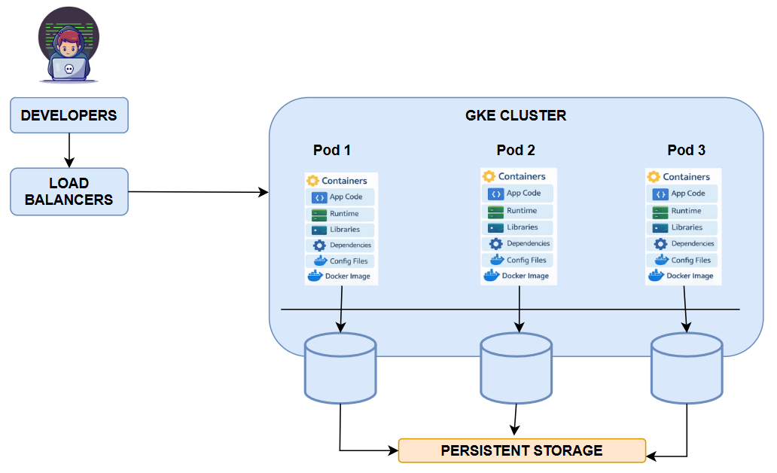
KUBERNETES IN GOOGLE CLOUD

One of the primary reasons Kubernetes is so vital in cloud computing is that it scales very well. Most applications experience traffic fluctuations, but Kubernetes can easily scale containers up or down based on usage. In addition, Kubernetes can make applications more reliable by distributing workloads across many nodes in the cluster. If any container crashes or fails for any reason, Kubernetes can easily restart it, ensuring the application does not stop working altogether. Furthermore, Kubernetes can easily roll out updates to an application without causing any service downtime.

In Google Cloud, Google Kubernetes Engine (GKE) provides a fully managed Kubernetes service. GKE simplifies cluster management by handling control plane operations, upgrades, security patches, and monitoring. It allows organizations to focus on application development rather than infrastructure management.

Containers in Google Cloud
Containers in Google Cloud are small, lightweight packages that contain an applications code, dependencies, and runtime environment. Unlike virtual machines, containers use the host operating system kernel. It makes them more efficient in resource use. It also faster to start. It provides a consistent environment across development, testing, and production. It ensures environmental differences cause no errors. In Google Cloud, containers are created using Docker images. They are then stored in Artifact Registry. They are deployed through GKE or Cloud Run. The use of containers enhances portability, scalability, and operational efficiency in cloud environments.
A container is a lightweight package that includes:
- Application code
- Runtime
- Libraries
- Dependencies
Containers:
- Run consistently across environments
- Start quickly
- Use fewer resources than virtual machines
In GCP:
- Cloud Run runs containers serverlessly.
- GKE manages container clusters.
- Containers use Docker images stored in Artifact Registry.
Containers improve portability, scalability, and microservices architecture.

3. If you need to design a secure network system in Google Cloud computing What are the major components you need to consider especially the network, security part. Create an architecture design/similar block diagram as a Cloud security engineer for medium size organization. (Hints: refer google Cloud documentation for network, IAM policy)

Designing a secure network architecture in Google Cloud for a medium-sized organization requires careful consideration of network segmentation, access control, encryption, and monitoring. Organizations must integrate security into every layer of the architecture to defend against both external and internal threats.
Network Components
- VPC (custom mode)
- Public and Private Subnets
- Private IP for databases
- Cloud NAT
- Cloud Router
- VPN / Interconnect

The foundation of a secure cloud network begins with a Virtual Private Cloud (VPC). A custom-mode VPC allows the organization to define IP address ranges and create separate subnets for different workloads.
In most cloud environments, public subnets are used for internet-facing resources, such as web servers and load balancers. In contrast, private subnets are used for sensitive resources, such as application servers and databases. This separation of resources ensures minimal exposure to the internet and reduces the overall risk of attacks.

Security Components
- IAM with least privilege
- Role-based access control
- Firewall rules (allow only required ports)
- Cloud Armor for DDoS protection
- Security Command Center
- Cloud Logging & Monitoring
- Encryption (AES-256 at rest, TLS in transit)

Organizations need to manage access to cloud resources through Identity and Access Management (IAM). It is recommended that users be granted the minimum privilege required to fulfill the specific role they are expected to play. In addition, multi-factor authentication can enhance the security of admin accounts. In addition, firewall rules should limit traffic to specific ports and IP ranges, ensuring that only authorized and necessary communication occurs between different system tiers.
Security Best Practices Used
- No public IP for the database
- Private service access
- IAM least privilege
- Multi-factor authentication
- VPC firewall rules
- Zero-trust model
To protect against external attacks, Cloud Armor can be deployed in front of load balancers to mitigate DDoS attacks and web-based threats. Secure communication should be enforced using HTTPS and TLS encryption. Databases such as Cloud SQL should not have public IP addresses; instead, they should use private IP connectivity within the VPC. Cloud NAT may be used to allow private instances to access the internet securely without exposing them directly.
Monitoring and logging are essential aspects in maintaining a secure cloud architecture. Cloud Logging and Cloud Monitoring provide organizations with complete visibility into system activity. It ensures that there are no issues. The audit logs record administrative activity. It makes it easier to detect unusual activity. Security Command Center enables organizations to manage security centrally. It ensures that there are no vulnerabilities in the system.
Using network segmentation, IAM controls, encryption, firewall configurations, DDoS mitigation, and monitoring, organizations can effectively protect cloud resources. These mechanisms can also ensure the confidentiality, integrity, and availability of cloud resources, while also facilitating compliance with relevant regulations.

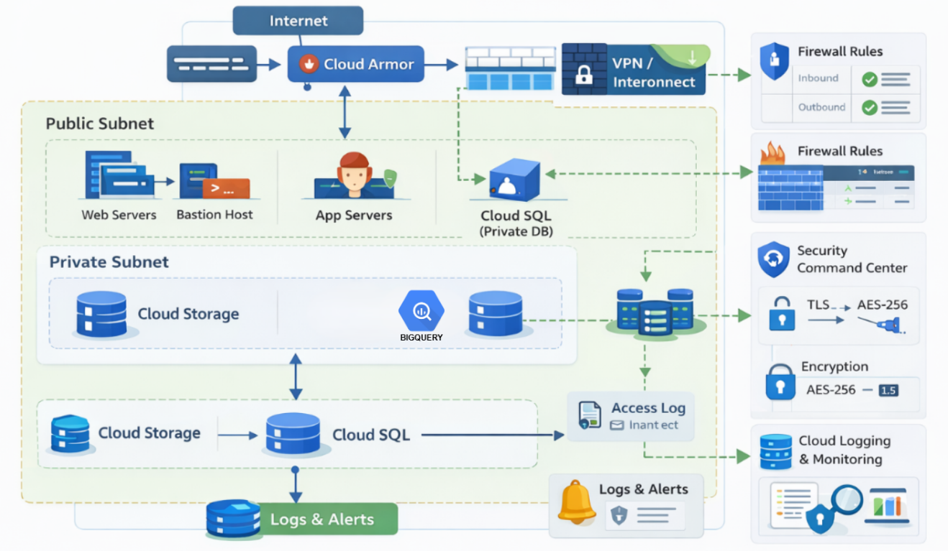
SECURE NETWORK ARCHITECTURE IN GOOGLE CLOUD

The secure network architecture in Google Cloud follows a layered defense strategy to protect organizational resources from external and internal threats. User traffic from the internet first enters the system through the External HTTP(S) Load Balancer, which distributes incoming requests across available backend services to maintain scalability and availability. Cloud Armor is integrated with the load balancer to provide Web Application Firewall (WAF) capabilities and protect against distributed denial-of-service (DDoS) attacks and malicious traffic.
The infrastructure operates inside a Virtual Private Cloud (VPC) that isolates organizational resources within a secure network environment. The architecture separates workloads into public and private subnets to minimize exposure. Public subnet resources such as web servers handle external requests, while application servers and databases operate within private subnets where direct internet access is restricted.
Administrative access is securely managed through a bastion host, allowing controlled entry into private resources. Access permissions are enforced using Identity and Access Management (IAM) policies based on the principle of least privilege. Network communication between components is further controlled using VPC firewall rules, ensuring that only authorized traffic flows between system layers.
Sensitive data services such as Cloud SQL databases use private IP connectivity and remain inaccessible from public networks. Data protection is strengthened through encryption mechanisms, including TLS encryption for data in transit and AES-256 encryption for data at rest. Continuous monitoring and threat detection are enabled using Cloud Logging, Cloud Monitoring, and Security Command Center, which provide real-time visibility into system activities.
This architecture ensures secure access control, network segmentation, threat prevention, and continuous monitoring, thereby maintaining confidentiality, integrity, and availability within the Google Cloud environment.

4. Briefly explain and draw diagram to design a cloud SQL database system along with cloud storage, bigquery and Data Studio in GCP.
Designing a cloud-based data system in Google Cloud that integrates Cloud SQL, Cloud Storage, BigQuery, and Looker Studio enables both operational data processing and advanced analytics. Each component serves a distinct role within the data architecture.
Cloud SQL functions as the transactional database system. It stores structured data generated by applications, such as customer records, transactions, and business operations. Because Cloud SQL is a managed service, Google handles backups, patching, and high availability configurations, reducing administrative overhead.
Cloud Storage serves as an intermediate storage layer for backups, exported data, and large unstructured files. Data from Cloud SQL can be periodically exported to Cloud Storage for archival purposes or further processing. Cloud Storage provides high durability and supports lifecycle management policies for cost optimization.
Cloud Storage
Used for:
- Backups
- Data exports
- Raw file storage

BigQuery

BigQuery acts as the analytical data warehouse. Data from Cloud Storage can be loaded into BigQuery for large-scale querying and analysis. BigQuery is serverless and supports SQL-based analytics across massive datasets, making it suitable for business intelligence workloads and reporting.

Looker Studio, formerly known as Data Studio, connects directly to BigQuery to create interactive dashboards and reports. It allows decision-makers to visualize trends, metrics, and key performance indicators in real time. This separation between transactional databases and analytical warehouses improves performance and scalability.
In this architecture, operational workloads are handled by Cloud SQL, while analytical workloads are handled by BigQuery. Cloud Storage acts as a bridge between systems, and Looker Studio provides visualization. This layered design ensures efficiency, scalability, and clear separation of concerns within the data ecosystem.

BigQuery Used for:
- Analytics
- Reporting
- Data warehousing
Looker Studio (Data Studio)
Used for:
- Dashboards
- Business intelligence reports

Detailed Data Flow
- Application writes data to Cloud SQL.
- Data exported to Cloud Storage.
- BigQuery loads data for analytics.
- Looker Studio connects to BigQuery.
- Business dashboards generated.

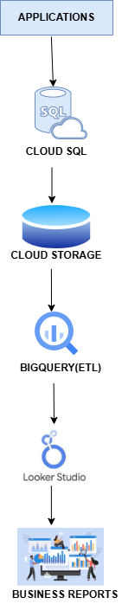
CLOUD DATA ANALYTICS WORK FLOW

