27.2

1. Who is the customer who spent the most on rental movies? Return his/her customer id, first name and the amount spent.

Most on rental movies = max rental rate. Amount spent = rental rate



   

2. Give an interesting query of your own that is not already in the assignment. The query should involve at least two joins, HAVING clause and aggregation operation. Give the answer.

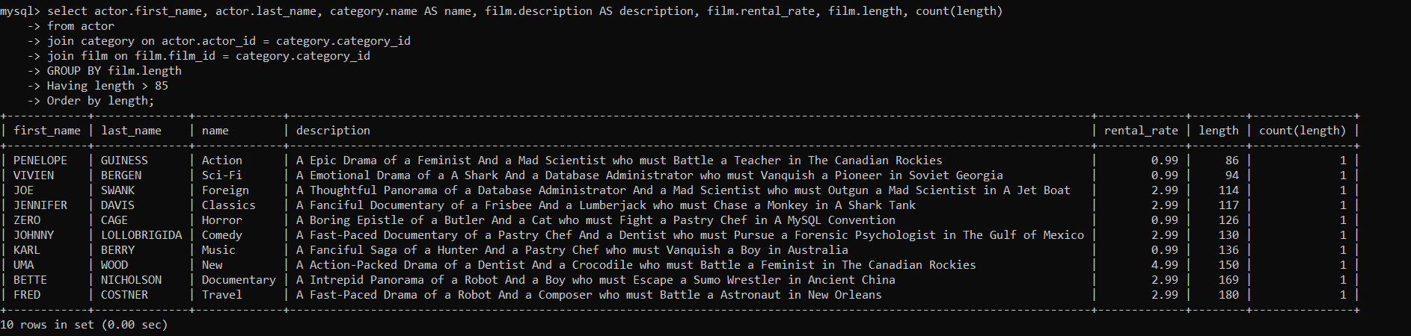

**Give the English explanation:**

The above query selects columns first name, last name**,** category name, film description, film rental rate and film length

From **table 1 (Actor)**

To combine the output result from three tables, we use **two joins** as below.

Ie **join <table 1 (Actor).column name(actor_id) and table 2 (Category).column name(category_id)>**

**Join <table 3 (Film).column name(film_id) and table 2 (Category) .column name(category_id)>**

Used **aggregate** operator **(count**) (under each category name only 1 record is displayed, so count is1)

Used **Having clause (Having length > 85)**