**Name:** Tejasvi Bhagwatkar **Date: 11/09/2021**

**Lab section: 007**

**Show your work!!!**

**Acquire**

Week: 30

Date: July 25 Year: **2021** Data: U.S. Census

**Source Article/Visualization:**

America’s Racial Breakdown by State. Data source: Kaiser Family Foundation, U.S. Census Bureau Suggested by: Rodrigo Calloni.

<https://www.makeovermonday.co.uk/data/data-sets-2018/>

**Represent**

**Critique**

I like that the boxes are in places of the actual states on a map. I also like that each boxes represents all the races included in the dataset. I also like that everything is clearly labeled. Things that I did not like about this visualization is that it is very crowded. The colors used in the visualization are also too close to each other and blend together at times. There is also a lot of reading involved, while trying to understand this visualization. Things that I am planning on doing differently are making the visualization simpler and having less text on the screen. I am also planning on representing this data on an actual map of the United States.

Based on my knowledge of the Periodic Table of Visualization Methods, this visualization falls in the Tree Map category. A tree map is used as an information visualization, and it is used as an interactive visual representation of data to amplify cognition. Meaning, the data is transformed into an image and then mapped. In this case the imaged has been mapped into the shape of the US. The characteristics of this representation are convergent thinking, with detail and overview.

**Mine**

Which state has the largest and smallest, percent of population of white and black races?

Which state has the largest and smallest, percent of population of Hispanic and Asian races?

**Filter**



**Stakeholders**

* My audience can be marketers who are trying to market a product to specific race in the US. They can use the map and see which state has to largest population of that race and spend most of their energy to that state. My audience can also include politicians who are trying to get a certain race to favor them. They can determine which state has the highest population of that race and arrange rallies and visits in those states only.
* Some of the assumptions that I made is that the dataset took a survey of rural and urban areas when determining the percentage of each race. Another assumption that I made is that the calculations done to get these percentages is accurate.
* What visualization tool/software did you use? Tableau

**What to submit:** This document in PDF format only (if you do not know how to do this, ask).

**Choose the best layout** for your makeover visualization: Portrait or Landscape, Remove the page of the layout that you DO NOT choose. No blank pages!

**NEW Sketch your Makeover**

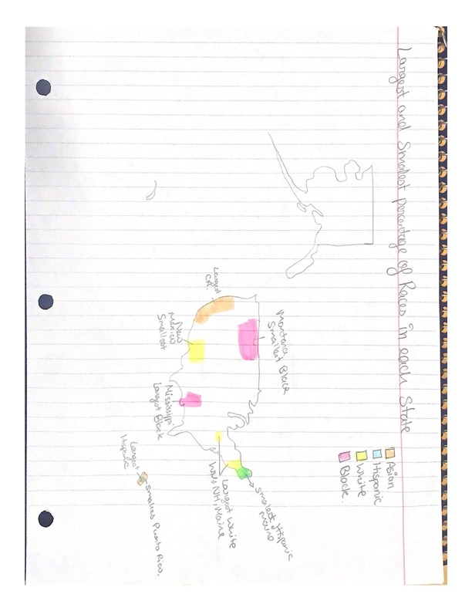

**Refine (Makeover – Landscape view)**

Figure Caption: United States map displaying the percentage of the While population per state using a color range. And representing the percentage of Black population using various circle sizes.

Figure Caption. United States map displaying the percentage of the Asian population per state using a color range. And representing the percentage of Hispanic population using various circle sizes.

**Resources**

Data Visualization Checklist:

<http://stephanieevergreen.com/wp-content/uploads/2016/10/DataVizChecklist_May2016.pdf>

How to give constructive criticism:

<https://personalexcellence.co/blog/constructive-criticism/>

Sample Makeovers

<https://www.makeovermonday.co.uk/gallery/>

**Grading Rubric**

|  |  |  |  |
| --- | --- | --- | --- |
| **Excellent**  **(11-15 pts)** | **Good**  **(6 -10 pts)** | **Fair**  **(2-5 pts)** | **Needs Improvement (0 - 1 pt)** |
| Meets **ALL** or most of these: Makeover is esthetically pleasing (color, perception), best practices followed (insightful), Correct dataset downloaded; provided an interesting point of view of the data; critiqued previous makeover, critique is constructive (indicates one thing that is done well, and one thing that could be done differently, what will be done to improve the visualization), assumptions (more than one) are listed. | Meets **MOST** of these: Makeover is esthetically pleasing (color, perception), best practices followed (insightful), Correct dataset downloaded; provided an interesting point of view of the data; critiqued previous makeover, critique is constructive (indicates one thing that is done well, and one thing that could be done differently, what will be done to improve the visualization), assumptions (more than one) are listed. | Consistently meets **SOME** of these: Makeover is esthetically pleasing (color, perception), best practices followed (insightful), Correct dataset downloaded; provided an interesting point of view of the data; critiqued previous makeover, critique is constructive (indicates one thing that is done well, and one thing that could be done differently, what will be done to improve the visualization), assumptions (more than one) are listed. | Little to no evidence of the understanding of the data visualization process.  Lackluster makeover or no makeover.  Little effort. |
| Sketch included: hand drawn [5 pts] | Sketch included, but was generated by computer [2 pts] | No sketch included. [0 pts] |  |
| Makeover Monday Assessment Completed  [5 pts] | Makeover Monday Assessment not completed [0 pts] |  |  |