**Name:** Tejasvi Bhagwatkar **Date:** October 19, 2021

**Lab section:** 007

**Show your work!!!**

**Acquire**

Week: 1

Date: January 1 Year: **2018** Data: data.world

Source Article/Visualization:

[U.S. Per Capita Consumption of Poultry and Livestock](https://www.theatlas.com/charts/SkwA7QzL)

Data Source: [National Chicken Council](http://www.nationalchickencouncil.org/about-the-industry/statistics/per-capita-consumption-of-poultry-and-livestock-1965-to-estimated-2012-in-pounds/)

<https://www.makeovermonday.co.uk/data/data-sets-2018/>

**Critique**

I like that the data is being represented using the best kind of graph necessary. I also like that all the information necessary to understand the data is being shown on the graph. However, by showing all the data the graph is a bit crowded and difficult to read at first glance. I plan to change this for my visualization. In my visualization I am planning on making the graph a bit less complicated and making a comparison between the total consumption of red meat and poultry.

**Mine**

Did we consume more red meat or poultry from the years 1960 – 2020? During which year did we consume the most amount of red meat or poultry? What kinds of red meat and poultry did we consume the most?

**Filter**



**Stakeholders**

* Who is your audience? Meat manufactures or farmers.
* What assumptions did you make? The data considered every single city in the US and not just the populated ones. Did the data only consider big meat manufacturers and not the small independent ones? Another one of my assumptions would has the data set been measured properly. Since there are no units in the excel sheet, I am going to assume that the unit of “Pounds” used in the original visualization is accurate.
* What visualization tool/software did you use? Tableau

**What to submit:** This document in PDF format only (if you do not know how to do this, ask).

**Choose the best layout** for your makeover visualization

* Portrait or Landscape
* Remove the page of the layout that you DO NOT choose. No blank pages!

**Refine (Makeover – Landscape view)**

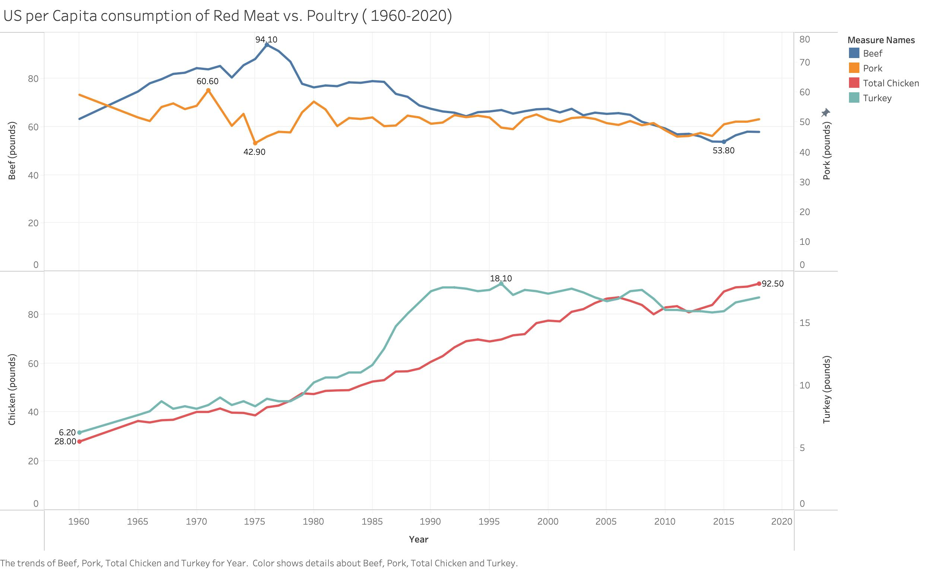

Total consumption of red meat vs. poultry in the US per capita. Labels provided on the years where the most amount of a particular meat was consumed and the least amount was consumed.

**Resources**

Data Visualization Checklist:

<http://stephanieevergreen.com/wp-content/uploads/2016/10/DataVizChecklist_May2016.pdf>

How to give constructive criticism:

<https://personalexcellence.co/blog/constructive-criticism/>

Sample Makeovers

<https://www.makeovermonday.co.uk/gallery/>

**Grading Rubric**

|  |  |  |  |
| --- | --- | --- | --- |
| **Excellent**  **(21-25 pts)** | **Good**  **(10-20 pts)** | **Fair**  **(5 – 9 pts)** | **Needs Improvement (0 – 4 pts)** |
| Meets **ALL** or most of these: Makeover is esthetically pleasing (color, perception), best practices followed (insightful), Correct dataset downloaded; provided an interesting point of view of the data; critiqued previous makeover, critique is constructive (indicates one thing that is done well, and one thing that could be done differently, what will be done to improve the visualization), assumptions (more than one) are listed. | Meets **MOST** of these: Makeover is esthetically pleasing (color, perception), best practices followed (insightful), Correct dataset downloaded; provided an interesting point of view of the data; critiqued previous makeover, critique is constructive (indicates one thing that is done well, and one thing that could be done differently, what will be done to improve the visualization), assumptions (more than one) are listed. | Consistently meets **SOME** of these: Makeover is esthetically pleasing (color, perception), best practices followed (insightful), Correct dataset downloaded; provided an interesting point of view of the data; critiqued previous makeover, critique is constructive (indicates one thing that is done well, and one thing that could be done differently, what will be done to improve the visualization), assumptions (more than one) are listed. | Little to no evidence of the understanding of the data visualization process.  Lackluster makeover or no makeover.  Little effort. |