CGT270 Midterm Part II

Data Visualization Challenge

Student:

<add your name here>

Professor

Dr. Vetria Byrd

TA

Subia Ansari

Course:

CGT 27000 Data Visualization

Term:

Fall 2021

Contents

Halloween Visualization 3

Data Description 3

Location of home 4

Example 4

The Assignment 5

Data Visualization Process 6

Acquire 6

The Data 6

Parse & Mine 7

Represent 8

Filter 11

Critique 12

Refine 14

What’s the story? 18

# Halloween Visualization

This in-class assignment is to create data visualizations using data collected about trick-or-treaters in Cincinnati, OH. **You should create two (2) visualizations**, this can be a collection of charts or a dashboard, whatever is necessary to the story or analysis that is shown in your visualizations. Make sure you **READ and FOLLOW ALL Instructions**. The goal is to demonstrate your understanding of the data visualization process.

# Data Description

|  |  |  |
| --- | --- | --- |
| The data is available in two formats   * Halloween data for Excel 2020 is a crosstab table which is ideal for creating visualizations in Excel. Numbers in the data file for Excel are **cumulative**. * Halloween data for Tableau 2020” is unpivoted which is ideal for creating visualizations in Tableau. Numbers in the data file for Tableau are **not cumulative**. * The data has been collected since 2008. * The numbers in the table are cumulative totals of the number of trick-or-treaters who visited one house each year. * The numbers are measured at 30-minute intervals, except for the last 15-minute interval. |  | * The trick-or-treat count was recorded in 30-minute intervals except for the last 15-minute interval. * The night of trick-or-treating has always been on October 31st each year (some neighborhoods change the night of trick-or-treating). * Official tick or treat hours are from 6 PM to 8 PM, but there are often “stragglers” past 8 PM that are not turned away. These stragglers are counted in the 8PM – 8:15 PM time slot. There has never been a trick-or-treater past 8:15 PM. * The type of candy did not vary year-by-year. It is always a general mix of candy purchased in bulk variety bags. |

## Location of home

Neighborhood: East Walnut Hills/Evanston

City, State: Cincinnati, Ohio

Zip code: 45207

Being a corner house on the neighborhood border likely increases the number of trick-or-treaters.

## Example

Here’ an example of how previous Halloween data have been visualized. Be creative!

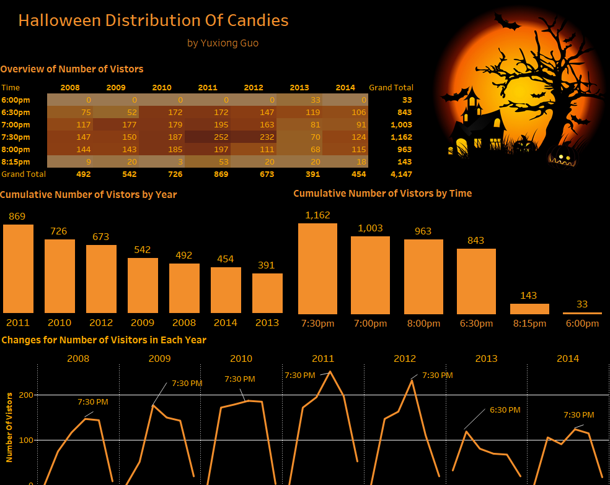

# The Assignment

There are multiple parts to this assignment. Make sure you read the entire assignment before starting.

Determine a story or goal to support the two (2) visualizations you will create using the Halloween data provided. Your two visualization MUST be different chart types. **This means DO NOT create two bar charts or two-line charts or two of the same chart types!** Challenge yourself. This is your time to show what you know.

Examples (these are examples):

* Homeowner dashboard summarizing Halloween
* Forecast future trick-or-treaters or estimate future candy needed
* Explore variation of the number of trick-or-treaters year by year
* **Be creative and think of other things you could do**

# Data Visualization Process

Show your understanding of the data visualization process.

# Acquire

## The Data

|  |  |  |  |  |  |  |
| --- | --- | --- | --- | --- | --- | --- |
| **Year** | **6pm** | **6:30pm** | **7pm** | **7:30pm** | **8pm** | **Total (8:15pm)** |
| 2020 | 11 | 55 | 107 | 155 | 211 | 219 |
| 2019 | 0 | 117 | 262 | 406 | 483 | 523 |
| 2018 | 18 | 191 | 342 | 497 | 589 | 600 |
| 2017 | 41 | 190 | 357 | 549 | 710 | 776 |
| 2016 | 22 | 160 | 386 | 612 | 759 | 822 |
| 2015 | 13 | 148 | 336 | 523 | 667 | 747 |
| 2014 | 0 | 106 | 197 | 321 | 436 | 454 |
| 2013 | 33 | 152 | 233 | 303 | 371 | 391 |
| 2012 | 0 | 147 | 310 | 542 | 653 | 673 |
| 2011 | 0 | 172 | 367 | 619 | 816 | 869 |
| 2010 | 0 | 172 | 351 | 538 | 723 | 726 |
| 2009 | 0 | 52 | 229 | 379 | 522 | 542 |
| 2008 | 0 | 75 | 192 | 339 | 483 | 492 |

Excel and Tableau versions of the data are provided in Brightspace. **Choose one (1) to work with**.

* HalloweenExcel
* HalloweenTableau

# Parse & Mine

Use this page to provide a parsing of the data. For quantitative fields list some basic statistical procedures that can be performed in the space below. To be clear, you are to list the procedure (you are not required to actually do any calculations here).

Use the Tab key to add more rows to the table below.

|  |  |  |
| --- | --- | --- |
| **Variable** | **Data type** | **Statistical Method**  **(where applicable)** |
| Year | Integer | Min, Max |
| Time | Integer | Min, Max |
| Count | Integer | Min, Max, Average, Mode |
| Day of the week | String |  |

# Represent

Figure 2. This chart represents the number of visitors throughout the different years.

Figure 1. This chart represents the number of visitors the house got at different time of the night.

Figure 3: This chart represents the number of trick or treaters who stopped by the house at different time of a given year.

# Filter

In this page show the data you used to create your visualizations.

**Figure 1**

|  |  |
| --- | --- |
| **Variable** | **Data Type** |
| Visitors Count | Integer |
| Year | Integer |

Used the color filter to split up the bar into different sections, each corresponding to a certain time at night.

**Figure 2**

|  |  |
| --- | --- |
| **Variable** | **Data Type** |
| Visitors Count | Integer |
| Time | Float |

Added labels, which display the count of visitors, to the different peaks and lows on the line.

**Figure 3**

|  |  |
| --- | --- |
| **Variable** | **Data Type** |
| Visitors Count | Integer |
| Day of the week | String |

# Critique

Rate your visualizations (Figure 1 and Figure 2) using the link below

<https://stephanieevergreen.com/rate-your-visualization/>

**Figure 3 Rating**

**Figure 1 Rating**

**Figure 2 Rating**

# 

# Refine

In this part of the visualization challenge, you should identify one or more characteristics of the visualizations you created (Figure 1 and Figure 2) and update the figures. Include an updated version of each Figure below. In the figure caption, state what changes were made.

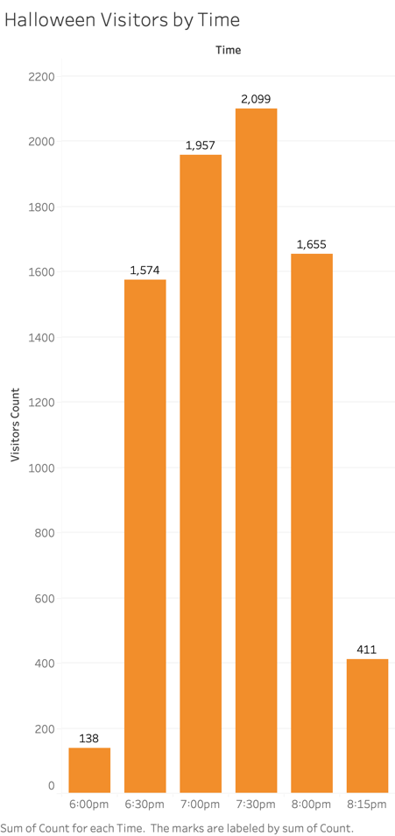

Figure 1 Refined. Updated the bar graph by increasing the font size of the numbers, in order to make it easy to read.

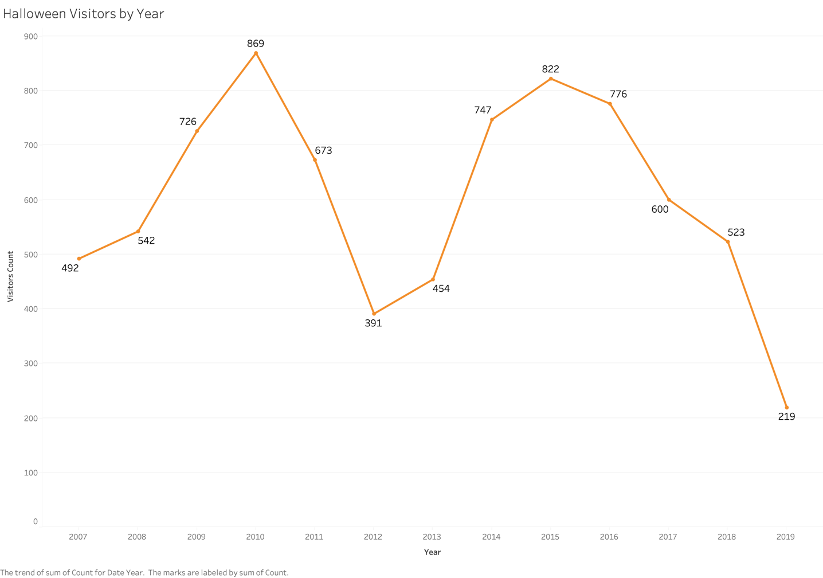

Figure 2 Refined. Increased the font size of the numbers.

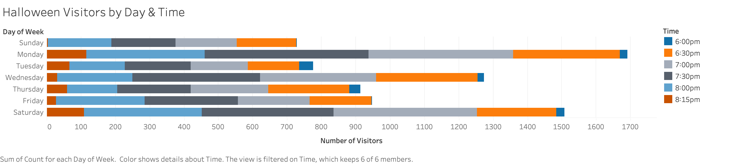

Figure 3 Refined: Updated the colors to make it more accessible for people with color blindness or are visually impaired.

# What’s the story?

I used the dataset to highlight the trends in between the number of trick or treaters who stopped by the house, and how that was impacted by a given time or day of the week. As seen in Figure 1, the number of visitors was the highest at 7:30 pm and the lowest at 6:00 pm. As seen in Figure 2, the number of visitors was the highest in the year 2010 and the lowest in the year 2019. Finally, Figure 3 shows that Monday had the highest number of visitors and Sunday had the lowest. These highs and lows in the graphs can help our target audience, who consists of middle-class families that give out candy every year on Halloween. The graphs can help them determine how much candy they should expect to give out at a given time or how much candy to buy, depending on what day Halloween falls on.

* Three assumptions I made while implementing the data visualization process
  + The number of trick or treaters increase after parents are back home from work and the families are done having dinner. This time happens to be 7:30 pm. The number of visitors decrease later in the night because the kids are tending to get tired and fall asleep.
  + The number of visitors increase in a certain year because on the day of Halloween the weather was good. Compared to the years which had the lowest number of visitors because of bad weather.
  + The number of visitors was the lowest during the weekdays because parents were not up to taking their kids trick or treating after a long day of work.

**Checklist of what to submit:**

* **Save this file as LastnameFirstInitial_CGT270Fall2021_MidtermPartII.pdf**
* **Only submit one (1) file. All of your work should be contained in this file.**
* **Failure to follow these instructions will result in your work NOT being graded.**

**General Deductions (others made accordingly)**

* **No name on the first page of the document: -5 pts**
* **Altered template: -10 pts**
* **No figures included: -15 pts for each missing figure**
* **No figure captions: -10 pts for each missing caption**
* **Zip file submitted: See Checklist of what to submit (-80 pts)**
* **Late submissions: Will NOT be graded (-80 pts)**
* **Provided a link to visualizations instead of providing screenshot of the visualization: this will be treated as no figure, no figure caption (-25 pts)**
* **Failure to follow data visualization best practices (data visualization checklist): deductions made appropriately.**

**Keep in mind: one (1) second after the submission deadline is considered late.**



Byrd Data Visualization Lab