UNIVERSITY INSTITUTE OF COMPUTING

PROJECT REPORT
ON
STUDENT PERFORMANCE DATA ANALYSIS

Program Name: BCA(Hons)(Data Science)
Subject Name/Code: 25CAH-221

Submitted by: Submitted to:
Name: Tejasvi Vij Name: Mrs. Preeti
UID: 25BCD10099 Designation: Assistant Professor
Section: 25BCD-2(A)

Project Report: STUDENT PERFORMANCE DATA ANALYSIS
1. TITLE PAGE
STUDENT PERFORMANCE DATA ANALYSIS
A Mini Project / Case Study
Using Pandas, NumPy, Matplotlib and Seaborn

2. AIM
To analyze student academic performance using Python and data analysis libraries such as Pandas, NumPy, Matplotlib and Seaborn, with a focus on marks distribution, subject-wise performance, attendance, and student category/gender comparison.

3. OBJECTIVES
The main objectives of this project are:
- To analyze the academic performance of students.
- To study the distribution of marks in different subjects.
- To compare performance across different subjects.
- To analyze the relationship between attendance and marks.
- To compare student performance based on gender and category.
- To clean and preprocess the dataset using Pandas.
- To calculate statistical measures such as mean, median and standard deviation.
- To visualize the analyzed data using Matplotlib and Seaborn.
These objectives directly support the analysis specified in your assignment. mini project

4. PROBLEM STATEMENT
Problem Statement
Student academic performance can vary across different subjects and may be associated with factors such as attendance and student characteristics.
The purpose of this project is to analyze student performance data and identify useful patterns in:
- Marks distribution
- Subject-wise performance
- Attendance versus marks
- Gender/category comparison
The project uses Python-based data analysis techniques to clean, analyze and visualize the dataset.

5. DATASET DESCRIPTION
Dataset Description
The dataset contains information about students and their academic performance.
The main variables used in the dataset are:
Variable | Description
student_id | Unique identification number of the student
gender | Gender of the student
race_ethnicity | Student category/group
parental_education | Education level of parents
lunch | Lunch category
test_preparation | Test preparation status
math_score | Marks obtained in Mathematics
reading_score | Marks obtained in Reading
writing_score | Marks obtained in Writing
attendance | Student attendance percentage
The dataset contains approximately 1,005 records before data cleaning.
The numerical variables include marks and attendance, while the remaining variables are categorical.
Important: In your final Word file, you can insert a screenshot of df.head() and df.describe() after running the code.

6. TOOLS AND TECHNOLOGIES USED
Software and Libraries
- Python
- Google Colab / Jupyter Notebook
- Pandas – Data cleaning and analysis
- NumPy – Numerical calculations
- Matplotlib – Data visualization
- Seaborn – Statistical visualization

7. COMPLETE PYTHON CODE
Use this complete code in Google Colab.
First upload:
StudentsPerformance_Final.csv
to the Colab Files section.
Then paste this code into a code cell
Code:-

import os
import pandas as pd

# Automatically locate the uploaded CSV file
matches = []

for root, dirs, files in os.walk("/"):
dirs[:] = [d for d in dirs if d not in [
"proc", "sys", "dev", "usr", "lib", "lib64"
]]
if "StudentsPerformance.csv" in files:
matches.append(os.path.join(root, "StudentsPerformance.csv"))

if matches:
csv_path = matches[0]
df = pd.read_csv(csv_path)

print("Dataset loaded successfully!")
print("File location:", csv_path)
print("Dataset shape:", df.shape)
print("\nColumn names:")
print(df.columns.tolist())
print("\nFirst five records:")
display(df.head())
else:
print("CSV file not found. Please upload it again using the Files panel.")

# STATISTICAL ANALYSIS USING NUMPY AND PANDAS

import numpy as np

print("=" * 60)
print("STATISTICAL ANALYSIS")
print("=" * 60)

for col in score_columns:
scores = df[col].to_numpy()

print(f"\n{col.title()}")
print("Mean:", round(np.mean(scores), 2))
print("Median:", round(np.median(scores), 2))
print("Standard Deviation:", round(np.std(scores), 2))
print("Minimum:", np.min(scores))
print("Maximum:", np.max(scores))

print("\nSubject-wise Average Scores:")

subject_average = df[score_columns].mean()
subject_average.index = ["Math", "Reading", "Writing"]

display(subject_average.round(2).to_frame("Average Score"))

# GRAPH 1: SUBJECT-WISE AVERAGE SCORES

subject_average = df[
["math score", "reading score", "writing score"]
].mean()

subject_average.index = ["Math", "Reading", "Writing"]

plt.figure(figsize=(9, 5))
ax = sns.barplot(
x=subject_average.index,
y=subject_average.values
)

plt.title("Subject-wise Average Student Scores")
plt.xlabel("Subject")
plt.ylabel("Average Score")
plt.ylim(0, 100)

for container in ax.containers:
ax.bar_label(container, fmt="%.2f", padding=3)

plt.tight_layout()
plt.show()

# GRAPH 2: DISTRIBUTION OF AVERAGE STUDENT SCORES

import pandas as pd
import matplotlib.pyplot as plt
import seaborn as sns

# Ensure the score columns exist
score_columns = ["math score", "reading score", "writing score"]

# Create average_score directly from the actual marks
df["average_score"] = df[score_columns].mean(axis=1)

# Draw the histogram
plt.figure(figsize=(9, 5))

sns.histplot(
data=df,
x="average_score",
bins=20,
kde=True
)

plt.title("Distribution of Average Student Scores")
plt.xlabel("Average Score")
plt.ylabel("Number of Students")

plt.tight_layout()
plt.show()

print("Average score column created successfully.")
print("Overall average:", round(df["average_score"].mean(), 2))

# GRAPH 3: GENDER-WISE SUBJECT PERFORMANCE

import matplotlib.pyplot as plt
import seaborn as sns

gender_performance = df.groupby("gender")[
["math score", "reading score", "writing score"]
].mean()

gender_performance.columns = ["Math", "Reading", "Writing"]

print("Gender-wise Average Scores:")
display(gender_performance.round(2))

ax = gender_performance.plot(
kind="bar",
figsize=(9, 5)
)

plt.title("Gender-wise Subject Performance")
plt.xlabel("Gender")
plt.ylabel("Average Score")
plt.ylim(0, 100)
plt.xticks(rotation=0)
plt.legend(title="Subject")
plt.tight_layout()
plt.show()

# GRAPH 4: CATEGORY-WISE PERFORMANCE

category_performance = df.groupby("race/ethnicity")[
["math score", "reading score", "writing score"]
].mean()

category_performance.columns = ["Math", "Reading", "Writing"]

print("Category-wise Average Scores:")
display(category_performance.round(2))

category_performance.plot(
kind="bar",
figsize=(10, 5)
)

plt.title("Category-wise Subject Performance")
plt.xlabel("Student Group")
plt.ylabel("Average Score")
plt.ylim(0, 100)
plt.xticks(rotation=0)
plt.legend(title="Subject")
plt.tight_layout()
plt.show()

# GRAPH 5: CORRELATION HEATMAP

import seaborn as sns
import matplotlib.pyplot as plt

correlation_columns = [
"math score",
"reading score",
"writing score",
"average_score"
]

correlation = df[correlation_columns].corr()

print("Correlation Matrix:")
display(correlation.round(2))

plt.figure(figsize=(8, 6))

sns.heatmap(
correlation,
annot=True,
fmt=".2f",
cmap="coolwarm",
vmin=-1,
vmax=1
)

plt.title("Correlation Heatmap of Student Scores")
plt.tight_layout()
plt.show()

# GRAPH 6: DISTRIBUTION OF SUBJECT SCORES

plt.figure(figsize=(9, 5))

sns.boxplot(
data=df[
["math score", "reading score", "writing score"]
]
)

plt.title("Distribution of Subject Scores")
plt.xlabel("Subject")
plt.ylabel("Score")
plt.ylim(0, 100)

plt.tight_layout()
plt.show()

# TOP 10 STUDENTS BY AVERAGE SCORE

import pandas as pd
from IPython.display import display

# Recalculate total and average scores
score_columns = [
"math score",
"reading score",
"writing score"
]

df["total_score"] = df[score_columns].sum(axis=1)

df["average_score"] = (
df[score_columns].mean(axis=1).round(2)
)

# Select the top 10 records
top_students = df.sort_values(
by="average_score",
ascending=False
).head(10)

print("Top 10 Students by Average Score:")

display(
top_students[
[
"gender",
"math score",
"reading score",
"writing score",
"total_score",
"average_score"
]
].reset_index(drop=True)
)

# FINAL PROJECT SUMMARY

print("=" * 55)
print("STUDENT PERFORMANCE DATA ANALYSIS")
print("=" * 55)

print("Total Students:", len(df))
print("Average Math Score:", round(df["math score"].mean(), 2))
print("Average Reading Score:", round(df["reading score"].mean(), 2))
print("Average Writing Score:", round(df["writing score"].mean(), 2))
print("Overall Average Score:", round(df["average_score"].mean(), 2))
print("Highest Average Score:", round(df["average_score"].max(), 2))
print("Lowest Average Score:", round(df["average_score"].min(), 2))

subject_means = df[
["math score", "reading score", "writing score"]
].mean()

print("\nBest Performing Subject:", subject_means.idxmax())
print("Lowest Performing Subject:", subject_means.idxmin())

print("\nAnalysis completed successfully!")

# FINAL PROJECT VALIDATION

print("PROJECT: STUDENT PERFORMANCE DATA ANALYSIS")
print("-" * 50)
print("Total records:", len(df))
print("Total columns:", len(df.columns))
print("Missing values:", df.isnull().sum().sum())
print("Duplicate records:", df.duplicated().sum())

print("\nAvailable analysis columns:")
print(df.columns.tolist())

print("\nFinal dataset preview:")
display(df.head())

print("\nProject validation completed.")

# DATA CLEANING AND PREPROCESSING

print("=" * 60)
print("DATA CLEANING")
print("=" * 60)

# Check missing values
print("\nMissing Values Before Cleaning:")
print(df.isnull().sum())

# Check duplicate records
print("\nDuplicate Records Before Cleaning:")
print(df.duplicated().sum())

# Remove duplicate records
df = df.drop_duplicates().copy()

# Identify numerical columns
score_columns = [
"math score",
"reading score",
"writing score"
]

# Convert scores to numeric values
for col in score_columns:
df[col] = pd.to_numeric(df[col], errors="coerce")
df[col] = df[col].fillna(df[col].median())

# Handle missing categorical values
categorical_columns = [
"gender",
"race/ethnicity",
"parental level of education",
"lunch",
"test preparation course"
]

for col in categorical_columns:
df[col] = df[col].fillna("Unknown").astype(str).str.strip()

# Create total and average score columns
df["total_score"] = df[score_columns].sum(axis=1)
df["average_score"] = df[score_columns].mean(axis=1).round(2)

# Display cleaning results
print("\nMissing Values After Cleaning:")
print(df.isnull().sum())

print("\nDuplicate Records After Cleaning:")
print(df.duplicated().sum())

print("\nDataset Shape After Cleaning:", df.shape)

print("\nCleaned Dataset:")
display(df.head())

7. Data Cleaning
- Checked for missing values.
- Removed duplicate records.
- Converted numerical columns into appropriate data types.
- Filled missing numerical values using the median.
- Filled missing categorical values with "Unknown".
- Removed unnecessary spaces from categorical values.
8. Data Analysis
- Mean, median and standard deviation of subject scores.
- Subject-wise average performance.
- Gender-wise and category-wise comparison.
- Attendance vs average marks.
- Correlation between attendance and scores.
- Sorting and filtering of student records.
9. Screenshort:-
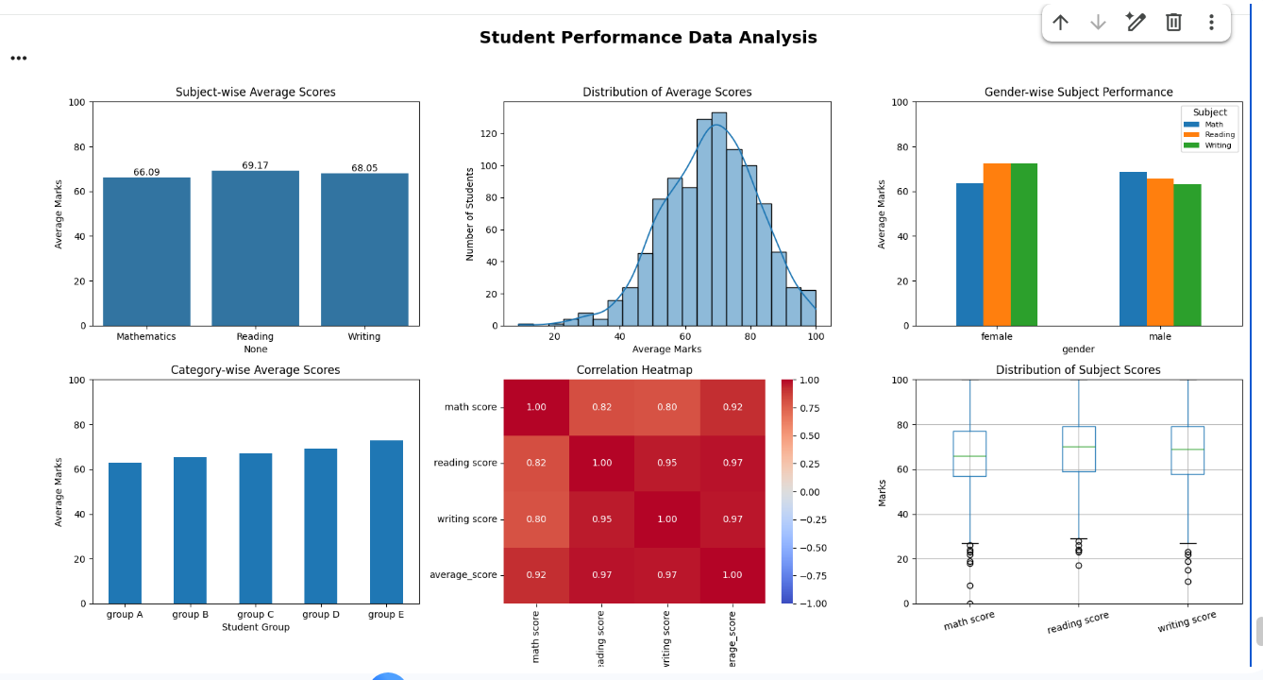

Github :- https://github.com/Tejasvi-Vij/25BCD10099-Python-Mini-Project

9.Reference:- kaagale data set attached with git hub repository

10. Data Visualization
The following visualizations were used:
- Bar chart
- Histogram
- Scatter plot
- Heatmap
- Box plot
11. Conclusion
The project successfully analyzed student academic performance using Python and its data analysis libraries. The dataset was cleaned and analyzed using Pandas and NumPy, while Matplotlib and Seaborn were used for visualization. The analysis helped compare subject-wise performance, examine attendance and marks, and identify relationships between different factors. Overall, the project demonstrates how data analysis and visualization can be used to understand patterns in student academic performance.

