**--Loading the table data**

SELECT * FROM db1.netflix_data_1;

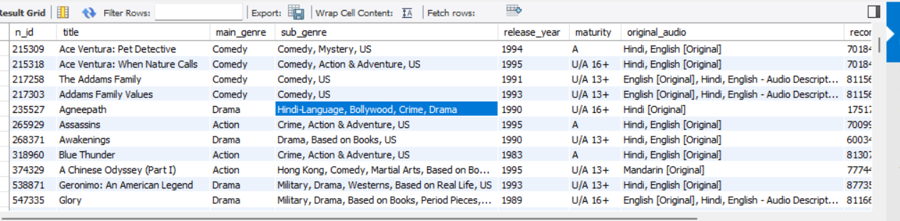

**--Count of total entries**

select count(*) from netflix_data_1;

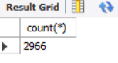

**--Describing the type of data present**

describe netflix_data_1;

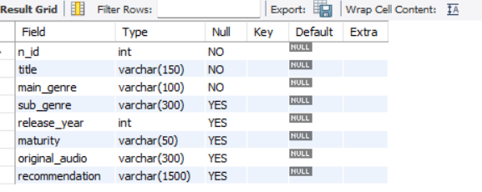

**--Displaying the minimum and maximum release year found in the table data**

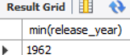 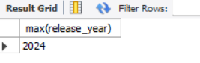

select max(release_year) from netflix_data_1;

select min(release_year) from netflix_data_1;

select * from netflix_data_1 where main_genre = 'comedy' limit 3 ;

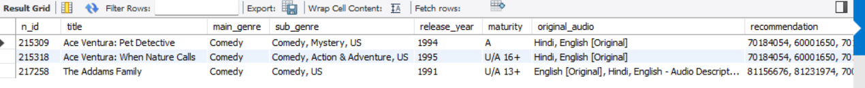

**-- Content over time**

SELECT

release_year, COUNT(*) AS total_titles

FROM

netflix_data_1

GROUP BY release_year

ORDER BY release_year DESC;

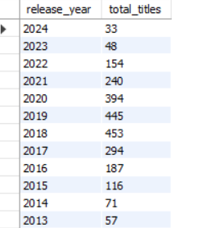

SELECT main_genre, COUNT(*) AS total

FROM netflix_data_1

GROUP BY main_genre

ORDER BY total DESC;

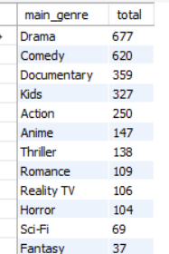

SELECT sub_genre, COUNT(*) AS total

FROM netflix_data_1

GROUP BY sub_genre ORDER BY total DESC limit 10;

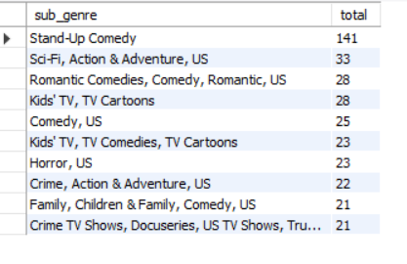

**-- Checking if subgenre is empty or having any missing values**

select * from netflix_data_1 where sub_genre = 'null' or sub_genre='';

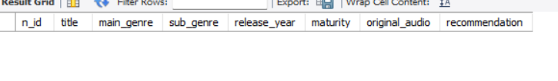

select main_genre, count(*) as total from netflix_data_1 group by main_genre order by total desc limit 10;

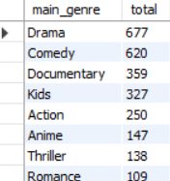

**-- Maturity rating distribution**

select maturity, count(*) as t from netflix_data_1 group by maturity order by t;

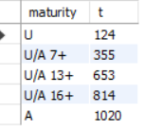

**-- Count of titles with "us" in subgenre**

select count(*) as us_titles from netflix_data_1 where sub_genre like '%Us%';



**-- Most frequent original audio languages**

SELECT original_audio, COUNT(*) AS total

FROM netflix_data_1

GROUP BY original_audio

ORDER BY total DESC

LIMIT 10;

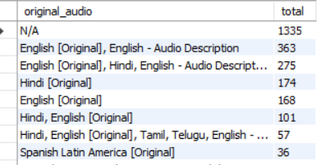

**-- Count of titles per maturity per year**

SELECT release_year, maturity, COUNT(*) AS total

FROM netflix_data_1

GROUP BY release_year, maturity

ORDER BY release_year, total DESC limit 20;

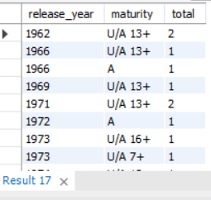

**-- Top 5 genre with most recommendations**

SELECT main_genre, AVG(LENGTH(recommendation)) AS avg_recommendation_length

FROM netflix_data_1

GROUP BY main_genre

ORDER BY avg_recommendation_length DESC

LIMIT 5;

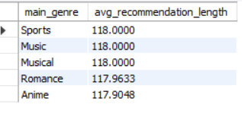

**-- Finding duplicate titles**

SELECT title, release_year, COUNT(*) AS count

FROM netflix_data_1

GROUP BY title, release_year

HAVING COUNT(*) > 1;

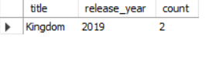

**-- Finding which rows are duplicated using CTE**

WITH duplicates AS (

SELECT title, release_year

FROM netflix_data_1

GROUP BY title, release_year

HAVING COUNT(*) > 1

)

SELECT *

FROM netflix_data_1

WHERE (title, release_year) IN (

SELECT title, release_year FROM duplicates

);

