**Results:**

✅ Data Loaded Successfully

Fund_ID Region Quarter Capital_Calls Distributions NetAssetValue Investments Management_Fees

0 F001 India 2018-Q%q 2719110 2429084 14335494 13576316 169879

1 F001 India 2018-Q%q 610268 932180 13868468 13231131 137498

2 F001 India 2018-Q%q 2772355 1439911 15279079 14737989 117221

3 F001 India 2018-Q%q 1287201 1570455 15122894 13845897 55311

4 F001 India 2019-Q%q 603355 1462752 14248276 13400827 180608

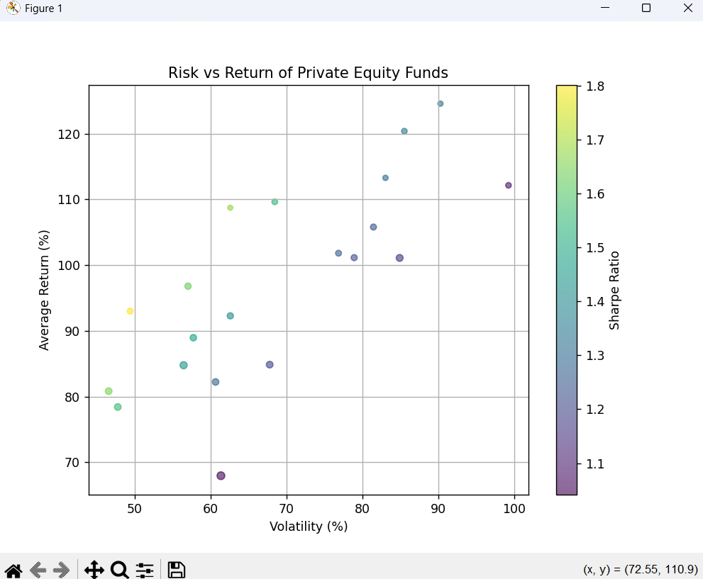

Fund Performance:

Fund_ID Average_Return Volatility Latest_NAV Latest_Investments Sharpe_Ratio

0 F001 84.781540 56.471103 33776316 32630402 1.430493

1 F002 105.798198 81.468885 23884912 22577548 1.249535

2 F003 67.977210 61.383879 40059578 38662519 1.042248

3 F004 82.235475 60.681725 28398508 27073582 1.289276

4 F005 84.870839 67.803890 29560277 28683312 1.192717

