Explainable AI Governance Framework for Fair Student Performance Evaluation

Tejasvi Kolhe
Symbiosis Institute of Technology, Nagpur Campus, Symbiosis International (Deemed University), Nagpur, India Tejasvi.kolhe.batch2024@sitnagp ur.siu.edu.in

Sahiti Chhanam
Symbiosis Institute of Technology, Nagpur Campus, Symbiosis International (Deemed University), Nagpur, India sahiti.chhanam.batch2024@sitnagpur.s iu.edu.in
Yatharth Deotale
Symbiosis Institute of Technology, Nagpur Campus, Symbiosis International (Deemed University), Nagpur, India yatharth.deotale.batch2024@sitnagpur.si u.edu.in

Abstract- Student dropout is a significant impediment to quality education, and the use of machine-learning systems as an early-warning system is becoming more and more common in attempts to solve this problem. However, none of them go beyond prediction without providing explanations for the individual decision for teachers or evaluating whether the prediction discriminates between different demographic groups. This paper proposes an Explainable AI Governance Framework for equitable student performance assessment, consistent with the UN SDGs 4 (Quality Education) and 10 (Reduced Inequalities), which was constructed as five consecutive steps: data preparation, model benchmarking, explanation, fairness audit and institutional governance. Expanding the dropout indicator study of Silva et al. [1] with the same data on Brazilian technical education (15,084 students, 22.4% dropout), we consider cumulative first-year GPA, course failures and attendance as operational indicators of early warning and benchmark 48 different combinations of balance strategy, feature selection and classifier according to the recall-first criterion. The best-performing Random Forest algorithm achieves 84.8% recall, 83.6% precision, 92.9% accuracy and AUC of 0.951 on the 3,017 unseen students. Fairness audits on gender, race, income, age, and internet access prove that the model is actually taking into account the disparity in dropouts: disparate impact is within the four-fifths range for race (1.180), outside the range for gender (0.707 – women less often marked and detected), but above the range for income (1.411), age (1.590) and internet access (1.403) where the members of protected categories are nonetheless detected equally well. The governance charter, comprising five elements (advisory use only, explainability coupling, bi-annual recalibration, independent appeals and counselor final say), makes sure that all outputs are recommendations for further consideration by people.
- INTRODUCTION
Student attrition undermines quality education, which UN SDG 4 links to inclusion and equity. Machine learning on administrative records enables early support [5], [1]; random forests and support vector machines reach up to 90% accuracy [6].
Accuracy alone is insufficient when predictions influence decisions about people. Post-hoc attribution methods such as SHAP [12] and LIME [13] show which features drive a tree-ensemble prediction. Silva et al. applied both to 15,084 students of a Brazilian technical institution and found attendance, family income and residence among the strongest dropout drivers, with a Random Forest reaching 85% recall [1]. Because income and residence emerge as predictors, equity across backgrounds must be tested. AIF360 makes this measurable [14], but fairness criteria cannot all be satisfied at once [15], so any audit must state its trade-offs (SDG 10).
Existing work treats prediction, explanation, fairness and accountability separately: admissions studies use sensitive or proxy variables without a bias audit [4]; early-warning pipelines offer no explanation or fairness check [5]; adversarial debiasing reduces false negatives for marginalised applicants but acts only during training, without explanation [3]; and the closest analogue, combining a transformer, SHAP and fairness analysis, lacks access control, governance and appeal [2]. No reviewed study delivers an explainable, fairness-audited pipeline inside a governance structure a university could adopt.
We close this gap with an Explainable AI Governance Framework in which every prediction carries a human-readable explanation, every model is audited for group-level bias, and no output is final until a counselor has reviewed it. We adopt Silva et al. [1] as base paper and reuse its Brazilian dataset, so results can be compared with a published benchmark before the explanation, fairness and governance layers are added. We hypothesize that a model can be highly accurate yet flag students from different backgrounds unevenly, so a fairness audit, not accuracy alone, is the real safeguard, and that academic-performance features make a pre-enrollment risk model an operational early-warning tool.
The contribution is integration, not new algorithms: a recall-first model-selection protocol, SHAP and LIME explanations and a five-axis fairness audit in one reproducible pipeline, plus a five-pillar governance charter (strictly advisory use, explainability coupling, bi-annual recalibration, independent appeals, counselor final authority) so that no output is an automated decision. It is a research prototype with a documented deployment path, not a production tool.
Section II reviews the literature, Section III the methodology, Section IV the results and discussion, and Section V concludes with implications, limitations and future work.

LITERATURE REVIEW
Student outcome research has shifted from the question of whether performance could be predicted to the question of whether the prediction was trustworthy (see Table I). Institutional datasets alone have made accurate early prediction possible: Silva et al. achieved 85% recall for dropout prediction on 15,084 students [1], and a systematic review shows an accuracy of nearly 90% [6]. Explainability has been achieved with SHAP and LIME [1], [2], and the use of adversarial debiasing by Priyadarshini and Gago-Masague improved recall for marginalized applicants [3], but only in the training set. Since Disparate Impact, Equalized Odds and Calibration cannot be simultaneously satisfied [15], it is necessary to declare in advance which criterion will be prioritized. In total, the surveyed studies are individually solid but collectively incomplete: well-performing pipelines fail to provide explainability [5], [10]; pipelines providing explainability fail to perform audits [1], [4]; pipelines performing audit or debiasing fail to provide explanation or governance [3]; and the closest equivalent fails to provide access control or an appeal system [2]. The present work extends the base study [1] with three additional layers.
TABLE I. SUMMARY OF SURVEYED LITERATURE ON EXPLAINABLE, FAIR AND GOVERNED STUDENT-OUTCOME PREDICTION.
Source | Research Focus | Key Findings | Gaps
Silva et al. (2025) [1] | Dropout, technical education; RF with LIME and SHAP | 85% recall; attendance and income key drivers | No fairness audit or governance
Zanellati et al. (2024) [2] | Dropout, Italy; RF vs transformer, SHAP | 81% sensitivity; explainable | No governance or appeal
Priyadarshini & Gago-Masague (2024) [3] | Admissions; adversarial debiasing | Fewer false negatives for marginalised groups | In-training only; no audit or XAI
Mengash (2020) [4] | Pre-admission prediction; ANN | Accuracy above 79% | Sensitive data; no bias audit
Alhazmi & Sheneamer (2023) [5] | Early at-risk prediction | Early features suffice | No explanation or fairness check
Pelima et al. (2024) [6] | Review of graduation prediction | RF, SVM; accuracy up to 90% | Explainability and fairness rarely joint
Ma et al. (2023) [7] | Exam prediction under uncertainty | Higher accuracy at low cost | No fairness or governance
Jiang & Wang (2020) [8] | Interpretable cognitive diagnosis | Better accuracy, interpretable | Not post-hoc; no fairness
Zhang & Yang (2022) [9] | Teacher appraisal; fuzzy GA | More systematic ranking | No fairness or appeal
Zhou (2022) [10] | Education informatization; neural network | Error only 0.1 to 0.5 | Black box; no explanation
Lu et al. (2024) [11] | Institution quality; fuzzy ExpTODIM | Captures holistic quality | Expert weights; no bias check

METHODOLOGY
Methodology transforms the validated dropout prediction pipeline to the governed one through five steps (Figure 1): data preparation, model benchmarking, explainable AI, fairness auditing and institutional governance, with monitoring that sends us back to the first step. After Silva et al. [1], we choose secondary technical education as our context in order to have an opportunity to compare the predictive part of our system with a benchmark in the literature, and include first year cumulative GPA, failed courses, and attendance as early warning factors, auditing for fairness and institutionalization of the model in policy.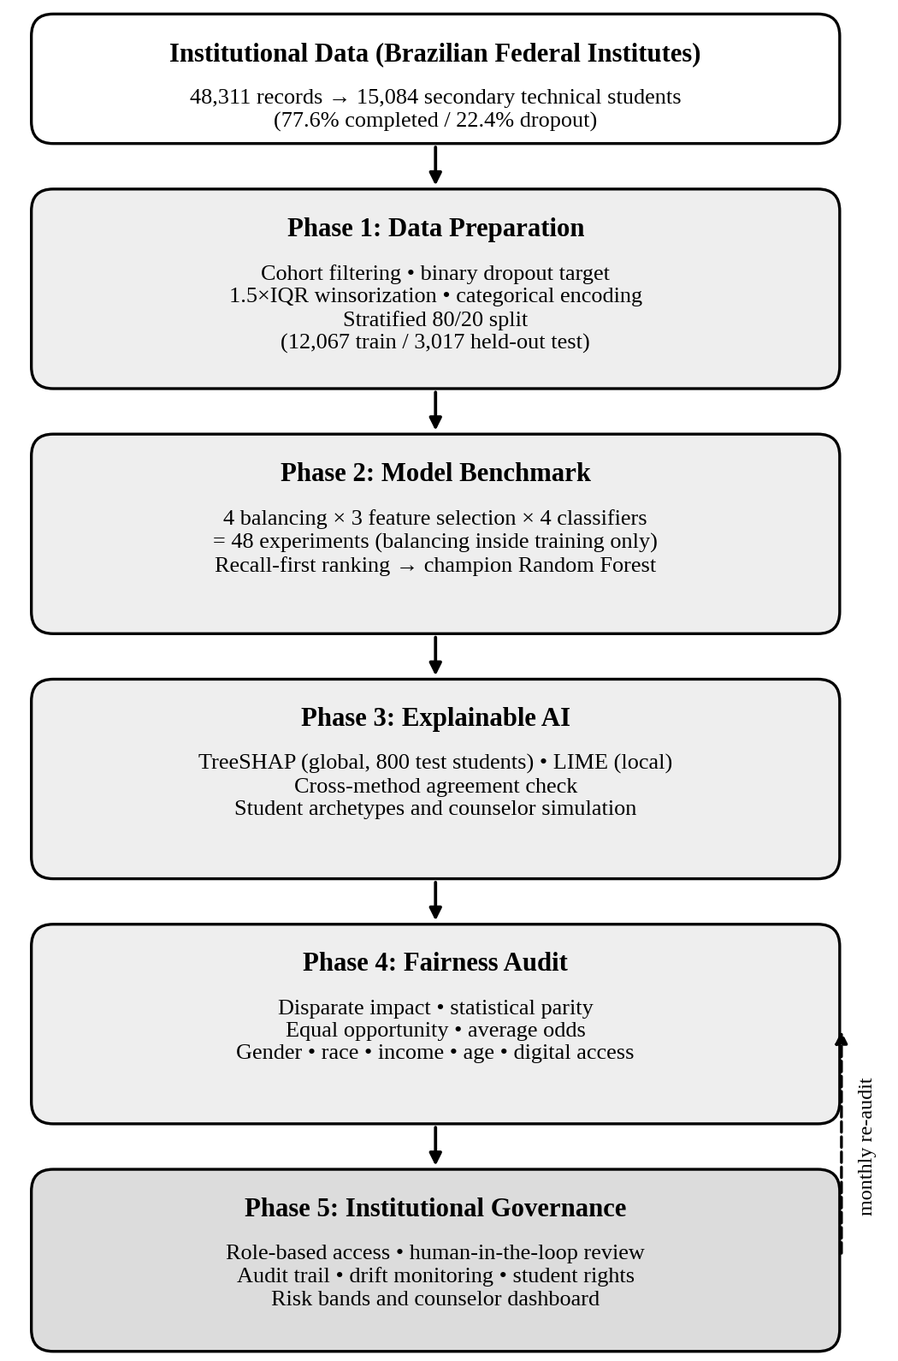
Fig. 1. Overview of the five-phase methodology.
A. Phase 1: Data Preparation and Exploration
Data are extracted from the database of the Brazilian Federal Institutes of Education, Science and Technology (N=48,311; 30 attributes) [1]. Courses with specified outcome were categorized in four types: Integrado, Subsequente, Concomitante and PROEJA/Integrado EJA. Class 0 (completed) consisted of 11,703 students; Class 1 (dropout, cancellation, expulsion due to insufficient progress, or transfer) consisted of 3,381 students. Incomplete cases were excluded. The 15,084 students were divided proportionally 77.6%/22.4% (3.46:1) making the universal completion prediction rate equal to 77.6% while ignoring all dropouts.
The stratified sampling yielded 12,067 training (80%) and 3,017 test (20%) samples. The training set was used for balancing, features selection and cross-validation based tuning of parameters; the test set was untouched. The 2,722 test set students that had positive GPA values made up the validation set. The continuous variables were truncated by Q1 − 1.5·IQR and Q3 + 1.5·IQR (IQR=Q3-Q1) or by the 1st/99th percentiles if IQR=0.
B. Phase 2: Model Benchmarking
The full factorial design (4 × 3 × 4 = 48 experiments) was used to select the model. Balancing methods on training set only: None, random undersampling, SMOTE [16] (x_syn = x_i + λ(x_kNN − x_i), λ ~ uniform [0, 1]) and SMOTEENN [17]. Feature selection methods: ANOVA, backward selection, Random Forest Importance. Models: Random Forest [18], Decision Tree, Logistic Regression and SVM optimized via grid search with 5-fold cross-validation and tested using 10-fold cross-validation.
Recall, Precision, F1-Score, Accuracy and ROC AUC were the metrics. Recall = TP/(TP + FN), which is the first metric, is a fraction of detected dropouts. Precision = TP/(TP + FP) describes purity of alerts, preventing advisor's tiredness. Models were ordered according to recall, since false negative cases are more critical than false positives.
C. Phase 3: Explainable AI
The global interpretability involves applying SHAP [12] together with TreeSHAP [19] on 800 test individuals (441 female, 359 male): f(x) = φ_0 + Σ φ_i(x), where the absolute mean values of the factors indicate their level of importance, the beeswarm plots indicate the effect direction and the dependence plots indicate non-linear thresholds and interactions. The counselors get per-prediction SHAP waterfall plots and LIME [13] explanation (g(z’) = w_0 + Σ w_j z’_j, proximity kernel). Twelve archetypes were distinguished, among which four were investigated thoroughly: the high-risk one (#0), the low-risk one (#1), the borderline one (#37) and the critical-risk one (#43, the counselor simulation).
D. Phase 4: Fairness Audit
Performance was assessed using the 3,017 test students for fairness on five protected attributes: gender, race/ethnicity (white/brown vs. black/or indigenous), income (high vs. low/medium ≤$930 median), age (young vs. old >20), and ownership of home computer. Metrics used in this study include AIF360 [14] metrics such as disparity impact (DI)= P(ŷ = 1| protected)/P(ŷ = 1 | privileged), outside of 0.80 to 1.25 [20]; statistical parity difference (SPD) and equal opportunity difference (EOD) [21], which should be within ±0.10. The former two metrics indicate who is flagged while the last metric determines if at-risk students are flagged similarly. If the drop out ratios vary for each group, then there will not be a model which satisfies both requirements [15].
E. Phase 5: Institutional Governance

The governance solves the problem of regulation in such models [2], [9]. Five obligatory principles: (1) purely advisory role, with sanctions and exclusion being prohibited; (2) risk classification should be complemented with a SHAP or LIME card; (3) bi-annual calibration based on new data to prevent concept drift and repeat four-fifths rule check; (4) appeals with explanation right; (5) counselor absolute power over all interventions. Mutable interventions allow counseling only on actionable levers (attendance counseling, peer tutoring, academic remediation, transportation/ nutrition assistance); non-maleficence protects immutable traits (race, gender, age, family history) from penalties or exclusion due to constant checking of the four-fifths rule; human supremacy provides that any intervention is possible only after counselor permission and dual decision-making for borderline cases. RBAC guarantees privacy according to GDPR and Brazil’s LGPD [22]; immutable audit trail keeps record of queries, predictions, and notes; predictions are available only on counselor dashboards. Risk levels: low (< 0.40), borderline (0.40 - 0.70, human review), critical (> 0.70, multidisciplinary case conference).

RESULTS AND DISCUSSION
Figures refer to the 3,017-student test set unless noted; the baseline study is [1].
A. Phase 1: Data Characteristics and Exploratory Findings

The stratified split yielded 12,067 training and 3,017 test students (2,722 active, non-zero GPA). Winsorization removed no data, thus the cohort (15,084 students; 77.6% graduated, 22.4% dropped out) equals [1]

The largest modality, Integrado (10,076 students), shows the lowest dropout (16.3%), compared to Concomitante (32.7%), Subsequente (34.6%) and PROEJA/Integrado EJA (39.5%, twice that of Integrado). The two modalties with the highest dropout rates cater to working adults, which implies economic pressure and time constraints rather than age.
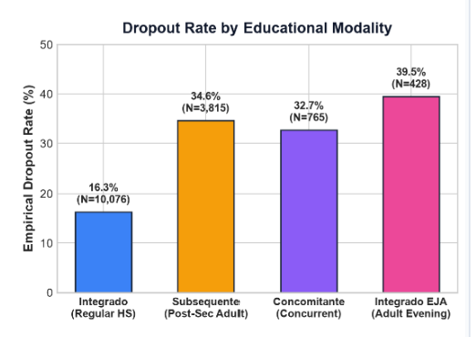
Fig. 2. Empirical dropout rate by educational modality (N = number of students in each modality).
Three patterns have been observed: an attendance cliff (Fig. 3), whereby despite the 75% threshold dropout rate increased from 8.4% at 90% and higher to 18.2% (75% to 89%), 48.7% (60% to 74%) and 62.4% (less than 60%), almost seven times the exemplary figure and much greater than the average of 22.4%; an academic cliff, where graduates averaged the GPA of 7.2/10 compared to 5.0 and below for dropouts; and the digital divide, whereby 28.4% of students dropped out with no home laptop compared to 18.1%. The attendance and socioeconomic trends correlate with [1]; the academic cliff is a new finding, divides the population better than any admission indicator, and justifies academic indicators [5].
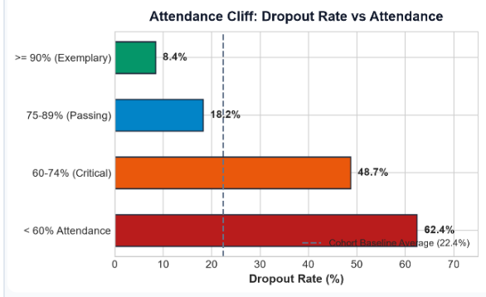
Fig. 3. Dropout rate by attendance band, with the cohort baseline of 22.4% shown as a dashed line.
B. Phase 2: Model Benchmarking Results

Out of 48 experiments, the best combination of models was Random Forest with under-sampling and feature importance selection: recall 84.8%, precision 83.6%, F1-score 84.2%, accuracy 92.9%, and AUC 0.951. Ten-fold cross-validation (CV) recall of 87.8% is close to the held-out result; therefore, it is not the artefact of one split. Recall is close to the 85% recall rate of Silva et al. [1], proving faithful replication even with additional academic features. Accuracy is comparable to the rough 90% of Pelima et al. [6] while the recall is close to the 81% sensitivity of Zanellati et al. [2].

Other models (Decision Tree with under-sampling, Logistic Regression and SVM with SMOTEENN) illustrate that recall by itself is insufficient. The Decision Tree detected almost the same number of dropout students (84.6%) with lower precision (64.0%, F1-score 72.9%, AUC 0.854, accuracy 85.9%, CV recall 87.9%), making one out of three false alarms and overwhelming advisors. Logistic Regression performed poorly (recall 78.7%, precision 71.8%, F1-score 75.1%, AUC 0.899, accuracy 88.3%, CV recall 86.2%), which is expected due to the linear nature of its boundaries. The SVM with recall of all 48 experiments' maximum (91.4%) had a low precision (23.1%), F1-score (36.9%), and accuracy (30.1%), AUC
C. Phase 3: Explainability Results
TreeSHAP with global values on 800 students demonstrates substantial dependency on academic performance. The mean absolute SHAP value of GPA is 0.2717, which is about 4.6 times larger than SHAP for course failures (0.0596) and almost nine times bigger than the one of attendance (0.0305); GPA alone accounts for about 54% of total attribution among 15 features, and GPA, failures, and attendance together – almost 72%. Third in importance is the enrollment year (0.0415), which depends on differences between cohorts (for example, due to changed curriculum) and needs drift detection; fourth is the modality (0.0263). Socioeconomic and demographic variables remain below 0.02: age (0.0174), family income (0.0127), employment (0.0084), parental education (0.0073, 0.0066), having company at home (0.0067), having home notebooks (0.0046), gender (0.0040, 0.0032) and area of residence (0.0031). As reported by Silva et al. [1], income and attendance were important predictors without academic data, and adding GPA and failures into the analysis makes socioeconomic contribution very small, which is beneficial for fairness as the model depends on controllable behavior of individuals.
From the beeswarm plot (Fig. 4) we see that high GPA (red) decreases the risk, low GPA (blue) increases it by +0.5, extra failures bring additional risks
.
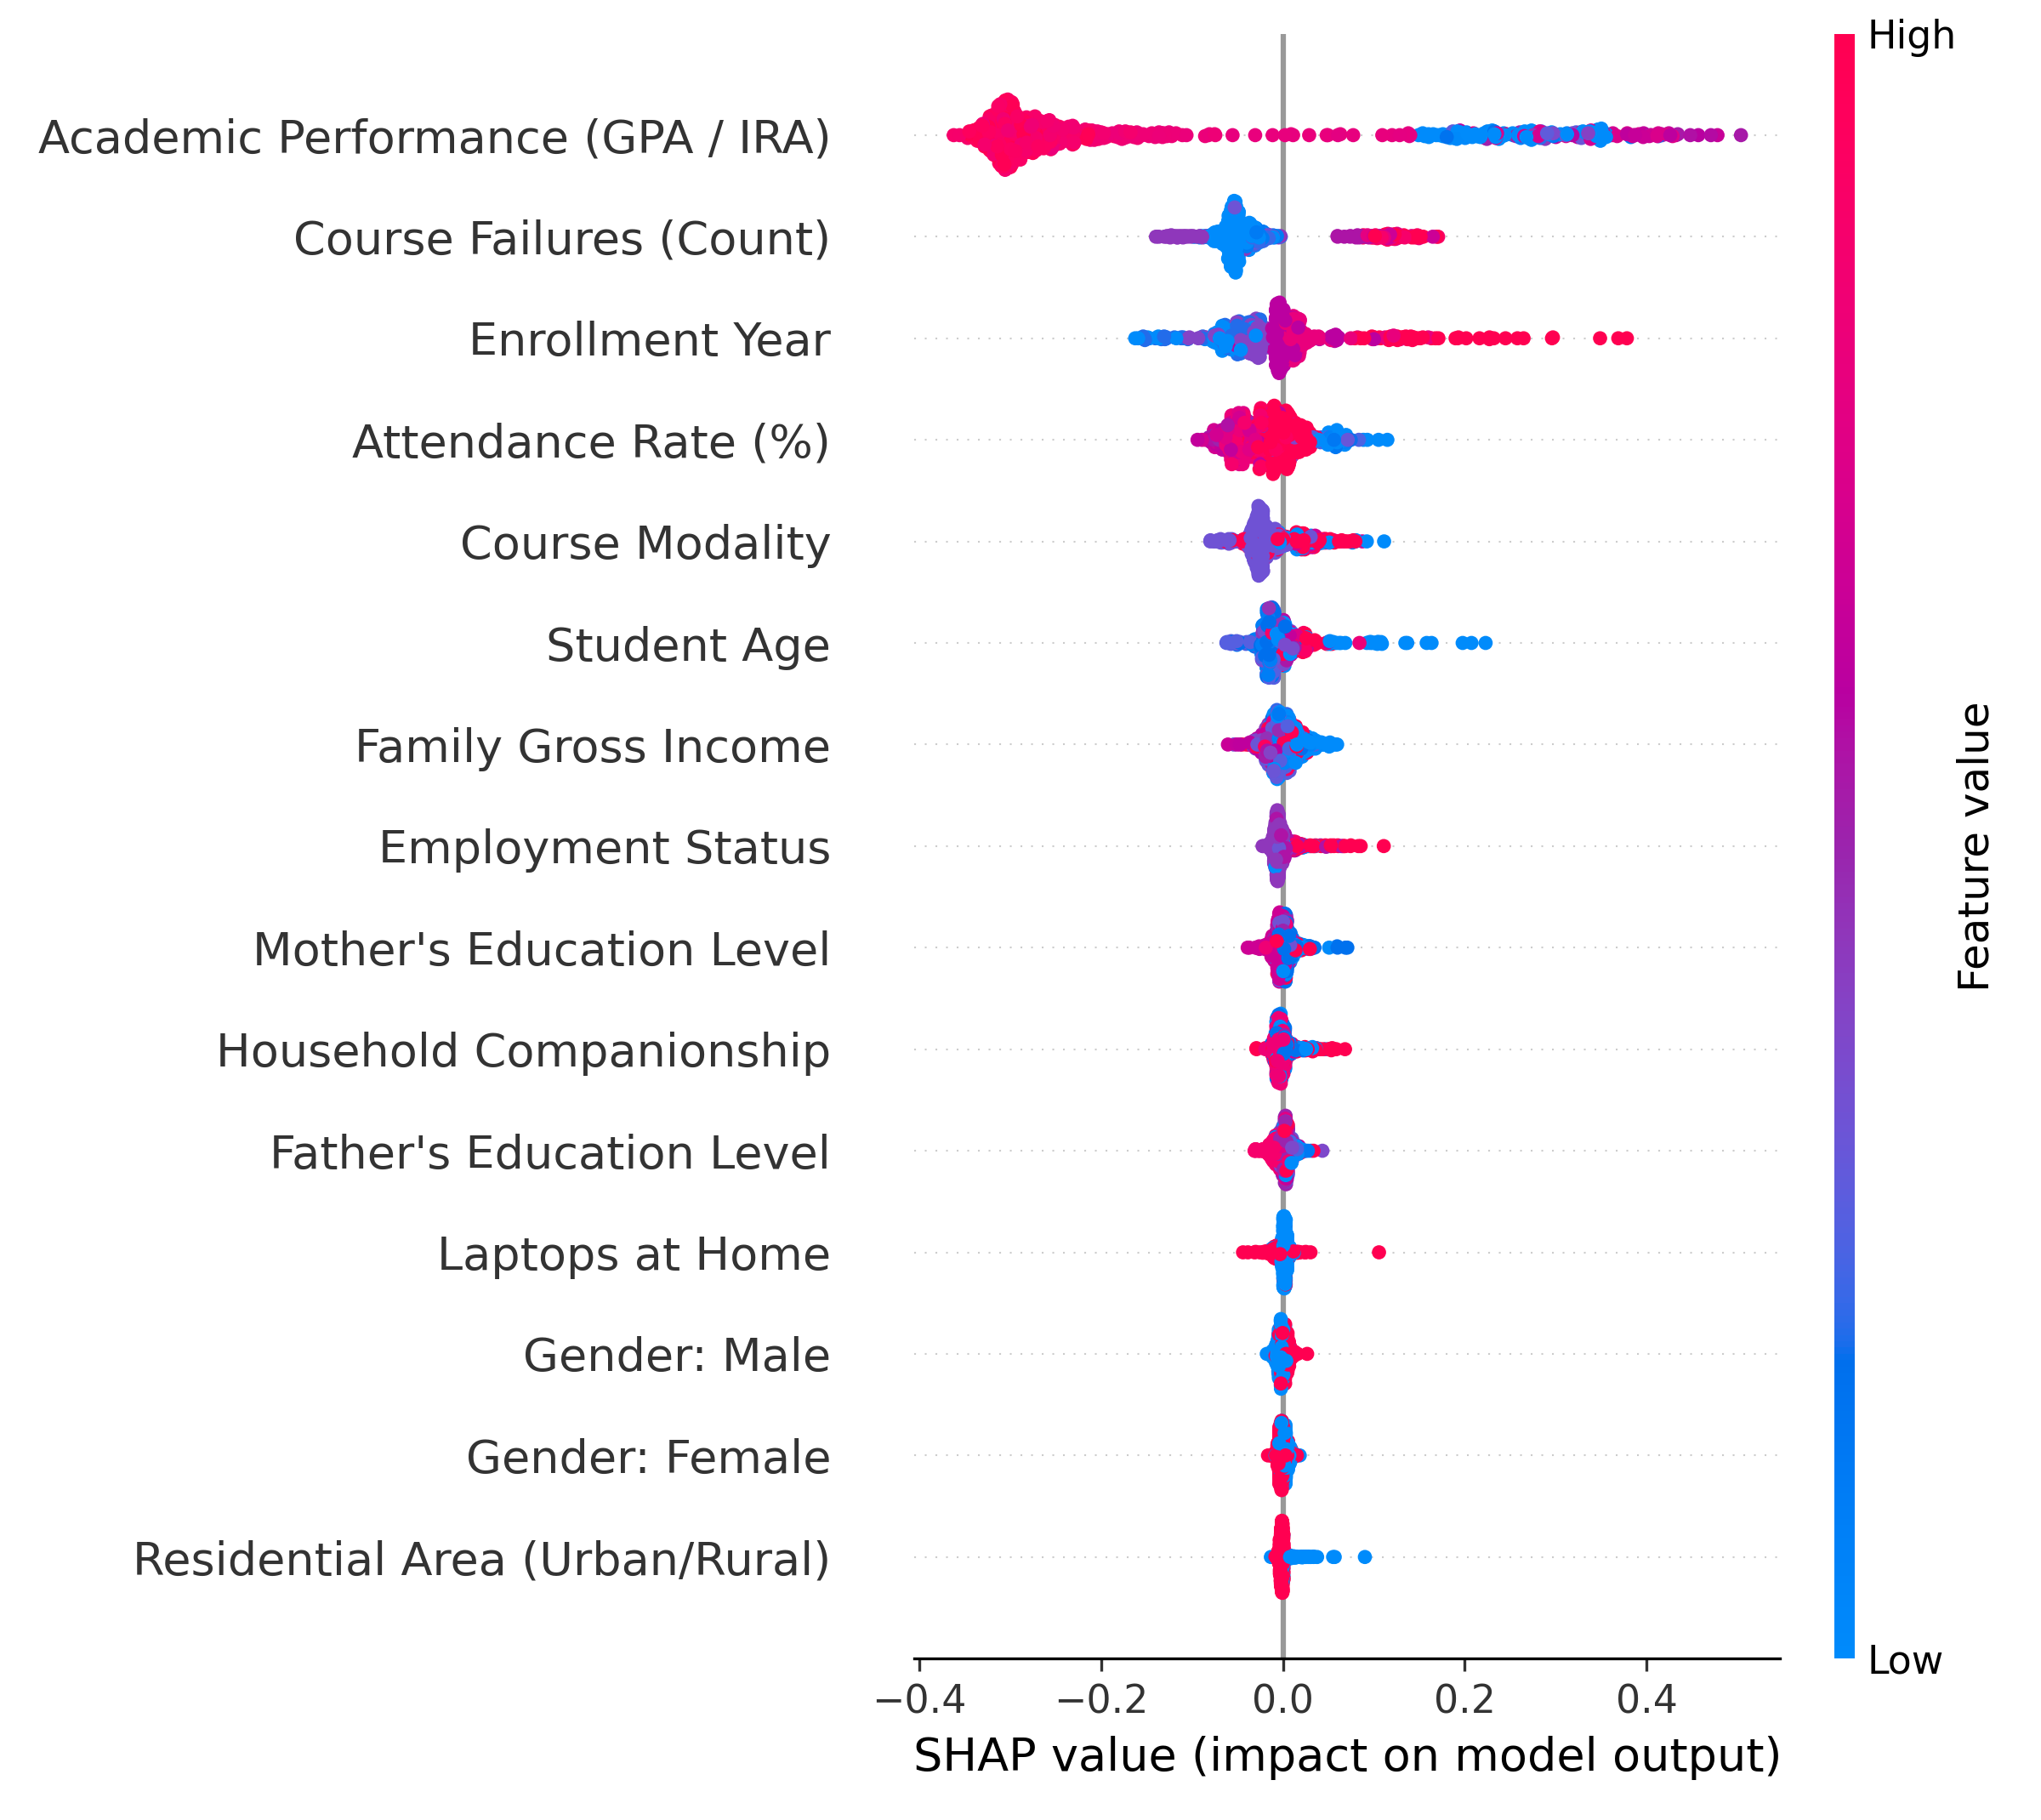
Fig. 4. Global SHAP beeswarm plot: each point is a student, colour shows the feature value and position shows its effect on the predicted dropout risk.

Local explanations support the above conclusions. Students #0 and #43 have low GPAs (1.89, 0.63), many failures (8, 7) and poor attendance; GPA contribution is +0.2831 and +0.2672, respectively. Attendance control will miss the worsening of academic performance since student #185 with perfect attendance, no failures and 89.2% predicted risk is driven by GPA (+0.5039). Students with low risks #1 and #102 (3.4%, 2.8%) are safe because of GPA (−0.3065, −0.3227); the other low-risk archetypes are #25, #60, #14, #52 and #312 (≤11.1%).

The borderline student #37 (predicted risk 50.1%, margin 0.1%) passed; it is a false alarm. GPA (7.12) is not the main contributor; irregular attendance (+0.0746) is the largest one, which is a weak signal that counselors should take into account, supporting the importance of human decision-making for borderline cases. The LIME explanation contradicts the SHAP explanation for clearly high- and low-risk students; LIME provides opposite contributions in the borderline case. The agreement of explanations obtained by the methods with completely different underlying assumptions [12], [13] confirms their reliability, while disagreement means the necessity of consulting a professional. The archetype of the counselor-simulation is student #43.
D. Phase 4: Fairness Audit Results
The pattern was erratic (Fig. 5). The only characteristic that fell within the range was race (DI = 1.180); gender did not (DI = 0.707), with 29% fewer women recorded than men (SPD = −0.079). The same applies to income (DI = 1.411), age group (DI = 1.590) and digital access (DI = 1.403), as groups receiving assistance in the population were identified more frequently. In the case of SPDs, the value falls within ±0.10.

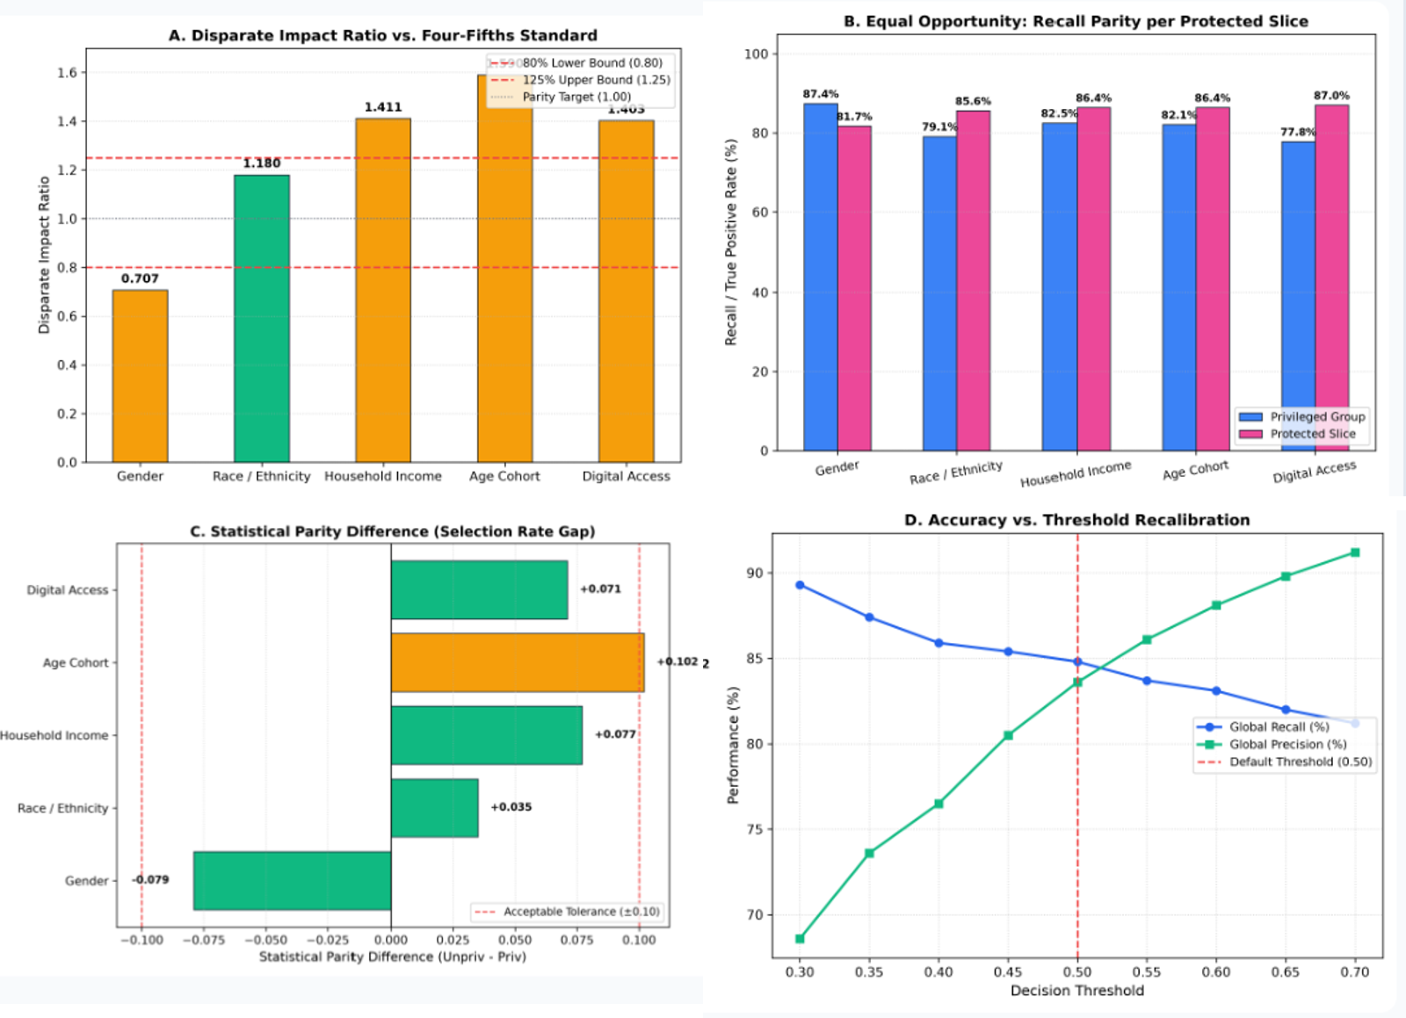
Fig. 5. Fairness audit dashboard: (a) disparate impact against the four-fifths band, (b) recall by group, (c) statistical parity difference and (d) global recall and precision across decision thresholds.

The differences can be attributed to the data and not to the model penalty. Dropout is strikingly high among adults, employed people and students without personal computers (IV-A), which is why the model does well by identifying them. DI higher than 1.25 for income, age and digital access is a natural consequence of getting things right rather than discrimination. Panel (b) illustrates this: as far as limitations are concerned, except for gender, groups needing help have lower EOD (+0.039 to +0.092).
The priority is on gender: women are identified less frequently (DI = 0.707) and spotted less often (recall 81.7% vs. 87.4% for men; EOD = −0.057); it is the only area that suffers both from fewer flags and detections, which may indicate that women in need of additional assistance. Gender is not likely to be a requirement, but part of the correlation of uncontrollable variables such as selection, thus the need for an additional analysis.
Figure (d) depicts institutional power: if the threshold goes beyond 0.50, recall drops and precision increases, while if it goes the opposite way, it is vice-versa. Recall came to 89% at 0.30 and precision about 69%, at the same time this is 81% at 0.70 and about 91%, while according to the report received 84.8% and 83.6% respectively. Without particular thresholds, this is a global trade-off rather than the mitigation; thus it is a governmental difficult choice concerning false calls for advisers.
The priority is on gender: women are identified less frequently (DI = 0.707) and spotted less often (recall 81.7% vs. 87.4% for men; EOD = −0.057); it is the only area that suffers both from fewer flags and detections, which may indicate that women in need of additional assistance. Gender is not likely to be a requirement, but part of the correlation of uncontrollable variables such as selection, thus the need for an additional analysis.
E. Phase 5: Governance Results

The risk bands turn outputs to actionable insights. For instance, all students #0, #43, #85 and #185 (risk between 89.2% to 100%) fall into the category of critical risk, and require a multidisciplinary case conference to be held. Student #37 (risk = 50.1%) is borderline and a counselor's review is required before making any decision. The students with low risk ( risk similiar to or lower than 11.1%) undergoes a general academic monitoring. Of all risk bands, borderline is the one which confirms necessity of human intervention.

The governing pillars resolve the issues brought up by the audit; the policy that prescribes advisory involvement only, safeguarding of immutable characteristics and bi-annual audit prevent over-flagging of at-risk groups as well as under-flagging of women as flags may lead to assistance and not to sanctions and identification of drift gaps. Access is minimized: counselors can see risks regarding the particular individual using SHAP and LIME, log all the decisions taken; heads of departments have access to aggregates and appeals; software engineers work with anonymized data for retraining purposes; students see simplified interpretation of the data.

CONCLUSION
The Explainable AI Governance Framework assists in assessing how students performed. This idea was tested by applying Silva et al. [1] to 15,084 Brazilian Federal Institute students. The Random Forest algorithm was able to identify that 84.8% of those who dropped out were indeed flagged, yielding 83.6% precision and 0.951 AUC. The interpretations provided by SHAP and LIME demonstrate that the model primarily relied on GPA, failure in subjects, study year, and attendance. The five-dimensions fairness audit and five principles of governance mark each flag as explainable, auditable, and disputeable.
The audit does not show any certain opinion on equity and therefore has value. The only variable which found its place in the band of 80% (DI=1.180), is race. On the contrary, income, age, and computer usage have been misidentified (DI from 1.403 to 1.590), though the recall rates of the protected groups are still quite high: “misidentifications” reflect the actual base rate rather than not taken into account factor. The gender issue is crucial: women are less often flagged (DI=0.707) and recalled (81.7% vs. 87.4%).
There are several limitations: only one nationally-based network since the partition was non-reliable, and there was no mitigation considered and no tests made with respect to the provided governance layer with its advisers and students. As for future research work, it should entail conducting intersectional audits, introducing group criteria, and applying adversarial debiasing [3], as well as with respect to many other educational entities, including Indian colleges.
References
- F. da C. Silva, A. M. Santana, and R. M. Feitosa, “An investigation into dropout indicators in secondary technical education using explainable AI,” IEEE Rev. Iberoam. Tecnol. Aprendiz., vol. 20, 2025.
- A. Zanellati, S. P. Zingaro, and M. Gabbrielli, “Balancing performance and explainability in academic dropout prediction,” IEEE Trans. Learn. Technol., vol. 17, pp. 2086–2099, 2024, doi: 10.1109/TLT.2024.3425959.
- A. Priyadarshini and S. Gago-Masague, “Fair Evaluator: An adversarial debiasing-based deep learning framework in student admissions,” in Proc. IEEE Int. Conf. Cogn. Mach. Intell. (CogMI), 2024, pp. 152–161.
- H. A. Mengash, “Using data mining techniques to predict student performance to support decision making in university admission systems,” IEEE Access, vol. 8, pp. 55462–55470, 2020, doi: 10.1109/ACCESS.2020.2981905.
- E. Alhazmi and A. Sheneamer, “Early predicting of students performance in higher education,” IEEE Access, vol. 11, pp. 27579–27589, 2023, doi: 10.1109/ACCESS.2023.3250702.
- L. R. Pelima, Y. Sukmana, and Y. Rosmansyah, “Predicting university student graduation using academic performance and machine learning: A systematic literature review,” IEEE Access, vol. 12, pp. 23451–23465, 2024, doi: 10.1109/ACCESS.2024.3361479.
- H. Ma, Z. Huang, W. Tang, H. Zhu, H. Zhang, and J. Li, “Predicting student performance in future exams via neutrosophic cognitive diagnosis in personalized e-learning environment,” IEEE Trans. Learn. Technol., vol. 16, no. 5, pp. 680–693, 2023.
- P. Jiang and X. Wang, “Preference cognitive diagnosis for student performance prediction,” IEEE Access, vol. 8, pp. 219775–219787, 2020, doi: 10.1109/ACCESS.2020.3042775.
- Y. Zhang and S. Yang, 2022Y. Zhang and S. Yang, "The application of genetic algorithm and fuzzy evaluation method in Teachers' performance appraisal," 2022 International Conference on Artificial Intelligence of Things and Crowdsensing (AIoTCs), 2022.
- [10] L. Zhou, "Performance Evaluation of Basic Education Informatization Based on Improved BP Algorithm," 2022 International Conference on Artificial Intelligence of Things and Crowdsensing (AIoTCs), 2022.
- R. Lu, G. Gao, and Y. Xiang, “Extended ExpTODIM framework based on improved GRA approach for comprehensive quality evaluation of physical education institutions under hesitant triangular fuzzy sets,” IEEE Access, vol. 12, pp. 117581–117594, 2024, doi: 10.1109/ACCESS.2024.3447355.
- S. M. Lundberg and S.-I. Lee, “A unified approach to interpreting model predictions,” in Proc. Adv. Neural Inf. Process. Syst., vol. 30, 2017, pp. 4765–4774.
- M. T. Ribeiro, S. Singh, and C. Guestrin, “‘Why should I trust you?’: Explaining the predictions of any classifier,” in Proc. 22nd ACM SIGKDD Int. Conf. Knowl. Discovery Data Mining, 2016, pp. 1135–1144, doi: 10.1145/2939672.2939778.
- R. K. E. Bellamy et al., “AI Fairness 360: An extensible toolkit for detecting and mitigating algorithmic bias,” IBM J. Res. Develop., vol. 63, no. 4/5, pp. 4:1–4:15, 2019, doi: 10.1147/JRD.2019.2942287.
- J. Kleinberg, S. Mullainathan, and M. Raghavan, “Inherent trade-offs in the fair determination of risk scores,” in Proc. 8th Innov. Theor. Comput. Sci. Conf. (ITCS), 2017, vol. 67, pp. 43:1–43:23, doi: 10.4230/LIPIcs.ITCS.2017.43.
- N. V. Chawla, K. W. Bowyer, L. O. Hall, and W. P. Kegelmeyer, “SMOTE: Synthetic minority over-sampling technique,” J. Artif. Intell. Res., vol. 16, pp. 321–357, 2002, doi: 10.1613/jair.953.
- G. E. A. P. A. Batista, R. C. Prati, and M. C. Monard, “A study of the behavior of several methods for balancing machine learning training data,” ACM SIGKDD Explor. Newsl., vol. 6, no. 1, pp. 20–29, 2004, doi: 10.1145/1007730.1007735.
- L. Breiman, “Random forests,” Mach. Learn., vol. 45, no. 1, pp. 5–32, 2001, doi: 10.1023/A:1010933404324.
- S. M. Lundberg et al., “From local explanations to global understanding with explainable AI for trees,” Nat. Mach. Intell., vol. 2, no. 1, pp. 56–67, 2020, doi: 10.1038/s42256-019-0138-9.
- Equal Employment Opportunity Commission, Civil Service Commission, Department of Labor, and Department of Justice, “Uniform guidelines on employee selection procedures,” Fed. Regist., vol. 43, no. 166, pp. 38290–38315, 1978 (29 C.F.R. Part 1607).
- M. Hardt, E. Price, and N. Srebro, “Equality of opportunity in supervised learning,” in Proc. Adv. Neural Inf. Process. Syst., vol. 29, 2016, pp. 3315–3323.
- Brasil, “Lei nº 13.709, de 14 de agosto de 2018: Lei Geral de Proteção de Dados Pessoais (LGPD),” Diário Oficial da União, 2018.

