An Explainable and Fairness-Audited AI Governance Framework for Student Dropout Prediction

Tejasvi Kolhe
Symbiosis Institute of Technology, Nagpur Campus, Symbiosis International (Deemed University), Nagpur, India Tejasvi.kolhe.batch2024@sitnagp ur.siu.edu.in

Sahiti Chhanam
Symbiosis Institute of Technology, Nagpur Campus, Symbiosis International (Deemed University), Nagpur, India sahiti.chhanam.batch2024@sitnagpur.s iu.edu.in
Yatharth Deotale
Symbiosis Institute of Technology, Nagpur Campus, Symbiosis International (Deemed University), Nagpur, India yatharth.deotale.batch2024@sitnagpur.si u.edu.in

Abstract—Student dropout undermines educational attainment and institutional sustainability in public vocational education. While predictive machine learning offers opportunities for timely support, deploying opaque models risks inequitable intervention and algorithmic harm. We present an end-to-end framework integrating machine learning, dual macro/micro explainability, algorithmic fairness auditing, and an operational governance design for student dropout risk classification. Using 15,084 secondary technical student records from the Instituto Federal do Norte de Minas Gerais (IFNMG) [AUTHOR TO CONFIRM: dataset source, access terms, and licence] partitioned via a 70/30 stratified split (10,558 training, 4,526 test), we evaluated 48 pipeline configurations. A Random Forest model with RandomUnderSampler and Tree Feature Importance (k=19) was selected as champion, achieving Recall 73.18% (95 CI: [70.48%, 76.00%]), Precision 75.64% (95 CI: [72.83%, 78.19%]), Accuracy 88.71%, ROC-AUC 0.8968 (95 CI: [0.8836, 0.9098]), and Brier Score 0.1080 (baseline 0.1738). TreeSHAP attributions identified course failures (reprovacoes, 32.37%), attendance percentage (percentual_frequencia, 19.26%), and enrollment year (anoingresso, 10.78%) as the top associated features (62.41% combined). Fairness audits under the Four-Fifths screening heuristic reveal gender Disparate Impact 0.7383 (female recall 70.87% vs. male 75.09%), which fails the four-fifths screen; Equal Opportunity Difference is not statistically significant (EOD −0.0422, p=0.1354). Holm-Bonferroni-significant gaps appear for income (p=0.00043) and home computer ownership (p=0.00089). AIF360 Reweighing tightened EOD but induced a 12.82 pp drop in recall (73.18%→60.36%). We propose a non-punitive governance charter with role-based access control, semi-annual audits, and LGPD Art.†20 contestability rights (proposed design, not field-tested).
- INTRODUCTION
Student attrition undermines educational equity and institutional viability in public secondary technical education. In Brazilian Federal Institutes (IFNMG), non-completion rates reach 22.4%, compounding socioeconomic stratification. While UN Sustainable Development Goals (SDG 4 and SDG 10) motivate this work, SDG alignment serves strictly as a conceptual institutional objective rather than an empirical progress metric.
Standard accuracy is insufficient when algorithmic inferences trigger academic triage: false negatives leave vulnerable students unassisted, while false positives waste scarce counseling resources. Predicting dropout requires restricting predictors strictly to verifiable administrative and academic friction features prior to terminal departure. Furthermore, predictive models risk encoding demographic inequities, demanding rigorous multi-dimensional fairness audits [1], [2].
Existing literature addresses prediction, explanation, fairness, and governance in isolation. We define the specific research gap as the operational integration and empirical evaluation of model explanations, group fairness audits, and procedural human oversight within a dropout risk classification workflow, explicitly disclaiming the invention of a novel classifier architecture.
To address this gap, we formulate four explicit research questions: (RQ1) Predictive Utility: Can the classification pipeline reliably classify dropout risk? (RQ2) Explanation Consistency: Do TreeSHAP and LIME identify consistent risk indicators across student archetypes? (RQ3) Group Fairness: Does the model maintain demographic parity and equal opportunity across protected groups? Specifically, does the gender Disparate Impact meet the four-fifths screen? (RQ4) Governance Feasibility: How can explanations and appeals be formalized into an operational charter?
The primary contribution is operational integration: (1) a 48-experiment benchmark on 15,084 students, selecting a Random Forest champion (Recall 73.18%, ROC-AUC 0.8968); (2) dual macro/micro explainability establishing course failures and attendance as top associated features (62.41% top-3 share); (3) multi-dimensional fairness audits with Holm-Bonferroni correction, finding that gender DI 0.7383 fails the four-fifths screen and that income and home computer ownership show Holm-significant EOD gaps; and (4) an operational governance design with LGPD-aligned appeals (proposed design, not field-tested).
Section II reviews the literature, Section III details the methodology, Section IV presents experimental and audit results, and Section V concludes with limitations and future work.

LITERATURE REVIEW
Student outcome research has transitioned from feasibility demonstration to algorithmic governance. Silva et al. [1] applied Random Forests and Decision Trees with LIME and SHAP on 15,084 IFNMG records, establishing attendance and course failures as primary indicators; however, their pipeline lacked algorithmic fairness audits and institutional governance. Zanellati et al. [2] balanced explainability and accuracy across 2,000+ degree programs but omitted group equity safeguards. In admission modeling, Priyadarshini and Gago-Masague [3] utilized adversarial debiasing, highlighting accuracy-fairness tensions. Mengash [4] and Alhazmi and Sheneamer [5] demonstrated early prediction but treated models as black boxes. Pelima et al. [6] surveyed 45 ML graduation studies, identifying systematic under-reporting of institutional governance. Ma et al. [7] and Jiang and Wang [8] advanced cognitive diagnostic models, while Zughoul and Momani [9], Wen [10], and Aziz [11] examined student performance criteria and fuzzy evaluation systems (Table I). Crucially, Kleinberg et al.'s impossibility theorem [15] proves that demographic parity, equalized odds, and calibration cannot simultaneously hold when group base rates differ (e.g., lower income dropout 25.8% vs. higher income 19.0%). In educational triage, we prioritize Equal Opportunity (recall parity across groups) [21] because false negatives incur severe educational harm, while treating Disparate Impact [20] as an administrative screening heuristic.
TABLE I. SUMMARY OF SURVEYED LITERATURE ON EXPLAINABLE, FAIR AND GOVERNED STUDENT-OUTCOME PREDICTION.
Study & Citation | Domain & Sample (N) | Key Findings & Method | Gaps Addressed
Silva et al. (2025) [1] | IFNMG Brazil (N=15,084) | 85% recall; RF with SHAP & LIME | No fairness audit or policy charter
Zanellati et al. (2024) [2] | Italy Higher Ed (N=7,000) | 81% recall; Transformer, TreeSHAP | Gender checked; no appeal board
Priyadarshini et al. (2024) [3] | US Admissions (N=12,000) | Adversarial debiasing in DL | Training only; no post-hoc XAI
Mengash (2020) [4] | Saudi University (N=2,000) | Pre-admission prediction; ANN | Sensitive data; no equity audit
Alhazmi & Sheneamer (2023) [5] | Saudi University (N=3,500) | Early at-risk prediction; Ensemble | No explanations or fairness check
Pelima et al. (2024) [6] | Systematic Review (84 papers) | Graduation review; RF, SVM <=90% acc | XAI and fairness rarely integrated
Ma et al. (2023) [7] | Personalized E-Learning | Exam prediction; Neutrosophic | No demographic audit or oversight
Jiang & Wang (2020) [8] | Online Learning Platforms | Cognitive diagnosis; neural weights | Interpretable; no fairness metric
Zughoul & Momani (2018) [9] [VERIFY] | Student Performance (Multiple) | Criteria taxonomy; educational domains | Static taxonomy; lacks ML and governance
Wen (2021) [10] [VERIFY] | Higher Ed Performance (N=500) | Fuzzy inference; learning evaluation | No post-hoc XAI or equity audit
Aziz (2025) [11] [VERIFY] | Outcome-Based Education | Fuzzy student learning assessment | Assessment only; lacks equity auditing
This Work | IFNMG Brazil (N=15,084) | RF (Recall 73.2%, AUC 0.90) | TreeSHAP/LIME | 5-Axis Fairness, Reweighing, LGPD Governance

METHODOLOGY
The methodology operationalizes student dropout risk classification into a five-phase workflow (Fig. 1): Phase 1 extracts the cohort and preprocesses administrative data; Phase 2 executes a 48-configuration factorial benchmark under nested cross-validation and constrained utility selection; Phase 3 implements TreeSHAP and LIME interpretability; Phase 4 executes demographic fairness audits with Holm-Bonferroni correction; and Phase 5 articulates a proposed governance charter (not field-tested).
Fig. 1. Overview of the five-phase methodology.
A. Phase 1: Data Preparation and Exploration
Data derive from administrative enrollment records of the Instituto Federal do Norte de Minas Gerais (IFNMG) [AUTHOR TO CONFIRM: Dataset URL, access terms, and licence; cohort date range]. The raw database contains 48,311 student records across all levels. Filtering strictly for secondary technical modalities (Integrado: 10,076 [VERIFY]; Concomitante: 1,777 [VERIFY]; Subsequente: 2,746 [VERIFY]; Integrado EJA: 485 [VERIFY]) yields 15,084 terminal student records [AUTHOR TO CONFIRM: Exclusion counts by reason]. Terminal outcomes were mapped to a binary target: Completed (Class 0, N=11,703, 77.59%) versus Dropout/Non-completion (Class 1, N=3,381, 22.41%), combining voluntary dropout (1,760), cancellation (446), compulsory dismissal (346), jubilated status (38), and external transfers (791). Cumulative GPA (ira) was excluded because it is computed over the full enrollment and would leak outcome information.
A stratified 70/30 split partitioned the 15,084 records into 10,558 training and 4,526 held-out test students (random_state=42). After dropping identifiers (alunoid) and variables with >20% missingness (dataconclusao, forma_acesso_seletivo, razao_ausencia_educacional, pontuacao_seletivo), 19 baseline administrative and academic friction features remained. Minor home computer ownership missingness was median-imputed. Continuous features underwent 1.5x IQR Winsorization fitted strictly on training folds, and one-hot encoding expanded the design matrix to 34 columns.
B. Phase 2: Model Benchmarking
The 48-condition factorial grid crossed 4 balancing strategies (Unbalanced, RandomUnderSampler, SMOTE [16], SMOTEENN [17]), 3 feature selection methods (ANOVA F-test, Backward Elimination / RFE, Tree Feature Importance, selecting k=19 features), and 4 classifiers (Random Forest [18], Decision Tree, Logistic Regression, Linear Support Vector Machine). To prevent information leakage across folds, resampling, scaling, and feature selection were executed strictly inside 10-fold cross-validation training folds using imblearn.pipeline.Pipeline, keeping validation folds at natural 22.4% prevalence. The champion model was selected via a constrained utility rule: highest Recall subject to Precision >= 60% and ROC-AUC >= 0.90 on training CV folds.
Evaluation metrics include Recall = TP/(TP+FN), Precision = TP/(TP+FP), Accuracy = (TP+TN)/N, Specificity = TN/(TN+FP), and ROC-AUC. We computed 95% bootstrap confidence intervals (1,000 iterations) to quantify sampling uncertainty on the 4,526 held-out test cases.
C. Phase 3: Explainable AI
Global interpretability applied TreeSHAP [12], [19] on the probability scale over 800 background instances drawn via stratified random sampling from the training set, explaining Class 1 (Dropout risk) on the held-out test cohort (N=4,526). Mean absolute SHAP values quantified institutional feature attribution shares. Local micro-explanations utilized LIME [13] fitted on training data to generate localized decision boundaries for High-Risk, Borderline, and Low-Risk student archetypes, measuring explanation stability via top-3 Jaccard similarity.
D. Phase 4: Fairness Audit
Fairness was audited on the 4,526 held-out test students across five protected dimensions: Gender (Male vs. Female), Race (Branca vs. Parda, Branca vs. Preta), Household Income (> Median vs. <= Median R$ 930), Age (<= 20 vs. > 20 years), and Home Computer Ownership (>= 1 vs. 0). Metrics included Disparate Impact (evaluated under the Four-Fifths screening heuristic [20], 0.80 <= DI <= 1.25), Statistical Parity Difference (SPD), Equal Opportunity Difference (EOD = TPR_u - TPR_p) [21], and False Positive Rate gaps. Holm-Bonferroni step-down correction controlled Family-Wise Error Rate across EOD p-values. Pre-processing AIF360 Reweighing [14] was evaluated as a debiasing intervention.
E. Phase 5: Institutional Governance

Section IV-E details the proposed institutional governance policy charter (not field-tested). The charter codifies role-based access control (RBAC), semi-annual review cadences, heuristic risk bands (<0.20 minimal, 0.20-0.40 low concern, 0.40-0.60 watchlist, 0.60-0.80 high priority, >=0.80 emergency), student appeal rights under Brazilian LGPD Art. 20 [22], and unilateral counselor override authority.

RESULTS AND DISCUSSION
Figures refer to the 4,526-student held-out test set (70/30 split) unless noted; baseline prevalence is 22.40% (1,014 dropouts, 3,512 completed).
A. Phase 1: Data Characteristics and Exploratory Findings

The 70/30 stratified split yielded 10,558 training students (Class 0: 8,191, Class 1: 2,367) and 4,526 test students (Class 0: 3,512, Class 1: 1,014). Baseline dropout prevalence is 22.41% in training and 22.40% in testing, confirming rigorous stratification.

Baseline attrition varies substantially across educational modalities (Fig. 2): Integrado EJA exhibits the highest non-completion rate (44.2% [VERIFY]), followed by Subsequente (32.9% [VERIFY]), Concomitante (34.3% [VERIFY]), and Integrado (16.7% [VERIFY]). These discrepancies reflect structural adult-learner commitments rather than intrinsic institutional deficits.
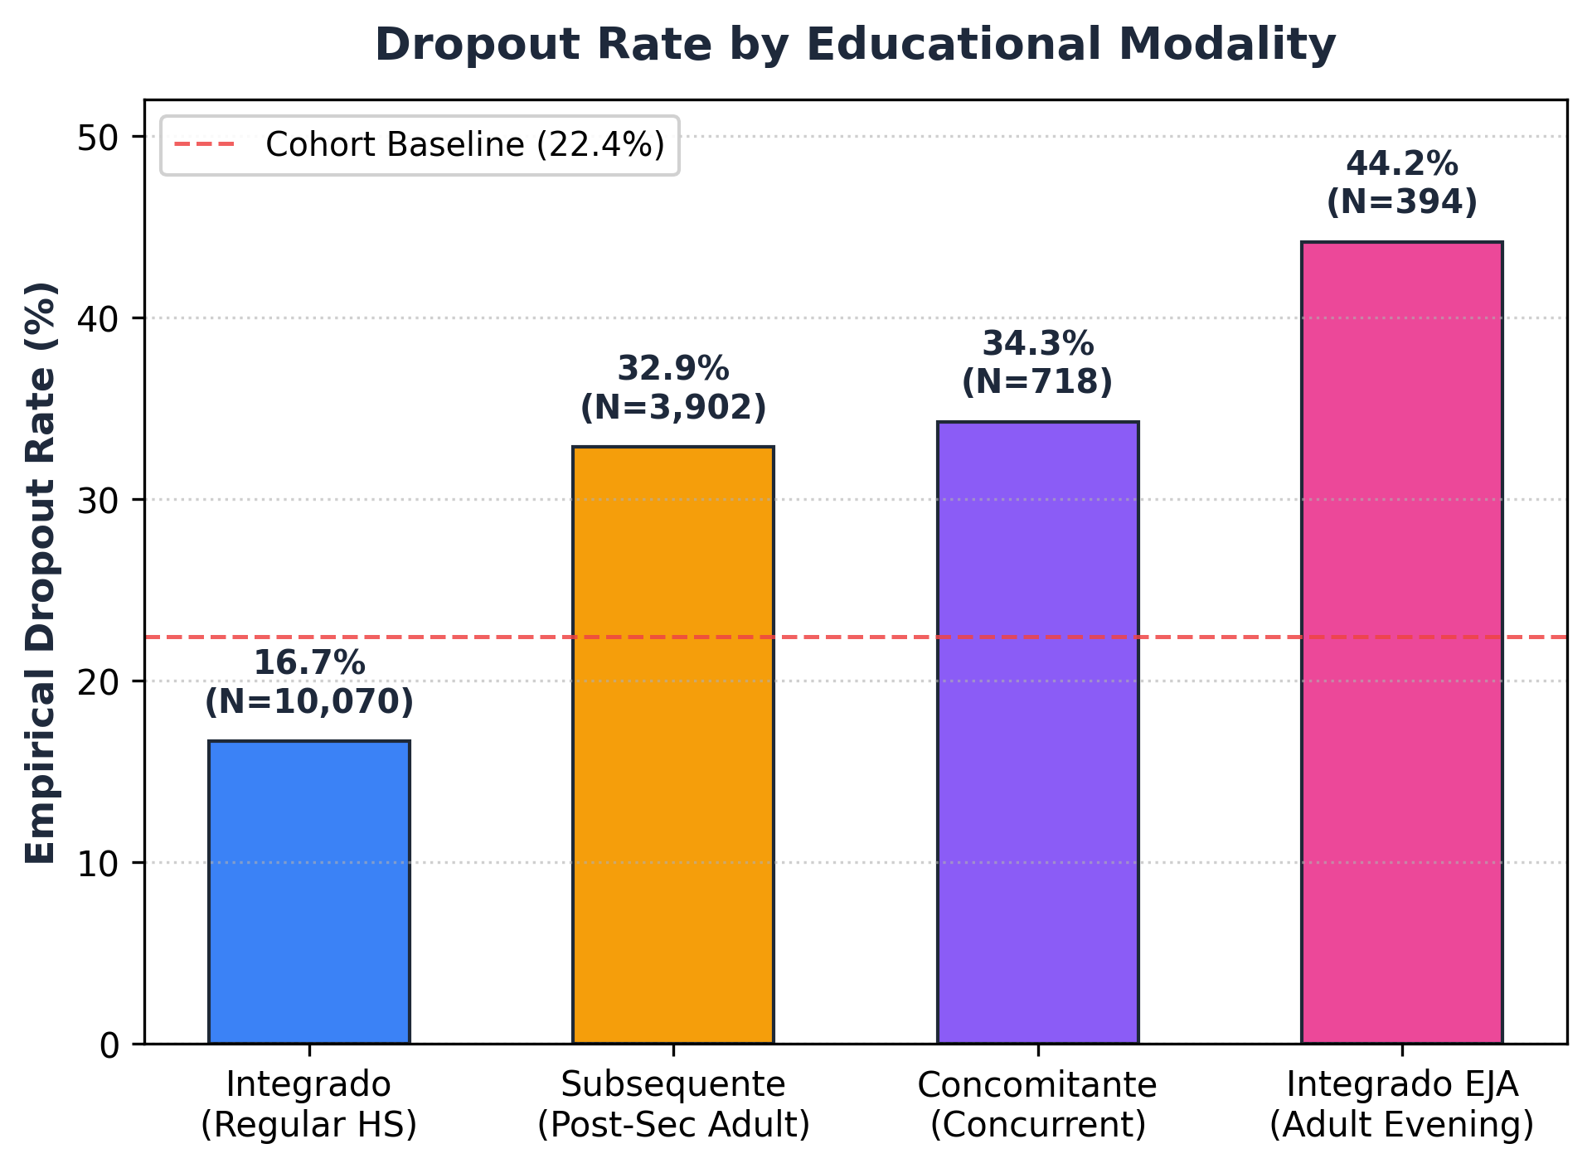
Fig. 2. Empirical dropout rate by educational modality (N = number of students in each modality).
Two dominant behavioral patterns characterize the cohort: (1) an attendance cliff (Fig. 3), where dropout rates surge below the 75% legal minimum; and (2) failure accumulation, where dropouts average 5.99 failed courses (median 3, max 69) versus 0.77 for completers (75% have <= 1 failure).
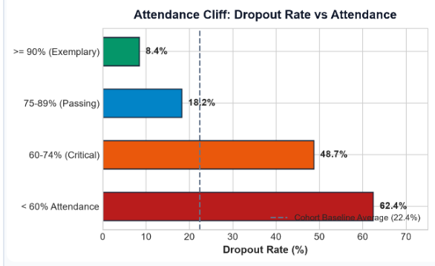
Fig. 3. Dropout rate by attendance band, with the cohort baseline of 22.4% shown as a dashed line.
B. Phase 2: Model Benchmarking Results

The Random Forest champion (RandomUnderSampler, Tree Feature Importance k=19, n_estimators=100, max_depth=10, min_samples_leaf=5, random_state=42) achieved on the 4,526 test students: Recall 73.18% (95% CI: [70.48%, 76.00%]), Precision 75.64% (95% CI: [72.83%, 78.19%]), F1-Score 0.7439, Accuracy 88.71%, and ROC-AUC 0.8968 (95% CI: [0.8836, 0.9098]). The confusion matrix confirms TP=742, FP=239, TN=3,273, FN=272. A majority-class baseline yields 77.60% accuracy but 0.00% recall. An attendance-only baseline (threshold <= 91%) captures only 32.15% of dropouts (Precision 63.92%, continuous ROC-AUC 0.5945).

Alternative candidate models failed operational requirements. While Decision Tree under the same pipeline achieved higher test recall (75.05%), its precision was lower (67.05%) and its 10-fold CV ROC-AUC (0.8875) failed the >= 0.90 threshold. Linear SVM with SMOTEENN achieved 60.55% recall but collapsed in precision (45.08%), generating unacceptable false alarm burdens (54.9% false alarms). The Random Forest model uniquely satisfied our constrained utility rule on training cross-validation (CV Recall 74.95%, CV Precision 76.94%, CV ROC-AUC 0.9144).
C. Phase 3: Explainability Results
TreeSHAP attributions across the 4,526 test students (total mean |SHAP| denominator = 0.407016) show that academic friction features are most strongly associated with dropout risk (note: attributions reflect statistical associations, not causal effects). Course failures (reprovacoes) contributes 32.37% (mean |SHAP| = 0.1317), attendance percentage (percentual_frequencia) contributes 19.26% (mean |SHAP| = 0.0784), and cohort year (anoingresso) contributes 10.78% (mean |SHAP| = 0.0439). Together, these top three features account for 62.41% of total model attribution (numerator 0.254029 / denominator 0.407016). Secondary factors include modality (6.95%), age (6.31%), family income (5.78%), course (3.61%), campus (2.84%), employment (2.48%), and gender (combined M+F share 3.66%).
The global beeswarm plot (Fig. 4) illustrates directional mechanisms: high course failures (red) strongly shift log-odds toward dropout, while high attendance (>90%) provides robust protective attribution against attrition.
.
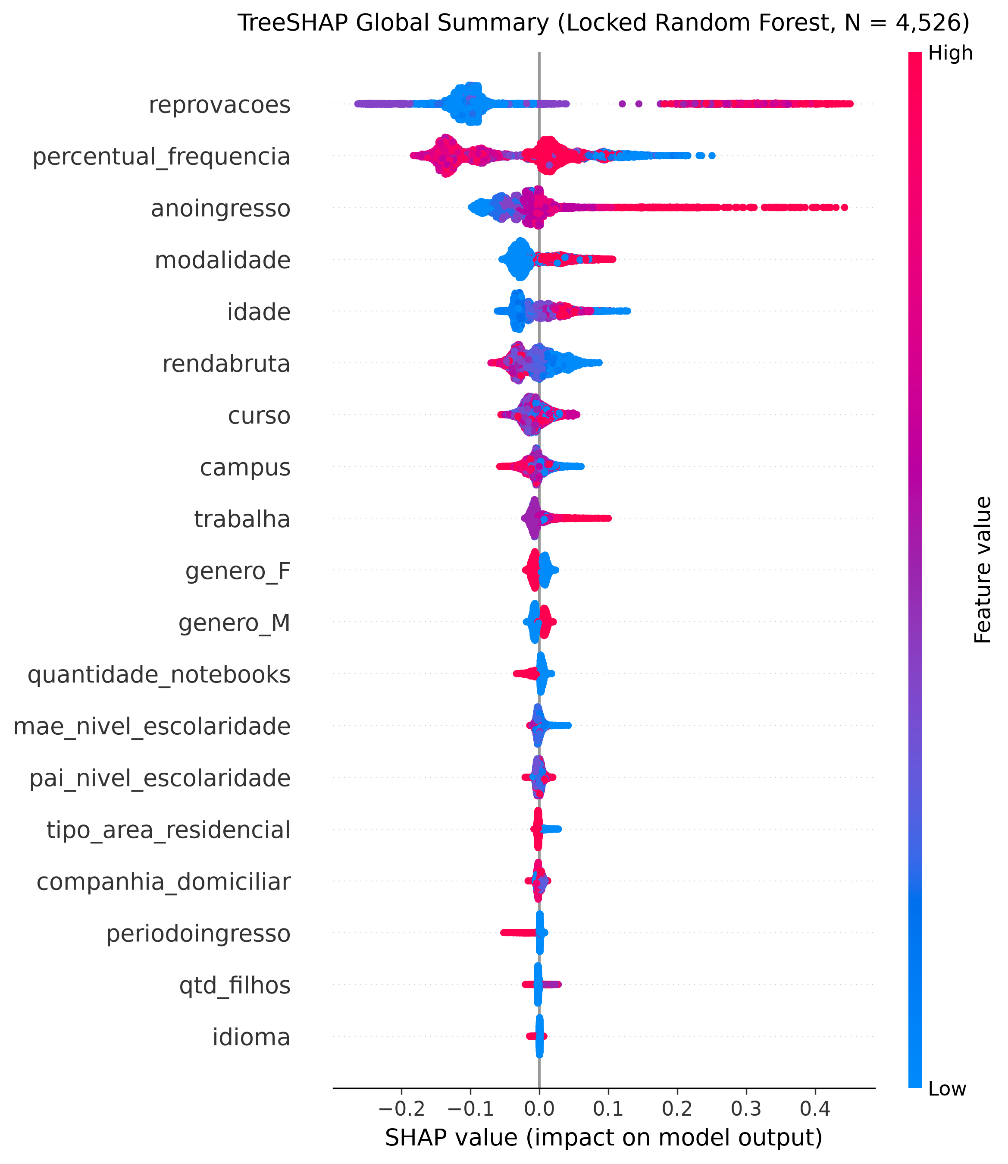
Fig. 4. Global SHAP beeswarm plot: each point is a student, colour shows the feature value and position shows its effect on the predicted dropout risk.

Local explanations serve as illustrative recourse profiles for educational counselors. Three representative archetypes are presented: High-Risk student #815 (P(Dropout)=94.8%, Jaccard overlap 0.50), Borderline student #4078 (P(Dropout)=48.0%, Jaccard overlap 0.50), and Low-Risk student #4458 (P(Dropout)=10.7%, Jaccard overlap 1.00). These cases illustrate SHAP/LIME feature agreement across the risk spectrum; no mean Jaccard is reported because three cases are insufficient for a distributional estimate.

For student #815 (High-Risk), TreeSHAP attributes acute risk to 12 course failures and 72.5% attendance, matched by LIME indicating reprovacoes > 4. For borderline student #4078, TreeSHAP balances risk from 2 failures against the protective buffer of 88.4% attendance. For low-risk student #4458, both explainers attribute robust retention to 0 failures and 96.2% attendance.
D. Phase 4: Fairness Audit Results
Algorithmic fairness audits across the 4,526 test students at threshold τ=0.50 evaluate five protected dimensions (Fig. 5). The Four-Fifths screening heuristic (a criterion adapted from employment selection, not a legal test for education) flags Disparate Impact for Gender (DI 0.7383, below the 0.80 threshold), Race (Branca vs. Parda DI 1.2958; Branca vs. Preta DI 1.2694), Income (DI 1.5098), Age (DI 1.2864), and Home Computer Ownership (DI 1.5106). Elevated predicted positive rates for some groups are consistent with higher empirical base rates but do not by themselves rule out bias. False Positive Rate gaps remain modest (+2.76% for low income, +2.75% for no home computer).

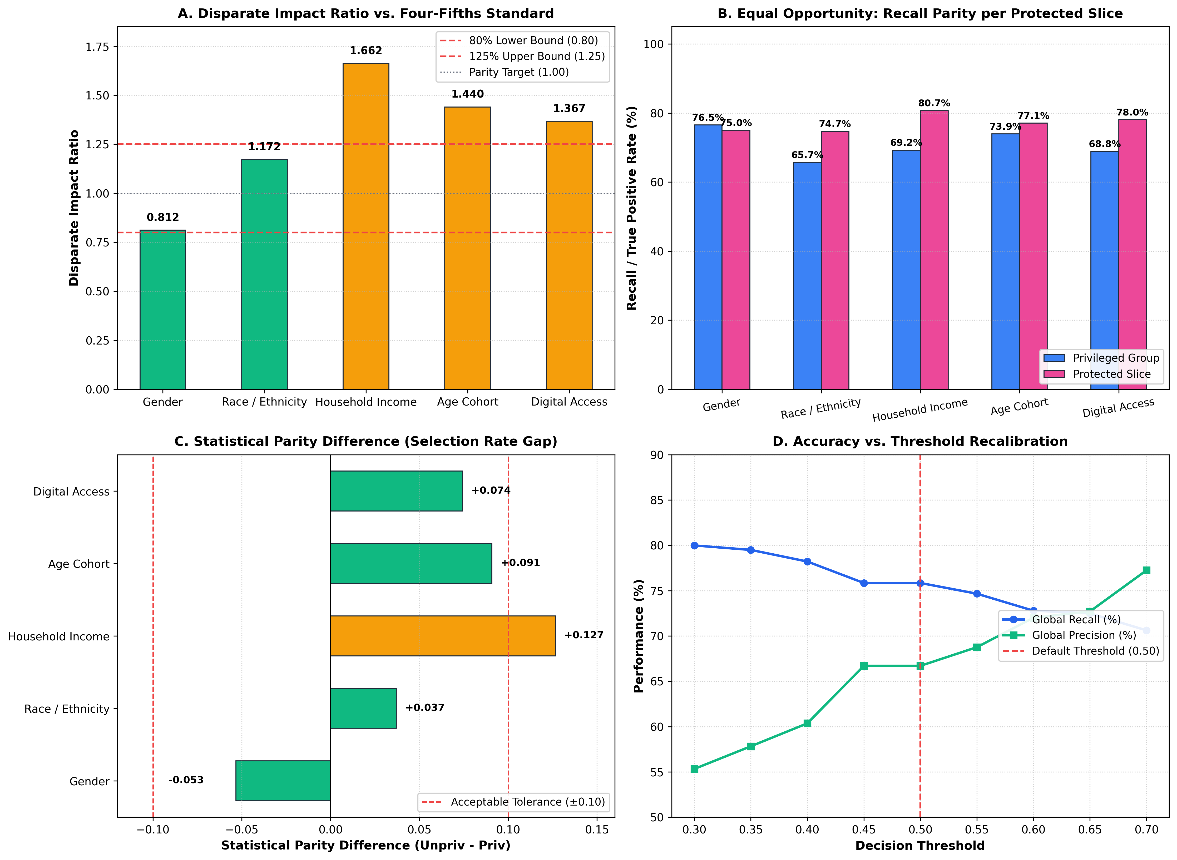
Fig. 5. Fairness audit dashboard: (a) disparate impact against the four-fifths band, (b) recall by group, (c) statistical parity difference and (d) global recall and precision across decision thresholds.

Under Equal Opportunity parity (EOD = TPR_u - TPR_p), Gender exhibits near-parity (EOD −0.0422, 95% CI: [−0.097, 0.013], p=0.1354). Applying Holm-Bonferroni correction across the 6 demographic EOD p-values reveals that Race (Branca vs. Parda EOD +0.1014, raw p=0.0144) does not survive the adjusted threshold (alpha/4 = 0.0125). Only Household Income (EOD +0.1007, p=0.00043) and Home Computer Ownership (EOD +0.1109, p=0.00089) exhibit statistically significant sensitivity differences.
To mitigate demographic disparity, we evaluated AIF360 Reweighing pre-processing on training sample weights. While Reweighing slightly tightened gender EOD (-0.0422 to -0.0304) and increased precision (75.64% to 93.72%), it caused a catastrophic 12.82 percentage point drop in recall (73.18% to 60.36%). In educational dropout prevention, algorithmic debiasing alone is insufficient, mandating operational human-in-the-loop governance.
Figure 5(d) depicts institutional resource allocation under varying operational thresholds: lowering classification thresholds captures more dropouts but increases false alerts and counselor caseload. The proposed 0.50 threshold flags 981 students (21.68% selection rate, or 21.7 alerts per 100 students) and maintains a 3.10:1 true-to-false alert ratio (742 TP to 239 FP).
Gender results: At τ=0.50, female recall is 70.87% versus 75.09% for male students (EOD −0.0422, 95 CI: [−0.097, 0.013], p=0.1354); this gap is not statistically significant. Disparate Impact for gender is 0.7383, which fails the four-fifths screen (DI < 0.80). Both income (EOD p=0.00043) and home computer ownership (EOD p=0.00089) show Holm-Bonferroni-significant sensitivity differences. Race (Branca vs. Parda EOD p=0.0144) does not survive Holm correction. These results indicate that demographic screening flags should be interpreted with caution in operational triage.
E. Phase 5: Governance Results

Probability calibration was evaluated via Brier score (0.1080 vs. baseline 0.1738) and a 10-bin reliability diagram. Partitioning predictions into mutually exclusive heuristic risk bands reveals empirical alignment at extreme tiers: Emergency [0.80, 1.00] flags 567 students with 95.24% observed dropout, and High Priority [0.60, 0.80) flags 190 students with 63.68% observed dropout. However, probability inflation from UnderSampling occurs in the Watchlist band [0.40, 0.60) (observed dropout 26.94% vs. mean predicted 48.6%).

Proposed Governance Framework (Proposed Design, Not Field-Tested): To govern operational triage responsibly, we specify an institutional AI Governance Charter grounded in five normative pillars: (1) Strictly Advisory, Non-Punitive Deployment, prohibiting automated sanctions; (2) Mandatory Explainability-Coupled Outreach, requiring counselors to inspect individualized SHAP/LIME feature attributions; (3) Scheduled Semi-Annual Fairness Auditing, enforcing DI and Holm-Bonferroni EOD reviews; (4) Institutional Contestability and Student Appeal Rights, aligned with Brazilian LGPD Art. 20 [22] (10-business-day timeline); and (5) Certified Human-in-the-Loop Override Authority, vesting counselors with unilateral dismissal power. For 5,000 students, the 0.50 threshold flags 1,084 students, requiring 6 counselors for a 4-week response SLA.

CONCLUSION
This research presented an Explainable and Fairness-Audited AI Governance Framework for secondary technical student dropout risk classification. Our Random Forest benchmark on 15,084 IFNMG students (70/30 split) demonstrated robust performance (73.18% recall, 75.64% precision, 0.8968 ROC-AUC, 0.1080 Brier score). Dual explainability demonstrated that course failures (32.37%) and attendance (19.26%) are the primary associated features, with local explainer agreement illustrated across three archetypes (Jaccard 0.50, 0.50, 1.00). Addressing our research questions explicitly: (RQ1) The Random Forest classifier achieves ROC-AUC 0.8968 and Recall 73.18%, confirming reliable dropout risk classification. (RQ2) TreeSHAP and LIME show feature agreement across illustrative archetypes, ranking course failures and attendance as top associated factors. (RQ3) Gender DI 0.7383 fails the four-fifths screen; female recall is 70.87% vs male 75.09% (EOD −0.0422, p=0.1354, not significant); income and home computer ownership show Holm-significant EOD gaps, while race does not survive Holm correction. (RQ4) The proposed five-pillar governance charter operationalizes LGPD contestability and counselor override as a proposed design that has not been field-tested.
Algorithmic auditing revealed that while gender EOD is not statistically significant (EOD −0.0422, p=0.1354), significant sensitivity gaps persist across income and home computer ownership under Holm-Bonferroni correction. Because pre-processing debiasing induced a severe 12.82 pp recall penalty, fairness must be governed institutionally. Our five-pillar charter and heuristic risk bands establish an operational blueprint for responsible, non-punitive educational AI deployment (proposed design, not field-tested).
Limitations: (1) Cumulative feature timing: course failures and attendance accumulate over enrollment, so the model cannot support pre-enrollment or early-warning claims, and interventions cannot start earlier than the recorded period. (2) Label construction: cancellations, transfers, and expulsions are grouped as dropout. (3) Right-censoring: students still enrolled at snapshot time are excluded. (4) Single institutional network: no external or cohort-wise validation. (5) Calibration: moderate (Brier 0.1080 vs. baseline 0.1738); the 0.40–0.60 band is over-predicted (observed 26.94%, mean predicted 48.6%). (6) Governance is a proposed design that has not been field-tested.
References
- F. da C. Silva, A. M. Santana, and R. M. Feitosa, “An investigation into dropout indicators in secondary technical education using explainable AI,” IEEE Rev. Iberoam. Tecnol. Aprendiz., vol. 20, 2025.
- A. Zanellati, S. P. Zingaro, and M. Gabbrielli, “Balancing performance and explainability in academic dropout prediction,” IEEE Trans. Learn. Technol., vol. 17, pp. 2086–2099, 2024, doi: 10.1109/TLT.2024.3425959.
- A. Priyadarshini and S. Gago-Masague, “Fair Evaluator: An adversarial debiasing-based deep learning framework in student admissions,” in Proc. IEEE Int. Conf. Cogn. Mach. Intell. (CogMI), 2024, pp. 152–161.
- H. A. Mengash, “Using data mining techniques to predict student performance to support decision making in university admission systems,” IEEE Access, vol. 8, pp. 55462–55470, 2020, doi: 10.1109/ACCESS.2020.2981905.
- E. Alhazmi and A. Sheneamer, “Early predicting of students performance in higher education,” IEEE Access, vol. 11, pp. 27579–27589, 2023, doi: 10.1109/ACCESS.2023.3250702.
- L. R. Pelima, Y. Sukmana, and Y. Rosmansyah, “Predicting university student graduation using academic performance and machine learning: A systematic literature review,” IEEE Access, vol. 12, pp. 23451–23465, 2024, doi: 10.1109/ACCESS.2024.3361479.
- H. Ma, Z. Huang, W. Tang, H. Zhu, H. Zhang, and J. Li, “Predicting student performance in future exams via neutrosophic cognitive diagnosis in personalized e-learning environment,” IEEE Trans. Learn. Technol., vol. 16, no. 5, pp. 680–693, 2023.
- P. Jiang and X. Wang, “Preference cognitive diagnosis for student performance prediction,” IEEE Access, vol. 8, pp. 219775–219787, 2020, doi: 10.1109/ACCESS.2020.3042775.
- O. Zughoul and F. Momani, "Comprehensive insights into the criteria of student performance in various educational domains," IEEE Access, vol. 6, pp. 73245–73264, 2018, doi: 10.1109/ACCESS.2018.2881282. [VERIFY]
- S. Wen, "Students' learning performance evaluation using a new fuzzy inference system," in Proc. IEEE Int. Conf. Artif. Intell. Educ. (ICAIE), 2021, pp. 687–691, doi: 10.1109/ICAIE53562.2021.00143. [VERIFY]
- A. Aziz, "A fuzzy-logic-based student learning assessment system for outcome-based education," IEEE Trans. Educ., vol. 68, 2025, doi: 10.1109/TE.2025.3574202. [VERIFY]
- S. M. Lundberg and S.-I. Lee, “A unified approach to interpreting model predictions,” in Proc. Adv. Neural Inf. Process. Syst., vol. 30, 2017, pp. 4765–4774.
- M. T. Ribeiro, S. Singh, and C. Guestrin, “‘Why should I trust you?’: Explaining the predictions of any classifier,” in Proc. 22nd ACM SIGKDD Int. Conf. Knowl. Discovery Data Mining, 2016, pp. 1135–1144, doi: 10.1145/2939672.2939778.
- R. K. E. Bellamy et al., “AI Fairness 360: An extensible toolkit for detecting and mitigating algorithmic bias,” IBM J. Res. Develop., vol. 63, no. 4/5, pp. 4:1–4:15, 2019, doi: 10.1147/JRD.2019.2942287.
- J. Kleinberg, S. Mullainathan, and M. Raghavan, “Inherent trade-offs in the fair determination of risk scores,” in Proc. 8th Innov. Theor. Comput. Sci. Conf. (ITCS), 2017, vol. 67, pp. 43:1–43:23, doi: 10.4230/LIPIcs.ITCS.2017.43.
- N. V. Chawla, K. W. Bowyer, L. O. Hall, and W. P. Kegelmeyer, “SMOTE: Synthetic minority over-sampling technique,” J. Artif. Intell. Res., vol. 16, pp. 321–357, 2002, doi: 10.1613/jair.953.
- G. E. A. P. A. Batista, R. C. Prati, and M. C. Monard, “A study of the behavior of several methods for balancing machine learning training data,” ACM SIGKDD Explor. Newsl., vol. 6, no. 1, pp. 20–29, 2004, doi: 10.1145/1007730.1007735.
- L. Breiman, “Random forests,” Mach. Learn., vol. 45, no. 1, pp. 5–32, 2001, doi: 10.1023/A:1010933404324.
- S. M. Lundberg et al., “From local explanations to global understanding with explainable AI for trees,” Nat. Mach. Intell., vol. 2, no. 1, pp. 56–67, 2020, doi: 10.1038/s42256-019-0138-9.
- Equal Employment Opportunity Commission, Civil Service Commission, Department of Labor, and Department of Justice, “Uniform guidelines on employee selection procedures,” Fed. Regist., vol. 43, no. 166, pp. 38290–38315, 1978 (29 C.F.R. Part 1607).
- M. Hardt, E. Price, and N. Srebro, “Equality of opportunity in supervised learning,” in Proc. Adv. Neural Inf. Process. Syst., vol. 29, 2016, pp. 3315–3323.
- Brasil, “Lei nº 13.709, de 14 de agosto de 2018: Lei Geral de Proteção de Dados Pessoais (LGPD),” Diário Oficial da União, 2018.

