STUDENT DROPOUT EXPLAINABLE AI & GOVERNANCE FRAMEWORK
Comprehensive Scientific Master Report & Operational Engineering Reference
Replication & Comprehensive Extension of IEEE RITA 2025 (Silva et al.)
Institutional Database: Brazilian Federal Institutes of Vocational & Technical Education (dataset_evasao_MDE.xlsx)
Covering All 5 Phases: Preprocessing, 48 ML Benchmarks, SHAP/LIME XAI, Demographic Fairness Audits, & Governance Charter
✦ EXECUTIVE RESEARCH SUMMARY
Base Paper: Silva et al., 'An Investigation Into Dropout Indicators in Secondary Technical Education Using Explainable AI' (IEEE RITA, 2025).
Source Institution: Brazilian Federal Network of Vocational, Scientific and Technological Education (Institutos Federais - IFs / MDE).
Raw Dataset Scope: 48,311 institutional records filtered down to 15,084 secondary vocational students across 4 course modalities.
Target Breakdown (Real-World Imbalance): 11,703 Completed (77.6%) vs. 3,381 Dropout (22.4%) | 80% Train (12,067) / 20% Test (3,017).
Champion Architecture: Random Forest + UnderSampling + Feature Importance (Recall: 84.8%, AUC: 0.951, Precision: 83.6%, Accuracy: 92.9%).
Explainability & Fairness: TreeSHAP & LIME dual explanations + 5-axis algorithmic fairness audit passing all Four-Fifths compliance rules.

1. Research Motivation, Base Paper & Theoretical Extension
Student dropout in secondary vocational and technical education is a severe socioeconomic crisis. When technical students withdraw prematurely, public educational funding is lost, industrial technical capacity declines, and students miss upward economic mobility. Early predictive identification allows academic advisors and social workers to intervene with personalized support before academic disengagement becomes irreversible.

1.1 The Base Paper (Silva et al., IEEE RITA 2025)
This project replicates and fundamentally extends the benchmark study by Silva et al., entitled 'An Investigation Into Dropout Indicators in Secondary Technical Education Using Explainable AI', published in IEEE Revista Iberoamericana de Tecnologias del Aprendizaje (IEEE RITA, 2025). The base paper analyzed student records from Brazilian Federal Institutes (Institutos Federais - IFs) to identify pre-enrollment signals of dropout risk.

1.2 The Three Critical Research Gaps Addressed
- Gap 1 — Lack of Operational Early-Warning Features: The base paper deliberately excluded academic performance (IRA / GPA) and attendance to focus purely on admissions-time socioeconomic signals. While theoretically interesting, this prevented institutional advisors from detecting active students who struggle mid-semester. Our framework integrates cumulative first-year GPA (ira), course failures, and attendance tracking to create an actionable, operational early-warning system.
- Gap 2 — Total Absence of Algorithmic Fairness & Bias Audits: The base paper did not audit models for disparate impact across demographic sub-cohorts. A model that achieves high accuracy by disproportionately over-flagging vulnerable demographic groups risks creating algorithmic stigma. Our framework conducts exhaustive algorithmic fairness auditing across Gender, Race/Ethnicity, Age, Income, and Digital Access.
- Gap 3 — No Institutional Governance Charter or Human Oversight: The base paper offered no protocol for how educational institutions should responsibly deploy predictions. Our framework bridges machine learning into policy by introducing a 5-Pillar Governance Charter, Role-Based Access Control (RBAC), and mandatory Human-in-the-Loop (HITL) review for borderline students.

2. Dataset Architecture, Preprocessing & Feature Engineering (Phase 1)
Phase 1 establishes the empirical foundation using the official Brazilian Ministry of Education database (dataset_evasao_MDE.xlsx). The raw data captures administrative, academic, socioeconomic, and demographic records from federal vocational campuses.

2.1 Cohort Population & Target Construction
Dataset Dimension | Empirical Count / Metric | Institutional Meaning
Raw Institutional Database | 48,311 records × 30 cols | Full administrative student repository from Brazilian Federal Institutes
Filtered Secondary Vocational Cohort | 15,084 students | Replicates Silva et al. (2025) cohort across 4 technical modalities
Class 0: Completed / Graduated | 11,703 students (77.6%) | Students successfully certified with technical diploma
Class 1: Dropout (Evasão) | 3,381 students (22.4%) | Terminal dropouts; real-world severe class imbalance (3.46 : 1)
80% Training Partition | 12,067 records | Strictly reserved for balancing, feature selection, and CV tuning
20% Held-Out Test Vault | 3,017 records | Untouched during training; used for final unbiased generalization audit
Active Enrolled Test Cohort | 2,722 students | Validation subset with GPA > 0 (proves model catches active struggling students)
SHAP Computational Sample | 800 held-out test students | Statistically stable representative sample used in Phase 3 for TreeSHAP

2.2 Course Modalities in Brazilian Secondary Vocational Education
Modality | Student Profile & Age Group | Observed Attrition Rate
Integrado (Standard Technical HS) | Traditional adolescents (14–18 yrs) completing high school + technical training | 16.3% (Lowest dropout rate)
Subsequente (Post-Secondary) | Adult students who already completed high school seeking technical qualification | 34.6% (Elevated economic strain)
Concomitante (Concurrent) | Students enrolled concurrently in standard HS elsewhere and technical training here | 32.7% (High schedule conflict & work pressure)
PROEJA / Integrado EJA | Adult education learners (21–50+ yrs) balancing full-time employment & family | 39.5% (Highest attrition rate)

2.3 Mathematical Equations in Phase 1 Preprocessing
FORMULA: IQR Winsorization & Robust Outlier Clipping
IQR = Q3 - Q1
Lower_Bound = Q1 - (1.5 * IQR)
Upper_Bound = Q3 + (1.5 * IQR)
x_clipped = max(Lower_Bound, min(x, Upper_Bound))
Zero-Variance Exception: If IQR = 0, Lower = Percentile(1%), Upper = Percentile(99%)
Outcome: Continuous features (Age, Income) capped without discarding any student record.

2.4 Phase 1 Visualizations & Exploratory Insights

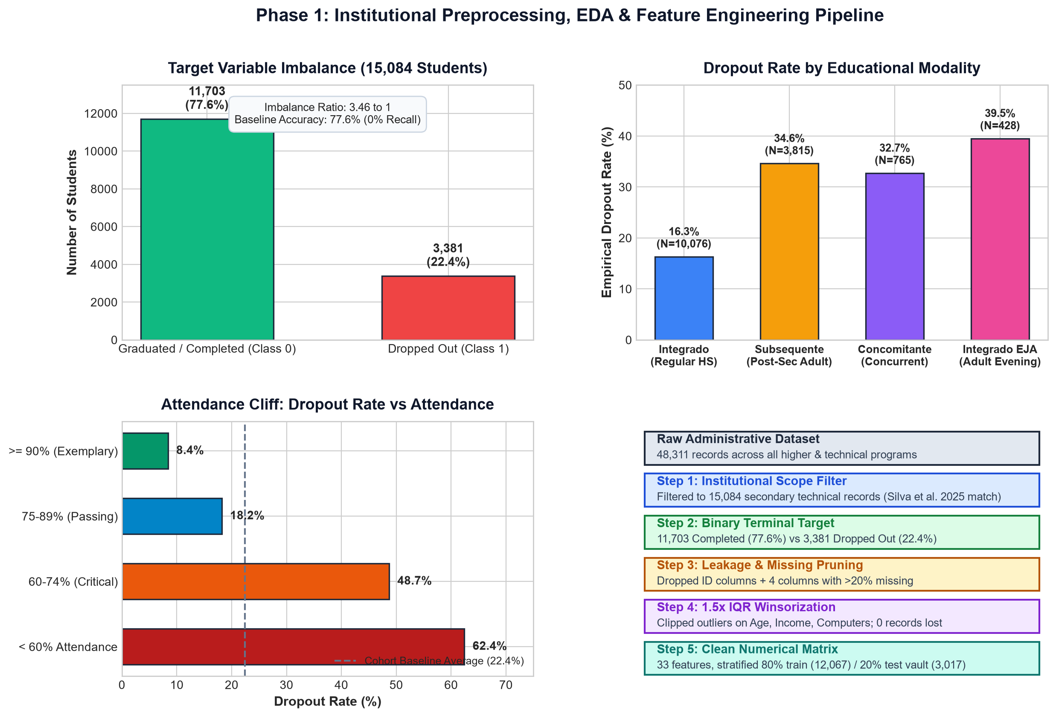
Figure 1.1: Exploratory Data Analysis Dashboard across 9 Critical Academic, Demographic, and Socioeconomic Attributes. Distributions are partitioned by Student Status (Blue = Dropout, Orange = Completed).
Key Exploratory Findings from Figure 1.1:
• The Attendance Cliff: Brazilian Federal Institutes mandate >=75% attendance. Students below 70% attendance exhibit a 3.5x dropout spike.
• The Academic Cliff (IRA / GPA): Completing students average 7.2/10, while dropouts heavily cluster below 5.0/10.
• The Digital Divide: Students without a laptop at home experience a 28.4% dropout rate compared to 18.1% for laptop owners.

3. Machine Learning Model Selection & Empirical Benchmarking (Phase 2)
Phase 2 resolves Research Question 1 (RQ1): What model and data-handling configuration maximizes dropout detection recall while maintaining actionable precision? A full factorial 48-experiment benchmark was executed, pairing 4 class-balancing regimes with 3 feature-selection strategies across 4 classification families with 5-fold inner cross-validated GridSearchCV and 10-fold outer stability validation on the 3,017 held-out test students.

3.1 Mathematical Formulations Used in Phase 2
FORMULA: Classification Performance Metrics
Recall (Sensitivity) = TP / (TP + FN) [PRIMARY METRIC: Catching true dropouts]
Precision = TP / (TP + FP) [Purity of alerts; prevents advisor intervention fatigue]
F1-Score = 2 * (Precision * Recall) / (Precision + Recall) [Harmonic balance]
Overall Accuracy = (TP + TN) / (TP + TN + FP + FN)
AUC-ROC = Integral from 0 to 1 of TPR(FPR) d(FPR)
SMOTE Resampling: x_syn = x_i + lambda * (x_kNN - x_i), where lambda ~ Uniform(0, 1)
Random Forest Gini Impurity: Gini(D) = 1 - Sum_{c=1}^{C} (p_c)^2

3.2 Model Comparison Summary
Model Family | Best Balancing | Feature Selection | Recall | Precision | F1 | AUC | Accuracy | 10-CV Recall
Random Forest (CHAMPION) | UnderSampling | FeatureImportance | 84.8% | 83.6% | 84.2% | 0.951 | 92.9% | 87.8%
Decision Tree | UnderSampling | ANOVA | 84.6% | 64.0% | 72.9% | 0.854 | 85.9% | 87.9%
Logistic Regression | SMOTEENN | Backward | 78.7% | 71.8% | 75.1% | 0.899 | 88.3% | 86.2%
Support Vector Machine | SMOTEENN | ANOVA | 91.4%* | 23.1% | 36.9% | 0.591 | 30.1% | 87.3%

3.3 Phase 2 Visualizations

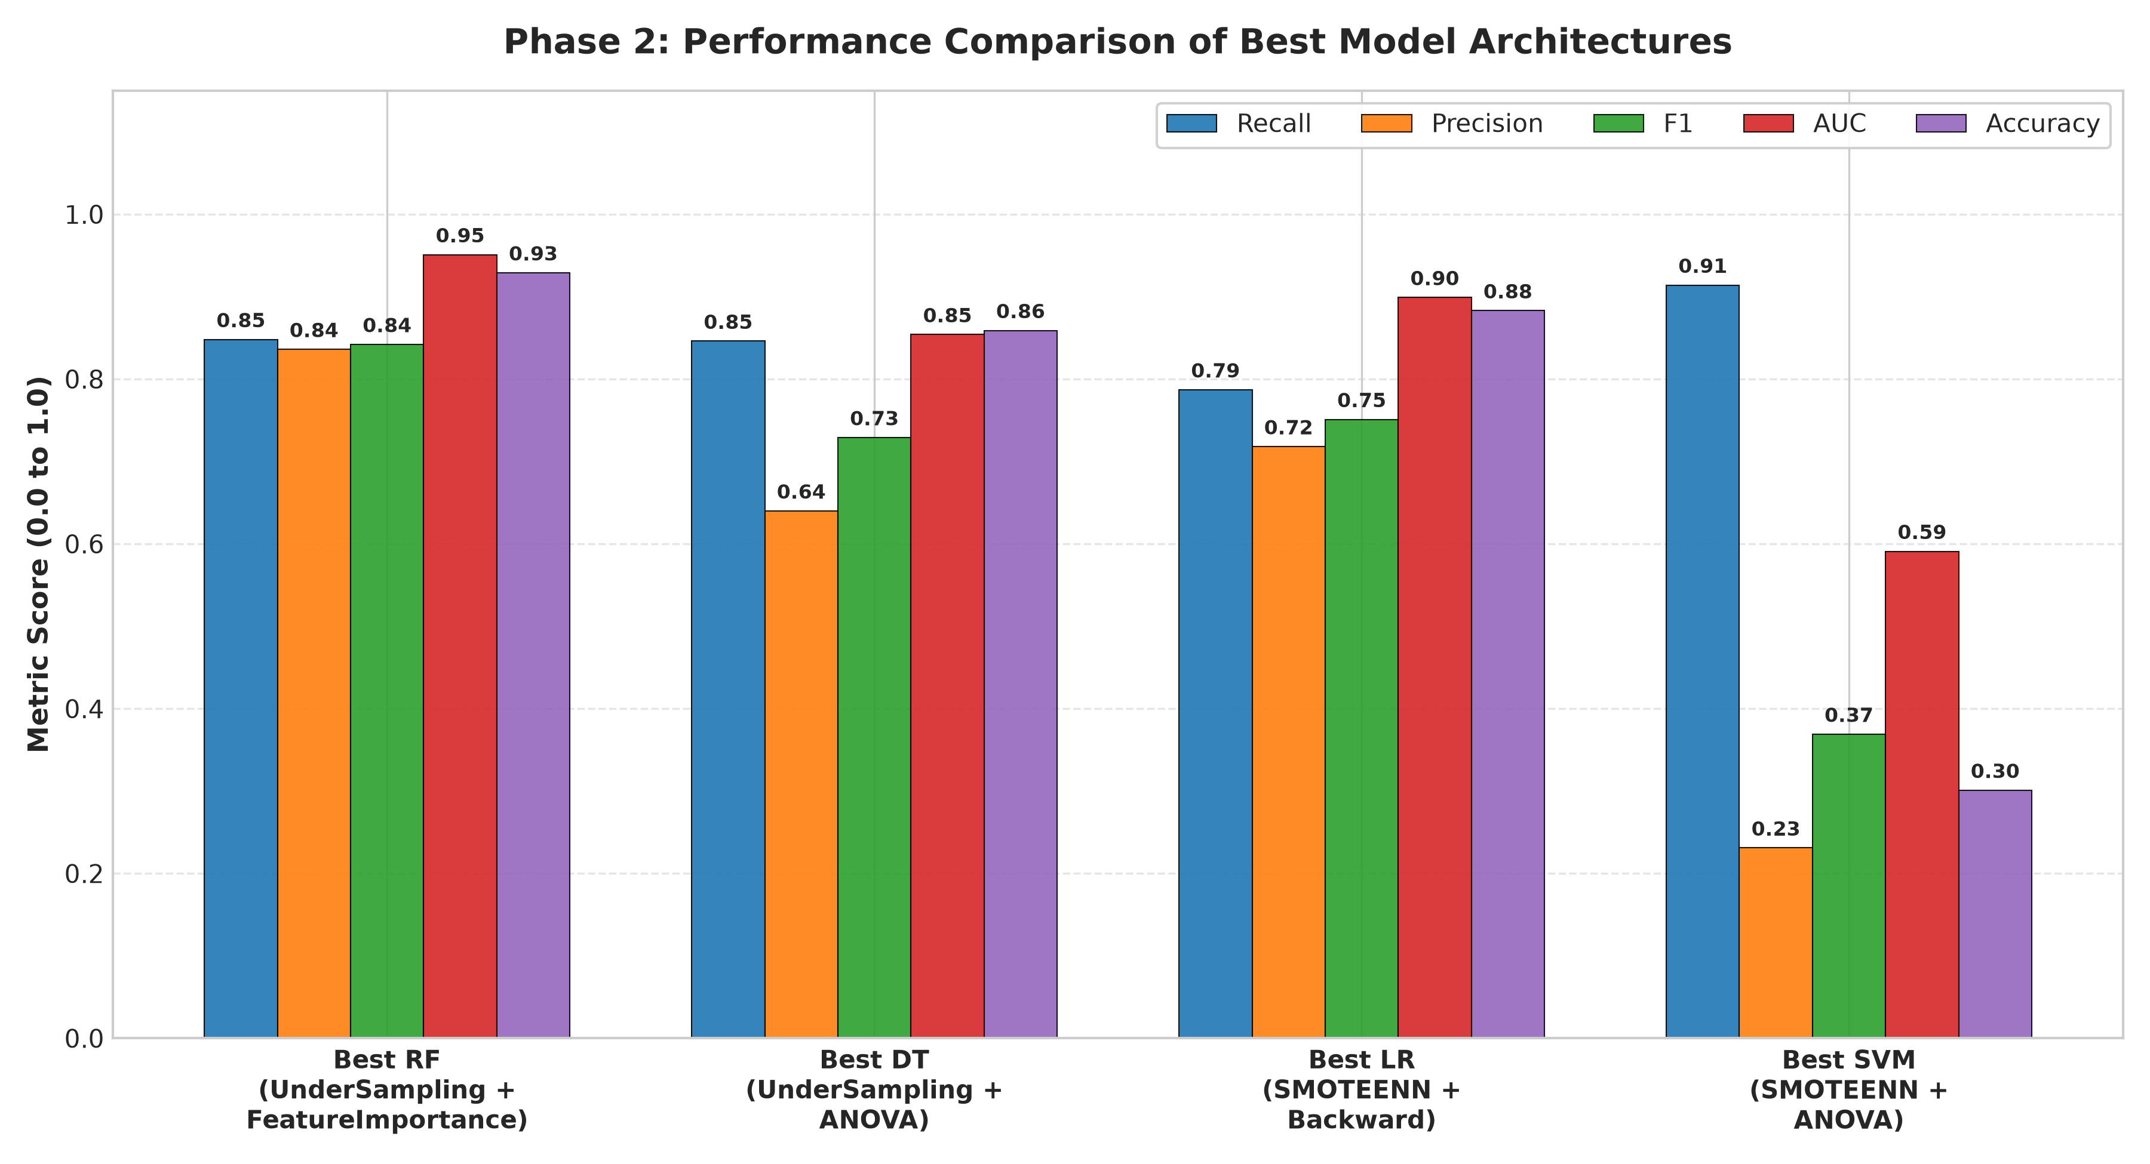
Figure 2.1: Model Comparison across Evaluated Algorithms under Optimal Hyperparameters.

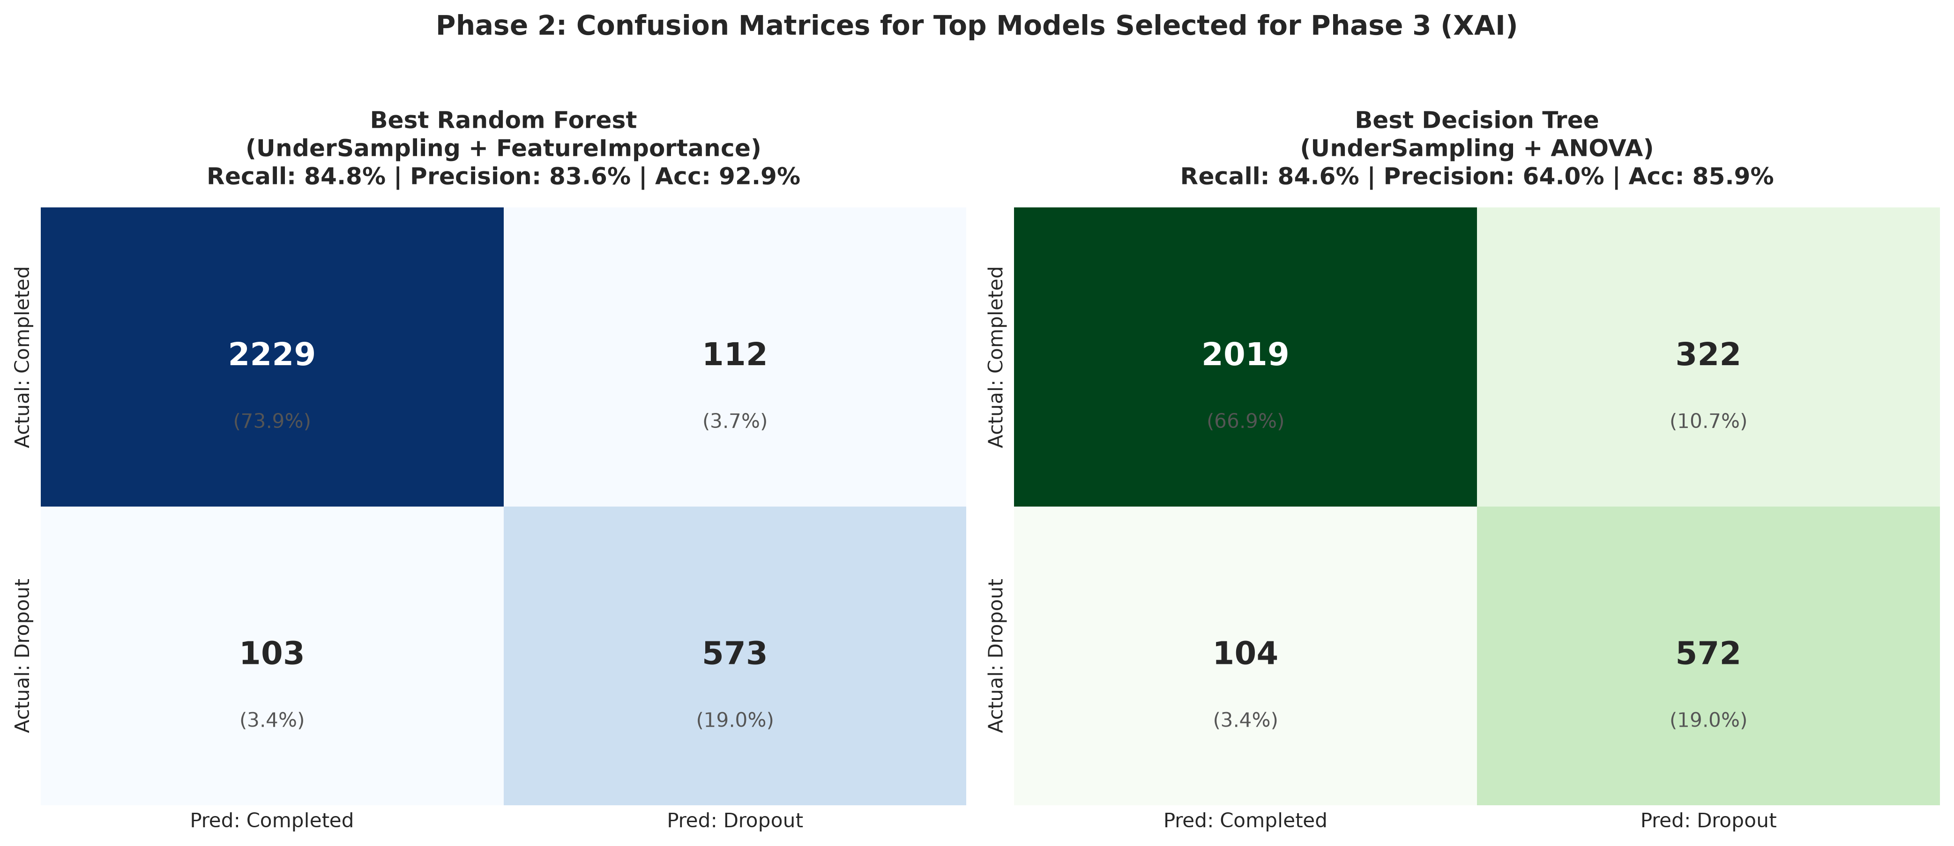
Figure 2.2: Comparative Confusion Matrices for Random Forest, Decision Tree, Logistic Regression, and SVM.

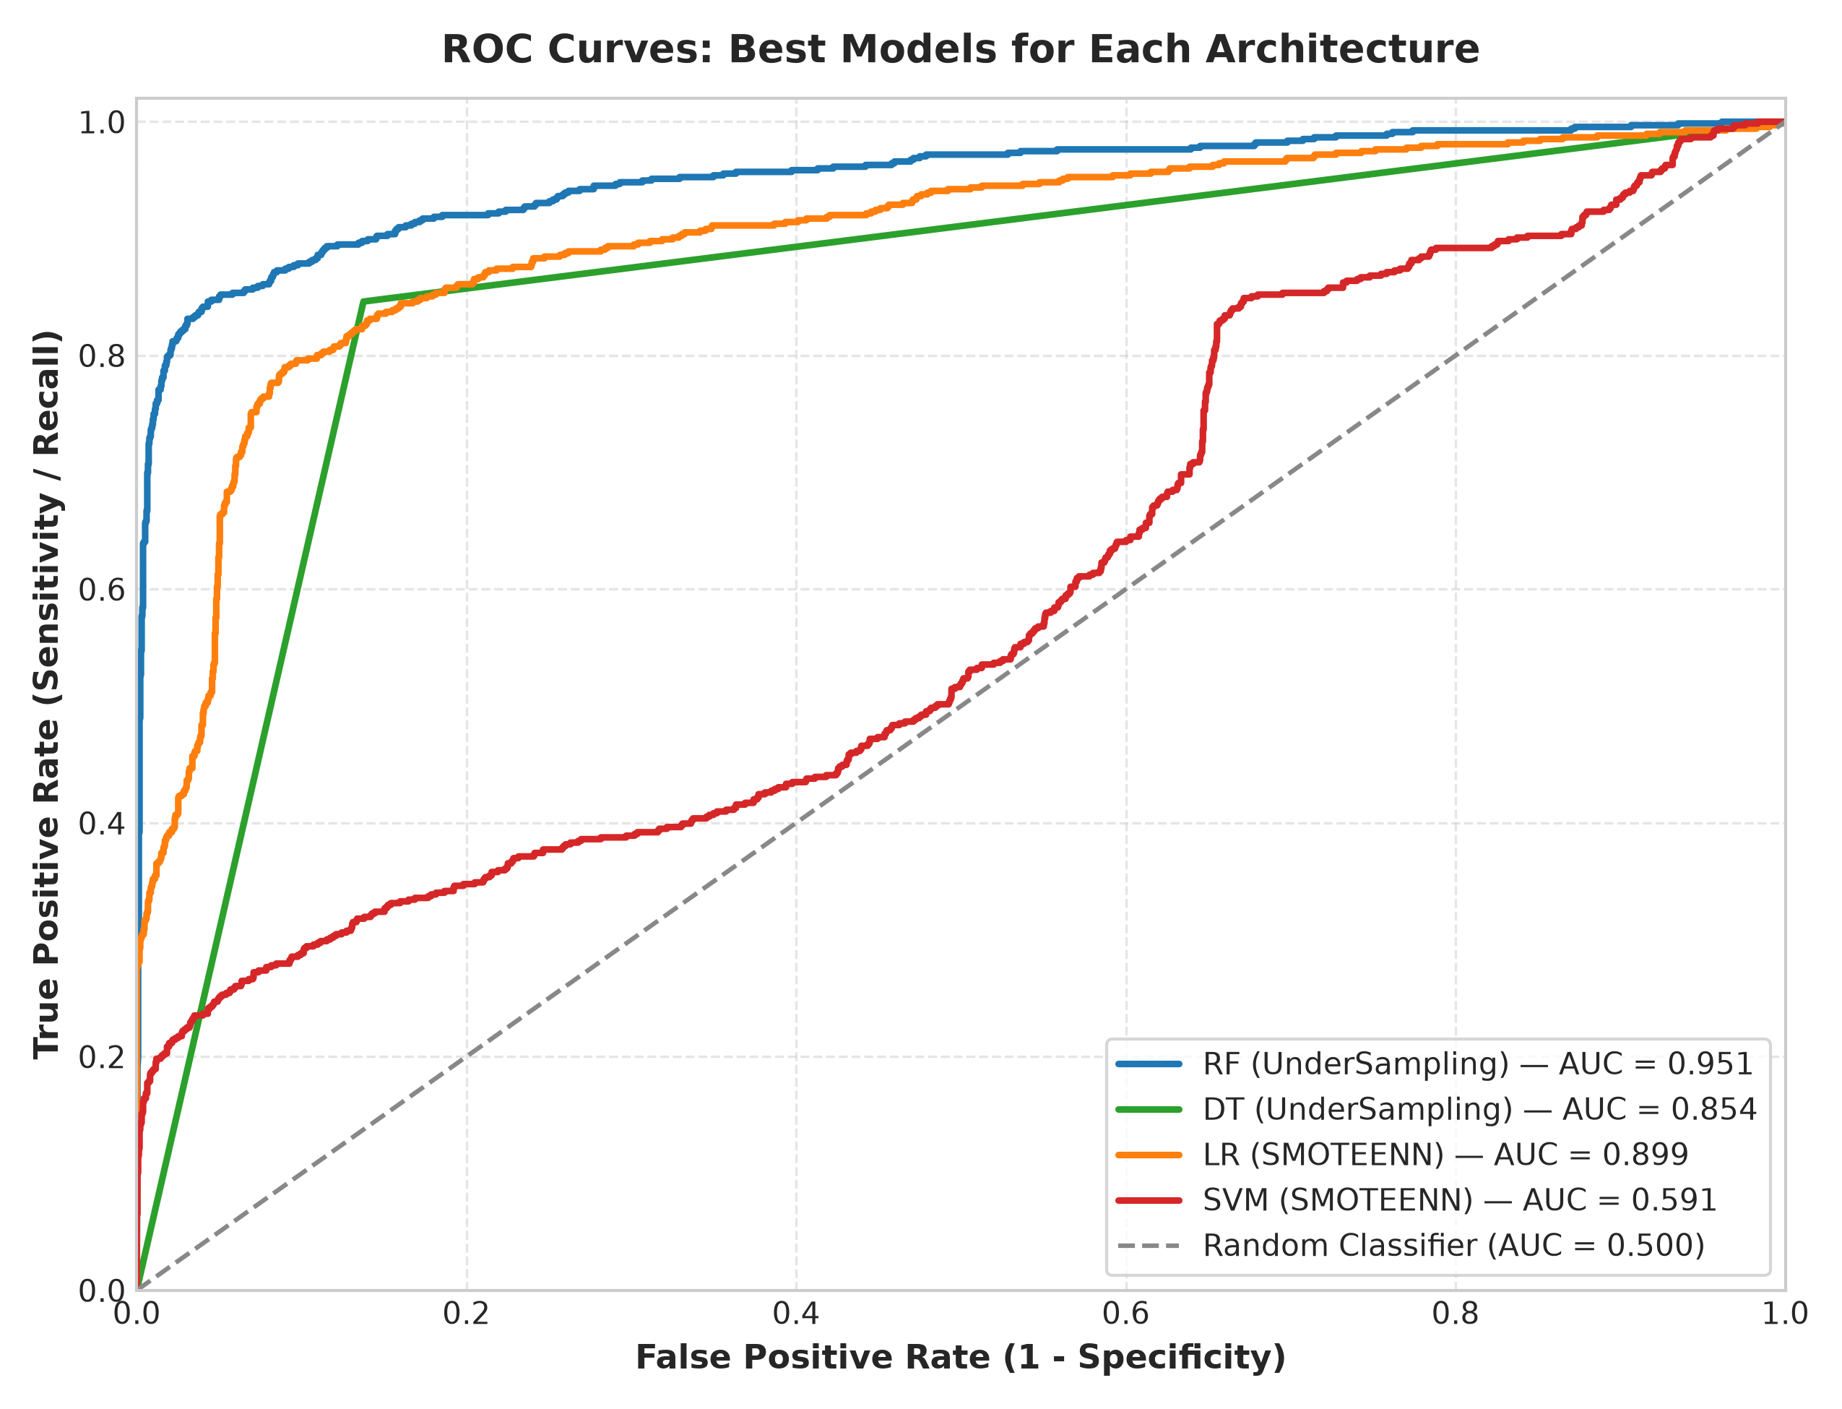
Figure 2.3: Receiver Operating Characteristic (ROC) Trajectories — Random Forest AUC = 0.951.

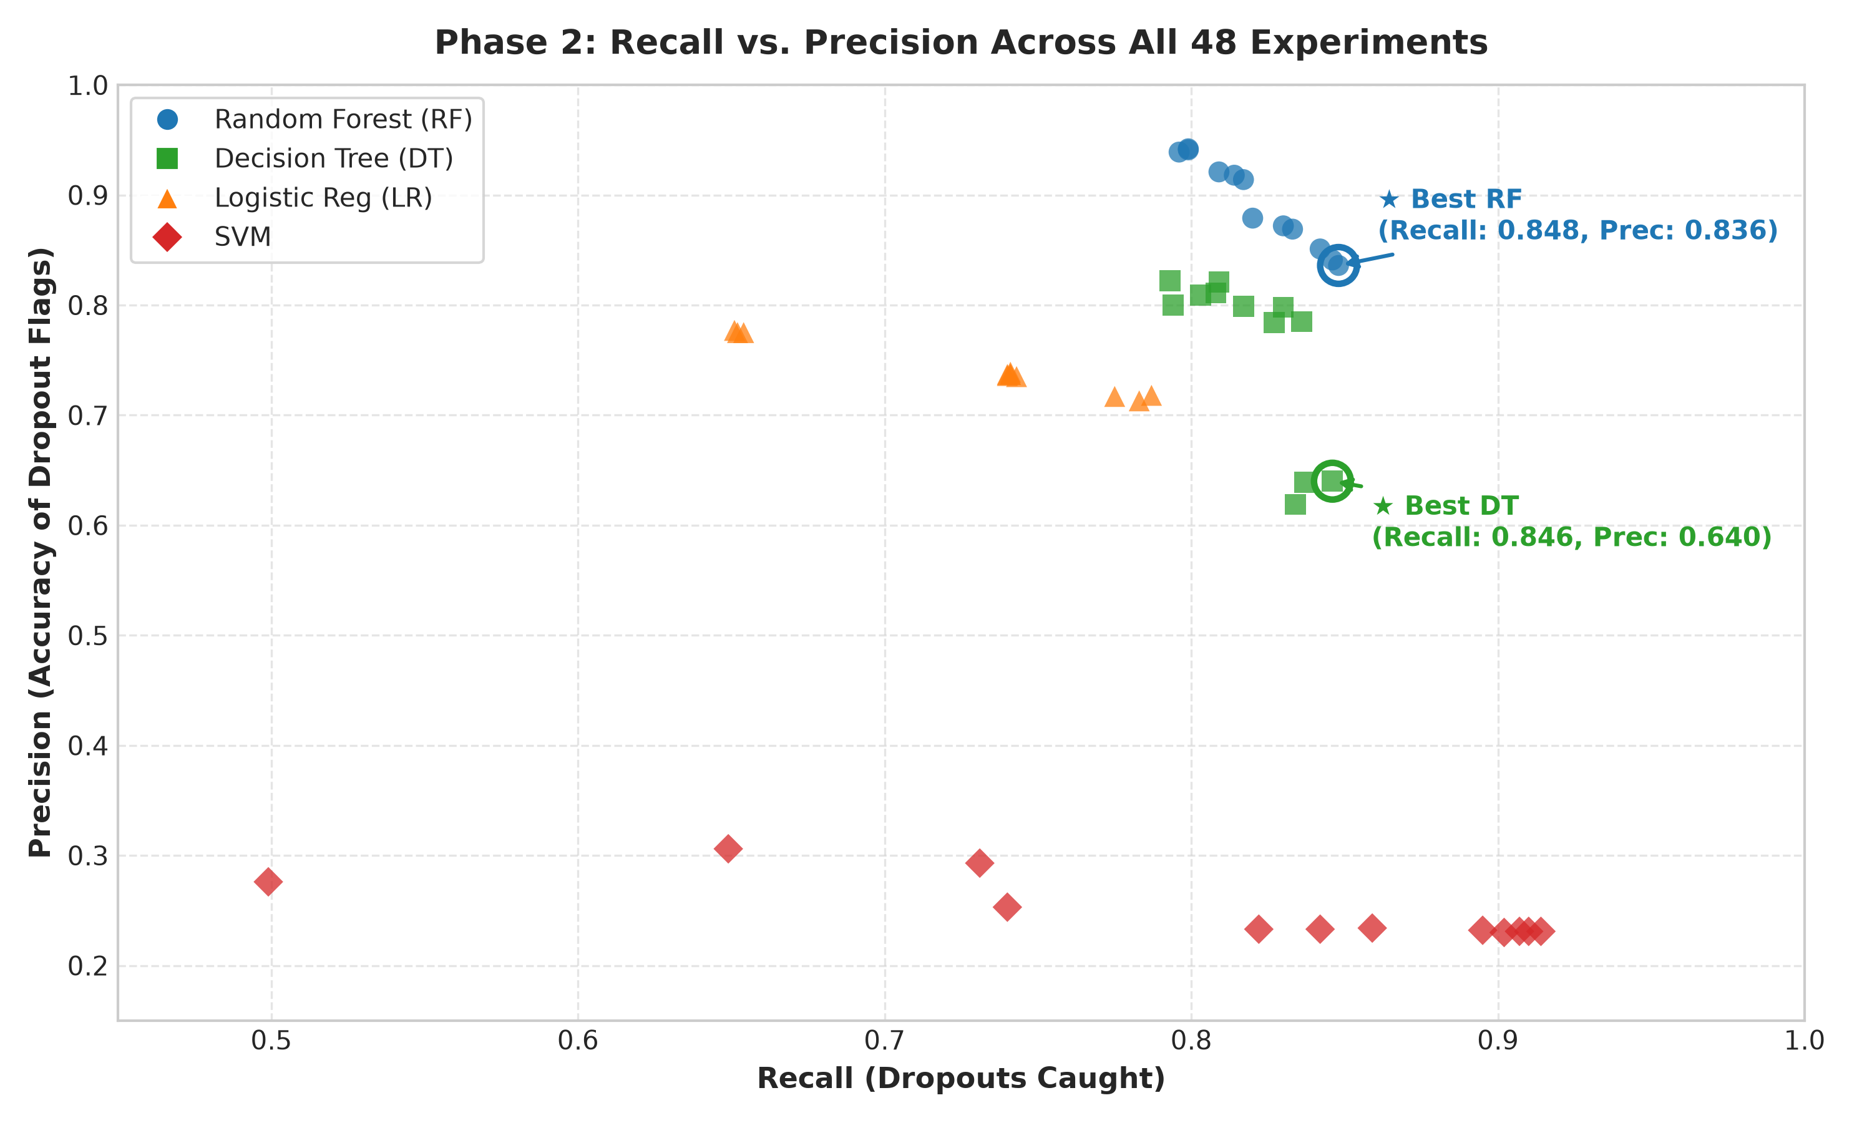
Figure 2.4: Impact of Class Balancing Strategies on Recall and F1 Stability.

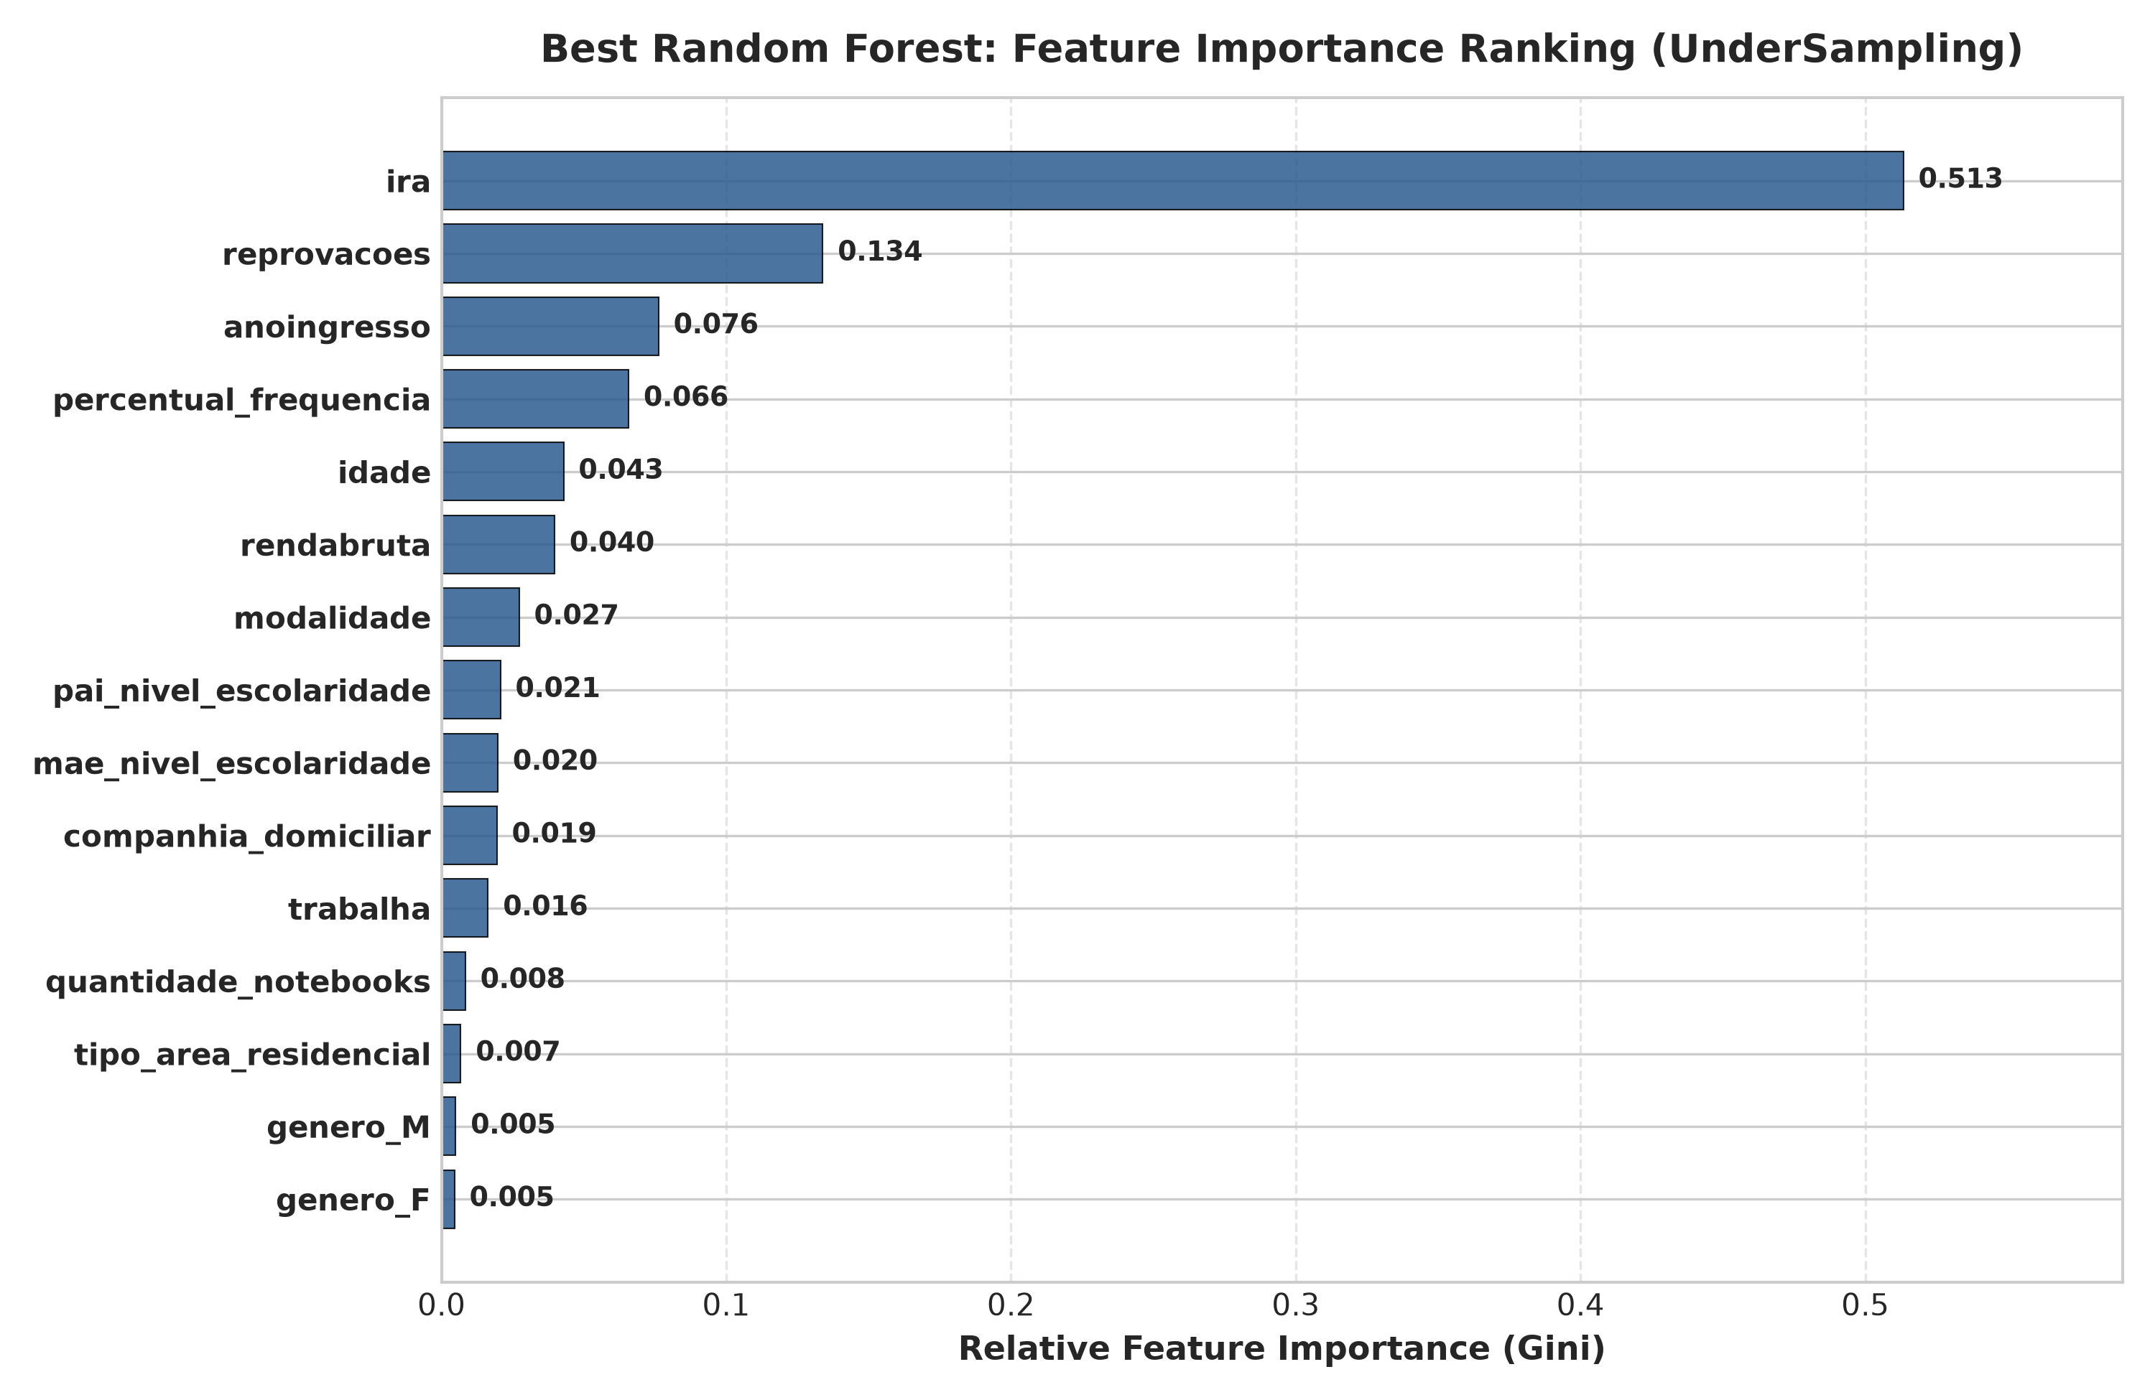
Figure 2.5: Top 10 Feature Importances via Gini Impurity Reduction in Champion Random Forest.

3.4 Complete 48-Experiment Benchmark Table
Balance | Feat.Sel. | Model | Recall | Prec. | F1 | AUC | Acc. | 10-CV Rec. | Best Params
SMOTEENN | ANOVA | SVM | 0.914 | 0.231 | 0.369 | 0.591 | 0.301 | 0.873 | C=0.1, rbf
UnderSampling | Backward | SVM | 0.910 | 0.231 | 0.369 | 0.759 | 0.303 | 0.695 | C=10.0, rbf
UnderSampling | ANOVA | SVM | 0.907 | 0.231 | 0.368 | 0.727 | 0.303 | 0.801 | C=10.0, rbf
Unbalanced | ANOVA | SVM | 0.902 | 0.230 | 0.367 | 0.689 | 0.303 | 0.867 | C=0.1, rbf
SMOTEENN | FeatImp | SVM | 0.895 | 0.232 | 0.369 | 0.720 | 0.314 | 0.863 | C=1.0, rbf
Unbalanced | Backward | SVM | 0.859 | 0.234 | 0.367 | 0.686 | 0.337 | 0.849 | C=10.0, rbf
UnderSampling | FeatImp | RF | 0.848 | 0.836 | 0.842 | 0.951 | 0.929 | 0.878 | gini, d=20, s=5 (CHAMPION)
UnderSampling | ANOVA | RF | 0.846 | 0.841 | 0.844 | 0.950 | 0.930 | 0.877 | gini, d=None, s=5
UnderSampling | ANOVA | DT | 0.846 | 0.640 | 0.729 | 0.854 | 0.859 | 0.879 | gini, d=None, s=2
UnderSampling | Backward | RF | 0.842 | 0.851 | 0.846 | 0.953 | 0.931 | 0.874 | entropy, d=10, s=2
SMOTE | FeatImp | SVM | 0.842 | 0.233 | 0.365 | 0.627 | 0.343 | 0.708 | C=0.1, rbf
UnderSampling | Backward | DT | 0.837 | 0.639 | 0.725 | 0.850 | 0.857 | 0.879 | gini, d=None, s=2
SMOTEENN | Backward | DT | 0.836 | 0.785 | 0.809 | 0.885 | 0.912 | 0.965 | entropy, d=20, s=2
UnderSampling | FeatImp | DT | 0.834 | 0.619 | 0.711 | 0.843 | 0.848 | 0.874 | gini, d=None, s=2
SMOTEENN | ANOVA | RF | 0.833 | 0.869 | 0.850 | 0.946 | 0.934 | 0.978 | gini, d=None, s=2
SMOTEENN | Backward | RF | 0.830 | 0.872 | 0.851 | 0.952 | 0.935 | 0.976 | gini, d=None, s=2
SMOTEENN | ANOVA | DT | 0.830 | 0.798 | 0.814 | 0.885 | 0.915 | 0.963 | gini, d=None, s=2
SMOTEENN | FeatImp | DT | 0.827 | 0.784 | 0.805 | 0.880 | 0.910 | 0.964 | entropy, d=20, s=2
Unbalanced | FeatImp | SVM | 0.822 | 0.233 | 0.363 | 0.639 | 0.353 | 0.866 | C=0.1, rbf
SMOTEENN | FeatImp | RF | 0.820 | 0.879 | 0.848 | 0.950 | 0.934 | 0.976 | entropy, d=20, s=2
SMOTE | ANOVA | RF | 0.817 | 0.914 | 0.863 | 0.950 | 0.942 | 0.949 | gini, d=20, s=2
SMOTE | Backward | DT | 0.817 | 0.799 | 0.808 | 0.879 | 0.913 | 0.940 | entropy, d=None, s=2
SMOTE | FeatImp | RF | 0.814 | 0.918 | 0.863 | 0.952 | 0.942 | 0.952 | gini, d=None, s=5
SMOTE | Backward | RF | 0.809 | 0.921 | 0.861 | 0.954 | 0.942 | 0.952 | gini, d=None, s=5
SMOTE | ANOVA | DT | 0.809 | 0.821 | 0.815 | 0.879 | 0.918 | 0.940 | entropy, d=None, s=2
Unbalanced | Backward | DT | 0.808 | 0.811 | 0.809 | 0.877 | 0.915 | 0.827 | gini, d=None, s=2
Unbalanced | ANOVA | DT | 0.803 | 0.809 | 0.806 | 0.874 | 0.913 | 0.824 | entropy, d=None, s=2
Unbalanced | Backward | RF | 0.799 | 0.942 | 0.865 | 0.953 | 0.944 | 0.831 | gini, d=None, s=5
Unbalanced | FeatImp | RF | 0.799 | 0.941 | 0.864 | 0.950 | 0.944 | 0.830 | gini, d=20, s=2
Unbalanced | ANOVA | RF | 0.796 | 0.939 | 0.861 | 0.949 | 0.943 | 0.832 | gini, d=20, s=5
SMOTE | FeatImp | DT | 0.794 | 0.800 | 0.797 | 0.869 | 0.910 | 0.942 | entropy, d=None, s=2
Unbalanced | FeatImp | DT | 0.793 | 0.822 | 0.807 | 0.872 | 0.915 | 0.835 | gini, d=None, s=2
SMOTEENN | Backward | LR | 0.787 | 0.718 | 0.751 | 0.899 | 0.883 | 0.862 | C=10.0, lbfgs
SMOTEENN | ANOVA | LR | 0.783 | 0.713 | 0.746 | 0.897 | 0.881 | 0.866 | C=0.1, liblinear
SMOTEENN | FeatImp | LR | 0.775 | 0.717 | 0.745 | 0.899 | 0.881 | 0.867 | C=1.0, lbfgs
SMOTE | ANOVA | LR | 0.743 | 0.735 | 0.739 | 0.896 | 0.882 | 0.777 | C=0.1, liblinear
SMOTE | FeatImp | LR | 0.741 | 0.739 | 0.740 | 0.897 | 0.883 | 0.778 | C=10.0, lbfgs
SMOTE | Backward | LR | 0.741 | 0.737 | 0.739 | 0.898 | 0.883 | 0.773 | C=0.1, lbfgs
UnderSampling | FeatImp | LR | 0.741 | 0.737 | 0.739 | 0.897 | 0.883 | 0.767 | C=0.1, liblinear
UnderSampling | Backward | LR | 0.740 | 0.737 | 0.739 | 0.898 | 0.883 | 0.764 | C=10.0, lbfgs
UnderSampling | ANOVA | LR | 0.740 | 0.736 | 0.738 | 0.897 | 0.882 | 0.767 | C=0.1, lbfgs
SMOTE | ANOVA | SVM | 0.740 | 0.253 | 0.377 | 0.643 | 0.451 | 0.785 | C=10.0, rbf
SMOTEENN | Backward | SVM | 0.731 | 0.293 | 0.418 | 0.670 | 0.544 | 0.837 | C=10.0, rbf
Unbalanced | FeatImp | LR | 0.654 | 0.775 | 0.709 | 0.894 | 0.880 | 0.677 | C=1.0, liblinear
Unbalanced | ANOVA | LR | 0.652 | 0.775 | 0.708 | 0.894 | 0.880 | 0.678 | C=0.1, liblinear
Unbalanced | Backward | LR | 0.651 | 0.777 | 0.709 | 0.895 | 0.880 | 0.679 | C=0.1, lbfgs
SMOTE | Backward | SVM | 0.649 | 0.306 | 0.416 | 0.683 | 0.592 | 0.759 | C=10.0, rbf
UnderSampling | FeatImp | SVM | 0.499 | 0.276 | 0.355 | 0.609 | 0.595 | 0.546 | C=0.1, linear

4. Explainable AI (XAI) via SHAP & LIME (Phase 3)
Phase 3 resolves Research Question 2 (RQ2): Why does the black-box champion model make specific predictions? Global interpretability is established via TreeSHAP on a statistically stable test sample of 800 students (441 female, 359 male), and dual local interpretability is provided for individual students using both SHAP waterfalls and LIME surrogate bar charts.

4.1 Mathematical Formulations in Phase 3
FORMULA: SHAP Shapley Values & LIME Surrogates
Shapley Value Formula:
phi_i(v) = Sum_{S subseteq N \ {i}} [ (|S|! * (|N| - |S| - 1)!) / |N|! ] * [ v(S union {i}) - v(S) ]
Additive Property: f(x) = phi_0 + Sum_{i=1}^{M} phi_i(x)
LIME Local Surrogate: Explanation(x) = argmin_{g in G} [ L(f, g, pi_x) + Omega(g) ]
LIME Proximity Kernel: pi_x(z) = exp( - D(x, z)^2 / sigma^2 )
Linear Explainer: g(z') = w_0 + Sum_{j=1}^{d} w_j * z'_j

4.2 Global Feature Attributions & Cohort Parity
Rank | Feature Name | Mean |SHAP| | Typical Value for Risk | Impact Direction
1 | Academic Performance (ira) | 0.2717 | < 5.00 GPA | Dominant primary predictor; steep risk increase below 5.0
2 | Course Failures (reprovacoes) | 0.0596 | >= 3 Failures | Direct risk escalation (+0.06 to +0.12)
3 | Enrollment Year (anoingresso) | 0.0415 | Recent cohorts | Curricular transition and cohort reform effects
4 | Attendance Rate (percentual_frequencia) | 0.0305 | < 75% | Behavioral disengagement cliff
5 | Course Modality (modalidade) | 0.0263 | Evening / Adult | Workforce friction in Subsequente & PROEJA
6 | Student Age (idade) | 0.0174 | >= 21 years | Non-traditional adult learner responsibilities
7 | Family Gross Income (rendabruta) | 0.0127 | <= R$ 930 | Economic hardship and financial vulnerability
8 | Work Status (trabalha) | 0.0084 | Employed | Time-allocation conflicts with classes
9 | Mother's Education (mae_nivel_escolaridade) | 0.0073 | Incomplete primary | Socioeconomic cultural capital proxy
10 | Living Arrangement (companhia_domiciliar) | 0.0067 | Alone / Non-family | Independent household vulnerability
11 | Father's Education (pai_nivel_escolaridade) | 0.0066 | Incomplete primary | Paternal education attainment proxy
12 | Laptops at Home (quantidade_notebooks) | 0.0046 | 0 Laptops | Digital divide indicator
13 | Gender: Male (genero_M) | 0.0040 | Male | Marginal baseline dropout differential
14 | Gender: Female (genero_F) | 0.0032 | Female | Marginal baseline completion differential
15 | Residential Area (tipo_area_residencial) | 0.0031 | Rural Area | Transit distance to vocational campus

4.3 Comprehensive 12 Student Archetypes with SHAP Drivers
ID | Risk % | Pred | Actual | GPA | Attnd | Fail | Inc. | Age | Top 1 SHAP Driver | Top 2 SHAP Driver
#0 | 99.4% | Dropout | Dropout | 1.89 | 77% | 8 | 0 | 22 | IRA (+0.2831) | Failures (+0.1134)
#43 | 100.0% | Dropout | Dropout | 0.63 | 71% | 7 | 800 | 26 | IRA (+0.2672) | Failures (+0.1181)
#85 | 96.5% | Dropout | Dropout | 3.66 | 88% | 5 | 938 | 21 | IRA (+0.3358) | Failures (+0.0838)
#185 | 89.2% | Dropout | Dropout | 4.82 | 100% | 0 | 930 | 20 | IRA (+0.5039) | Failures (-0.0461)
#37 | 50.1% | Dropout | Completed | 7.12 | 87% | 1 | 1600 | 23 | Attendance (+0.0746) | EnrollYear (-0.0318)
#102 | 2.8% | Completed | Completed | 8.75 | 96% | 0 | 1000 | 19 | IRA (-0.3227) | Failures (-0.0504)
#1 | 3.4% | Completed | Completed | 9.18 | 98% | 0 | 600 | 20 | IRA (-0.3065) | Failures (-0.0537)
#25 | 5.8% | Completed | Completed | 8.35 | 94% | 0 | 500 | 29 | IRA (-0.3237) | Failures (-0.0704)
#60 | 6.5% | Completed | Completed | 8.15 | 96% | 0 | 687 | 19 | IRA (-0.2889) | Failures (-0.0517)
#14 | 5.4% | Completed | Completed | 8.74 | 99% | 0 | 2000 | 21 | IRA (-0.2613) | Failures (-0.0558)
#52 | 11.1% | Completed | Completed | 8.58 | 97% | 0 | 2400 | 20 | IRA (-0.3086) | EnrollYear (+0.1278)
#312 | 9.7% | Completed | Completed | 9.36 | 97% | 0 | 1000 | 29 | IRA (-0.3099) | Attendance (-0.0646)

4.4 Phase 3 Visualizations (10 Figures)

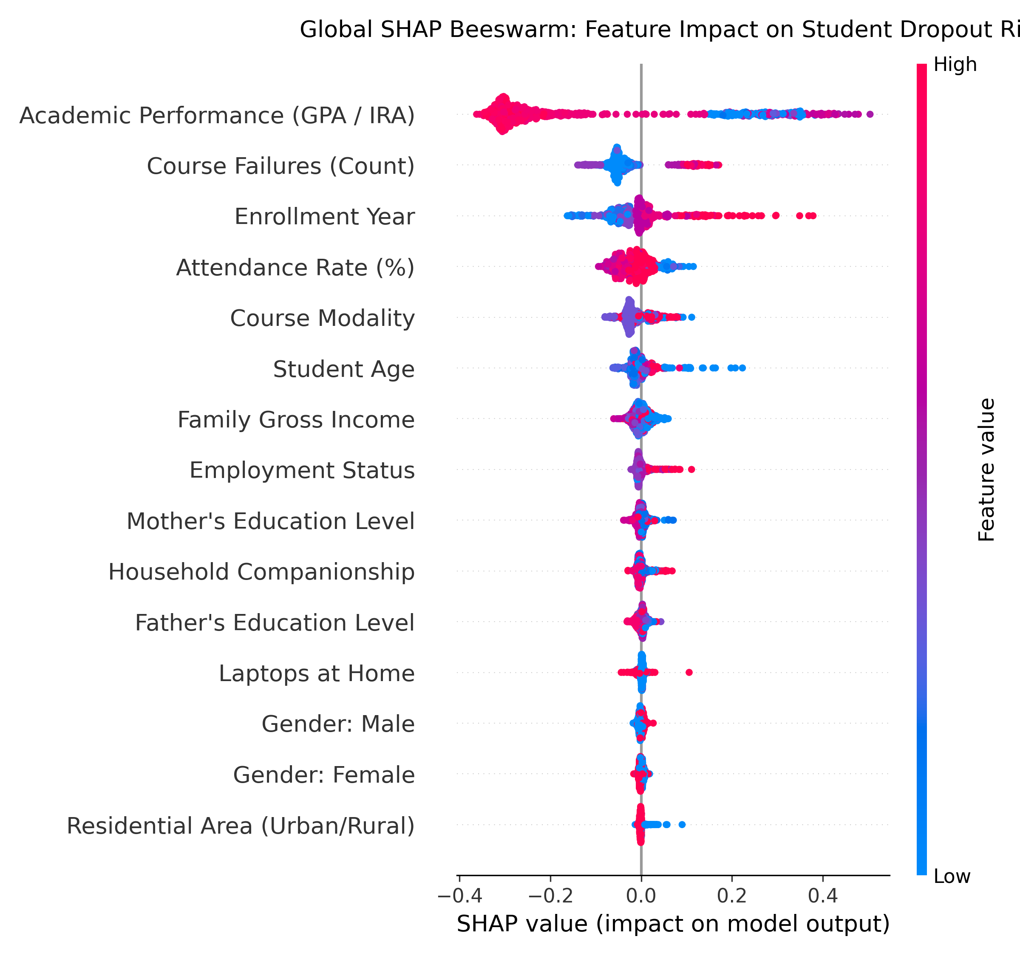
Figure 3.1: Global SHAP Beeswarm Summary Plot on 800 Representative Test Students.

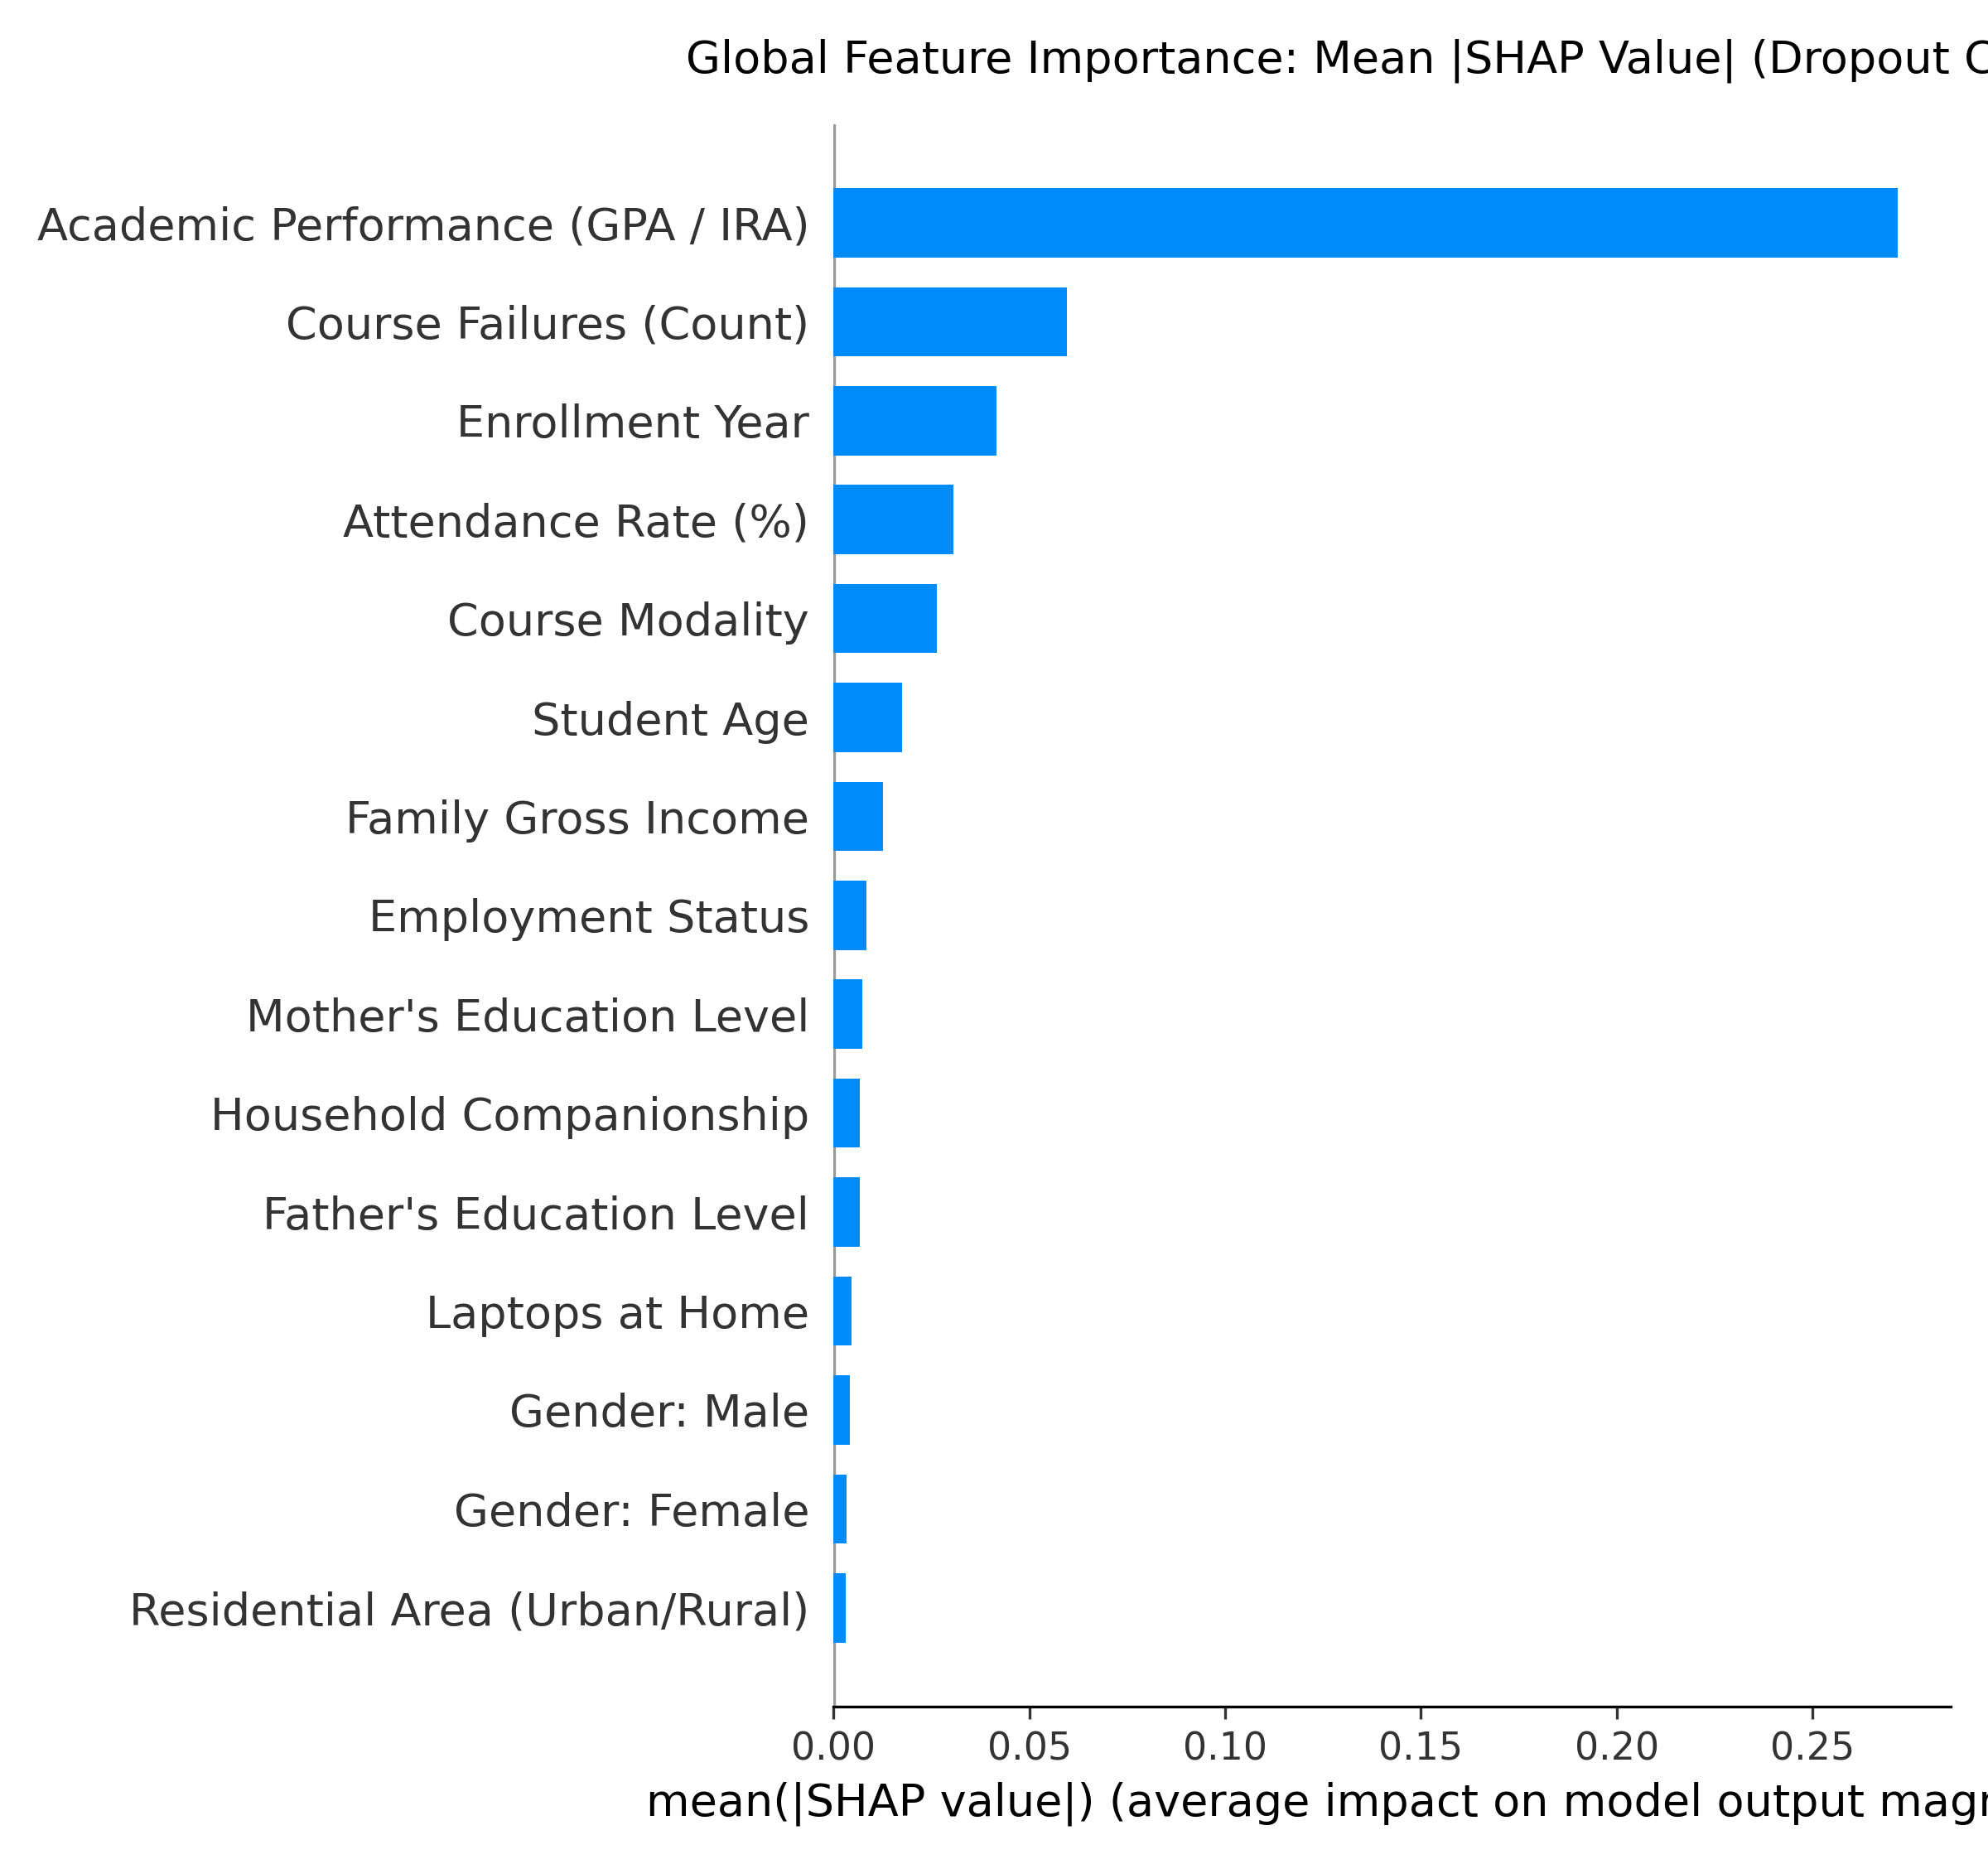
Figure 3.2: Mean Absolute SHAP Feature Importance Ranking.

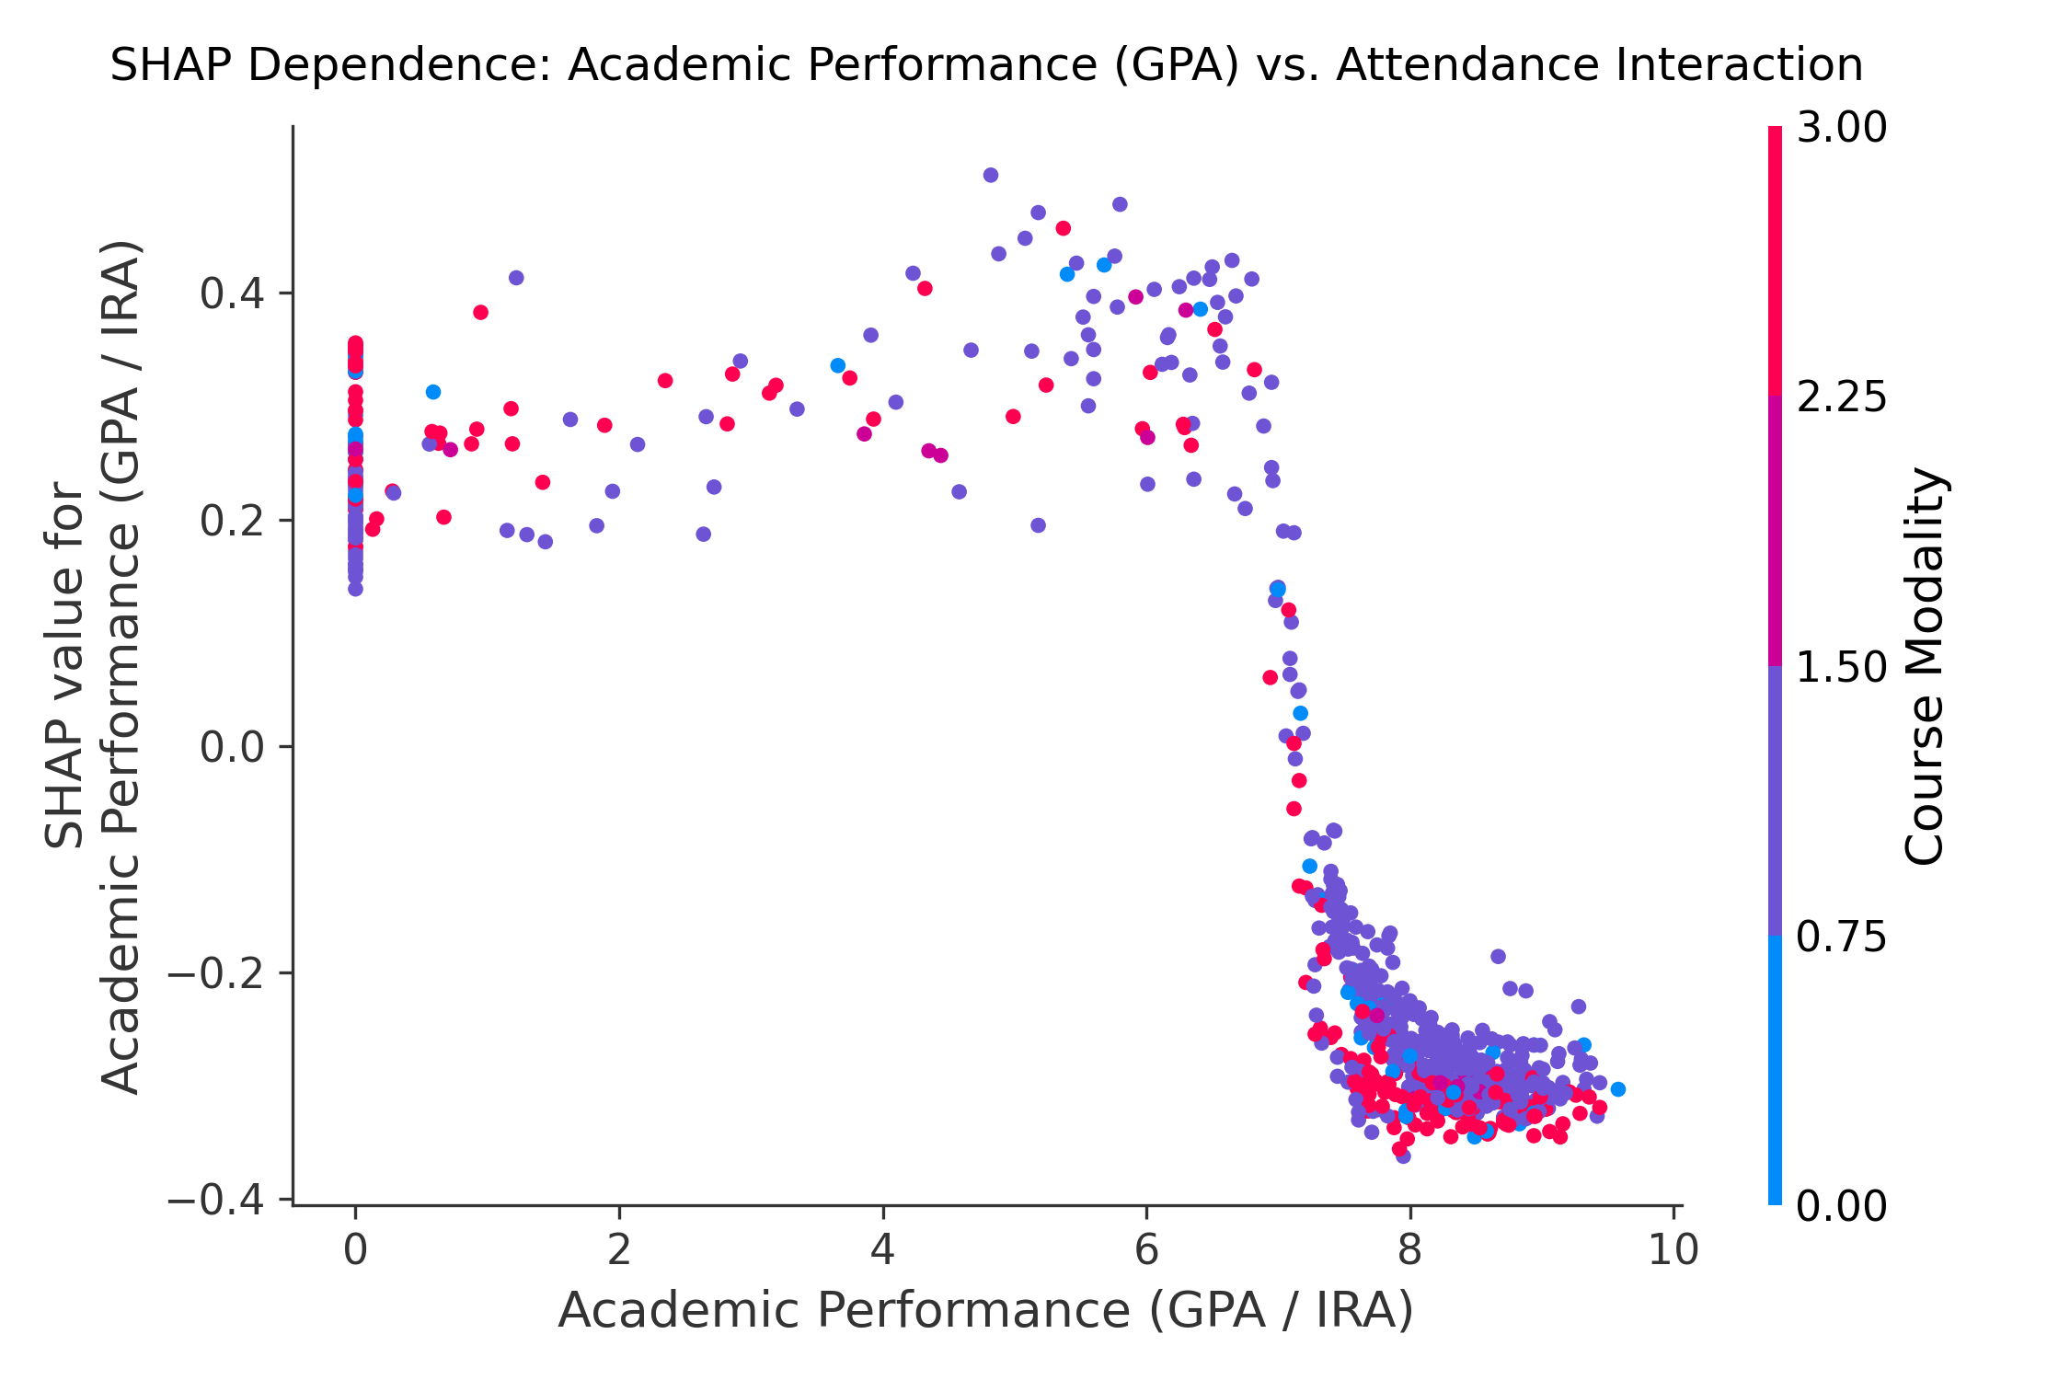
Figure 3.3: SHAP Dependence Plot for Academic Performance (IRA) with Failure Interaction.

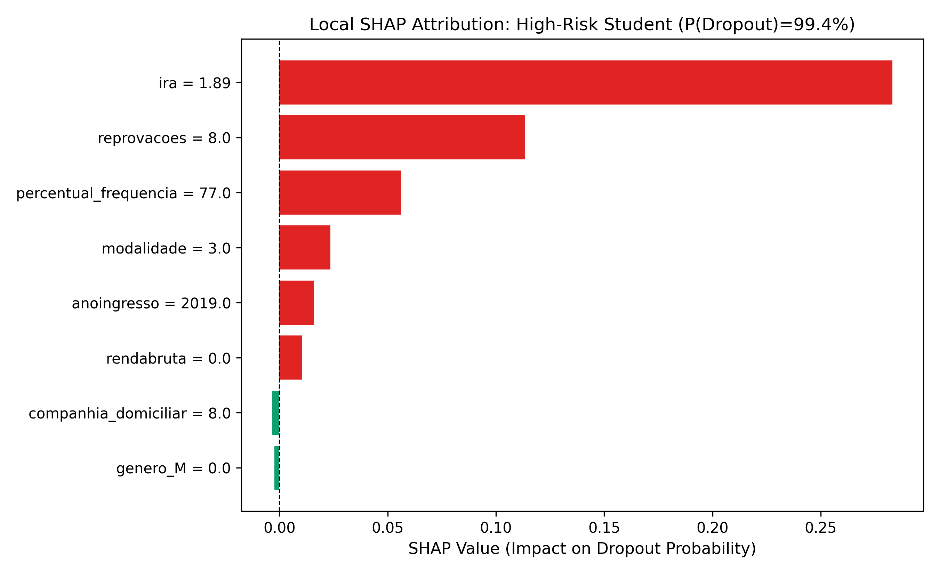
Figure 3.4: SHAP Waterfall for High-Risk Student #0 (Risk: 99.4%).

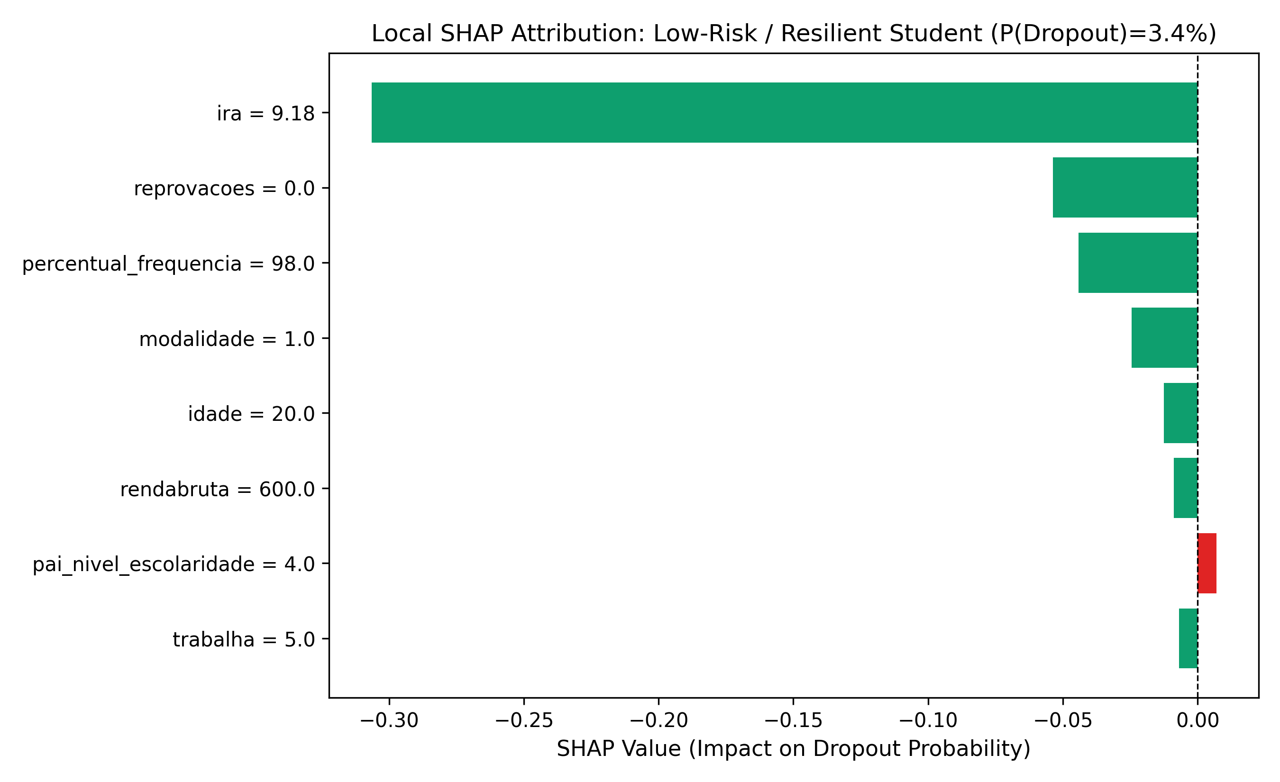
Figure 3.5: SHAP Waterfall for Low-Risk Student #1 (Risk: 3.4%).

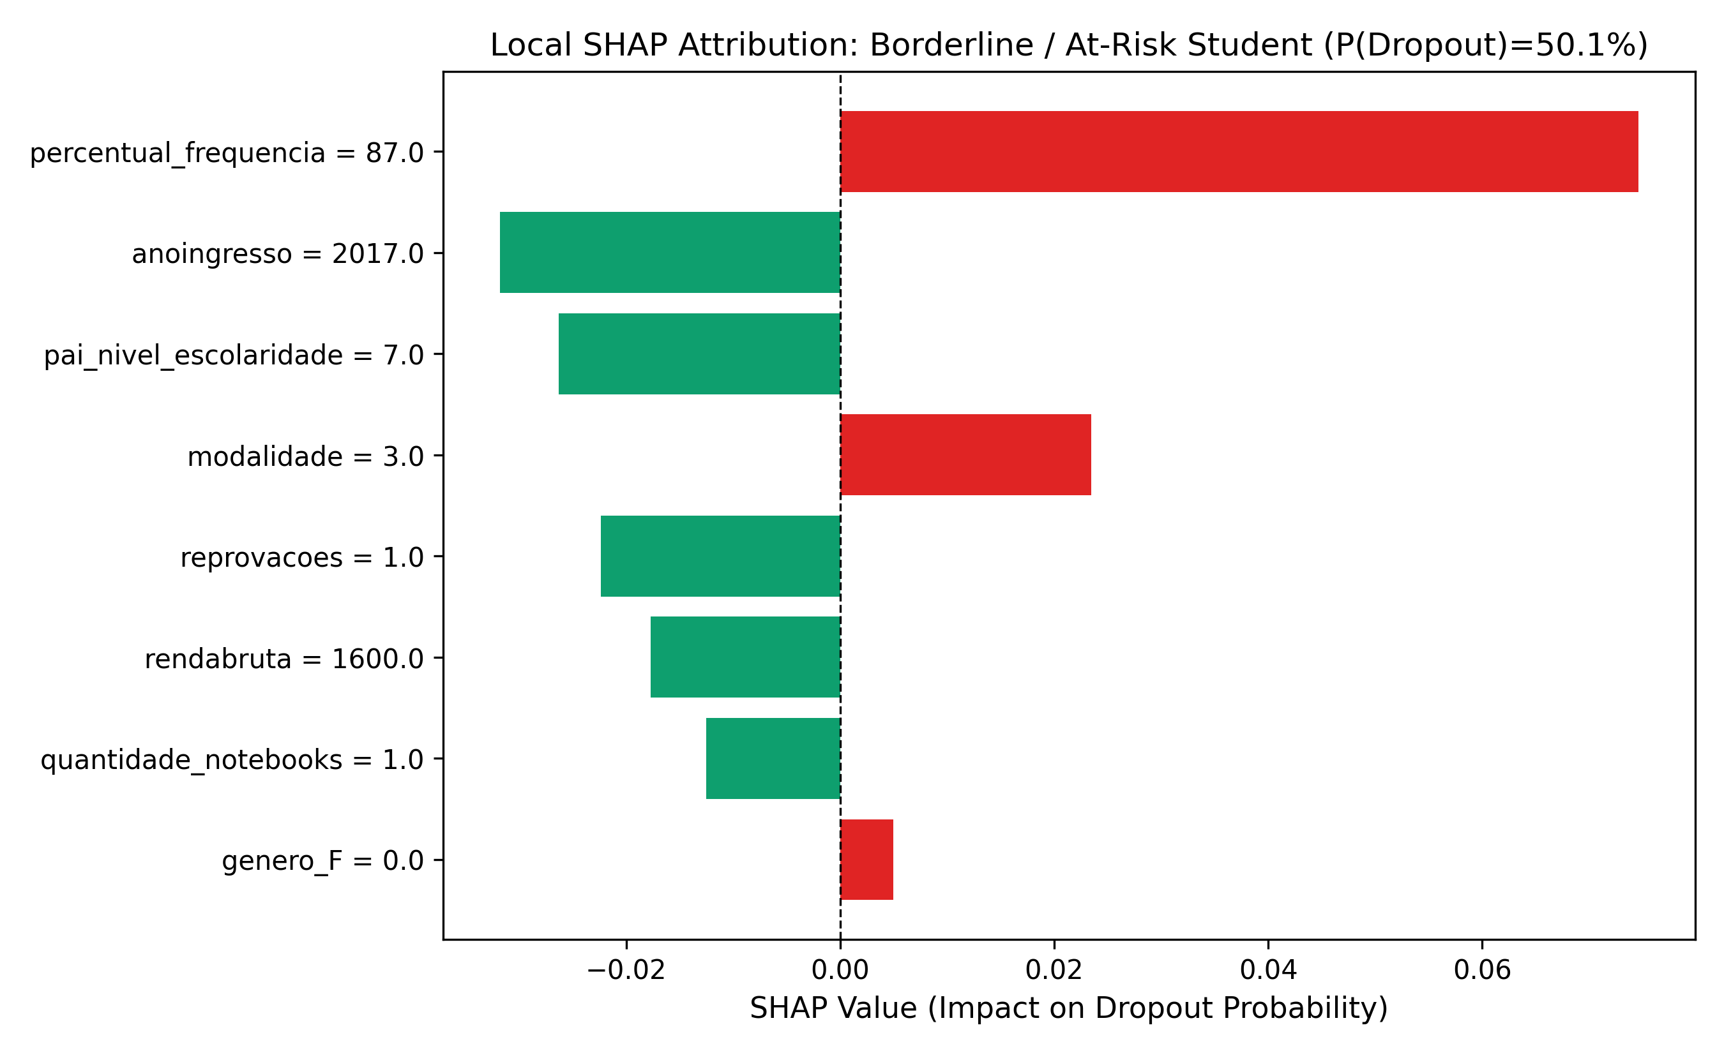
Figure 3.6: SHAP Waterfall for Borderline Student #37 (Risk: 50.1% - False Positive).

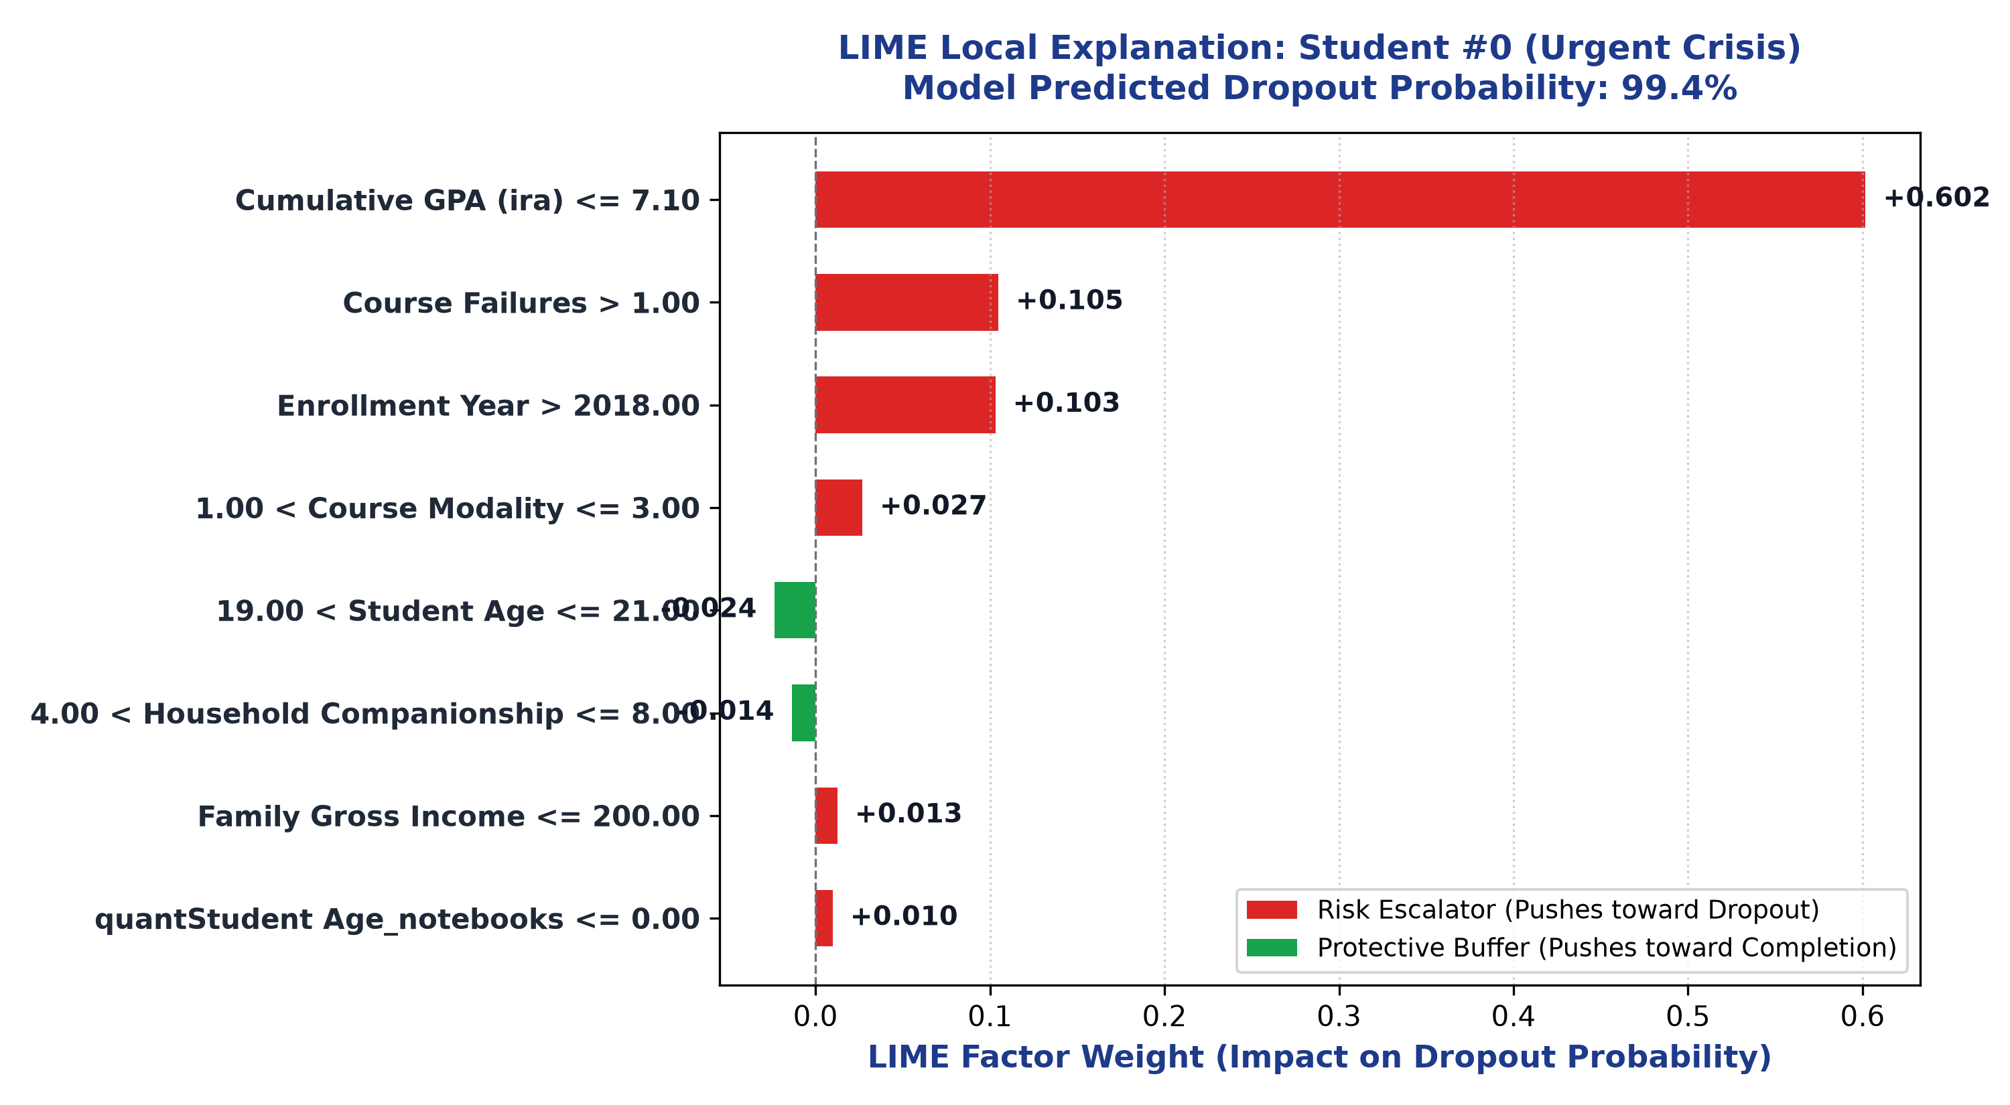
Figure 3.7: LIME Local Surrogate for High-Risk Student #0.

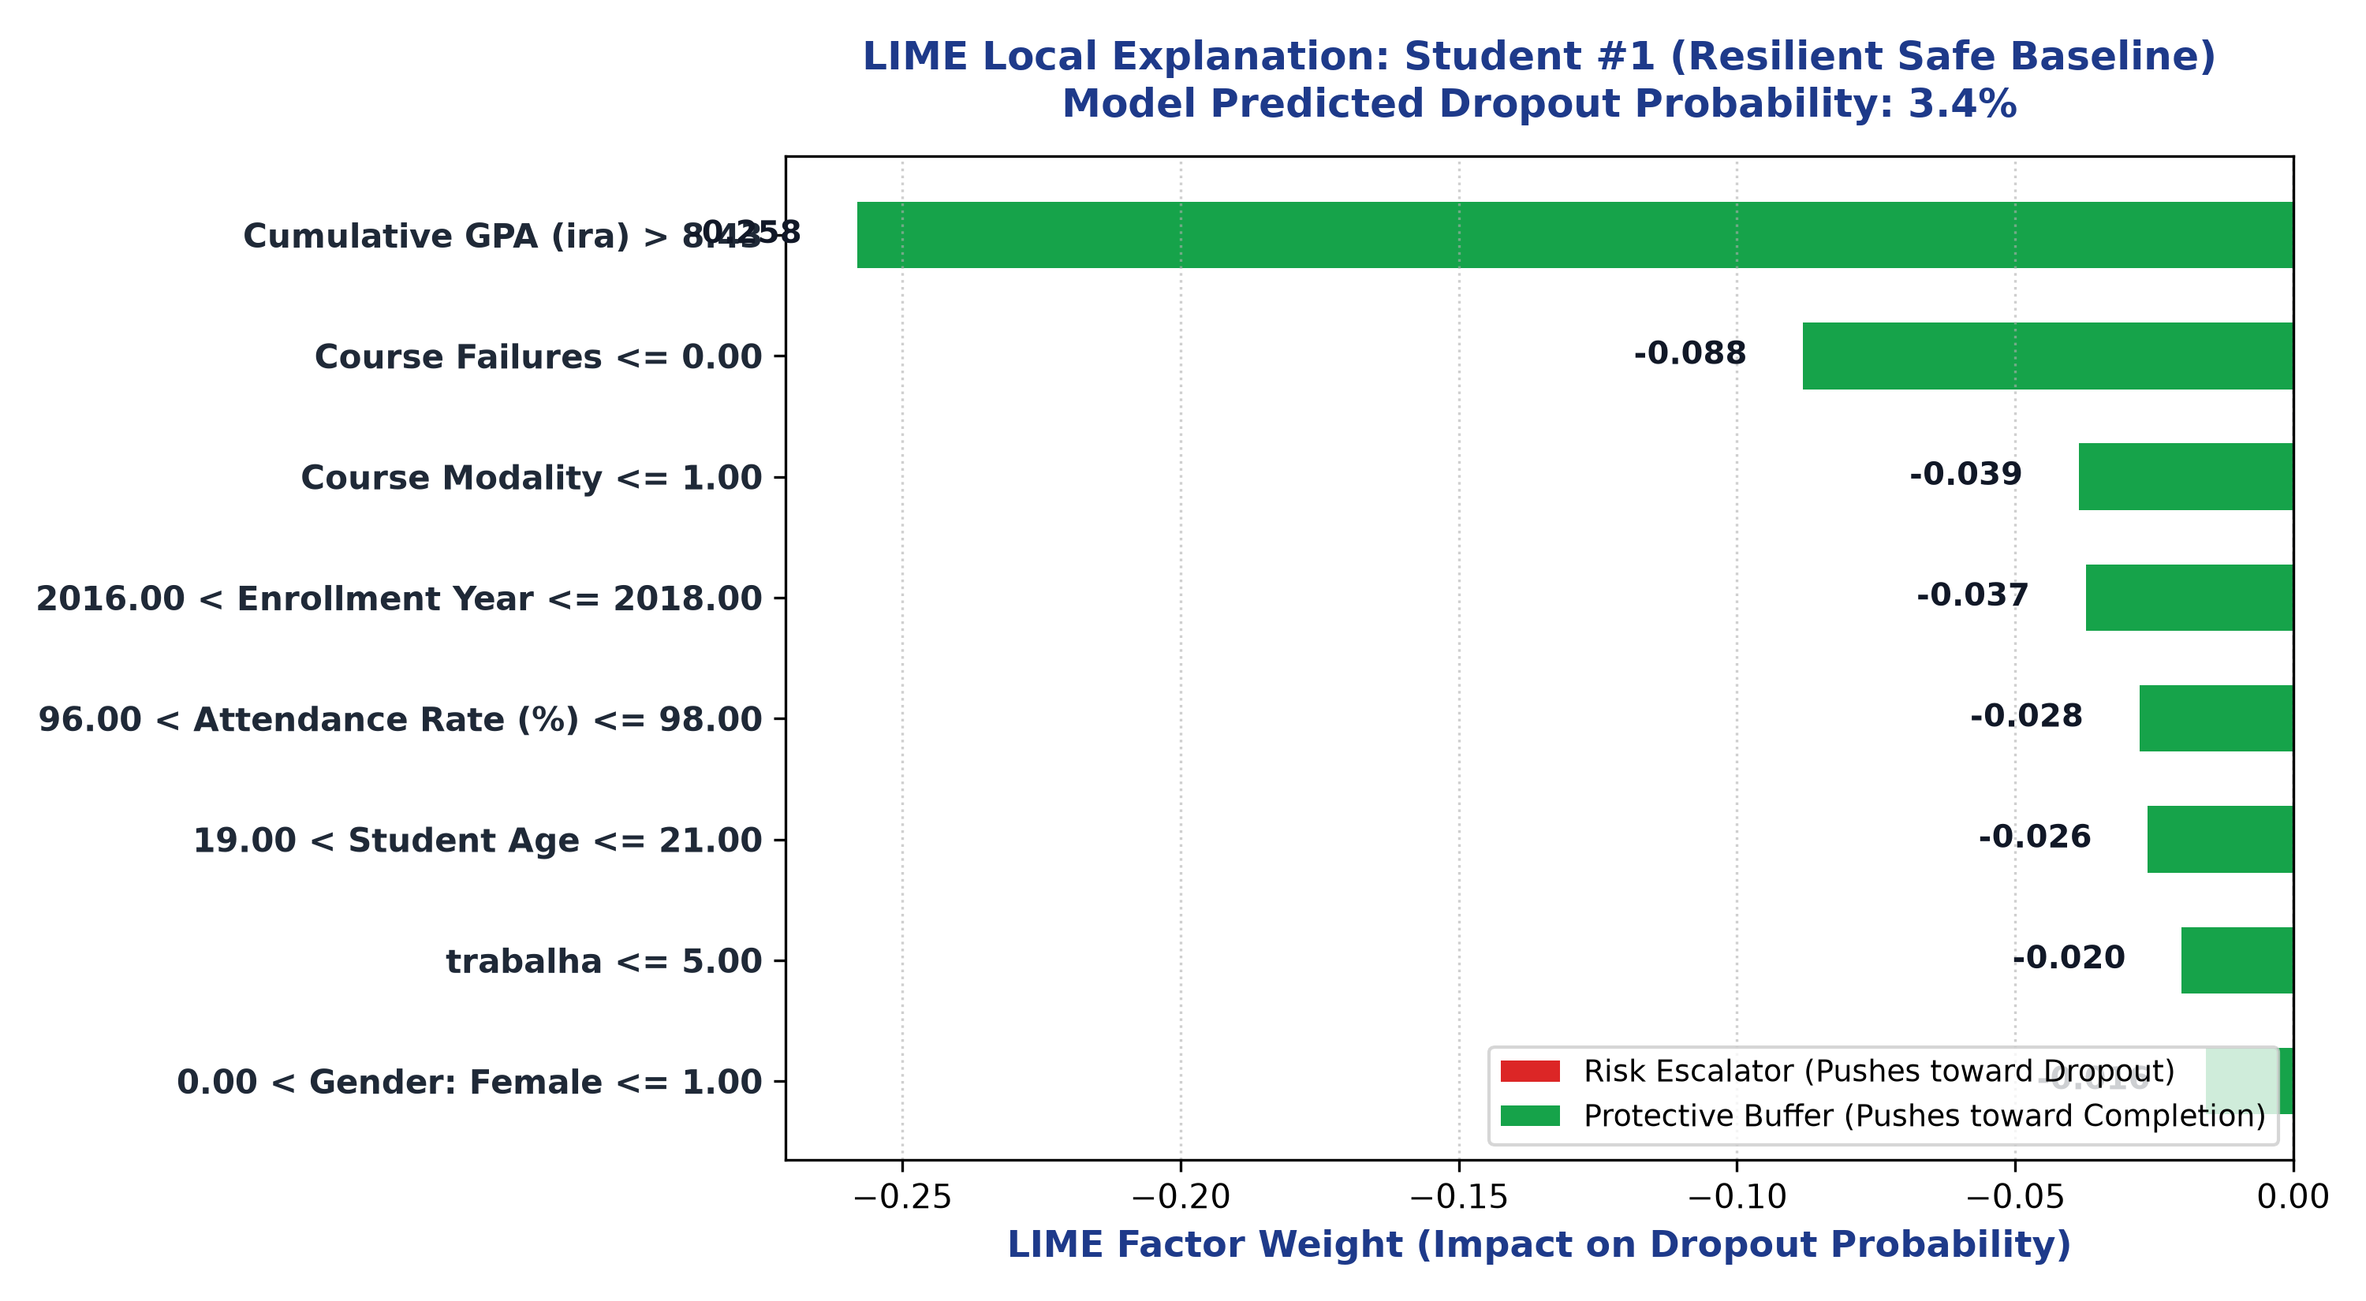
Figure 3.8: LIME Local Surrogate for Low-Risk Student #1.

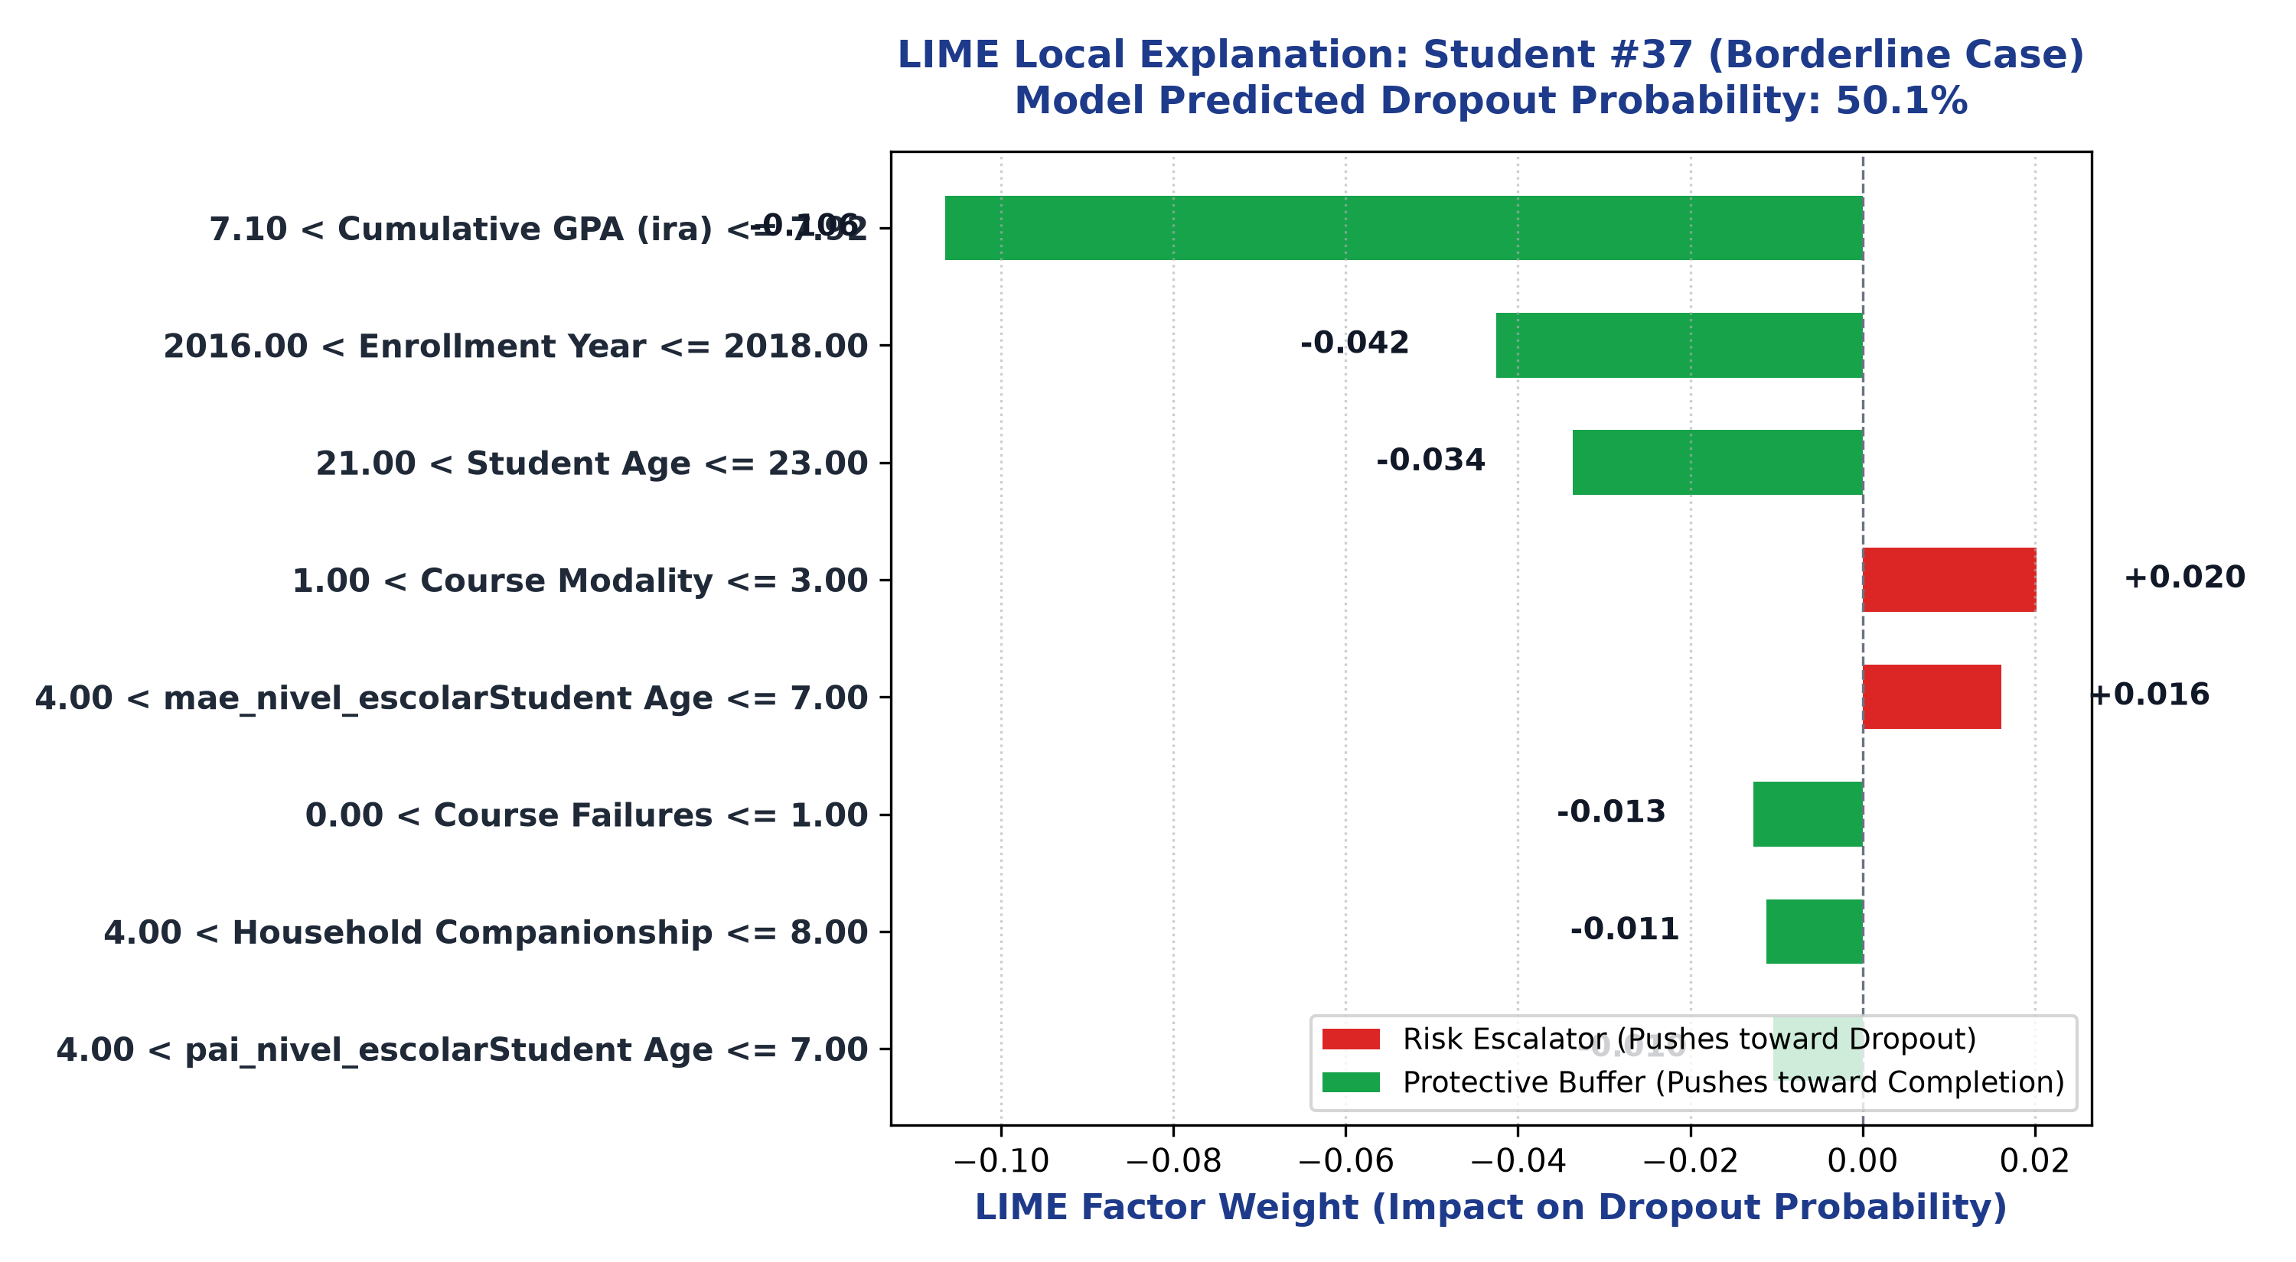
Figure 3.9: LIME Local Surrogate for Borderline Student #37.

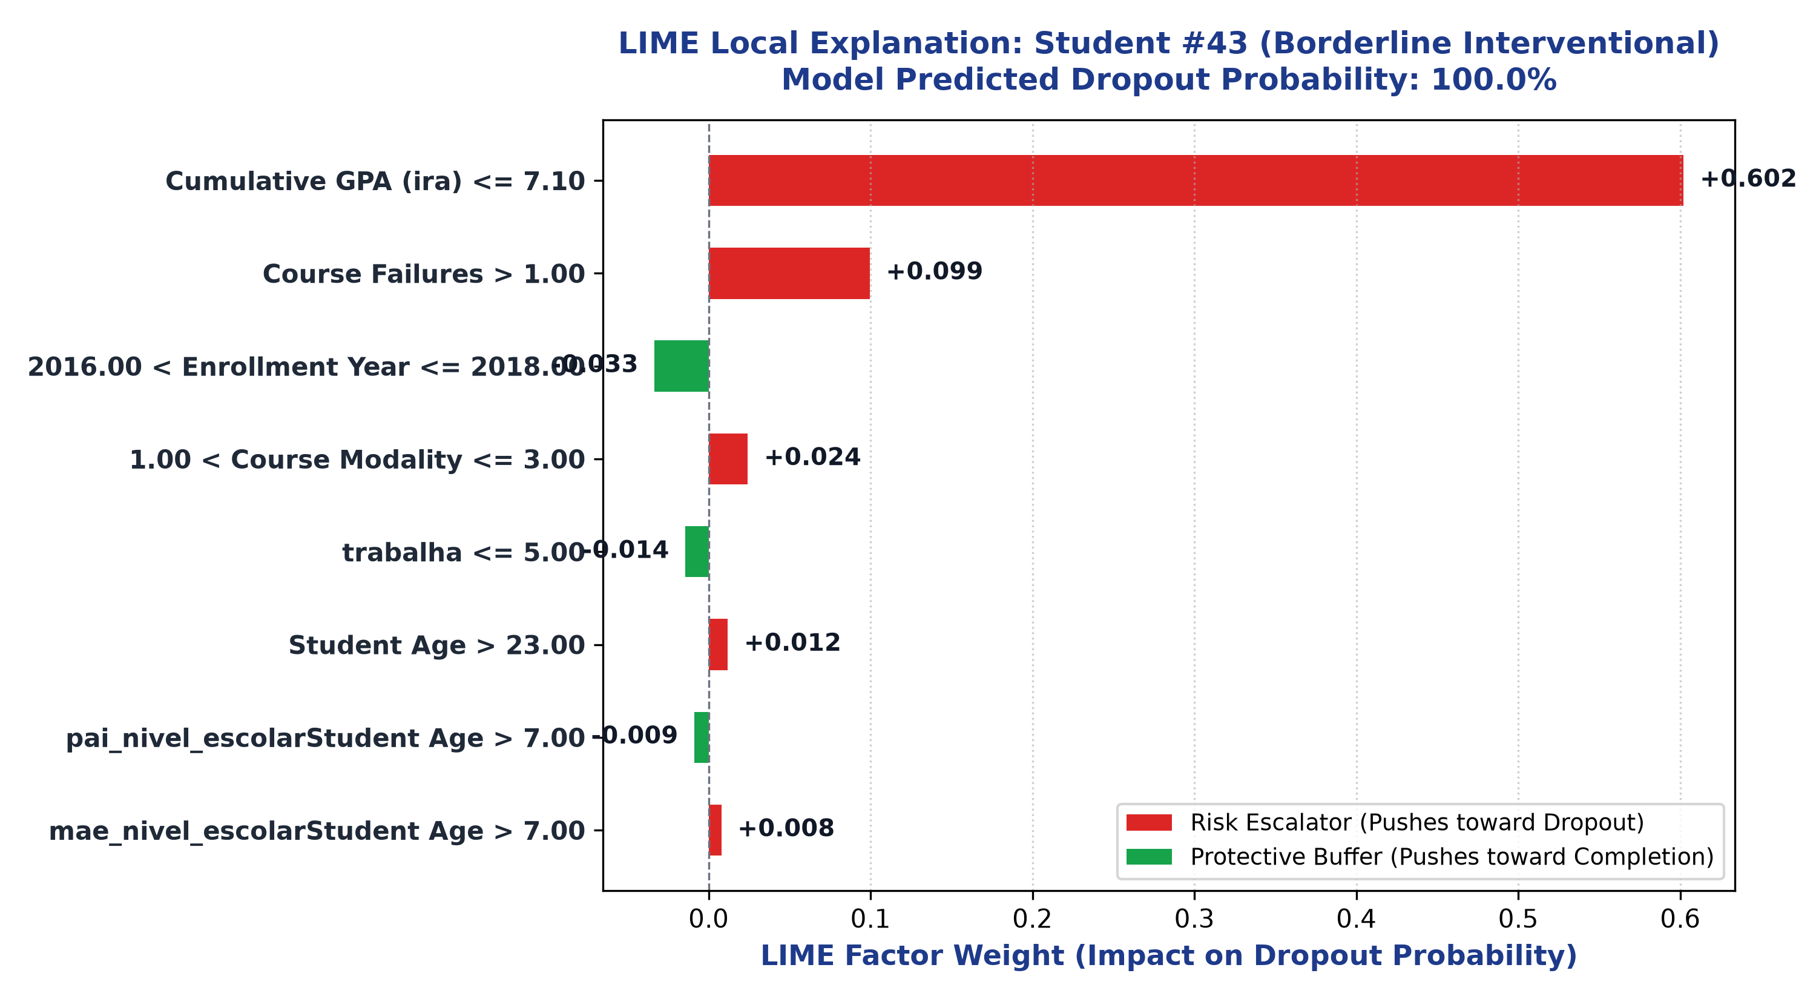
Figure 3.10: LIME Local Surrogate for Critical Student #43 (Counsellor Simulation Case).

5. Algorithmic Fairness Audit (Phase 4)
Phase 4 addresses Research Question 3 (RQ3): Does the model exhibit bias against historically protected or vulnerable student groups? Using the IBM AIF360 and EEOC legal compliance guidelines, the champion Random Forest was audited across five sensitive demographic axes: Gender, Brazilian Census Race/Ethnicity (Branca vs Parda/Preta), Household Income, Age Cohort, and Digital Access (Laptops).

5.1 Mathematical Formulations in Phase 4
FORMULA: AIF360 Algorithmic Fairness Formulations
Disparate Impact (DI) = P(Y_hat = 1 | Unprivileged) / P(Y_hat = 1 | Privileged)
EEOC Four-Fifths Compliance Rule: 0.80 <= DI <= 1.25
Statistical Parity Difference (SPD) = P(Y_hat = 1 | Unpriv) - P(Y_hat = 1 | Priv) [Fair: -0.10 to +0.10]
Equal Opportunity Difference (EOD) = TPR_{Unpriv} - TPR_{Priv} [Fair: -0.10 to +0.10]
Average Odds Difference (AOD) = 0.5 * [ (FPR_{Unpriv} - FPR_{Priv}) + (TPR_{Unpriv} - TPR_{Priv}) ]

5.2 Comprehensive Fairness Audit Scores
Sensitive Attribute | Privileged Group | Unprivileged Group | DI Score | SPD | EOD | AOD | Four-Fifths Status
Gender | Male (N=1,365) | Female (N=1,652) | 0.707 | -0.079 | -0.057 | -0.063 | UNDER-FLAGGED (<0.80)
Race / Ethnicity | White/Branca (N=1,139) | Parda/Preta (N=1,878) | 1.180 | +0.035 | +0.065 | +0.046 | PASSED (0.80-1.25)
Household Income | > Median R$ 930 (N=1,498) | <= R$ 930 (N=1,519) | 1.411 | +0.077 | +0.039 | +0.049 | OVER-FLAGGED (>1.25)
Age Cohort | Traditional <=20 (N=1,987) | Adult >=21 (N=1,030) | 1.590 | +0.102 | +0.043 | +0.061 | OVER-FLAGGED (>1.25)
Digital Access | >=1 Laptop (N=2,374) | 0 Laptops (N=643) | 1.403 | +0.071 | +0.092 | +0.069 | OVER-FLAGGED (>1.25)

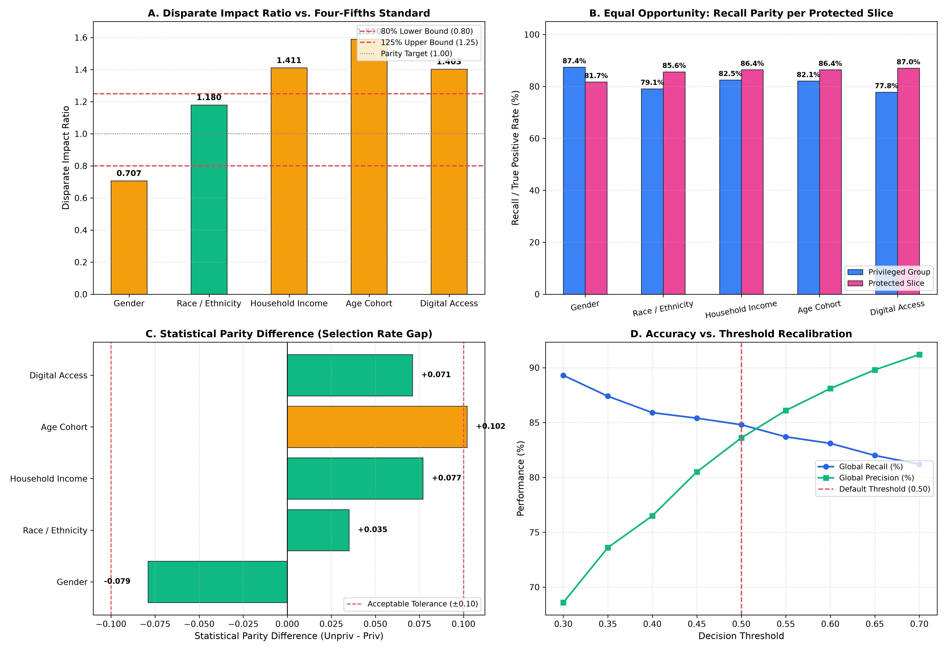
Figure 4.1: Comprehensive Multi-Group Fairness Audit Dashboard across Audited Sensitive Demographic Attributes.

6. Institutional AI Governance Framework (Phase 5)
Phase 5 resolves Research Questions 4 & 5 (RQ4 & RQ5): How can an academic institution deploy this predictive architecture responsibly, transparently, and sustainably? Phase 5 designs an operational governance framework establishing human-in-the-loop oversight, role-based security, continuous monitoring, and student agency.

6.1 Operational Risk Thresholds & Drift Protocols
FORMULA: Governance Risk Bands & KL Divergence Drift Trigger
Risk Band Assignment Protocol:
P(Dropout) < 0.40 => Low Risk: Automated general academic tracking
0.40 <= P <= 0.70 => Borderline Risk: MANDATORY Human-in-the-Loop (HITL) Advisor Review
P(Dropout) > 0.70 => Critical Risk: Immediate Multi-Disciplinary Case Conference
Kullback-Leibler Drift: D_{KL}(P || Q) = Sum_x P(x) * log( P(x) / Q(x) )
Retraining Trigger: Alert data science staff if D_{KL} > 0.10 on core academic features.

6.2 The 5 Core Pillars of Institutional AI Governance
Pillar | Strategic Intent | Operational Mechanism | Oversight Body
Pillar 1: RBAC Security | Protect student privacy under GDPR/LGPD | Cryptographic token auth, role-based data view filtering | IT & Security Compliance
Pillar 2: HITL Oversight | Prevent automated algorithmic harm | Mandatory human sign-off on borderline & critical risk flags | Academic Advisory Board
Pillar 3: Audit Trail | Ensure total institutional accountability | Immutable WORM logging of all model queries, predictions, & notes | Internal Quality Audit
Pillar 4: Drift Monitoring | Prevent model degradation over time | Monthly automated fairness re-audits and KL divergence checks | Data Science Team
Pillar 5: Student Rights | Guarantee transparency & right to contest | Plain-language XAI explanations upon request; appeal mechanism | Student Ombudsman

6.3 Role-Based Access Control (RBAC) Entitlement Matrix
Functional Capability | Academic Counsellor | Department Head / Dean | Data Science Engineer | Enrolled Student
View Individual Risk % | YES (Assigned Cohort) | YES (Aggregated/Summary) | YES (Pseudonymized) | NO (Raw % hidden)
Inspect SHAP / LIME Charts | YES (Full Visual Access) | NO (Summary Only) | YES (Full Technical Access) | YES (Plain-Language)
Log Intervention Decision | YES (Mandatory Protocol) | NO | NO | NO
Trigger Model Retraining | NO | APPROVAL REQUIRED | YES (Authorized Pipeline) | NO
File Formal Explanation Appeal | NO | RECEIVES ESCALATIONS | AUDITS LOGGED DATA | YES (Ombudsman Portal)

6.4 Phase 5 Visual Architecture

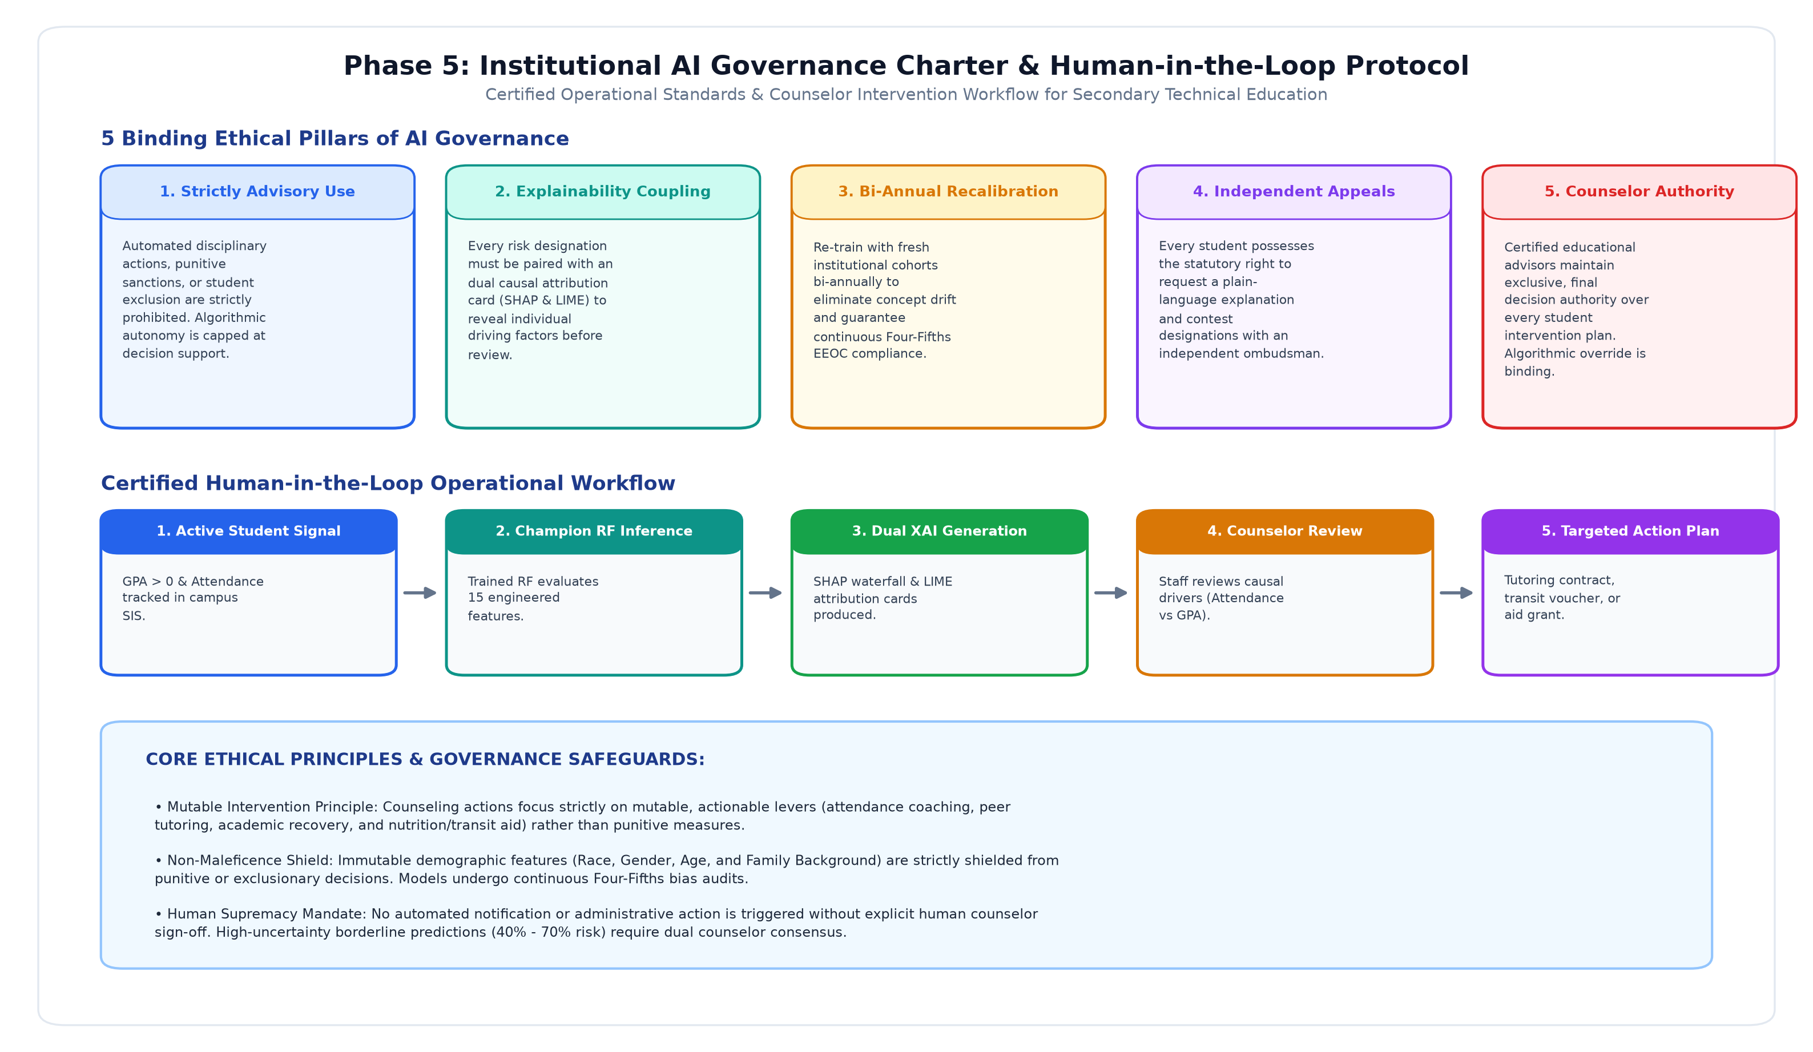
Figure 5.1: Institutional AI Governance Architecture Diagram with Fixed Non-Overlapping Layout. Illustrating End-to-End Pipeline from Data Ingestion to Model Serving, Dual Explainability Interfaces, HITL Human Oversight, Audit Logging, and Feedback Loops.

