


TWEET MANAGEMENT SYSTEM

_
____________
_________________

Title of Project

Data Structure and C++

_____________________________

Subject Name

Submitted By

Tejasvi Maheshwari

Department - BCA

Semester - Second

Session – 2025-26

Project Report of
TWEET MANAGEMENT SYSTEM

Submitted to
Dezyne École College
Towards the Partial Fulfilment of
BCA Second Semester

By
Tejasvi Maheshwari


www.dezyneecole.com
2025-2026

Acknowledgement

We take this opportunity to express our sincere gratitude to Dezyne École College for providing us with the knowledge, resources, and guidance essential to the successful completion of this project.

Our deepest thanks to our respected Principal, Dr. Vinita Mathur, for her visionary leadership and continuous encouragement. Her commitment to academic excellence and student growth has been a constant source of motivation and pride.

We are equally thankful to all our faculty members for their consistent support, expert advice, and valuable insights that shaped our learning and helped us achieve this milestone.

Lastly, we extend heartfelt thanks to everyone who directly or indirectly contributed to the success of this project.

We are proud to be part of Dezyne École College, an institution that truly nurtures professionalism, innovation, and purpose.

With sincere appreciation,
Tejasvi Maheshwari
Department of BCA
Dezyne École College, Ajmer

Contents
1. Introduction 1
2. Theoretical Foundation 2
2.1 Why Linked Lists Matter 2
2.2 What is a Linked List? 2
2.3 Linked List vs Array 2
2.4 Types of Linked Lists 2
3. Data Structure Design 3
3.1 The NODE Class (Singly) 3
3.2 The DNODE Class (Doubly) 3
3.3 List Manager Classes 3
4. Pointer Mechanics — A Deep Dive 4
5. Singly Linked List Walkthrough 5
5.1 Insertion Operations 5
5.1.1 Insert at Beginning 5
5.1.2 Insert at End 5
5.1.3 Insert at Given Position (e.g. position 3) 6
5.2 Traversal & Search 6
5.2.1 Forward Traversal 6
5.2.2 Search by Tweet ID / User Name 6
5.3 Deletion Operations 7
5.3.1 Delete from Beginning 7
5.3.2 Delete from End 8
5.3.3 Delete at Given Position (e.g. position 2) 8
6. Doubly Linked List Walkthrough 10
6.1 Insertion Operations 10
6.1.1 Insert at Beginning 10
6.1.2 Insert at End 10
6.1.3 Insert at Given Position (e.g. position 3) 11
6.2 Forward & Backward Traversal 11
6.2.1 Forward (START → NEXT) 12
6.2.2 Backward (END → PREV) 12
Backward: tail -> prev ... NULL. 12
6.3 Search Operation 12
6.4 Deletion Operations 13
6.4.1 Delete from Beginning 13
6.4.2 Delete from End 14
6.4.3 Delete at Given Position (e.g. position 2) 14
7. Appendix — Source Code 15
7.1 main.cpp 15
Main File Menu 15
7.2 singlyLinkList.hpp 16
SINGLY LINKED LIST OUTPUT UI 24
Singly Main Menu 24
► Insertion Menu 24
1. Insert at Beginning 24
2. Insert at End 25
3. Insert at Position 25
► Deletion Menu 25
1. Delete from Beginning 26
2. Delete from End 26
3. Delete from Position 26
► Searching Menu 27
1. Search Operation 27
► Traversal Menu 27
1. Traversal 27
► Count Menu 28
7.3 DoublyLinkList.hpp 29
DOUBLY LINKED LIST OUTPUT 38
►Doubly Main Menu 38
► Insertion Menu 38
1. Insert at Beginning 38
2. Insert at End 38
3. Insert at Position 39
► Deletion Menu 39
1. Delete from Beginning 39
2. Delete from End 40
3. Delete from Position 40
► Searching Menu 40
1. Search Operation 41
► Traversal Menu 41
1. Forward & Backward Traversal 41
► Count Menu 41

1. Introduction
The Tweet & Data Management System stores tweet records in dynamic memory using two flavours of linked lists. This document is a visual map of how each operation moves bytes on the heap .
Aspect | Details
Project | Tweet & Data Management System
Language | C++ (procedural / class-based)
Data Unit | Tweet → { ID, USERNAME, TWEET }
Structures | Singly Linked List, Doubly Linked List
Operations | Insert, Traverse, Search, Delete, Count

Real-World Context — Twitter Timeline
Twitter's home timeline shows tweets in reverse-chronological order — newest at the top, oldest at the bottom. Three operations dominate this system:
- Insert at head: A new tweet always goes at the very top. This must be instant — O(1).
- Delete from any position: Content moderation removes any tweet immediately — O(1).
- Traverse from head to tail: Displaying the timeline scrolls from newest to oldest — O(n).
These three needs define the Linked List — a data structure that does all three efficiently.

2. Theoretical Foundation

2.1 Why Linked Lists Matter
A tweet feed grows and shrinks unpredictably. Linked lists allocate one node at a time on the heap, so memory cost scales exactly with the number of tweets — no resizing, no shifting.

2.2 What is a Linked List?
A chain of self-referential nodes. Each node carries data plus the address of the next (and, in a doubly list, the previous) node. The chain is anchored by a HEAD pointer; the tail points to NULL.

2.3 Linked List vs Array
Criterion | Array | Linked List
Memory layout | Contiguous block | Scattered nodes on the heap
Size | Fixed at allocation | Grows/shrinks at runtime
Insert / Delete (middle) | O(n) — shift elements | O(1) — re-wire pointers
Random access | O(1) by index | O(n) — must traverse
Memory overhead | None per element | Pointer field per node
Cache locality | Excellent | Poor

2.4 Types of Linked Lists
Type | Pointer Fields | Direction
Singly Linked | NEXT only | Forward only
Doubly Linked | PREV + NEXT | Forward & Backward
Circular Singly | NEXT (tail → head) | Forward, looped
Circular Doubly | PREV + NEXT (looped) | Both, looped

3. Data Structure Design

3.1 The NODE Class (Singly)
class NODE {
public:
string ID; // e.g. "TWEET1001"
string NAME; // user name
string TWEET; // tweet body
NODE *NEXT; // address of next node

NODE(string X, string Y, string Z) {
ID = X; NAME = Y; TWEET = Z;
NEXT = nullptr;
}
};
Memory footprint of one NODE (illustrative):
Field | Type | Role
ID | string | Auto-generated tweet identifier
NAME | string | Author handle
TWEET | string | Tweet payload
NEXT | NODE* | Address of the next node, or nullptr

3.2 The DNODE Class (Doubly)
class DNODE {
public:
DNODE *PREV; // address of previous node
string ID;
string UNAME;
string TWEET;
DNODE *NEXT; // address of next node

DNODE(string X, string Y, string Z) {
PREV = nullptr;
ID = X; UNAME = Y; TWEET = Z;
NEXT = nullptr;
}
};

3.3 List Manager Classes
Class | Owns | Tracks
singlylinklist | NODE* START, *END | CountNode, AutoTID
Doublylinklist | DNODE* START, *END | CountNode, AutoTID

4. Pointer Mechanics — A Deep Dive
A pointer is a variable whose value is the address of another variable. Drawing pointers as arrows hides their true nature: they are integers that index the heap.
Symbol | Means | Example
NODE *p | Declare p as address of a NODE | NODE *p;
new NODE(...) | Allocate node on heap, return its address | p = new NODE(...);
p->NEXT | Field NEXT of the node p points to | p->NEXT = q;
delete p | Free the heap block at address p | delete p;
nullptr | The address "nowhere" (end-of-list) | p->NEXT = nullptr;
Below: the same chain seen as the programmer's mental model (left) and as raw memory addresses (right).
HEAD | → | 0x1002  T1001  Asha  hello | → | 0x1004  T1002  Ravi  hi | → | 0x1006  T1003  Neha  hola | → | NULL

5. Singly Linked List Walkthrough

5.1 Insertion Operations

5.1.1 Insert at Beginning
A new node is created and linked at the head. The previous head becomes the second node.
STATE [PRE] — Memory Heap
HEAD | → | 0x1002  T1001  Asha  hello | → | 0x1004  T1002  Ravi  hi | → | 0x1006  T1003  Neha  hola | → | NULL
ACTION [CODE] — Pointer Reassignment
NODE *TEMP = new NODE(TID, UNAME, UTWEET);
if (START == nullptr) {
END = START = TEMP;
} else {
TEMP->NEXT = START; // new node points to old head
START = TEMP; // head now refers to new node
}
CountNode++; AutoTID++;
RESULT [POST] — Healed Links
HEAD | → | 0x100E  T1004  Kiran  new! | → | 0x1002  T1001  Asha  hello | → | 0x1004  T1002  Ravi  hi | → | 0x1006  T1003  Neha  hola | → | NULL

5.1.2 Insert at End
Traverse to the last node, set its next pointer to the new node.
STATE [PRE] — Memory Heap
HEAD | → | 0x1002  T1001  Asha  hello | → | 0x1004  T1002  Ravi  hi | → | 0x1006  T1003  Neha  hola | → | NULL
ACTION [CODE] — Pointer Reassignment
NODE *TEMP = new NODE(TID, UNAME, UTWEET);
if (START == nullptr) {
END = START = TEMP;
} else {
END->NEXT = TEMP; // current tail links to new node
END = TEMP; // tail pointer advances
}
RESULT [POST] — Healed Links
HEAD | → | 0x1002  T1001  Asha  hello | → | 0x1004  T1002  Ravi  hi | → | 0x1006  T1003  Neha  hola | → | 0x100E  T1004  Kiran  new! | → | NULL

5.1.3 Insert at Given Position (e.g. position 3)
Traverse to position-3, splice the new node between it and the next node.
STATE [PR] — Memory Heap
HEAD | → | 0x1002  T1001  Asha  hello | → | 0x1004  T1002  Ravi  hi | → | 0x1006  T1003  Neha  hola | → | NULL
ACTION [CODE] — Pointer Reassignment
NODE *TEMP1 = START;
for (int i = 2; i < pos; i++) TEMP1 = TEMP1->NEXT;
NODE *TEMP = new NODE(TID, UNAME, UTWEET);
TEMP ->NEXT = TEMP1->NEXT; // new node inherits the rest
TEMP1->NEXT = TEMP; // predecessor adopts new node
RESULT [POST] — Healed Links
HEAD | → | 0x1002  T1001  Asha  hello | → | 0x1004  T1002  Ravi  hi | → | 0x100E  T1004  Kiran  new! | → | 0x1006  T1003  Neha  hola | → | NULL

5.2 Traversal & Search

5.2.1 Forward Traversal
Walk from head to NULL printing each node.
NODE *TEMP = START;
while (TEMP != nullptr) {
cout << "[ " << TEMP->ID << ", "
<< TEMP->NAME << ", " << TEMP->TWEET << " ] -> ";
TEMP = TEMP->NEXT;
}
cout << "Null";
Sample run:
----------Link List----------

Head -> [ TWEET1001 , Asha , hello ] -> [ TWEET1002 , Ravi , hi ] -> [ TWEET1003 , Neha , hola ] -> Null

5.2.2 Search by Tweet ID / User Name
Linear search by Tweet ID or User Name; print matching node.
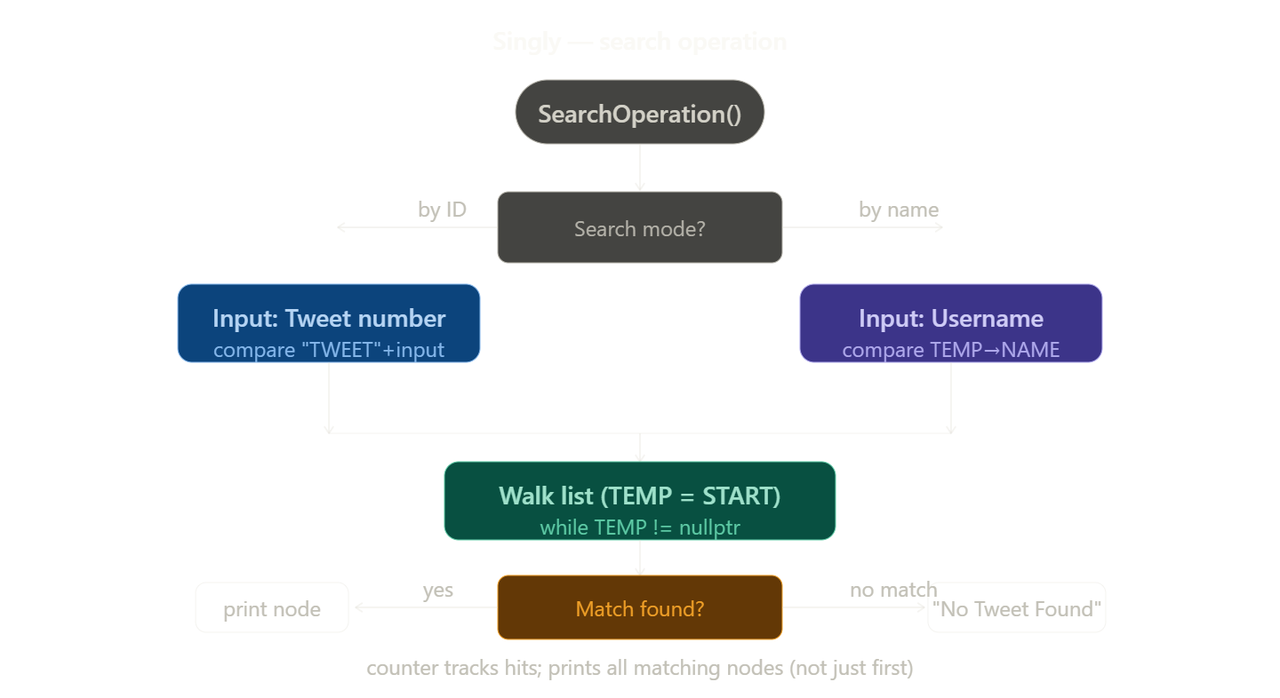
while (TEMP != nullptr) {
if (TEMP->ID == ("TWEET" + TweetID)) {
cout << "[ " << TEMP->ID << " , "
<< TEMP->NAME << " , " << TEMP->TWEET << " ]";
counter++;
}
TEMP = TEMP->NEXT;
}
if (counter == 0) cout << "No Tweet Found";
Search Tweet by Tweet ID----------

Enter Tweet ID to find the Tweet -- 1002

[ TWEET1002 , Ravi , hi ]

5.3 Deletion Operations

5.3.1 Delete from Beginning
Move head to head->next, free the old head node.
STATE [PRE] — Memory Heap
HEAD | → | 0x1002  T1001  Asha  hello | → | 0x1004  T1002  Ravi  hi | → | 0x1006  T1003  Neha  hola | → | NULL
ACTION [CODE] — Pointer Reassignment
TEMP = START;
START = TEMP->NEXT; // head jumps over the old node
delete TEMP; // heap block freed
CountNode--;
RESULT [POST] — Healed Links
HEAD | → | 0x1004  T1002  Ravi  hi | → | 0x1006  T1003  Neha  hola | → | NULL

5.3.2 Delete from End
Walk to second-last node, set its next to NULL, free last node.
STATE [PRE] — Memory Heap
HEAD | → | 0x1002  T1001  Asha  hello | → | 0x1004  T1002  Ravi  hi | → | 0x1006  T1003  Neha  hola | → | NULL
ACTION [CODE] — Pointer Reassignment
TEMP = START;
while (TEMP->NEXT != END) TEMP = TEMP->NEXT; // walk to penultimate
NODE *TEMP1 = END;
TEMP->NEXT = nullptr; // new tail terminates
END = TEMP;
delete TEMP1;
RESULT [POST] — Healed Links
HEAD | → | 0x1002  T1001  Asha  hello | → | 0x1004  T1002  Ravi  hi | → | NULL

5.3.3 Delete at Given Position (e.g. position 2)
Walk to position-2, bypass the target node, free it.
STATE [PRE] — Memory Heap
HEAD | → | 0x1002  T1001  Asha  hello | → | 0x1004  T1002  Ravi  hi | → | 0x1006  T1003  Neha  hola | → | NULL
ACTION [CODE] — Pointer Reassignment
TEMP = START;
for (int i = 2; i < pos; i++) TEMP = TEMP->NEXT;
NODE *TEMP1 = TEMP->NEXT; // node to remove
TEMP->NEXT = TEMP1->NEXT; // bypass it
delete TEMP1;
RESULT [POST] — Healed Links
HEAD | → | 0x1002  T1001  Asha  hello | → | 0x1006  T1003  Neha  hola | → | NULL

6. Doubly Linked List Walkthrough
Each DNODE keeps two pointers, so every edit must mend both directions. The diagrams below use the [ PREV | DATA | NEXT ] motif to make link surgery obvious.

6.1 Insertion Operations

6.1.1 Insert at Beginning
New node becomes head; old head's prev points to it.
STATE [PRE] — Memory Heap
NULL | ⇄ | 0x1002  [ PREV | T1001 | NEXT ]  Asha | ⇄ | 0x1004  [ PREV | T1002 | NEXT ]  Ravi | ⇄ | 0x1006  [ PREV | T1003 | NEXT ]  Neha | ⇄ | NULL
ACTION [CODE] — Pointer Reassignment
DNODE *TEMP = new DNODE(TID, UNAME, UTWEET);
if (START == nullptr) {
END = START = TEMP;
} else {
TEMP ->NEXT = START; // new -> old head
START->PREV = TEMP; // old head -> new
START = TEMP; // head moves
}
RESULT [POST] — Healed Links
NULL | ⇄ | 0x100E  [ PREV | T1004 | NEXT ]  Kiran | ⇄ | 0x1002  [ PREV | T1001 | NEXT ]  Asha | ⇄ | 0x1004  [ PREV | T1002 | NEXT ]  Ravi | ⇄ | 0x1006  [ PREV | T1003 | NEXT ]  Neha | ⇄ | NULL

6.1.2 Insert at End
Walk to last; set last->next = new, new->prev = last.
STATE [PRE] — Memory Heap
NULL | ⇄ | 0x1002  [ PREV | T1001 | NEXT ]  Asha | ⇄ | 0x1004  [ PREV | T1002 | NEXT ]  Ravi | ⇄ | 0x1006  [ PREV | T1003 | NEXT ]  Neha | ⇄ | NULL
ACTION [CODE] — Pointer Reassignment
DNODE *TEMP = new DNODE(TID, UNAME, UTWEET);
if (START == nullptr) {
END = START = TEMP;
} else {
END->NEXT = TEMP; // old tail -> new
TEMP->PREV = END; // new -> old tail
END = TEMP; // tail moves
}
RESULT [POST] — Healed Links
NULL | ⇄ | 0x1002  [ PREV | T1001 | NEXT ]  Asha | ⇄ | 0x1004  [ PREV | T1002 | NEXT ]  Ravi | ⇄ | 0x1006  [ PREV | T1003 | NEXT ]  Neha | ⇄ | 0x100E  [ PREV | T1004 | NEXT ]  Kiran | ⇄ | NULL

6.1.3 Insert at Given Position (e.g. position 3)
Re-wire four pointers: prev<->new and new<->next.
STATE [PRE] — Memory Heap
NULL | ⇄ | 0x1002  [ PREV | T1001 | NEXT ]  Asha | ⇄ | 0x1004  [ PREV | T1002 | NEXT ]  Ravi | ⇄ | 0x1006  [ PREV | T1003 | NEXT ]  Neha | ⇄ | NULL
ACTION [CODE] — Pointer Reassignment
DNODE *TEMP1 = START;
for (int i = 2; i < pos; i++) TEMP1 = TEMP1->NEXT;
DNODE *TEMP = new DNODE(TID, UNAME, UTWEET);
TEMP ->NEXT = TEMP1->NEXT;
TEMP1->NEXT = TEMP;
TEMP ->PREV = TEMP1;
TEMP ->NEXT->PREV = TEMP; // mend the back-link of successor
RESULT [POST] — Healed Links
NULL | ⇄ | 0x1002  [ PREV | T1001 | NEXT ]  Asha | ⇄ | 0x1004  [ PREV | T1002 | NEXT ]  Ravi | ⇄ | 0x100E  [ PREV | T1004 | NEXT ]  Kiran | ⇄ | 0x1006  [ PREV | T1003 | NEXT ]  Neha | ⇄ | NULL

6.2 Forward & Backward Traversal
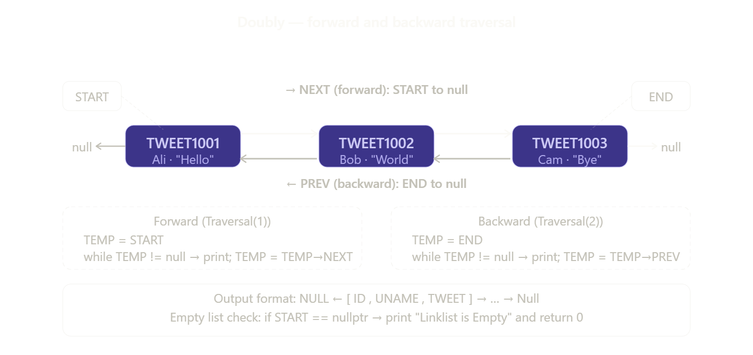

6.2.1 Forward (START → NEXT)
Forward: head -> next ... NULL.
DNODE *TEMP = START;
while (TEMP != nullptr) {
cout << "[ " << TEMP->ID << ", "
<< TEMP->UNAME << ", " << TEMP->TWEET << " ] -> ";
TEMP = TEMP->NEXT;
}
NULL <- [ TWEET1001 , Asha , hello ] -> [ TWEET1002 , Ravi , hi ] -> [ TWEET1003 , Neha , hola ] -> Null

6.2.2 Backward (END → PREV)

Backward: tail -> prev ... NULL.
DNODE *TEMP = END;
while (TEMP != nullptr) {
cout << "[ " << TEMP->ID << ", "
<< TEMP->UNAME << ", " << TEMP->TWEET << " ] -> ";
TEMP = TEMP->PREV;
}
NULL <- [ TWEET1003 , Neha , hola ] -> [ TWEET1002 , Ravi , hi ] -> [ TWEET1001 , Asha , hello ] -> Null

6.3 Search Operation
Search walks forward from START, comparing against TweetID or username. Identical to the singly version, but operates on DNODE.
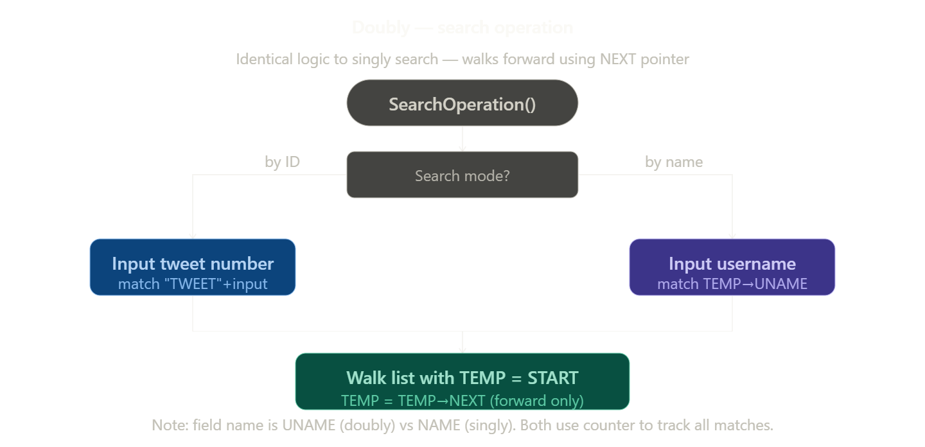
while (TEMP != nullptr) {
if (TEMP->UNAME == uname) {
cout << "[ " << TEMP->ID << ", "
<< TEMP->UNAME << ", " << TEMP->TWEET << " ]";
counter++;
}
TEMP = TEMP->NEXT;
}

6.4 Deletion Operations

6.4.1 Delete from Beginning
head = head->next; head->prev = NULL; free old head.
STATE [PRE] — Memory Heap
NULL | ⇄ | 0x1002  [ PREV | T1001 | NEXT ]  Asha | ⇄ | 0x1004  [ PREV | T1002 | NEXT ]  Ravi | ⇄ | 0x1006  [ PREV | T1003 | NEXT ]  Neha | ⇄ | NULL
ACTION [CODE] — Pointer Reassignment
TEMP = START;
START = TEMP->NEXT;
START->PREV = nullptr; // new head has no predecessor
delete TEMP;
RESULT [POST] — Healed Links
NULL | ⇄ | 0x1004  [ PREV | T1002 | NEXT ]  Ravi | ⇄ | 0x1006  [ PREV | T1003 | NEXT ]  Neha | ⇄ | NULL

6.4.2 Delete from End
STATE [PRE] — Memory Heap
Walk to last; last->prev->next = NULL; free last.
NULL | ⇄ | 0x1002  [ PREV | T1001 | NEXT ]  Asha | ⇄ | 0x1004  [ PREV | T1002 | NEXT ]  Ravi | ⇄ | 0x1006  [ PREV | T1003 | NEXT ]  Neha | ⇄ | NULL
ACTION [CODE] — Pointer Reassignment
TEMP = END;
END = END->PREV; // tail steps back
END->NEXT = nullptr; // terminate the chain
delete TEMP;
RESULT [POST] — Healed Links
NULL | ⇄ | 0x1002  [ PREV | T1001 | NEXT ]  Asha | ⇄ | 0x1004  [ PREV | T1002 | NEXT ]  Ravi | ⇄ | NULL

6.4.3 Delete at Given Position (e.g. position 2)
STATE [PRE] — Memory Heap
Re-wire prev->next and next->prev around the target, free target.
NULL | ⇄ | 0x1002  [ PREV | T1001 | NEXT ]  Asha | ⇄ | 0x1004  [ PREV | T1002 | NEXT ]  Ravi | ⇄ | 0x1006  [ PREV | T1003 | NEXT ]  Neha | ⇄ | NULL
ACTION [CODE] — Pointer Reassignment
TEMP = START;
for (int i = 1; i < pos; i++) TEMP = TEMP->NEXT;
TEMP->PREV->NEXT = TEMP->NEXT; // bridge forward link
TEMP->NEXT->PREV = TEMP->PREV; // bridge backward link
delete TEMP;
RESULT [POST] — Healed Links
NULL | ⇄ | 0x1002  [ PREV | T1001 | NEXT ]  Asha | ⇄ | 0x1006  [ PREV | T1003 | NEXT ]  Neha | ⇄ | NULL

7. Appendix — Source Code

7.1 main.cpp
#include "singlyLinkList.hpp"
#include "DoublyLinkList.hpp"
int main()
{
singlylinklist sl;
Doublylinklist dl;
while (true)
{
system("cls");
cout<<"\n\n==============Main Link List Menu==============\n";
cout<<"1.Singly Link List\n";
cout<<"2.Doubly Link List\n";
cout<<"3.Exit\n";
char c = getch();
if(c == '1'){
sl.MainMenu();
}else if (c == '2'){
dl.MainMenu();
}else if (c == '3'){
break;
}
}
cout<<"\n\nThank you for using my Application...\n\n";
return 0;
}

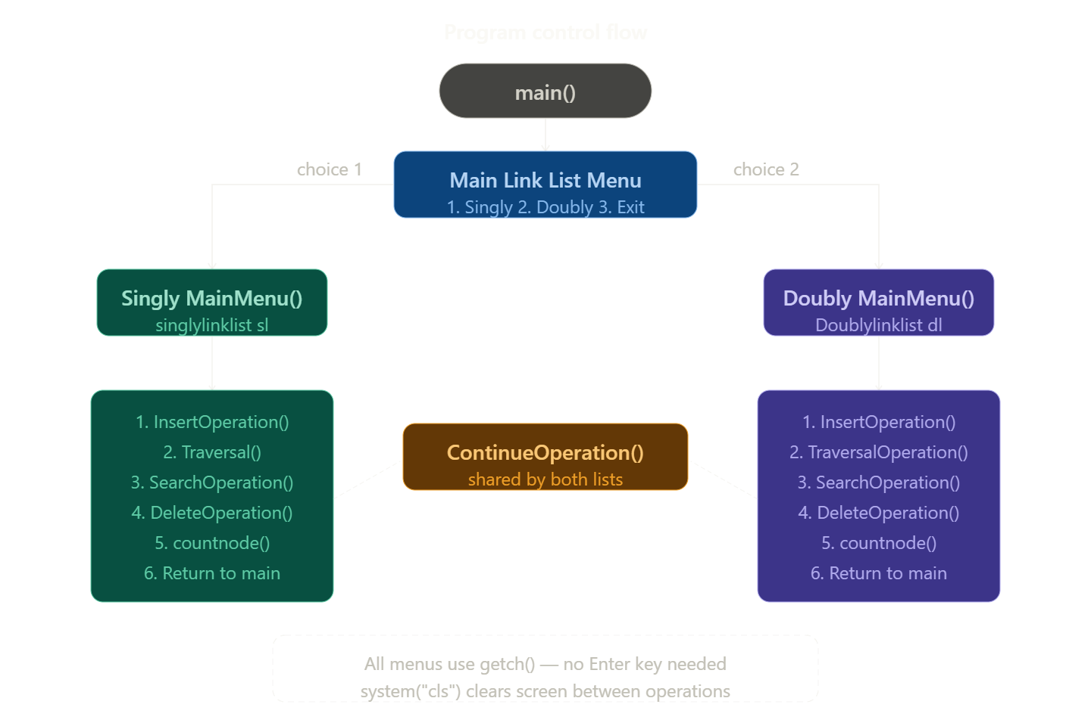

Main File Menu
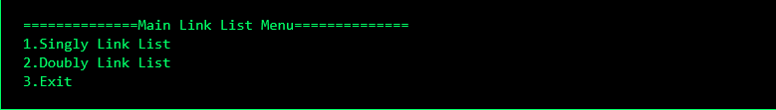

7.2 singlyLinkList.hpp
#include<iostream>
#include<conio.h>
#include<string>
using namespace std;
class NODE
{
public:
string ID;
string NAME;
string TWEET;
NODE *NEXT ;

NODE(string X , string Y , string Z)
{
ID = X;
NAME = Y;
TWEET = Z;
NEXT = nullptr;
}
};
class singlylinklist
{
public:
string TID;
string UNAME;
string UTWEET;
int CountNode;
int AutoTID;
NODE *START , *END ;
singlylinklist()
{
AutoTID=1001;
CountNode=0;
START=nullptr;
END=nullptr;
}

//Get Data
void getdata()
{
TID = "TWEET" + to_string(AutoTID);
cout<<"\nEnter TID :-"<<TID<<endl;
cout<<"Enter User Name :- ";
getline(cin,UNAME);
cout<<"Enter Tweet :- ";
getline(cin,UTWEET);
}

//Insert Operation
void InsertOperation()
{
system("cls");
cout<<"\n==============Insertion Opertaion==============\n";
cout<<"1.Insert at Beggining\n";
cout<<"2.Insert at End\n";
cout<<"3.Insert at given Position\n";
cout<<"4.Go to Main Menu\n";
cout<<"5.Exit\n";
char c = getch();
if(c == '1'){
InsertNode(1);
}else if (c == '2'){
InsertNode(2);
}else if (c == '3'){
InsertNode(3);
}else if (c == '4'){
MainMenu();
}else if (c == '5'){
thankyouLine();
exit(0);
}
}

//Insert Module
int InsertNode(int x)
{
system("cls");
if(x == 1){
cout<<"----------Insertion at Beggining----------\n";
getdata();
NODE *TEMP = new NODE(TID,UNAME,UTWEET);
if (TEMP == nullptr){
cout<<"Insufficient Memory\n";
return 0;
}
if(START == nullptr){
END = START = TEMP;
}else {
TEMP->NEXT = START;
START = TEMP;
}
CountNode++;
AutoTID++;
}else if (x == 2){
cout<<"----------Insertion at End----------\n";
getdata();
NODE *TEMP = new NODE(TID,UNAME,UTWEET);
if (TEMP == nullptr){
cout<<"Insufficient Memory\n";
return 0;
}
if(START == nullptr){
END = START = TEMP;
}else {
END->NEXT = TEMP;
END = TEMP;
}
CountNode++;
AutoTID++;
}else if (x == 3){
cout<<"----------Insertion at given Position----------\n";
cout<<"Total Number of Nodes Are -- "<<CountNode<<endl;
int pos;
cout<<"Enter Position Between 0 and "<<CountNode<<" - ";
cin>>pos;
cin.ignore();
getdata();
NODE *TEMP = new NODE(TID,UNAME,UTWEET);
if (TEMP == nullptr){
cout<<"Insufficient Memory";
return 0;
}
int i ;
NODE *TEMP1 = START;
for(i = 2 ; i < pos ; i++){
TEMP1 = TEMP1->NEXT;
}
if(START == nullptr){
END = START = TEMP;
}else {
TEMP->NEXT = TEMP1->NEXT;
TEMP1->NEXT=TEMP;
if (TEMP1 == END){
END = TEMP1->NEXT;
}
}
CountNode++;
AutoTID++;
}
char c = ContinueOperation();
if(c == '1'){
InsertNode(x);
}else if(c == '2'){
InsertOperation();
}else if(c == '3'){
MainMenu();
}

}

//Show Module
void Traversal()
{
system("cls");
cout<<"\n----------Link List----------\n\n";
cout<<"Head -> ";
NODE *TEMP = START;
if ( START == nullptr){
cout<<"NULL \n\nLinklist is Empty";
}
else {
while(TEMP != nullptr){
cout<<"[ "<<TEMP->ID<<" , ";
cout<<TEMP->NAME<<" , ";
cout<<TEMP->TWEET<<" ] -> ";
TEMP=TEMP->NEXT;
}
cout<<"Null";
}
cout<<"\n\nDo you want to -- \n";
cout<<"1.Continue the Same\n";
cout<<"2.Go to Main Menu\n";
cout<<"3.Exit\n";
char c = getch();
if(c == '1'){
Traversal();
}else if(c == '2'){
MainMenu();
}else if(c == '3'){
thankyouLine();
exit(0);
}
}
//Search Operation
void SearchOperation()
{
system("cls");
cout<<"==============Search Module==============\n\n";
cout<<"1.Search by Tweet ID \n";
cout<<"2.Search by User Name \n";
cout<<"3.Main Menu \n";
cout<<"4.Exit\n";
char c = getch();
if(c == '1'){
searchNode(1);
}else if(c == '2'){
searchNode(2);
}else if(c == '3'){
MainMenu();
}else if(c == '4'){
exit(0);
}
}

//Search Module
int searchNode(int x)
{
system("cls");
if (x == 1){
cout<<"Search Tweet by Tweet ID----------\n\n";
NODE *TEMP = START;
if (START == nullptr){
cout<<"Head -> Null \n\nLink List is Empty...";
return 0;
}else{
int counter=0;
cout<<"Enter Tweet ID to find the Tweet -- ";
string TweetID;
getline(cin,TweetID);
while (TEMP != nullptr){
if(TEMP->ID == ("TWEET" + TweetID)){
cout<<"\n[ "<<TEMP->ID<<" , ";
cout<<TEMP->NAME<<" , ";
cout<<TEMP->TWEET<<" ]\n";
counter++;
}
TEMP = TEMP->NEXT;
}
if(counter == 0){
cout<<"\nNo Tweet Found\n\n";
}
}
}
else if(x == 2){
cout<<"----------Search Tweet by User Name----------\n\n";

NODE *TEMP = START;
if (START == nullptr){
cout<<"Head -> Null \n\nLink List is Empty...";
return 0;
}else{
int counter=0 ;
cout<<"Enter user Name to find the Tweet -- ";
string uname;
getline(cin,uname);
cout<<endl<<"Head -> ";
while (TEMP != nullptr){
if(TEMP->NAME == uname){
cout<<"\n[ "<<TEMP->ID<<" , ";
cout<<TEMP->NAME<<" , ";
cout<<TEMP->TWEET<<" ]\n";
counter++;
}
TEMP = TEMP->NEXT;
}
if(counter == 0){
cout<<"\nNo Tweet Found\n\n";
}
}
}
cout<<"Do you want to -- \n";
cout<<"1.Continue the Same\n";
cout<<"2.Go to Main Menu\n";
cout<<"3.Exit\n";
char c = getch();
if(c == '1'){
searchNode(x);
}else if(c == '2'){
MainMenu();
}else if(c == '3'){
thankyouLine();
exit(0);
}
}

//Delete Operation
void DeleteOperation()
{
system("cls");
cout<<"\n==============Deletion Opertaion==============\n";
cout<<"1.Delete from Beggining\n";
cout<<"2.Delete from End\n";
cout<<"3.delete from a given Position\n";
cout<<"4.Go to Main Menu\n";
cout<<"5.Exit\n";
char c = getch();
if(c == '1'){
DeleteNode(1);
}else if (c == '2'){
DeleteNode(2);
}else if (c == '3'){
DeleteNode(3);
}else if (c == '4'){
MainMenu();
}else if (c == '5'){
thankyouLine();
exit(0);
}
}

//Delete Module
int DeleteNode(int x)
{
system("cls");
NODE *TEMP ;
if(x == 1){
cout<<"----------Delete from Beggining----------\n";
if(START == nullptr)
{
cout<<"Link List is Empty...\n\n";
return 0;
}
else if (START->NEXT == nullptr)
{
TEMP = START;
END = START = nullptr;
}else
{
TEMP = START;
START = TEMP->NEXT;
}

CountNode--;
delete(TEMP);
cout<<"Node Deleted Successfully...\n";

}
else if (x == 2)
{
cout<<"----------Delete from End----------\n";
if(START == nullptr)
{
cout<<"Link List is Empty...\n\n";
return 0;
}
else if (START->NEXT == nullptr)
{
TEMP = START;
END = START = nullptr;
}
else
{
TEMP = START ;
while(TEMP->NEXT != END){
TEMP = TEMP->NEXT;
}
NODE *TEMP1 = END;
TEMP->NEXT = nullptr;
END = TEMP;
delete(TEMP1);
}
CountNode--;
cout<<"Node Deleted Successfully...\n";
}
else if (x == 3)
{
cout<<"\n----------Delete from given Position----------\n";
if (START == nullptr){
cout<<"Link List is Empty...\n\n";
return 0;
}
int pos ,i;
cout<<"Enter Position Between 1 and "<<CountNode<<"- ";
cin>>pos;
if (pos == 1 && START==END){
TEMP = START ;
END = START = nullptr;
}
else{
TEMP =START;
for(i = 2 ; i < pos ; i++){
TEMP = TEMP->NEXT;
}
if(TEMP->NEXT == END){
NODE *TEMP1 = END;
TEMP->NEXT = nullptr;
END = TEMP;
}else{
NODE *TEMP1 = TEMP->NEXT;
TEMP->NEXT = TEMP1->NEXT;
delete(TEMP1);
}
}
CountNode--;
cout<<"\nNode Deleted Successfully...\n";
}
char c = ContinueOperation();
if(c == '1'){
DeleteNode(x);
}else if(c == '2'){
DeleteOperation();
}else if(c == '3'){
MainMenu();
}

}

//Continue Menu
int ContinueOperation()
{
cout<<"\nDo you want to -- \n";
cout<<"1.Continue the Same\n";
cout<<"2.Go to Previous Menu\n";
cout<<"3.Go to Main Menu\n";
cout<<"4.Exit\n";
char c = getch();
if(c == '4'){
thankyouLine();
exit(0);
}else {
return(c);
}
}

//Count Node Module
void countnode()
{
system("cls");
cout<<"\n==============Count Node Module==============\n\n";
cout<<"Total Number of Nodes -- "<<CountNode<<" Available Nodes\n\n";
cout<<"Do you want to -- \n";
cout<<"1.Continue the Same\n";
cout<<"2.Go to Main Menu\n";
cout<<"3.Exit\n";
char c = getch();
if(c == '1'){
countnode();
}else if(c == '2'){
MainMenu();
}else if(c == '3'){
exit(0);
}
}
//MAIN MENU
void MainMenu()
{
system("cls");
cout<<"\n==============Singly LinkList Operations==============\n";
cout<<"1.Insertion Operation\n";
cout<<"2.Traversal Operation\n";
cout<<"3.Search Operation\n";
cout<<"4.Delete Operation\n";
cout<<"5.Count Node\n";
cout<<"6.Go To Main Link List Menu\n\n";
cout<<"Choose one of Them -- ";
char c = getch();
if(c == '1'){
InsertOperation();
}else if (c == '2'){
Traversal();
}else if (c == '3'){
SearchOperation();
}else if (c == '4'){
DeleteOperation();
}else if (c == '5'){
countnode();
}else if (c == '6'){
cout << "\n\nThank you for using my Singly Link List Operations...\n\n";
return;
}
}

void thankyouLine()
{
cout<<"\n\nThank you for using my Application...\n\n";
}

};

SINGLY LINKED LIST OUTPUT UI

Singly Main Menu
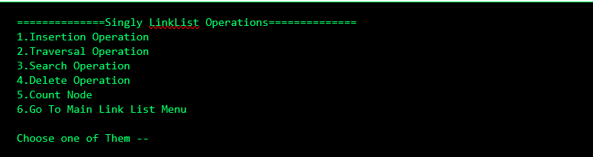

► Insertion Menu
==========Insertion Opertaion===========
1.Insert at Beggining0
2.Insert at End
3.Insert at given Position
4.Go to Main Menu
5.Exit
Choose one of Them --

1. Insert at Beginning
A new node is created and linked at the head. The previous head becomes the second node.
==========Insertion Opertaion===========
1.Insert at Beggining
2.Insert at End
3.Insert at given Position
4.Go to Main Menu
5.Exit
Choose one of Them -- 1

--------Insertion at Beggining--------
Enter TID :-TWEET1001
Enter User Name :- Tejasvi
Enter Tweet :- MY name is Tejasvi

Node Inserted at Beginning Successfully...

Do you want to --
1.Continue the Same
2.Go to Previous Menu
3.Go to Main Menu
4.Exit

2. Insert at End
Traverse to the last node, set its next pointer to the new node.
--------Insertion at End--------
Enter TID :-TWEET1002
Enter User Name :- Aarav
Enter Tweet :- Hello World

Node Inserted at End Successfully...

Do you want to --
1.Continue the Same
2.Go to Previous Menu
3.Go to Main Menu
4.Exit

3. Insert at Position
Traverse to position-1, splice the new node between it and the next node.
--------Insertion at given Position--------
Total Number of Nodes Are -- 0
Enter Position Between 0 and 0- 0

Enter TID :-TWEET1001
Enter User Name :- Tejasvi
Enter Tweet :- How are you?

Node Inserted at Position Successfully...

Do you want to --
1.Continue the Same
2.Go to Previous Menu
3.Go to Main Menu
4.Exit

► Deletion Menu
==========Deletion Opertaion==========
1.Delete from Beggining
2.Delete from End
3.delete from a given Position
4.Go to Main Menu
5.Exit
Choose one of Them --

1. Delete from Beginning
Move head to head->next, free the old head node.
--------Delete from Beggining--------

Node Deleted Successfully...

Do you want to --
1.Continue the Same
2.Go to Previous Menu
3.Go to Main Menu
4.Exit

2. Delete from End
Walk to second-last node, set its next to NULL, free last node.
--------Delete from End--------

Node Deleted Successfully...

Do you want to --
1.Continue the Same
2.Go to Previous Menu
3.Go to Main Menu
4.Exit

3. Delete from Position
Walk to position-1, bypass the target node, free it.
--------Delete from given Position--------
Enter Position Between 1 and 1- 1

Node Deleted Successfully...

Do you want to --
1.Continue the Same
2.Go to Previous Menu
3.Go to Main Menu
4.Exit

► Searching Menu
============Search Module============
1.Search by Tweet ID
2.Search by User Name
3.Main Menu
4.Exit
Choose one of Them --

1. Search Operation
Linear search by Tweet ID or User Name; print matching node.
============Search Module============
1.Search by Tweet ID
2.Search by User Name
3.Main Menu
4.Exit
Choose one of Them -- 1

---------Search Tweet by Tweet ID---------
Enter Tweet ID to find the Tweet -- 1001

[ TWEET1001 , Tejasvi , How are you? ]

Do you want to --
1.Continue the Same
2.Go to Main Menu
3.Exit

► Traversal Menu
--------Link List--------
Head -> [ TWEET1001 , Tejasvi , How are you? ] -> Null

Do you want to --
1.Continue the Same
2.Go to Main Menu
3.Exit

1. Traversal
Walk from head to NULL printing each node.
--------Link List--------
Head -> [ TWEET1001 , Tejasvi , How are you? ] -> Null

Do you want to --
1.Continue the Same
2.Go to Main Menu
3.Exit

► Count Menu
==========Count Node Module==========

Total Number of Nodes -- 1 Available Nodes

Do you want to --
1.Continue the Same
2.Go to Main Menu
3.Exit

7.3 DoublyLinkList.hpp
#include<iostream>
#include<conio.h>
#include<string>
using namespace std;
class DNODE
{
public:
DNODE *PREV ;
string ID;
string UNAME;
string TWEET;
DNODE *NEXT ;
DNODE(string X , string Y , string Z)
{
PREV = nullptr;
ID = X;
UNAME = Y;
TWEET = Z;
NEXT = nullptr;
}
};
class Doublylinklist
{
public:
string TID;
string UNAME;
string UTWEET;
int CountNode;
int AutoTID;
DNODE *START , *END ;
Doublylinklist()
{
AutoTID=1001;
CountNode=0;
START=nullptr;
END=nullptr;
}

//Get Data
void getdata()
{
TID = "TWEET" + to_string(AutoTID);
cout<<"Enter TID :-"<<TID<<endl;
cout<<"Enter User Name :- ";
getline(cin,UNAME);
cout<<"Enter Tweet :- ";
getline(cin,UTWEET);
}

//Insertion Operation
void InsertOperation()
{
system("cls");
cout<<"==============Insertion Opertaion==============\n";
cout<<"1.Insert at Beggining\n";
cout<<"2.Insert at End\n";
cout<<"3.Insert at given Position\n";
cout<<"4.Go to Main Menu\n";
cout<<"5.Exit\n";
char c = getch();
if(c == '1'){
InsertNode(1);
}else if (c == '2'){
InsertNode(2);
}else if (c == '3'){
InsertNode(3);
}else if (c == '4'){
MainMenu();
}else if (c == '5'){
thankyouLine();
exit(0);
}
}

//Insert Module
int InsertNode(int x)
{
system("cls");
if(x == 1){
cout<<"----------Insertion at Beggining----------\n";
getdata();
DNODE *TEMP = new DNODE(TID,UNAME,UTWEET);
if (TEMP == nullptr){
cout<<"Insufficient Memory\n";
return 0;
}
if(START == nullptr){
END = START = TEMP;
}else {
TEMP->NEXT = START;
START->PREV = TEMP;
START = TEMP;
}
CountNode++;
AutoTID++;
}else if (x == 2){
cout<<"----------Insertion at End----------\n";
getdata();
DNODE *TEMP = new DNODE(TID,UNAME,UTWEET);
if (TEMP == nullptr){
cout<<"Insufficient Memory\n";
return 0;
}
if(START == nullptr){
END = START = TEMP;
}else {
END->NEXT = TEMP;
TEMP->PREV = END;
END = TEMP;
}
CountNode++;
AutoTID++;
}else if (x == 3){
cout<<"----------Insertion at given Position----------\n";
cout<<"Total Number of Nodes Are -- "<<CountNode<<endl;
int pos;
getdata();
cout<<"Enter Position Between 0 and "<<CountNode<<"- ";
cin>>pos;
DNODE *TEMP = new DNODE(TID,UNAME,UTWEET);
if (TEMP == nullptr){
cout<<"Insufficient Memory";
return 0;
}
int i ;
DNODE *TEMP1 = START;
for(i = 2 ; i < pos ; i++){
TEMP1 = TEMP1->NEXT;
}
if(START == nullptr){
END = START = TEMP;
}else {
TEMP->NEXT = TEMP1->NEXT;
TEMP1->NEXT=TEMP;
TEMP->PREV = TEMP1;//!this is the question
TEMP->NEXT->PREV =TEMP;//!this is the question
if (TEMP1 == END){
END = TEMP1->NEXT;
}
}
CountNode++;
AutoTID++;
}
char c = ContinueOperation();
if(c == '1'){
InsertNode(x);
}else if(c == '2'){
InsertOperation();
}else if(c == '3'){
MainMenu();
}

}

//Traversal Module
void TraversalOperation()
{
system("cls");
cout<<"==============Traversal Module==============\n\n";
cout<<"1.Forward Traversal \n";
cout<<"2.Backward Traversal \n";
cout<<"3.Main Menu \n";
cout<<"4.Exit\n\n";
char c = getch();
if(c == '1'){
Traversal(1);
}else if(c == '2'){
Traversal(2);
}else if(c == '3'){
MainMenu();
}else if(c == '4'){
exit(0);
}
}

//Show Module
int Traversal(int x)
{
system("cls");
if(x == 1){
cout<<"\n\n----------Link List----------\n\n";
cout<<"NULL <- ";
DNODE *TEMP = START;
if ( START == nullptr){
cout<<"NULL \n\nLinklist is Empty";
return 0;
}
else {
while(TEMP != nullptr){
cout<<"[ "<<TEMP->ID<<" , ";
cout<<TEMP->UNAME<<" , ";
cout<<TEMP->TWEET<<" ] -> ";
TEMP=TEMP->NEXT;
}
cout<<"Null";
}
} else if(x == 2){
cout<<"\n\n----------Link List----------\n\n";
cout<<"NULL <- ";
DNODE *TEMP = END;
if ( START == nullptr){
cout<<"NULL \n\nLinklist is Empty";
}
else {
while(TEMP != nullptr){
cout<<"[ "<<TEMP->ID<<" , ";
cout<<TEMP->UNAME<<" , ";
cout<<TEMP->TWEET<<" ] -> ";
TEMP=TEMP->PREV;
}
cout<<"Null";
}
}
cout<<"\n\nDo you want to -- \n";
cout<<"1.Continue the Same\n";
cout<<"2.Go to Main Menu\n";
cout<<"3.Exit";
char c = getch();
if(c == '1'){
Traversal(x);
}else if(c == '2'){
MainMenu();
}else if(c == '3'){
thankyouLine();
exit(0);
}
}

//Search Operation
void SearchOperation()
{
system("cls");
cout<<"==============Search Module==============\n\n";
cout<<"1.Search by Tweet ID \n";
cout<<"2.Search by User Name \n";
cout<<"3.Main Menu \n";
cout<<"4.Exit\n\n";
char c = getch();
if(c == '1'){
searchNode(1);
}else if(c == '2'){
searchNode(2);
}else if(c == '3'){
MainMenu();
}else if(c == '4'){
exit(0);
}
}

//Search Module
int searchNode(int x)
{
system("cls");
if (x == 1){
cout<<"----------Search Tweet by Tweet ID----------\n\n";
DNODE *TEMP = START;
if (START == nullptr){
cout<<"Head -> Null \n\nLink List is Empty...";
return 0;
}else{
int counter=0;
cout<<"Enter Tweet ID to find the Tweet -- ";
string TweetID;
getline(cin,TweetID);
while (TEMP != nullptr){
if(TEMP->ID == ("TWEET" + TweetID)){
cout<<"\n[ "<<TEMP->ID<<" , ";
cout<<TEMP->UNAME<<" , ";
cout<<TEMP->TWEET<<" ]\n";
counter++;
}
TEMP = TEMP->NEXT;
}
if(counter == 0){
cout<<"\nNo Tweet Found\n\n";
}
}
}
else if(x == 2){
cout<<"----------Search Tweet by User Name----------\n\n";

DNODE *TEMP = START;
if (START == nullptr){
cout<<"Head -> Null \n\nLink List is Empty...";
return 0;
}else{
int counter=0 ;
cout<<"Enter user Name to find the Tweet -- ";
string uname;
getline(cin,uname);
cout<<endl<<"Head -> ";
while (TEMP != nullptr){
if(TEMP->UNAME == uname){
cout<<"\n[ "<<TEMP->ID<<" , ";
cout<<TEMP->UNAME<<" , ";
cout<<TEMP->TWEET<<" ]\n";
counter++;
}
TEMP = TEMP->NEXT;
}
if(counter == 0){
cout<<"\nNo Tweet Found\n\n";
}
}
}
cout<<"Do you want to -- \n";
cout<<"1.Continue the Same\n";
cout<<"2.Go to Main Menu\n";
cout<<"3.Exit\n";
char c = getch();
if(c == '1'){
searchNode(x);
}else if(c == '2'){
MainMenu();
}else if(c == '3'){
thankyouLine();
exit(0);
}
}

//Delete Operation
void DeleteOperation()
{
system("cls");
cout<<"==============Deletion Opertaion==============\n\n";
cout<<"1.Delete from Beggining\n";
cout<<"2.Delete from End\n";
cout<<"3.delete from a given Position\n";
cout<<"4.Go to Main Menu\n";
cout<<"5.Exit\n";
char c = getch();
if(c == '1'){
DeleteNode(1);
}else if (c == '2'){
DeleteNode(2);
}else if (c == '3'){
DeleteNode(3);
}else if (c == '4'){
MainMenu();
}else if (c == '5'){
thankyouLine();
exit(0);
}
}
//Delete Module
int DeleteNode(int x)
{
system("cls");
DNODE *TEMP ;
if(x == 1){
cout<<"----------Delete from Beggining----------\n";
if(START == nullptr)
{
cout<<"Link List is Empty...\n\n";
return 0;
}
else if (START->NEXT == nullptr)
{
TEMP = START;
END = START = nullptr;
}else
{
TEMP = START;
START = TEMP->NEXT;
START->PREV = nullptr;
}

CountNode--;
delete(TEMP);
cout<<"\nNode Deleted Successfully...\n";

}
else if (x == 2)
{
cout<<"----------Delete from End----------\n";
if(START == nullptr)
{
cout<<"Link List is Empty...\n\n";
return 0;
}
else if (START->NEXT == nullptr)
{
TEMP = START;
END = START = nullptr;
}
else
{
TEMP = END;
END = END->PREV;
END->NEXT=nullptr;
/*!
TEMP=END;
TEMP->PREV->NEXT=NULLPTR;
END=TEMP->PREV;
*/
delete(TEMP);
}
CountNode--;
cout<<"\nNode Deleted Successfully...";
}
else if (x == 3)
{
cout<<"\n\n----------Delete from given Position----------\n";
if (START == nullptr){
cout<<"Link List is Empty...\n\n";
return 0;
}
int pos ,i;
cout<<"Enter Position Between 1 and "<<CountNode<<"- ";
cin>>pos;
if (pos == 1 && START==END){
TEMP = START ;
END = START = nullptr;
}
else{
TEMP =START;
for(i = 1 ; i < pos ; i++){
TEMP = TEMP->NEXT;
}
if(TEMP == END){
TEMP->PREV->NEXT = nullptr;
END = TEMP->PREV;
delete(TEMP);
}else{
TEMP->PREV->NEXT = TEMP->NEXT;
TEMP->NEXT->PREV = TEMP->PREV;
delete(TEMP);
}
}
CountNode--;
cout<<"Node Deleted Successfully...";
}
char c = ContinueOperation();
if(c == '1'){
DeleteNode(x);
}else if(c == '2'){
InsertOperation();
}else if(c == '3'){
MainMenu();
}

}

//Continue Module
int ContinueOperation()
{
cout<<"Do you want to -- \n";
cout<<"1.Continue the Same\n";
cout<<"2.Go to Previous Menu\n";
cout<<"3.Go to Main Menu\n";
cout<<"4.Exit";
char c = getch();
if(c == '4'){
thankyouLine();
exit(0);
}else {
return(c);
}
}

//Count Node Module
void countnode()
{
system("cls");
cout<<"==============Count Node Module==============";
cout<<"\n\nTotal Number of Nodes -- "<<CountNode<<"Available Nodes\n\n";
cout<<"Do you want to -- \n";
cout<<"1.Continue the Same\n";
cout<<"2.Go to Main Menu\n";
cout<<"3.Exit";
char c = getch();
if(c == '1'){
countnode();
}else if(c == '2'){
MainMenu();
}else if(c == '3'){
exit(0);
}
}
//Main Menu
void MainMenu()
{
system("cls");
cout<<"==============Doubly LinkList Operations===========\n";
cout<<"1.Insertion Operation\n";
cout<<"2.Traversal Operation\n";
cout<<"3.Search Operation\n";
cout<<"4.Delete Operation\n";
cout<<"5.Count Node\n";
cout<<"6.Go To Main Link List Menu\n\n";
char c = getch();
if(c == '1'){
InsertOperation();
}else if (c == '2'){
TraversalOperation();
}else if (c == '3'){
SearchOperation();
}else if (c == '4'){
DeleteOperation();
}else if (c == '5'){
countnode();
}else if (c == '6'){
cout << "\n\nThank you for using my Doubly Link List Operations...\n\n";
return;
}
}

void thankyouLine()
{
cout<<"\n\nThank you for using my Application...\n\n";
}
};

DOUBLY LINKED LIST OUTPUT

►Doubly Main Menu
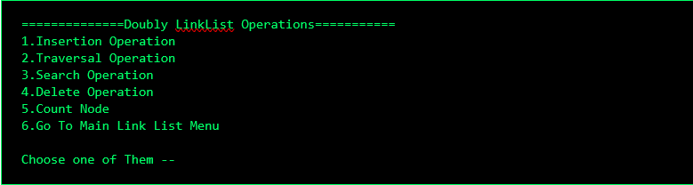

► Insertion Menu
============Insertion Opertaion============
1.Insert at Beggining
2.Insert at End
3.Insert at given Position
4.Go to Main Menu
5.Exit
Choose one of Them --

1. Insert at Beginning
New node becomes head; old head's prev points to it.
============Insertion Opertaion============
1.Insert at Beggining
2.Insert at End
3.Insert at given Position
4.Go to Main Menu
5.Exit
Choose one of Them -- 1

---------Insertion at Beggining---------
Enter TID :-TWEET1001
Enter User Name :- Tejasvi
Enter Tweet :- MY name is Tejasvi

Node Inserted at Beginning Successfully...

Do you want to --
1.Continue the Same
2.Go to Previous Menu
3.Go to Main Menu
4.Exit

2. Insert at End
Walk to last; set last->next = new, new->prev = last.
---------Insertion at End---------
Enter TID :-TWEET1002
Enter User Name :- Aarav
Enter Tweet :- Doubly node added

Node Inserted at End Successfully...

Do you want to --
1.Continue the Same
2.Go to Previous Menu
3.Go to Main Menu
4.Exit

3. Insert at Position
Re-wire four pointers: prev<->new and new<->next.
---------Insertion at given Position---------
Total Number of Nodes Are -- 1
Enter Position Between 1 and 2- 2

Enter TID :-TWEET1003
Enter User Name :- Riya
Enter Tweet :- Inserted at pos 2

Node Inserted at Position Successfully...

Do you want to --
1.Continue the Same
2.Go to Previous Menu
3.Go to Main Menu
4.Exit

► Deletion Menu
============Deletion Opertaion============
1.Delete from Beggining
2.Delete from End
3.delete from a given Position
4.Go to Main Menu
5.Exit
Choose one of Them --

1. Delete from Beginning
head = head->next; head->prev = NULL; free old head.
---------Delete from Beggining---------

Node Deleted Successfully...

Do you want to --
1.Continue the Same
2.Go to Previous Menu
3.Go to Main Menu
4.Exit

2. Delete from End
Walk to last; last->prev->next = NULL; free last.
---------Delete from End---------

Node Deleted Successfully...

Do you want to --
1.Continue the Same
2.Go to Previous Menu
3.Go to Main Menu
4.Exit

3. Delete from Position
Re-wire prev->next and next->prev around the target, free target.
---------Delete from given Position---------
Enter Position Between 1 and 2- 2

Node Deleted Successfully...

Do you want to --
1.Continue the Same
2.Go to Previous Menu
3.Go to Main Menu
4.Exit

► Searching Menu
==========Search Module==========
1.Search by Tweet ID
2.Search by User Name
3.Main Menu
4.Exit
Choose one of Them --

1. Search Operation
Linear scan by TID or User Name; both directions available.
==========Search Module==========
1.Search by Tweet ID
2.Search by User Name
3.Main Menu
4.Exit
Choose one of Them -- 2

--------Search Tweet by User Name--------
Enter user Name to find the Tweet -- Tejasvi

Head ->
[ TWEET1001 , Tejasvi , MY name is Tejasvi ]

Do you want to --
1.Continue the Same
2.Go to Main Menu
3.Exit

► Traversal Menu
==========Traversal Module==========
1.Forward Traversal
2.Backward Traversal
3.Main Menu
4.Exit
Choose one of Them --

1. Forward & Backward Traversal
Forward: head -> next ... NULL. Backward: tail -> prev ... NULL.
---------Link List---------

NULL <- [ TWEET1001 , Tejasvi , MY name is Tejasvi ] -> Null

---------Reverse Link List---------

NULL <- [ TWEET1001 , Tejasvi , MY name is Tejasvi ] -> Null

Do you want to --
1.Continue the Same
2.Go to Main Menu
3.Exit

► Count Menu
==========Count Node Module==========

Total Number of Nodes -- 1 Available Nodes

Do you want to --
1.Continue the Same
2.Go to Main Menu
3.Exit


Scan to see github repository and source code

Thank You

Tejasvi Maheshwari
BCA 2nd Semester

Dezyne École College

