VNRVJIET

Name of the laboratory:

OPERATING SYSTEMS

Name of the Experiment: FCFS and SJF

Scheduling algorithms

Experiment No: 1 Date: 23-07-2026

Aim: write a c-program for FCFS scheduling algorithm A. without arrival times, B. with arrival times
- without arrival times

Algorithm:
  - Start.
  - Input the number of processes (n).
  - Input the Arrival Time (AT) and Burst Time (BT) for each process.
  - Initialize current_time = 0, total_wt = 0, and total_tat = 0.
  - For each process:
    - If current_time < AT, set current_time = AT.
    - Calculate CT = current_time + BT.
    - Calculate TAT = CT − AT.
    - Calculate WT = TAT − BT.
    - Update current_time = CT.
  - Add WT and TAT to their respective totals.
    - Calculate:
    - Average Waiting Time = Total WT / n
    - Average Turnaround Time = Total TAT / n
  - Display AT, BT, CT, WT, TAT, Average WT, and Average TAT.
  - Stop.

- with arrival times

Algorithm:
  - Start.
  - Input the number of processes (n).
  - Input the Burst Time (BT) for each process.
  - Initialize WT[0] = 0, total_wt = 0, and total_tat = 0.
  - For each process:
    - Calculate WT using the previous process's burst time.
    - Calculate TAT = WT + BT.
    - Add WT and TAT to their respective totals.
  - Calculate:
    - Average Waiting Time = Total WT / n
    - Average Turnaround Time = Total TAT / n
  - Display BT, WT, TAT, Average WT, and Average TAT.
  - Stop.

25071A6224 1

25071A6224 2

VNRVJIET

Name of the laboratory:

OPERATING SYSTEMS

25071A6224

Name of the Experiment:

Experiment No: Date:

3

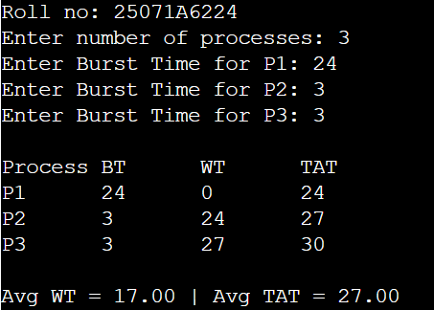
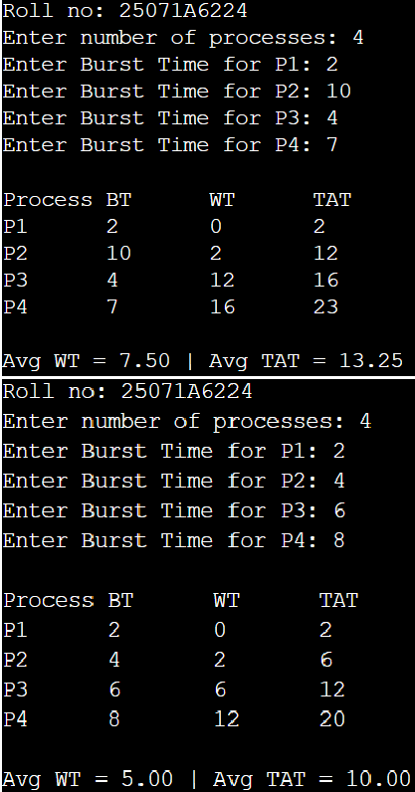
- without arrival times

Program:
#include <stdio.h> int main() {
int n, bt[20], wt[20], tat[20]; float twt = 0, ttat = 0;
printf("Roll no: 25071A6224\n"); printf("Enter number of processes: "); scanf("%d", &n);
for (int i = 0; i < n; i++) {
printf("Enter Burst Time for P%d: ", i + 1); scanf("%d", &bt[i]);
}
wt[0] = 0;
for (int i = 0; i < n; i++) {
if (i > 0) wt[i] = wt[i - 1] + bt[i - 1]; tat[i] = wt[i] + bt[i];
twt += wt[i]; ttat += tat[i];
}
printf("\nProcess\tBT\tWT\tTAT\n"); for (int i = 0; i < n; i++)
printf("P%d\t%d\t%d\t%d\n", i + 1, bt[i], wt[i], tat[i]); printf("\nAvg WT = %.2f | Avg TAT = %.2f\n", twt / n, ttat / n); return 0;
}

Testcases:

25071A6224 4

VNRVJIET

Name of the laboratory:

OPERATING SYSTEMS

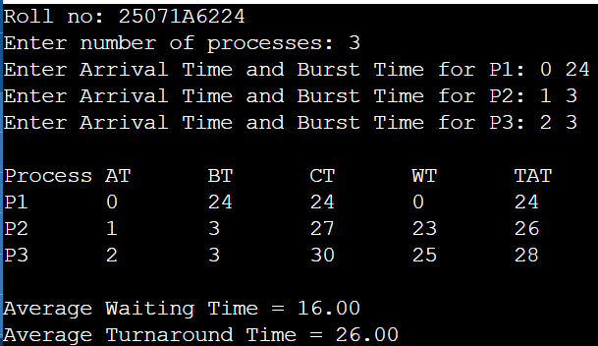
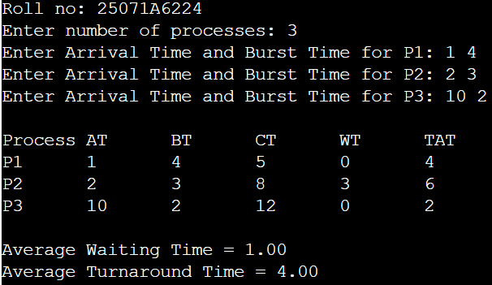
- with arrival times

Program:
#include <stdio.h> int main() {
int n, at[20], bt[20], time = 0; float twt = 0, ttat = 0; printf("Roll no: 25071A6224\n");
printf("Enter number of processes: "); scanf("%d", &n);
for (int i = 0; i < n; i++) {

Name of the Experiment:

Experiment No: Date:

printf("Enter Arrival Time and Burst Time for P%d: ", i + 1); scanf("%d%d", &at[i], &bt[i]);
}
printf("\nProcess\tAT\tBT\tCT\tWT\tTAT\n"); for (int i = 0; i < n; i++) {
if (time < at[i]) time = at[i]; time += bt[i];
int tat = time - at[i], wt = tat - bt[i]; twt += wt; ttat += tat;
printf("P%d\t%d\t%d\t%d\t%d\t%d\n", i + 1, at[i], bt[i], time, wt, tat);
}
printf("\nAverage Waiting Time = %.2f\nAverage Turnaround Time = %.2f\n", twt / n, ttat / n); return 0;
}

Testcases:

25071A6224 5

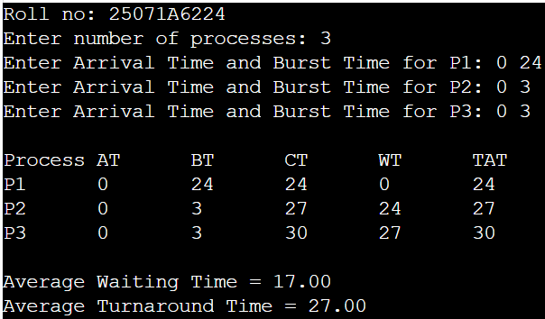

25071A6224 6

VNRVJIET

Name of the laboratory:
OPERATING SYSTEMS

Name of the Experiment:

Experiment No: Date:

Aim: write a c-program for SJF scheduling algorithm A. Non-preemptive B. Preemptive
- non-preemptive

Algorithm:
  - Start.
  - Input the number of processes (n), Arrival Time (AT), and Burst Time (BT).
  - Initialize current_time = 0 and mark all processes as unvisited.
  - Repeat until all processes are completed:
    - Select the arrived process (AT ≤ current_time) with the smallest Burst Time (BT).
    - If no process has arrived, increase current_time by 1.
  - Otherwise:
    - Execute the selected process.
    - Calculate CT, TAT, and WT.
    - Update current_time = CT.
    - Mark the process as completed.
  - Calculate the Average Waiting Time (AWT) and Average Turnaround Time (ATAT).
  - Display AT, BT, CT, WT, TAT, AWT, and ATAT.
  - Stop.
- Preemptive

Algorithm:
  - Start.
  - Input the number of processes (n), Arrival Time (AT), and Burst Time (BT). Set Remaining Time (RT) = BT for each process.
  - Initialize time = 0 and completed = 0.
  - Repeat until all processes are completed:
    - Select the arrived process (AT ≤ time) with the smallest Remaining Time (RT).
    - If no process is ready, increase time by 1.
    - Otherwise:
      - Execute the selected process for 1 time unit.
      - Decrease RT by 1 and increase time by 1.
      - If RT = 0, calculate CT, mark the process as completed, and increment completed.
  - Calculate TAT, WT, Average Waiting Time (AWT), and Average Turnaround Time (ATAT).
  - Display AT, BT, CT, WT, TAT, AWT, and ATAT.
  - Stop.

25071A6224 7

25071A6224 8

VNRVJIET

Name of the laboratory:

OPERATING SYSTEMS

25071A6224

Name of the Experiment:

Experiment No: Date:

9

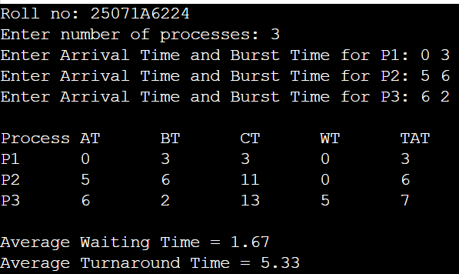
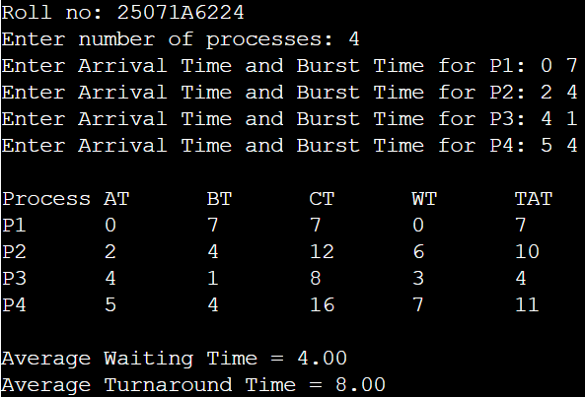
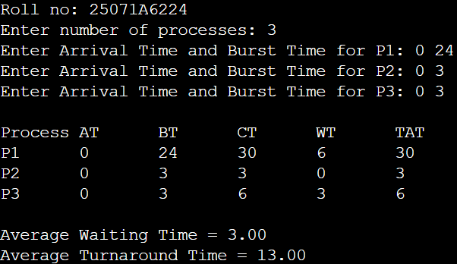
- non-preemptive

Program:
#include <stdio.h> int main() {
printf("Roll no: 25071A6224\n");
int n, p[10], at[10], bt[10], ct[10], tat[10], wt[10], vis[10]={0}, cur=0, done=0; float twt=0, ttat=0;
printf("Enter number of processes: "); scanf("%d", &n);
for(int i=0; i<n; i++) { p[i]=i+1; printf("Enter Arrival Time and Burst Time for P%d: ", i+1); scanf("%d%d", &at[i], &bt[i]); }
while(done < n) {
int idx = -1, min_bt = 1e9; for(int i=0; i<n; i++)
if(at[i] <= cur && !vis[i] && bt[i] < min_bt) { min_bt = bt[i]; idx = i; } if(idx == -1) cur++;
else {
cur += bt[idx]; ct[idx] = cur; tat[idx] = ct[idx] - at[idx];
wt[idx] = tat[idx] - bt[idx]; twt += wt[idx]; ttat += tat[idx]; vis[idx] = 1; done++;
}
}
printf("\nProcess\tAT\tBT\tCT\tWT\tTAT\n");
for(int i=0; i<n; i++) printf("P%d\t%d\t%d\t%d\t%d\t%d\n", p[i], at[i], bt[i], ct[i], wt[i], tat[i]); printf("\nAverage Waiting Time = %.2f\nAverage Turnaround Time = %.2f\n", twt/n, ttat/n); return 0;}

Testcases:

25071A6224 10

VNRVJIET

Name of the laboratory:

OPERATING SYSTEMS

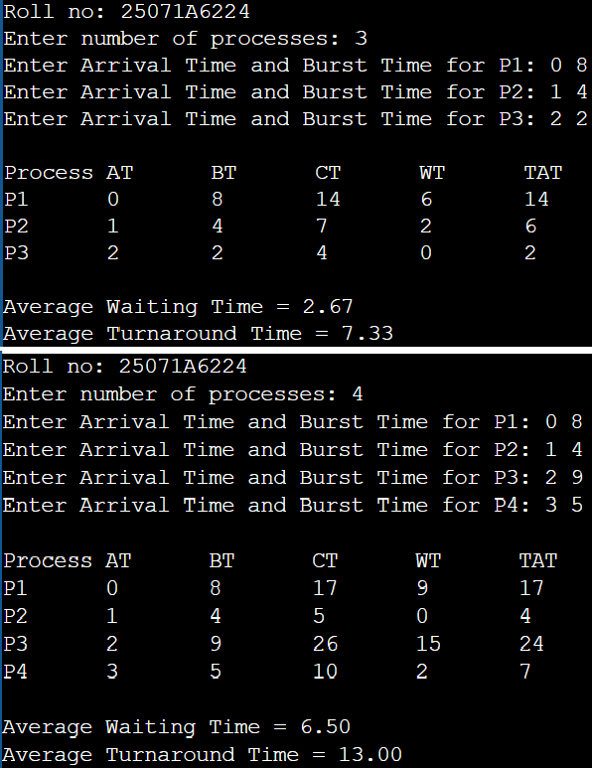
- preemptive

Program:
#include <stdio.h> int main() {
printf("Roll no: 25071A6224\n");

Name of the Experiment:

Experiment No: Date:

int n, at[10], bt[10], rt[10], ct[10], done = 0, time = 0, min_rt, idx; float twt = 0, ttat = 0;
printf("Enter number of processes: "); scanf("%d", &n); for (int i = 0; i < n; i++) {
printf("Enter Arrival Time and Burst Time for P%d: ", i + 1); scanf("%d%d", &at[i], &bt[i]); rt[i] = bt[i];
}
while (done < n) { min_rt = 1e9; idx = -1;
for (int i = 0; i < n; i++)
if (at[i] <= time && rt[i] > 0 && rt[i] < min_rt) { min_rt = rt[i]; idx = i; } if (idx == -1) { time++; continue; }
rt[idx]--; time++;
if (rt[idx] == 0) { done++; ct[idx] = time; }
}
printf("\nProcess\tAT\tBT\tCT\tWT\tTAT\n"); for (int i = 0; i < n; i++) {
int tat = ct[i] - at[i], wt = tat - bt[i]; twt += wt; ttat += tat;
printf("P%d\t%d\t%d\t%d\t%d\t%d\n", i + 1, at[i], bt[i], ct[i], wt, tat);
}
printf("\nAverage Waiting Time = %.2f\nAverage Turnaround Time = %.2f\n", twt / n, ttat / n); return 0;
}

Testcases:

25071A6224 11

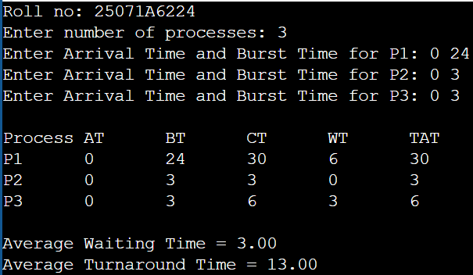

25071A6224 12

VNRVJIET

Name of the laboratory:
OPERATING SYSTEMS

Name of the Experiment: Priority and Round

Robin Scheduling algorithms

Experiment No: 2 Date: 30-07-2026

Aim: write a c-program for priority scheduling algorithm A. Non-preemptive B. Preemptive
- non-preemptive

Algorithm:
  - Start.
  - Input the number of processes (n), Arrival Time (AT), Burst Time (BT), and Priority (Pr).
  - Initialize current_time = 0 and mark all processes as unvisited.
  - Repeat until all processes are completed:
    - Select the arrived process (AT ≤ current_time) with the highest priority (lowest Priority value).
    - If no process is ready, increase current_time by 1.
    - Otherwise:
      - Execute the selected process.
      - Calculate CT, TAT, and WT.
      - Update current_time = CT.
      - Mark the process as completed.
  - Calculate Average Waiting Time (AWT) and Average Turnaround Time (ATAT).
  - Display AT, BT, Priority, CT, WT, TAT, AWT, and ATAT.
  - Stop.
- Preemptive

Algorithm:
  - Start.
  - Input the number of processes (n), Arrival Time (AT), Burst Time (BT), and Priority (Pr). Set Remaining Time (RT) = BT for each process.
  - Initialize time = 0 and completed = 0.
  - Repeat until all processes are completed:
    - Select the arrived process (AT ≤ time) with the highest priority (lowest Priority value).
    - If no process is ready, increase time by 1.
    - Otherwise:
      - Execute the selected process for 1 time unit.
      - Decrease RT by 1 and increase time by 1.
      - If RT = 0, calculate CT, mark the process as completed, and increment completed.
  - Calculate TAT, WT, Average Waiting Time (AWT), and Average Turnaround Time (ATAT).
  - Display AT, BT, Priority, CT, WT, TAT, AWT, and ATAT.
  - Stop.

25071A6224 13

25071A6224 14

VNRVJIET

Name of the laboratory:

OPERATING SYSTEMS

25071A6224

Name of the Experiment:

Experiment No: Date:

15

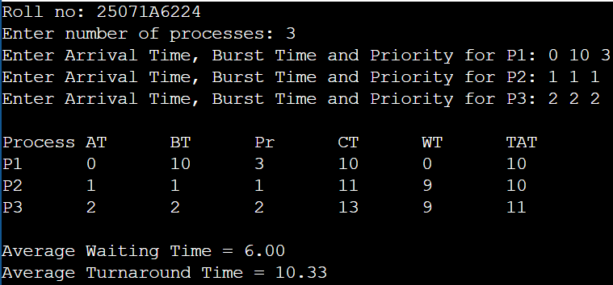
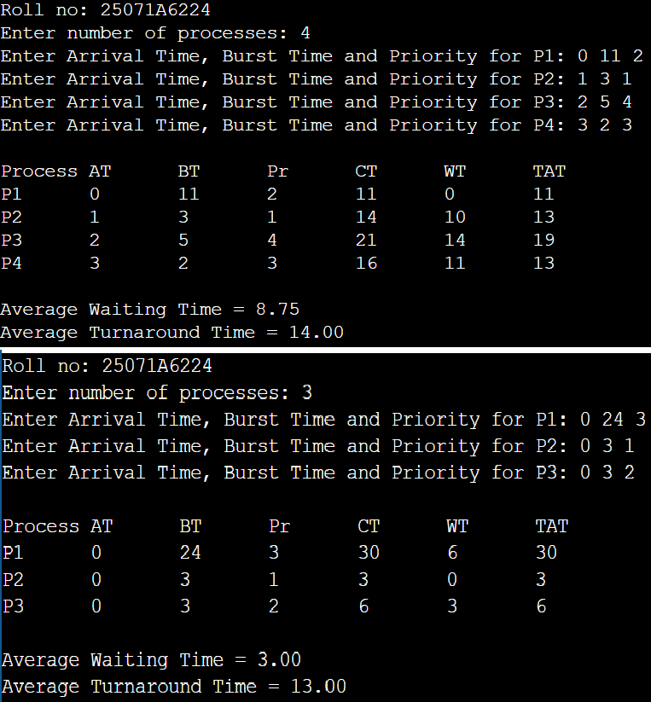
- non-preemptive

Program:
#include <stdio.h> int main() {
printf("Roll no: 25071A6224\n");
int n, at[10], bt[10], pr[10], ct[10], vis[10]={0}, cur=0, done=0; float twt=0, ttat=0;
printf("Enter number of processes: "); scanf("%d", &n);
for(int i=0; i<n; i++) {
printf("Enter Arrival Time, Burst Time and Priority for P%d: ", i+1); scanf("%d%d%d", &at[i], &bt[i], &pr[i]); } while(done < n) {
int idx = -1, min_pr = 1e9; for(int i=0; i<n; i++)
if(at[i] <= cur && !vis[i] && pr[i] < min_pr) { min_pr = pr[i]; idx = i; } if(idx == -1) cur++;
else { cur += bt[idx]; ct[idx] = cur; vis[idx] = 1; done++; }
}
printf("\nProcess\tAT\tBT\tPr\tCT\tWT\tTAT\n"); for(int i=0; i<n; i++) {
int tat = ct[i] - at[i], wt = tat - bt[i]; twt += wt; ttat += tat; printf("P%d\t%d\t%d\t%d\t%d\t%d\t%d\n", i+1, at[i], bt[i], pr[i], ct[i], wt, tat);
}
printf("\nAverage Waiting Time = %.2f\nAverage Turnaround Time = %.2f\n", twt/n, ttat/n); return 0;
}

Testcases:

25071A6224 16

VNRVJIET

Name of the laboratory:

OPERATING SYSTEMS

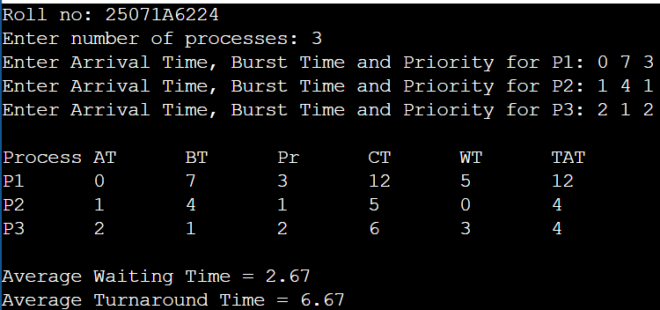
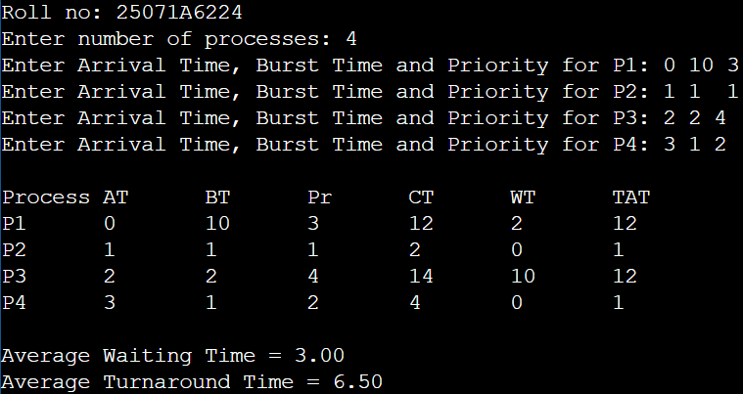
- preemptive

Program:
#include <stdio.h> int main() {
printf("Roll no: 25071A6224\n");

Name of the Experiment:

Experiment No: Date:

int n, at[10], bt[10], pr[10], rt[10], ct[10], done = 0, time = 0, min_pr, idx; float twt = 0, ttat = 0;
printf("Enter number of processes: "); scanf("%d", &n); for (int i = 0; i < n; i++) {
printf("Enter Arrival Time, Burst Time and Priority for P%d: ", i + 1); scanf("%d%d%d", &at[i], &bt[i], &pr[i]); rt[i] = bt[i];
}
while (done < n) { min_pr = 1e9; idx = -1; for (int i = 0; i < n; i++)
if (at[i] <= time && rt[i] > 0 && pr[i] < min_pr) { min_pr = pr[i]; idx = i; } if (idx == -1) { time++; continue; }
rt[idx]--; time++;
if (rt[idx] == 0) { done++; ct[idx] = time; }
}
printf("\nProcess\tAT\tBT\tPr\tCT\tWT\tTAT\n"); for (int i = 0; i < n; i++) {
int tat = ct[i] - at[i], wt = tat - bt[i]; twt += wt; ttat += tat; printf("P%d\t%d\t%d\t%d\t%d\t%d\t%d\n", i + 1, at[i], bt[i], pr[i], ct[i], wt, tat);
}
printf("\nAverage Waiting Time = %.2f\nAverage Turnaround Time = %.2f\n", twt / n, ttat / n); return 0;
}

Testcases:

25071A6224 17

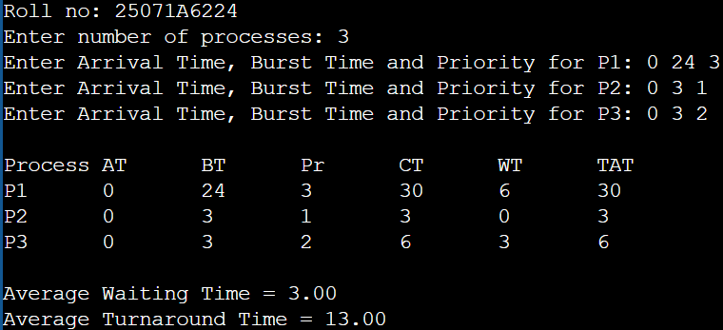

25071A6224 18

VNRVJIET

Name of the laboratory:
OPERATING SYSTEMS

Name of the Experiment:

Experiment No: Date:

Aim: write a c-program for Round Robin scheduling algorithm A. Time Quantum=2, B. Time Quantum=10
- Time Quantum=2

Algorithm:
  - Start.
  - Input the number of processes (n), Arrival Time (AT), and Burst Time (BT). Set Time Quantum (TQ) = 2 and Remaining Time (RT) = BT for each process.
  - Initialize time = 0 and completed = 0.
  - Repeat until all processes are completed:
    - Select the first process from the Ready Queue.
    - Execute the process for 2 units or until it finishes.
    - Update RT and time.
    - Add any newly arrived processes to the Ready Queue.
    - If RT > 0, add the process back to the Ready Queue; otherwise, calculate CT and mark it as completed.
  - Calculate TAT, WT, Average Waiting Time (AWT), and Average Turnaround Time (ATAT).
  - Display AT, BT, CT, WT, TAT, AWT, and ATAT.
  - Stop.
- Time Quantum=10

Algorithm:
  - Start.
  - Input the number of processes (n), Arrival Time (AT), and Burst Time (BT). Set Time Quantum (TQ) = 10 and Remaining Time (RT) = BT for each process.
  - Initialize time = 0 and completed = 0.
  - Repeat until all processes are completed:
    - Select the first process from the Ready Queue.
    - Execute the process for 10 units or until it finishes.
    - Update RT and time.
    - Add any newly arrived processes to the Ready Queue.
    - If RT > 0, add the process back to the Ready Queue; otherwise, calculate CT and mark it as completed.
  - Calculate TAT, WT, Average Waiting Time (AWT), and Average Turnaround Time (ATAT).
  - Display AT, BT, CT, WT, TAT, AWT, and ATAT.
  - Stop.

25071A6224 19

25071A6224 20

VNRVJIET

Name of the laboratory:

OPERATING SYSTEMS

25071A6224

Name of the Experiment:

Experiment No: Date:

21

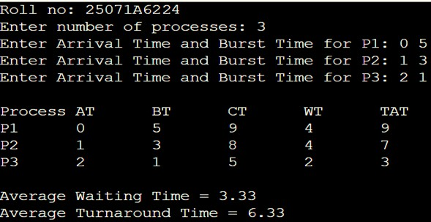
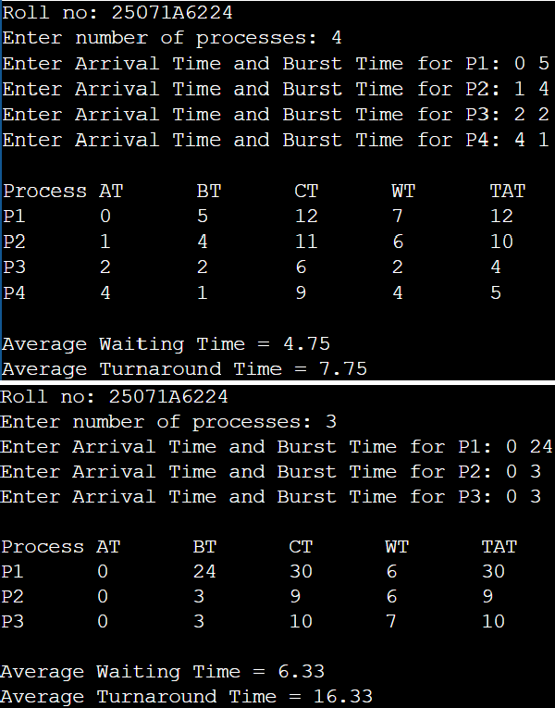
- Time Quantum=2

Program:
#include <stdio.h> int main() {
printf("Roll no: 25071A6224\n");
int n, tq = 2, at[10], bt[10], rt[10], ct[10], done = 0, time = 0; float twt = 0, ttat = 0;
printf("Enter number of processes: "); scanf("%d", &n); for (int i = 0; i < n; i++) {
printf("Enter Arrival Time and Burst Time for P%d: ", i + 1); scanf("%d%d", &at[i], &bt[i]); rt[i] = bt[i];}
while (done < n) { int exec = 0;
for (int i = 0; i < n; i++) {
if (at[i] <= time && rt[i] > 0) { exec = 1;
int slice = (rt[i] > tq) ? tq : rt[i]; rt[i] -= slice; time += slice;
if (rt[i] == 0) { done++; ct[i] = time; } }} if (!exec) time++;}
printf("\nProcess\tAT\tBT\tCT\tWT\tTAT\n"); for (int i = 0; i < n; i++) {
int tat = ct[i] - at[i], wt = tat - bt[i]; twt += wt; ttat += tat; printf("P%d\t%d\t%d\t%d\t%d\t%d\n", i + 1, at[i], bt[i], ct[i], wt, tat); }
printf("\nAverage Waiting Time = %.2f\nAverage Turnaround Time = %.2f\n", twt / n, ttat / n); return 0;}

Testcases:

25071A6224 22

VNRVJIET

Name of the laboratory:

OPERATING SYSTEMS

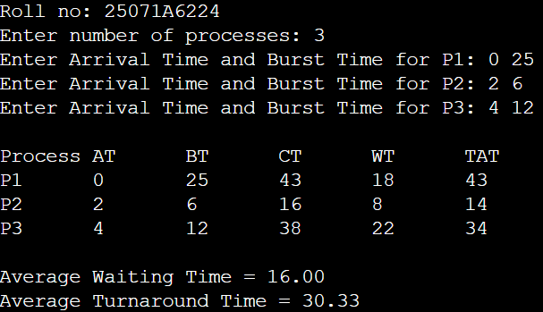
- Time Quantum=10

Program:
#include <stdio.h> int main() {
printf("Roll no: 25071A6224\n");

Name of the Experiment:

Experiment No: Date:

int n, tq = 10, at[10], bt[10], rt[10], ct[10], done = 0, time = 0; float twt = 0, ttat = 0;
printf("Enter number of processes: "); scanf("%d", &n); for (int i = 0; i < n; i++) {
printf("Enter Arrival Time and Burst Time for P%d: ", i + 1); scanf("%d%d", &at[i], &bt[i]); rt[i] = bt[i];
}
while (done < n) { int exec = 0;
for (int i = 0; i < n; i++) {
if (at[i] <= time && rt[i] > 0) { exec = 1;
int slice = (rt[i] > tq) ? tq : rt[i]; rt[i] -= slice; time += slice;
if (rt[i] == 0) { done++; ct[i] = time; }
}
}
if (!exec) time++;
}
printf("\nProcess\tAT\tBT\tCT\tWT\tTAT\n"); for (int i = 0; i < n; i++) {
int tat = ct[i] - at[i], wt = tat - bt[i]; twt += wt; ttat += tat; printf("P%d\t%d\t%d\t%d\t%d\t%d\n", i + 1, at[i], bt[i], ct[i], wt, tat);
}
printf("\nAverage Waiting Time = %.2f\nAverage Turnaround Time = %.2f\n", twt / n, ttat / n); return 0;
}

Testcases:

25071A6224 23

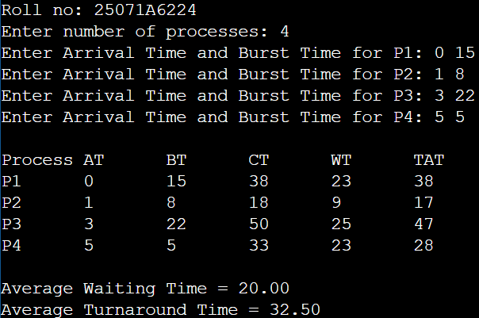
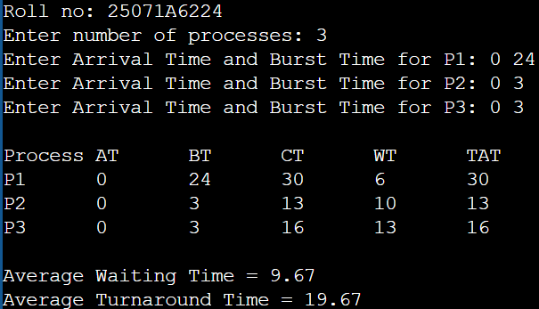

25071A6224 24

VNRVJIET

Name of the laboratory:

OPERATING SYSTEMS

Name of the Experiment: Banker’s algorithm and

Analysis of the scheduling algorithms

Experiment No: 3 Date: 23-07-2026

Aim: Make the analysis of all scheduling algorithms

Testcases:

FCFS scheduling without arrival times | FCFS scheduling arrival times
SJF scheduling non-preemptive | SJF scheduling preemptive
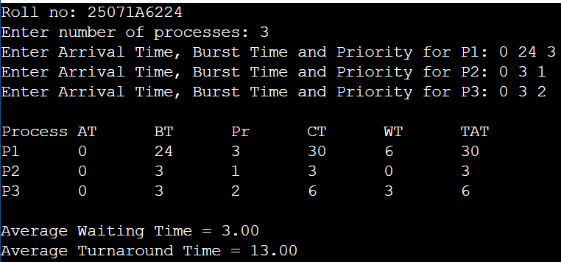  Priority scheduling non-preemptive | Priority scheduling preemptive
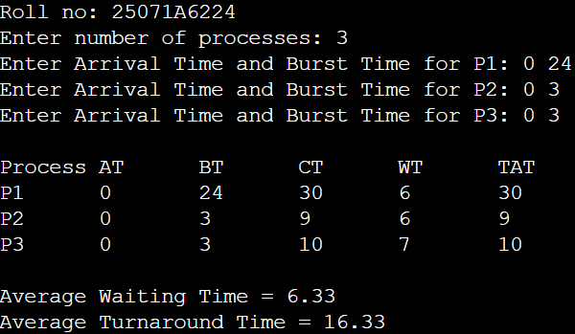  Round Robin scheduling, Time quantum=2 | Round Robin scheduling, Time quantum=10

25071A6224 25

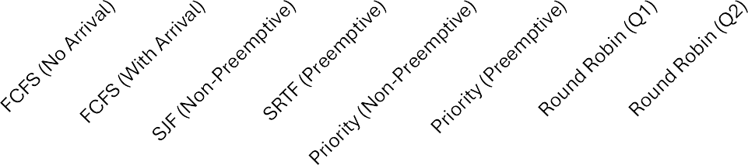
CPU SCHEDULING ANALYSIS
35.00

30.00

25.00

20.00

15.00

10.00

5.00
Avg Waiting Time (WT)
Avg Turnaround Time (TAT)
0.00
Scheduling Algorithms
Time Units (ms)

25071A6224 26

VNRVJIET

Name of the laboratory:
OPERATING SYSTEMS

Name of the Experiment:

Experiment No: Date:

Aim: write a c-program for Banker’s algorithm

Algorithm:

Start.
  - Input the number of processes (n), resource types (m), Allocation, Max, and Available matrices.
  - Calculate the Need Matrix:
    - Need = Max − Allocation
  - Initialize:
    - Work = Available
    - Mark all processes as unfinished.
  - Repeat until all processes are finished:
    - Select an unfinished process whose Need ≤ Work.
    - If found:
      - Work = Work + Allocation
      - Mark the process as finished.
      - Add it to the Safe Sequence.
    - If no suitable process is found, stop.
  - Check the result:
    - If all processes are finished, the system is in a Safe State and display the Safe Sequence.
    - Otherwise, the system is in an Unsafe State.

Stop.

25071A6224 27

25071A6224 28

VNRVJIET

Name of the laboratory:

OPERATING SYSTEMS

Program:
#include <stdio.h> int main() {
printf("Roll no: 25071A6224\n");

Name of the Experiment:

Experiment No: Date:

int n, m, alloc[10][10], max[10][10], need[10][10], avail[10], finish[10] = {0}, safeSeq[10], count = 0; printf("Enter number of processes: "); scanf("%d", &n);
printf("Enter number of resource types: "); scanf("%d", &m); printf("Enter Allocation Matrix:\n");
for (int i = 0; i < n; i++)
for (int j = 0; j < m; j++) scanf("%d", &alloc[i][j]); printf("Enter Max Matrix:\n");
for (int i = 0; i < n; i++)
for (int j = 0; j < m; j++) { scanf("%d", &max[i][j]);
need[i][j] = max[i][j] - alloc[i][j];
}
printf("Enter Available Resources:\n");
for (int j = 0; j < m; j++) scanf("%d", &avail[j]); int work[10];
for (int j = 0; j < m; j++) work[j] = avail[j]; while (count < n) {
int found = 0;
for (int i = 0; i < n; i++) { if (!finish[i]) {
int possible = 1;
for (int j = 0; j < m; j++) {
if (need[i][j] > work[j]) { possible = 0; break; }
}
if (possible) {
for (int j = 0; j < m; j++) work[j] += alloc[i][j]; safeSeq[count++] = i;

25071A6224 29

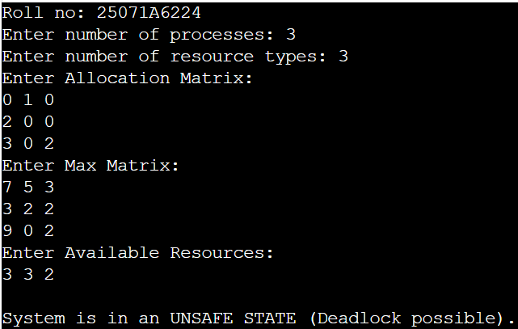
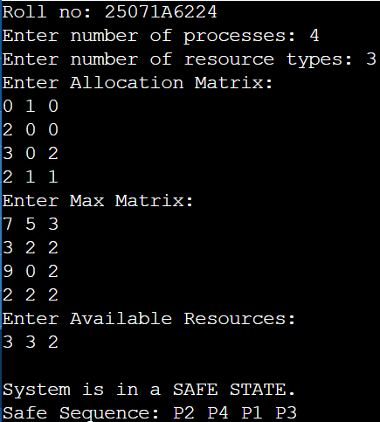
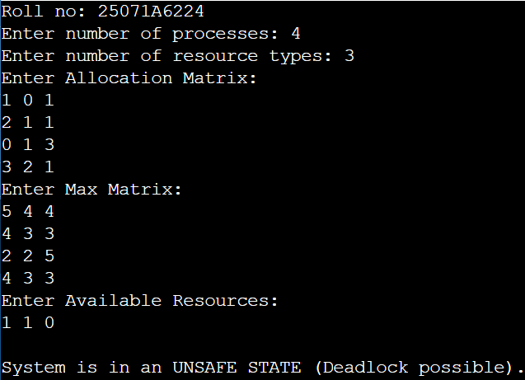
finish[i] = 1; found = 1; }
}
}
if (!found) break;
}
if (count == n) {
printf("\nSystem is in a SAFE STATE.\nSafe Sequence: "); for (int i = 0; i < n; i++) printf("P%d ", safeSeq[i] + 1); printf("\n");
} else {
printf("\nSystem is in an UNSAFE STATE (Deadlock possible).\n");
}
return 0;}

Testcases:

25071A6224 30

VNRVJIET

Name of the laboratory:
OPERATING SYSTEMS

Name of the Experiment: Implementation of

Memory Allocation Methods

Experiment No: 4 Date: 27-08-2026

Aim: Implementation of the following Memory Allocation Methods for fixed partition a) First Fit b) Worst Fit
- Best Fit
  - First Fit

Algorithm:
    - Start.
    - Input the number of memory partitions (m) and their sizes, and the number of processes (n) and their memory requirements.
    - Initialize all processes as unallocated.
    - For each process:
      - Search the partitions from the first partition.
      - If an unallocated partition is large enough, allocate it to the process.
      - Mark the partition as allocated and stop searching.
    - Calculate the Internal Fragmentation for each allocated partition:
      - Fragmentation = Partition Size − Process Size
    - Display the process, allocated partition, partition size, and internal fragmentation.
    - Stop.
  - Worst Fit

Algorithm:
    - Start.
    - Input the number of memory partitions (m) and their sizes, and the number of processes (n) and their memory requirements.
    - Initialize all processes as unallocated.
    - For each process:
      - Search all unallocated partitions.
      - Find the largest partition that is large enough for the process.
      - If a suitable partition is found, allocate it to the process and mark it as allocated.
    - Calculate the Internal Fragmentation:
      - Fragmentation = Partition Size − Process Size
    - Display the process, allocated partition, partition size, and internal fragmentation.
    - Stop.
  - Best Fit

Algorithm:
    - Start.
    - Input the number of memory partitions (m) and their sizes, and the number of processes (n) and their memory requirements.
    - Initialize all processes as unallocated.
    - For each process:
      - Search all unallocated partitions.
      - Find the smallest partition that is large enough for the process.
      - If a suitable partition is found, allocate it to the process and mark it as allocated.
    - Calculate the Internal Fragmentation:
      - Fragmentation = Partition Size − Process Size
    - Display the process, allocated partition, partition size, and internal fragmentation.
    - Stop.
25071A6224 31

25071A6224 32

VNRVJIET

Name of the laboratory:

OPERATING SYSTEMS

25071A6224

Name of the Experiment:

Experiment No: Date:

33

25071A6224 34

VNRVJIET

Name of the laboratory:

OPERATING SYSTEMS

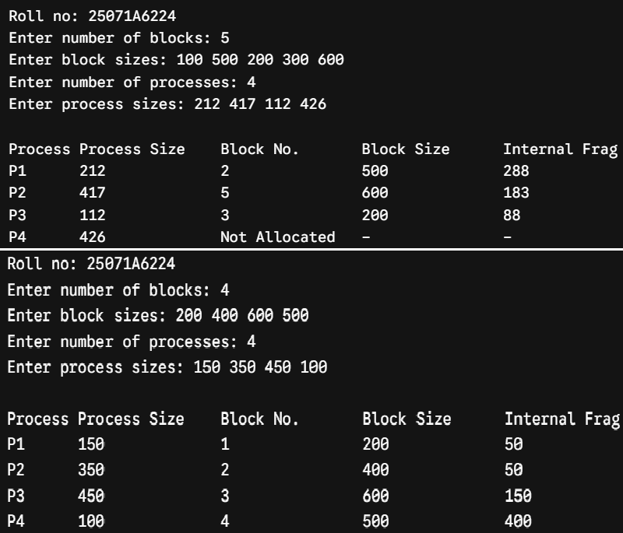
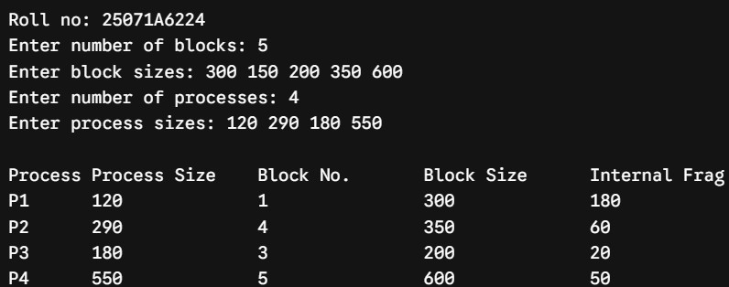
- First Fit

Program:
#include <stdio.h> int main() {
printf("Roll no: 25071A6224\n");

Name of the Experiment:

Experiment No: Date:

int m, n, bsize[10], psize[10], alloc[10], occupied[10] = {0}; printf("Enter number of blocks: "); scanf("%d", &m); printf("Enter block sizes: ");
for (int i = 0; i < m; i++) scanf("%d", &bsize[i]); printf("Enter number of processes: "); scanf("%d", &n); printf("Enter process sizes: ");
for (int i = 0; i < n; i++) { scanf("%d", &psize[i]); alloc[i] = -1;
}
for (int i = 0; i < n; i++) { for (int j = 0; j < m; j++) {
if (!occupied[j] && bsize[j] >= psize[i]) { alloc[i] = j;
occupied[j] = 1; break; } } }
printf("\nProcess\tProcess Size\tBlock No.\tBlock Size\tInternal Frag\n"); for (int i = 0; i < n; i++) {
if (alloc[i] != -1)
printf("P%d\t%d\t\t%d\t\t%d\t\t%d\n", i + 1, psize[i], alloc[i] + 1, bsize[alloc[i]], bsize[alloc[i]] - psize[i]); else
printf("P%d\t%d\t\tNot Allocated\t-\t\t-\n", i + 1, psize[i]);} return 0;}

Testcases:

25071A6224 35

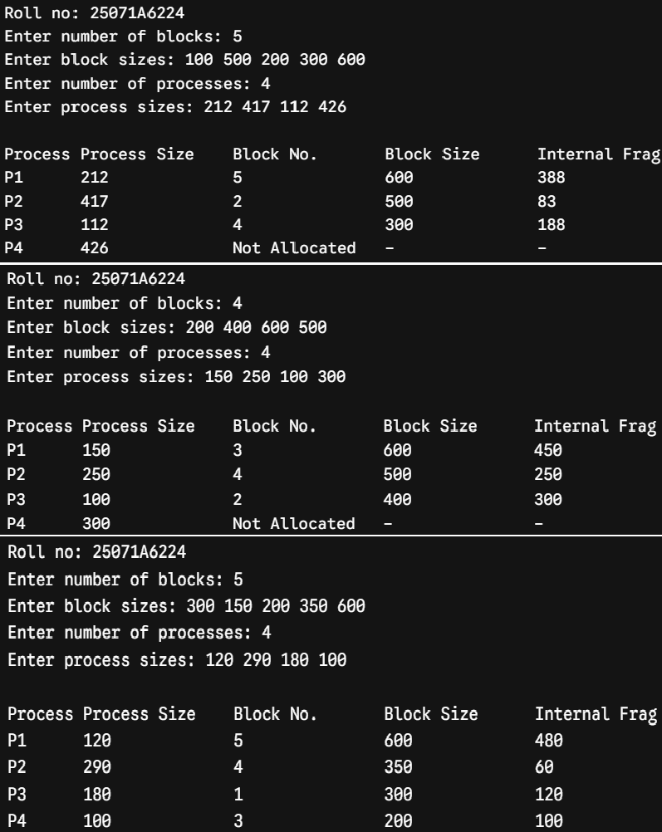
- Worst Fit

Program:
#include <stdio.h> int main() {
printf("Roll no: 25071A6224\n");
int m, n, bsize[10], psize[10], alloc[10], occupied[10] = {0}; printf("Enter number of blocks: "); scanf("%d", &m); printf("Enter block sizes: ");
for (int i = 0; i < m; i++) scanf("%d", &bsize[i]); printf("Enter number of processes: "); scanf("%d", &n); printf("Enter process sizes: ");
for (int i = 0; i < n; i++) { scanf("%d", &psize[i]); alloc[i] = -1; } for (int i = 0; i < n; i++) {
int worstIdx = -1;
for (int j = 0; j < m; j++) {
if (!occupied[j] && bsize[j] >= psize[i]) {
if (worstIdx == -1 || bsize[j] > bsize[worstIdx]) worstIdx = j;} }
if (worstIdx != -1) { alloc[i] = worstIdx;
occupied[worstIdx] = 1; }}
printf("\nProcess\tProcess Size\tBlock No.\tBlock Size\tInternal Frag\n"); for (int i = 0; i < n; i++) {
if (alloc[i] != -1)
printf("P%d\t%d\t\t%d\t\t%d\t\t%d\n", i + 1, psize[i], alloc[i] + 1, bsize[alloc[i]], bsize[alloc[i]] - psize[i]); else
printf("P%d\t%d\t\tNot Allocated\t-\t\t-\n", i + 1, psize[i]); } return 0;}

Testcases:

25071A6224 36

VNRVJIET

Name of the laboratory:

OPERATING SYSTEMS

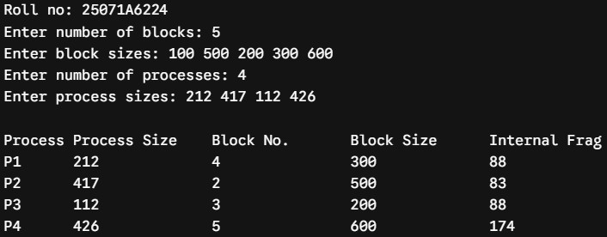
- Best Fit

Program:
#include <stdio.h> int main() {
printf("Roll no: 25071A6224\n");

Name of the Experiment:

Experiment No: Date:

int m, n, bsize[10], psize[10], alloc[10], occupied[10] = {0}; printf("Enter number of blocks: "); scanf("%d", &m); printf("Enter block sizes: ");
for (int i = 0; i < m; i++) scanf("%d", &bsize[i]); printf("Enter number of processes: "); scanf("%d", &n); printf("Enter process sizes: ");
for (int i = 0; i < n; i++) { scanf("%d", &psize[i]); alloc[i] = -1; }

for (int i = 0; i < n; i++) { int bestIdx = -1;
for (int j = 0; j < m; j++) {
if (!occupied[j] && bsize[j] >= psize[i]) {
if (bestIdx == -1 || bsize[j] < bsize[bestIdx]) bestIdx = j;
}
}
if (bestIdx != -1) { alloc[i] = bestIdx; occupied[bestIdx] = 1;
}
}
printf("\nProcess\tProcess Size\tBlock No.\tBlock Size\tInternal Frag\n"); for (int i = 0; i < n; i++) {
if (alloc[i] != -1)
printf("P%d\t%d\t\t%d\t\t%d\t\t%d\n", i + 1, psize[i], alloc[i] + 1, bsize[alloc[i]], bsize[alloc[i]] - psize[i]); else
printf("P%d\t%d\t\tNot Allocated\t-\t\t-\n", i + 1, psize[i]);
}
return 0;
}

Testcases:

25071A6224 37

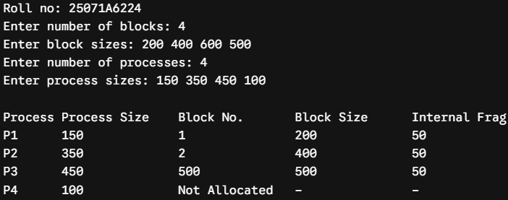
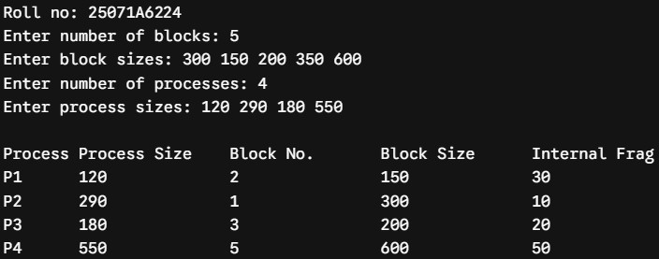

25071A6224 38

VNRVJIET

Name of the laboratory:

OPERATING SYSTEMS

Name of the Experiment: Paging Technique

Memory Management

Experiment No: 5 Date: 27-08-2026

Aim: Implementation of Paging Technique of Memory Management

Algorithm:
  - Start.
  - Input the main memory size (MS) and page size (PS), then calculate the Total Frames.
  - Input the process size and calculate the Total Pages required.
  - If Total Pages > Total Frames, display "Memory insufficient" and stop.
  - Input the frame number for each page and create the Page Table.
  - Input the Logical Address (LA) and calculate:
    - Page Number = LA / PS
    - Offset = LA % PS
  - If the page number is valid:
    - Find the Frame Number from the Page Table.
    - Calculate:
      - Physical Address = (Frame Number × PS) + Offset
    - Display the Page Number, Offset, Frame Number, and Physical Address.
  - Otherwise, display "Invalid Logical Address".
  - Stop

25071A6224 39

25071A6224 40

VNRVJIET

Name of the laboratory:

OPERATING SYSTEMS

Program:
#include <stdio.h>

int main() {
printf("Roll no: 25071A6224\n");
int ms, ps, p_size, total_frames, total_pages; int page_table[20];
int la, p, d, pa;

Name of the Experiment:

Experiment No: Date:

printf("Enter main memory size (in bytes): "); scanf("%d", &ms);
printf("Enter page size (in bytes): "); scanf("%d", &ps);

total_frames = ms / ps;
printf("Total frames available in memory: %d\n\n", total_frames);

printf("Enter process size (in bytes): "); scanf("%d", &p_size);

total_pages = p_size / ps;
if (p_size % ps != 0) total_pages++;

if (total_pages > total_frames) {
printf("\nMemory Allocation Failed: Not enough frames available.\n"); return 0;
}

printf("Total pages required for process: %d\n", total_pages); printf("Enter frame numbers allocated to each page:\n");
for (int i = 0; i < total_pages; i++) { printf("Page %d -> Frame No: ", i); scanf("%d", &page_table[i]);
}

printf("\nEnter Logical Address to translate: "); scanf("%d", &la);

p = la / ps; d = la % ps;

if (p >= total_pages) {
printf("\nInvalid Logical Address! (Page number %d exceeds allocated pages)\n", p);
}

25071A6224 41

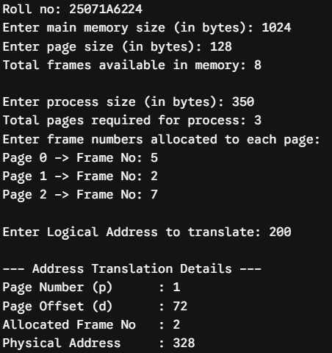
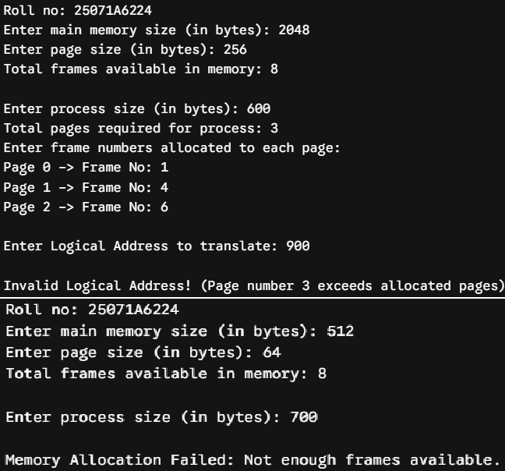
else {
pa = (page_table[p] * ps) + d;
printf("\n--- Address Translation Details ---\n"); printf("Page Number (p) : %d\n", p); printf("Page Offset (d) : %d\n", d);
printf("Allocated Frame No : %d\n", page_table[p]); printf("Physical Address : %d\n", pa);
}

return 0;
}

Testcases:

25071A6224 42

VNRVJIET

Name of the laboratory:

OPERATING SYSTEMS

Name of the Experiment: frame allocation

Methods.

Experiment No: 7 Date: 3-09-2026

Aim: Simulate frame allocation Methods. A) minimum number of frames B) equal allocation C) proportional allocation
- minimum number of frames

Algorithm:
  - Start.
  - Input total available frames and minimum frames required per process.
  - Input number of processes and their page requirements.
  - Check whether available frames are sufficient for all processes.
  - Allocate the minimum required frames to each process.
  - Calculate and display the remaining unallocated frames.
  - Stop.

- equal allocation

Algorithm:
  - Start.
  - Input total number of available frames and number of processes m.
  - Calculate frames allocated to each process: Frames per Process = Total Frames / m
  - Calculate remaining frames: Leftover = Total Frames % m
  - Display frames allocated to each process and the leftover frames.
  - Stop.

- proportional allocation

Algorithm:
  - Start.
  - Input total number of frames m and number of processes n.
  - Input page requirement s[i] for each process and calculate total requirement S.
  - Calculate frames allocated to each process: Allocation[i] = (s[i] / S) × m
  - Calculate total allocated frames and remaining unallocated frames.
  - Display process requirements, allocated frames, and remaining frames.
  - Stop.

25071A6224 43

25071A6224 44

VNRVJIET

Name of the laboratory:

OPERATING SYSTEMS

25071A6224

Name of the Experiment:

Experiment No: Date:

45

25071A6224 46

VNRVJIET

Name of the laboratory:

OPERATING SYSTEMS

- minimum number of frames

Program:
#include <stdio.h>

int main() {
printf("Roll no: 25071A6224\n\n"); int total_frames, min_per_process, n; int page_req[10], allocated[10];

Name of the Experiment:

Experiment No: Date:

printf("Enter total frames in physical memory: "); scanf("%d", &total_frames);
printf("Enter minimum frames required per process (by architecture): "); scanf("%d", &min_per_process);
printf("Enter number of processes: "); scanf("%d", &n);

int total_min_needed = n * min_per_process; if (total_min_needed > total_frames) {
printf("\nAllocation Failed! Total available frames (%d) < Required minimum frames (%d).\n", total_frames, total_min_needed);
return 0;
}

printf("\nEnter page requirements for each process:\n"); for (int i = 0; i < n; i++) {
printf("Process P%d: ", i + 1); scanf("%d", &page_req[i]); allocated[i] = min_per_process;
}

int total_allocated = total_min_needed;
int remaining = total_frames - total_allocated;

printf("\n--- Minimum Frame Allocation Result ---\n"); printf("Process\tPage Req\tAllocated Frames\tStatus\n"); for (int i = 0; i < n; i++) {
printf("P%d\t%d\t\t%d\t\t\t%s\n", i + 1, page_req[i], allocated[i],
(allocated[i] >= page_req[i]) ? "Satisfied" : "Needs Swap Space");
}
printf("\nTotal Frames Allocated: %d / %d", total_allocated, total_frames); printf("\nRemaining Unallocated Frames: %d\n", remaining);

return 0;
}
25071A6224 47

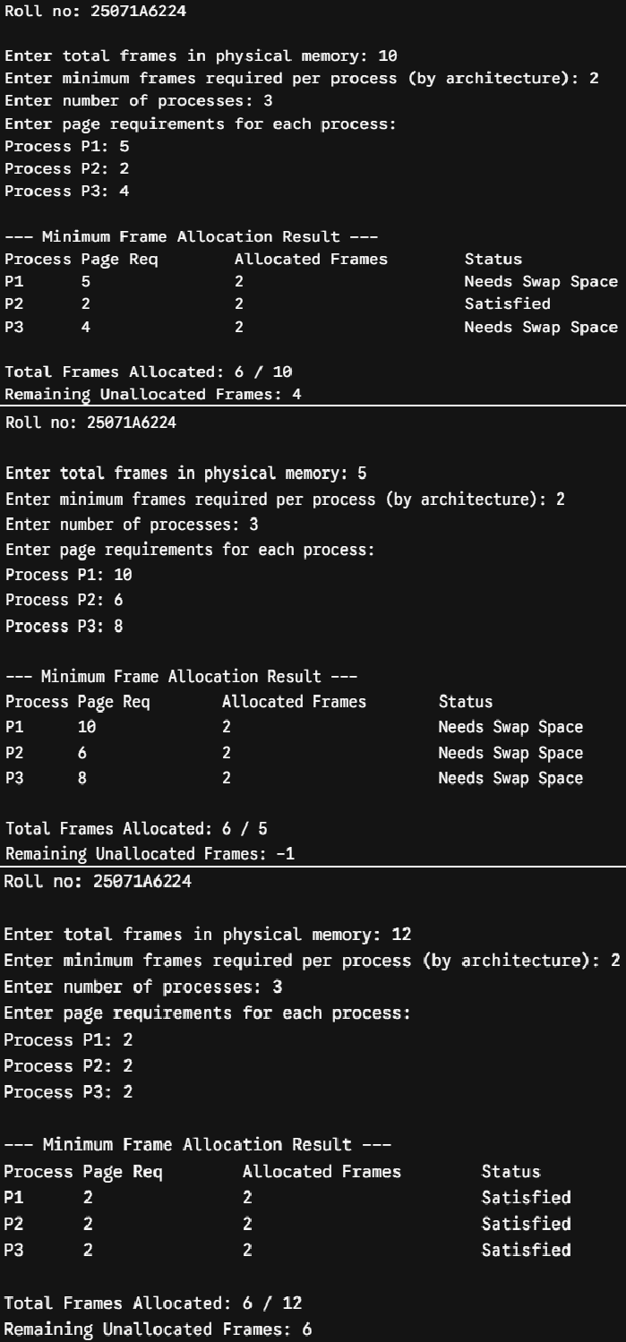
Testcases:

25071A6224 48

VNRVJIET

Name of the laboratory:

OPERATING SYSTEMS

- equal allocation

Program:
#include <stdio.h>

int main() {
printf("Roll no: 25071A6224\n\n");
int total_frames, m;
int page_req[10], allocated[10];

Name of the Experiment:

Experiment No: Date:

printf("Enter total frames in physical memory: "); scanf("%d", &total_frames);
printf("Enter number of processes: "); scanf("%d", &m);

if (m <= 0 || total_frames < m) {
printf("\nAllocation Failed! Insufficient frames for equal allocation.\n"); return 0;
}

printf("Enter page requirements for each process:\n"); for (int i = 0; i < m; i++) {
printf("Process P%d: ", i + 1); scanf("%d", &page_req[i]);
}

int equal_share = total_frames / m; int leftover = total_frames % m;

printf("\n--- Equal Frame Allocation Result ---\n"); printf("Process\tPage Req\tAllocated Frames\tUnmet Pages\n"); for (int i = 0; i < m; i++) {
allocated[i] = equal_share;
int unmet = (page_req[i] > allocated[i]) ? (page_req[i] - allocated[i]) : 0; printf("P%d\t%d\t\t%d\t\t\t%d\n", i + 1, page_req[i], allocated[i], unmet);
}

printf("\nTotal Allocated Frames: %d / %d", equal_share * m, total_frames); printf("\nLeftover System Frames: %d\n", leftover);

return 0;
}

25071A6224 49

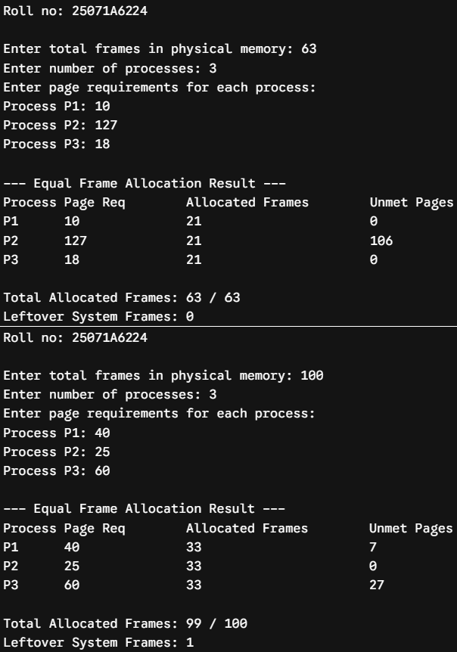
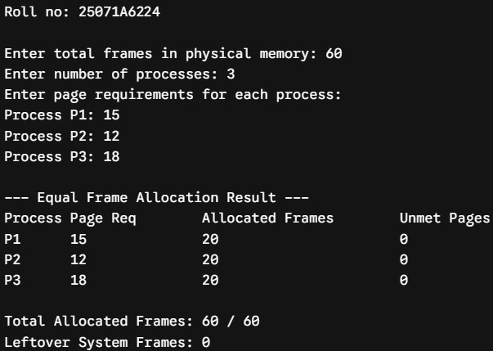
Testcases:

25071A6224 50

VNRVJIET

Name of the laboratory:

OPERATING SYSTEMS

- proportional allocation

Program:
#include <stdio.h> int main() {
printf("Roll no: 25071A6224\n\n");
int m, n;
int s[10], a[10];
int S = 0, total_allocated = 0;

Name of the Experiment:

Experiment No: Date:

printf("Enter total frames available in physical memory: "); scanf("%d", &m);
printf("Enter number of processes: "); scanf("%d", &n);

printf("Enter size (in pages/virtual memory) for each process:\n"); for (int i = 0; i < n; i++) {
printf("Process P%d size: ", i + 1); scanf("%d", &s[i]);
S += s[i];
}

if (S == 0) {
printf("\nInvalid total process size.\n"); return 0;
}
printf("\n--- Proportional Frame Allocation Result ---\n"); printf("Total Virtual Memory Required (S) = %d pages\n\n", S); printf("Process\tSize (s_i)\tAllocated Frames (a_i)\tPercentage\n");

for (int i = 0; i < n; i++) {
a[i] = (int)(((double)s[i] / S) * m); total_allocated += a[i];
double pct = ((double)s[i] / S) * 100.0; printf("P%d\t%d\t\t%d\t\t\t%.2f%%\n", i + 1, s[i], a[i], pct);
}
printf("\nTotal Frames Allocated: %d / %d", total_allocated, m); printf("\nUnallocated Buffer Frames: %d\n", m - total_allocated);

return 0;
}

25071A6224 51

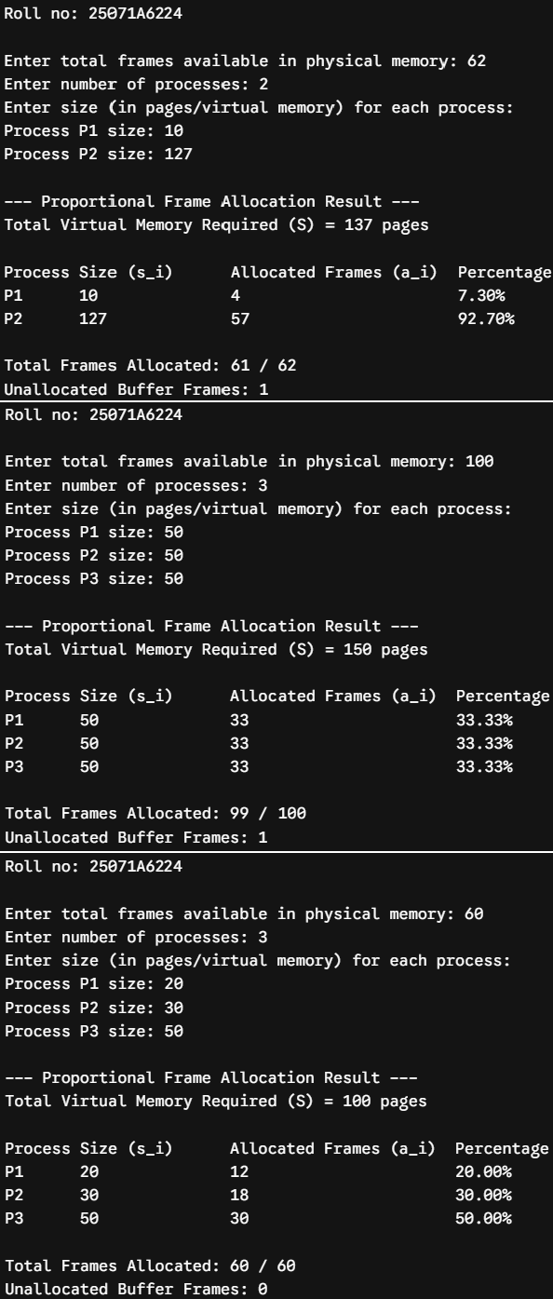
Testcases:

25071A6224 52

VNRVJIET

Name of the laboratory:

OPERATING SYSTEMS

Name of the Experiment: Disk Scheduling

Algorithms a) FCFS b) SSTF c) SCAN

Experiment No: 8 Date: 10-09-2026

Aim: Simulate the following Disk scheduling algorithms. A) FCFS B) SSTF C) SCAN
- FCFS

Algorithm:
  - Start.
  - Input the number of disk requests (n), request sequence, and initial head position.
  - Initialize Total Head Movement (THM) = 0.
  - For each request:
    - Calculate the distance between the current head and the request.
    - Add the distance to THM.
    - Move the head to the requested position.
  - Calculate:
    - Average Seek Time = THM / n
  - Display the Total Head Movement and Average Seek Time.
  - Stop.

- SSTF

Algorithm:

Start
  - Input number of requests n, request sequence, and initial head position.
  - Initialize THM = 0 and mark all requests as unvisited.
  - Repeat n times:
    - Find the unvisited request closest to the current head.
    - Mark it as visited.
    - Add the distance to THM.
    - Move the head to that request.
  - Calculate:
    - Average Seek Time = THM / n
  - Display Total Head Movement and Average Seek Time.
  - Stop.

- SCAN

Algorithm:

Start.
  - Input number of requests n, request sequence, initial head position, disk size, and direction (LEFT or RIGHT).
  - Sort the request sequence in ascending order.
  - Initialize THM = 0 and divide requests based on the current head position.
  - If direction is RIGHT:
  - Service requests to the right in ascending order.
  - Move the head to disk_size - 1.
  - Reverse direction and service remaining requests in descending order.
  - If direction is LEFT:
  - Service requests to the left in descending order.
  - Move the head to 0.
  - Reverse direction and service remaining requests in ascending order.
  - Calculate Average Seek Time = THM / n and display Total Head Movement and Average Seek Time.

Stop.
25071A6224 53

25071A6224 54

VNRVJIET

Name of the laboratory:

OPERATING SYSTEMS

25071A6224

Name of the Experiment:

Experiment No: Date:

55

25071A6224 56

VNRVJIET

Name of the laboratory:

OPERATING SYSTEMS

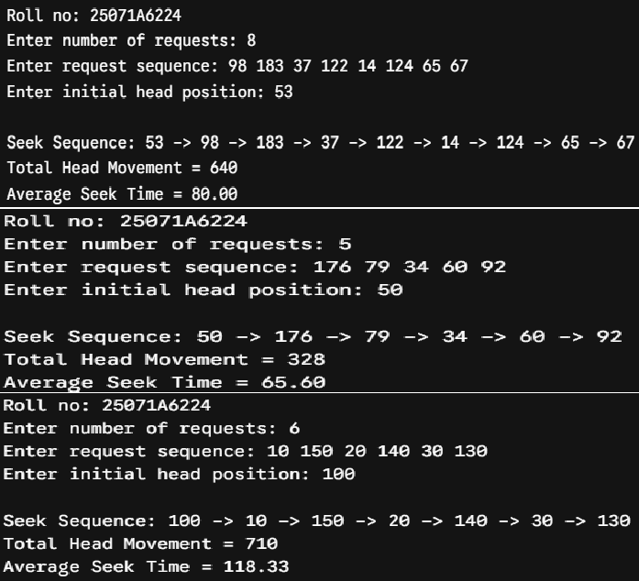
- FCFS

Program:
#include <stdio.h> #include <stdlib.h> int main() {
printf("Roll no: 25071A6224\n");
int n, head, req[20], thm = 0;

Name of the Experiment:

Experiment No: Date:

printf("Enter number of requests: "); scanf("%d", &n); printf("Enter request sequence: ");
for (int i = 0; i < n; i++) scanf("%d", &req[i]); printf("Enter initial head position: "); scanf("%d", &head);

printf("\nSeek Sequence: %d", head); for (int i = 0; i < n; i++) {
thm += abs(req[i] - head); head = req[i];
printf(" -> %d", head);
}
printf("\nTotal Head Movement = %d\nAverage Seek Time = %.2f\n", thm, (float)thm / n); return 0;
}

Testcases:

25071A6224 57

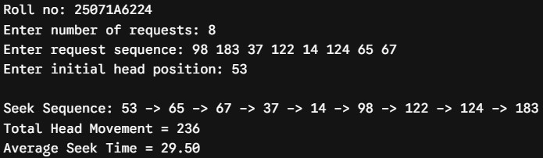
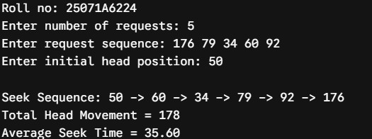
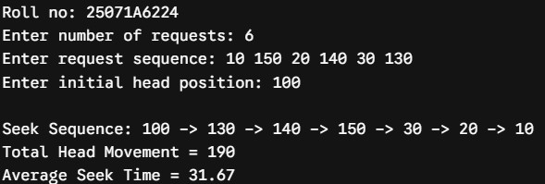
- SSTF

Program:
#include <stdio.h> #include <stdlib.h> int main() {
printf("Roll no: 25071A6224\n");
int n, head, req[20], visited[20] = {0}, thm = 0; printf("Enter number of requests: "); scanf("%d", &n); printf("Enter request sequence: ");
for (int i = 0; i < n; i++) scanf("%d", &req[i]); printf("Enter initial head position: "); scanf("%d", &head);

printf("\nSeek Sequence: %d", head); for (int count = 0; count < n; count++) {
int min_dist = 1e9, idx = -1; for (int i = 0; i < n; i++) {
if (!visited[i] && abs(req[i] - head) < min_dist) { min_dist = abs(req[i] - head);
idx = i;
}
}
visited[idx] = 1; thm += min_dist; head = req[idx];
printf(" -> %d", head);
}
printf("\nTotal Head Movement = %d\nAverage Seek Time = %.2f\n", thm, (float)thm / n); return 0;
}

Testcases:

25071A6224 58

VNRVJIET

Name of the laboratory:

OPERATING SYSTEMS

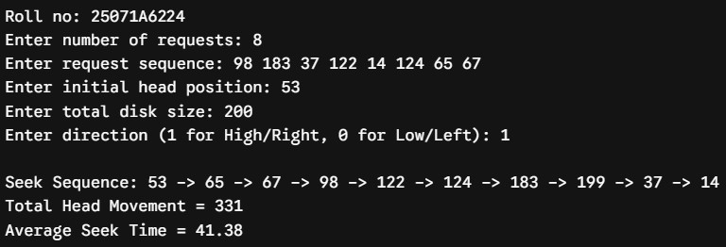
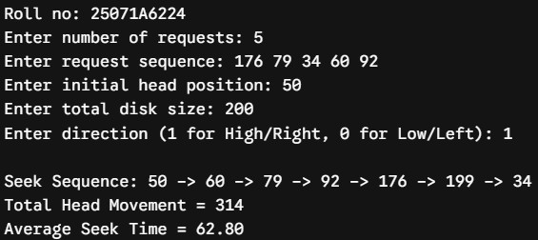
- SCAN

Program:
#include <stdio.h> #include <stdlib.h> int main() {
printf("Roll no: 25071A6224\n");
int n, h, r[30], s, d, thm = 0, p = 0;

Name of the Experiment:

Experiment No: Date:

printf("Enter number of requests: "); scanf("%d", &n);
printf("Enter request sequence: "); for (int i = 0; i < n; i++) scanf("%d", &r[i]); printf("Enter initial head position: "); scanf("%d", &h);
printf("Enter total disk size: "); scanf("%d", &s);
printf("Enter direction (1 for High/Right, 0 for Low/Left): "); scanf("%d", &d); r[n++] = h; r[n++] = d ? s - 1 : 0;
for (int i = 0; i < n - 1; i++)
for (int j = 0; j < n - i - 1; j++)
if (r[j] > r[j + 1]) { int t = r[j]; r[j] = r[j + 1]; r[j + 1] = t; } while (r[p] != h) p++;
printf("\nSeek Sequence: %d", h);
int cur = h, step = d ? 1 : -1, start = d ? p + 1 : p - 1, end = d ? n : -1; for (int pass = 0; pass < 2; pass++) {
for (int i = start; i != end; i += step) { thm += abs(r[i] - cur); cur = r[i]; printf(" -> %d", cur); } step = -step; start = (d == (pass == 0)) ? p - 1 : p + 1; end = (d == (pass == 0)) ? -1 : n;
}
printf("\nTotal Head Movement = %d\nAverage Seek Time = %.2f\n", thm, (float)thm / (n - 2)); return 0;
}

Testcases:

25071A6224 59

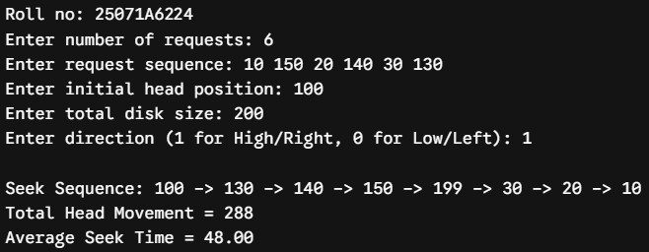

25071A6224 60

VNRVJIET

Name of the laboratory:

OPERATING SYSTEMS

Name of the Experiment: Disk scheduling

Algorithms a) C-SCAN b) LOOK c) C-LOOK

Experiment No: 9 Date: 17-09-2026

Aim: Simulate the following Disk scheduling algorithms. A) C-SCAN B) LOOK C) C-LOOK
- C- SCAN

Algorithm:
  - Start.
  - Input number of requests n, request sequence, initial head position, and disk size.
  - Sort the request sequence in ascending order.
  - If direction is RIGHT:
    - Service requests from the current head towards disk_size - 1.
    - Move the head directly to 0.
    - Continue servicing the remaining requests in ascending order.
  - Calculate Total Head Movement and Average Seek Time.
  - Display the results.
  - Stop.
- LOOK

Algorithm:

Start.
  - Input number of requests n, request sequence, initial head position, and direction.
  - Sort the request sequence in ascending order.
  - If direction is RIGHT:
    - Service requests to the right up to the maximum requested track.
    - Reverse direction and service the remaining requests to the left.
  - If direction is LEFT:
    - Service requests to the left up to the minimum requested track.
    - Reverse direction and service the remaining requests to the right.
  - Calculate Total Head Movement and Average Seek Time.
  - Display the results.
  - Stop.
- C-LOOK

Algorithm:

Start.
  - Input number of requests n, request sequence, initial head position, and direction.
  - Sort the request sequence in ascending order.
  - If direction is RIGHT:
    - Service requests to the right up to the maximum requested track.
    - Jump directly to the minimum requested track.
    - Service the remaining requests up to the track before the starting head.
  - Calculate Total Head Movement and Average Seek Time.
  - Display the results.

Stop.
25071A6224 61

25071A6224 62

VNRVJIET

Name of the laboratory:

OPERATING SYSTEMS

25071A6224

Name of the Experiment:

Experiment No: Date:

63

25071A6224 64

VNRVJIET

Name of the laboratory:

OPERATING SYSTEMS

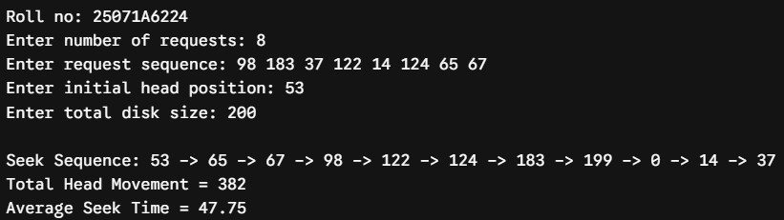
- C-SCAN

Program:
#include <stdio.h> #include <stdlib.h> int main() {
printf("Roll no: 25071A6224\n");
int n, head, req[30], disk_size, thm = 0;

Name of the Experiment:

Experiment No: Date:

printf("Enter number of requests: "); scanf("%d", &n); printf("Enter request sequence: ");
for (int i = 0; i < n; i++) scanf("%d", &req[i]); printf("Enter initial head position: "); scanf("%d", &head); printf("Enter total disk size: "); scanf("%d", &disk_size);

req[n++] = head; req[n++] = 0;
req[n++] = disk_size - 1;

for (int i = 0; i < n - 1; i++) {
for (int j = 0; j < n - i - 1; j++) { if (req[j] > req[j + 1]) {
int t = req[j]; req[j] = req[j + 1]; req[j + 1] = t;}}
}
int pos = 0;
for (int i = 0; i < n; i++) if (req[i] == head) { pos = i; break; }

printf("\nSeek Sequence: %d", head); int cur = head;
for (int i = pos + 1; i < n; i++) {
thm += abs(req[i] - cur); cur = req[i]; printf(" -> %d", cur);
}
for (int i = 0; i < pos; i++) {
thm += abs(req[i] - cur); cur = req[i]; printf(" -> %d", cur);}
printf("\nTotal Head Movement = %d\nAverage Seek Time = %.2f\n", thm, (float)thm / (n - 3)); return 0;
}

Testcases:

25071A6224 65

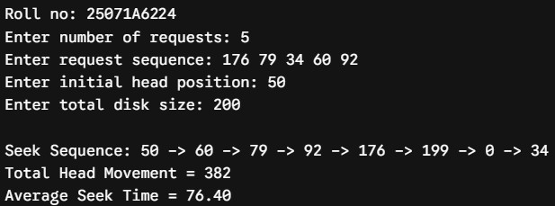
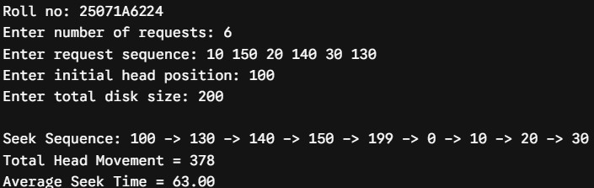

25071A6224 66

VNRVJIET

Name of the laboratory:

OPERATING SYSTEMS

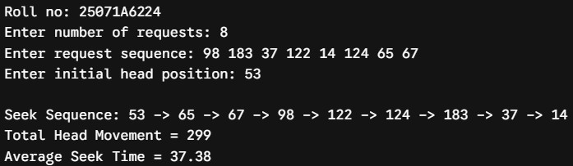
C) LOOK

Program:
#include <stdio.h> #include <stdlib.h> int main() {
printf("Roll no: 25071A6224\n");
int n, head, req[25], thm = 0;

Name of the Experiment:

Experiment No: Date:

printf("Enter number of requests: "); scanf("%d", &n); printf("Enter request sequence: ");
for (int i = 0; i < n; i++) scanf("%d", &req[i]); printf("Enter initial head position: "); scanf("%d", &head);

req[n++] = head;
for (int i = 0; i < n - 1; i++) {
for (int j = 0; j < n - i - 1; j++) { if (req[j] > req[j + 1]) {
int t = req[j]; req[j] = req[j + 1]; req[j + 1] = t;
}
}
}

int pos = 0;
for (int i = 0; i < n; i++) if (req[i] == head) { pos = i; break; }

printf("\nSeek Sequence: %d", head); int cur = head;
for (int i = pos + 1; i < n; i++) {
thm += abs(req[i] - cur); cur = req[i]; printf(" -> %d", cur);
}
for (int i = pos - 1; i >= 0; i--) {
thm += abs(req[i] - cur); cur = req[i]; printf(" -> %d", cur);
}

printf("\nTotal Head Movement = %d\nAverage Seek Time = %.2f\n", thm, (float)thm / (n - 1)); return 0;
}

Testcases:

25071A6224 67

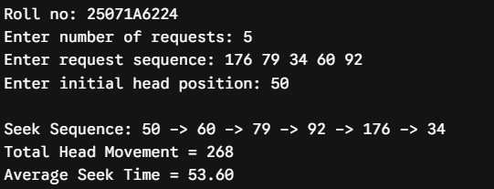
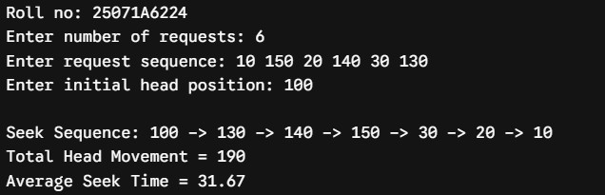

25071A6224 68

VNRVJIET

Name of the laboratory:

OPERATING SYSTEMS

C) C-LOOK

Program:
#include <stdio.h> #include <stdlib.h> int main() {
printf("Roll no: 25071A6224\n");
int n, head, req[25], thm = 0;

Name of the Experiment:

Experiment No: Date:

printf("Enter number of requests: "); scanf("%d", &n); printf("Enter request sequence: ");
for (int i = 0; i < n; i++) scanf("%d", &req[i]); printf("Enter initial head position: "); scanf("%d", &head);

req[n++] = head;
for (int i = 0; i < n - 1; i++) {
for (int j = 0; j < n - i - 1; j++) { if (req[j] > req[j + 1]) {
int t = req[j]; req[j] = req[j + 1]; req[j + 1] = t;
}
}
}

int pos = 0;
for (int i = 0; i < n; i++) if (req[i] == head) { pos = i; break; }

printf("\nSeek Sequence: %d", head); int cur = head;
for (int i = pos + 1; i < n; i++) {
thm += abs(req[i] - cur); cur = req[i]; printf(" -> %d", cur);
}
for (int i = 0; i < pos; i++) {
thm += abs(req[i] - cur); cur = req[i]; printf(" -> %d", cur);
}

printf("\nTotal Head Movement = %d\nAverage Seek Time = %.2f\n", thm, (float)thm / (n - 1)); return 0;
}

25071A6224 69

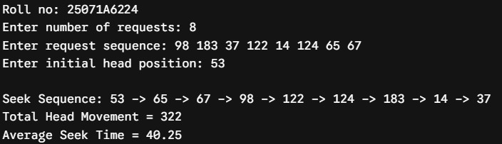
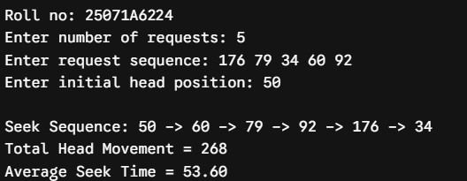
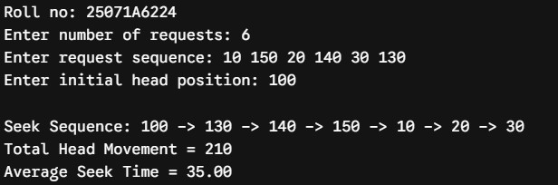
Testcases:

25071A6224 70

VNRVJIET

Name of the laboratory:
OPERATING SYSTEMS

Name of the Experiment: File Allocation

Strategies

Experiment No: 10 Date: 24-09-2026

Aim: Simulate all file allocation strategies. A. Sequential, B. Indexed, C. Linked
- Sequential

Algorithm:

Start.
  - Input disk block status, total number of blocks, starting block, and file length.
  - Check whether all blocks from start to start + length - 1 are free.
  - If all blocks are free, allocate them to the file.
  - Display the allocation status and allocated block numbers.
  - Stop.

- Indexed

Algorithm:

Start.
  - Input index block number and number of file blocks n.
  - Check whether the index block is free.
  - Input the required block numbers and check whether all blocks are free.
  - If all blocks are free, allocate the index block and all required blocks.
  - Display the index block and its allocated block mapping.
  - Stop.

- Linked

Algorithm:

Start.
  - Input starting block number and number of blocks n.
  - Input the block numbers forming the linked chain.
  - Check whether all required blocks are free.
  - Allocate the blocks and link them in sequence, ending with -1.
  - Display the linked block sequence.

Stop.

25071A6224 71

25071A6224 72

VNRVJIET

Name of the laboratory:

OPERATING SYSTEMS

25071A6224

Name of the Experiment:

Experiment No: Date:

73

25071A6224 74

VNRVJIET

Name of the laboratory:

OPERATING SYSTEMS

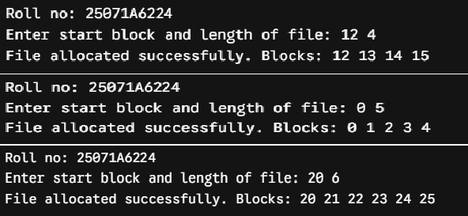
- Sequential

Program:
#include <stdio.h>

Name of the Experiment:

Experiment No: Date:

int main() {
printf("Roll no: 25071A6224\n");
int disk[50] = {0}, start, len, alloc = 1; printf("Enter start block and length of file: "); scanf("%d %d", &start, &len);
for (int i = start; i < start + len; i++) if (disk[i]) alloc = 0; if (alloc) {
printf("File allocated successfully. Blocks: "); for (int i = start; i < start + len; i++) {
disk[i] = 1; printf("%d ", i);
}
printf("\n");
} else printf("Allocation failed: Contiguous blocks unavailable.\n"); return 0;
}

Testcases:

25071A6224 75

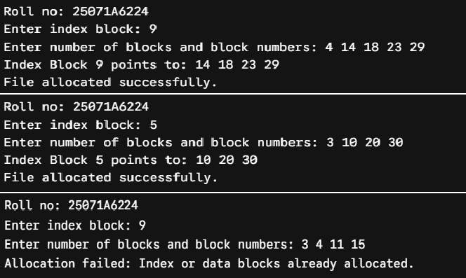
- Indexed

Program:
#include <stdio.h>

int main() {
printf("Roll no: 25071A6224\n");
int disk[50] = {0}, idx, n, b[20], alloc = 1; printf("Enter index block: "); scanf("%d", &idx);
printf("Enter number of blocks and block numbers: "); scanf("%d", &n); for (int i = 0; i < n; i++) scanf("%d", &b[i]);
if (disk[idx]) alloc = 0;
for (int i = 0; i < n; i++) if (disk[b[i]]) alloc = 0; if (alloc) {
disk[idx] = 1; printf("Index Block %d points to: ", idx);
for (int i = 0; i < n; i++) { disk[b[i]] = 1; printf("%d ", b[i]); } printf("\nFile allocated successfully.\n");
} else printf("Allocation failed: Index or data blocks already allocated.\n"); return 0;
}

Testcases:

25071A6224 76

VNRVJIET

Name of the laboratory:
OPERATING SYSTEMS

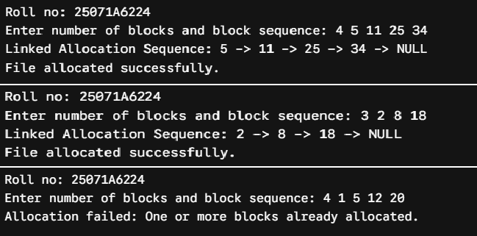
- Linked

Program:
#include <stdio.h>

Name of the Experiment:

Experiment No: Date:

int main() {
printf("Roll no: 25071A6224\n");
int disk[50] = {0}, n, b[20], alloc = 1;
printf("Enter number of blocks and block sequence: "); scanf("%d", &n); for (int i = 0; i < n; i++) scanf("%d", &b[i]);
for (int i = 0; i < n; i++) if (disk[b[i]]) alloc = 0; if (alloc) {
printf("Linked Allocation Sequence: "); for (int i = 0; i < n; i++) {
disk[b[i]] = 1; printf("%d -> ", b[i]);
}
printf("NULL\nFile allocated successfully.\n");
} else printf("Allocation failed: One or more blocks already allocated.\n"); return 0;
}

Testcases:

25071A6224 77

25071A6224 78

VNRVJIET

Name of the laboratory:
OPERATING SYSTEMS

Name of the Experiment: Page

Replacement algorithms

Experiment No: 6 Date: 08-10-2026

Aim: Implementation of the following Page Replacement Algorithms A. FIFO, B. LRU, C. Optimal.
- FIFO

Algorithm:

Start.
  - Input number of frames f, reference string length n, and page reference sequence.
  - Initialize all frames to -1, set replacement pointer idx = 0, and page faults to 0.
  - For each page in the reference string:
  - Check whether the page is already in a frame.
  - If not found, replace the page at idx.
  - Update idx = (idx + 1) % f and increment page faults.
  - Calculate and display total page faults and page fault rate.
  - Stop.

- LRU

Algorithm:

Start.
  - Input number of frames f, reference string length n, and page reference sequence.
  - Initialize all frames to -1, timestamps to 0, and page faults to 0.
  - For each page in the reference string:
  - Check whether the page is present in a frame.
  - If found, update its timestamp.
  - If not found, replace the page with the smallest timestamp and increment page faults.
  - Calculate and display total page faults and page fault rate.
  - Stop.

- Optimal

Algorithm:

Start.
  - Input number of frames f, reference string length n, and page reference sequence.
  - Initialize all frames to -1 and page faults to 0.
  - For each page in the reference string:
    - Check whether the page is already present.
    - If not present and an empty frame exists, allocate the page.
    - Otherwise, replace the page that will be used farthest in the future or not used again.
    - Increment page faults.
  - Calculate and display total page faults and page fault rate.

Stop.

25071A6224 79

25071A6224 80

VNRVJIET

Name of the laboratory:

OPERATING SYSTEMS

25071A6224

Name of the Experiment:

Experiment No: Date:

81

25071A6224 82

VNRVJIET

Name of the laboratory:

OPERATING SYSTEMS

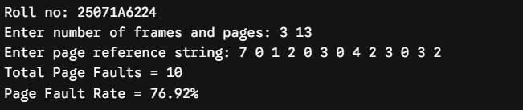
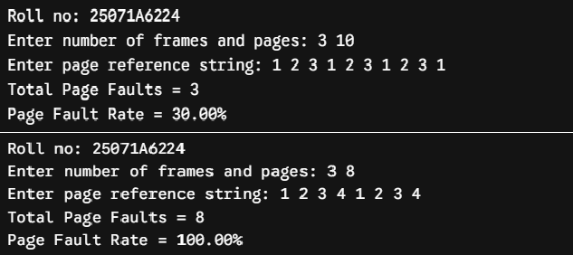
- FIFO

Program:
#include <stdio.h> int main() {
printf("Roll no: 25071A6224\n");
int f, n, p[30], m[10], pf = 0, idx = 0;

Name of the Experiment:

Experiment No: Date:

printf("Enter number of frames and pages: "); scanf("%d %d", &f, &n); printf("Enter page reference string: "); for (int i = 0; i < n; i++) scanf("%d", &p[i]); for (int i = 0; i < f; i++) m[i] = -1;
for (int i = 0; i < n; i++) { int hit = 0;
for (int j = 0; j < f; j++) if (m[j] == p[i]) hit = 1;
if (!hit) { m[idx] = p[i]; idx = (idx + 1) % f; pf++; }
}
printf("Total Page Faults = %d\nPage Fault Rate = %.2f%%\n", pf, (float)pf / n * 100); return 0;
}

Testcases:

25071A6224 83

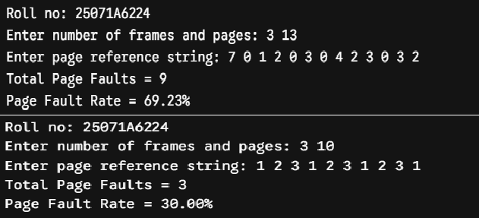
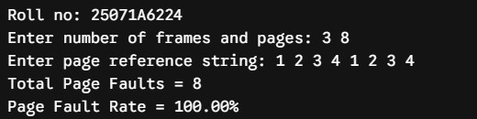
- LRU

Program:
#include <stdio.h> int main() {
printf("Roll no: 25071A6224\n");
int f, n, p[30], m[10], t[10] = {0}, pf = 0;
printf("Enter number of frames and pages: "); scanf("%d %d", &f, &n); printf("Enter page reference string: "); for (int i = 0; i < n; i++) scanf("%d", &p[i]); for (int i = 0; i < f; i++) m[i] = -1;
for (int i = 0; i < n; i++) { int hit = 0, lru = 0;
for (int j = 0; j < f; j++) if (m[j] == p[i]) { hit = 1; t[j] = i + 1; } if (!hit) {
for (int j = 1; j < f; j++) if (t[j] < t[lru]) lru = j; m[lru] = p[i]; t[lru] = i + 1; pf++;
}
}
printf("Total Page Faults = %d\nPage Fault Rate = %.2f%%\n", pf, (float)pf / n * 100); return 0;
}

Testcases:

25071A6224 84

VNRVJIET

Name of the laboratory:
OPERATING SYSTEMS

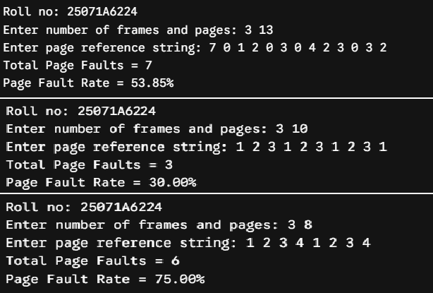
- Optimal

Program:
#include <stdio.h> int main() {
printf("Roll no: 25071A6224\n");
int f, n, p[30], m[10], pf = 0;

Name of the Experiment:

Experiment No: Date:

printf("Enter number of frames and pages: "); scanf("%d %d", &f, &n); printf("Enter page reference string: "); for (int i = 0; i < n; i++) scanf("%d", &p[i]); for (int i = 0; i < f; i++) m[i] = -1;
for (int i = 0; i < n; i++) {
int hit = 0, opt = -1, max = -1;
for (int j = 0; j < f; j++) if (m[j] == p[i]) hit = 1; if (!hit) {
for (int j = 0; j < f; j++) {
int k; for (k = i + 1; k < n; k++) if (m[j] == p[k]) break; if (k > max) { max = k; opt = j; }
}
m[opt] = p[i]; pf++;
}
}
printf("Total Page Faults = %d\nPage Fault Rate = %.2f%%\n", pf, (float)pf / n * 100); return 0;
}

Testcases:

25071A6224 85

25071A6224 86

