LAB 23.1(AIAC)
Ch .Tejaswi
2303A51944
B27

Task 1 – Project Proposal PROMPT:
Prepare a project proposal for an AI-assisted application e.g e-commerce billing system. Include objectives, features, tools/technologies to be used, and expected outcome.

OUTPUT:
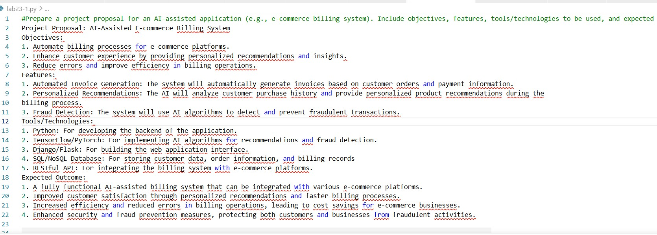
EXPLANATION:
- This task is about creating a project idea to solve a real problem.
- It explains the objective, features, tools, and expected results.
- AI features like recommendations and fraud detection are included.
- It gives a basic plan for building the application.

Task 2 – Application Design
PROMPT:
design the system architecture diagrams and define the dabase schemas if needed and create a wirefrrames/ui mockups for frontend design OUTPUT:
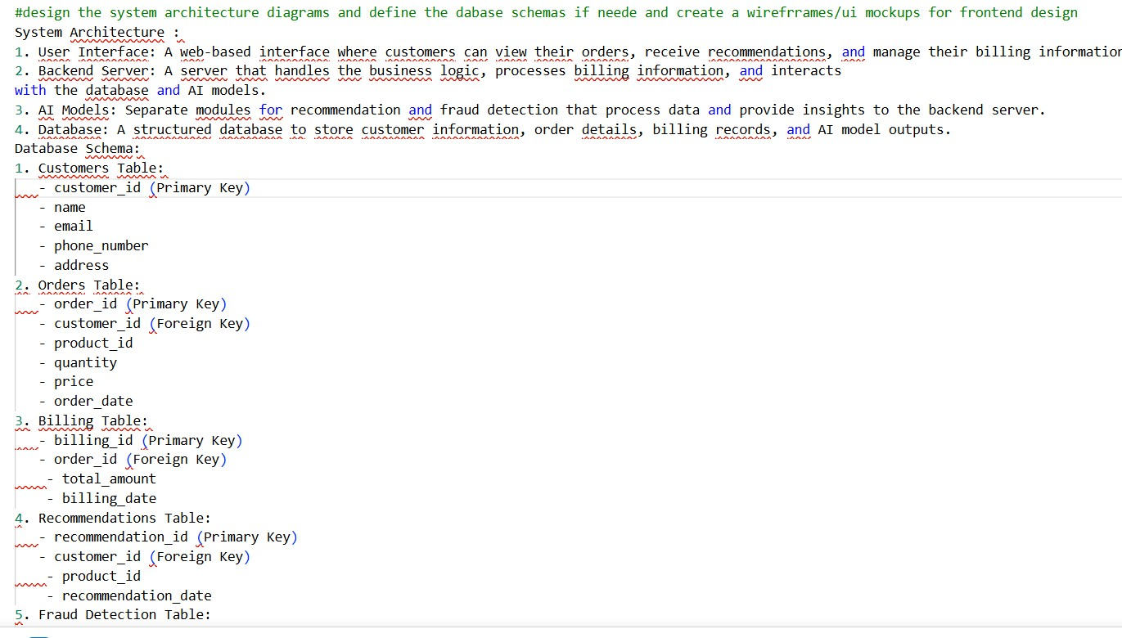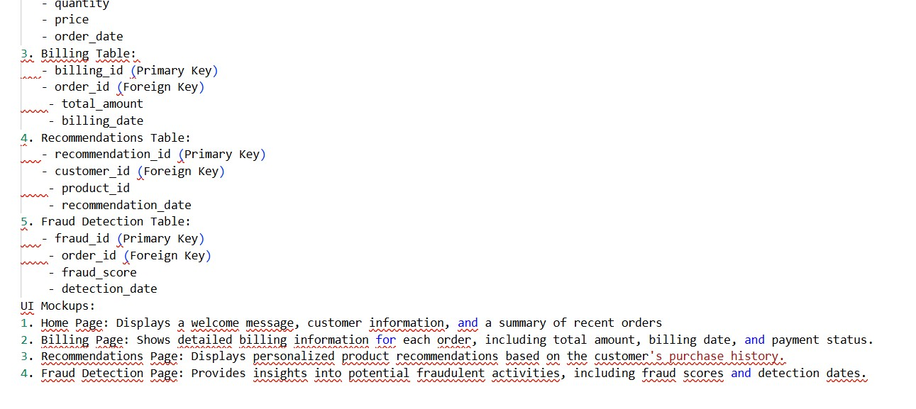
EXPLANATION:
- This task focuses on designing how the application will work.
- It includes system architecture, database schema, and UI design.
- It shows how frontend, backend, and database are connected.
- It helps in planning the structure before coding.

Task 3 – AI-Assisted Code Development PROMPT:
Implement the application in phase:
- Frontend: Build a simple UI using HTML, CSS, and JavaScript (login page, dashboard, and main functionality).
- Backend: Create RESTful APIs with proper server logic and user authentication.
- Database: Design schema and provide SQL queries for storing data.
- Integration: Connect frontend and backend using API calls, include authentication, error handling, and proper data flow.
Ensure the code is simple, well-structured, and includes comments for understanding.
Frontend (HTML/CSS/JavaScript)

CODE:
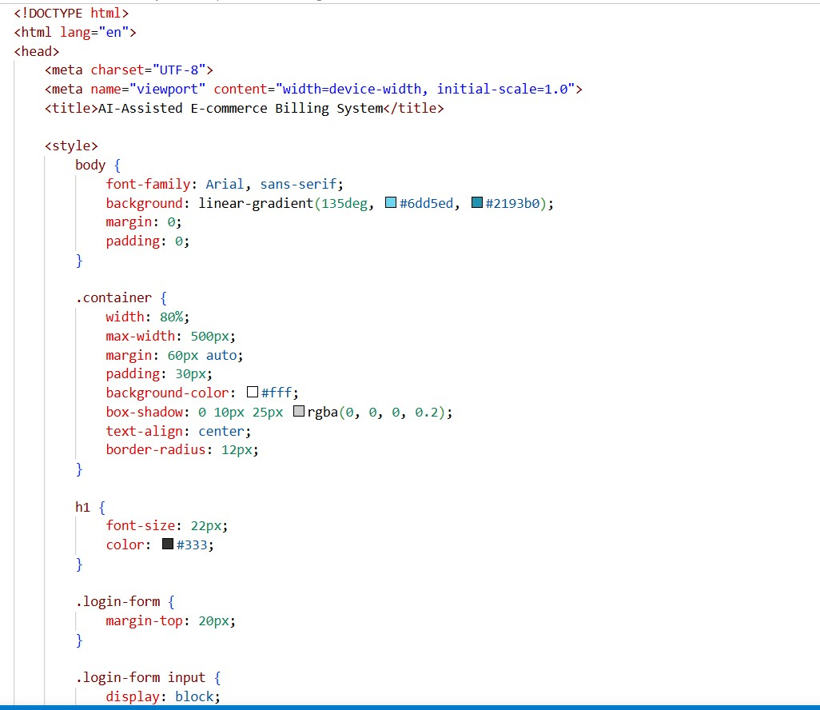

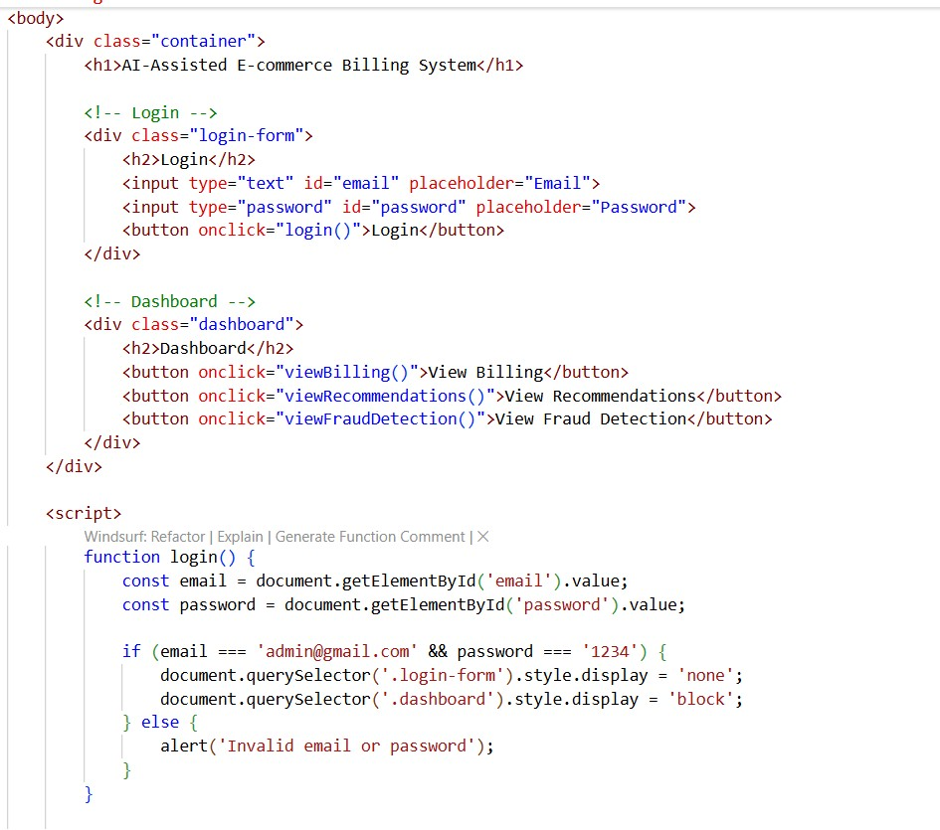

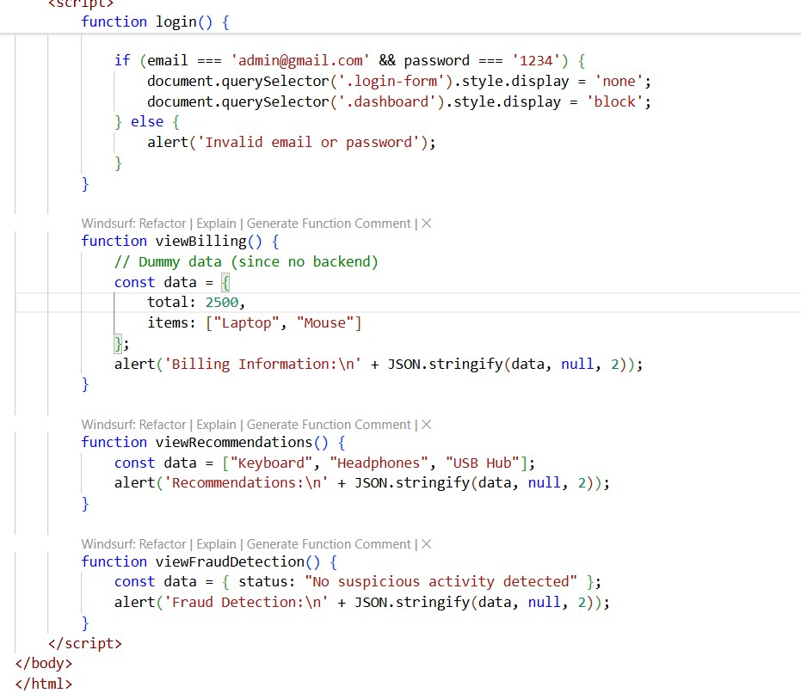
OUTPUT:
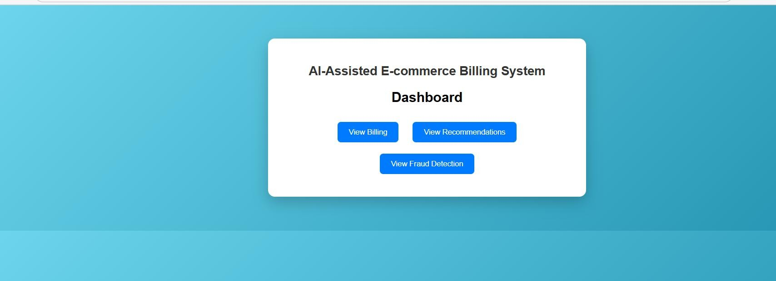
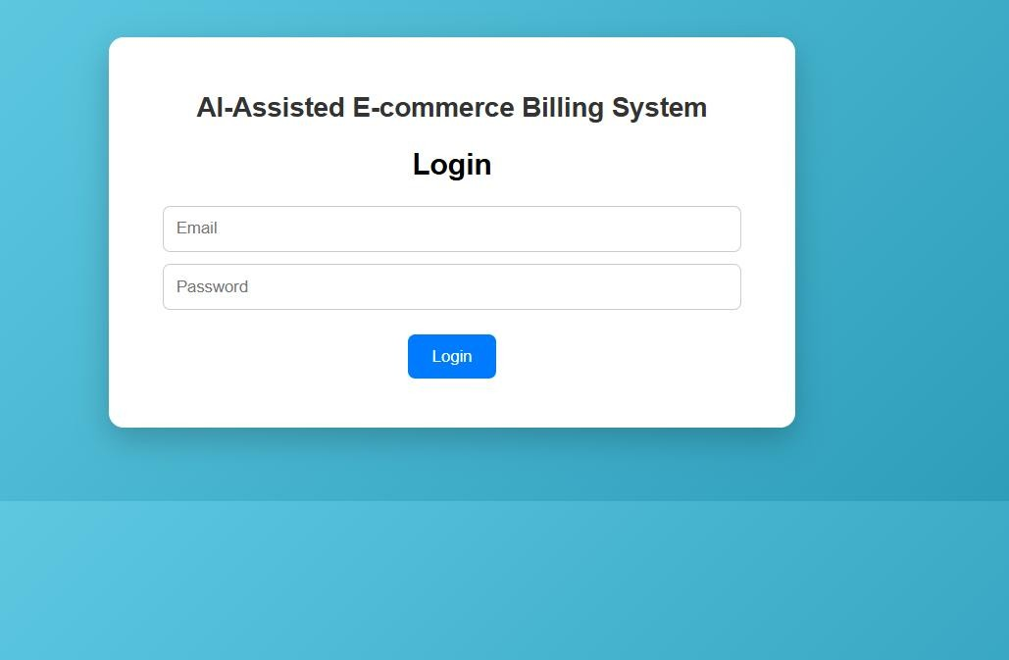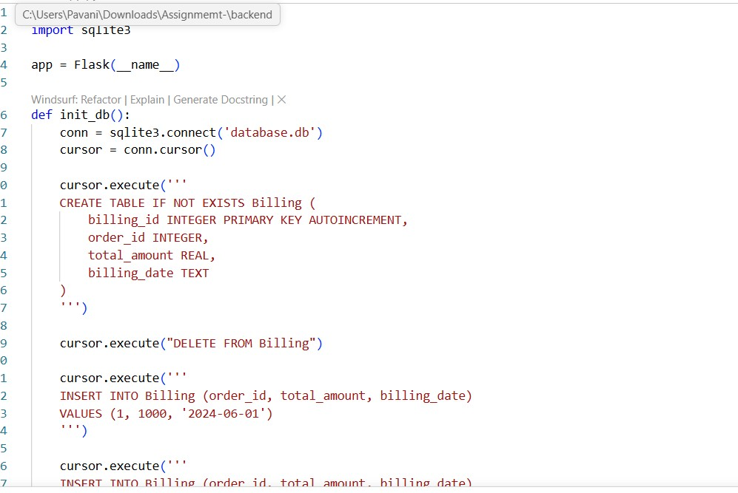
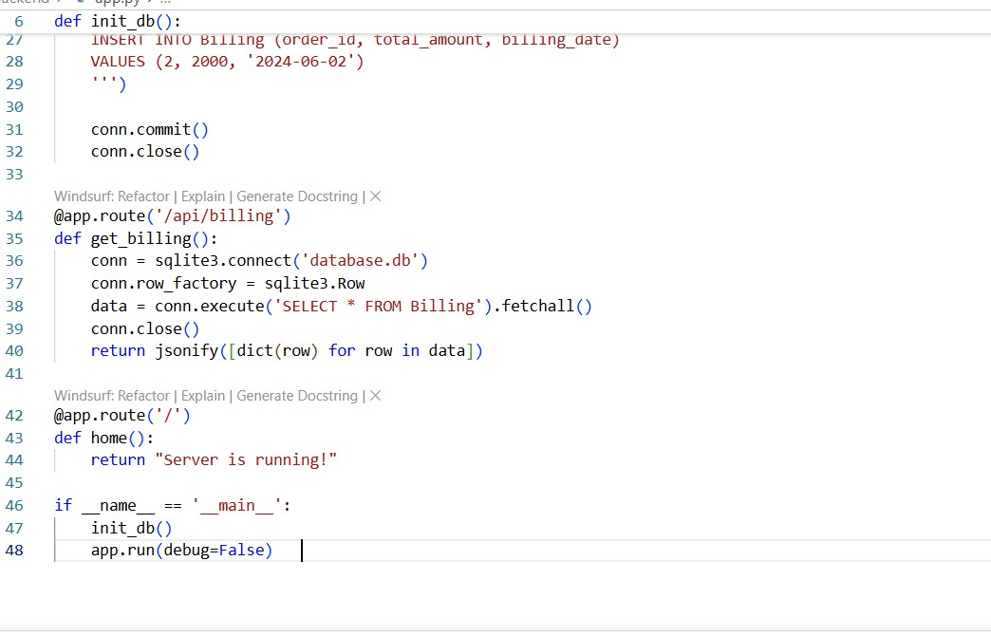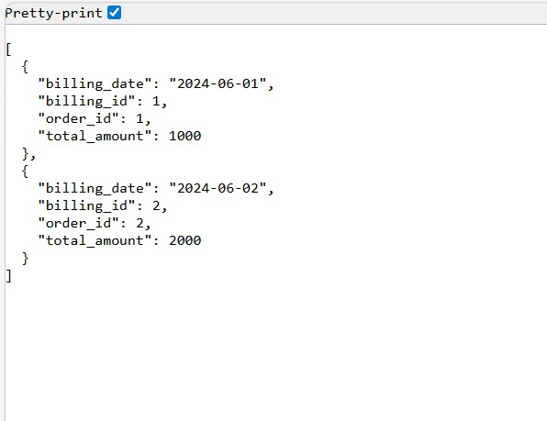

EXPLANATION:
  - This task involves creating the user interface using HTML, CSS, and JavaScript.
  - It includes pages like login, dashboard, and main features.
  - The design should be simple, user-friendly, and easy to use.
  - It connects with backend APIs to display data and perform actions.

Task 4 – Documentation & Code Quality PROMPT:
generate automatic documentation and line comments using ai and ensure clear Readme.md for project setup and usage conduct Ai-assisted code review to refine readability and maintainability of the codebase, ensuring adherence to best practices and coding standards.
OUTPUT:
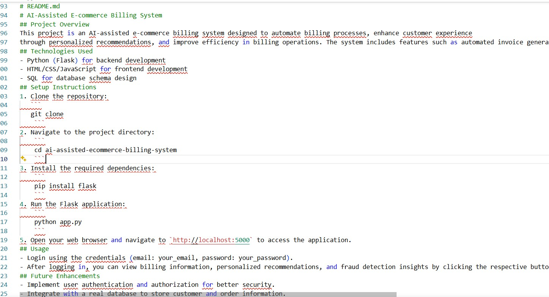
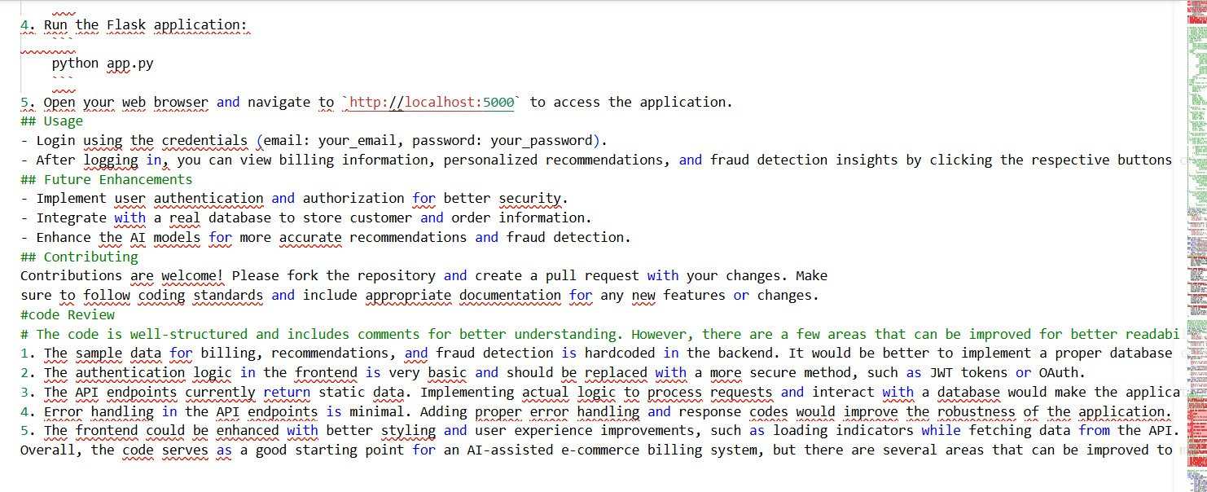
EXPLANATION:
  - This task focuses on writing clear documentation for the project.
  - AI is used to generate comments and improve code readability.
  - A README file is created for setup and usage instructions.
  - Code review is done to ensure good quality and best practices.

Task 5 – Testing & Debugging
PROMPT:
Generate unit tests and identify vulnerabilities/ security flaws and suggest optimization for performance CODE:
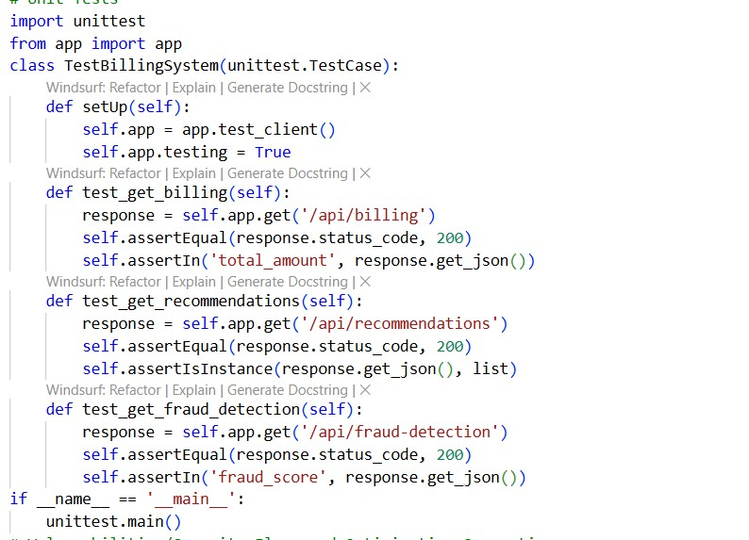
OUTPUT:
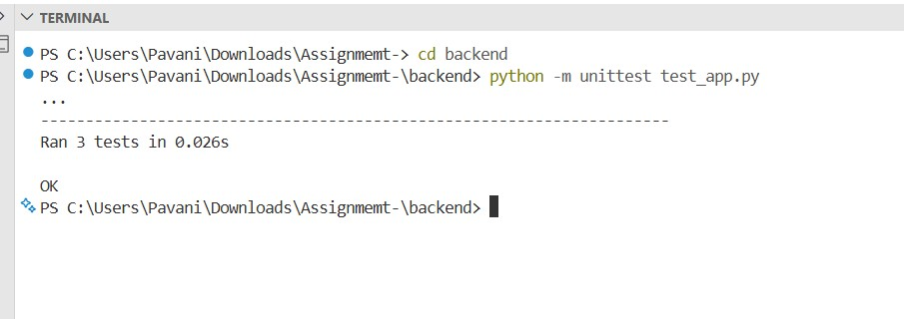
EXPLANATION:
  - This task involves creating unit tests to check if the application works correctly.
  - AI is used to find bugs, security issues, and vulnerabilities in the code.
  - It also suggests improvements to make the application faster and efficient.
  - Overall, it ensures the application is reliable, secure, and well-optimized.

Task 6 – Deployment & Presentation
PROMPT:
deploy application on a free hosting platform eg.Hroku github pages or firebase etc
OUTPUT:
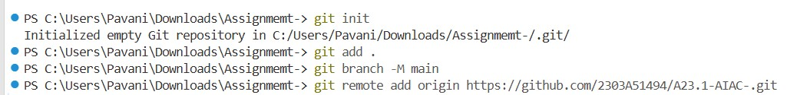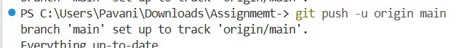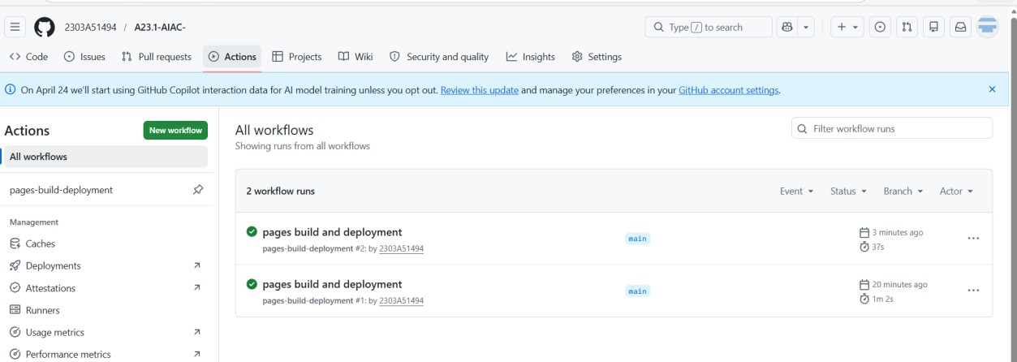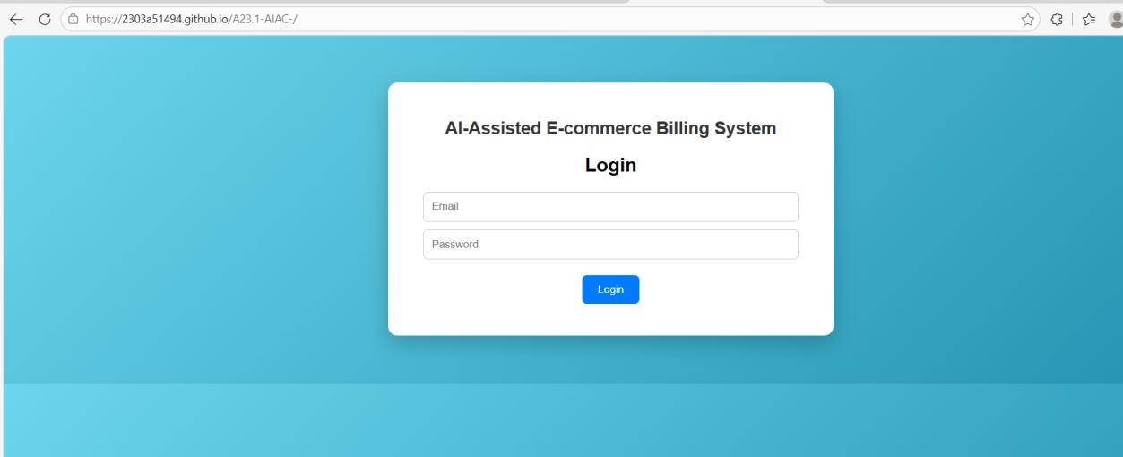

EXPLANATION:
  - This task involves deploying the application on a free platform like GitHub Pages.
  - The frontend of the project is successfully hosted and accessible online.
  - It allows users to view and interact with the application through a live link.
  - Deployment makes the project easy to share and demonstrate.

