**Analyzing Swiggy**

Wireframe Documentation

In accordance to the problem statement , the project has been divided in the chunks for making the visualization more feasible.

**1. Ratings of the Cuisines of swiggy**

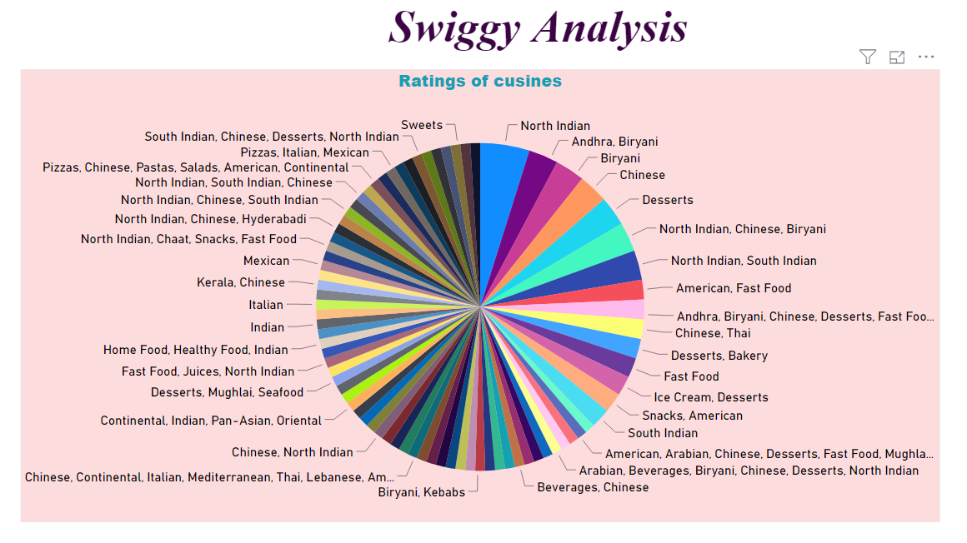

In the next visual , which displays the ratings of the cuisines, in accordance to the cost per head.

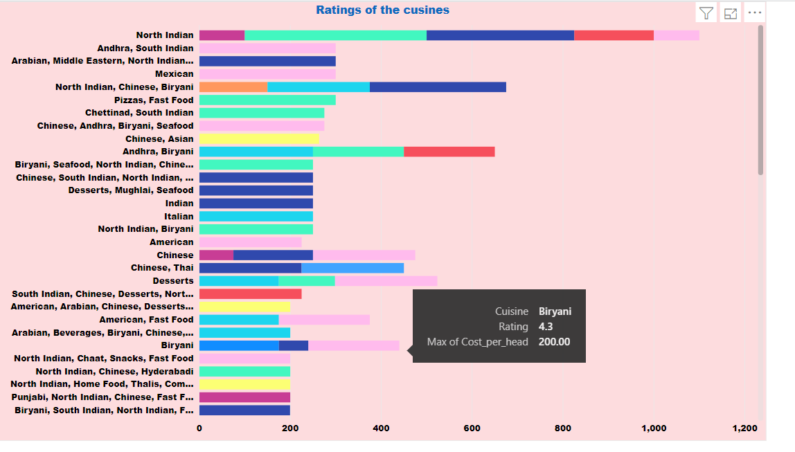

**2. Minimum ratings of the cuisines with cost per head**

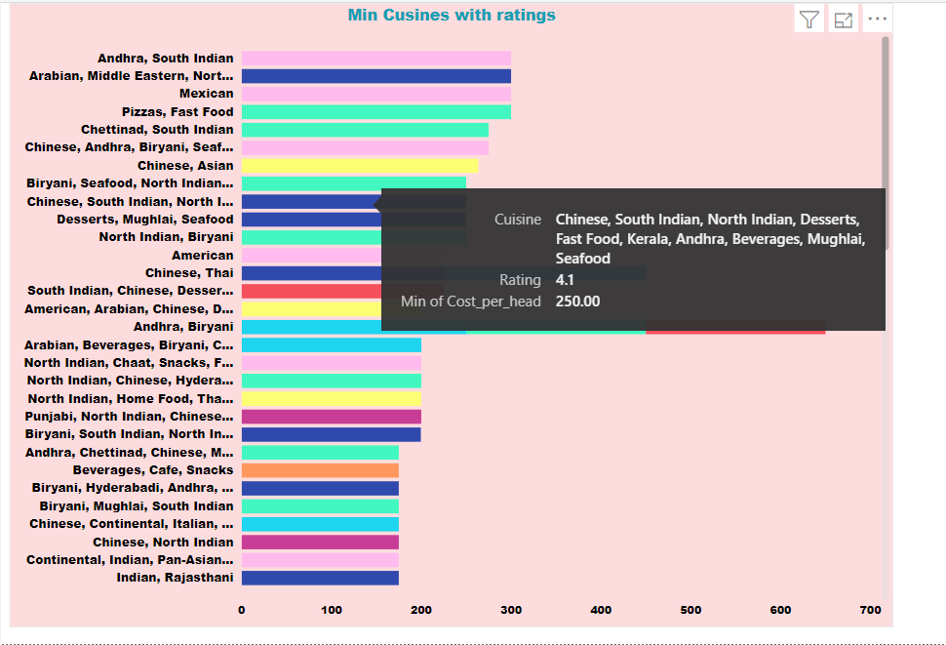

**3. Shops with their ratings in accordance to the cuisines.**

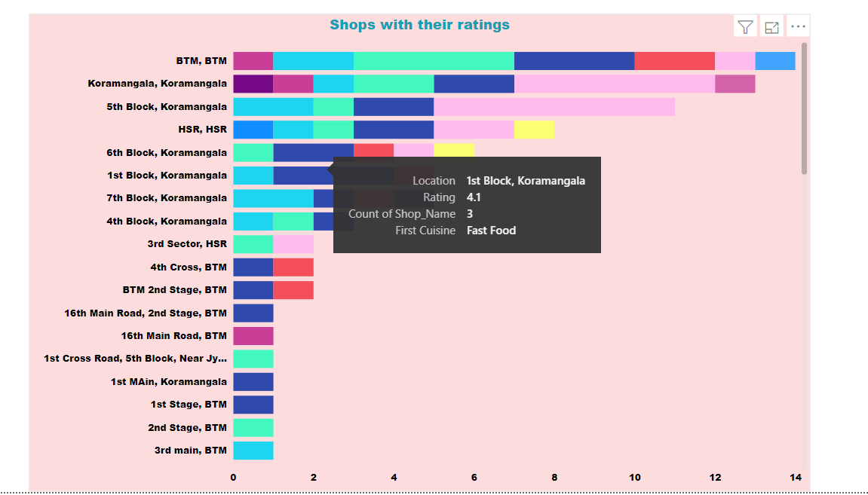

This, came to the dashboard of the analysis of the swiggy.

The dashboard majorly focuses on the ratings of cuisines with their costs and their locations.

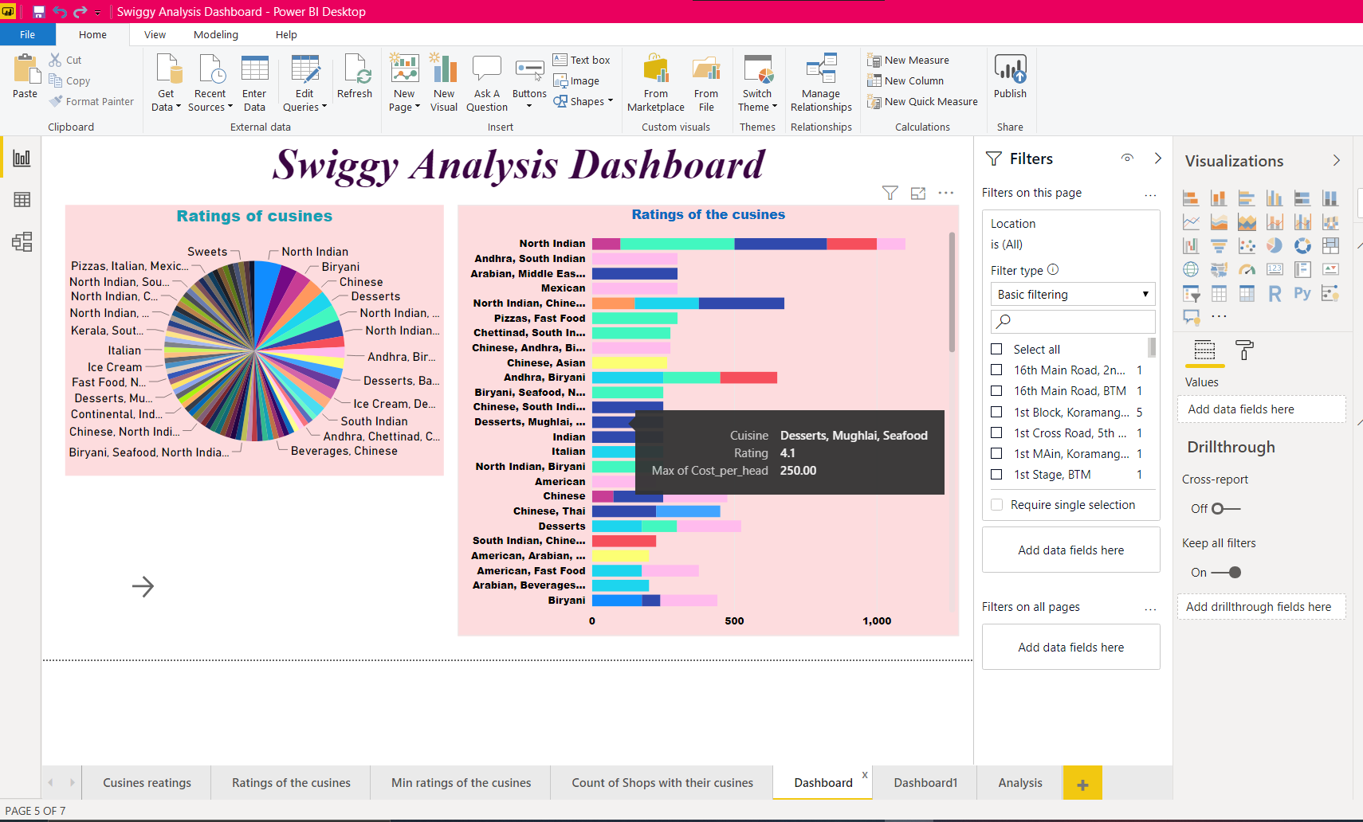

The next part of the dashboard focuses on the cuisines and shops with their ratings.

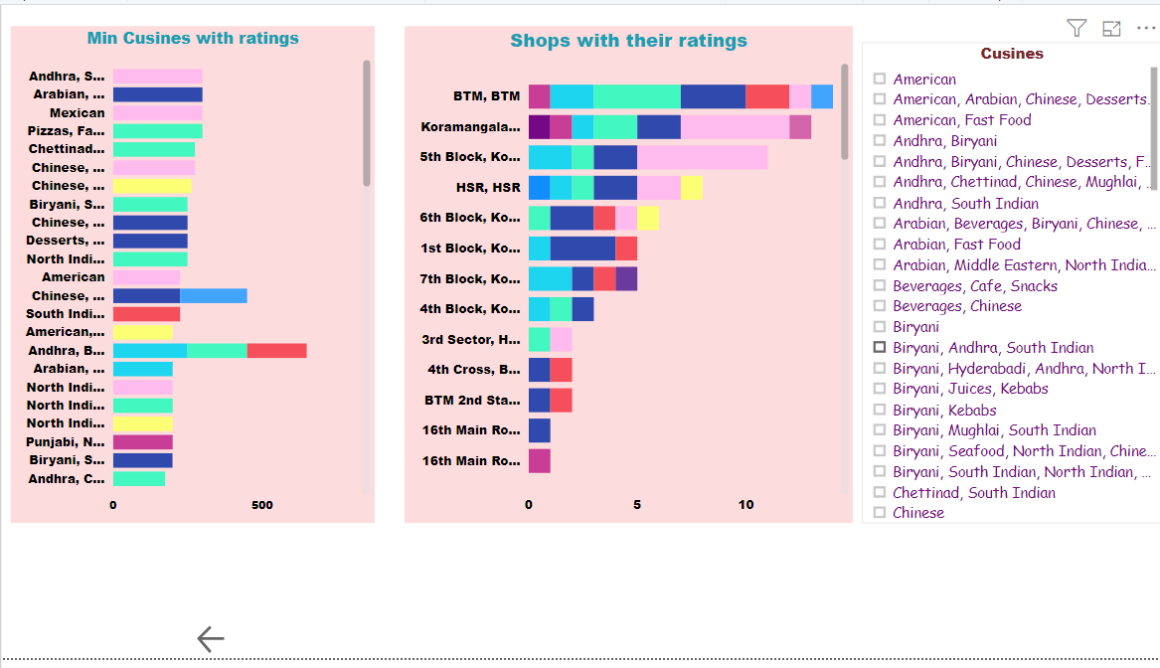

The next dashboard , gives the insights of ratings of the cuisines in the locations.

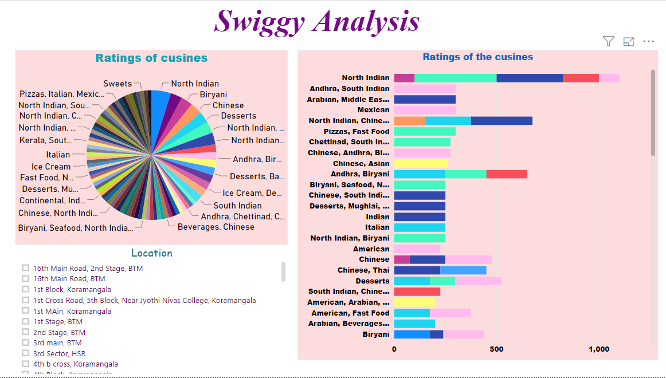

Driving relationships between the variables

Relationship between the cost per head and the ratings

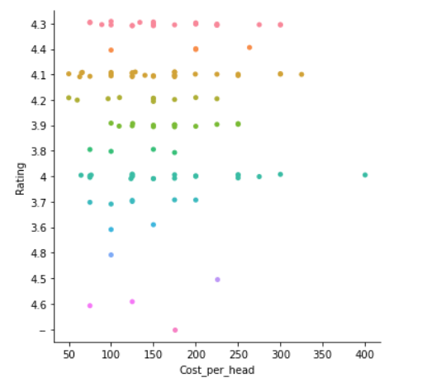

Relationship between the cost per head and ratings with the cuisines

