ISL HW2 SP19

Tejaswi Ayyadapu

Student ID: 16272957

Email ID: rdcb3@mail.umkc.edu

1.

Null hypothesis for “TV”: In the presence of radio, newspaper, and Internet ads, TV ads have no effect on sales.

Null hypothesis for “radio”: In the presence of TV, newspaper, and Internet ads, radio ads have effect on sales.

Null hypothesis for “Internet”: In the presence of TV, newspaper, and radio ads, Internet ads have no effect on sales. The low p-values of TV and Internet suggest that the null hypotheses are false for TV and Internet. The high p-values of newspaper and radio suggest that the null hypothesis is true for newspaper and radio.
Null hypothesis for “Newspaper”: In the presence of TV, radio and Internet, newspaper has effect on sales. The high p-vale suggests that null hypothesis is true for newspaper and radio.

2.

The final result of KNN classifier is the classification output for Y (qualitative), whereas the output for a KNN regression predicts the quantitative value for f(X). Otherwise, the functional form is very similar.

The KNN classifier is typically used to solve classification problems (those with a qualitative

response) by identifying the neighborhood of x0x0 and then estimating the conditional

probability P(Y=j|X=x0)P(Y=j|X=x0) for class jj as the fraction of points in the neighborhood whose

response values equal jj. The KNN regression method is used to solve regression problems (those

with a quantitative response) by again identifying the neighborhood of x0x0 and then

estimating f(x0)f(x0) as the average of all the training responses in the neighbourhood.

3.

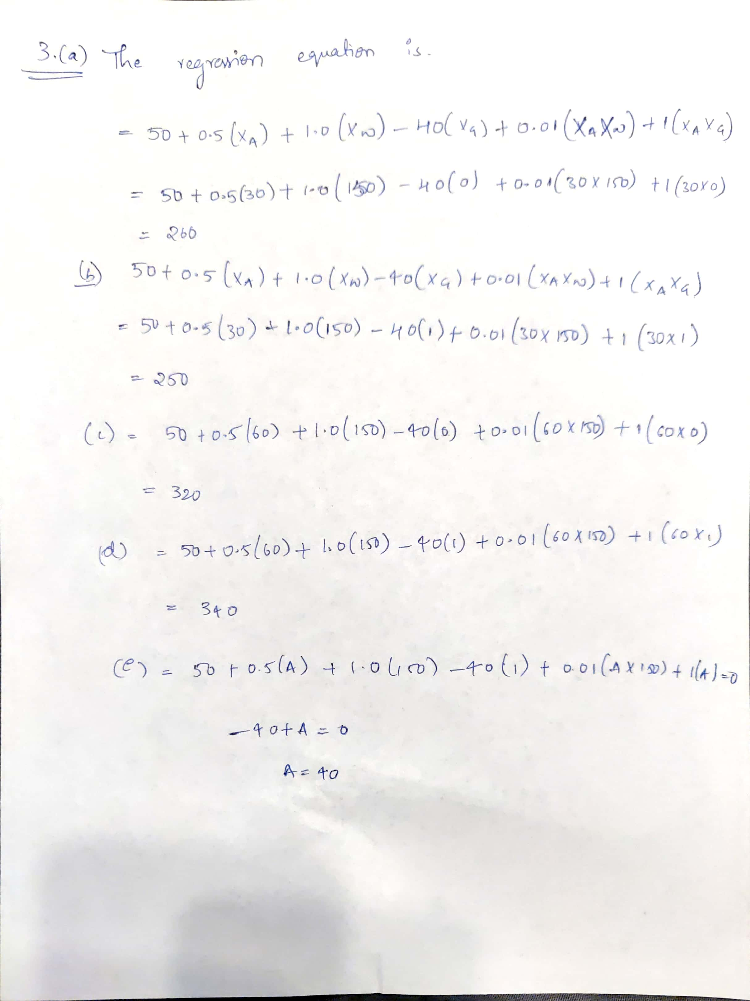

4.

a.) One would expect the polynomial regression to have a lower training RSS than the linear regression because it could make a tighter fit against data that matched with a wider irreducible error ϵ.

b.) Converse to above, one would expect the polynomial regression to have a higher test RSS as the overfit from training would have more error than the linear regression.

c.) Polynomial regression has lower training RSS than the linear fit because of higher flexibility: no matter what the underlying true relationship is, the more flexible model will closer follow points and reduce the training RSS.

d.) There is not enough information to tell which test RSS would be lower for either regression given the problem statement is defined as not knowing “how far it is from linear”. If it is closer to linear than cubic, the linear regression test RSS could be lower than the cubic regression test RSS. Or, if it is closer to cubic than linear, the cubic regression test RSS could be lower than the linear regression test RSS. It is dues to bias-variance tradeoff: it is not clear what level of flexibility Will fit data better.

5.



