ISL Lab 6 & 7

Tejaswi Ayyadapu

Student ID: 16278799

Email ID: atgkp@mail.umkc.edu

- (20 points total) In this exercise, you will further analyze the Wage data set considered throughout this chapter.

- (10 points) Perform polynomial regression to predict wage using age. Use cross-validation to select the optimal degree d for the polynomial. What degree was chosen, and how does this compare to the results of hypothesis testing using ANOVA? Make a plot of the resulting polynomial fit to the data.

Ans.

We will perform K-fold cross-validation with K=10.

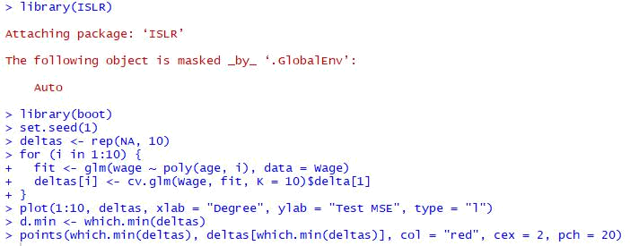
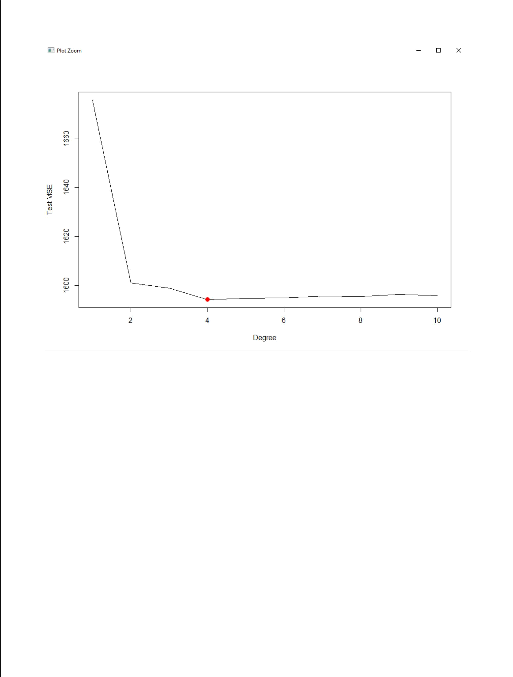

We may see that d=4 is the optimal degree for the polynomial. We now use ANOVA to test the null hypothesis that a model M1 is sufficient to explain the data against the alternative hypothesis that a more complex M2 is required.

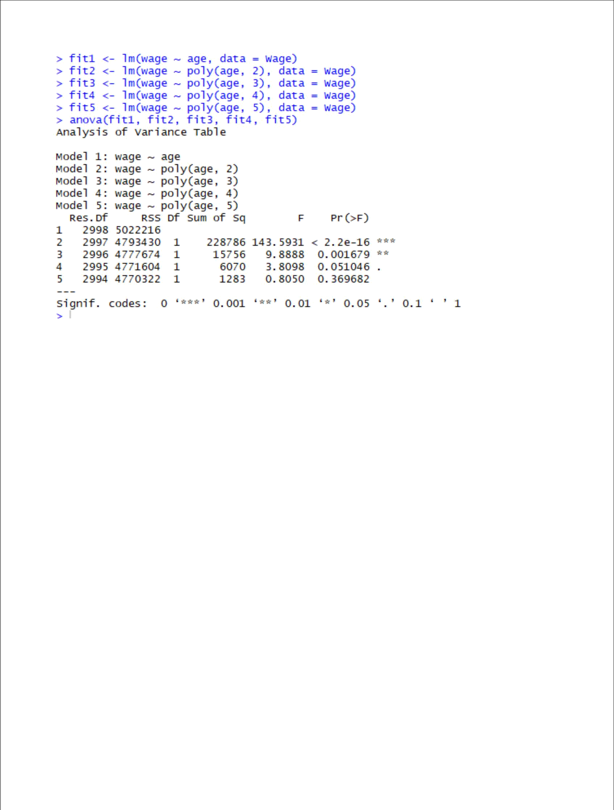

We may see, by examining the p-values, that either a cubic or quartic polynomial appear to provide a reasonable fit to the data, but lower or higher order models are not justified. It remains to plot the resulting polynomial fit to the data.

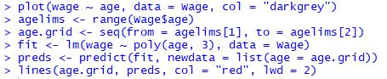
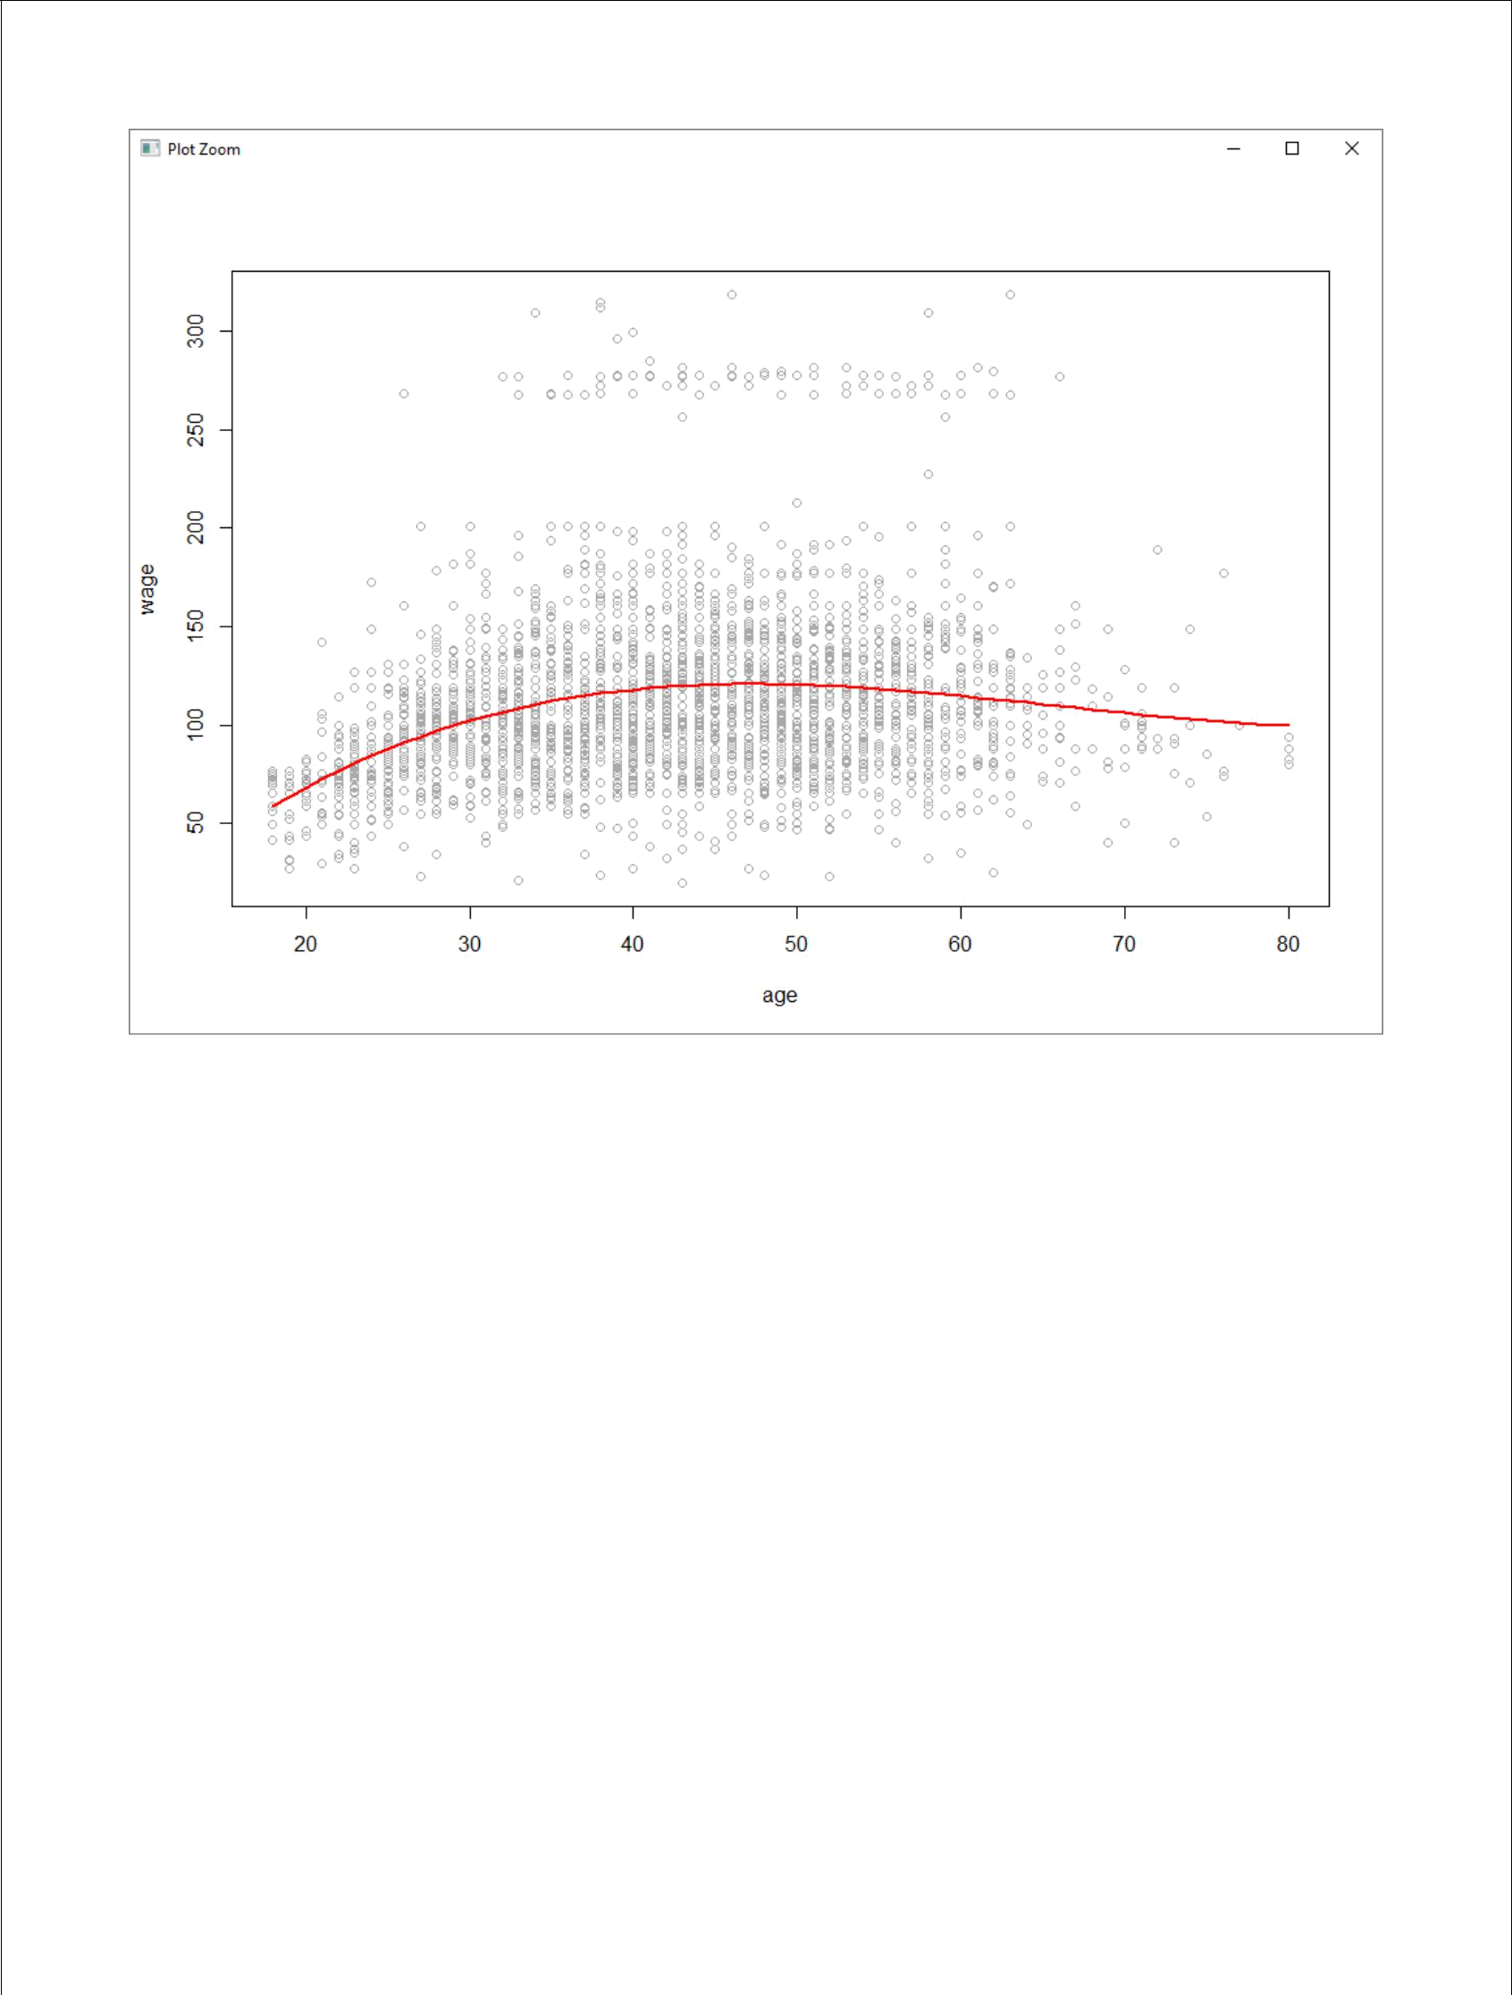

- (10 points) Fit a step function to predict wage using age, and perform cross-validation to choose the optimal number of cuts. Make a plot of the fit obtained.

Ans.

We will perform K-fold cross-validation with K=10.

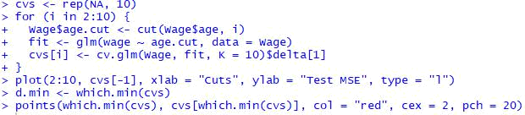
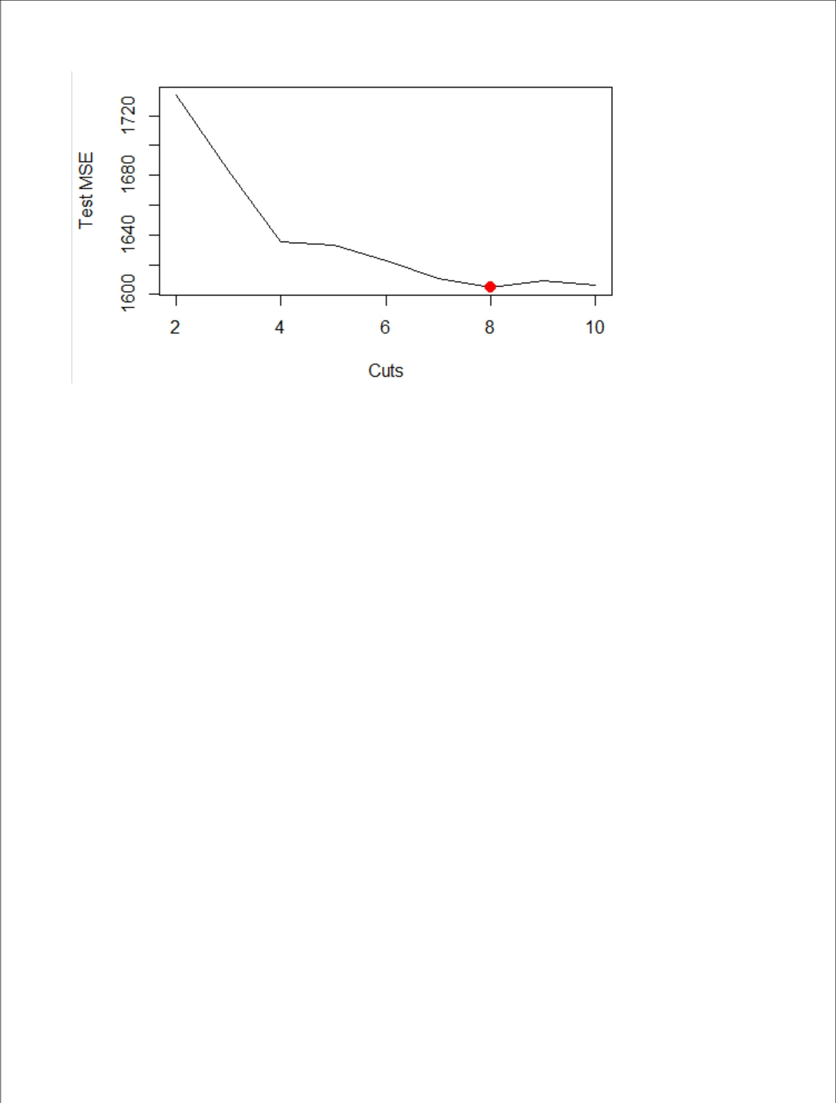

We may see that the error is minimum for 8 cuts. Now, we fit the entire data with a step function using 8 cuts and plot it.

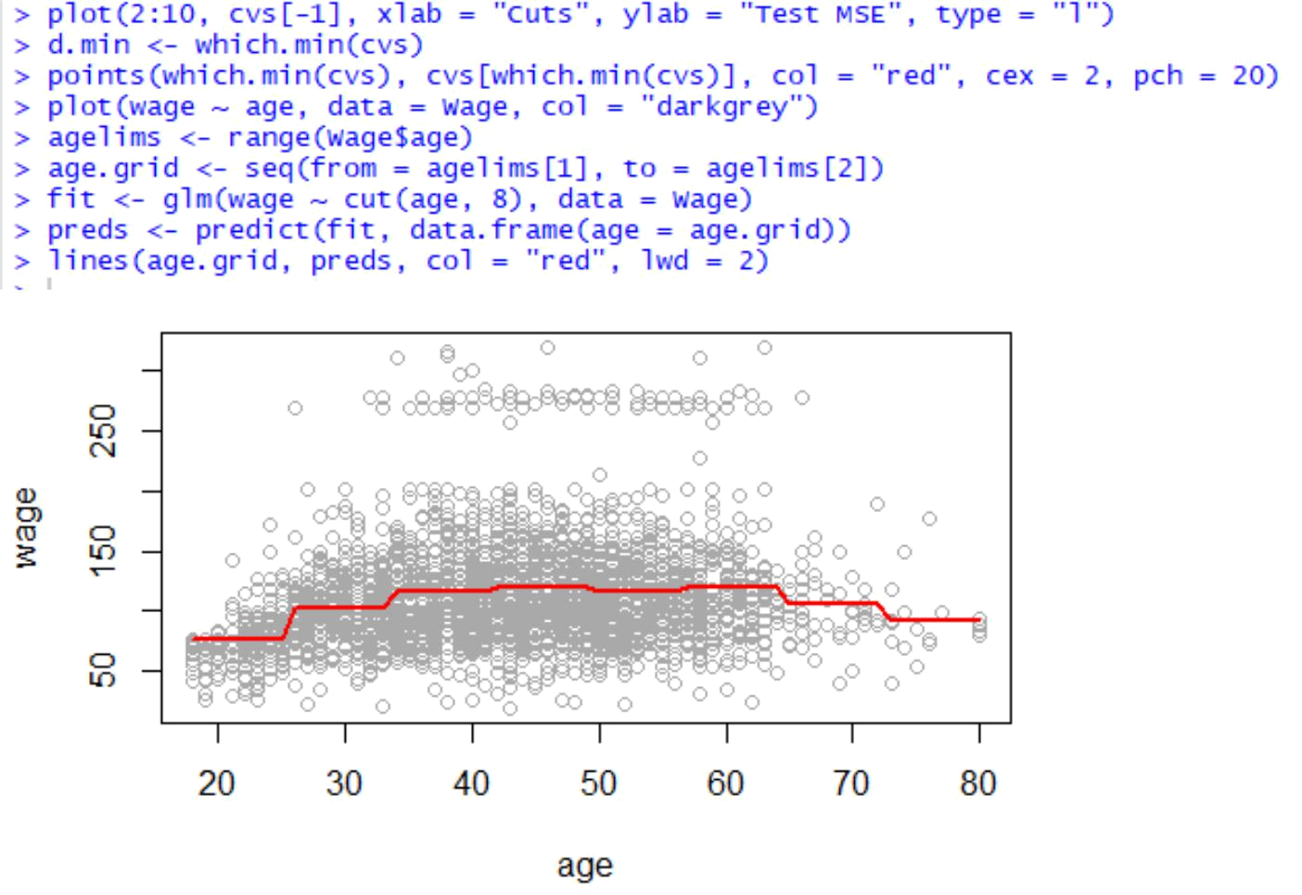

- (30 points total) This question uses the variables dis (the weighted mean of distances to five Boston employment centers) and nox (nitrogen oxides concentration in parts per 10 million) from the Boston data. We will treat dis as the predictor and nox as the response.

- (5 points) Use the poly() function to fit a cubic polynomial regression to predict nox using dis. Report the regression output, and plot the resulting data and polynomial fits.

Ans.

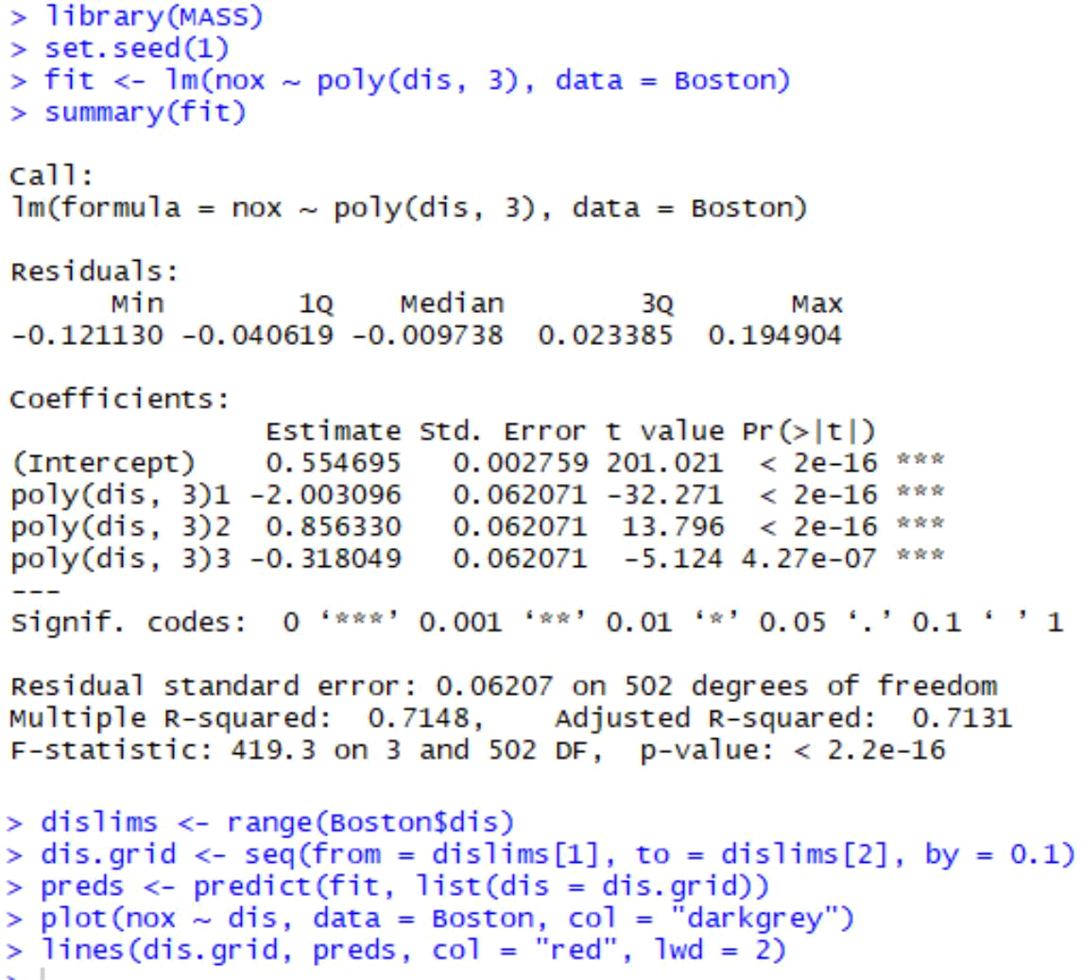
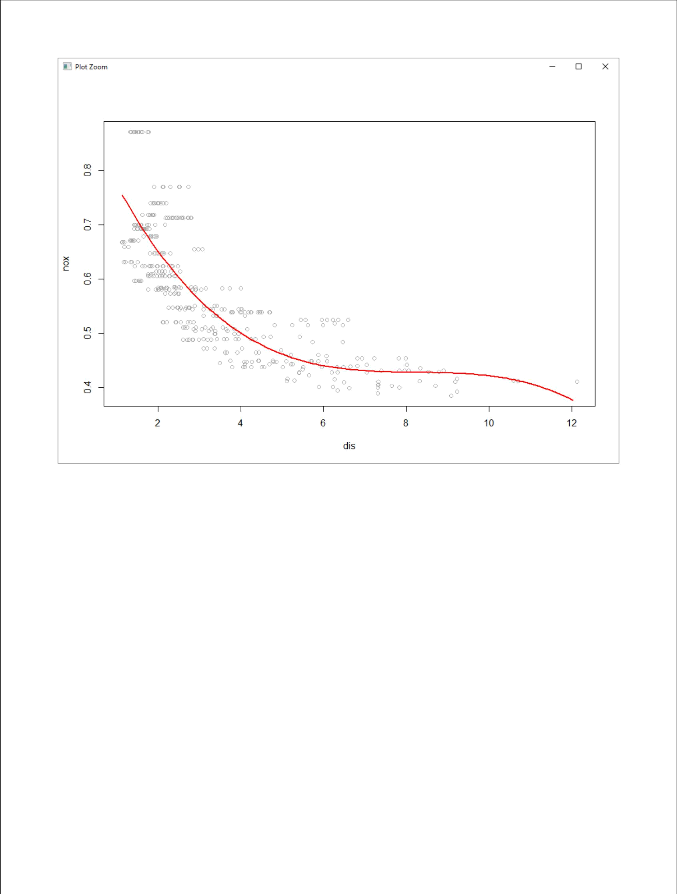

We may conclude that all polynomial terms are significant.

- (5 points) Plot the polynomial fits for a range of different polynomial degrees (say, from 1 to 10), and report the associated residual sum of squares.

Ans.

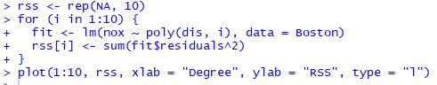
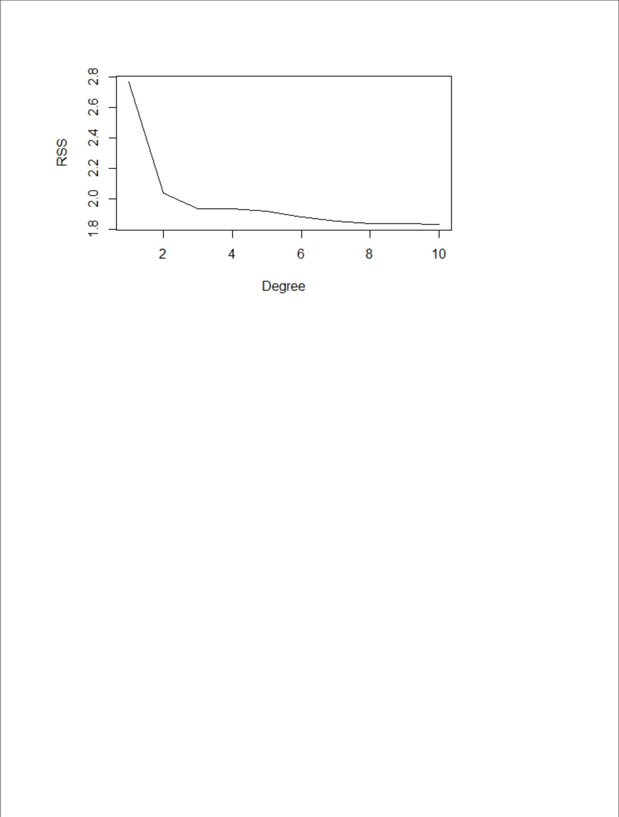

It seems that the RSS decreases with the degree of the polynomial, and so is minimum for a polynomial of degree 10.

- (5 points) Perform cross-validation or another approach to select the optimal degree for the polynomial and explain your results.

Ans.

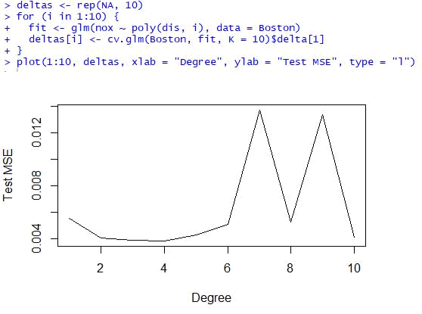
We may see that a polynomial of degree 4 minimizes the test MSE.

- (5 points) Use the bs() function to fit a regression spline to predict nox using dis. Report the output for the fit using four degrees of freedom. How did you choose the knots? Plot the resulting fit.

Ans.

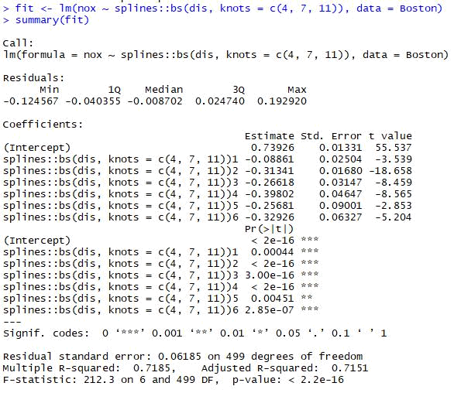

- pred <- predict(fit, list(dis = dis.grid))

- plot(nox ~ dis, data = Boston, col = "darkgrey")

- lines(dis.grid, preds, col = "red", lwd = 2)

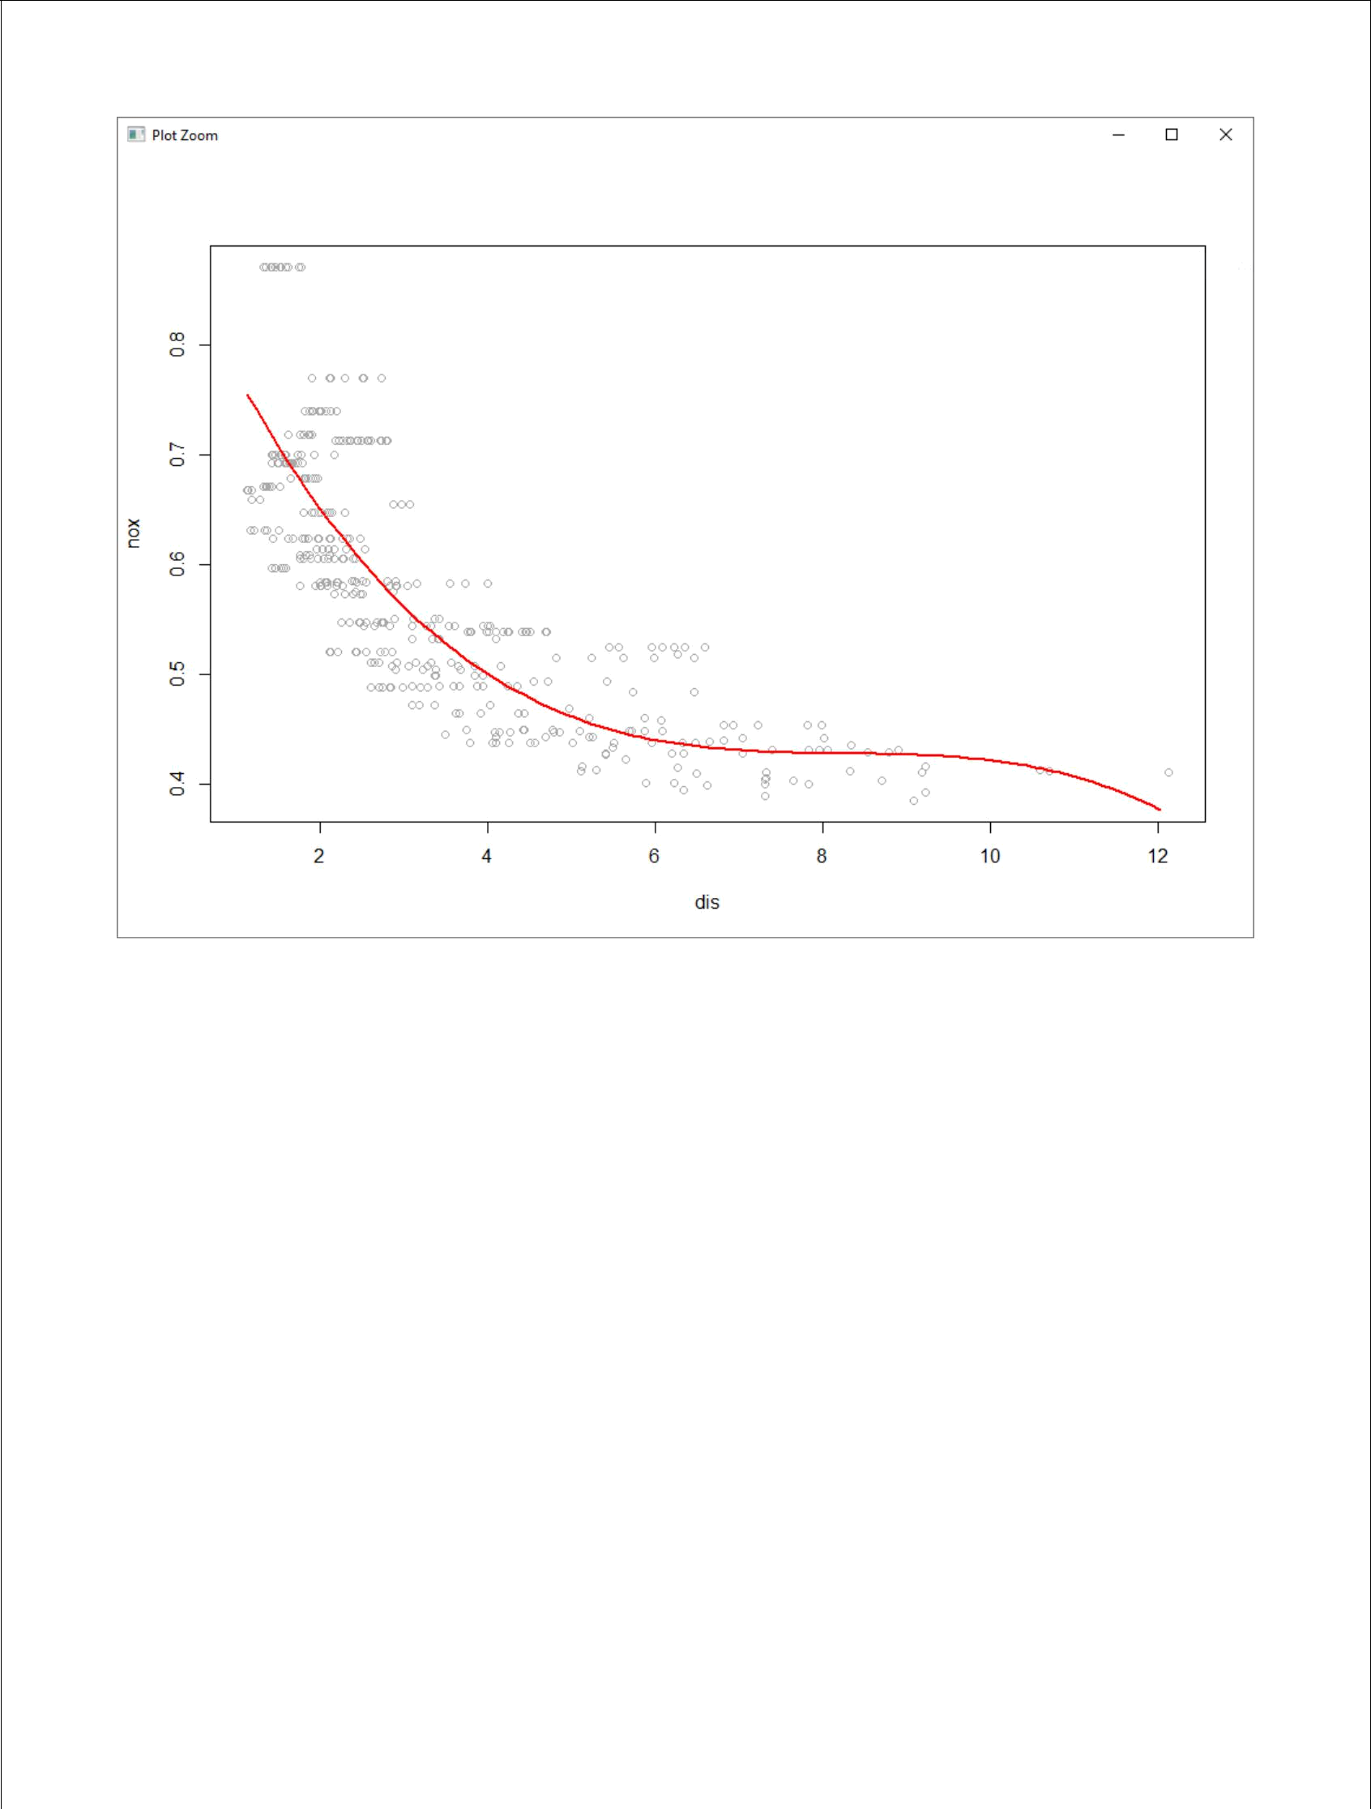

We may conclude that all terms in spline fit are significant.

- (5 points) Now fit a regression spline for a range of degrees of freedom, and plot the resulting fits and report the resulting RSS. Describe the results obtained.

Ans.

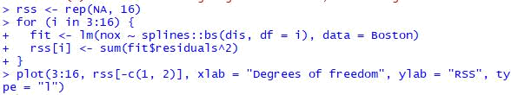
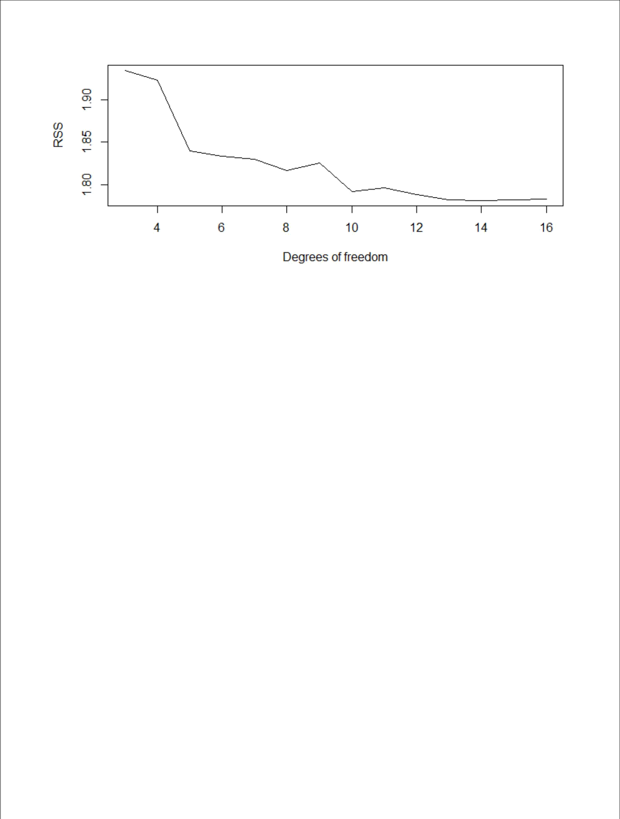

We may see that RSS decreases until 14 and then slightly increases after that.

- (5 points) Perform cross-validation or another approach in order to select the best degrees of freedom for a regression spline on this data. Describe your results.

Ans.

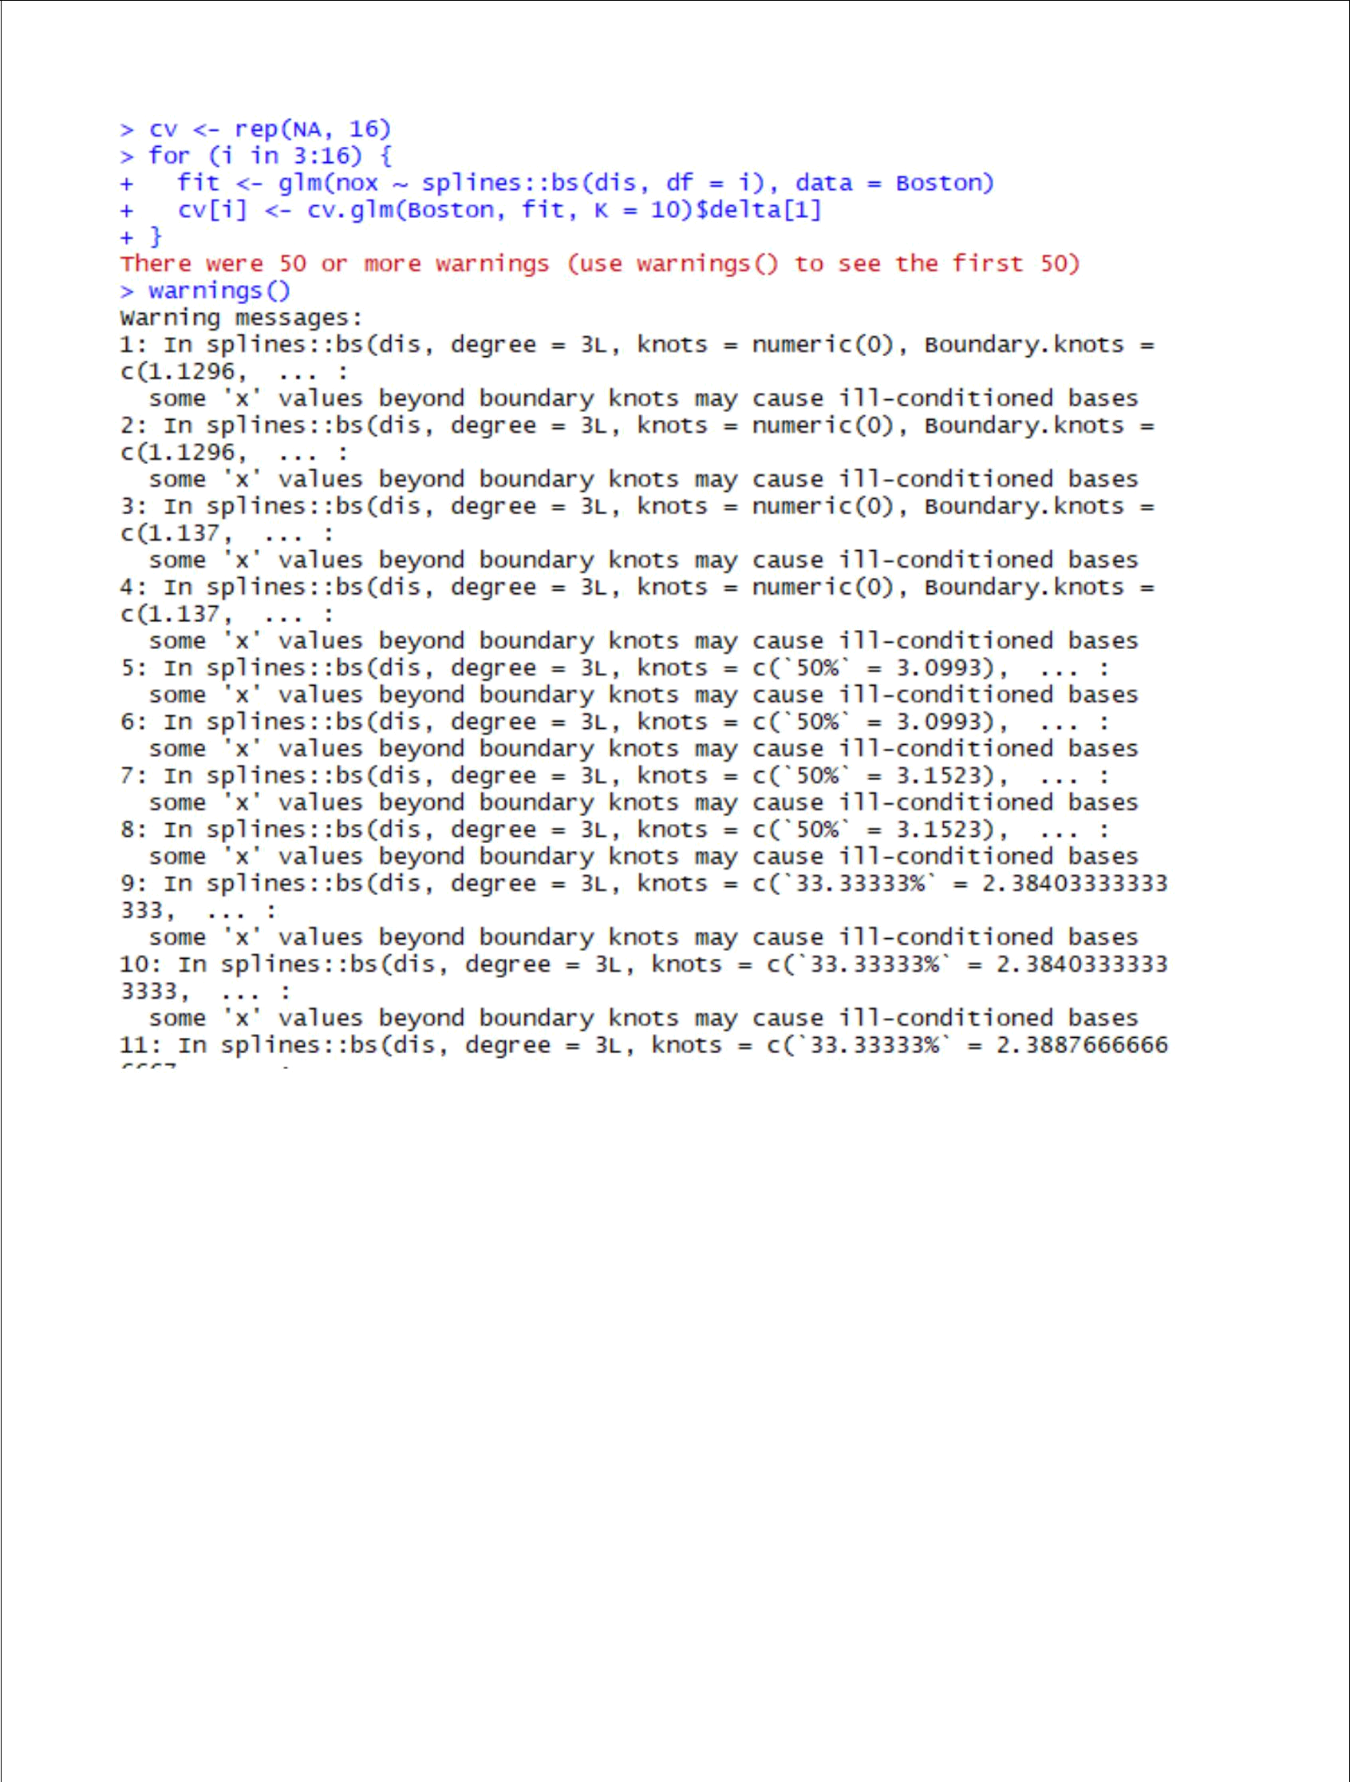

- plot(3:16, cv[-c(1, 2)], xlab = "Degrees of freedom", ylab = "Test MSE", ty pe = "l")

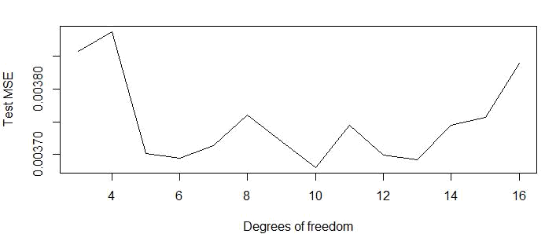
Test MSE is minimum for 10 degrees of freedom.

- (25 points total) In the lab, a classification tree was applied to the Carseats data set after converting Sales into a qualitative response variable. Now we will seek to predict Sales using regression trees and related approaches, treating the response as a quantitative variable.

- (5 points) Split the data set into a training set and a test set. Ans.

- (5 points) Fit a regression tree to the training set. Plot the tree, and interpret the results. What test MSE do you obtain?

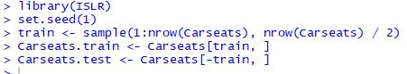

Ans.

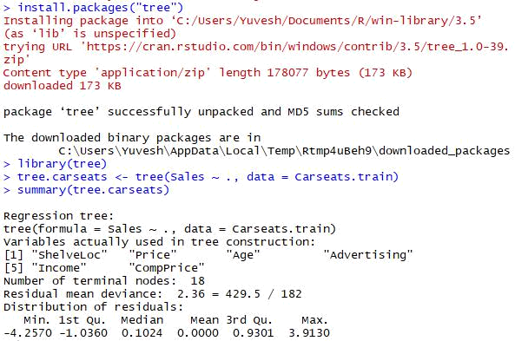

- plot(tree.carseats)

- text(tree.carseats, pretty = 0)

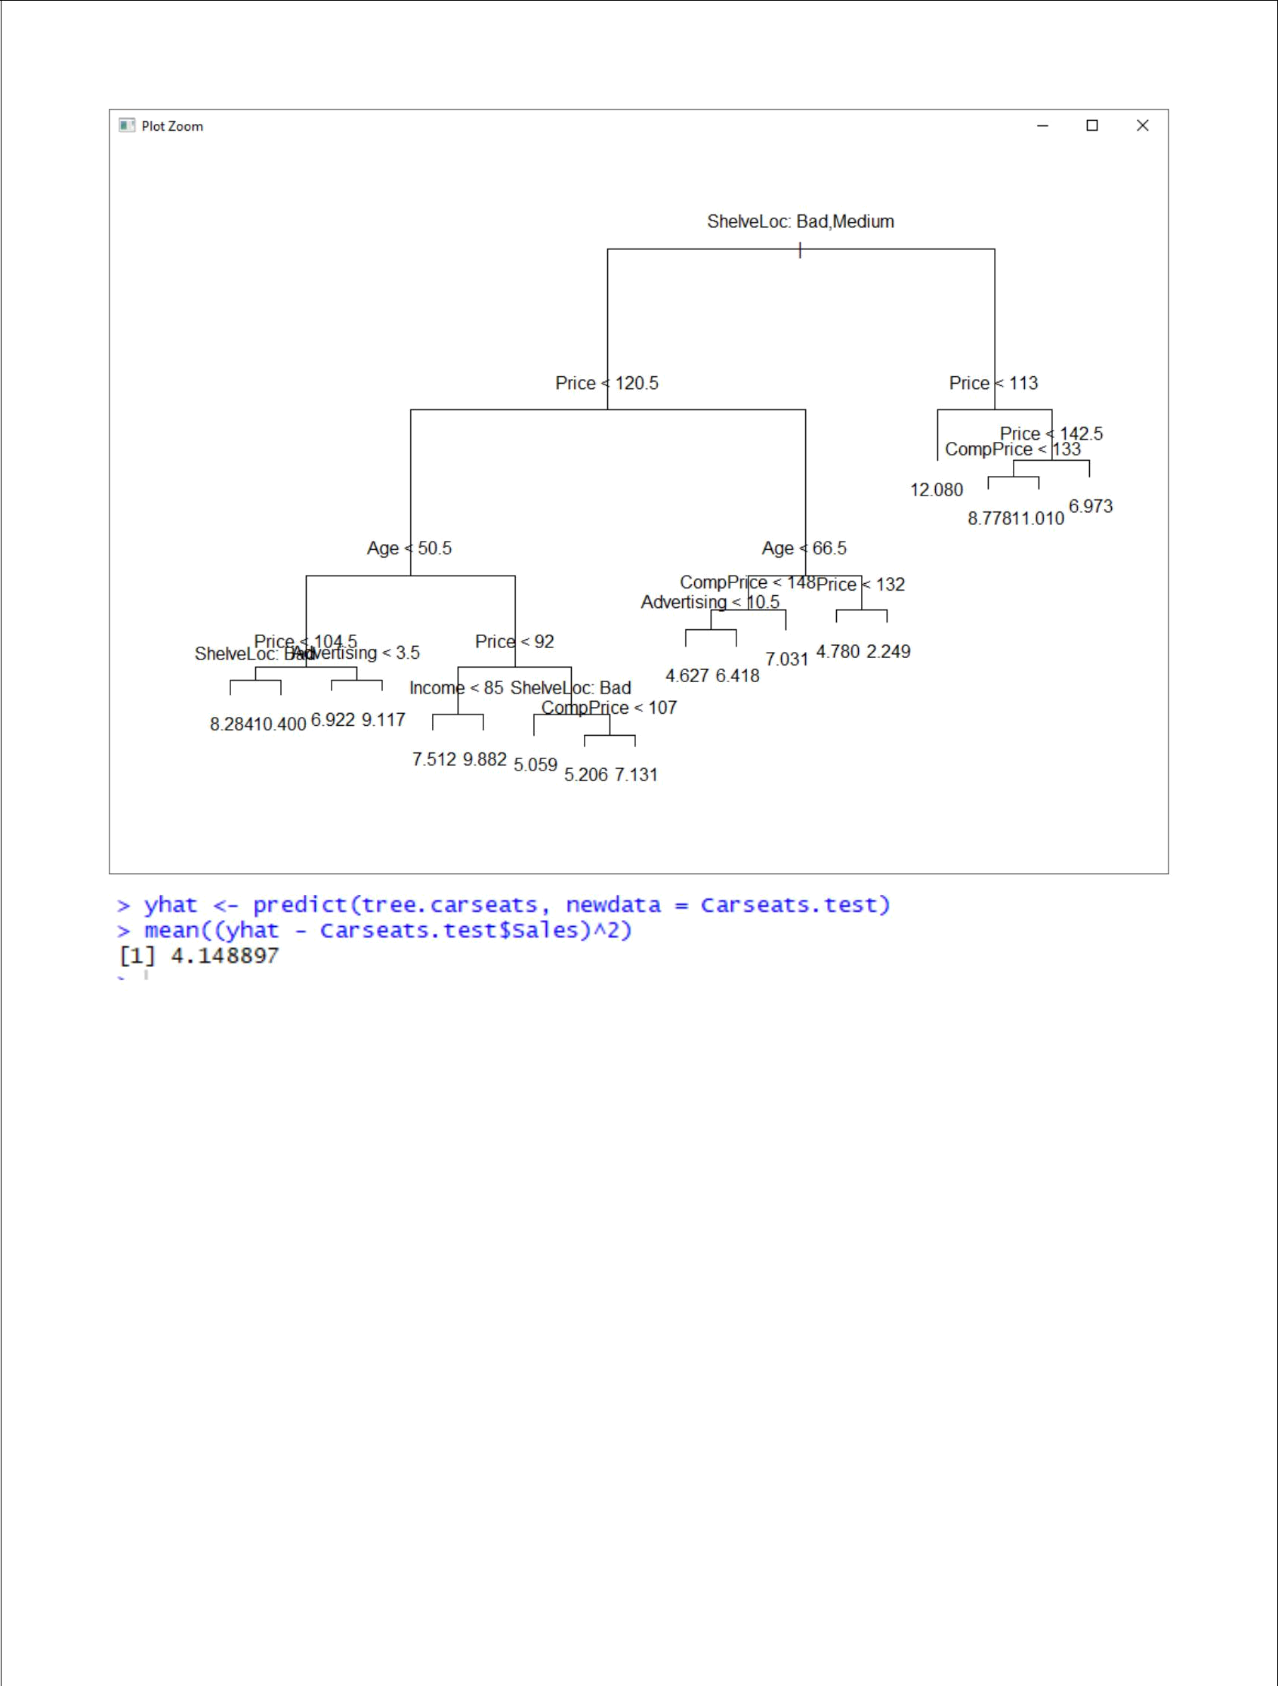

We may conclude that the Test MSE is about 4.15.

- (5 points) Use cross-validation in order to determine the optimal level of tree complexity. Does pruning the tree improve the test MSE?

Ans.

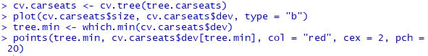
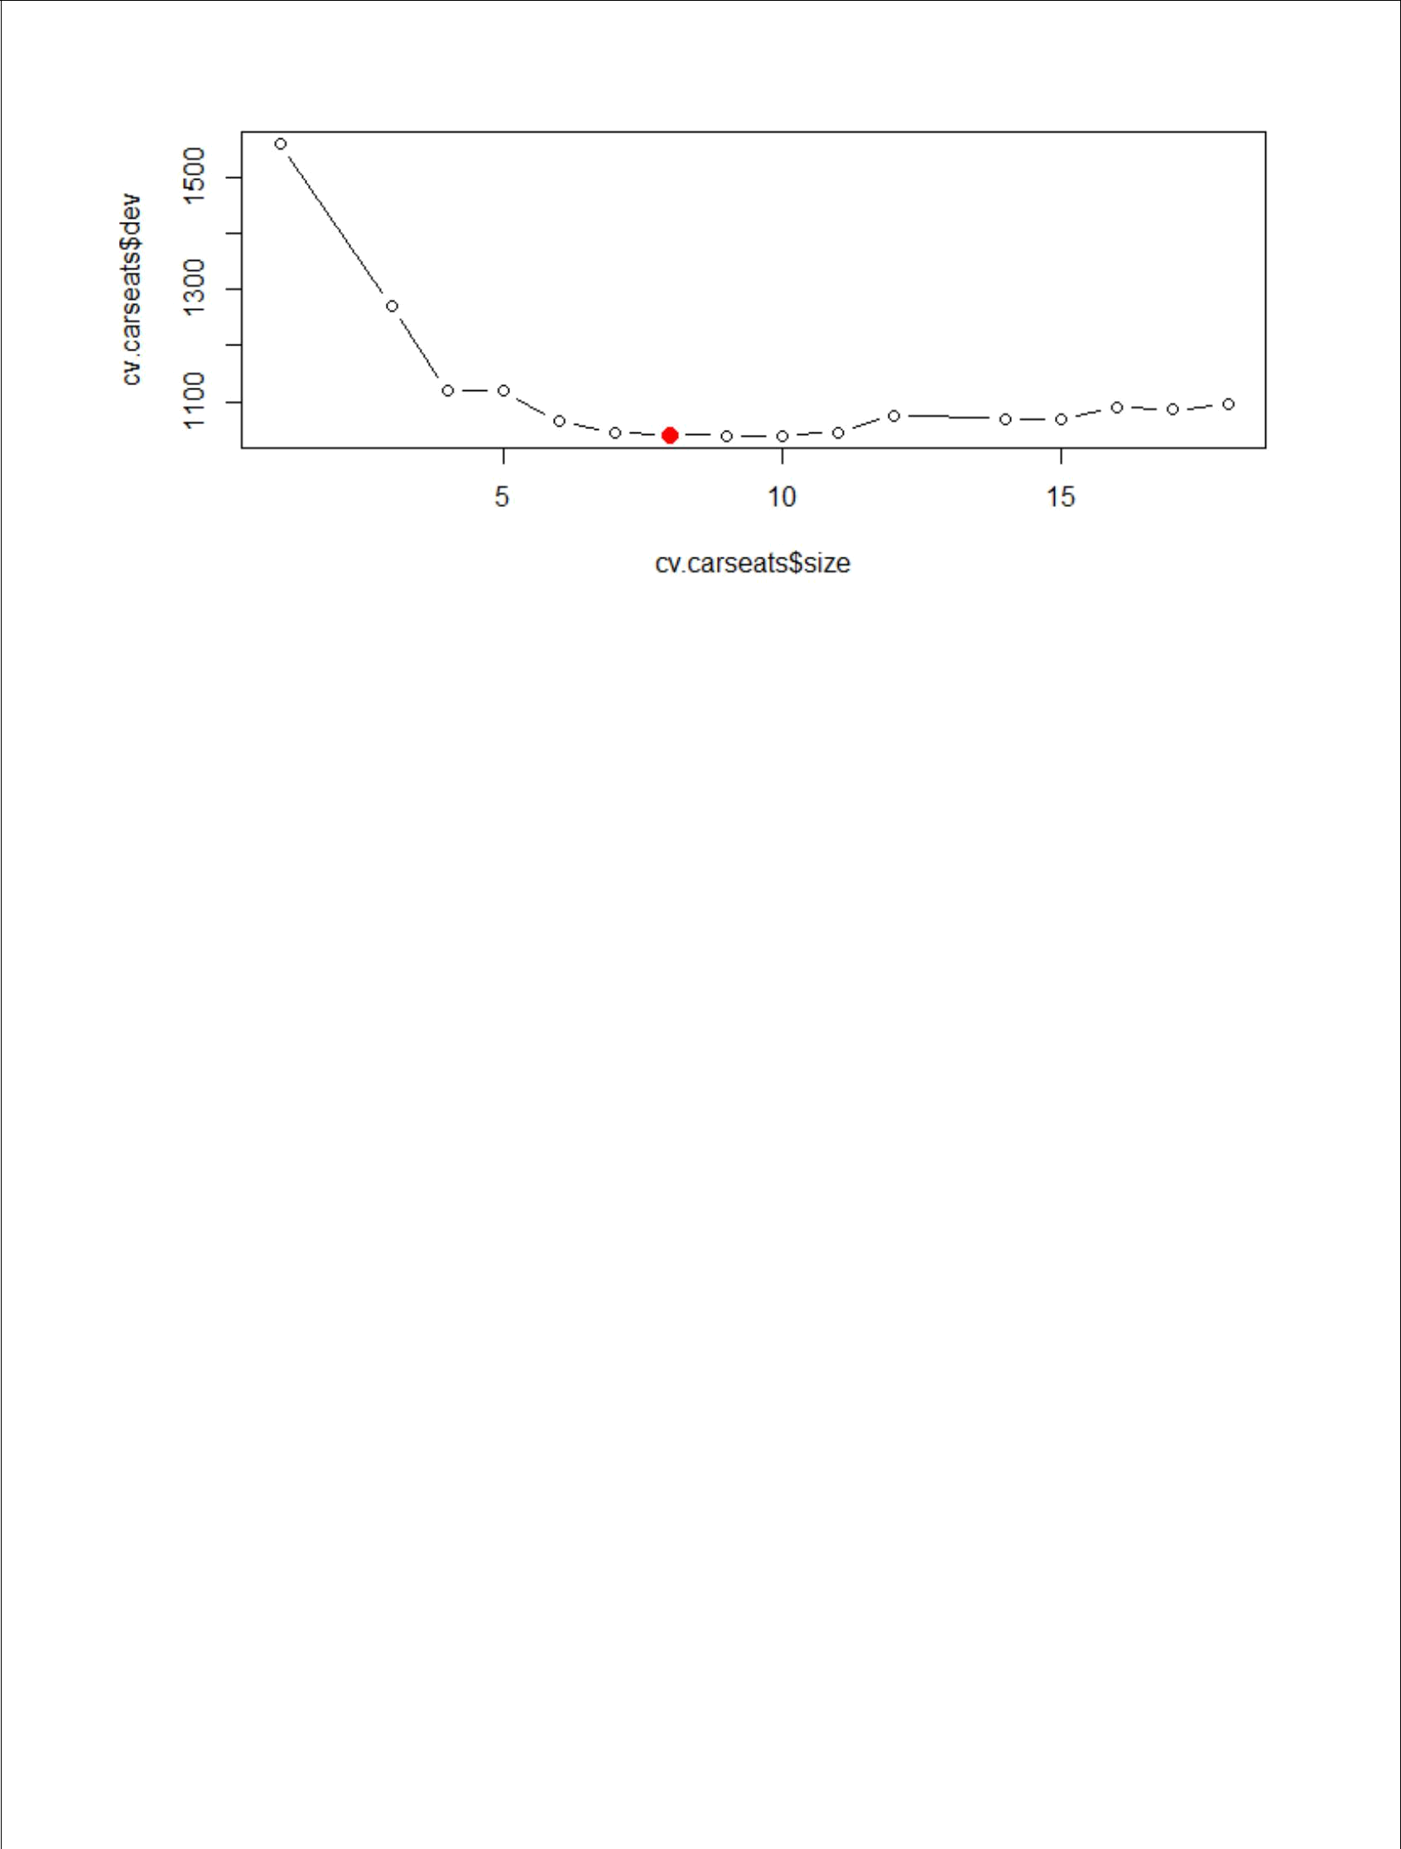

In this case, the tree of size 8 is selected by cross-validation. We now prune the tree to obtain the 8-node tree.

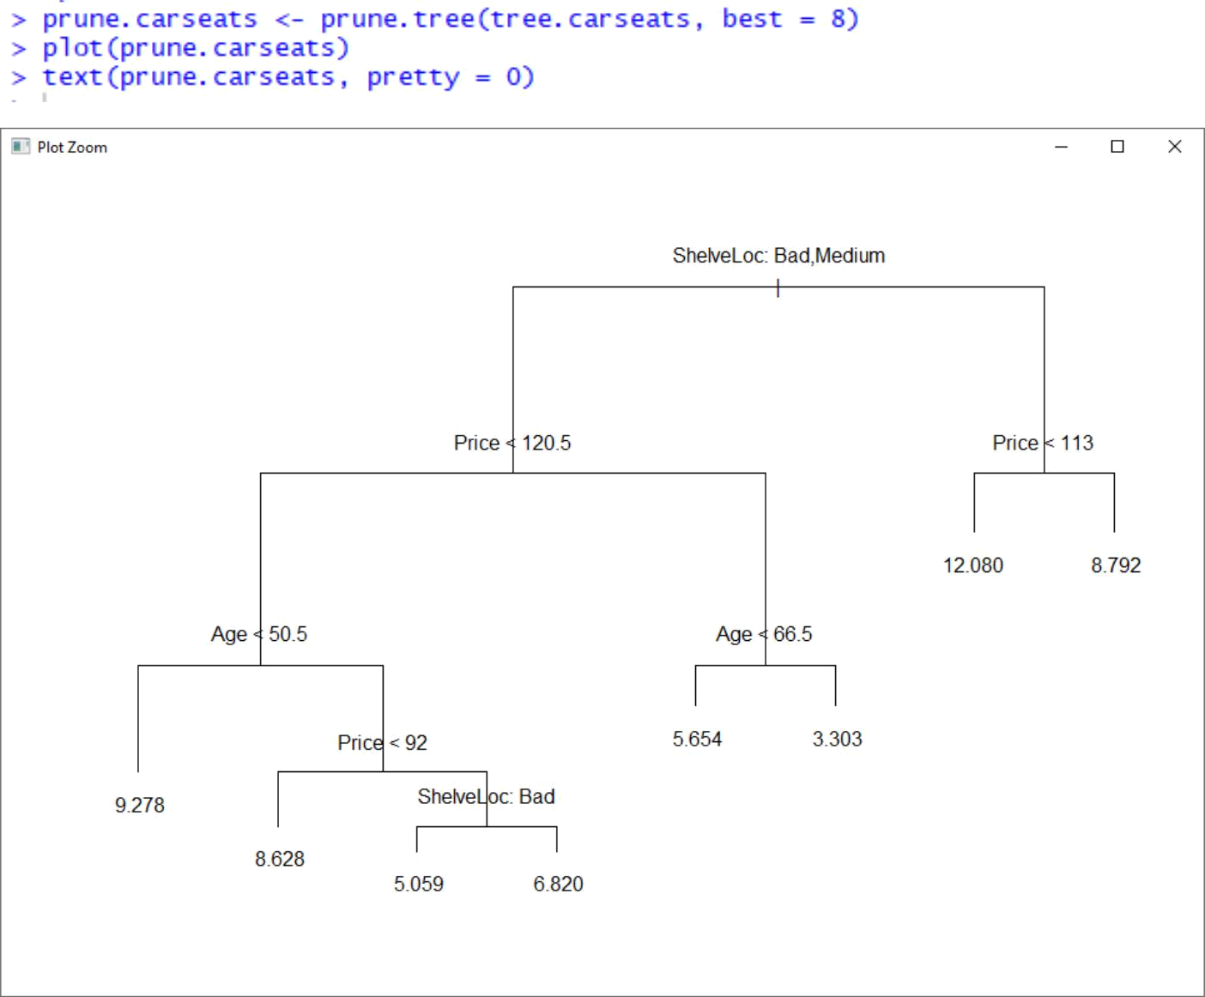


We may see that pruning the tree increases the Test MSE to 5.1.

- (5 points) Use the bagging approach in order to analyze this data. What test MSE do you obtain? Use the importance() function to determine which variables are most important.

Ans.

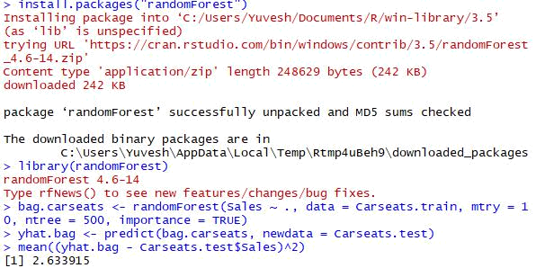

We may see that bagging decreases the Test MSE to 2.6.

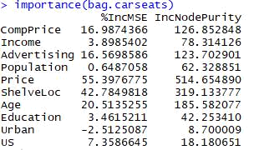

We may conclude that “Price” and “ShelveLoc” are the two most important variables.

- (5 points) Use random forests to analyze this data. What test MSE do you obtain? Use the importance() function to determine which variables are most important. Describe the effect of m, the number of variables considered at each split, on the error rate obtained.

Ans.

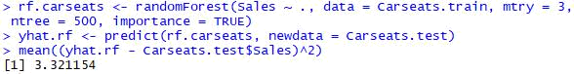

In this case, with m=p–√, we have a Test MSE of 3.3.

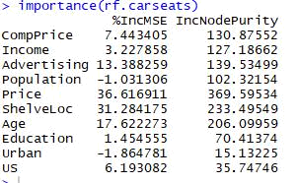

We may conclude that, in this case also, “Price” and “ShelveLoc” are the two most important variables.

6. (35 points total) We now use boosting to predict Salary in the Hitters data set.

- (5 points) Remove the observations for whom the salary information is unknown, and then log-transform the salaries.

Ans.

  - Hitters <- na.omit(Hitters)

- Hitters$Salary <- log(Hitters$Salary)

- (5 points) Create a training set consisting of the first 200 observations, and a test set consisting of the remaining observations.

Ans.

  - train <- 1:200

- Hitters.train <- Hitters[train, ]

- Hitters.test <- Hitters[-train, ]

- (5 points) Perform boosting on the training set with 1,000 trees for a range of values of the shrinkage parameter λ. Produce a plot with different shrinkage values on the x-axis and the corresponding training set MSE on the y-axis.

Ans.

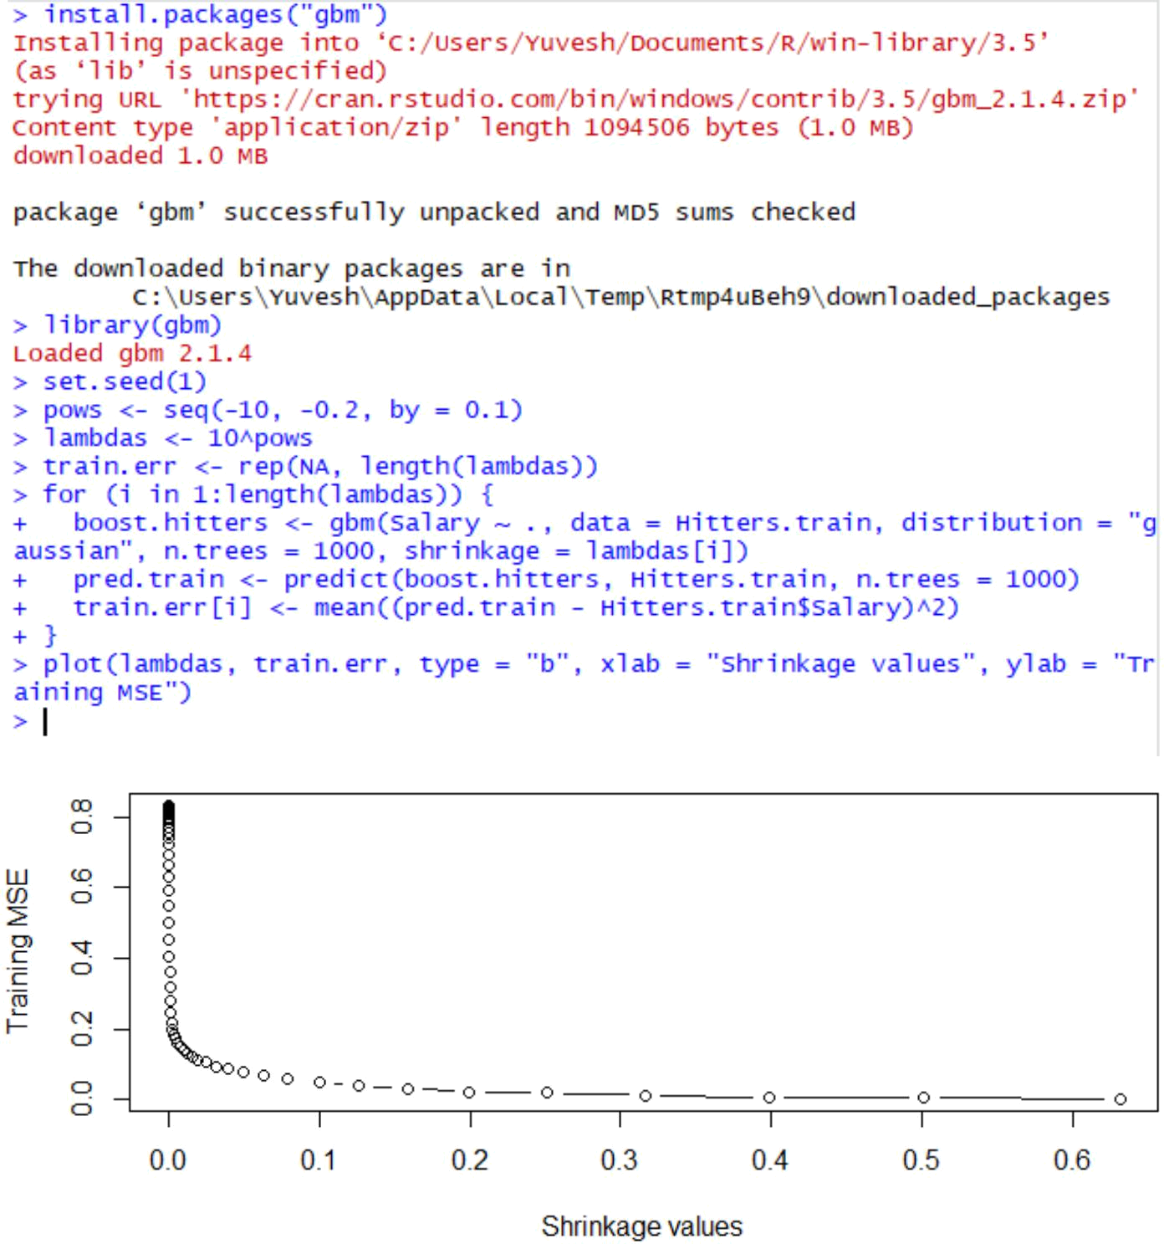

- (5 points) Produce a plot with different shrinkage values on the x-axis and the corresponding test set MSE on the y-axis.

Ans.

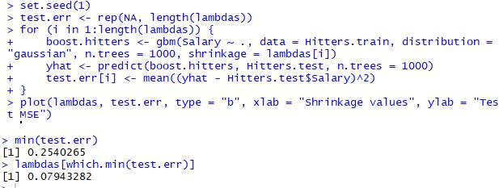

The minimum test MSE is 0.25, and is obtained for λ=0.079.

- (5 points) Compare the test MSE of boosting to the test MSE that results from applying two of the regression approaches seen in Chapters 3 and 6.

Ans.

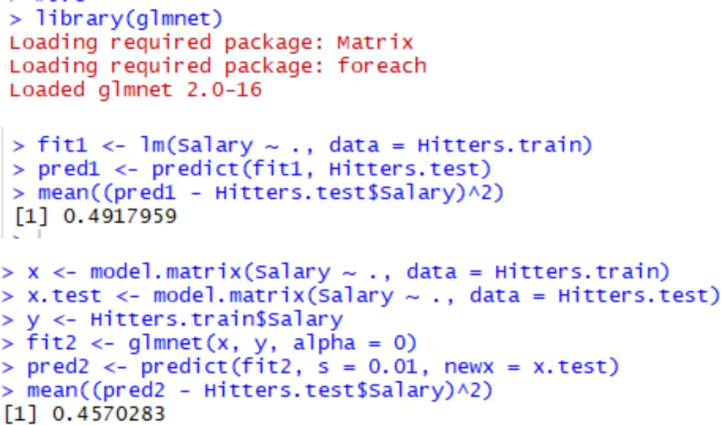

The test MSE for boosting is lower than for linear regression and ridge regression.

- (5 points) Which variables appear to be the most important predictors in the boosted model?

Ans.

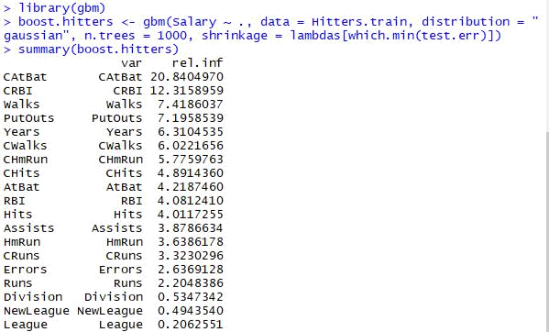
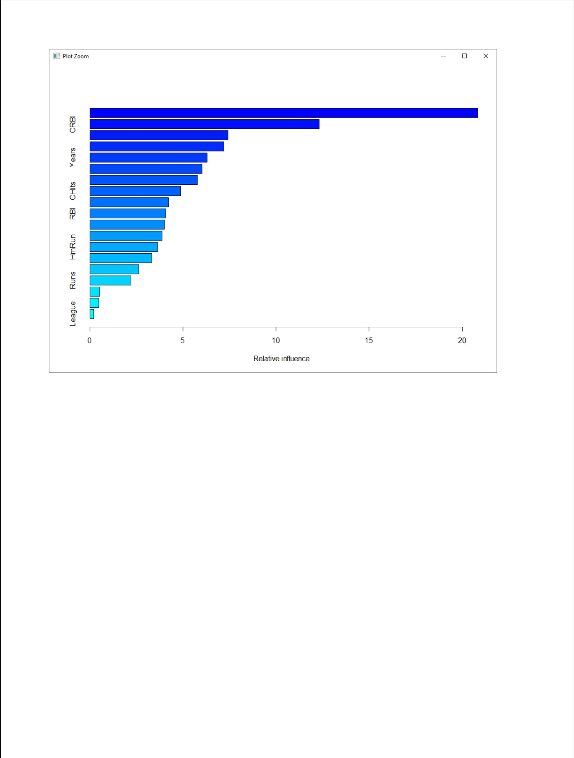

We may see that “CAtBat” is by far the most important variable.

- (5 points) Now apply bagging to the training set. What is the test set MSE for this approach?

Ans.

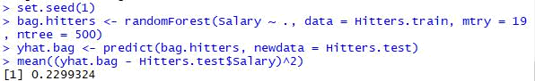

The test MSE for bagging is 0.23, which is slightly lower than the test MSE for boosting.

