ISL HOMEWORK 3
Name:Tejaswi Ayyadapu
StudentId:16278799
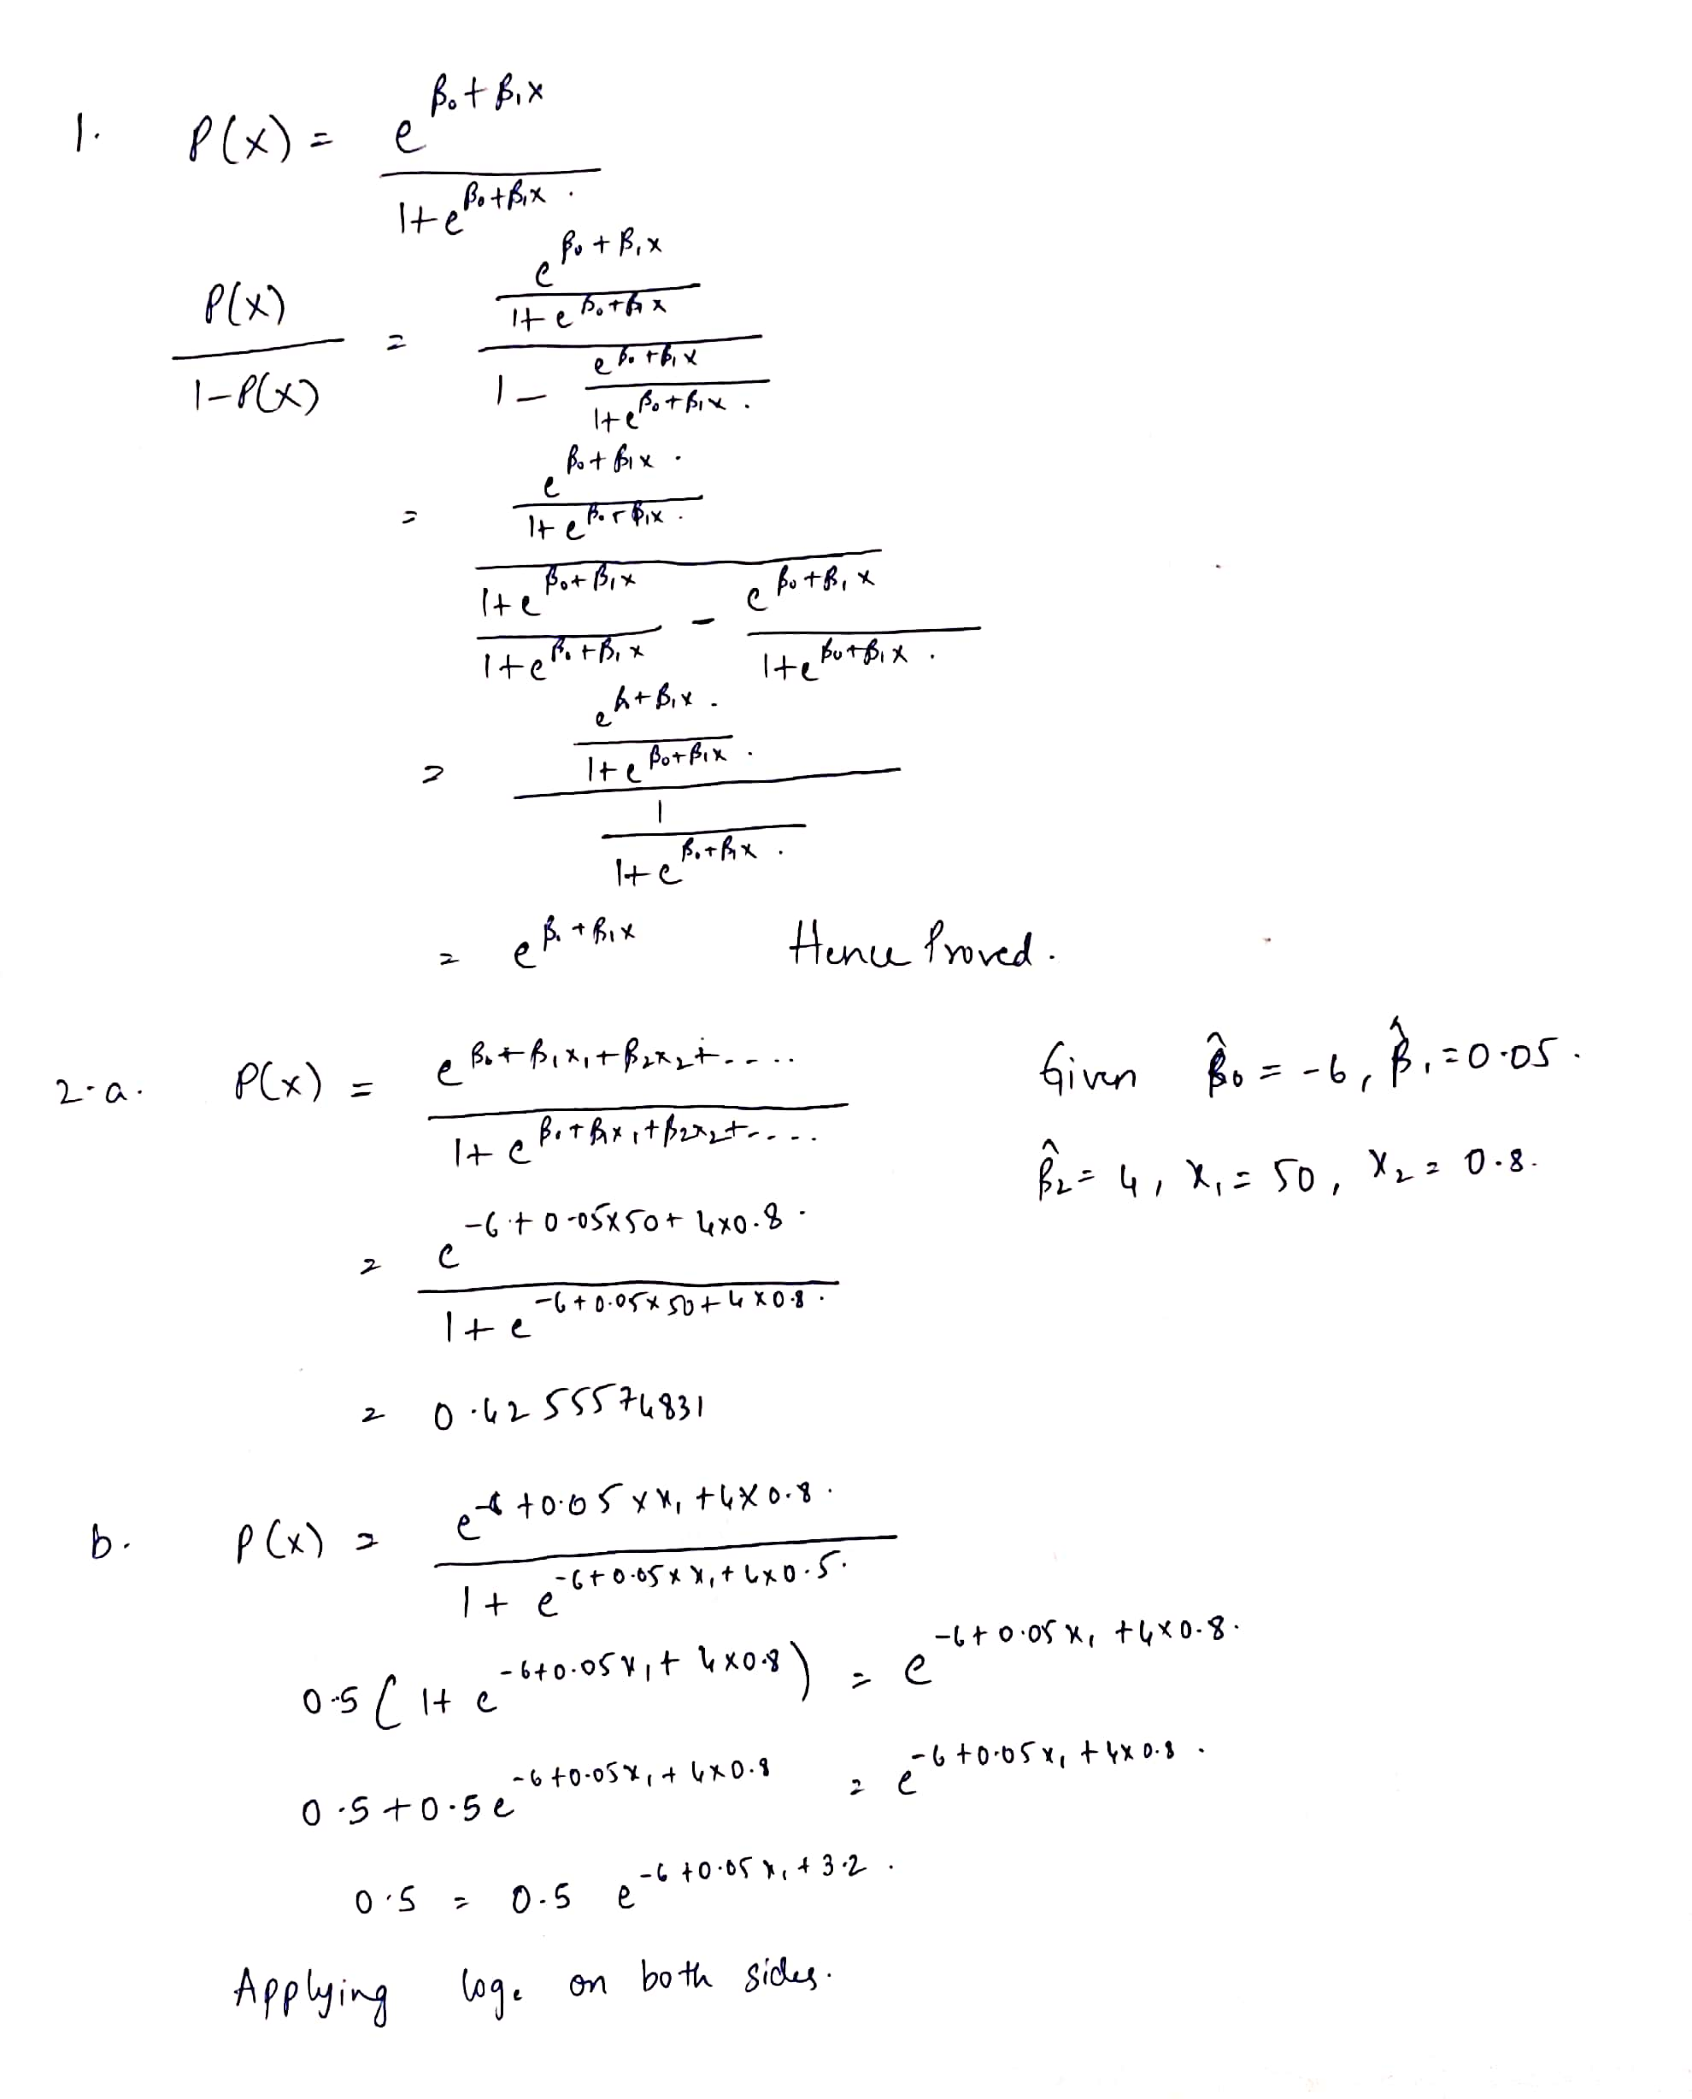

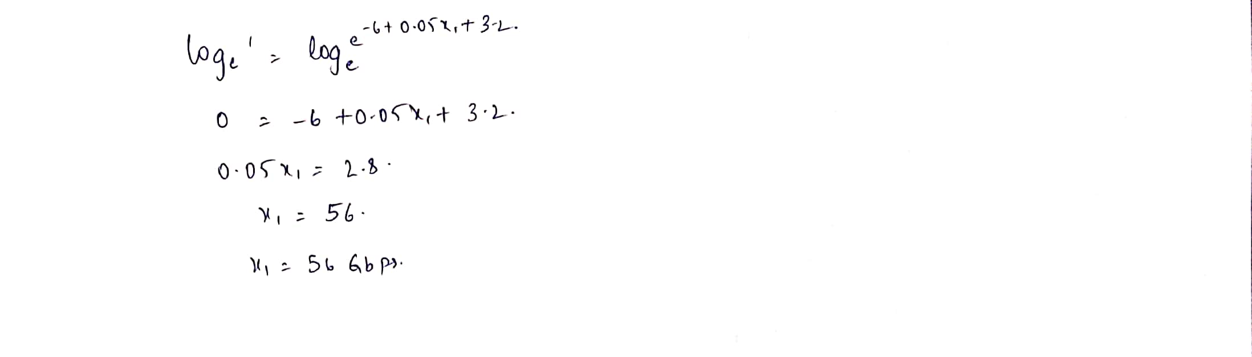

3. a
If the Bayes decision boundary is linear, we expect QDA to perform better on the training set because its higher flexibility may yield a closer fit. On the test set, we expect LDA to perform better than QDA, because QDA could over fit the linearity on the Bayes decision boundary.
3.b
If the Bayes decision boundary is non-linear, we expect QDA to perform better both on the training and test sets.
3.c
Roughly speaking, QDA (which is more flexible than LDA and so has higher variance) is recommended if the training set is very large, so that the variance of the classifier is not a major concern.
3.d
False. With fewer sample points, the variance from using a more flexible method such as QDA, may lead to over fit, which in turns may lead to an inferior test error rate.

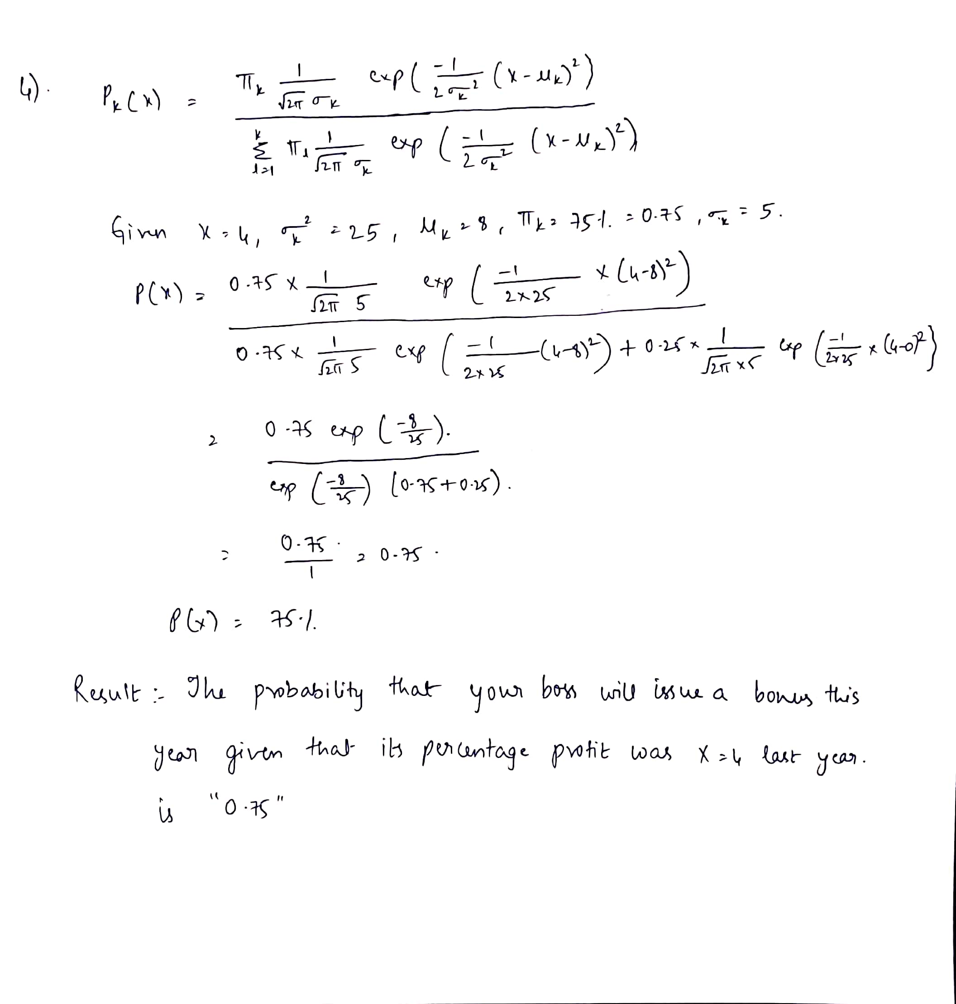

5.
In the case of KNN with K=1, we have a training error rate of 0% because in this case, we have P(Y=j|X=xi)=I(yi=j) Which is equal to 1 if yi=j and 0 if not. We do not make any error on the training data within this setting that explains the 0% training error rate. However, we have an average error rate of 16% which implies a test error rate of 32% for KNN which is greater than the test error rate for logistic regression of 26%. So, it is better to choose logistic regression because of its lower test error rate.
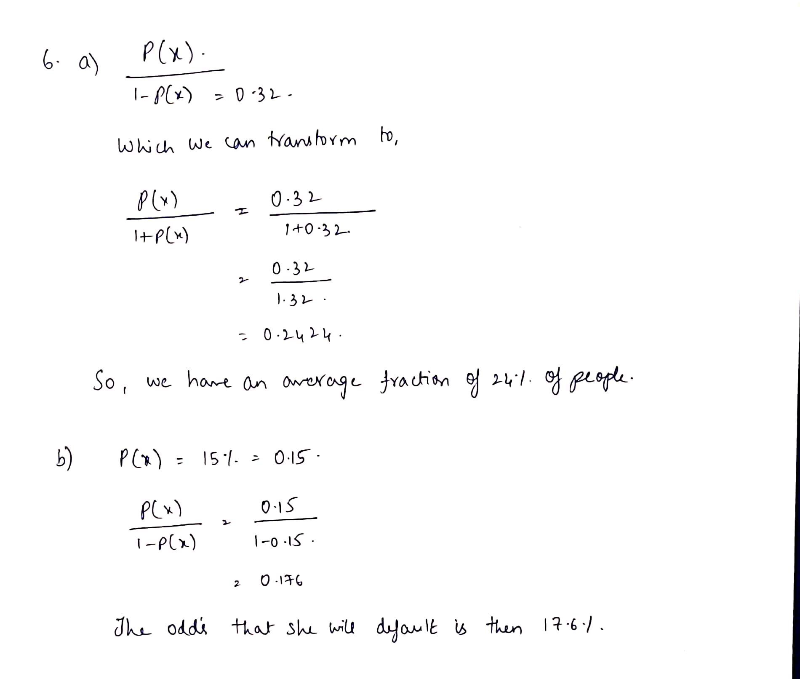
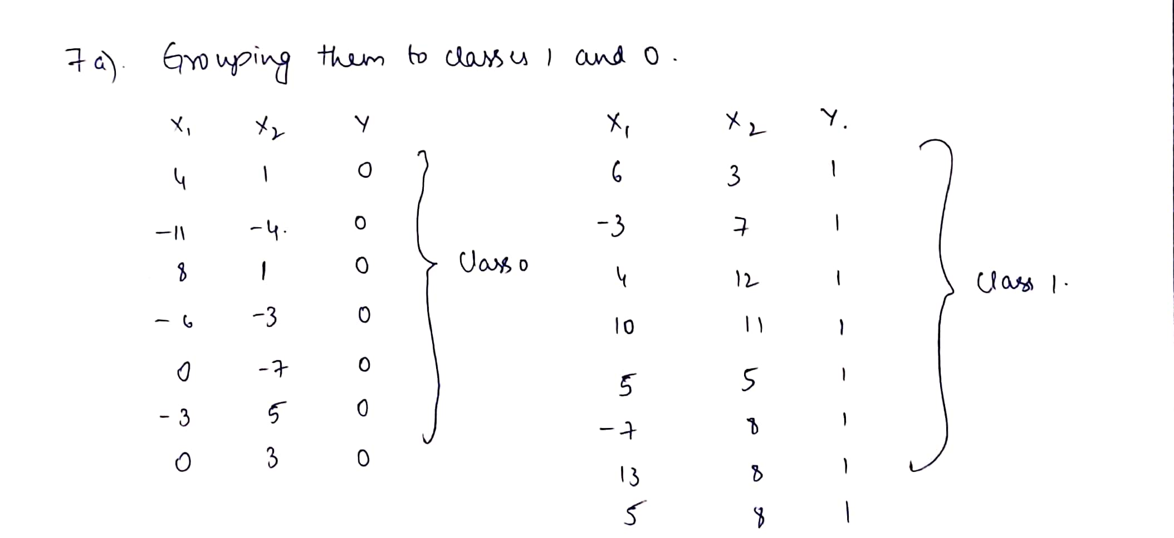
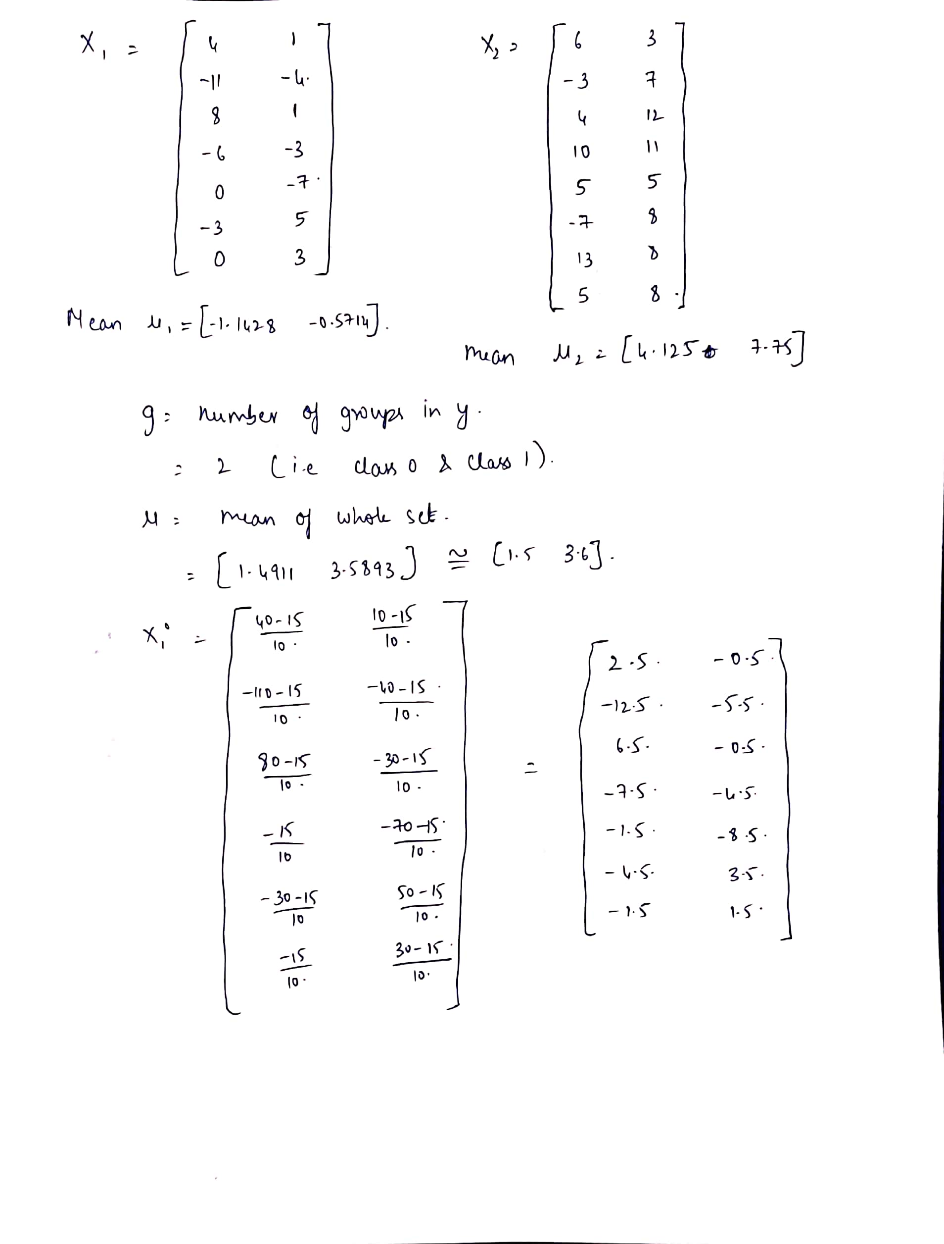
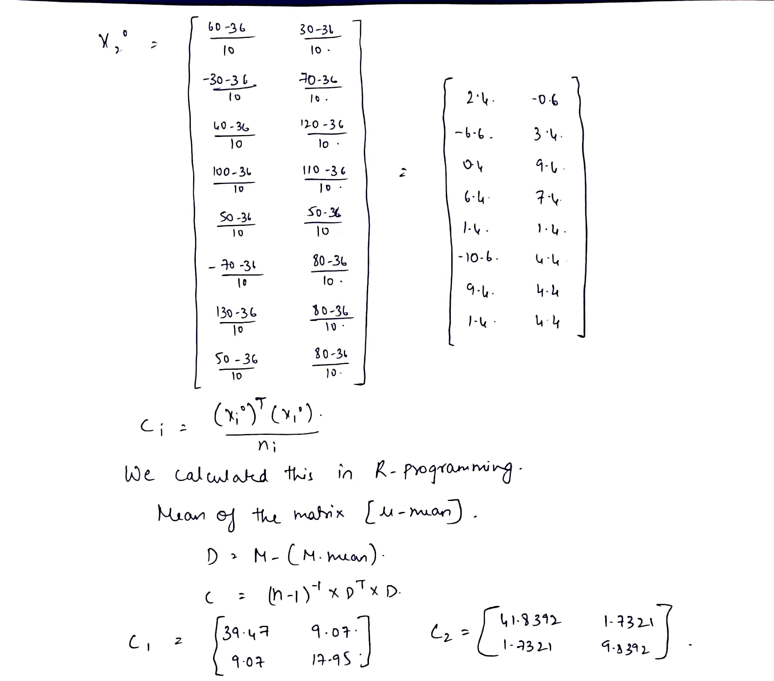
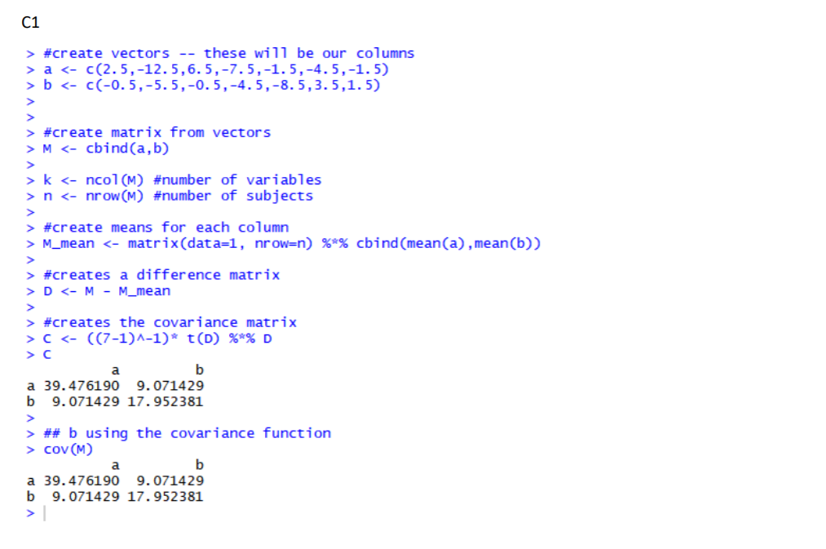
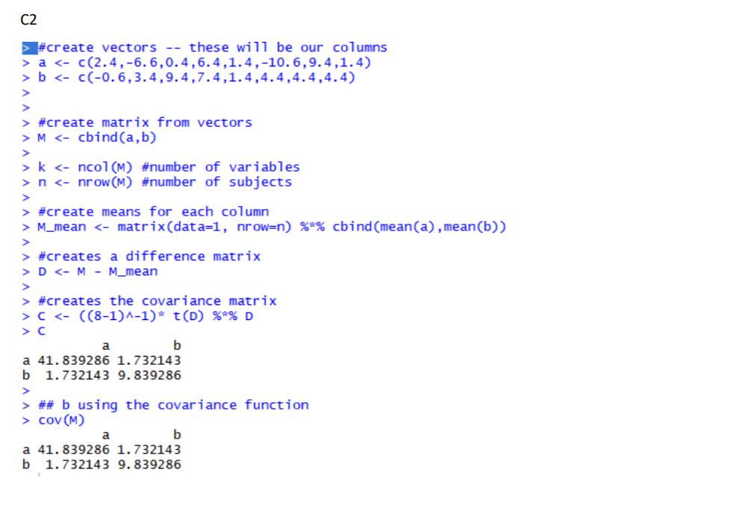

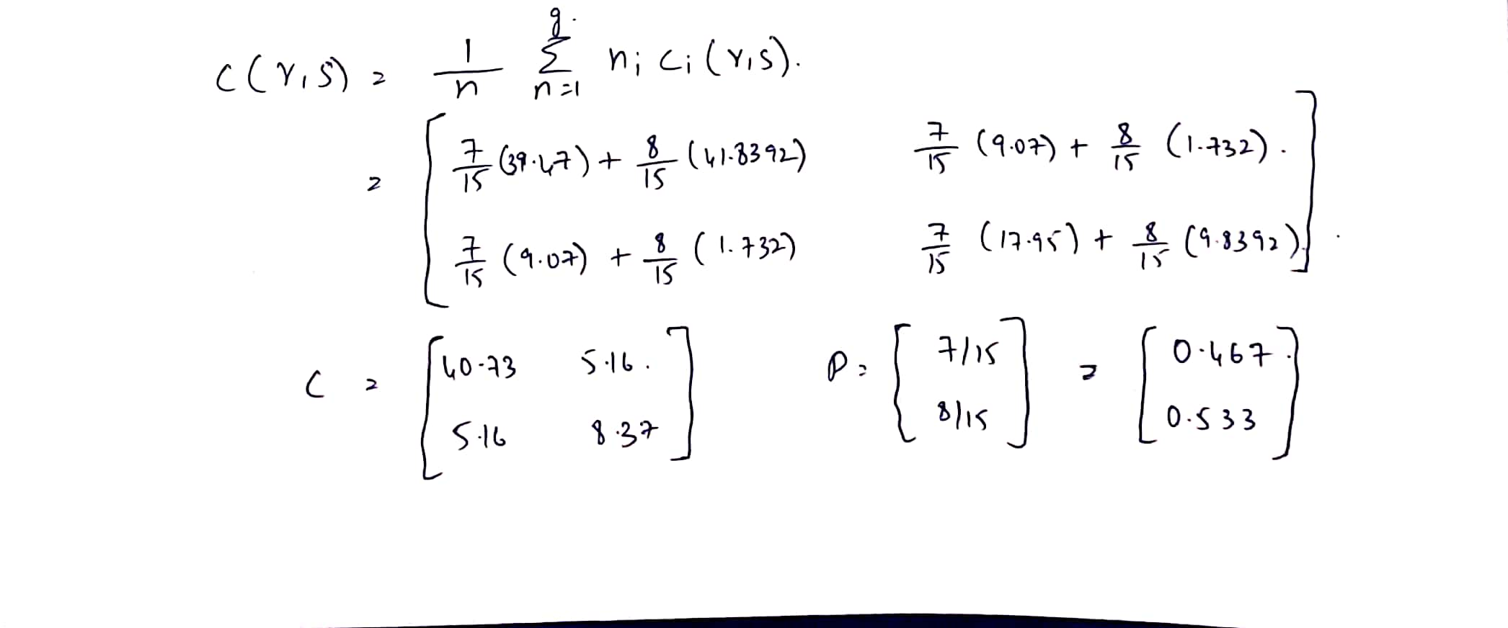
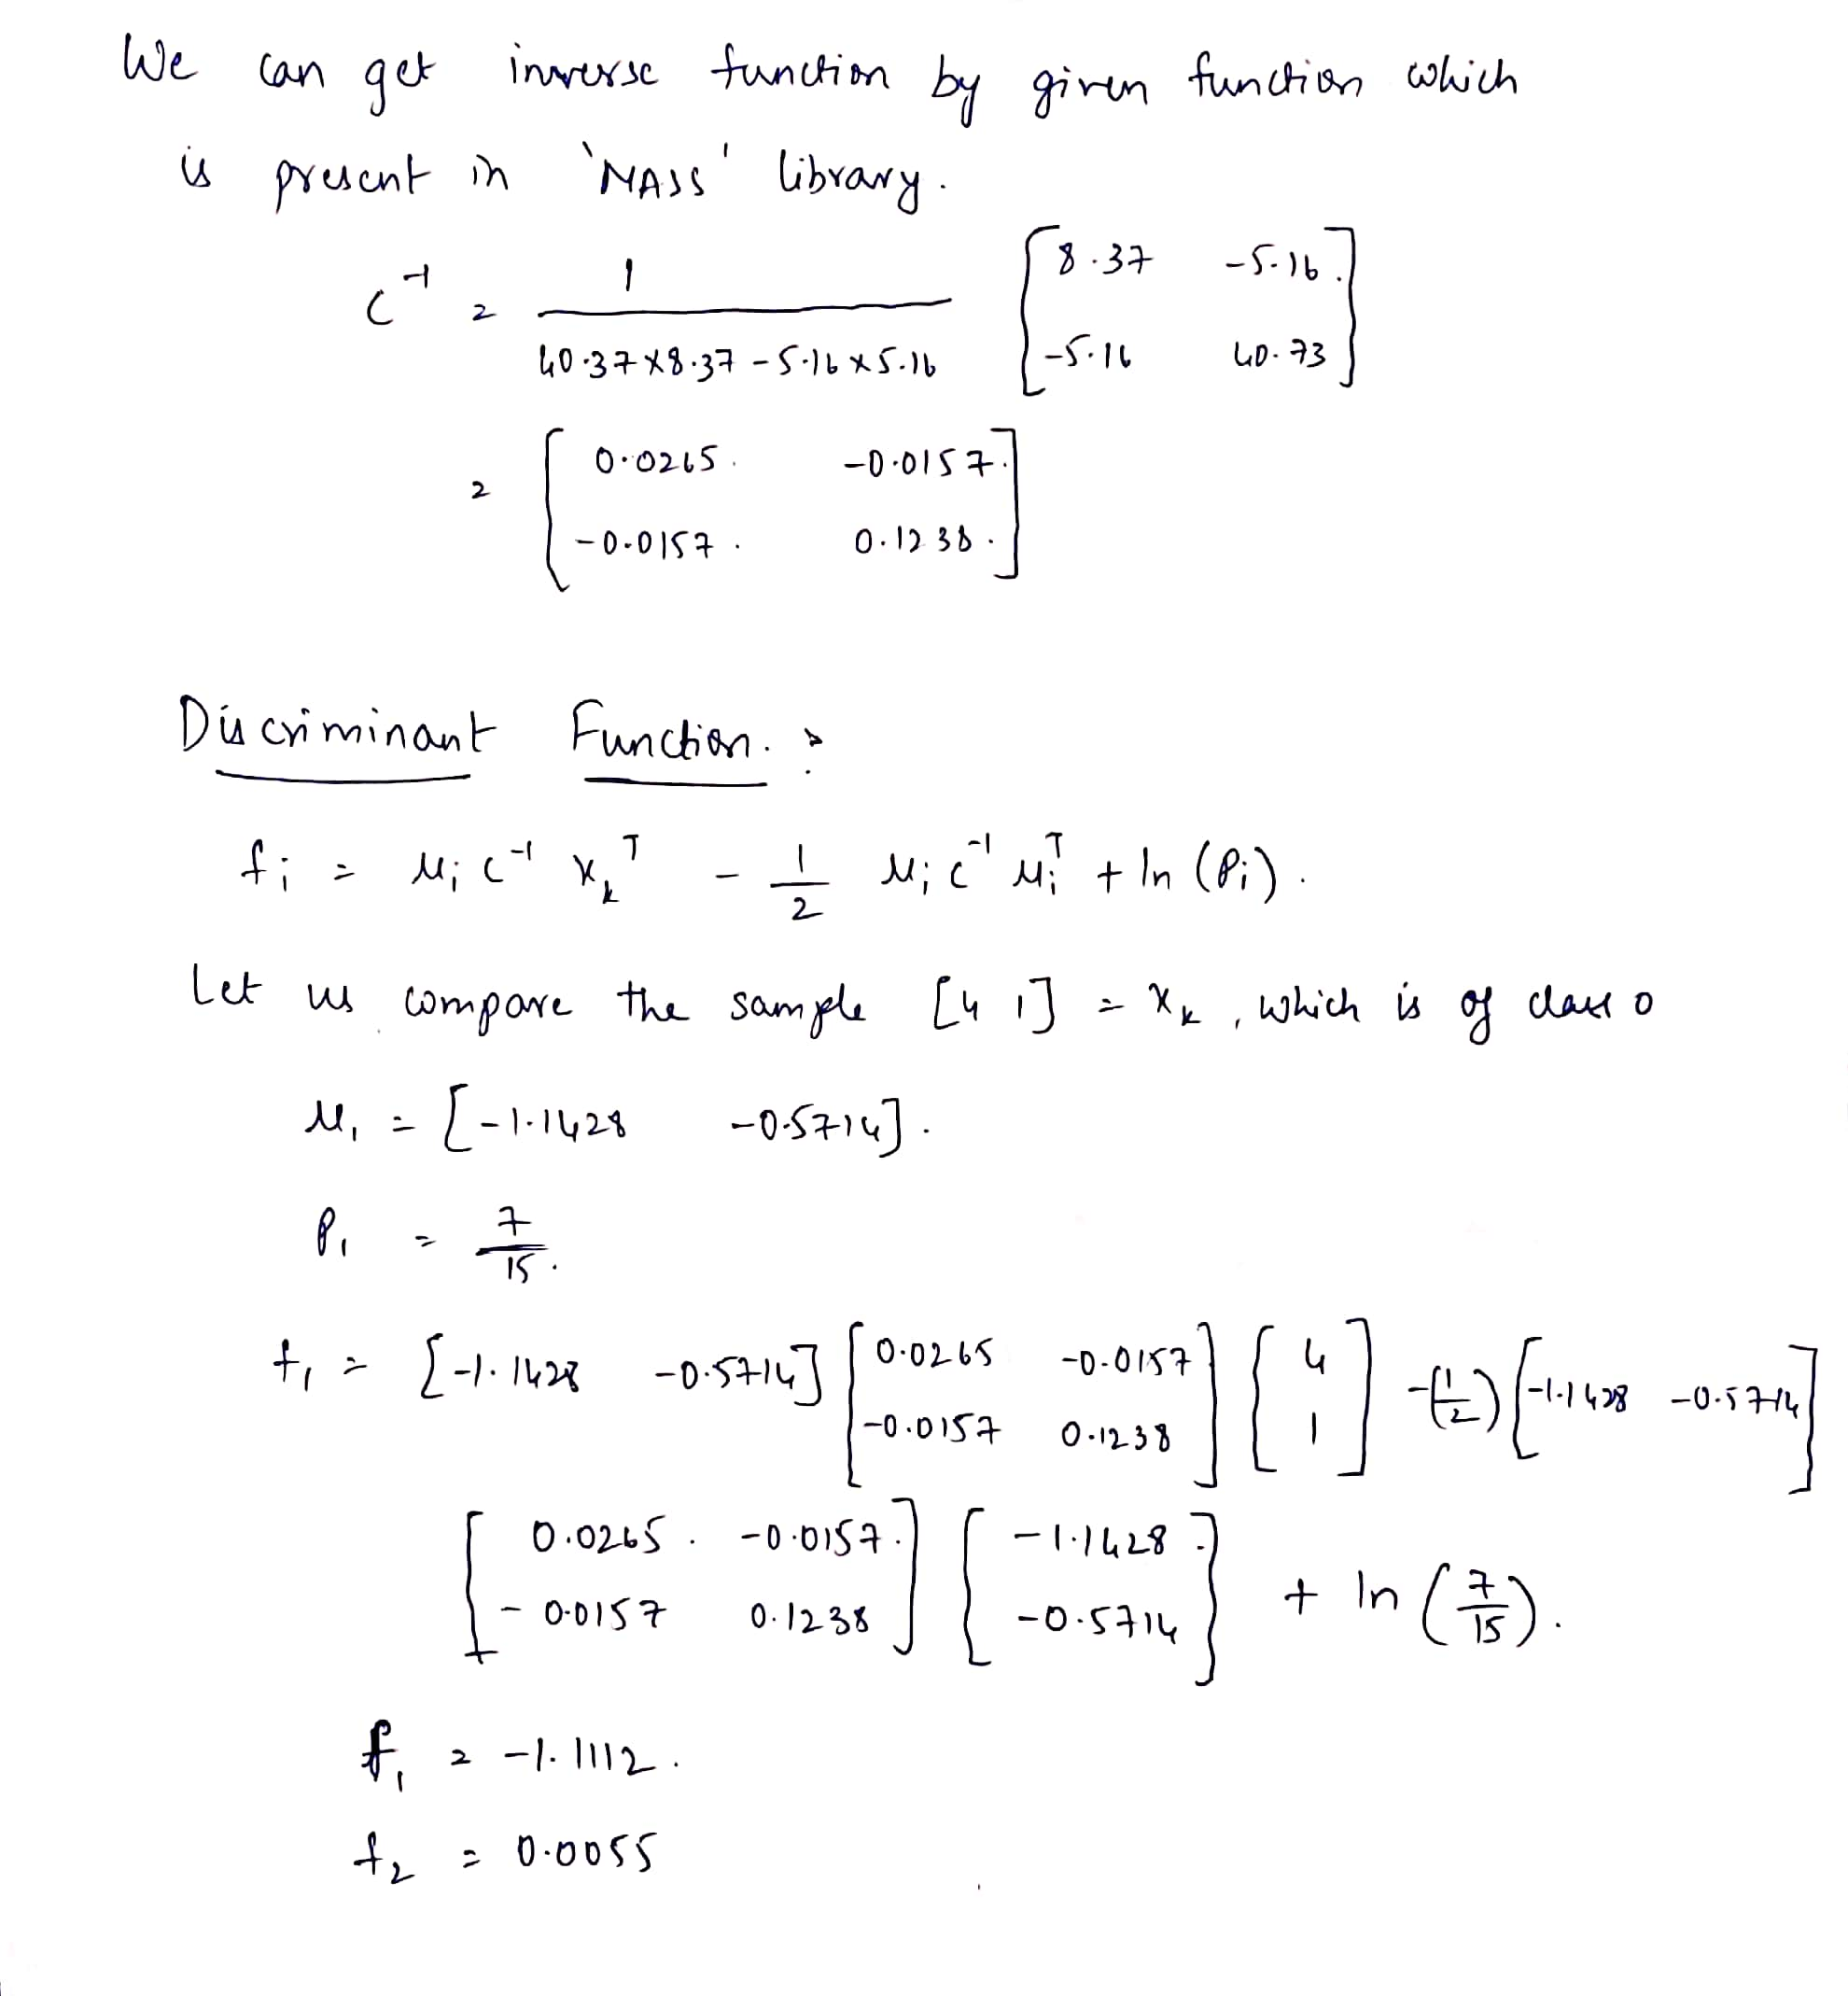

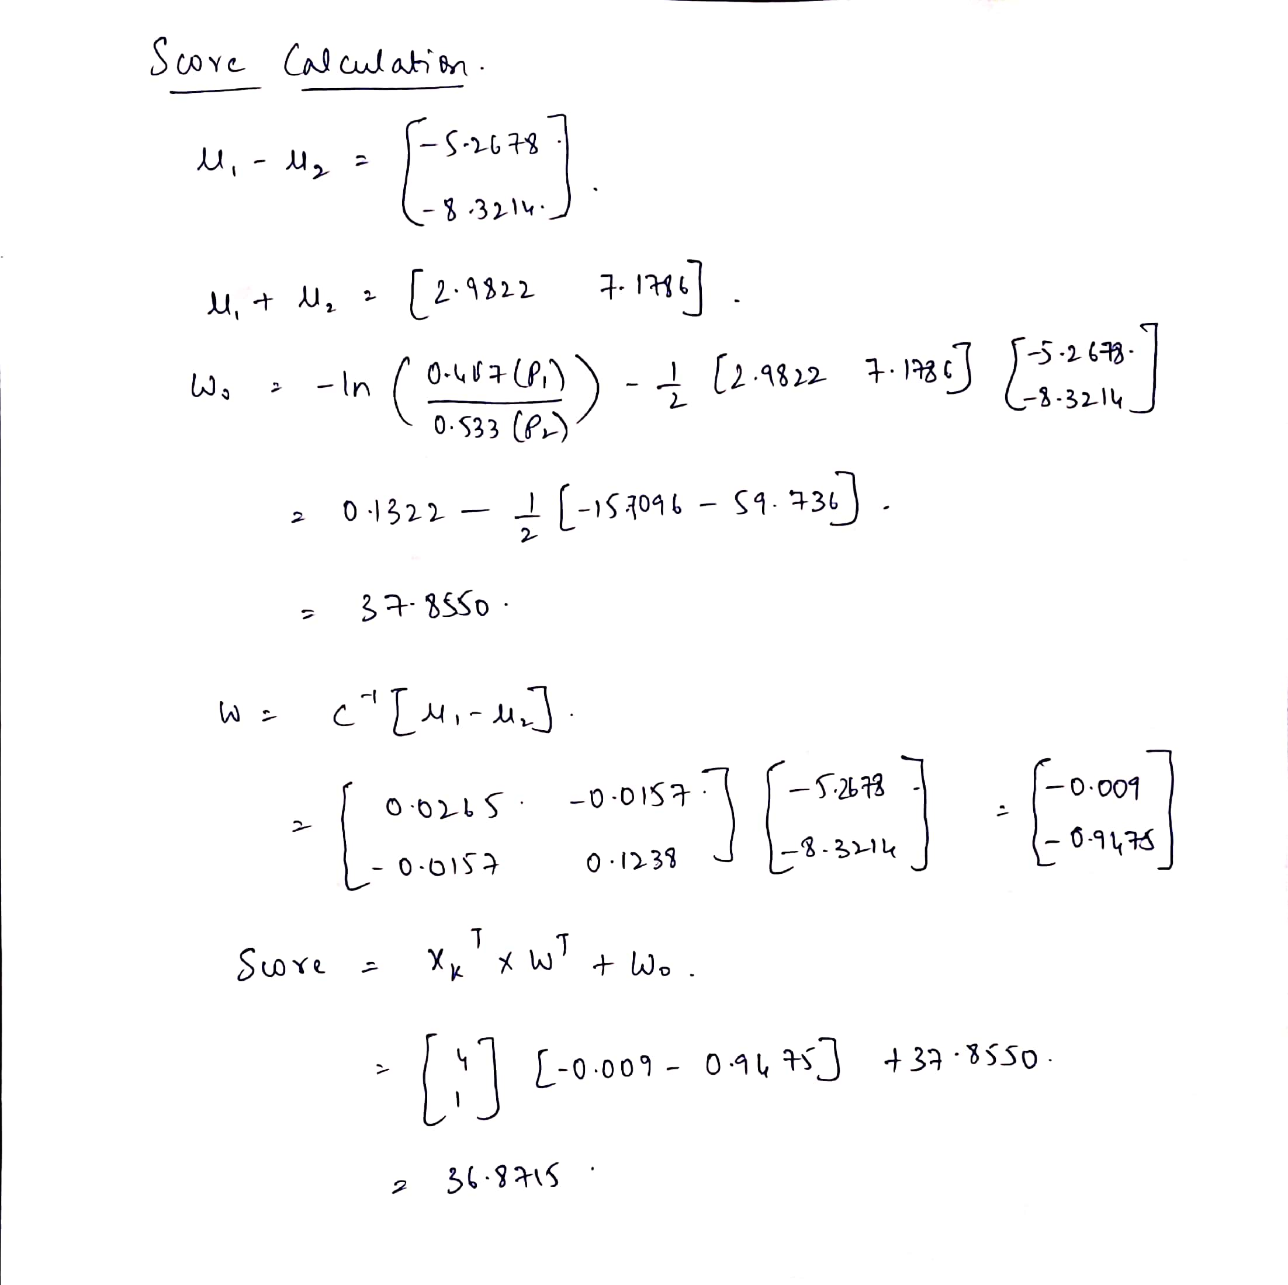
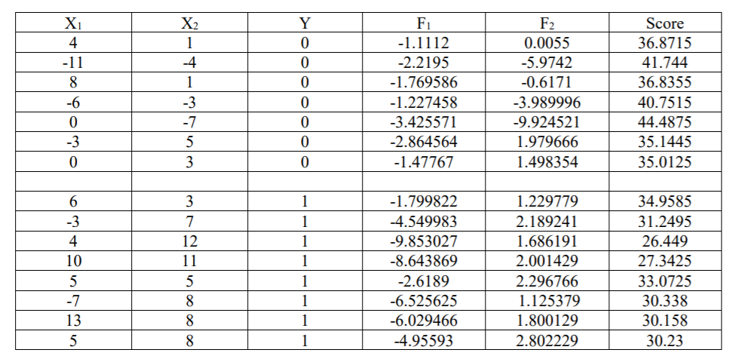
So by this we can assume that all the values of class 0 have the score above 35 (class0 if(score>35)) and we see that if the scores are below 35 then it is class1

b.
