Validations

When chunking size 512/128 is used
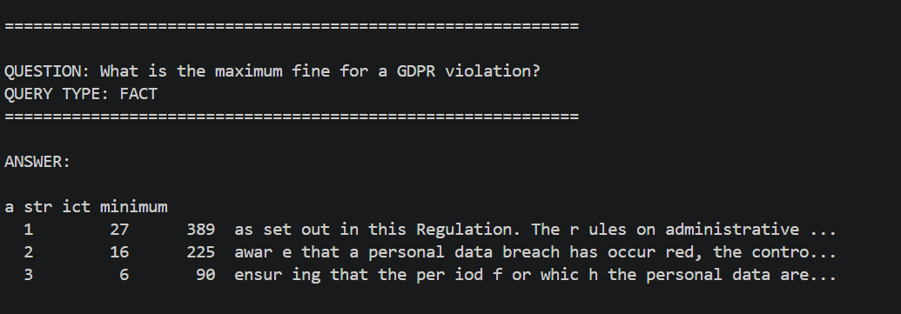
When 800/200 is used
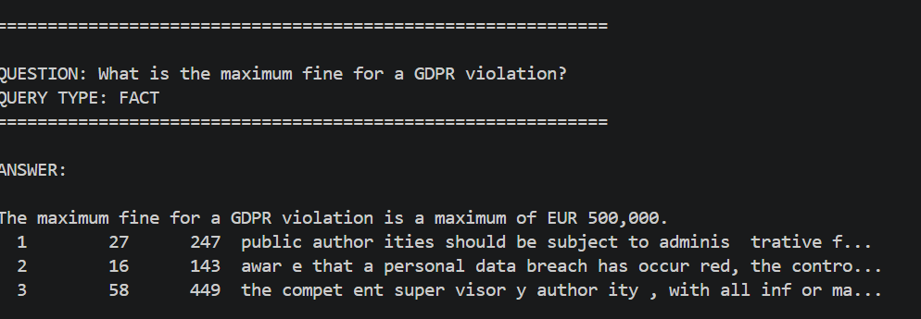

When Flan-t5-base is used
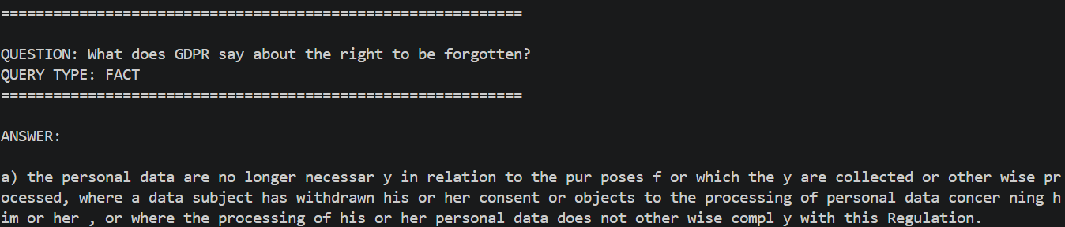

With Flan-t5-small
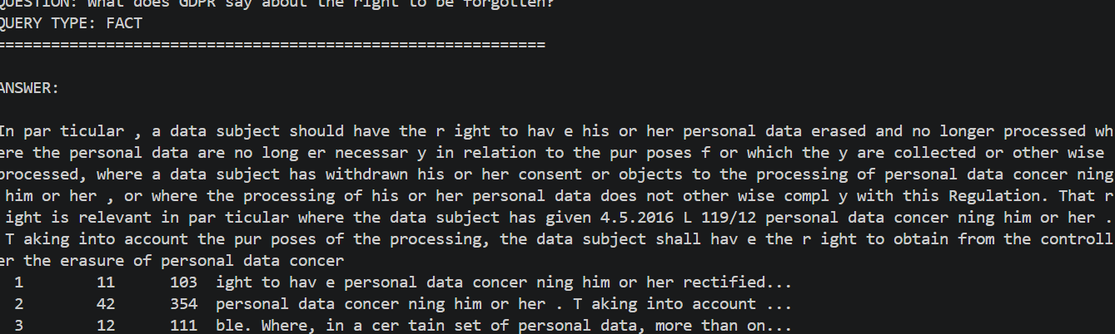

Performance validations
