**LAB3 REPORT**

**INTRODUCTION:**

**OBJECTIVES:**

* This assignment is about creating a Login and Register page and implementing local storage functionality in the Register page.
* To display the calories and weight info of the food searched by the user using the Nutritionix Api.
* Creating own keys to display the above and to read out the text entered using the text to speech Api.

**DESIGN / IMPLEMENTATION:**

* The technologies and the languages that we’ll be using in this project are:

Webstorm Ide

Angular 7

Npm

Bootstrap

* Firstly, we created a new project added the required dependencies such as Bootstrap and jQuery to the project.
* Next, we created 3 components Home, Login and Register and the service called Nutrinix for the project.
* We created the App routing module and set all the paths to the components.
* Next, we developed the basic register and login pages.
* Then we implemented the Local storage functionality to the register page to save and fetch the user details.
* So once when the user tries to login, it uses the local storage to fetch the data and check the credentials.
* Next we will integrate this project with Nutrinix API by generating and using the API key.
* We next develop the home page that comes up after logging in, which displays the required info of calories and weight and this done by using Http get request method to fetch the data from the API
* We do also write text to speech API in code to use in the application.
* In this application, there will be a search bar, when user enters something, the text to speech API will help to speak out the data entered by user.

**OUTPUT ( Screenshots):**

**Basic Project Structure**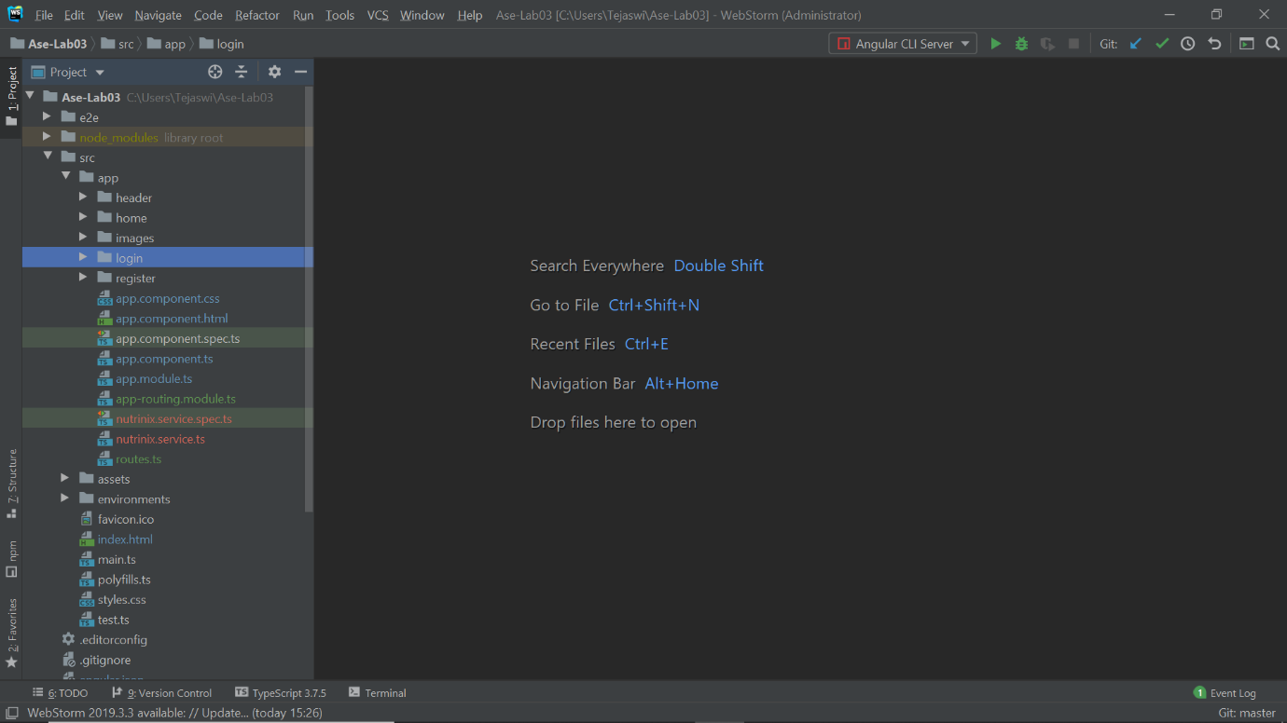

**App Routing Module**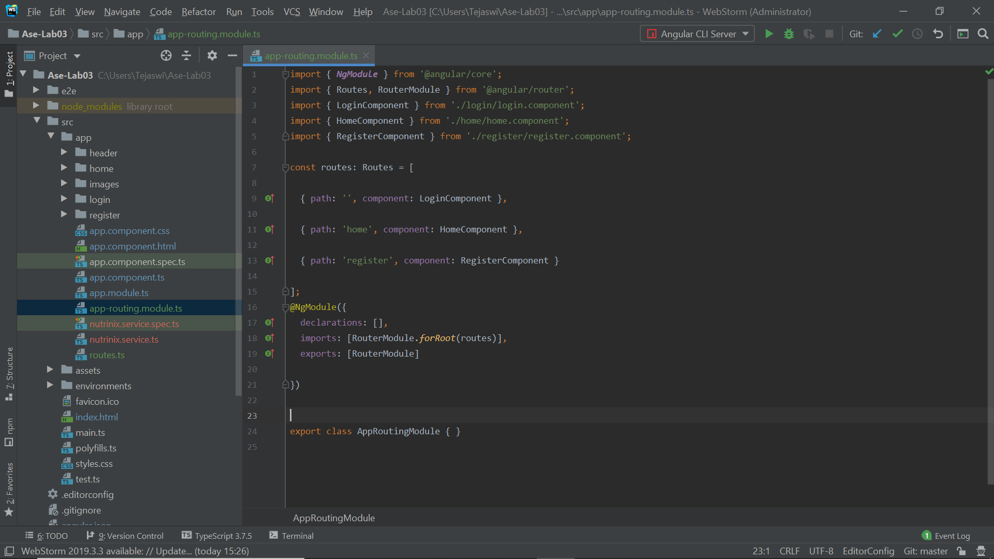

**Local Storage Functionality**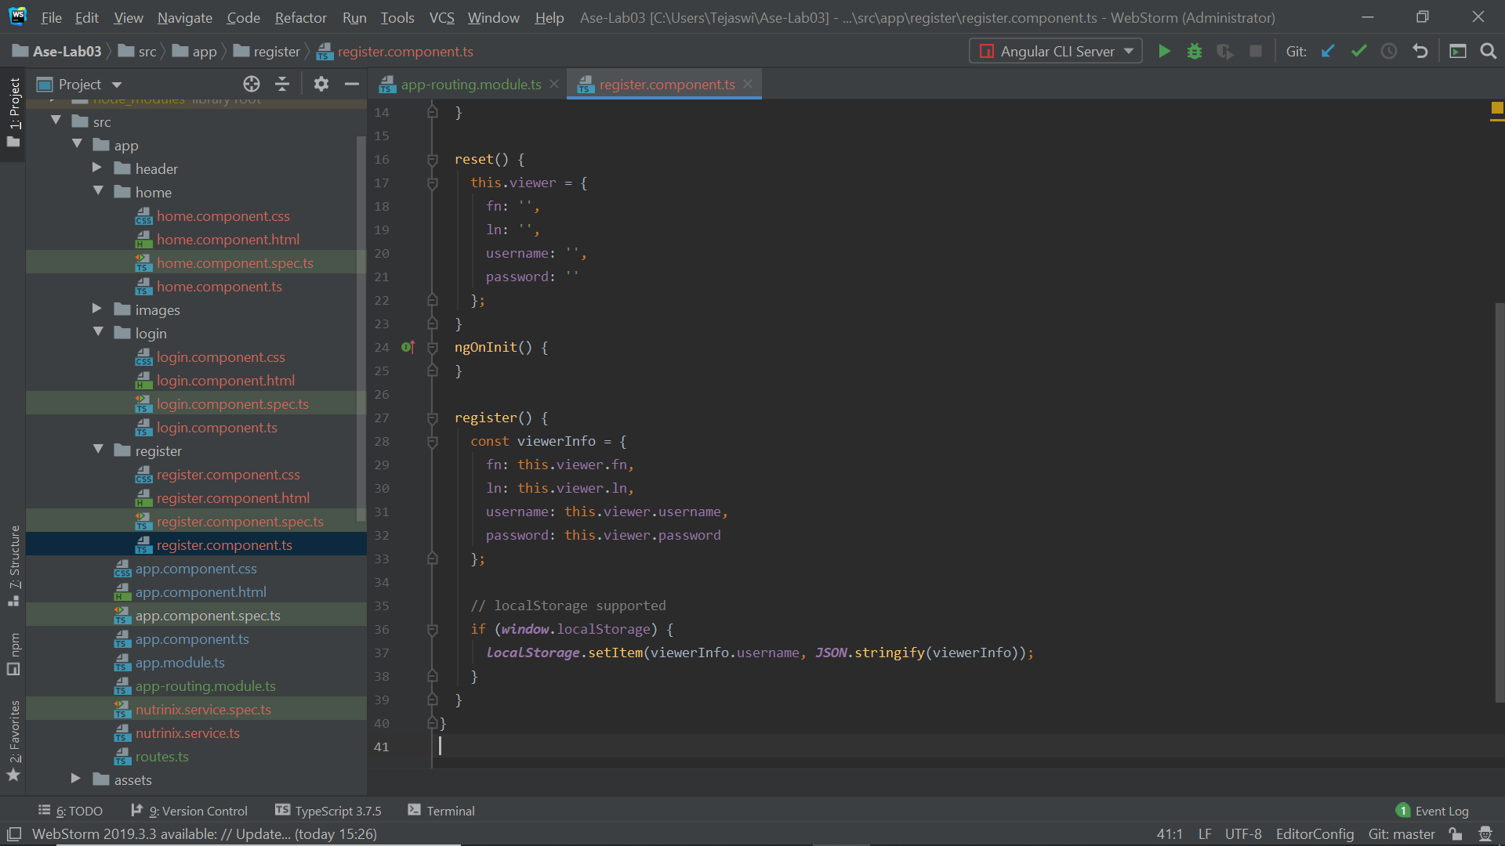

**Accessing API**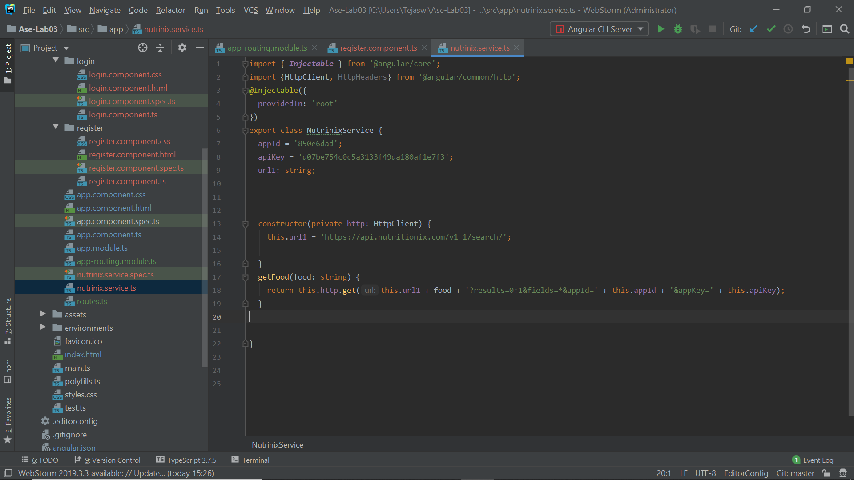

**Text to Speech API implementation** 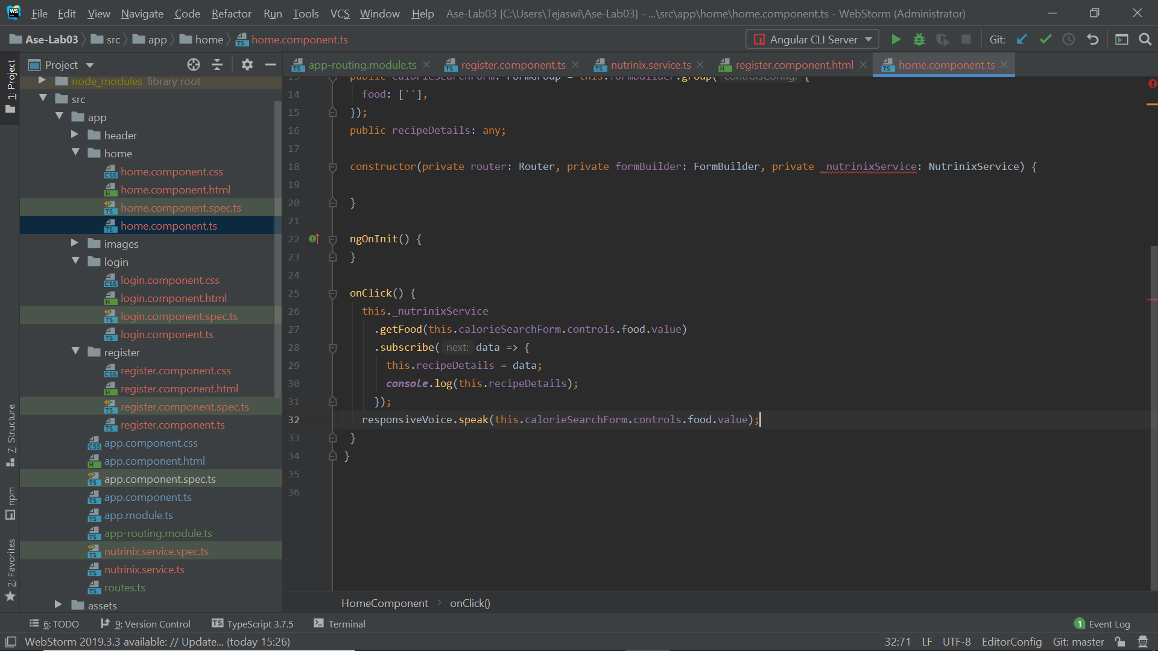

**Output1: Login Page**

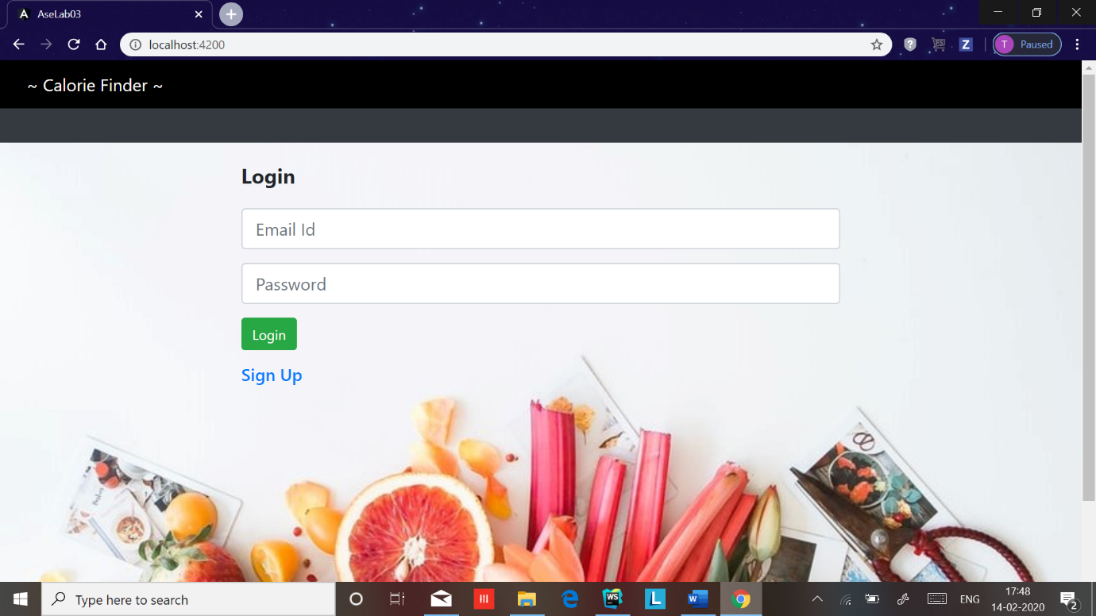

**Output2: Register Page**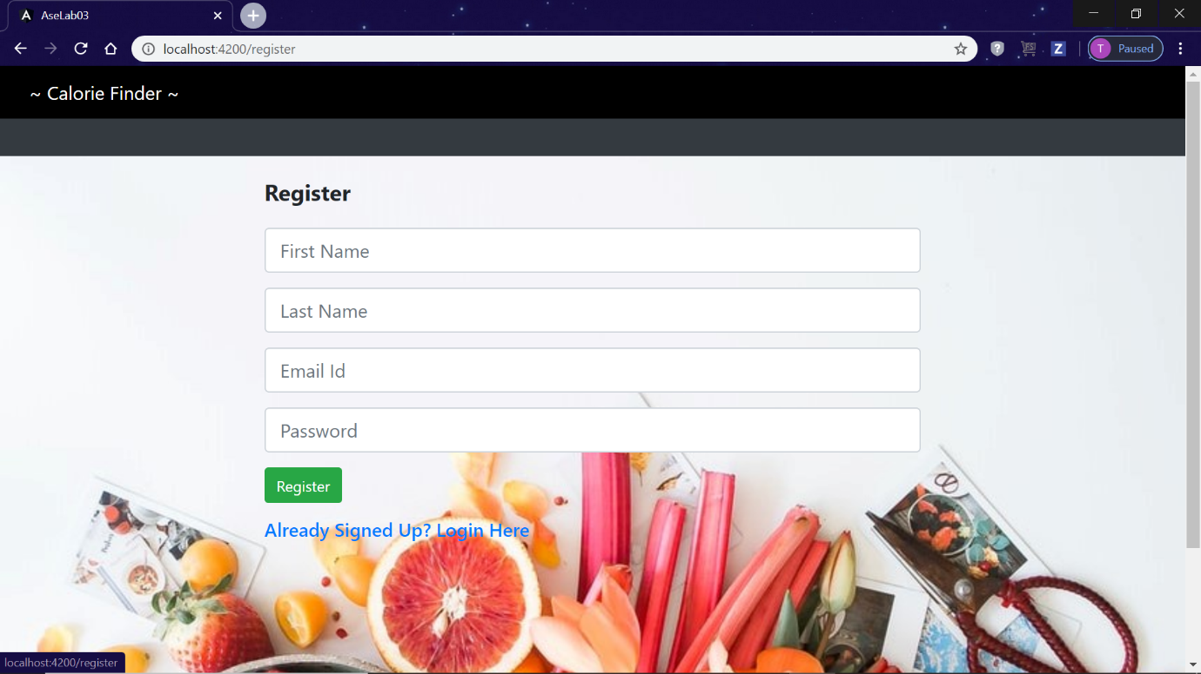

**Output3: Search Recipe Page**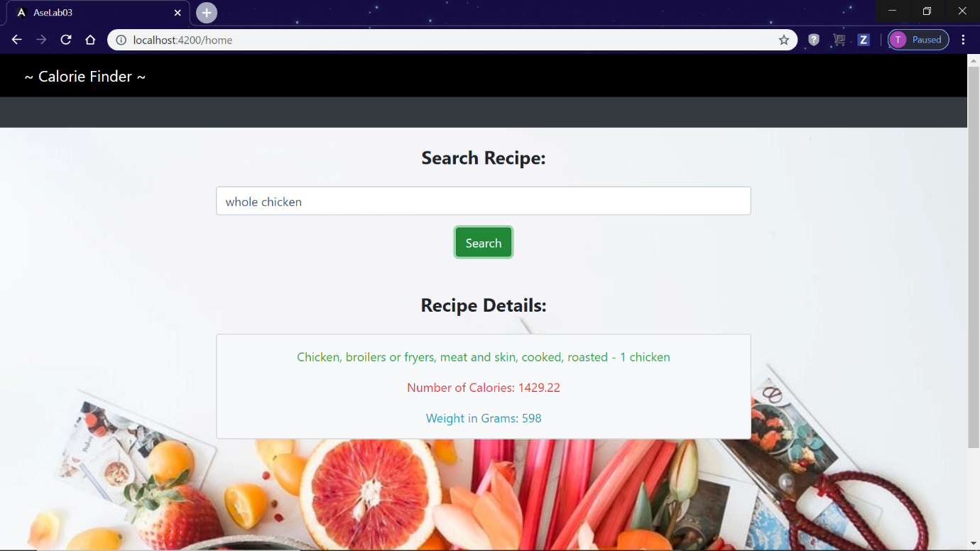

**Output 4: Invalid Credentials**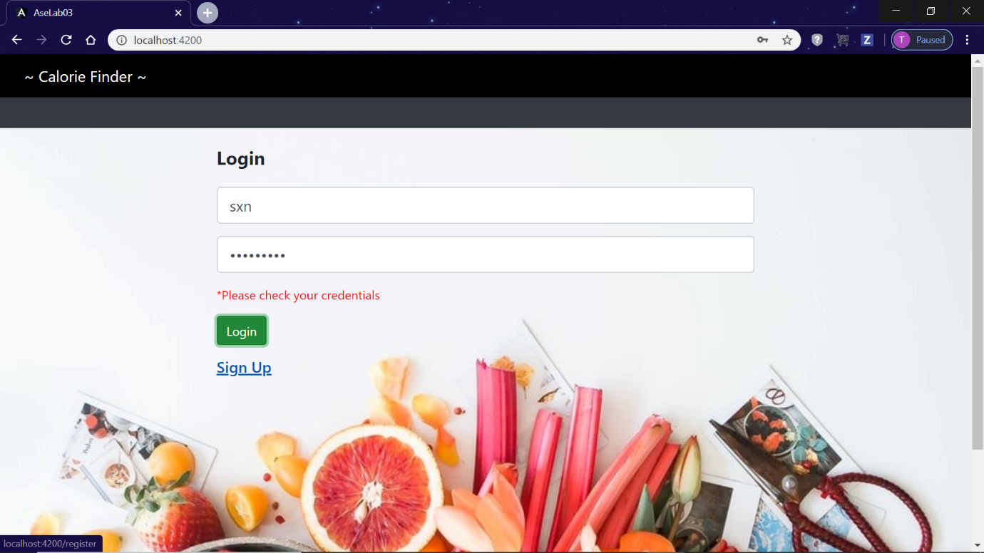

**CONCLUSION:**

This assignment helped learning the proper basics of Angular7 concepts, local storage Functionality, calling API’s and implementing services using UI mashup.

**TEAM:**

Tejaswi Guturu (Class Id :16),

Karishma Yallanki (Class Id :29).