**LAB 10**

**Installing and Configuring AWS CLI**

**Objective**

* In this lab, firstly we create an IAM user in the AWS account.
* Next, we follow the steps to install AWS CLI on Windows.
* Lastly, we configure the AWS CLI.

**Features**

* IAM:

1. Shared access to administer and use resources in your AWS account.
2. Grant different permissions to different people for different resources.
3. IAM features to securely provide credentials for applications that run on EC2 instances.
4. Adding two-factor authentication to your account and to individual users for extra security.
5. Achieves high availability by replicating data across multiple servers within Amazon's datacentres.

* AWS CLI: the AWS CLI enables you to start running commands that implement functionality equivalent to that provided by the browser-based AWS Management Console from the command prompt. The AWS CLI provides direct access to the public APIs of AWS services.

**Implementation**

* IAM User: AWS Identity and Access Management (IAM) is a web service that helps you control access to AWS resources.

1. Sign into the aws account and open the IAM console. Choose Users>Add Users in the navigation pane.

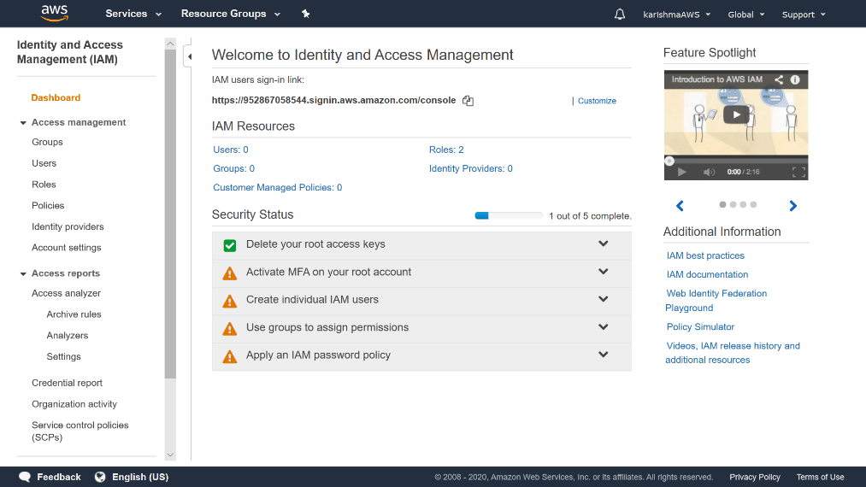

1. Enter the sign-in user name of the user you want to add. Give the access type as programmatic access. This gives the access key ID and secret access key that can be used for the AWS CLI.

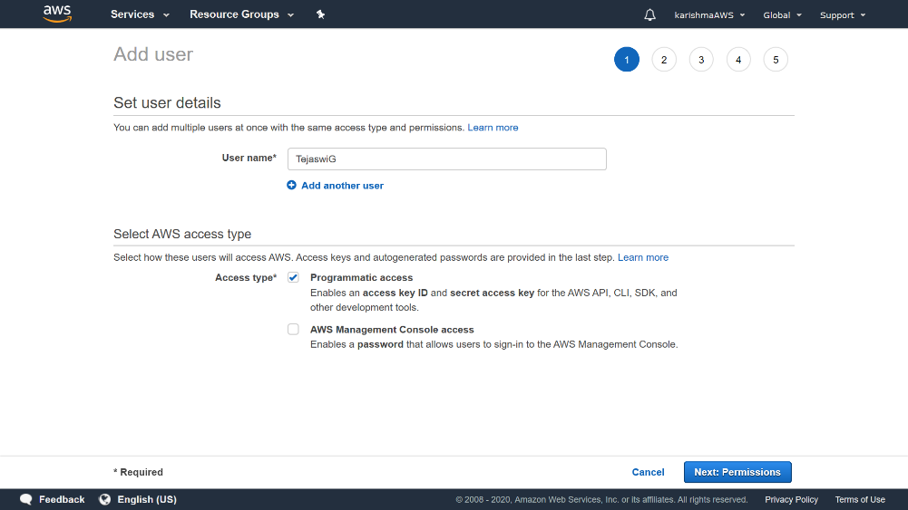

1. In the next page you can set permissions to the user in one of three ways:

Either by adding to a group, copying permissions from already existing IAM user or attaching existing policies directly.

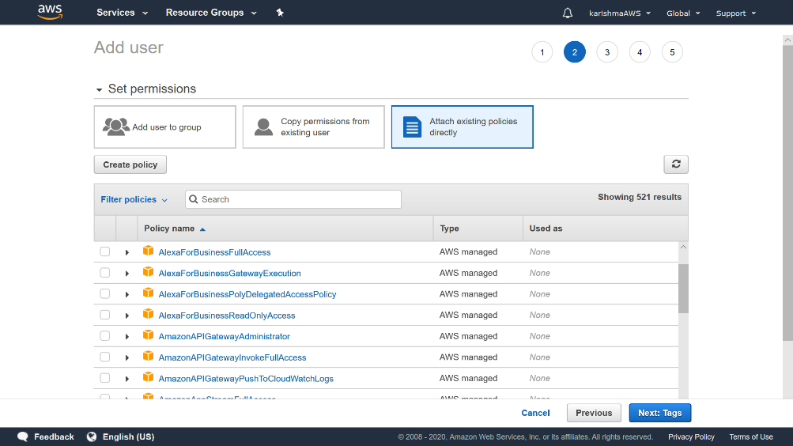

1. Now at the end, after creating the user, the access key ID and the secret access key is displayed where you can download the credentials in the form of .cvs.

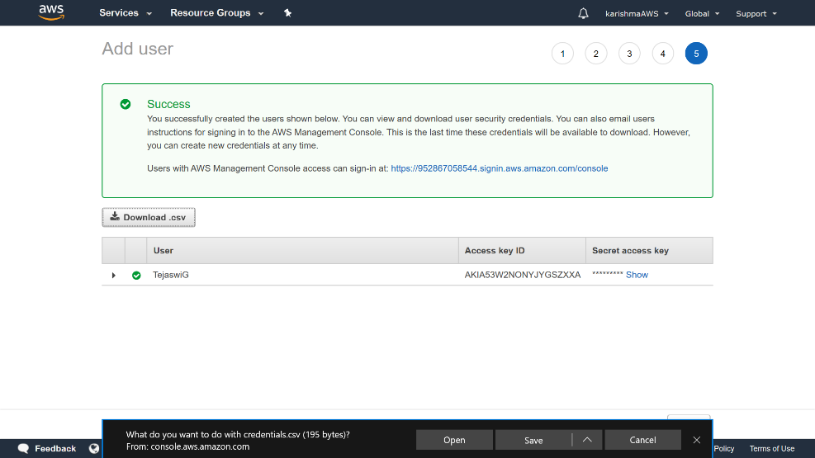

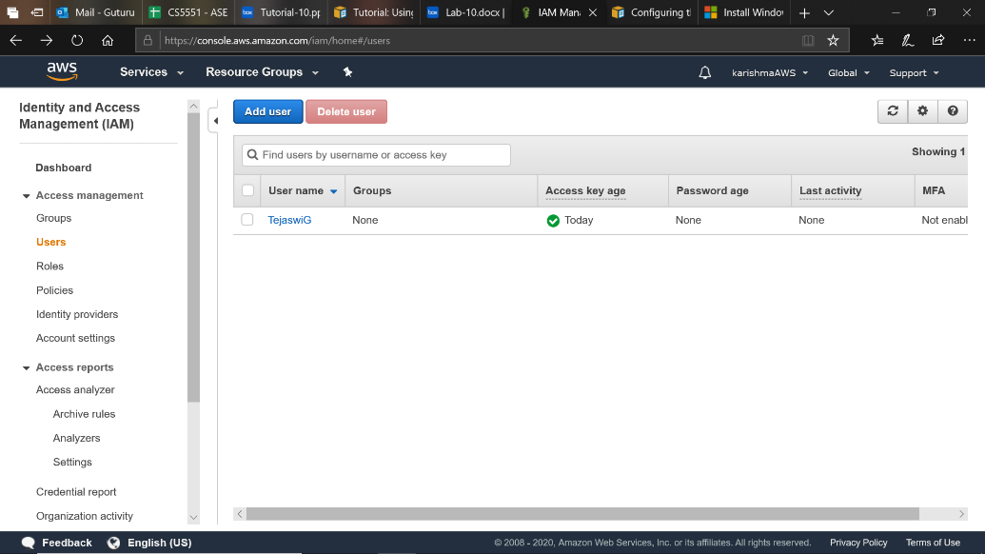

* Install AWS CLI: For Windows users, the MSI installation package should be first installed that offers a convenient way to install the AWS CLI version 2.

Run the downloaded MSI installer and follow the onscreen instructions.

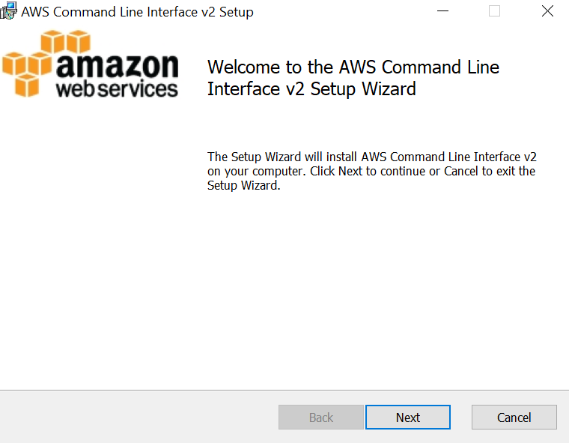 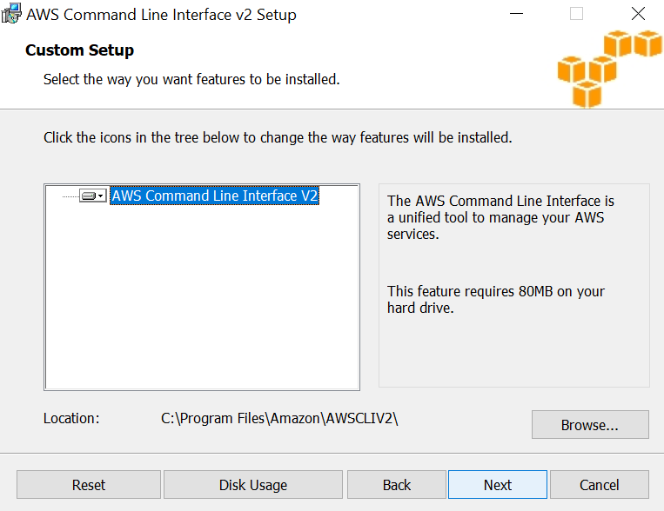

To confirm the installation, in the cmd prompt, use the ‘ aws --version’ .

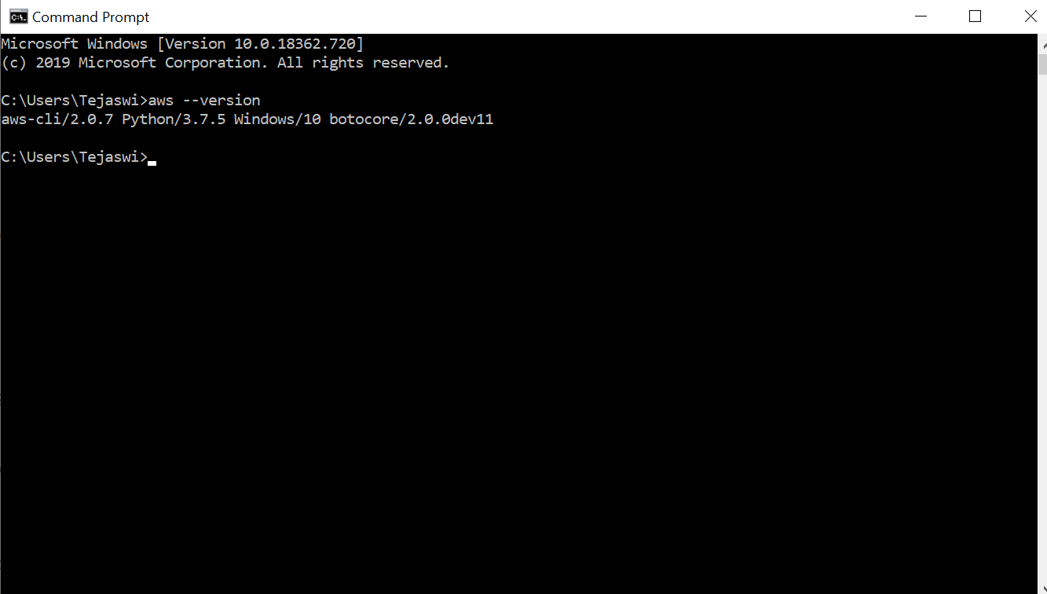

* Configure AWS CLI: To configure your AWS CLI on your laptop to work with AWS services in your AWS account, use the ‘aws configure’

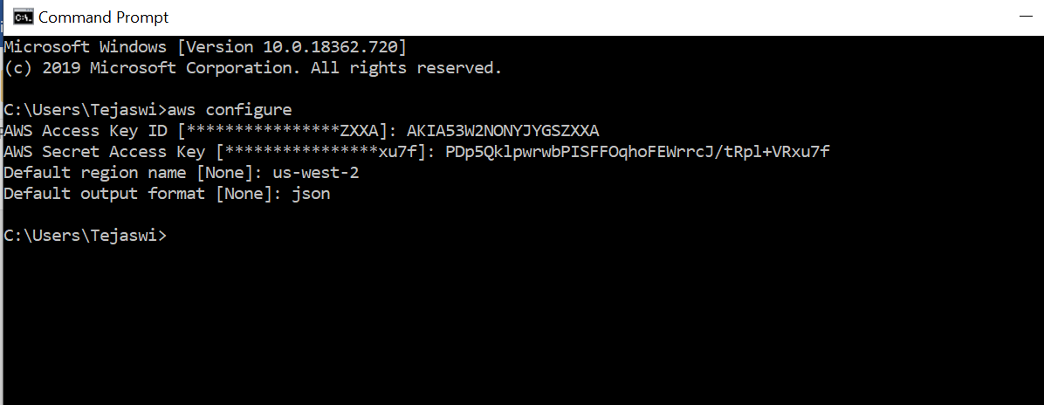

The Default region name identifies the AWS Region whose servers you want to send your requests to by default. The Default format specifies how the results are formatted.

**Conclusion**

So, in this lab we’ve learned all about IAM users and how to create them along with installing the AWS CLI and configure the Aws Cli uses to interact with Aws.

**References**

* <https://docs.aws.amazon.com/IAM/latest/UserGuide/id_users_create.html>
* <https://docs.aws.amazon.com/cli/latest/userguide/install-cliv2.html>
* https://docs.aws.amazon.com/cli/latest/userguide/cli-chap-configure.html

**Team 4-2**

**1. Tejaswi Guturu (Class Id: 16)**

**2. Karishma Yallanki (Class Id:29)**