CSD326

Lab 5

2110110556

Tejaswi Manavala Narayanan

Link: https://online.visual-paradigm.com/community/share/lab5-1nrmrp9y3c

Update Password

First the user must login to the application, or choose the Forgot Password option. If they forgot password, they will receive an email. The email will contain a link to update password. If they login, they must go to Settings and choose Update Password. User must type a new password and site will check its validity. If password is invalid, they must try again. If valid, password wil be updated.

Link: https://online.visual-paradigm.com/w/dlfcdono/diagrams/#diagram:workspace=dlfcdono&proj=1&id=1&type=ActivityDiagram&width=11&height=8.5&unit=inch&page=8WwPXJ4g1yeVyx1e84f1&lightbox=1&highlight=0000ff&edit=https%3A%2F%2Fonline.visual-paradigm.com%2Fw%2Fdlfcdono%2Fdiagrams%2F%23diagram%3Aworkspace%3Ddlfcdono%26proj%3D1%26id%3D1%26type%3DActivityDiagram%26width%3D11%26height%3D8.5%26unit%3Dinch&editBlankUrl=https%3A%2F%2Fonline.visual-paradigm.com%2Fapp%2Fdiagrams%2F%23diagram%3Aproj%3D0%26vpov%3D16.3%26vpob%3D20220410%26client%3D1%26edit%3D_blank&layers=1&nav=1

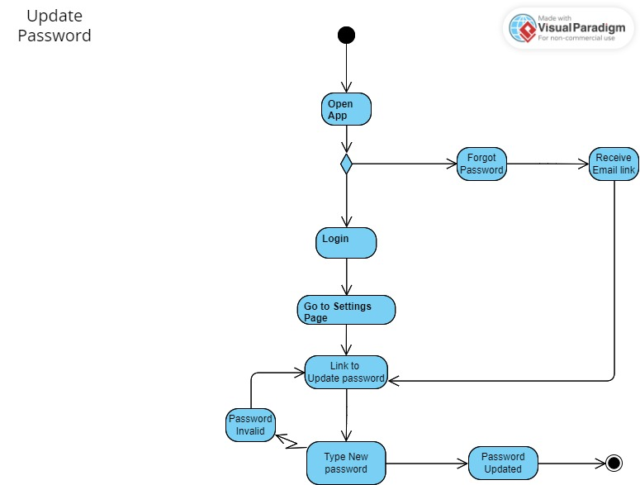

Upload Picture

User must login if they have an account, or Sign up if they don’t. They must go to Home screen and choose between Taking a Photo or Uploading from Gallery. They can retake the photo if not satisfied, then edit the photo. Then the photo will be uploaded.

Link: <https://online.visual-paradigm.com/w/dlfcdono/diagrams/#diagram:workspace=dlfcdono&proj=1&id=1&type=ActivityDiagram&width=11&height=8.5&unit=inch&page=wkC2EaH8k3NAKWEOvotU&lightbox=1&highlight=0000ff&edit=https%3A%2F%2Fonline.visual-paradigm.com%2Fw%2Fdlfcdono%2Fdiagrams%2F%23diagram%3Aworkspace%3Ddlfcdono%26proj%3D1%26id%3D1%26type%3DActivityDiagram%26width%3D11%26height%3D8.5%26unit%3Dinch&editBlankUrl=https%3A%2F%2Fonline.visual-paradigm.com%2Fapp%2Fdiagrams%2F%23diagram%3Aproj%3D0%26vpov%3D16.3%26vpob%3D20220410%26client%3D1%26edit%3D_blank&layers=1&nav=1&page=wkC2EaH8k3NAKWEOvotU>

