**Execution Steps:**

The main code for extracting features and training models is in FeatureExtraction_ModelGeneration.py file

1. Make sure that at line 22 in FeatureExtraction_ModelGeneration.py file jsons_path variable has the correct path which has json files to extract features.
2. Using the command line arguments while executing the python files values of the variables choice and fileName can be changed.
   * Options for choice variable are 1- only to extract features, 2- only to train models and 3- both for feature extraction and model training. By default, the choice is 3
   * Variable fileName can be used to give the fileName of the csv which will be generated with feature extraction or in case of model training the csv file which can be used for training models. By default, the fileName is feature_points.csv

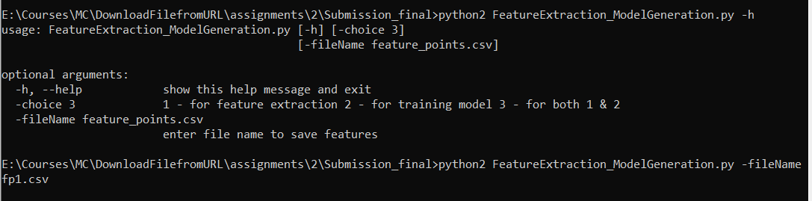

Whereas, file predict_gestures.py is to predict the gestures of the given jsons and calculate the accuracy on how correctly models has predicted the gestures. To execute this, make sure at line 42 predict_gesture.py file jsons_path variable is pointing to correct path which has json files.

**Hosted Service URL and Result:**

**URL:** <https://mcspring2020-group15.wm.r.appspot.com/predictgesture>

**Json Result:**

{

    "1": "gesture predicted by KNN",

    "2": "gesture predicted by DecisionTree",

    "3": "gesture predicted by Random Forest",

    "4": "gesture predicted by Neural Networks"

}

**Sample Output:**

