**Multiple Linear Regression**

**CSE 303: Machine Learning**

Submitted by

Name: Darsi Tejaswi

Roll No: AP22110011503

Section: CSE M

Lab Date: 27/08/2024

Submission Date: 02/09/2024

**Department Computer Science and Engineering**

**School of Engineering and Sciences**

**SRM University–AP**

**Amaravati, Andhra Pradesh – 522 240, India**

1. **Question**

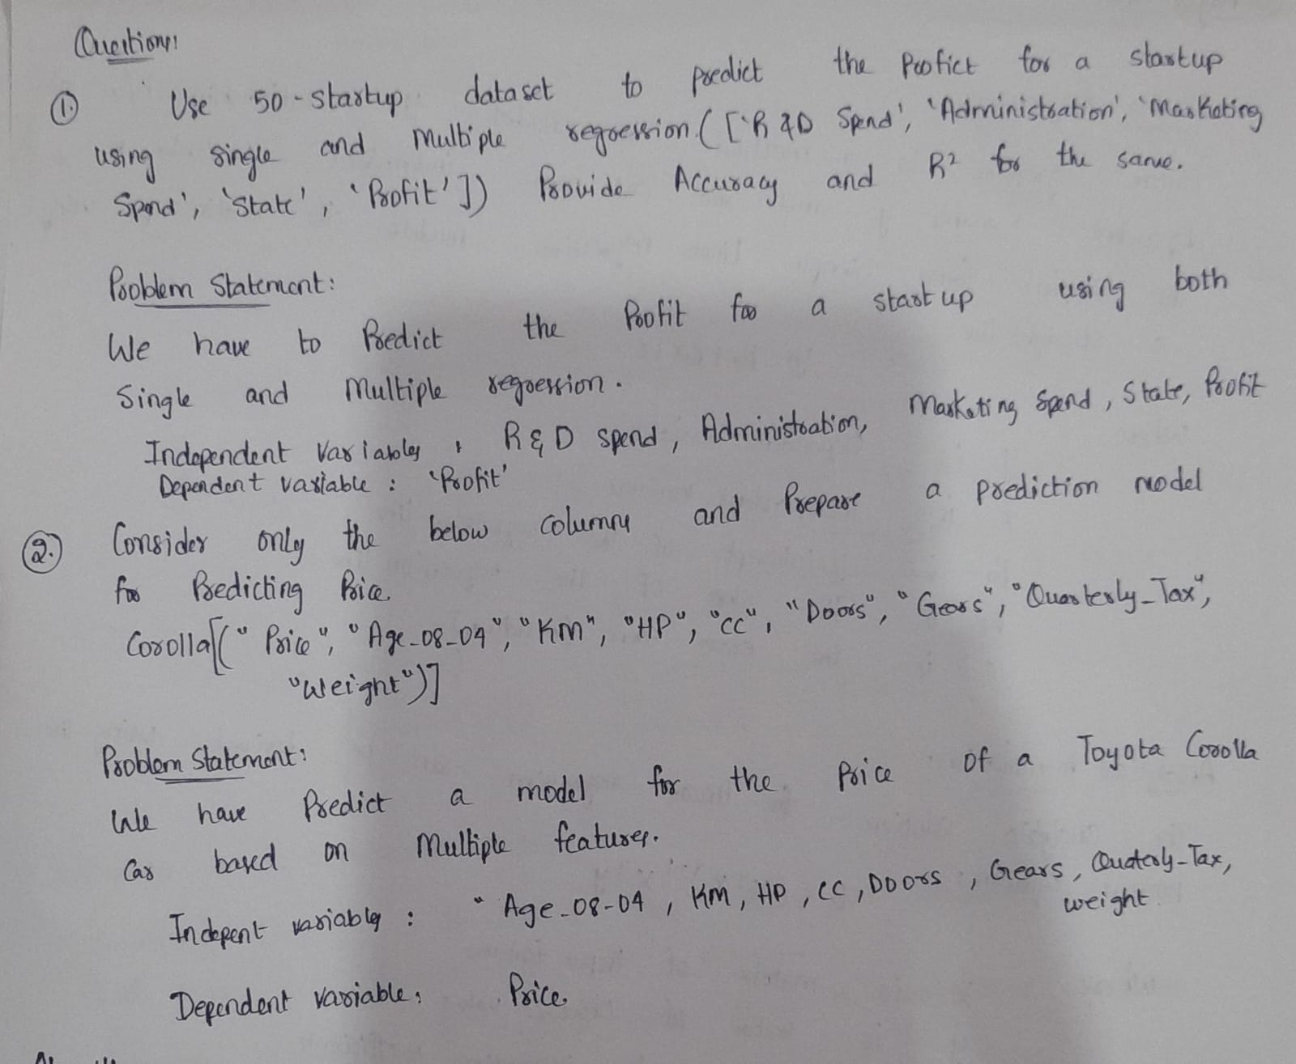

1. **Algorithm Description**

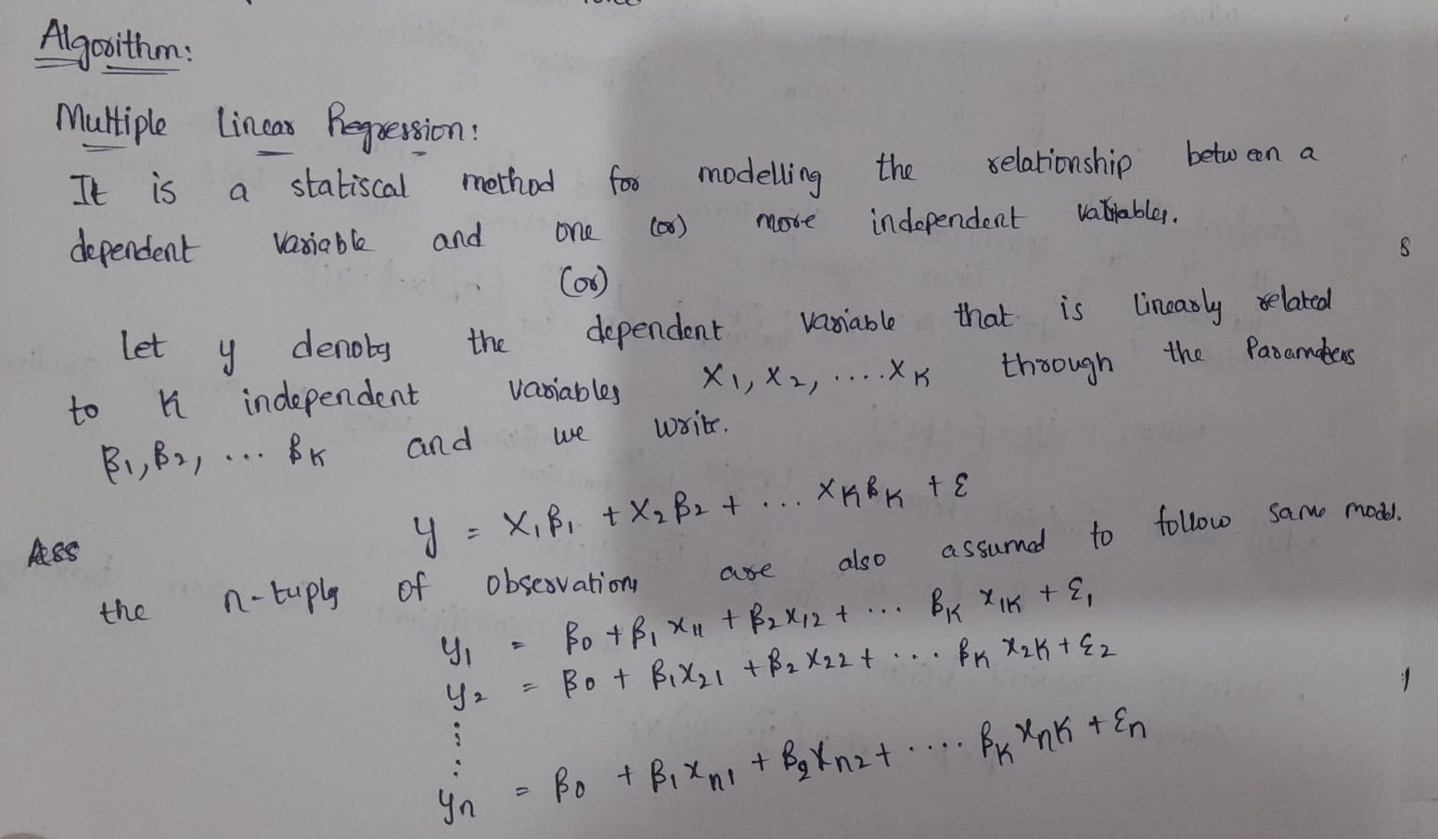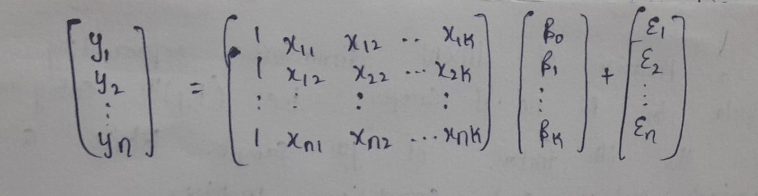

1. **Solution**

Dataset used:  
data preprocessing if any

(Add all the code here: provide code and corresponding solution using markdown-cell style)

1. **Code Repository:**

Provide GitHub link for the assignment