Project Overview:
This project focuses on analyzing an insurance dataset to understand the key factors influencing insurance claim amounts.
The analysis uses Exploratory Data Analysis (EDA) techniques to uncover patterns, trends, and relationships within customer data.
The project demonstrates practical application of Python, Pandas, Matplotlib, and Seaborn in a real-world business scenario.

Business Problem Statement:
- Insurance companies face challenge to set fair prices for their policies, but it’s hard because:
- Some customers are riskier than others (more likely to make claims).
- Factors like age, weight (BMI), smoking habits, and number of dependents affect the risk.
If they don’t analyze these factors:
- They might charge too little for high-risk customers → lose money on claims.
- They might charge too much for low-risk customers → lose potential customers.

Objectives of the Analysis:
- To identify key factors influencing insurance claim amounts.
- To analyze customer demographics and health indicators.
- To compare insurance charges across different customer groups.
- To uncover relationships between numerical variables such as age, BMI, and charges.
- To provide insights that can help insurers improve:
Risk profiling
Premium pricing
Policy design strategies.

Dataset Description:
The dataset contains customer-level insurance information with the following attributes:
age – Age of the policyholder
sex – Gender of the customer
bmi – Body Mass Index (health indicator)
children – Number of dependents covered
smoker – Smoking status (Yes / No)
region – Residential region of the customer
charts – Insurance claim amount

Data Cleaning Steps Performed:
Loaded the dataset into a Pandas DataFrame.
Verified column names and data types.
Checked for missing and null values.
Ensured numerical columns (age, bmi, charges) were in correct format.
Verified categorical columns (sex, smoker, region) for consistency.
Confirmed data quality before performing analysis.
Outcome:
Dataset was clean, consistent, and ready for exploratory analysis.

Exploratory Data Analysis(EDA)

1. Does the gender of the person matter for the company as a constraint for
extending policies?(Barplot)
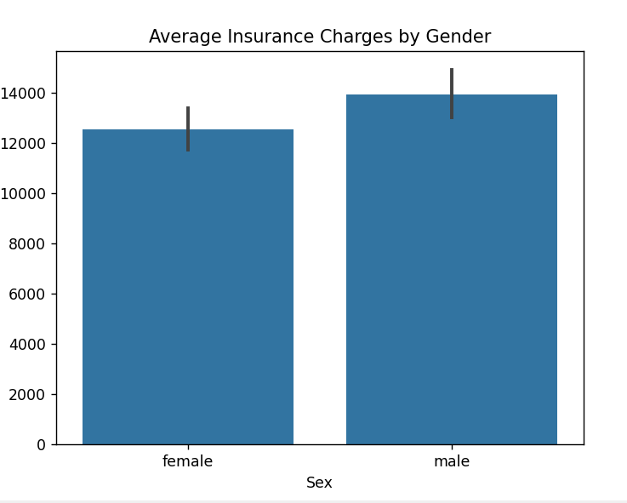

Average Insurance Charges by Gender
- Average charges for males and females are very similar (or only slightly different).
- Gender alone does not significantly influence insurance costs.
Business Recomondations:
- Gender-based pricing is not a strong business requirement.
- Supports fair and unbiased policy pricing.

2. What is the average amount of money the company spent over each policy(Histogram,Boxplot&BarChart)
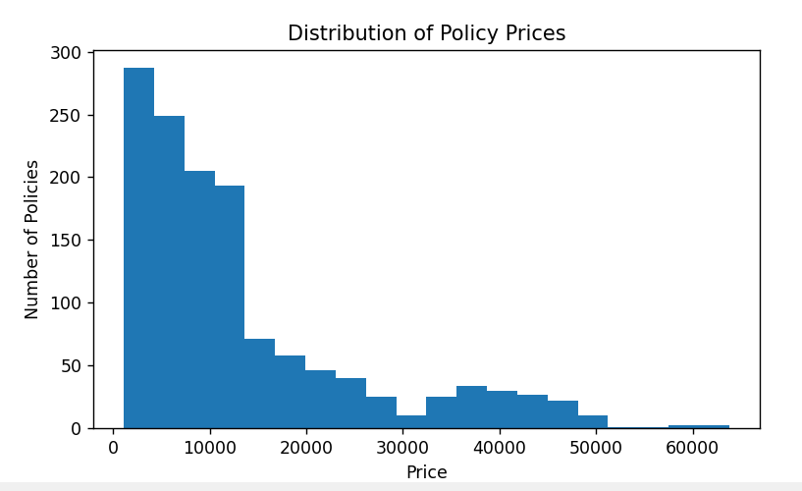

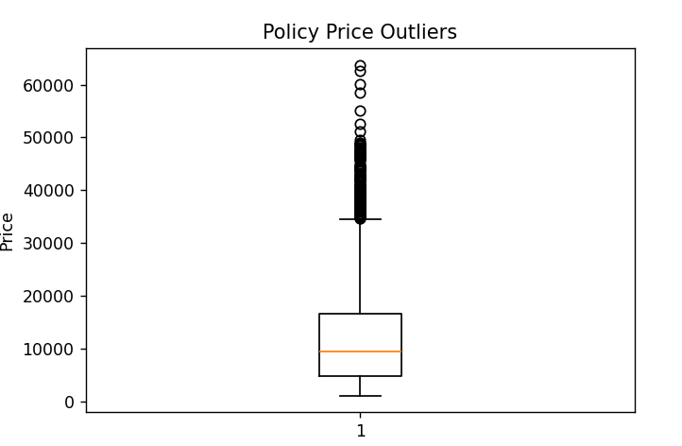

What this chart shows:
• The median policy price is relatively low compared to the maximum values.
• The upper side has many outliers, extending up to ~60,000+.
• The distribution is right-skewed, meaning most customers pay lower prices, but a few pay very high premiums.1
Most policy prices are concentrated in a lower range
• The majority of customers fall within a moderate pricing band.
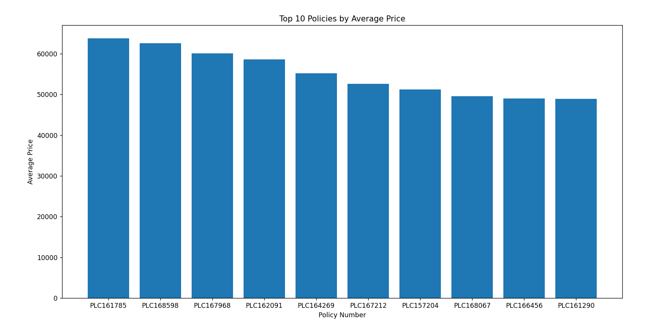

What this chart shows:
- Each bar represents a policy number.
- The height of the bar indicates the average price (premium) of that policy.
- All top 10 policies have very high average prices, roughly in the 50,000–65,000 range.
- There is a gradual decline, not a sharp drop, indicating these policies belong to a similar premium tier.

3. Could you advice if the company needs to offer separate policies based upon the
geographic location of the person?(Boxplot)

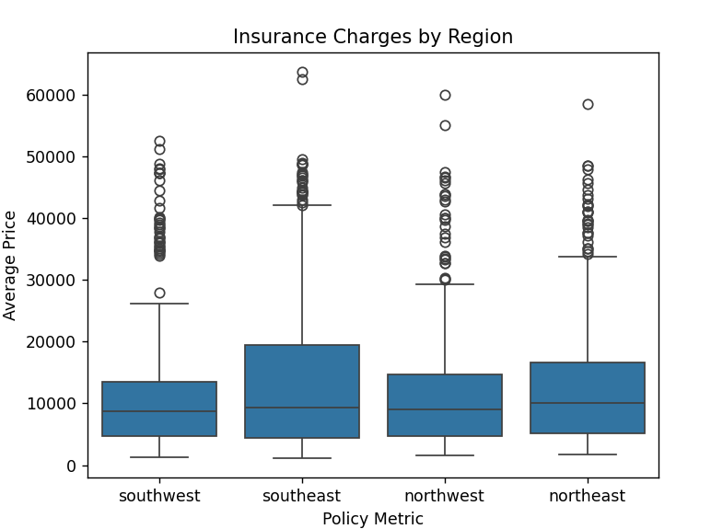

Insurance Charges Across Regions
- Certain regions show slightly higher average charges.
- Regional differences exist, likely due to:
- Healthcare cost variation
- Lifestyle and environmental factors
Business Recomondations:
- Region alone should not heavily affect pricing.
- Can be used for operational planning, not strict premium changes.

4. Does the no. of dependents make a difference in the amount claimed?(Barplot)

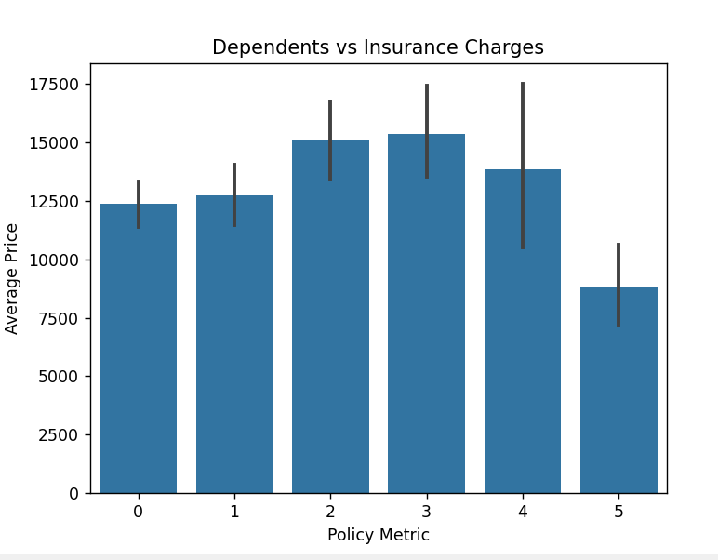

Number of Dependents on Insurance Charges:
- Charges do not increase significantly with more dependents.
- Number of dependents has minimal impact on individual claim cost.
Business Recomondations:
- Dependents should not heavily influence premium pricing.
- Avoids unfair cost burden on families.

5. Does a study of persons BMI get the company any idea for the insurance claim
that it would extend?(Scatterplot)
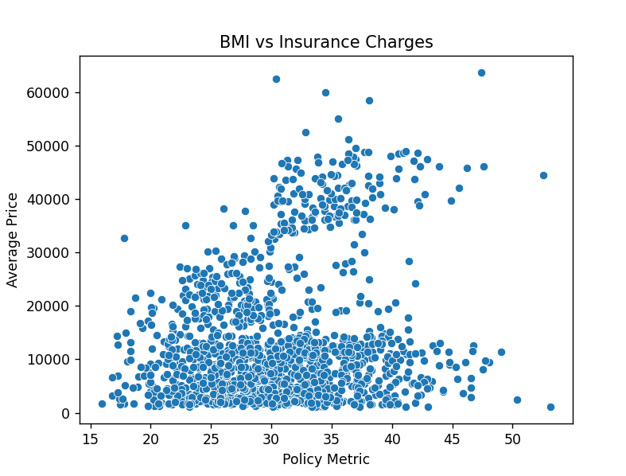
- As BMI increases, insurance charges tend to increase, especially for smokers.
- High BMI combined with smoking leads to very high claims.
Business Recomondations:
- Supports health-based premium adjustments.
- Encourages insurers to offer BMI-based wellness incentives.

6. Is it needed for the company to understand whether the person covered is a
smoker or a non-smoker?(Boxplot)
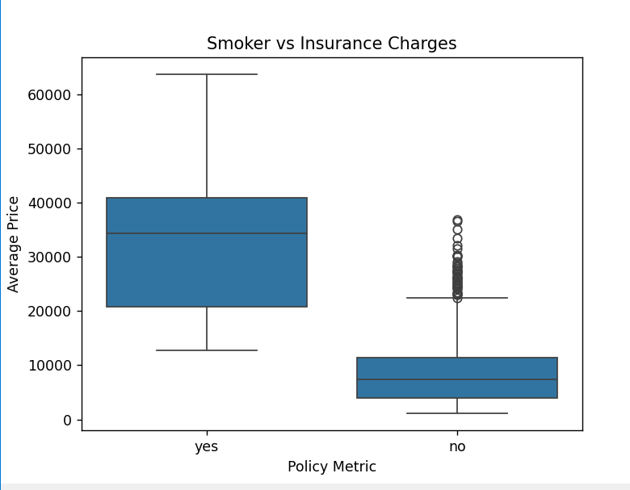

Impact of Smoking on Insurance Charges
- Smokers have significantly higher insurance charges than non-smokers.
- Smoking is a major health risk factor that directly increases claim costs.
Business Recomondations:
- Justifies higher premiums for smokers.
- Encourages the company to introduce:
- Smoking cessation programs
- Preventive healthcare incentives
- This is the strongest cost driver in the dataset

- Does age have any barrier on the insurance claimed?(Scatterplot)
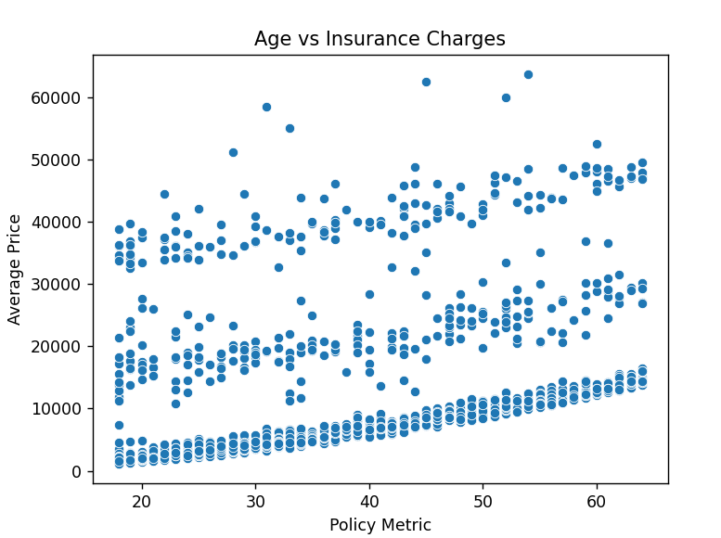

Age Distribution of Policyholders
- Most policyholders are between young to middle age.
- The company’s core customer base is economically active individuals.
- Very young and very old age groups form a smaller portion of customers.
Business Recomondations:
- Focus marketing and product design on working-age customers.
- Design specialized plans for senior citizens instead of general policies.

8. Can the company extend certain discounts after checking the health status
(BMI)inthiscase?(BarChart)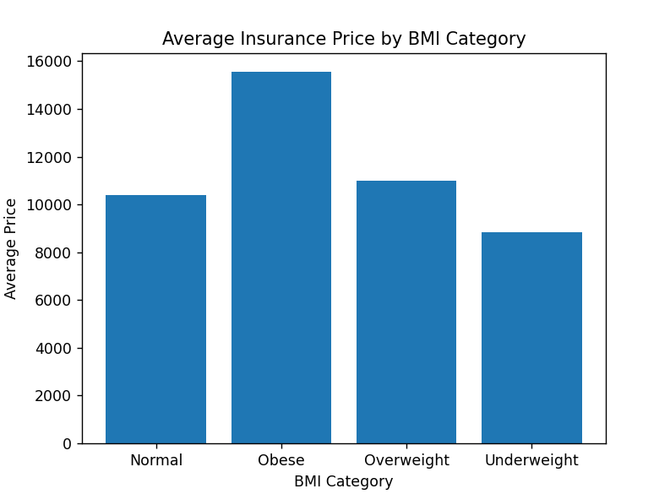

What the chart shows:
- Majority of customers fall into normal or overweight BMI categories.
- Obese category is smaller but important.
- Most customers have moderate health risk.
- Higher BMI groups represent potential future claim risk.
Business Recomondations:
- BMI can be used as an early risk indicator.
- Supports health monitoring and preventive programs.

9 Total claimed Insurance (KPI)
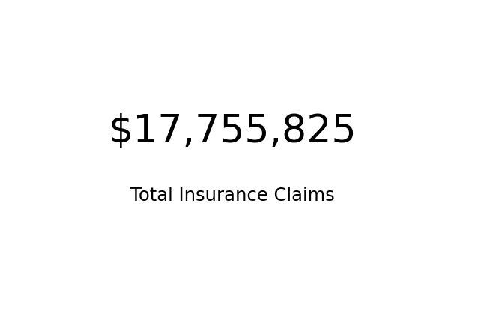
10, Insurance claims by Region(Pie-Chart)
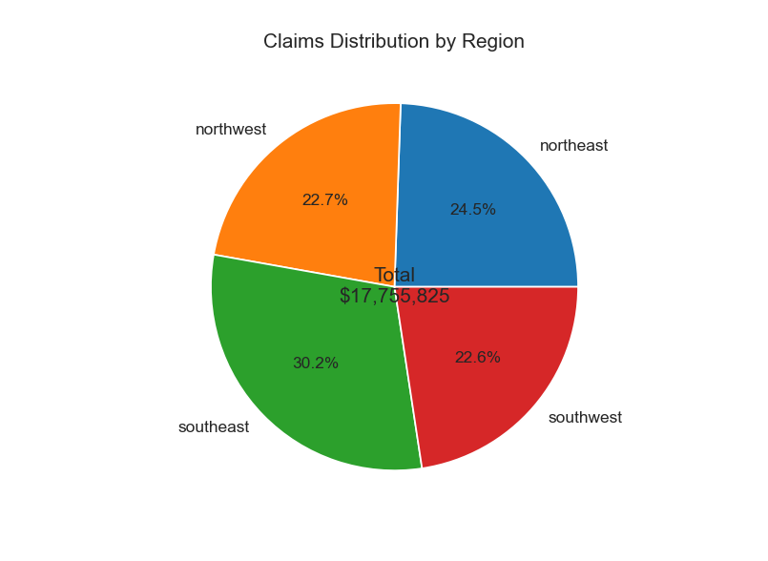

11, Age Distribution of Customers Count(Histogram)
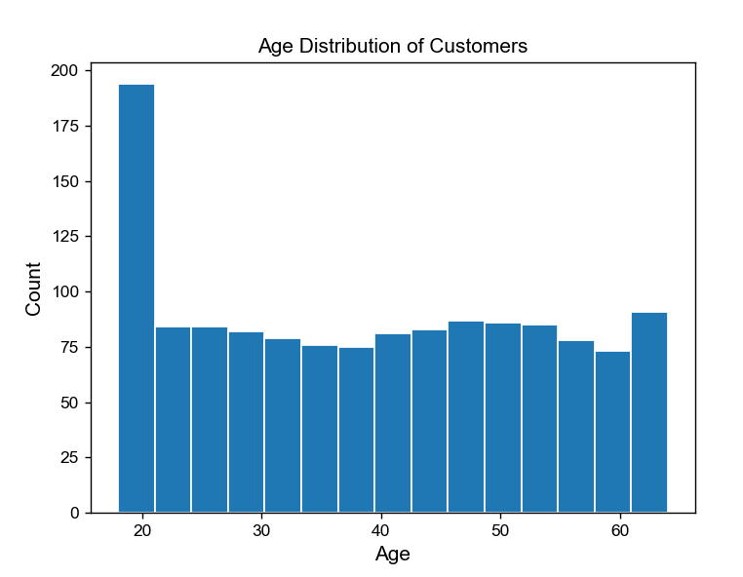
12, BMI Distribution by Customers Count(Histogram)
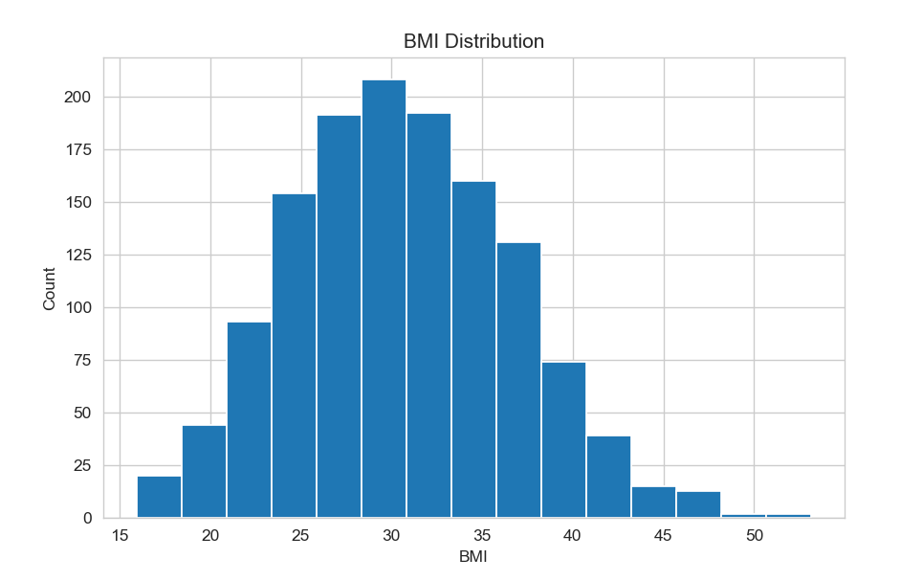

13, Customer Distribution by Region(Pie Chart)

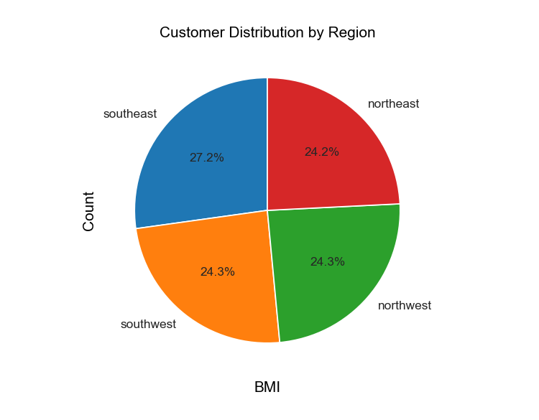

14, Average Charges by region and Smoking Status(HEATMAP)
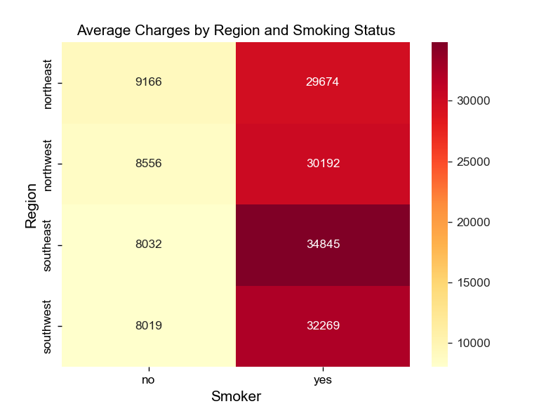

15,Customer Count and Avg Charges by Age Group(Bar&Plot Chart)
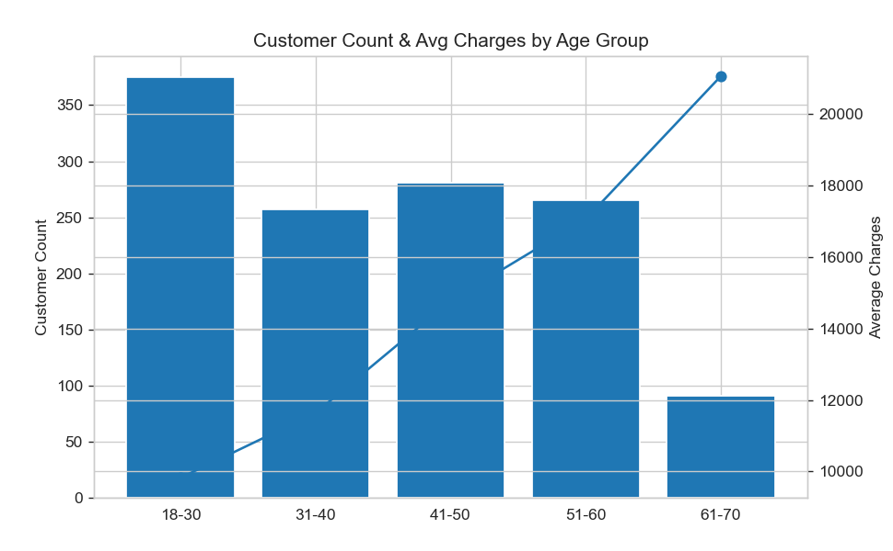

- Business Insights Summary

1. Main Factors That Increase Insurance Cost
The analysis clearly shows that customers with unhealthy habits and higher age create Increase Insurance cost.
- Smoking status has the strongest impact on insurance cost.
- Age is the second most important factor; charges increase as age increases.
- BMI (Body Mass Index) also affects insurance cost, especially when combined with smoking.
- Factors That Have Little Impact on Insurance Cost:Some factors show very minimal influence on insurance charges:
Gender
Region
Number of dependents
These factors should not be heavily used for premium pricing because they do not significantly change claim cost.

3. Customer Risk Segmentation
Customers can be clearly grouped into low-risk and high-risk categories:
Low-risk customers: Non-smokers, younger age, normal BMI
High-risk customers: Smokers, older age, high BMI
Risk-based customer segmentation helps the company:
Price policies fairly
Control claim losses
Improve profitability

4. Preventive Healthcare Opportunity
High charges are linked to preventable health conditions such as smoking and high BMI. The company can reduce future claims by:
Offering wellness programs
Encouraging healthy lifestyles
Providing incentives for non-smokers and healthy BMI customers
Conclusion: Insurance charges are mainly affected by smoking, age, and BMI. Gender, region, and number of dependents have very little impact. The company should focus on promoting preventive healthcare programs, the company can reduce claim costs, improve customer health, and increase long-term profitability..

