**The main page**. 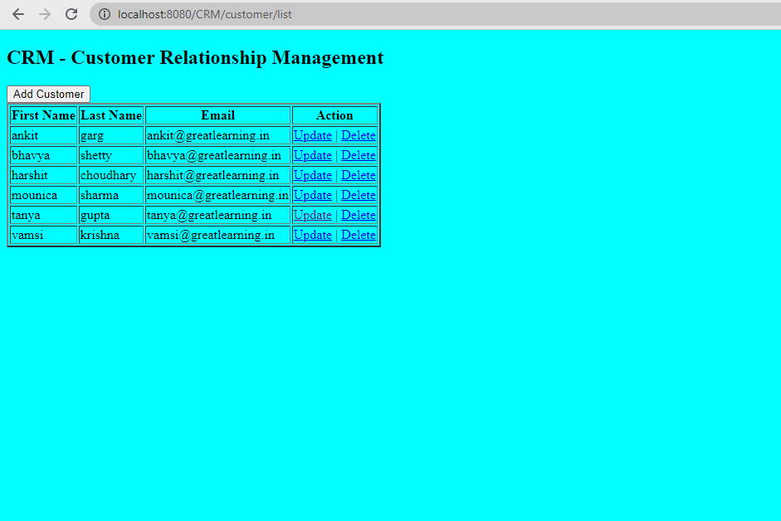

**Saving New Customer** 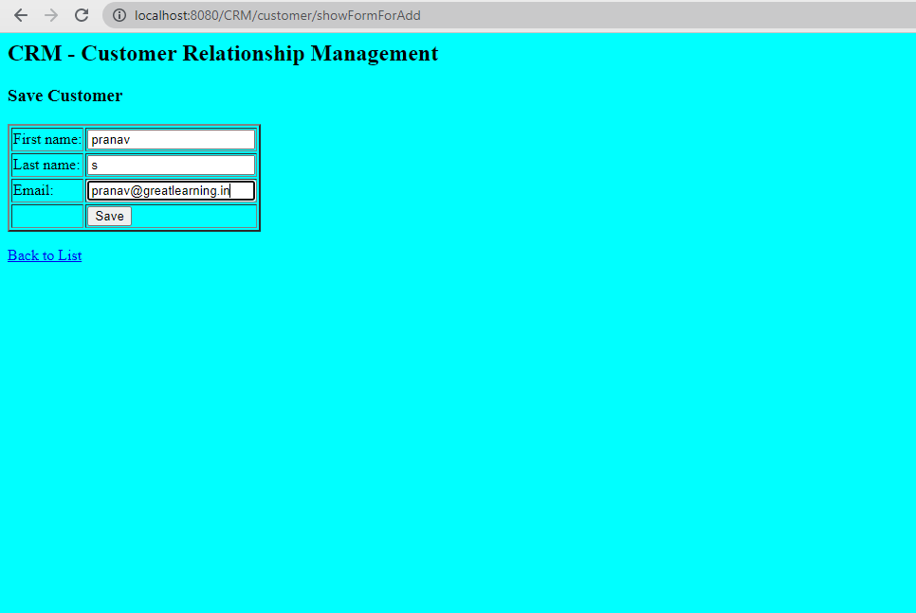

**Updated list of customers after adding a new customer pranav s.** 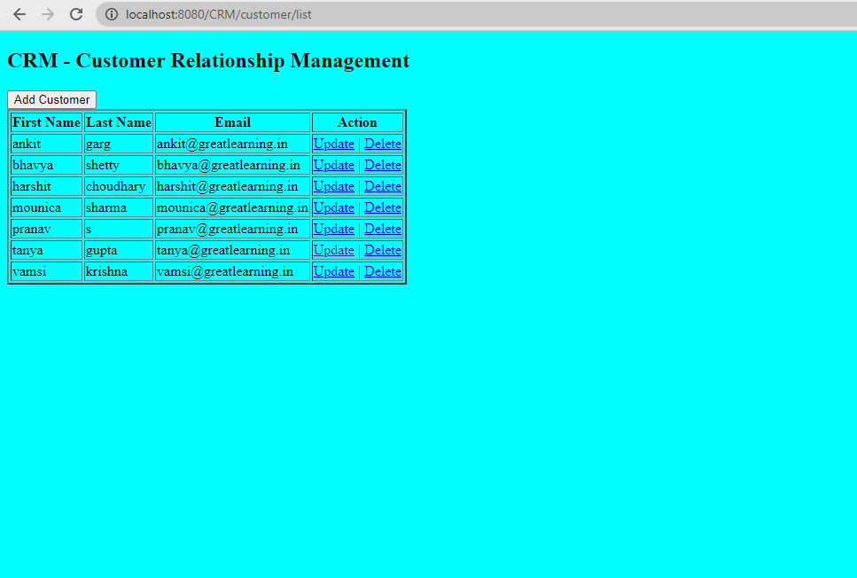

**Updating the email address for customer harshit choudhary and saving it with address gmail.com** 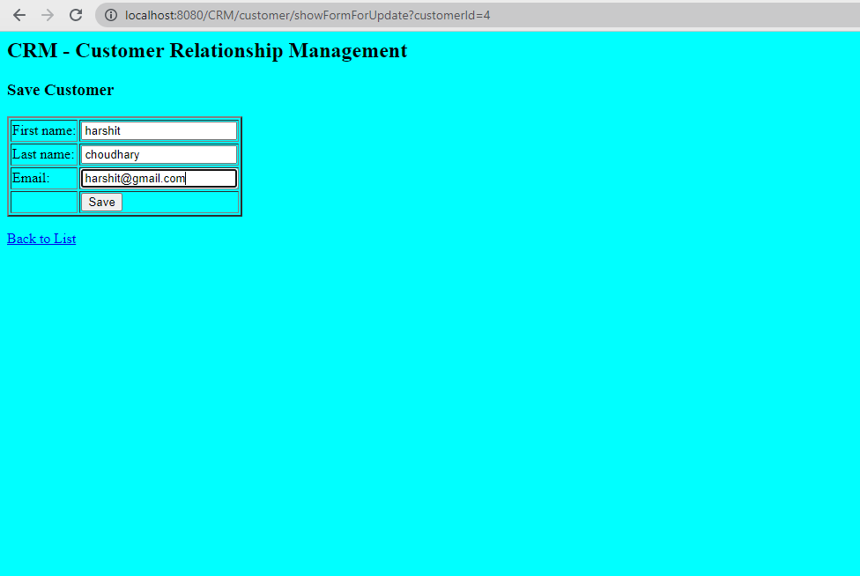

**After Updating the email address of customer harshit choudhary** 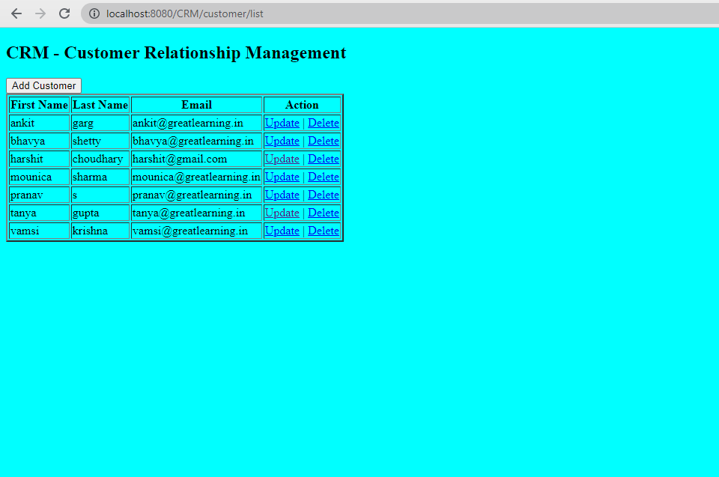

**Updated value of Customer harshit choudhary with email address ending with gmail.com, also upon clicking the delete button, a pop up is generated.** 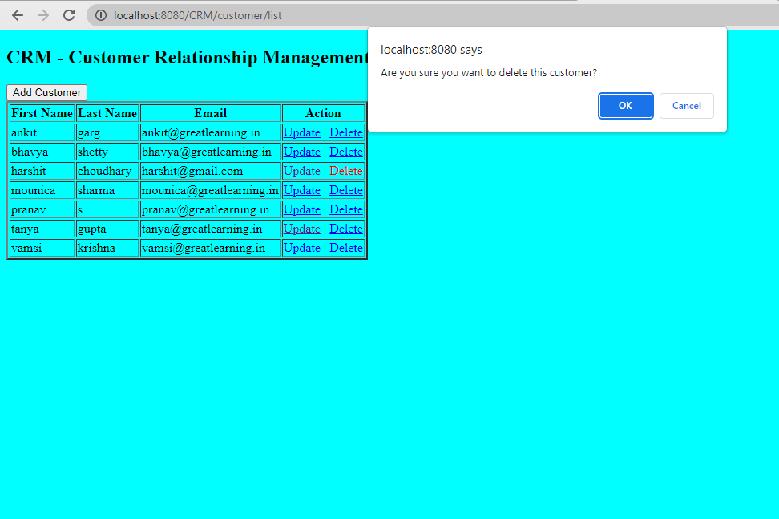

.

**Upon clicking on the delete button , the customer entry deleted from the database and Updated list after deleting customer harshit choudhary**. 