***TEST-8***

***TEJASWI NARNE***

***192372120***

1. interface Animal {

void makeSound();}

class Dog implements Animal {

public void makeSound() {

System.out.println("Woof");}

}

class Cat implements Animal {

public void makeSound() {

System.out.println("Meow");}

}

class Cow implements Animal {

public void makeSound() {

// Oops! This is wrong.

System.out.println("Moo");}

}

public class Zoo {

public static void main(String[] args) {

Animal dog = new Dog();

Animal cat = new Cat();

Animal cow = new Cow();

dog.makeSound();

cat.makeSound();

cow.makeSound();}

}

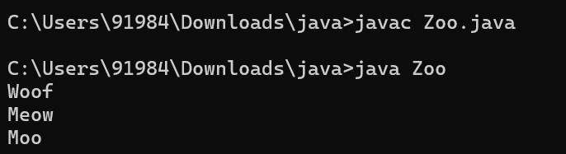

1. abstract class Vehicle {

abstract void startEngine();

public void display() {

System.out.println("Vehicle is ready.");}

}

class Car extends Vehicle {

void startEngine() {

System.out.println("Car engine started");}

}

class Boat extends Vehicle {

void startEngine() {

System.out.println("Boat engine started");

}

public void anchor() {

System.out.println("Boat is anchored");}

}

public class Main {

public static void main(String[] args) {

Vehicle myCar = new Car();

Vehicle myBoat = new Boat();

myCar.startEngine();

myBoat.startEngine();}

}

