SCHOOL OF COMPUTER SCIENCE AND ARTIFICIAL INTELLIGENCE |  |  |  |  | DEPARTMENT OF COMPUTER SCIENCE ENGINEERING
Program Name: B. Tech |  |  |  | Assignment Type: Lab |  |  | Academic Year:2025-2026
Course Coordinator Name |  |  |  | Venkataramana Veeramsetty
Instructor(s) Name |  |  |  | Dr. V. Venkataramana (Co-ordinator)  Dr. T. Sampath Kumar  Dr. Pramoda Patro  Dr. Brij Kishor Tiwari  Dr.J.Ravichander  Dr. Mohammand Ali Shaik  Dr. Anirodh Kumar  Mr. S.Naresh Kumar  Dr. RAJESH VELPULA  Mr. Kundhan Kumar  Ms. Ch.Rajitha  Mr. M Prakash  Mr. B.Raju  Intern 1 (Dharma teja)  Intern 2 (Sai Prasad)  Intern 3 (Sowmya)  NS_2 ( Mounika)
Course Code |  |  | 24CS002PC215 | Course Title |  | AI Assisted Coding
Year/Sem |  |  | II/I | Regulation |  | R24
Date and Day  of Assignment |  |  | Week7 - Thursday | Time(s)
Duration |  |  | 2 Hours | Applicable to  Batches
AssignmentNumber:13.1(Present assignment number)/24(Total number of assignments)
 | Q.No. | Question |  |  |  |  |  | Expected Time  to complete
 | 1 | Lab 13: Code Refactoring – Improving Legacy Code with AI Suggestions  Lab Objectives:  - Identify code smells and inefficiencies in legacy Python scripts.  - Use AI-assisted coding tools to refactor for readability, maintainability, and performance.  - Apply modern Python best practices while ensuring output correctness.  Task 1  - Task: Refactor repeated loops into a cleaner, more Pythonic approach.  Instructions:  - Analyze the legacy code.  - Identify the part that uses loops to compute values.  - Refactor using list comprehensions or helper functions while keeping the output the same.  Legacy Code:  numbers = [1, 2, 3, 4, 5]  squares = []  for n in numbers:  squares.append(n ** 2)  print(squares)  Expected Output:  [1, 4, 9, 16, 25]  Prompt :  This code calculates the squares and cubes of numbers in a list.  - It initializes a list called numbers with values from 1 to 5.  - It then initializes two empty lists, squares and cubes.  - The first loop iterates through the numbers list and appends the square of each number to the squares list.  - The second loop iterates through the numbers list again and appends the cube of each number to the cubes list.  - Finally, it prints the squares and cubes lists.  Code :  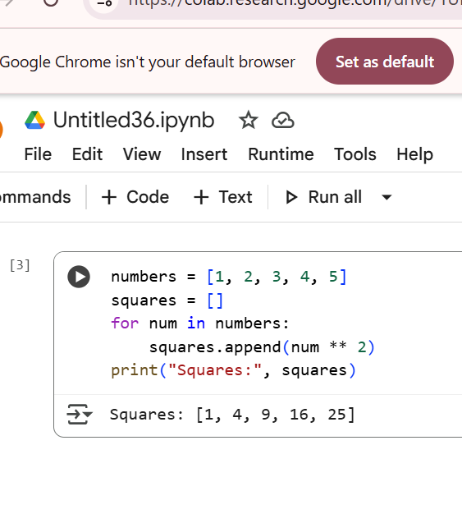  Explanation :  - Initializes a list of numbers: It creates a list named numbers containing the integers from 1 to 5.  - Initializes empty lists: It creates two empty lists, squares and cubes, which will store the calculated values.  - Calculates squares: It loops through each num in the numbers list and appends the square of that number (num ** 2) to the squares list.  - Calculates cubes: It loops through each num in the numbers list again and appends the cube of that number (num ** 3) to the cubes list.  - Prints the results: It prints the contents of the squares list and the cubes list, clearly labeled.  Task 2  Task: Simplify string concatenation.  Instructions:  - Review the loop that builds a sentence using +=.  - Refactor using " ".join() to improve efficiency and readability.  Legacy Code:  words = ["AI", "helps", "in", "refactoring", "code"]  sentence = ""  for word in words:  sentence += word + " "  print(sentence.strip())  Expected Output:  AI helps in refactoring code  Prompt :  The code in cell mboRdwNSX88u takes a list of words and joins them together into a single sentence with spaces in between.  Code :  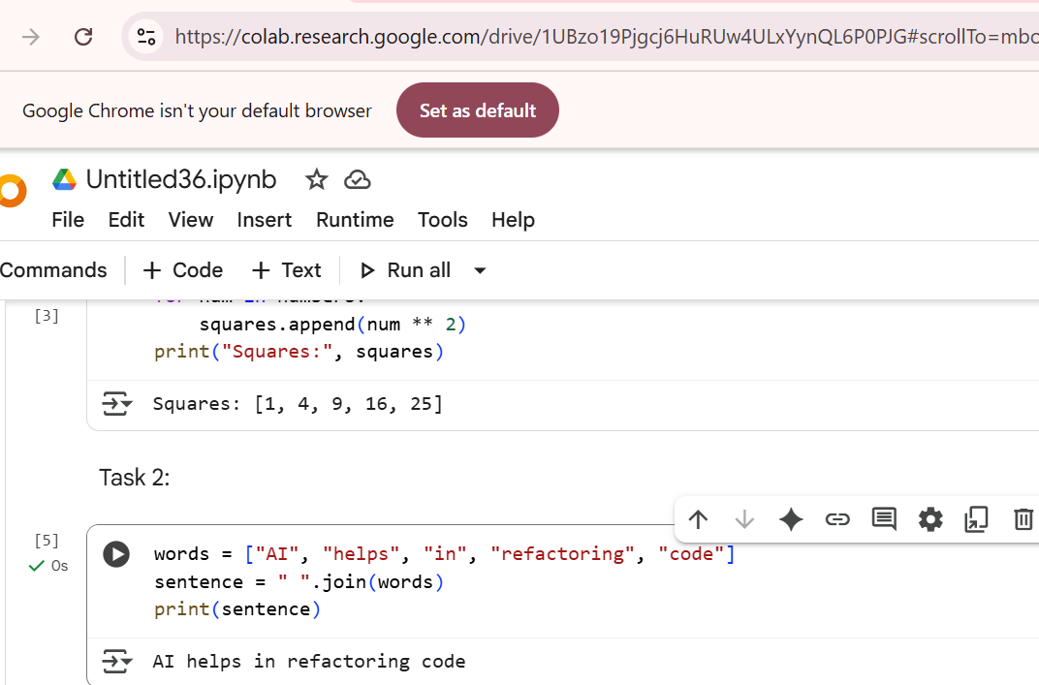  Explanation :  - Creates a list of words: It initializes a list named words containing several strings.  - Joins the words into a sentence: It uses the " ".join(words) method to concatenate the strings in the words list into a single string. The space " " inside the join() method specifies that a space should be placed between each word.  - Prints the sentence: It prints the resulting sentence to the console.  Task 3  Task: Replace manual dictionary lookup with a safer method.  Instructions:  - Check how the code accesses dictionary keys.  - Use .get() or another Pythonic approach to handle missing keys gracefully.  Legacy Code:  student_scores = {"Alice": 85, "Bob": 90}  if "Charlie" in student_scores:  print(student_scores["Charlie"])  else:  print("Not Found")  Expected Output:  Not Found  Prompt :  The code in cell N7UN0CM9ZlnE accesses a value from the student_scores dictionary using the .get() method. This method allows you to provide a default value ("Not Found" in this case) that will be returned if the key ("Charlie") is not found in the dictionary, preventing a KeyError.  Code :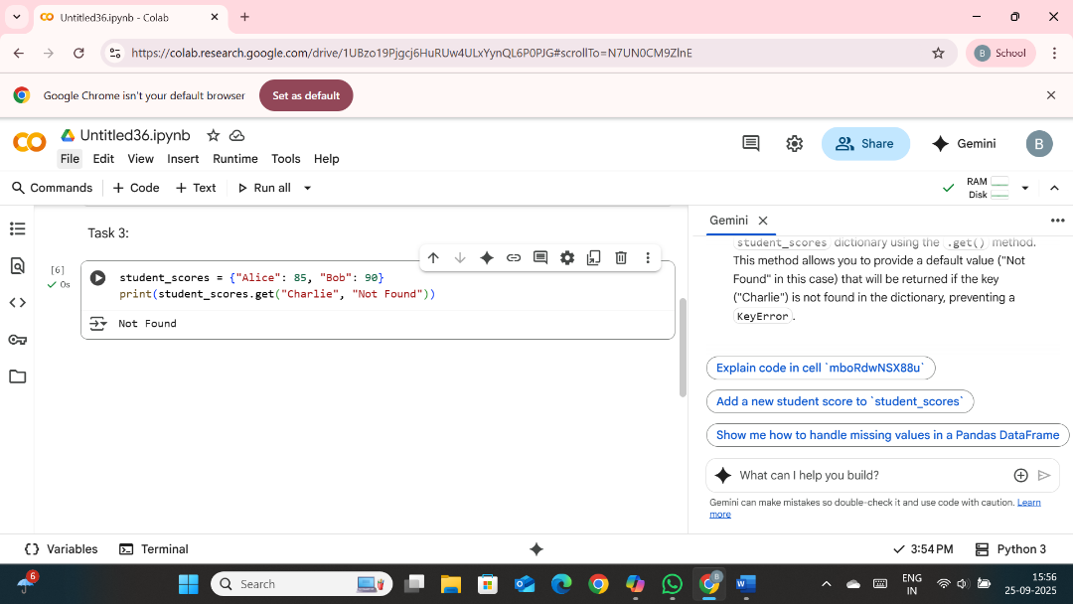  Explanation :  The code in cell N7UN0CM9ZlnE does the following:  - Initializes a dictionary: It creates a dictionary named student_scores with two key-value pairs, representing student names and their scores.  - Accesses a value using .get(): It attempts to retrieve the value associated with the key "Charlie" from the student_scores dictionary using the .get() method.  - Provides a default value: The .get() method is used with a second argument, "Not Found". This means if the key "Charlie" is not found in the dictionary, the method will return the string "Not Found" instead of raising a KeyError.  - Prints the result: It prints the value returned by the .get() method. In this case, since "Charlie" is not in the dictionary, it prints "Not Found".  Task 4  Task: Refactor repetitive if-else blocks.  Instructions:  - Examine multiple if-elif statements for operations.  - Refactor using dictionary mapping to make the code scalable and clean.  Legacy Code:  operation = "multiply"  a, b = 5, 3  if operation == "add":  result = a + b  elif operation == "subtract":  result = a - b  elif operation == "multiply":  result = a * b  else:  result = None  print(result)  Expected Output:  15  Prompt :  The code in cell 6be11dc9 refactors a series of if-elif statements for performing different arithmetic operations. It uses a dictionary to map operation names (like "add", "subtract", "multiply") to corresponding lambda functions that perform the actual calculations. It then retrieves the appropriate function from the dictionary using the operation variable and calls it with the values of a and b to get the result.  Code :  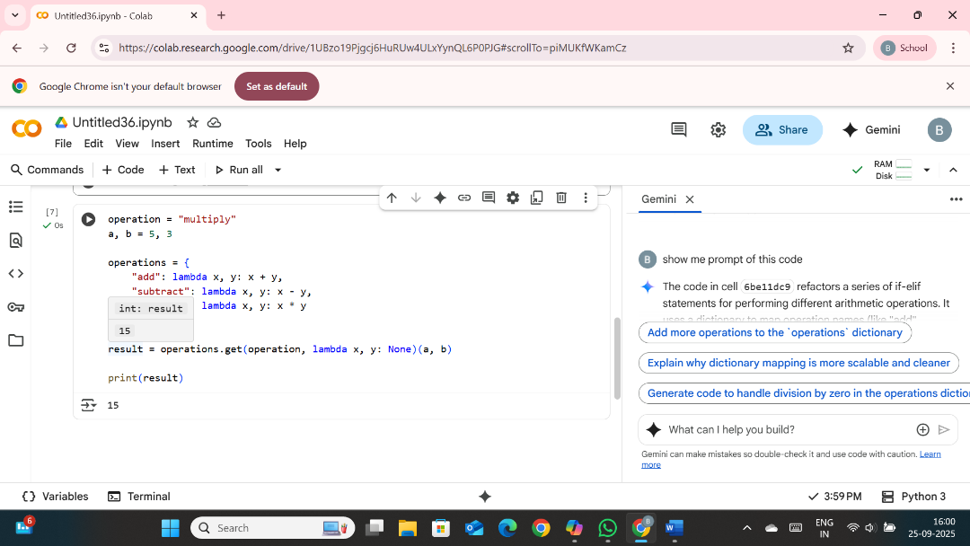  Explanation :  - Defines operation and operands: It sets the desired operation as a string ("multiply") and the operands a and b to 5 and 3 respectively.  - Creates an operations dictionary: It creates a dictionary called operations. The keys of this dictionary are the names of the operations (strings like "add", "subtract", "multiply"), and the values are anonymous functions (lambdas) that perform the corresponding arithmetic operation on two arguments.  - Retrieves and executes the operation: It uses the .get() method on the operations dictionary with the operation variable as the key.  - If the operation key is found in the dictionary, .get() returns the corresponding lambda function.  - If the operation key is not found (like if you had a typo or an unsupported operation), .get() returns the default value provided, which in this case is another lambda function that returns None.  - Immediately after .get(), the retrieved function (either the arithmetic one or the None-returning one) is called with a and b as arguments: (a, b).  - Stores and prints the result: The return value of the executed function is stored in the result variable, and then result is printed. In this example, since operation is "multiply", the lambda x, y: x * y function is called with 5 and 3, and the output is 15  Task 5  Task: Optimize nested loops for searching.  Instructions:  - Identify the nested loop used to find an element.  - Refactor using Python’s in keyword or other efficient search techniques.  Legacy Code:  items = [10, 20, 30, 40, 50]  found = False  for i in items:  if i == 30:  found = True  break  print("Found" if found else "Not Found")  Expected Output:  Found  Prompt :  The code in cell b21198d2 checks if a specific target value is present in the items list using the in keyword. It then prints "Found" if the target is in the list, and "Not Found" otherwise. This is a more concise and Pythonic way to check for membership in a list compared to using a loop.  Code :  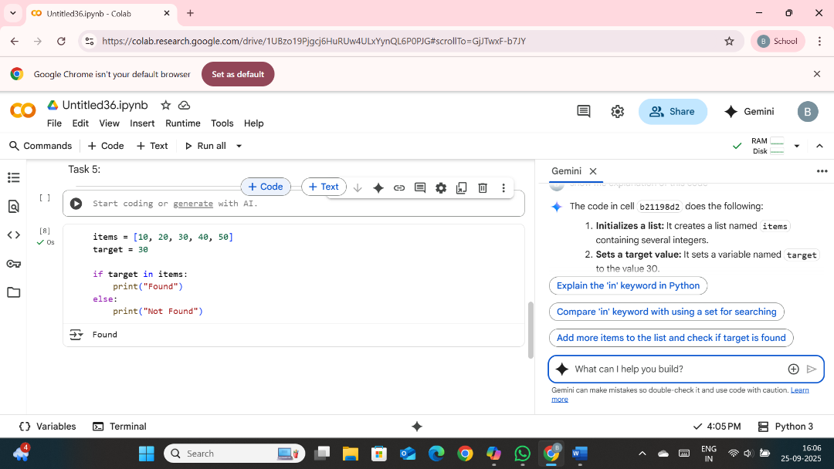  Explanation :  - Initializes a list: It creates a list named items containing several integers.  - Sets a target value: It sets a variable named target to the value 30.  - Checks for membership: It uses the in keyword to check if the value of target (30) is present within the items list. The in keyword returns True if the element is found and False otherwise.  - Prints the result: Based on the result of the in check, it prints either "Found" if the target was in the list, or "Not Found" if it wasn't. |  |  |  |  |  | Week7 - Thursday

