**Lab 3: Shell Scripting**

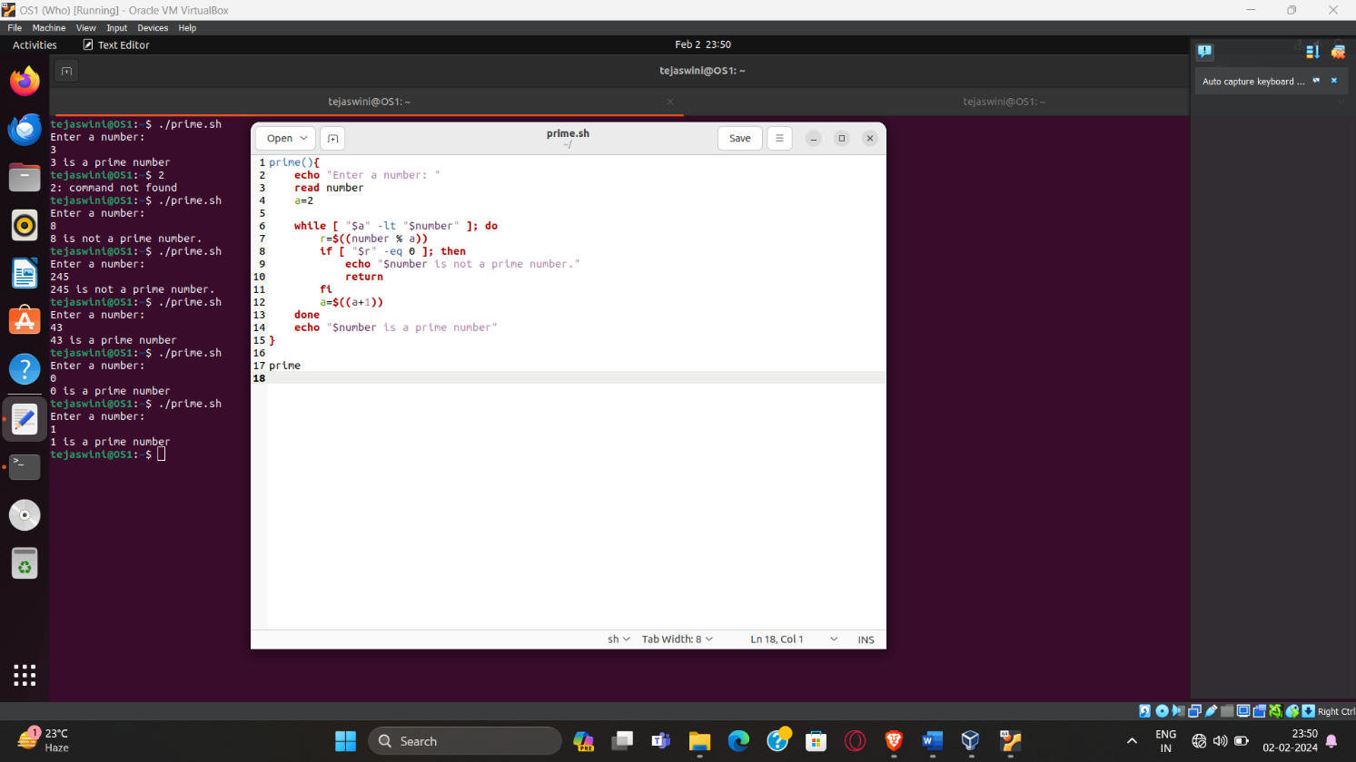

1. **Check if Prime no. :**

prime(){

echo "Enter a number: "

read number

a=2

while [ “$a” -lt “$number” ]; do

r=$((number % a))

if [ “$r” -eq 0 ]; then

echo "$number is not a prime number."

return

fi

a=$((a+1))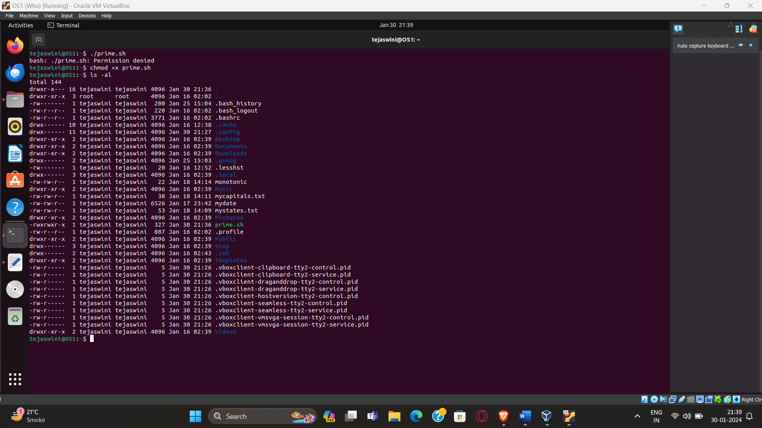

done

echo "$number is a prime number"

}

prime

1. **Factorial**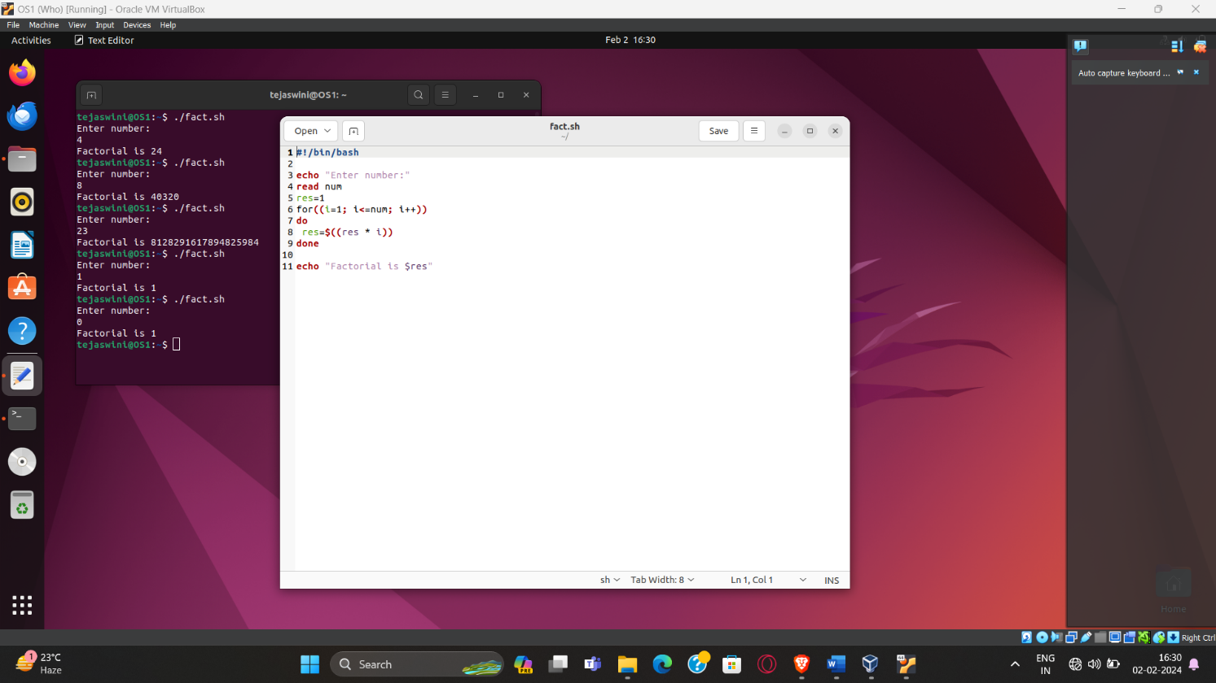

#!/bin/bash

echo "Enter a number:"

read num

res=1

for (( i=1; i<=num; i++ ))

do

res=$((res * i))

done

echo "Factorial of $num is $res"

1. **Take str. Check palindrome**

echo "Enter a String"

read str

reverse=" "

len=${#str}

for (( i=len-1; i>=0; i-- ))

do

reverse="$reverse${str:$i:1}"

done

if [[ “$str” == “$reverse” ]]; then

echo "$str is a palindrome"

else

echo "$str is not palindrome"

fi

