**Assignment 1**

Tejaswini Wanare

Roll no- 48

AI-C B2

1. Download

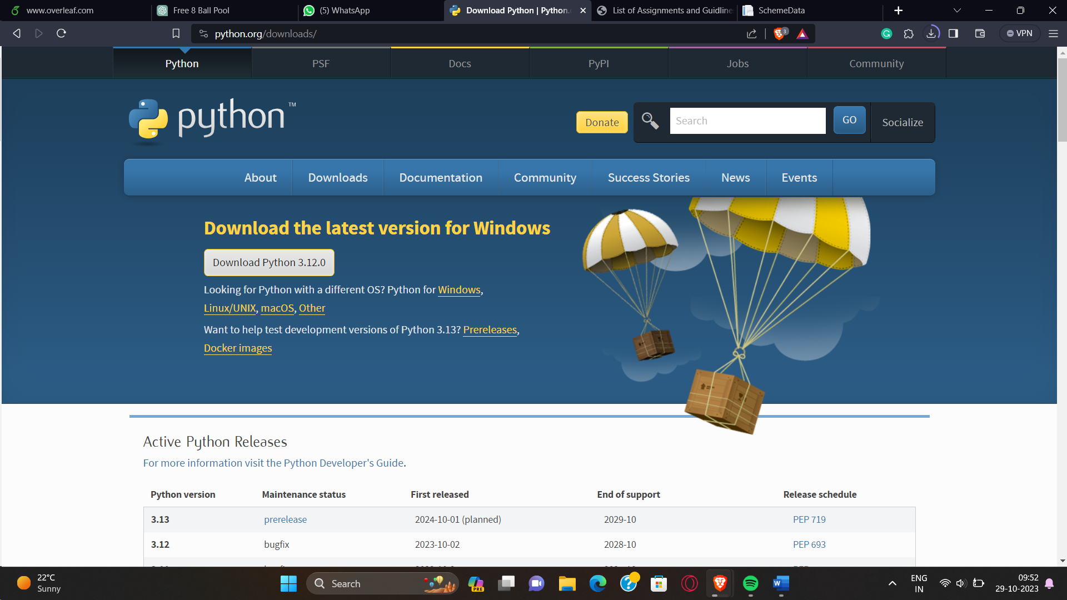

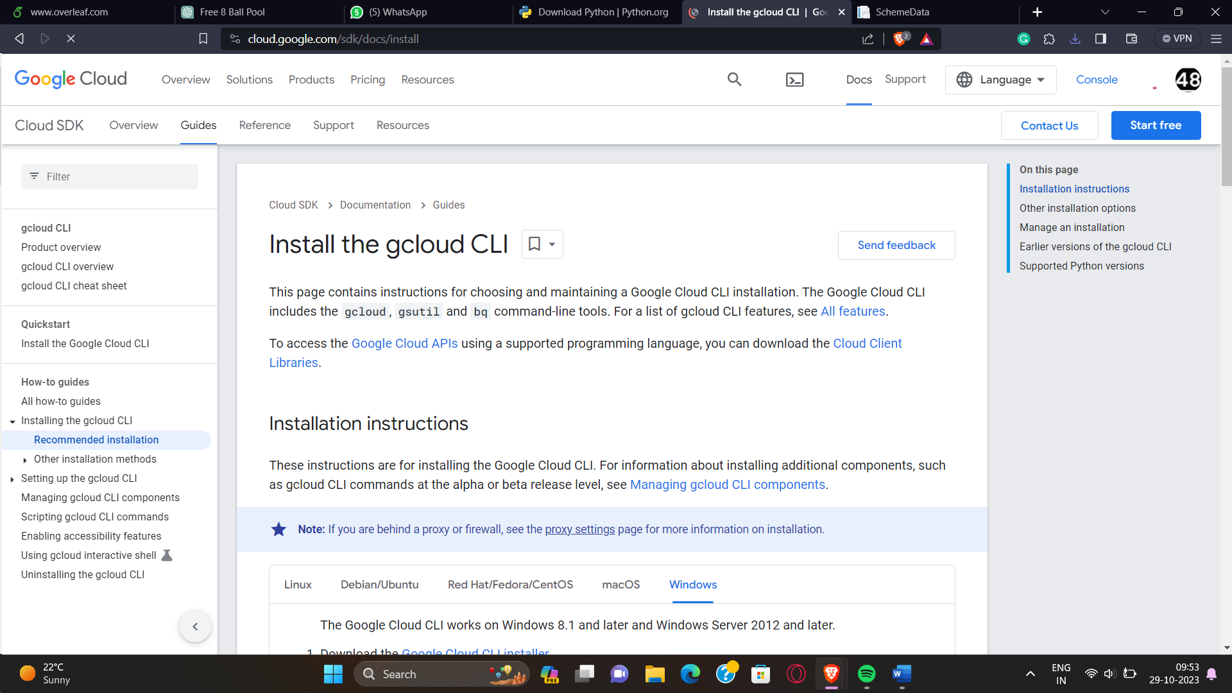

If we get some error that a component is missing type this in cmd: **gcloud components install [COMPONENT-ID]**

## **Hello World Program**

Code:

Test.py

import webapp2

class Mainpage(webapp2.RequestHandler):

    def get(self):

        self.response.write("Hello World")

app = webapp2.WSGIApplication([('/',Mainpage)], debug=True)

app.yml

runtime: python27

api_version: 1

threadsafe: false    //multiple threads cannot use a single ...

handlers:

- url: /

  script: test.app

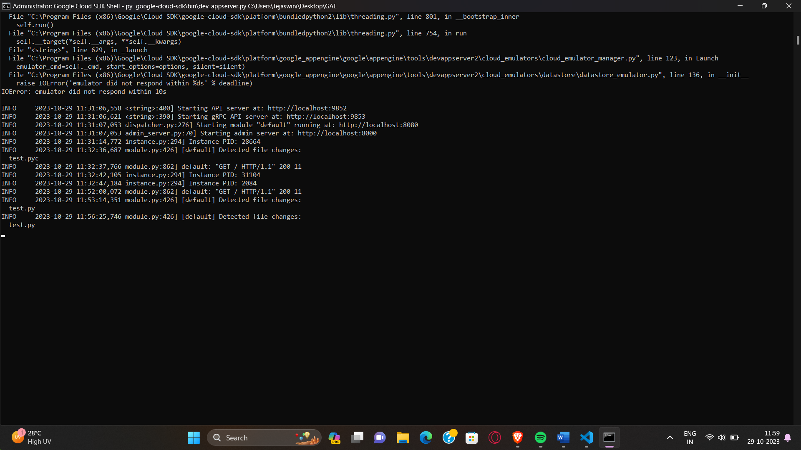py google-cloud-sdk\bin\dev_appserver.py C:\Users\Tejaswini\Desktop\GAE

**Output:**

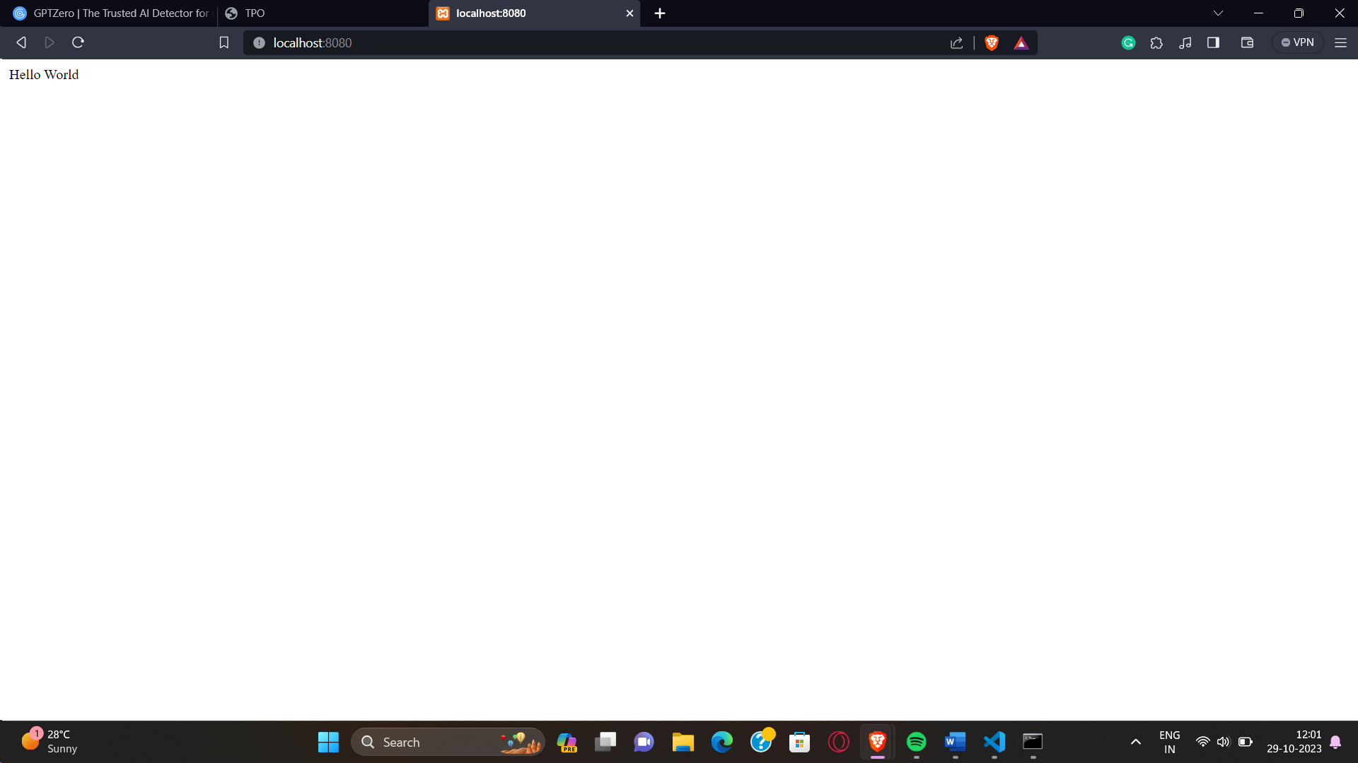

## **Post Office Finder**

Code:

runtime: python27

threadsafe: true

handlers:

- url: /

  script: main.app

Main.py

import os

import json

import urllib

import webapp2

from google.appengine.ext.webapp import template

class MainPage(webapp2.RequestHandler):

    def get(self):

        template_values = {}

        path = os.path.join(os.path.dirname(__file__), 'index.html')

        self.response.out.write(template.render(path, template_values))

    def post(self):

        pincode = self.request.get('zipCode')

        if not pincode.isnumeric() or not len(pincode) == 6:

            template_values = {

                "error": "Incorrect Pin Code (String / False Code entered)"

            }

            path = os.path.join(os.path.dirname(__file__), 'index.html')

            return self.response.out.write(template.render(path, template_values))

        url = "https://api.postalpincode.in/pincode/" + pincode

        data = urllib.urlopen(url).read()

        data = json.loads(data)

        if(data[0]['Status'] == 'Success'):

            post_office = data[0]['PostOffice'][0]['State']

            name = data[0]['PostOffice'][0]['Name']

            block = data[0]['PostOffice'][0]['Block']

            district = data[0]['PostOffice'][0]['District']

            template_values = {

                "post_office": post_office,

                "name": name,

                "block": block,

                "district": district

            }

            path = os.path.join(os.path.dirname(__file__), 'results.html')

            self.response.out.write(template.render(path, template_values))

        else:

            template_values = {}

            path = os.path.join(os.path.dirname(__file__), 'error.html')

            self.response.out.write(template.render(path, template_values))

app = webapp2.WSGIApplication([('/', MainPage)], debug=True)

html

<html>

  <style>

    .weatherText {

      font-family: 'Lato', 'sans-serif';

      font-size: 24px;

      text-align: center;

    }

    #weatherForm {

      padding: 20px;

    }

    #weatherSubmit {

      color: white;

      background-color: #083375;

      padding: 5px 20px;

      border-radius: 5px;

      margin-top: 20px;

    }

    #weatherSubmit:hover {

      cursor: pointer;

    }

    body {

      display: flex;

      justify-content: center;

      align-items: center;

    }

    .card {

      border: 2px solid black;

      width: 50%;

      justify-content: center;

      align-items: center;

    }

  </style>

  <head>

    <title class="alignct">Post Office Finder</title>

    <link

      href="https://fonts.googleapis.com/css2?family=Lato:wght@400;700&display=swap"

      rel="stylesheet"

    />

  </head>

  <body>

    <div class="card">

      <h2 class="weatherText">Post Office Finder Using WebApp</h2>

      <h1 id="error_head" style="display: none" value="{{error}}">{{error}}</h1>

      <form class="weatherText" id="weatherForm" action="/" method="post">

        Location Zip Code:

        <input

          class="weatherText"

          id="weatherInput"

          type="text"

          name="zipCode"

        /><br />

        <input

          class="weatherText"

          id="weatherSubmit"

          type="submit"

          value="Submit"

        />

        <button

          id="weatherSubmit"

          class="weatherText"

          onclick="document.getElementById(

         'weatherInput').value = ''"

        >

          Clear

        </button>

      </form>

    </div>

    <!-- <script>

      let err = document.getElementById('error_head');

      function myFunction() {

        alert('Please Enter the Valid Pin Code!');

      }

      if (err) {

        myFunction();

      }

    </script> -->

  </body>

</html>

Results:

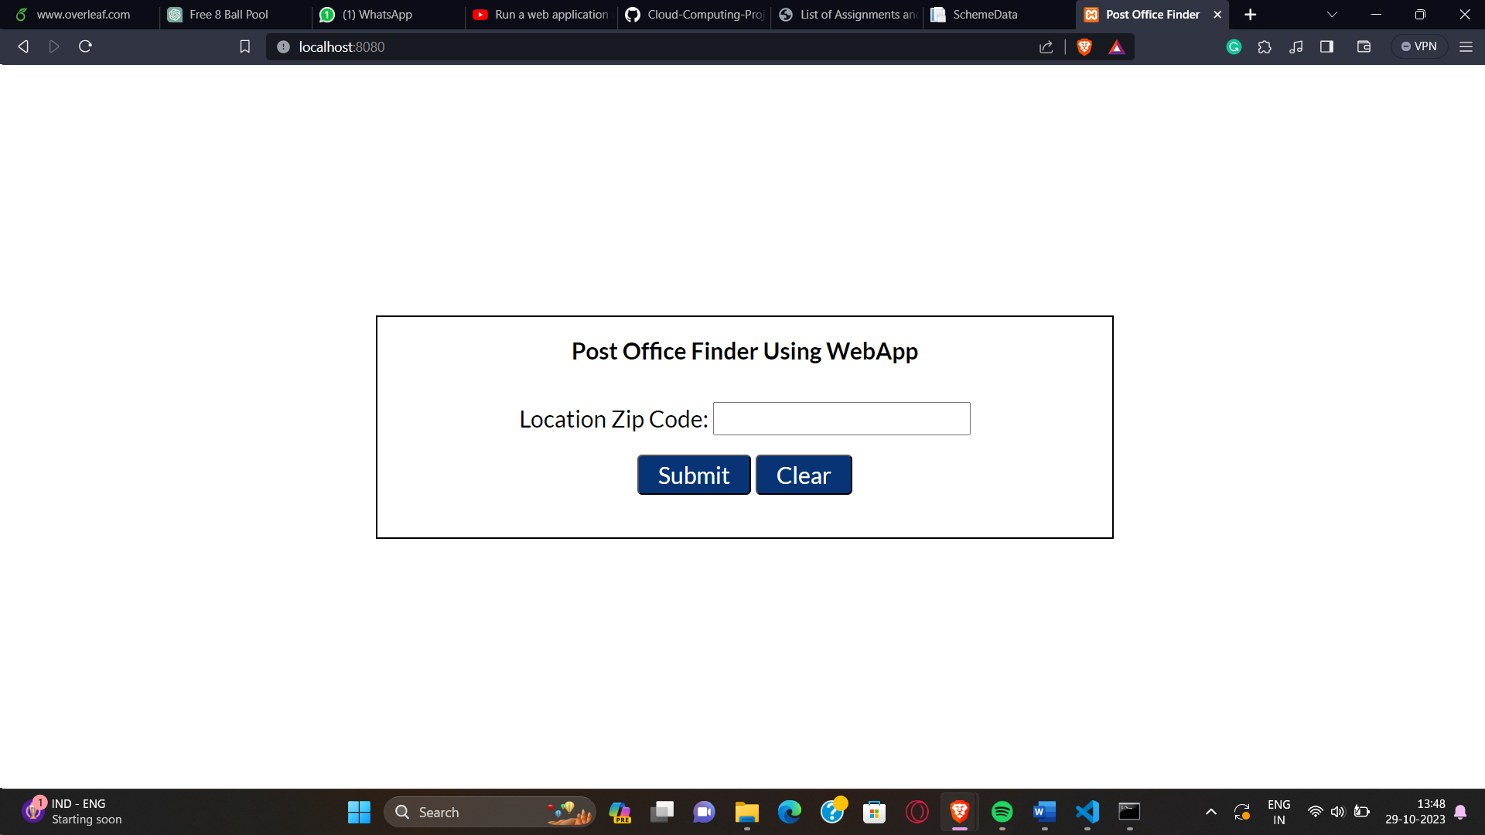

444303

