**Assignment 3**

Tejaswini Wanare

Roll no- 48

AI-C B2

# Transfer files from one Virtual Machine to Another Virtual machine.

Reqirements:

Type 2 lhypervisor:like Virtual Box

VMDK image(It is a image of an OS) of 2.2 linux version

Oracle VM Virtual Box Exension Download

Uwe will be transferring files from 1 VM to another using SCP(Secure Copy Protocol)

## **P**

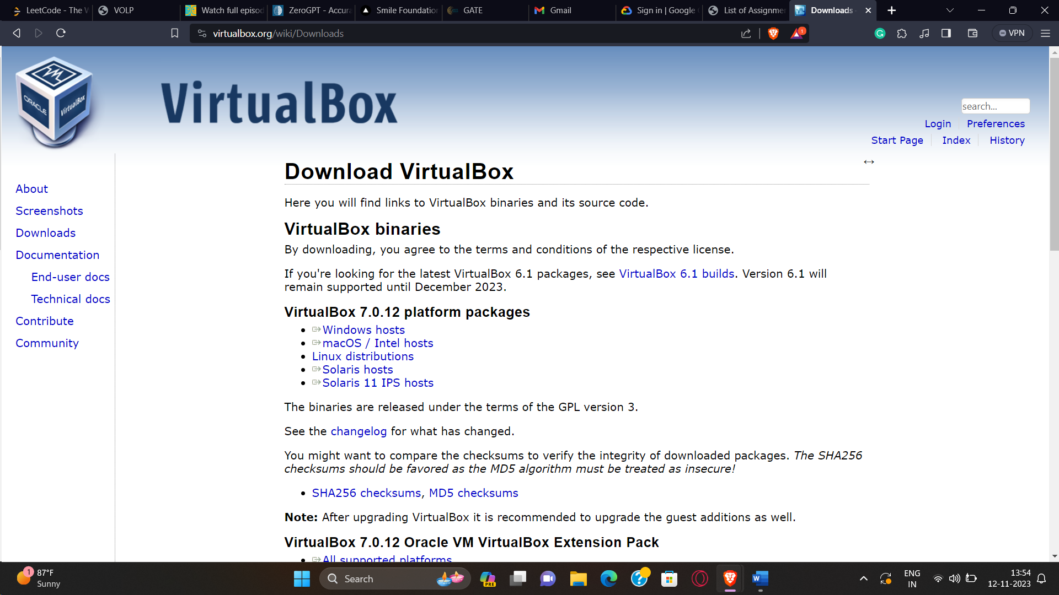

## **Create VM**

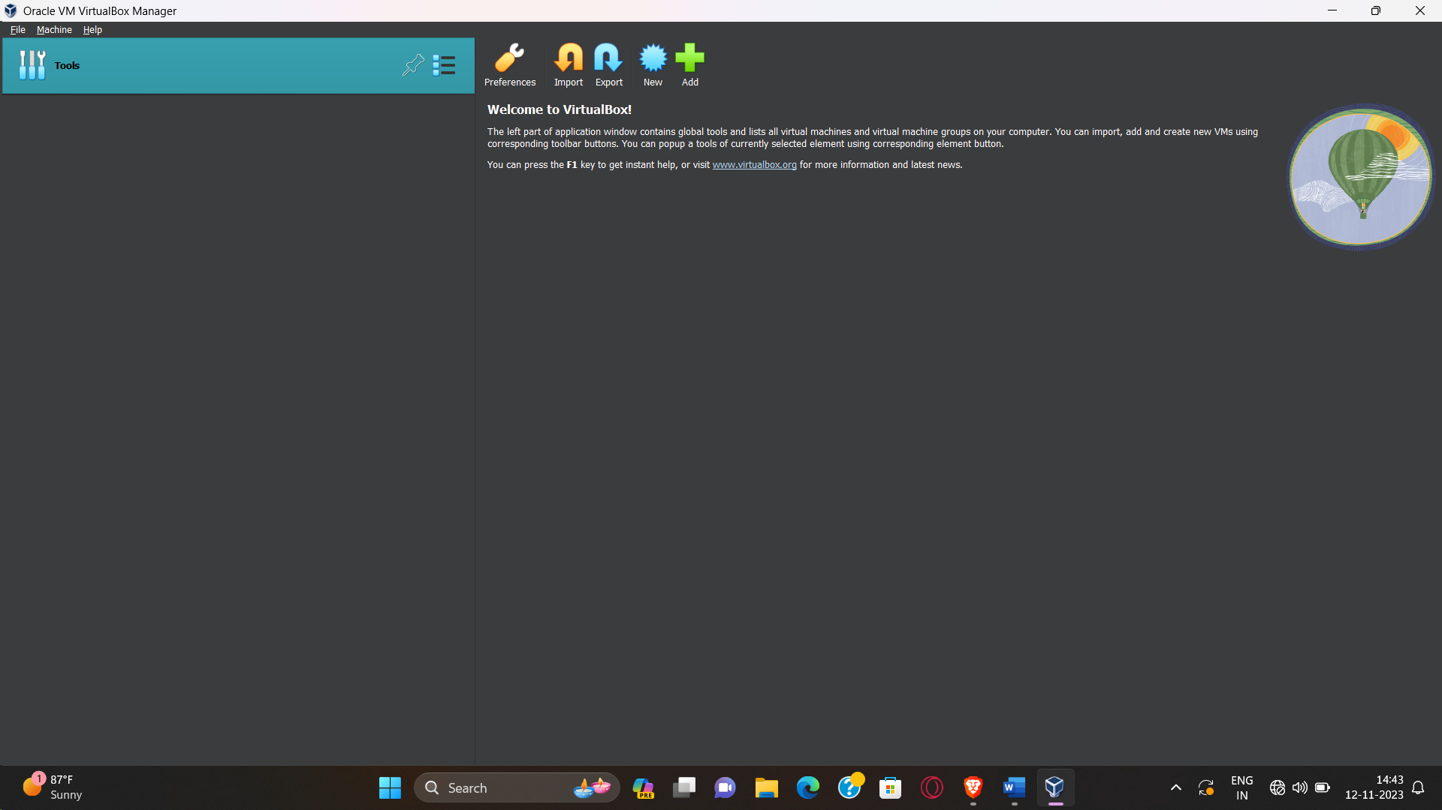

New => Select type=Linux, version: Ubuntu(64-bit)

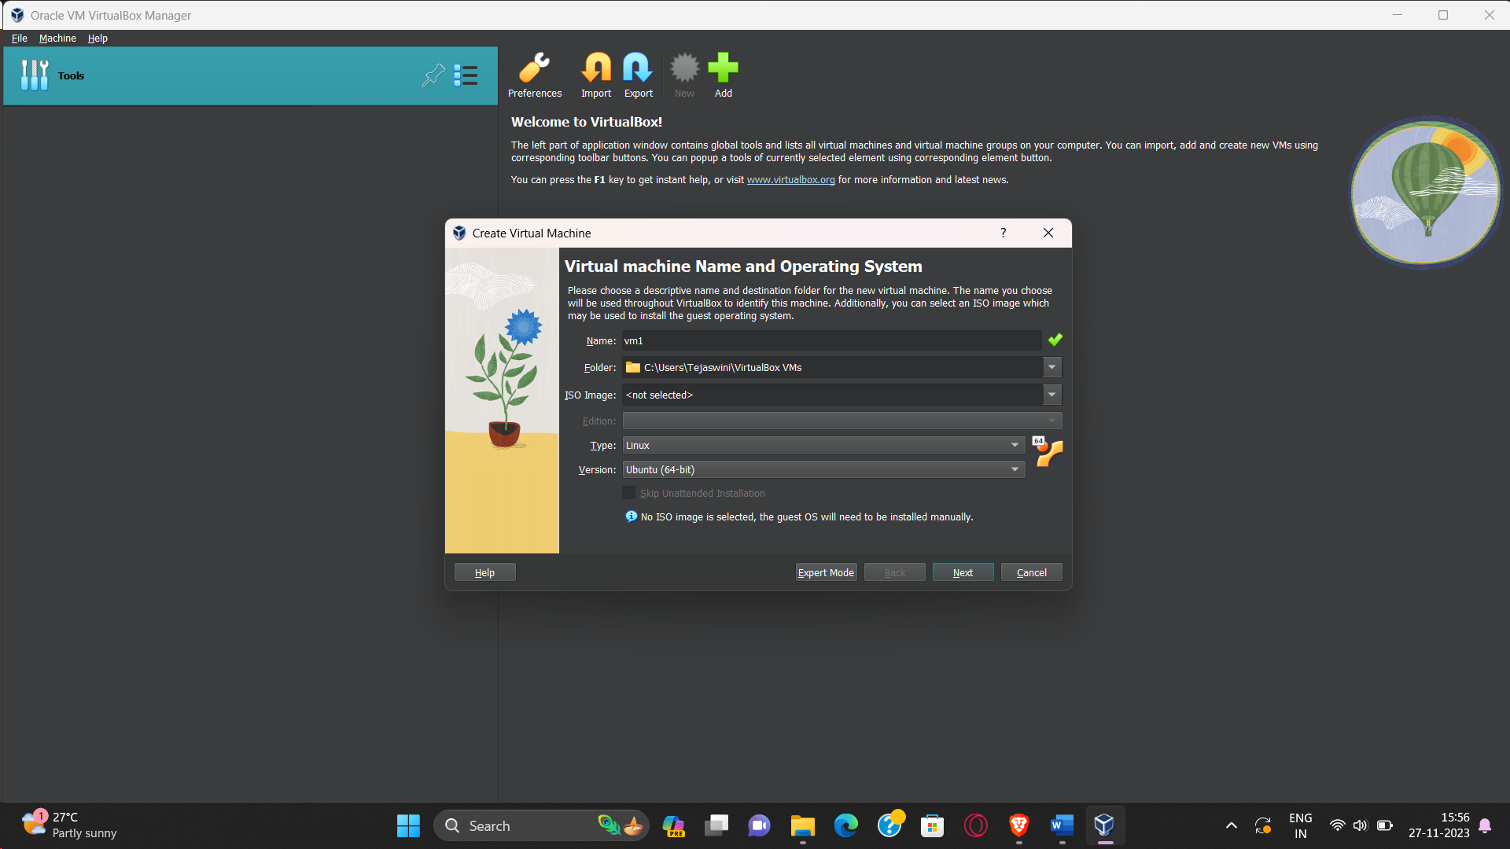

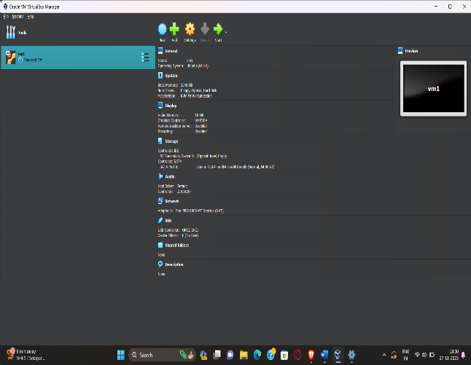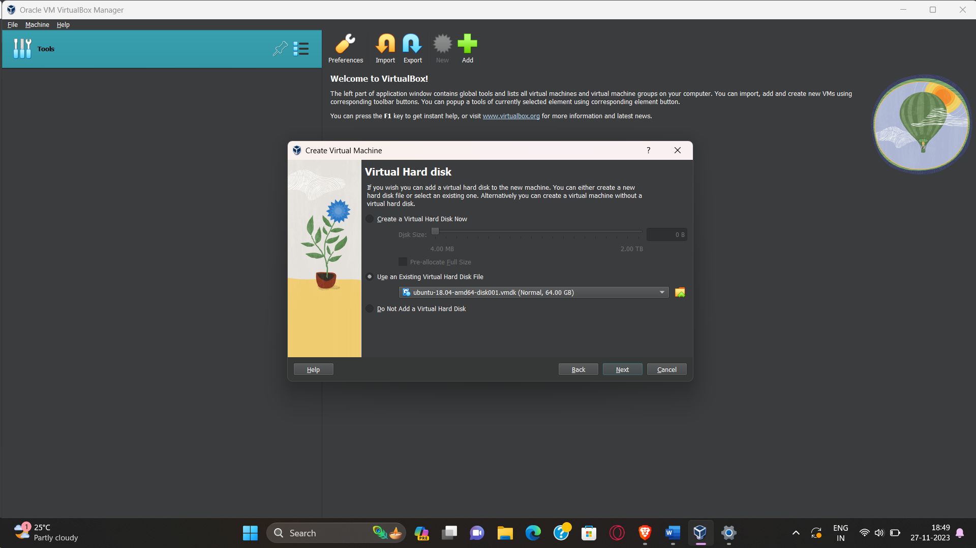

**Next phase: Form a network(NAT Network)**

Go toTools=> Network =>NAT Networks => Create

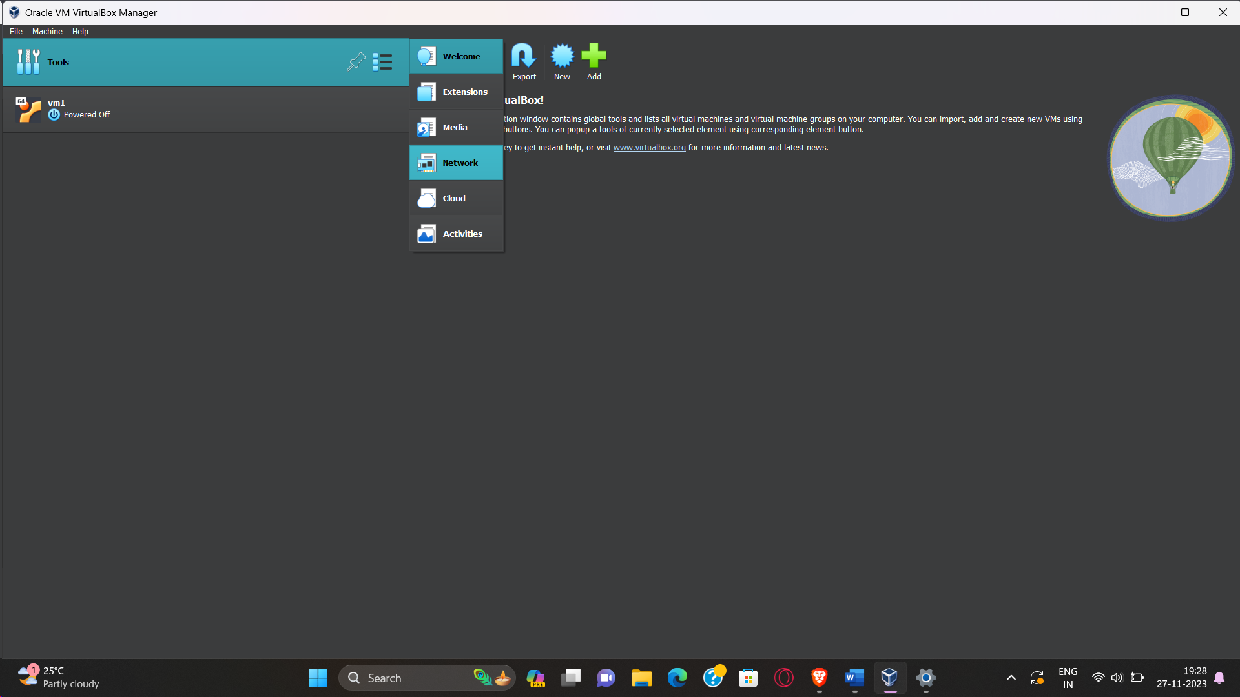

Properties

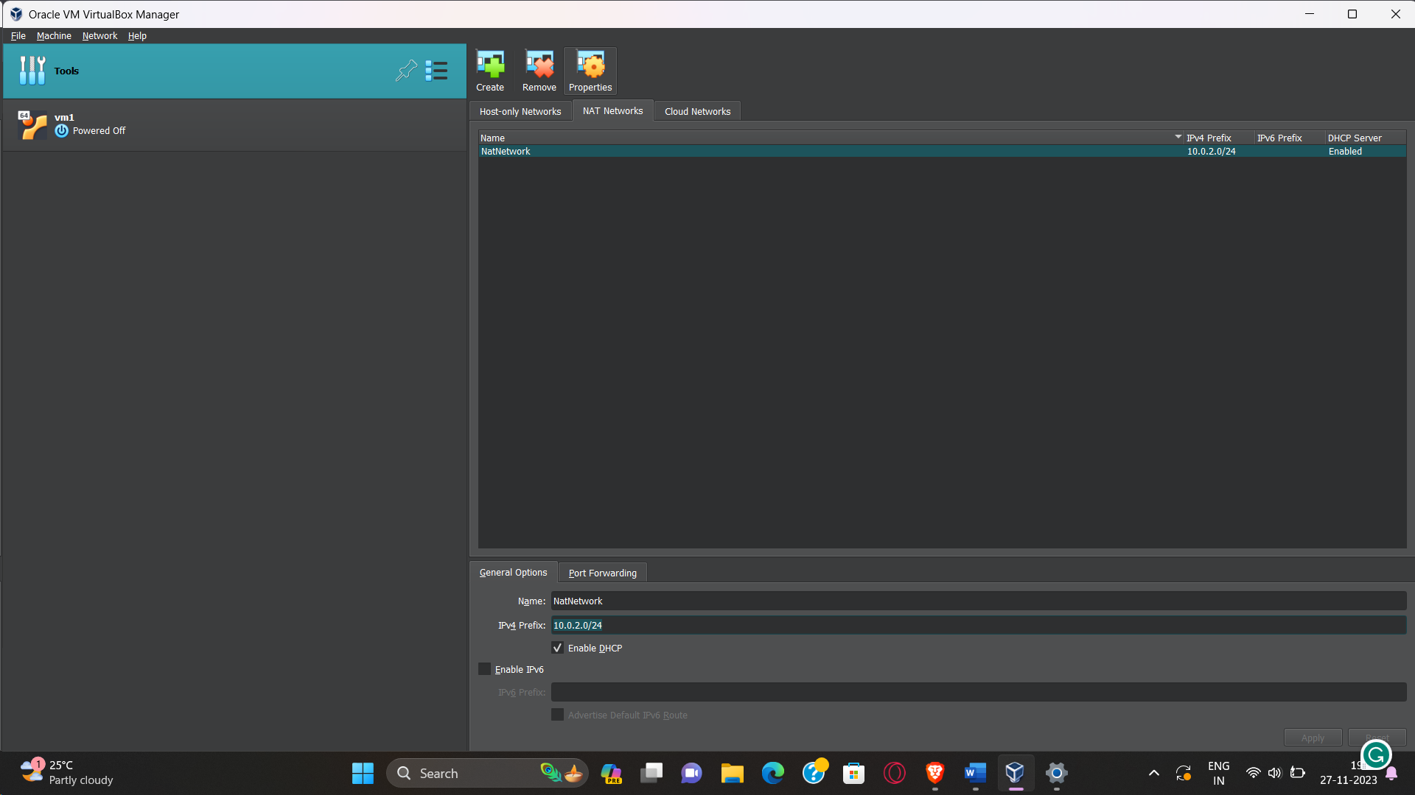

Here IPV4 prefix: The VMs that are going to get inside Virtual Box and which will ask NAT engine of Virtual box to provide them a IP at the boot time, they will get IP in range of 10.0.2.1 to 10.0.2.255

Select your virtual machine(VM1) => Settings => Network

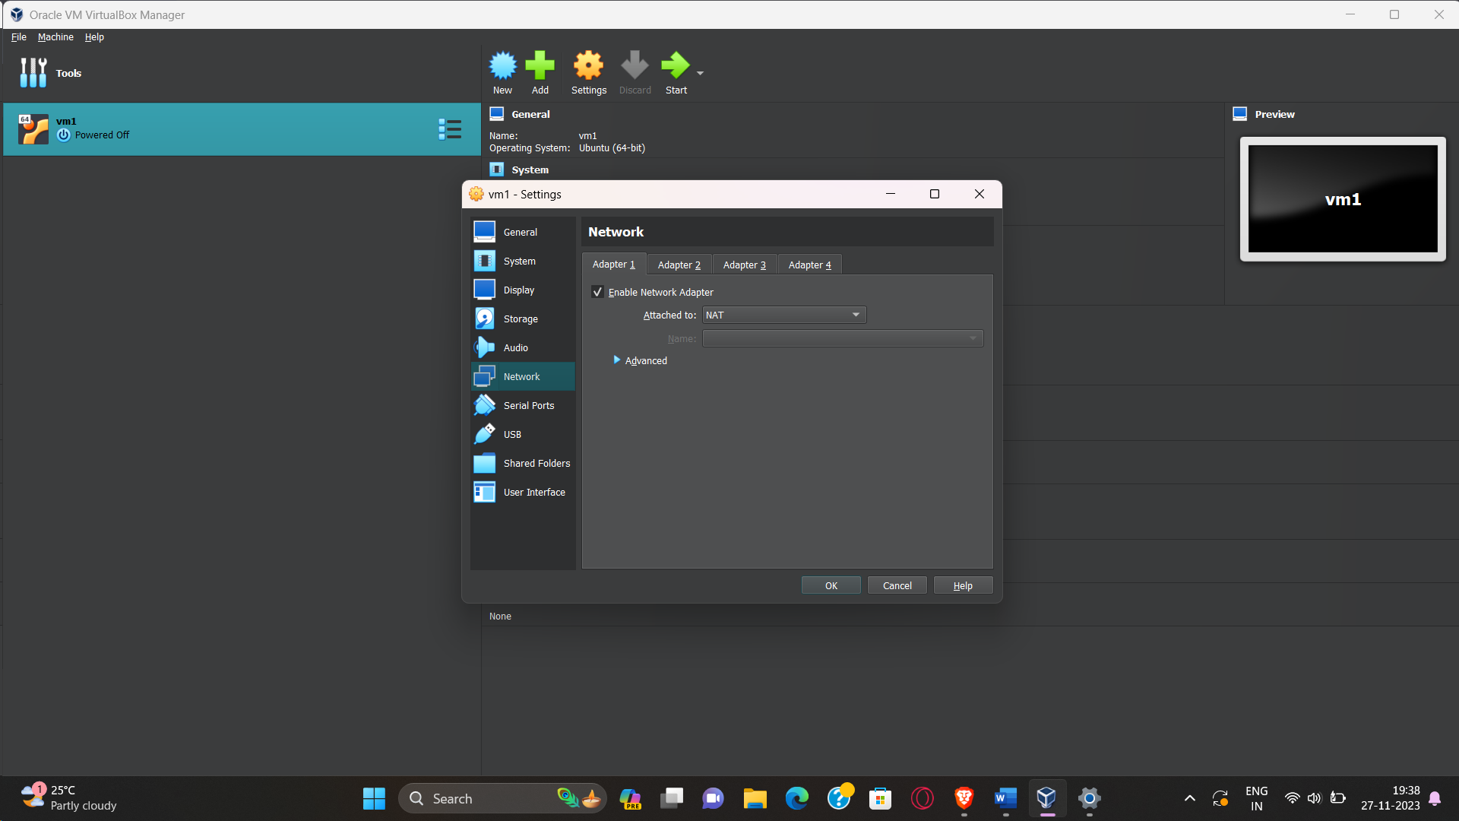

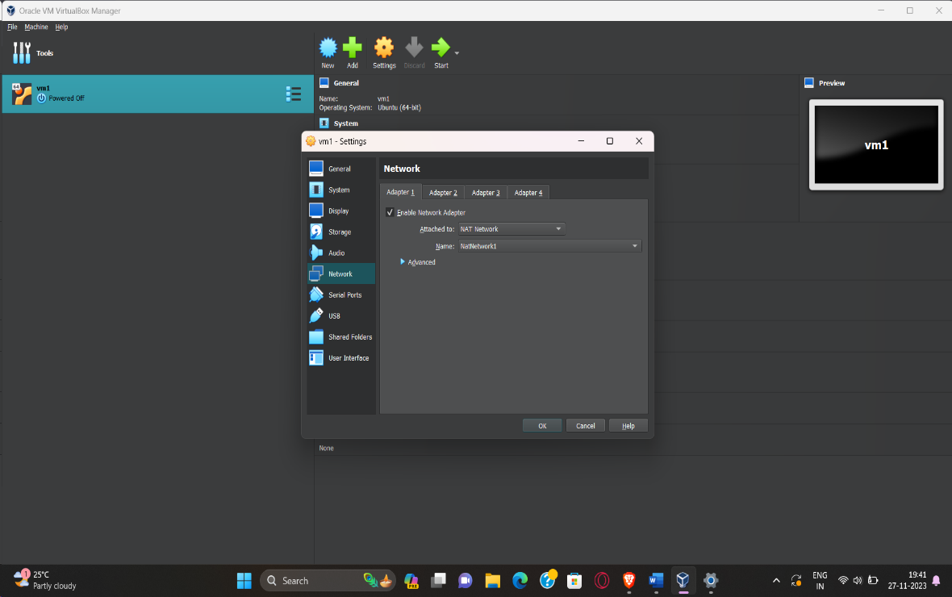Change network

To NAT Network

Create VM2 repeating the above steps

Boot VM

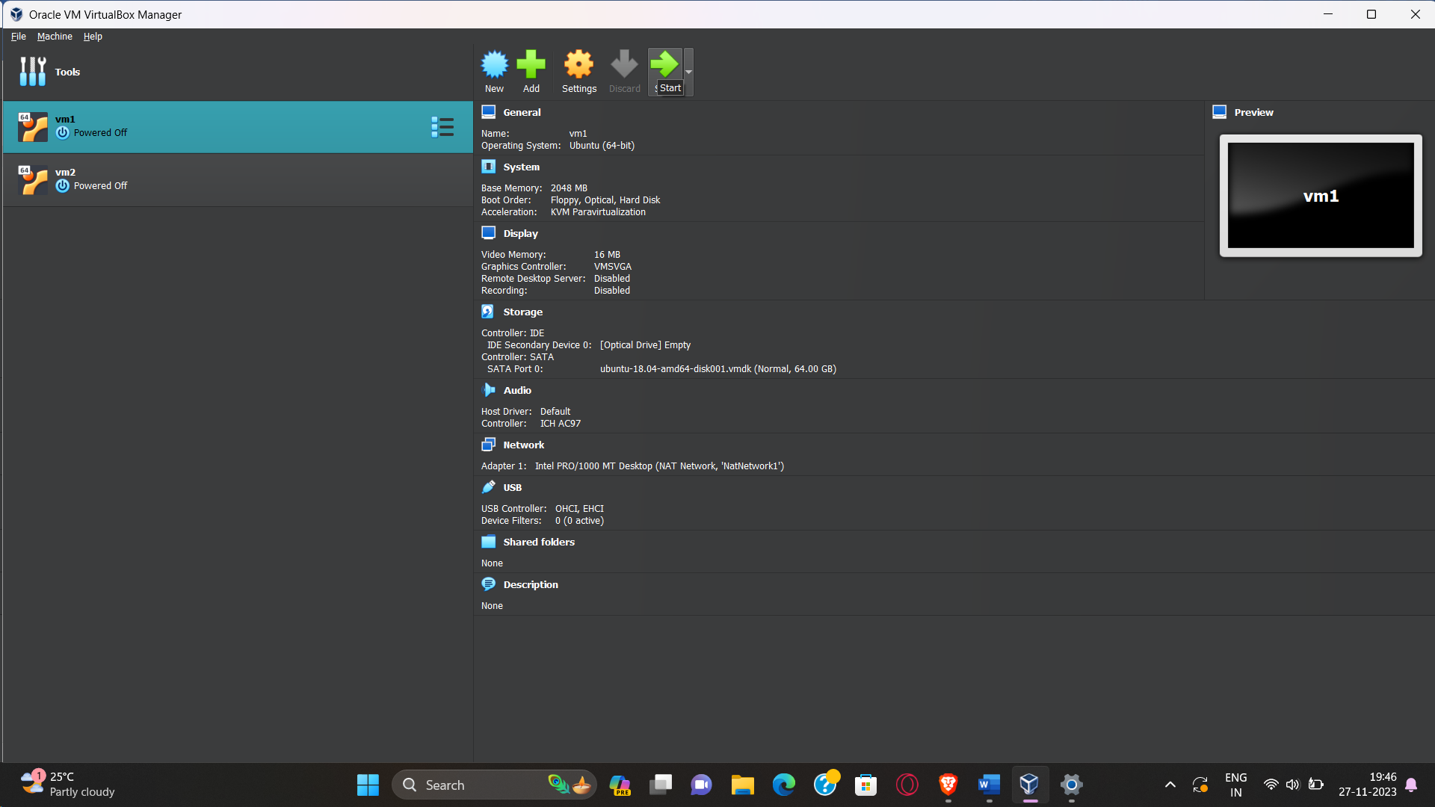

ifconfig

Ctrl C - to stop the pings

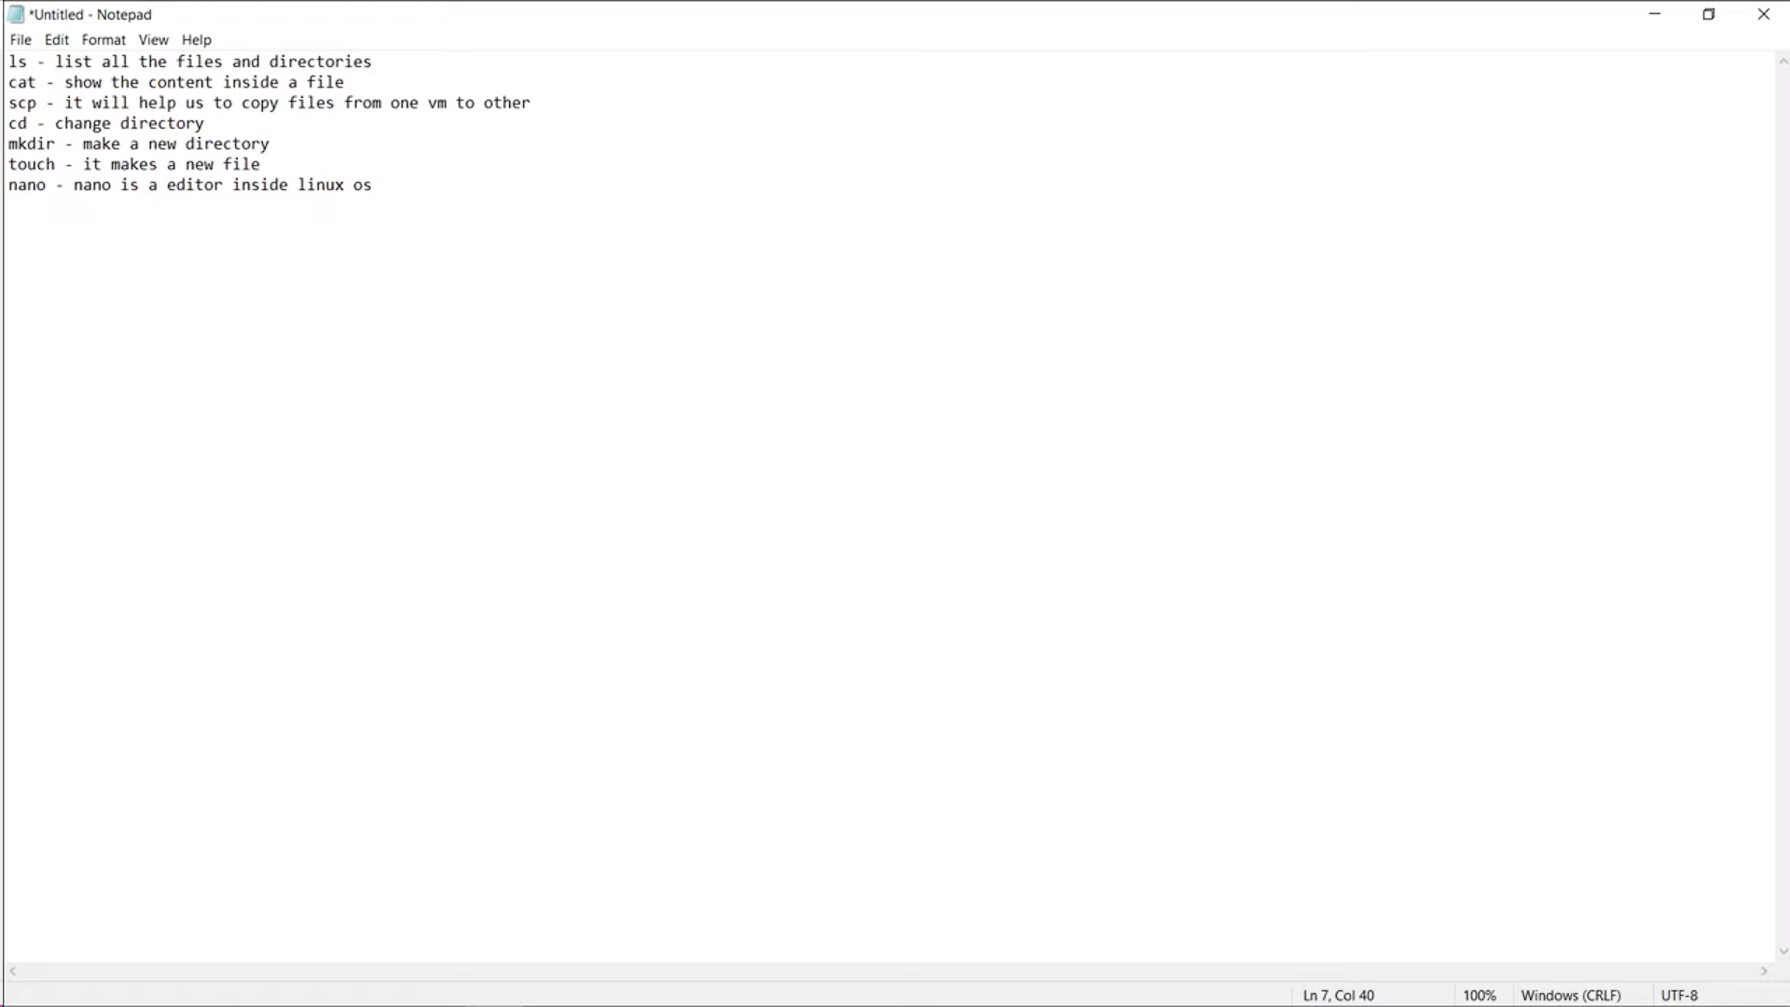

Results:

