|  |
| --- |
| Transact SQL Report |
|  |

|  |  |
| --- | --- |
| February 14, 2022 | Data Reporting and Analysis with T-SQL. |

By Tejaswini Jayashanker.

Virtual Internship at AINE AI | February 2022 batch.

Figure 1: Establish SQL Connection. 2

Figure 2: All Tables used in this project. 3

Figure 3: Depicting few rows and columns of Customer Table. 3

Figure 4: Extract Name from Customer Table. 4

Figure 5: Customer Name, Phone Number and Sales person in charge. 4

Figure 6: List of <Customer ID : Company> 5

Figure 7: List of Sales Order Revisions. 6

Figure 8: Full Name of Customers 6

Figure 9: Primary contact of the Customers. 7

Figure 10: Shipping status of Orders. 7

Figure 11: Address Table. 8

Figure 12: Customer Location (City/Province). 8

Figure 13: Top 10% heaviest products. 9

Figure 14: 100 heaviest products excluding top 10. 10

Figure 15: List of product details of model -1. 10

Figure 16: Products with Red, Black and White colors and Size 'S' or 'M'. 11

Figure 17: List of products with Product Number starts with ‘BK’. 11

Figure 18:Join of Customer and Order Header tables. 12

Figure 19: Joining Customer, Order Header and Address tables. 12

Figure 20: Customer Name and Order ID list. 13

Figure 21: Customers' Name, Phone Number and associated Company name. 13

Figure 22: List of Customer IDs that have not ordered. List of Product IDs which never been ordered. 14

Figure 23: List of Products with List price > Unit Price. 15

Figure 24: List price = 100 USD or more, Selling Price Less than 100USD. 15

Figure 25: List of Products with their prices. 16

Figure 26: List of Products with selling price lower than cost. 16

To Analyze the Product sales performance using T-SQL. Analysis of sales of various products by customer’s demographics and product categories for “Adventure Works Cycles” using T-SQL Programming on Azure Data Studio.

**NOTE:** This report contains the Screenshots of the Query results, that indicate the columns/rows. Since the dataset is big, the screenshot captures certain rows and columns. The total row count is present at the bottom of the screenshot. Confidential information in the Screenshots are blocked in different colors.

# AIM

Using T-SQL Programming to Summarize the sales of Adventure Works Cycles w.r.t product characteristics, promotion cost and customer demographics.

# Objectives

1. Establish Connection with SQL Servers

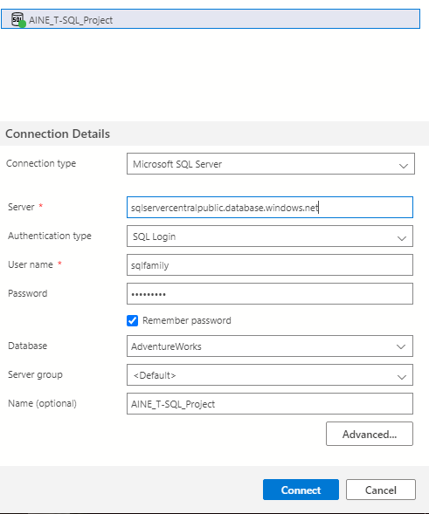

Figure : Establish SQL Connection.

Establish a connection to the SQL Microsoft server with Adventure Works Database SQL Login.

These credentials are confidential and hence are blocked in the above image.

Once the connection is established, we should be able to see disconnect option enabled.



1. Generate Reports to containing details of the company’s customers to support sales campaign.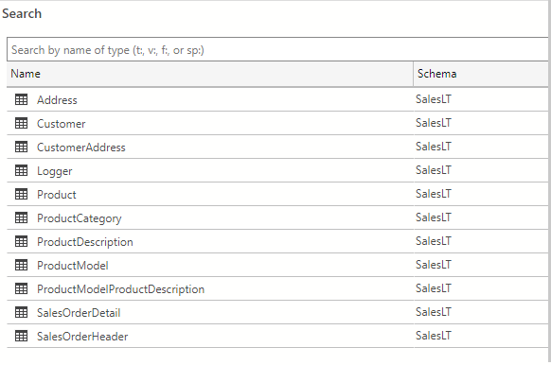

Figure : All Tables used in this project.

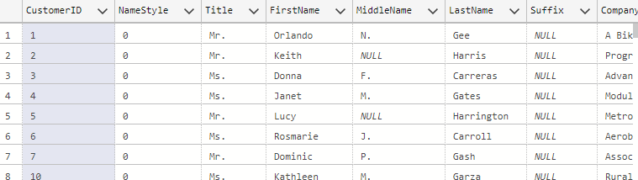

Figure : Depicting few rows and columns of Customer Table.

The Customer Table has a total of 847 rows and 15 columns.

This exercise mainly focuses on extracting the Customer Name, Contact details and Assigned Sales person for each customer.

The results after querying are displayed in the figures 2, 3, 4 and 5.

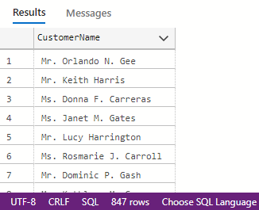

Figure : Extract Name from Customer Table.

*Note: Q2 is to become familiar with T-SQL Query and Syntax.*

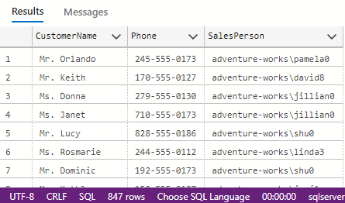

Figure : Customer Name, Phone Number and Sales person in charge.

1. Concatenating the columns to create reports from the same tables.

* Firstly, we have to retrieve the list of customer ID along with the Customer companies.

This gives us the following image as a result on querying from the Customer table.

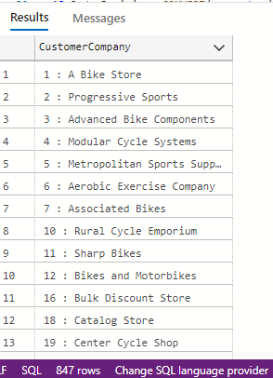

Figure : List of <Customer ID : Company>

* The Sales Order Header table contains 32rows and 22 columns.

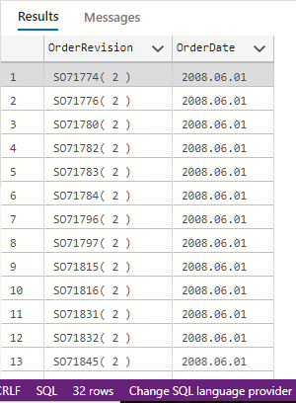

Figure : List of Sales Order Revisions.

1. Handling NULL Values in the Database.

* Some records in the database include missing or unknown values that are returned as NULL.

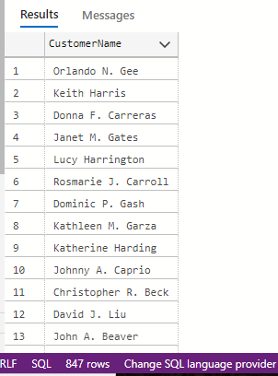

Figure : Full Name of Customers

* If the Middle name is Null, the full name of the customer will include only the First and Last name.

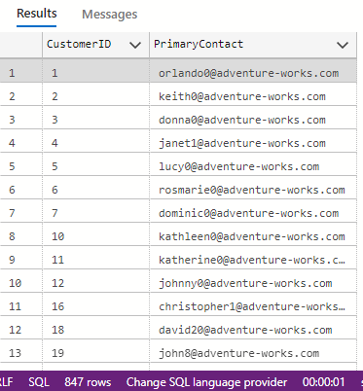

Figure : Primary contact of the Customers.

The primary contact of the customer will be the email ID. In case the email ID is not present, use Phone number as the primary contact.

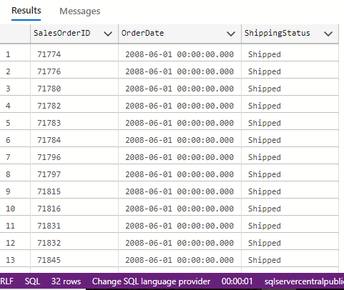

Figure : Shipping status of Orders.

The shipping status will be shipped if the ship date is available else the status is awaiting shipment.

1. Querying Tables to Filter and sort data.

* The Address table has 11 columns and 450 rows.

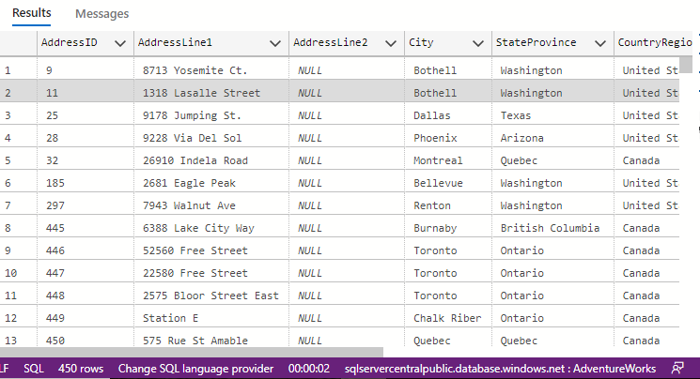

Figure : Address Table.

* Firstly, list the Customers’ location.

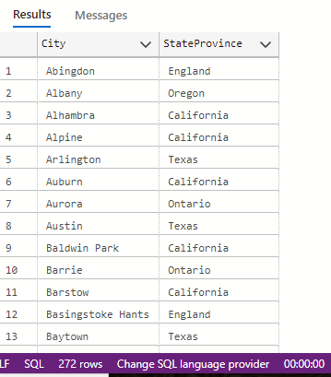

Figure : Customer Location (City/Province).

* List of top 10% of heaviest products.

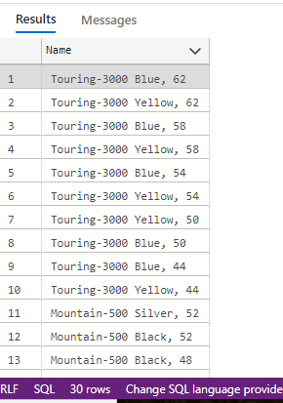

Figure : Top 10% heaviest products.

* List of 100 heaviest products.

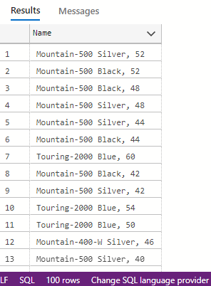

Figure : 100 heaviest products excluding top 10.

* List of products with Product model -1.

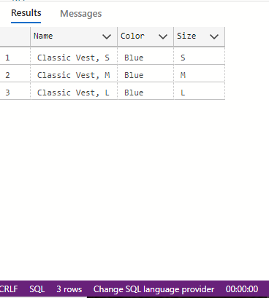

Figure : List of product details of model -1.

* Filtering products by color and Size.

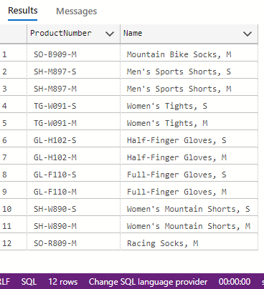

Figure : Products with Red, Black and White colors and Size 'S' or 'M'.

* List of all products that start with a certain Product number.

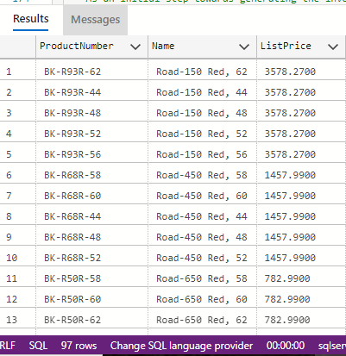

Figure : List of products with Product Number starts with ‘BK’.

1. Querying tables to join multiple tables and generate reports.

* List of Customer Orders to generate invoice reports.

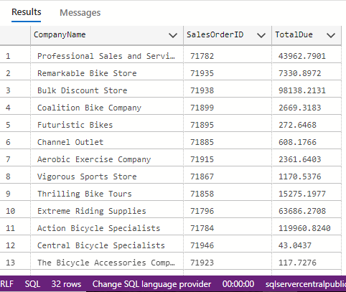

Figure :Join of Customer and Order Header tables.

* List of Customer Orders with Addresses.

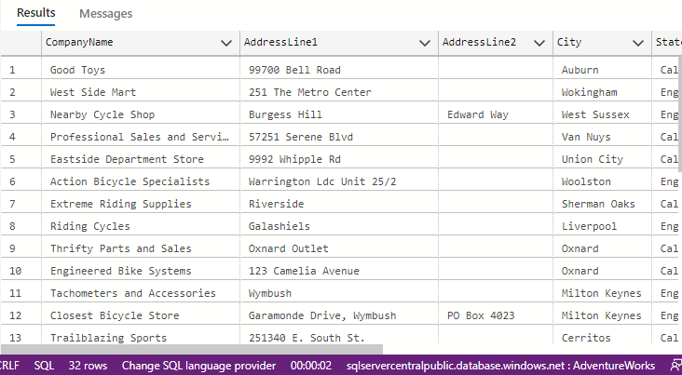

Figure : Joining Customer, Order Header and Address tables.

* List of Customers and their orders.

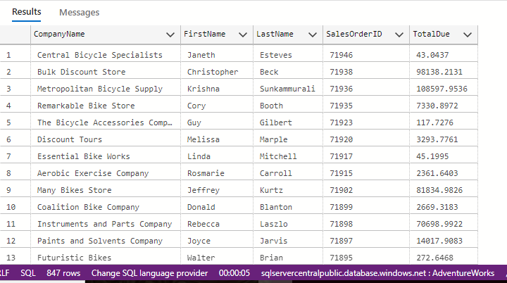

Figure : Customer Name and Order ID list.

* List of Customers with no address.

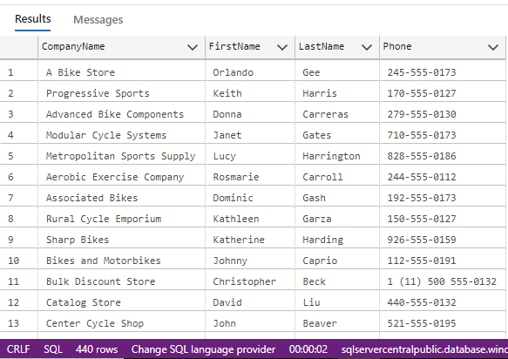

Figure : Customers' Name, Phone Number and associated Company name.

* List of Customers and Products without Orders.

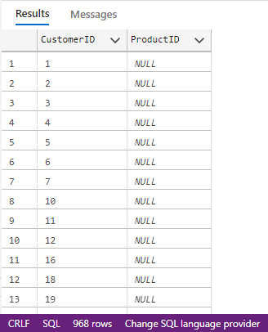

Figure : List of Customer IDs that have not ordered. List of Product IDs which never been ordered.

1. Working with Conditions, Aggregations and Sub-Queries in T-SQL.

Adventure Works products, each have a standard cost that indicates the cost of manufacturing the product. The list price indicates the recommended selling price for the product.

* List of Products whose list price is higher than the average unit price.

This gives us 39 rows, with Product ID, Name and List Price.

NOTE: The average Unit Price is considered in this case for comparison.

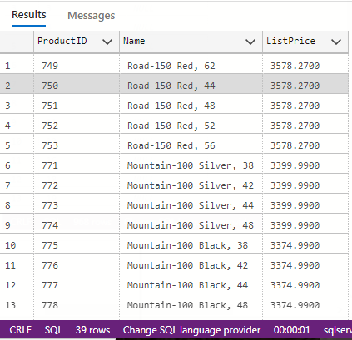

Figure : List of Products with List price > Unit Price.

* List of Products with List Price of 100 dollars or more that have been sold for less than 100 dollars.

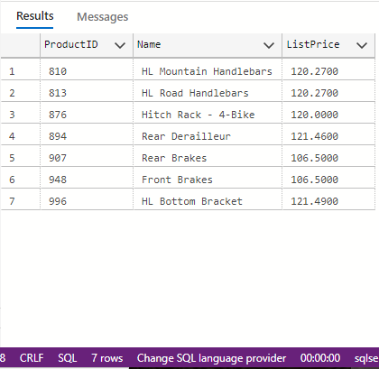

Figure : List price = 100 USD or more, Selling Price Less than 100USD.

* List of Cost, List and average selling price for each product.

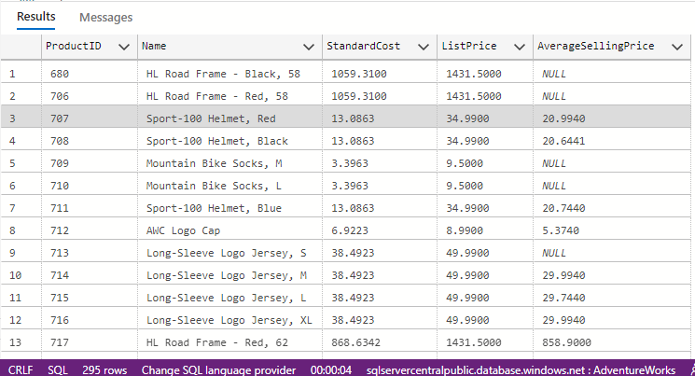

Figure : List of Products with their prices.

* List of products with average selling price lower than cost price.

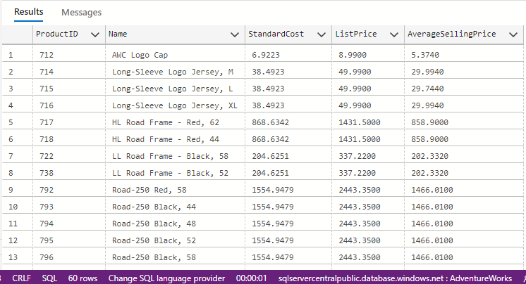

Figure : List of Products with selling price lower than cost.