1. **Before executing the first query:**

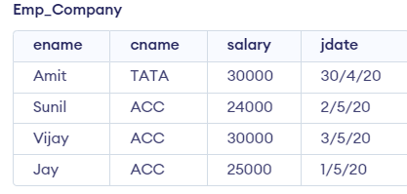

**After executing the first query:**

update Emp_Company set salary=salary-100 where ename='Vijay' and exists(select ename from Employee where ename='Vijay' and city='Madras' and city in (select city from Employee where ename='Sunil'));

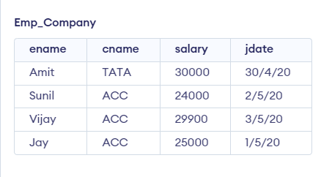

1. **Before executing the second query:**

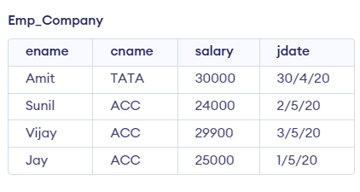

**After executing the second query:**

update Emp_Company set cname='TATA' where cname='ACC' and salary>8000;

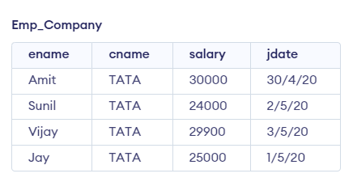

1. **Before executing the third query:**

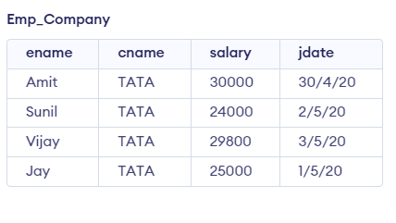

**After executing the third query:**

update Emp_Company set salary=(select salary from Emp_Company where ename='Vijay')-100 where ename='Vijay';

AND

--update Emp_Company set salary=(select salary from Emp_Company where ename='Sunil')+100 where ename='Sunil';

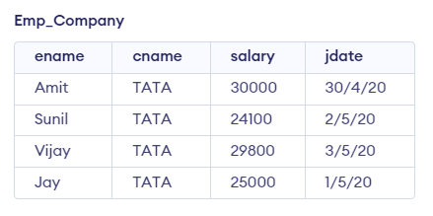

1. **Before executing the fourth query:**

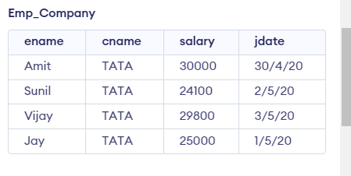

**After executing the fourth query:**

delete from Emp_Company where salary>8000;

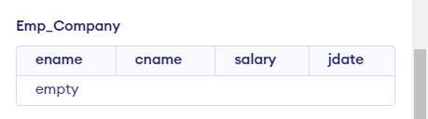

**Practical 3**

**Question 1:** Find employee names and cities they live in for the employee working in company ‘ACC’.

**Query🡪** select e.ename , e.city from Employee e where e.ename in (select ec.ename from Emp_Company ec where ec.cname='ACC' );

**Output🡪**

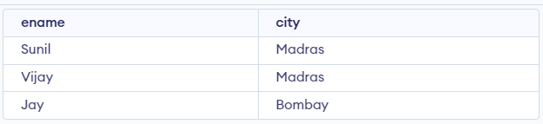

**Question 2:** List the employees living in city ‘Bombay’ and those having company located in ‘Delhi’.

**Query🡪**select e.ename from Employee e where e.city='Bombay' and e.ename in(select ec.ename from Emp_Company ec where ec.cname in(select c.cname from Company c where c.city='Delhi'));

**Output🡪**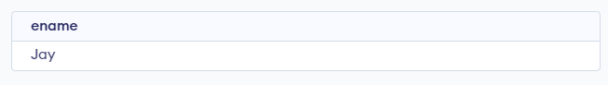

**Question 3** : List the names of the employees living in the same city where ‘Sunil’ is also living.

**Query🡪** select e2.ename from Employee e2 where exists (select e1.city from Employee e where e1.ename=’Sunil’ and e2.city=e1.city);

**Output🡪**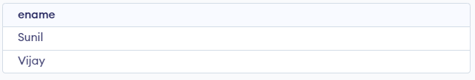

**Practical 4**

**Question 1:** Find sailor ids who have reserved Red or Green coloured boats.

**Query🡪** select s.sid from Sailors s,Reserves r,Boats b where (b.color='Red' or b.color='Green') and b.bid=r.bid and r.sid=s.sid;

**Output🡪**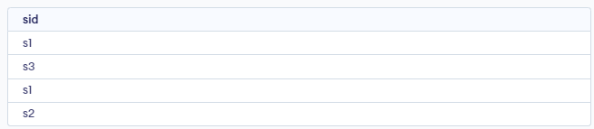

**Question 2:** Find sailor ids who have reserved Red as well as Green coloured boats.

**Query🡪** select s.sid from Reserves r1,Boats b1,Reserves r2,Boats b2, Sailors s where (b1.color='Red' and b1.bid=r1.bid and r1.sid=s.sid) and (b2.color='Green' and b2.bid=r2.bid and r2.sid=s.sid );

**Output🡪**

**Question 3:** Find sailor ids who have reserved Red coloured boats but not Green coloured boats.

**Query🡪**select s.sid from Sailors s ,Reserves r1,Reserves r2,Boats b1,Boats b2 where (b1.color='Red' and b1.bid=r1.bid and r1.sid=s.sid) except (b2.color='Green' and b2.bid=r.bid and r2.sid=s.sid);

**Output🡪**

**Practical 5**

**Question 1:** Find the employee names having max salary

**Query->**select ename from Emp_Company where salary in(select max(salary) from Emp_Company);

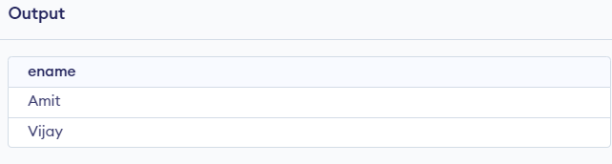

**Question 2**: List the name of employees having max salary in their company.

**Query ->** select ename from Emp_Company where salary in(select max(salary) from Emp_Company );



**Question 3:** Find the average salary of each company except ‘ACC’.

**Query->** select avg(salary) from Emp_Company where cname!=’ACC’ group by cname;

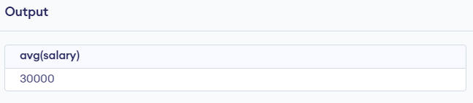

**Question 4:** Find the average salary of company only for those employees living in ‘Delhi’.

**Query->**select avg(salary) from Emp_Company where ename in(select ename from Employee where city=’Delhi’);

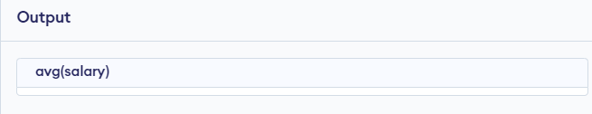

(since we haven’t made any entry of employee living ‘Delhi’, the output was empty).

**Question 5:** Find the name of the company having highest average salary.

**Query->** select cname , avg(salary) from Emp_Company group by cname having avg(salary)>(select avg(salary) from Emp_Company group by cname);

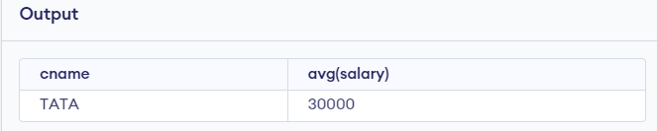

**Question 6:** List the number of employees living in ‘Bombay’.

**Query->** select count (ename) from Employee where city=’Bombay’;

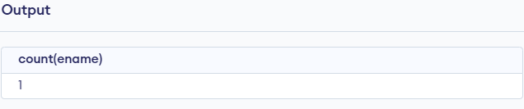

**Question 7:** List the name of the employees with their living cities having max salary in company ‘TATA’.

**Query->** select e.ename,e.city from Employee e where e.ename in(select ec.ename from Emp_Company ec where ec.cname='TATA' and ec.salary in (select max(ec1.salary)from Emp_Company ec1));

