E-Commerce Sales & Customer Behavior Analysis
IBM SkillsBuild Data Analytics with AI – Academic Internship Project
Author: Tejaswini Yalam
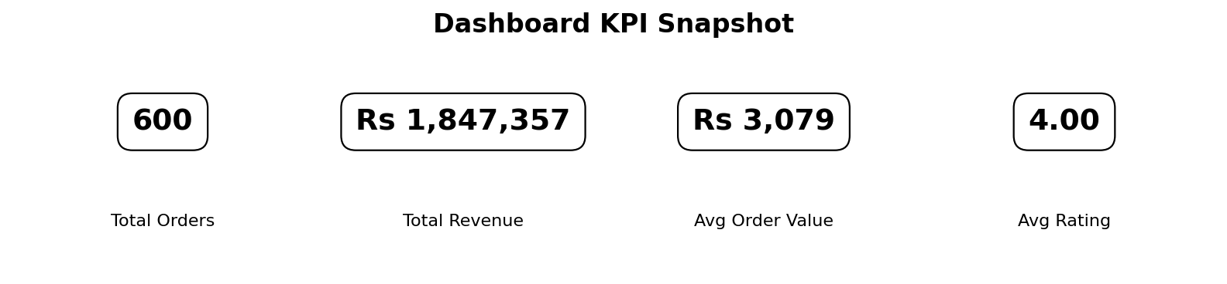
Figure 1. Dashboard KPI snapshot

1. Introduction
The project develops an interactive dashboard for e-commerce sales and customer behavior analysis. The application uses Python-based data generation, cleaning, analysis, visualization, and reporting. Streamlit is used to provide an interactive dashboard through a web browser.
2. Problem Statement
E-commerce data can contain duplicate records, inconsistent text values, invalid numerical values, missing values, and other data-quality problems. This project demonstrates a complete analytics workflow in which such issues are identified and cleaned before business-oriented analysis is performed.
3. Objectives
The main objectives are to generate a realistic sales dataset, demonstrate data cleaning, calculate key performance indicators, analyze revenue patterns, compare customer segments and regions, examine delivery performance, and present the results through an interactive dashboard and downloadable PowerPoint report.
4. Tools and Technologies
Python, Pandas, NumPy, Streamlit, Plotly, Matplotlib, and python-pptx are used in the project.
5. Dataset
The project generates its own synthetic e-commerce dataset. It contains order information, customer information, product category and product name, pricing, quantity, discounts, payment method, delivery information, ratings, and calculated sales. The generator creates 600 rows and deliberately introduces duplicate rows and data-quality issues so that the cleaning stage can be demonstrated.
6. Data Cleaning
The cleaning process removes duplicate records, trims text fields, standardizes product-category capitalization, corrects negative prices by using absolute values, replaces non-positive quantities with 1, fills missing delivery days using category medians and an overall median fallback, records missing ratings, recalculates total sales, and converts order dates to datetime values.
7. Analysis
The project calculates total orders, total revenue, average order value, average customer rating, and cancellation rate. It also calculates revenue by product category, revenue by region, customer-segment performance, monthly revenue trends, delivery performance, and the top products by revenue.
8. Streamlit Dashboard
The dashboard provides sidebar filters for region, product category, customer segment, and order date range. After filtering, KPI cards and interactive Plotly charts update to reflect the selected data. The dashboard also shows top products, delivery performance, and the filtered dataset.
9. PowerPoint Report
The application can generate a PowerPoint report in memory. The report contains KPI information, revenue by product category, regional revenue share, monthly revenue trend, and a table of the top 10 products by revenue.
10. How to Run
Create a Python virtual environment, install the packages listed in requirements.txt, and run the Streamlit application with `streamlit run Tejaswini_Ecommerce_Sales_Analysis.py` or `python -m streamlit run Tejaswini_Ecommerce_Sales_Analysis.py`. The exact command used in the supplied project configuration is `.\venv\Scripts\python.exe -m streamlit run Tejaswini_Ecommerce_Sales_Analysis.py`.
11. Expected Outcome
The final output is an interactive e-commerce analytics dashboard that allows users to explore sales and customer behavior and generate a PowerPoint report from the selected data.
12. Conclusion
This project demonstrates an end-to-end data analytics workflow: data generation, data cleaning, exploratory analysis, interactive visualization, KPI reporting, and automated report generation. It provides a practical example of using Python and Streamlit to turn structured sales data into an interactive analytical application.

13. Visual Diagrams and Project Insights
The diagrams below provide a visual representation of the project's end-to-end workflow, data-cleaning operations, and selected analytical outputs.
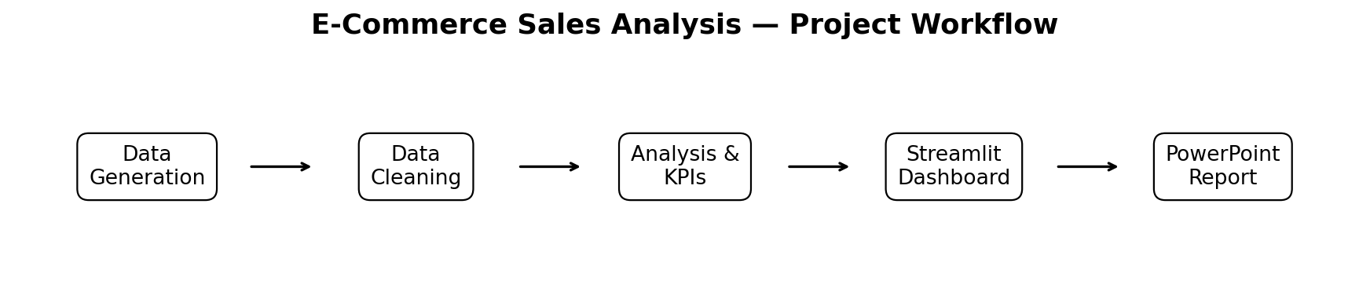
Figure 2. End-to-end project workflow
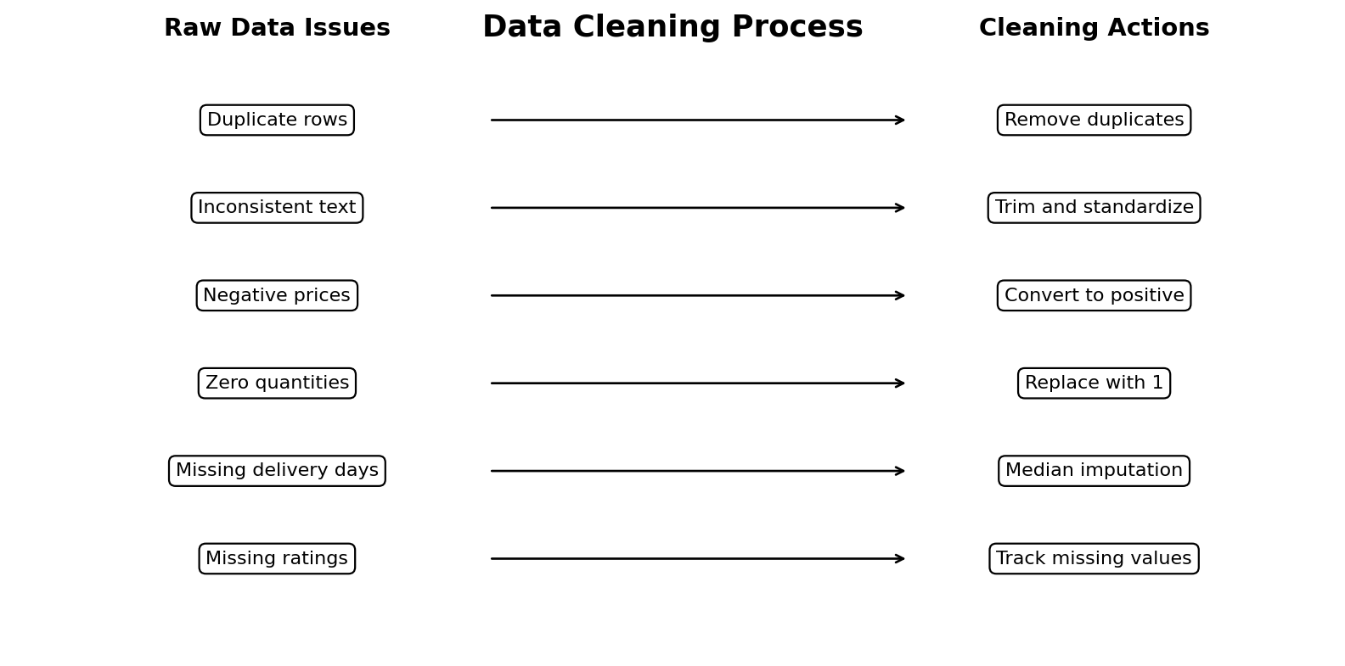
Figure 3. Data cleaning process
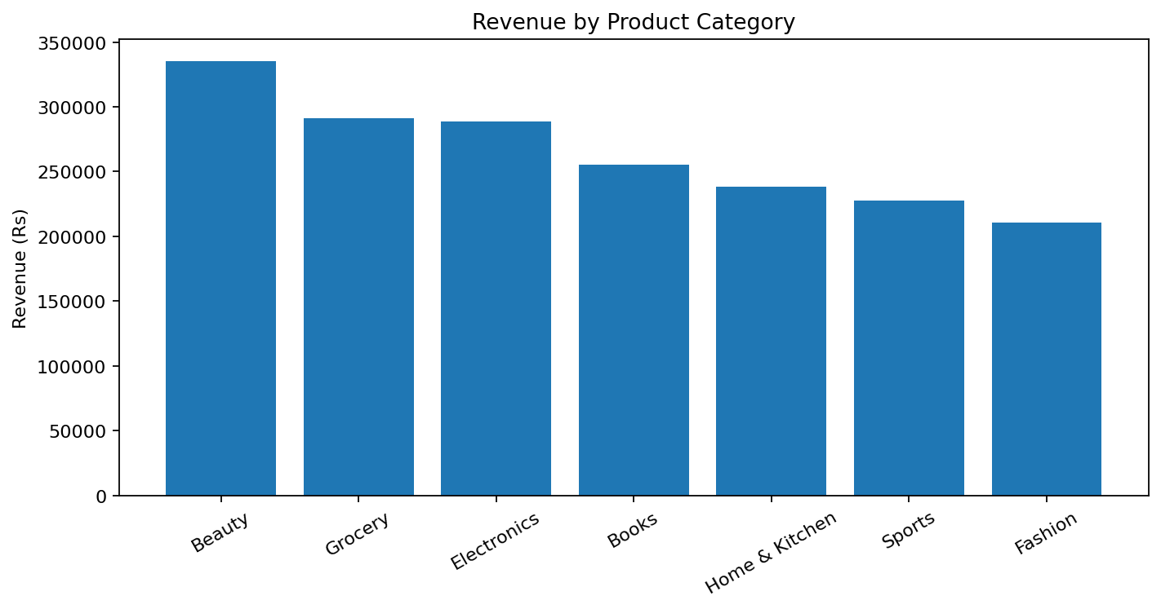
Figure 4. Revenue by product category
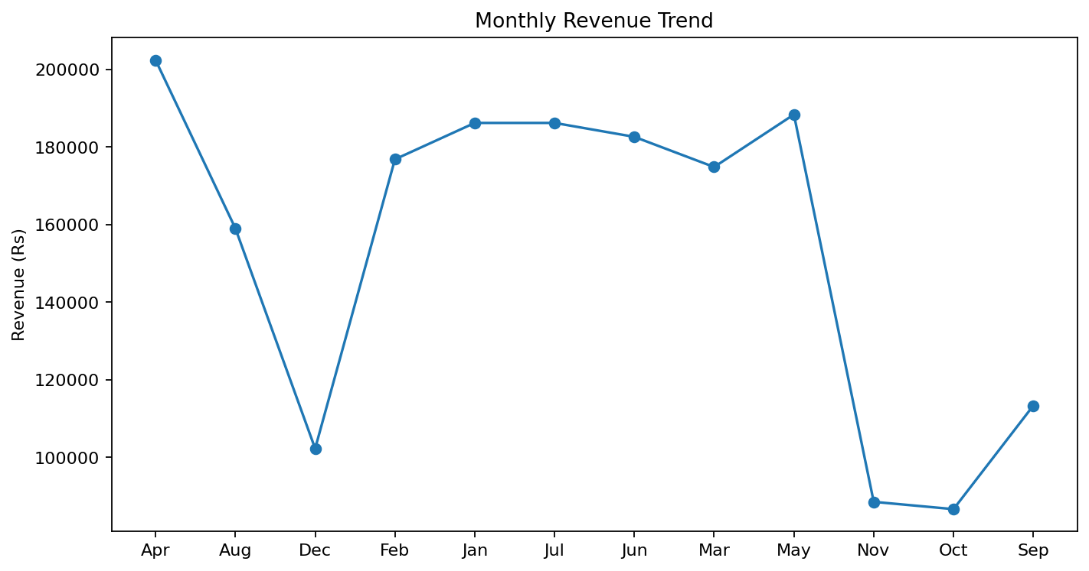
Figure 5. Monthly revenue trend
These visuals complement the Streamlit dashboard by showing the data pipeline and the types of business insights produced by the application. The charts use the same analytical structure as the submitted project.

