Kitchen-story

# Developer name: Resapu Sai Tejaswini

Core concepts that were used in the project are:

* DataBase
* Java Collections
* Exception Handling

# Technologies that were used in the project are:

* Spring boot.
* Handling exceptions.
* Spring boot CRUD api
* JDBC
* Java classes
* MySQL
* Angular 13
* Typescript

# Application features:

* Sign in page for admin.
* Change password for admin.
* View a list of all products for admin.
* Search a product by name.
* Admin password change.
* Admin adds a new product to website.
* Admin deletes product.

The application was done in three sprints, the first sprint for sprint planning and preparing. Next, two sprint for developing and testing the application. Moving on to the first sprint we planned the flow of the development and how we are approaching the project.

Furthermore, we developed the database tables and entered products, admin’ information and orders details. Then, we created the packages and java classes for each table in the database. Moving on, to the developing the repository packages to link the classes and the database code. Then, we created the services and rest api controllers to get to the code. Finally, we tested the website using postman. Then we created the frontend using angular.

Below you will find screenshots of the application:

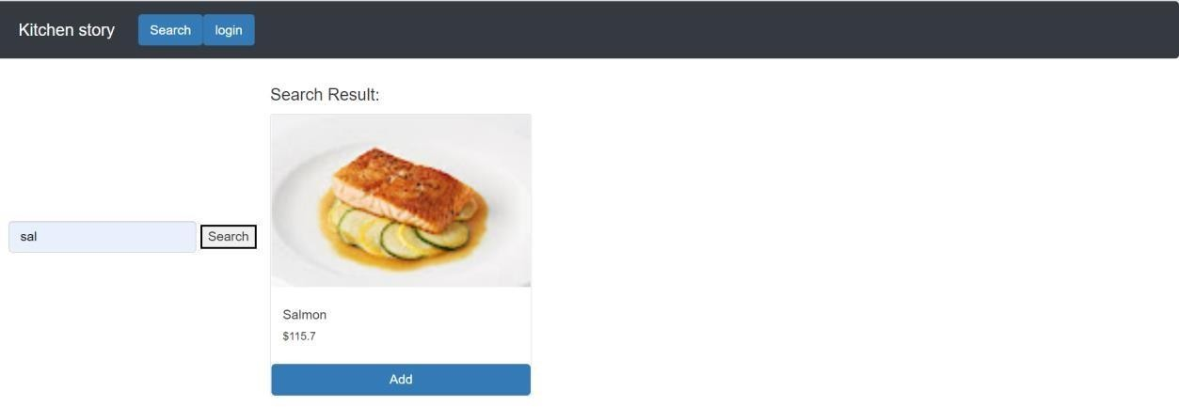

User search page

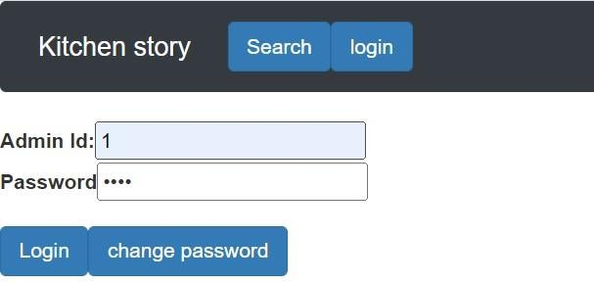

Admin login page

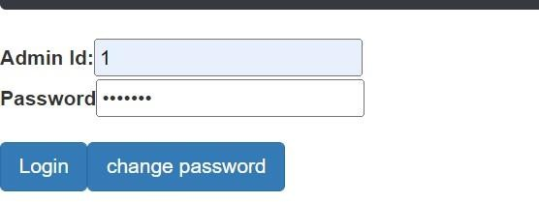

Admin changepassword

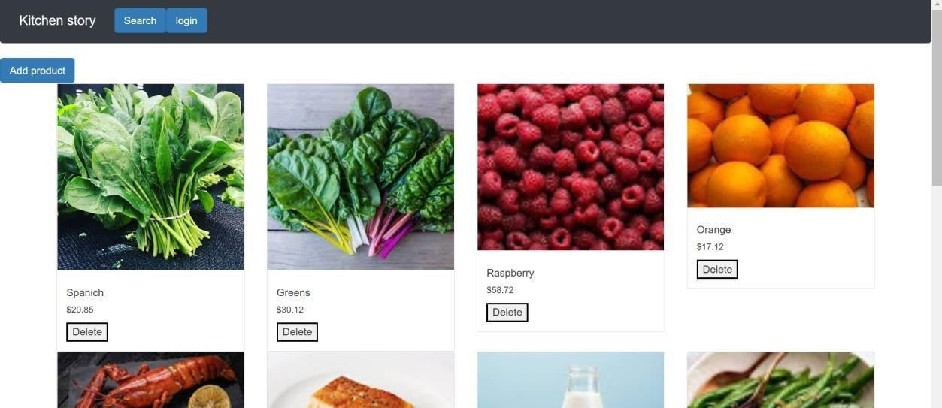

Admin view all products

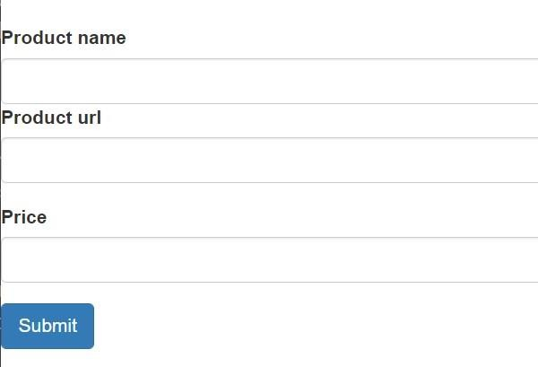

admin add product his project will help the customer a lot in his/her everyday use to buy their groceries . It is developed in a way to make their life easier as it is user-friendly and

easy to learn. In the future, we would like to improve the frontend website so that its easier. This project aims to design and develop a website spring boot framework and angular. The goal of this project is to apply angular concept with JDBC concepts and spring boot.

you will also find the code of the database below.

REATE SCHEMA `kitchen_story` ; use kitchen_story;

CREATE TABLE `admin` (

`admin_id` int NOT NULL AUTO_INCREMENT,

`email` varchar(200) NOT NULL,

`full_name` varchar(200) NOT NULL,

`password` varchar(55) NOT NULL, primary key (`admin_id`)

) ENGINE=InnoDB DEFAULT CHARSET=utf8mb4;

INSERT INTO `products` (`product_id`,`product_name`,`MSRP`,`url`) VALUES (1,'Spanich','20.85','https://[www.newyorkfamily.com/wp-content/uploads/2020/03/elianna-friedman4jpNPu7IW8k-](http://www.newyorkfamily.com/wp-content/uploads/2020/03/elianna-friedman4jpNPu7IW8k-) unsplash.jpg');

INSERT INTO `products` (`product_id`,`product_name`,`MSRP`,`url`) VALUES

(2,'Greens','30.12','https://encrypted-tbn0.gstatic.com/images?q=tbn:ANd9GcTKyW3K6515A3HGkX08PBQBfPUe - XZNUJQ&usqp=CAU');

INSERT INTO `products` (`product_id`,`product_name`,`MSRP`,`url`) VALUES (3,'Raspberry ','58.72','https://lh3.googleusercontent.com/eOfrgrcAaeRazgAMBgM5GdYK_6XqcMjHs79u6jCdC7i4qRjuMK IOhvpQpppSNoPXMiVUA-0=s95');

INSERT INTO `products` (`product_id`,`product_name`,`MSRP`,`url`) VALUES (4,'Orange','17.12','https://lh3.googleusercontent.com/SF3IUjS6AZhAgNClrfoXcMBq90pFmZvO8jscCncFC4i0mH2V VvLUnmLrg2Tp3816C4x=s128');

INSERT INTO `products` (`product_id`,`product_name`,`MSRP`,`url`) VALUES (5,'Lobster','168.12','https://lh3.googleusercontent.com/XSFvVNWdjiQBLF0V538NuebUNkwhDAjcqvIcx5XZ 6khv7Dv-qbLtTTxJE9W7DHkHZFZdsQ=s151');

INSERT INTO `products` (`product_id`,`product_name`,`MSRP`,`url`) VALUES (6,'Salmon','115.70','https://lh3.googleusercontent.com/RLfRAl7elqzDW1H7R2KdUfz6At602YZ2Oxrpyj3ab7I3JopEr d7k_Ex74Ml95JKt_a_kA=s128');

INSERT INTO `products` (`product_id`,`product_name`,`MSRP`,`url`) VALUES (7,'Milk','14.86','https://lh3.googleusercontent.com/rHuJaZmk01jIG7nKriA3jJJUBmcX7Og7QT1Zu9AJVZ54mFMqZ EsOUaipGwm81KppqjD=s113');

INSERT INTO `products` (`product_id`,`product_name`,`MSRP`,`url`) VALUES (8,'Green Beans','22.50','https://lh3.googleusercontent.com/OJNwyW- D5lxWrXzegqJUPIRTVUCHWeUYKGtvJVoarBSwEPihWHFDIWXOCKFkigmoktO7Sw=s85');

INSERT INTO `products` (`product_id`,`product_name`,`MSRP`,`url`) VALUES (9,'Calamari','200.77','https://lh3.googleusercontent.com/M14kXSQAjdTG1_ee8hKv6H9JXElyZBs0NsNHVLDhRt9i- Ucn28DODHI3u65g9kAlbEX=s113');

INSERT INTO `products` (`product_id`,`product_name`,`MSRP`,`url`) VALUES (10,'Coconut','66.99','https://lh3.googleusercontent.com/hHBLuGjRlGpcpNevXKUa_sciW6dDE53kAjVti11wj2 XFHL4ayTyWO4eJMO72TYVLJGlZKQ=s128');

INSERT INTO `products` (`product_id`,`product_name`,`MSRP`,`url`) VALUES (11,'Steak','250.99','https://lh3.googleusercontent.com/Mwb9u2ptUq2ZaMZTALNLA3q3yTgepddBtwbXNNVc yOowLFXPZeqjrklJnYIERYQsowLFmA=s128');

INSERT INTO `products` (`product_id`,`product_name`,`MSRP`,`url`) VALUES (12,'Mango','111.87','https://static.toiimg.com/photo/69185542.cms');

INSERT INTO `products` (`product_id`,`product_name`,`MSRP`,`url`) VALUES (20,'testttt388','123.97','huhhgvjbj23456');

INSERT INTO `products` (`product_id`,`product_name`,`MSRP`,`url`) VALUES (21,'testttt3','123.97','huhhgvjbj23456');

INSERT INTO `products` (`product_id`,`product_name`,`MSRP`,`url`) VALUES (22,'testttt3','123.97','huhhgvjbj23456');

INSERT INTO `products` (`product_id`,`product_name`,`MSRP`,`url`) VALUES (23,'testttt388','123.9','huhhgvjbj23456');

INSERT INTO `admin` (`admin_id`,`email`,`full_name`,`password`) VALUES (1,'alaa56mm@gmail.com','Alaa Hendi','root');

CREATE TABLE `products` (

`product_id` int NOT NULL AUTO_INCREMENT,

`product_name` varchar(6000) NOT NULL,

`MSRP` varchar(200) NOT NULL,

`url` varchar(6000) NOT NULL,

primary key (`product_id`)

) ENGINE=InnoDB DEFAULT CHARSET=utf8mb4