**Learner’s Academy Specification Document**

**Project Detail**

Project Name: Learner’s Academy

**Project Details:** This project is for the design and developing a backend administrative portal for the Learner’s Academy using Java EE technologies

**Objective**: The Objective of this project is to apply servlet, jsp and JDBC concepts.

**Technologies and tools Used:**

* Servlet: to do the business logic and works a controller for the project.
* JSP: to handle the presentation view.
* SQL: to create and manage the database.
* JDBC: to make operations on the database for the project.
* CSS: to format the contents.
* Eclipse: to write and run the code.
* Tomcat: to run and deploy servlet application.

**Flow Chart:**

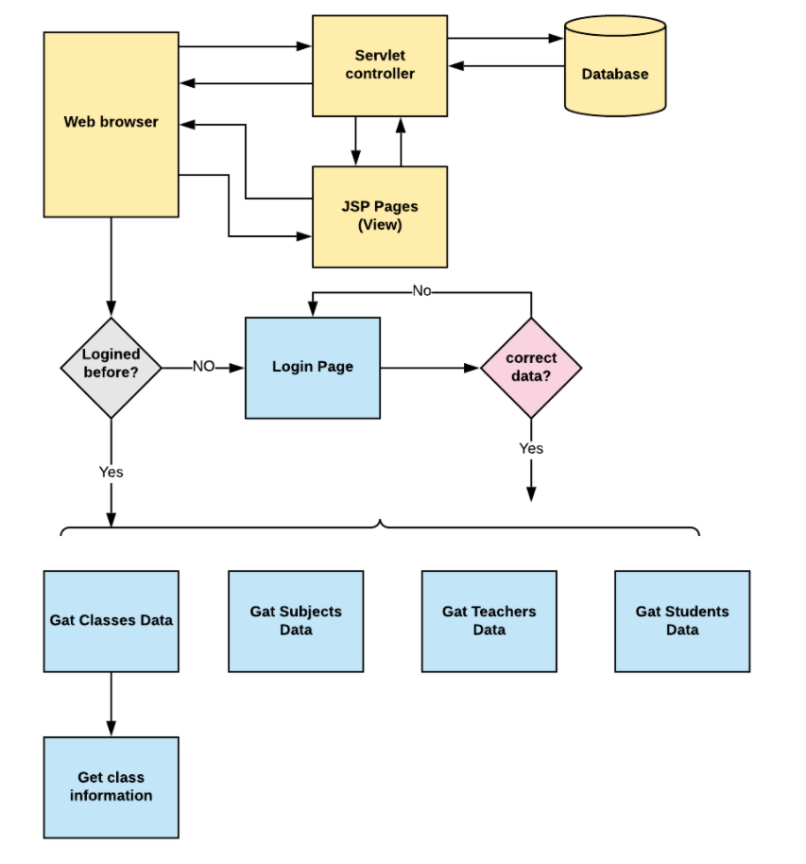

ADD CLASS

ADD CLASS

ADD TEACHER

ADD SUBJECT

ADD SUBJECT

ADD STUDENT

ADD ADMIN

**Sprint Plan:**

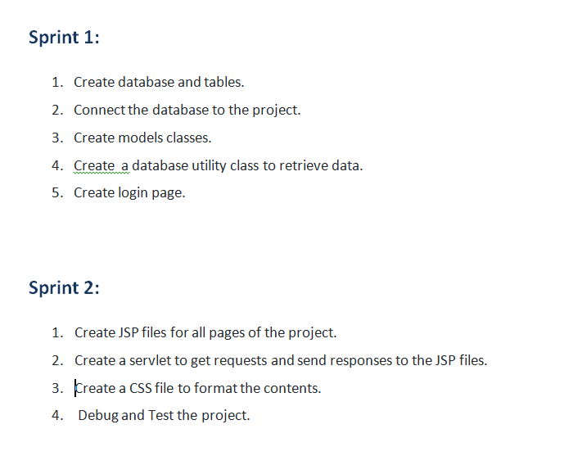

**Concept used in this programme:**

1. Object-Oriented: used to create and model objects for users and their credentials.
2. Databases: used to store and retrieve data.
3. Data Sources: used to define a set of properties required to identify and access the database.
4. Collections: used some collections such arraylist to store collection of data.
5. Exception Handling: used to catch problems that arises in the code especially in I/O blocks.
6. Cookies: to store log-in data on the client browser. Searching and Sorting