**Project Problem Statement**

Sporty Shoes is a website to shop sports shoes. It has both admin and user interfaces separately. Admin has features to add products, add product category, view users list and purchase records.

**Project Functionalities**

1. Create account.
2. Add products to the cart.
3. Buy products.

**Appearance**



**Database design**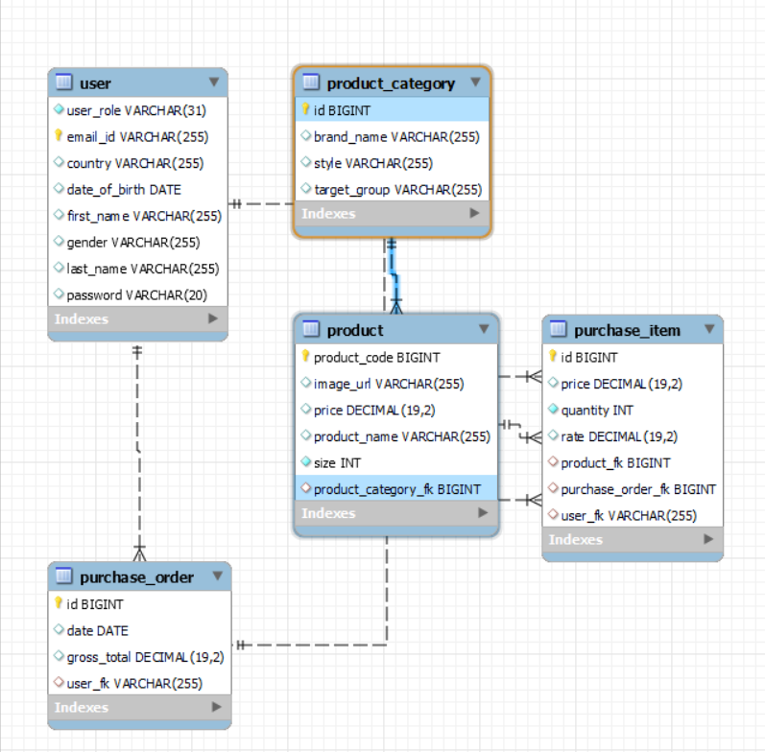

**Java Concepts Used in the project**

1. SpringBoot.
2. HTML.
3. CSS.
4. JSP.
5. MySQL.
6. Exception Handling.

**Conclusion**

This product makes things easy to shop sports for all ages and genders (basically biological genders).

**Github link:**

https://github.com/Tejaswini188/simplilearn.git