**Project Problem Statement**

Company Lockers Pvt. Ltd. is looking for command line java application (console application prototype) to manage their file on given drive. Java concepts being used in the project. Data Structures where sorting and searching techniques are used. Option to close the application.

**Project Proto-Type Functionalities**

1. Displays all Filenames in Ascending Order.

2. Adds a new file in pre-defined path.

3. Deletes a file from the pre-defined path.

4. Searches a file with in the pre-defined path.

5. Exits from the application.

**Appearance**

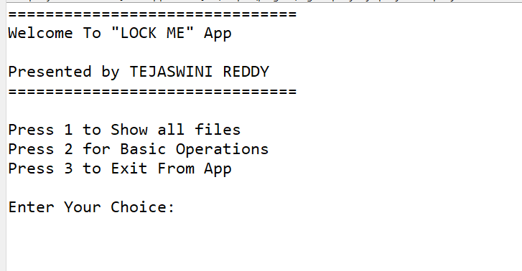

**Project development model**

We have approached the solution for this project with **Agile Model** approach, with 3 sprints. The duration of each sprint is 1 week. Time taken to deliver this project will be 3 weeks.

**Tasks achieved in each Sprint**

* Week-1:
  1. Explored for the suitable solution.
  2. Created a basic framework.
* Week-2:
  1. Added File Handling.
  2. Added Exception Handling.
  3. Modified the code to move from one context to another.
* Week-3:
  1. Created the Document.
  2. Learned Git and Created a Git Repository.
  3. Checked in the code.

**Source code management and version control**

As discussed, and agreed, we have created Git and GitHub account to store and track enhancements of the prototype and we are using the same for Version Control of the product.

**User Interactions**

The prototype developed is a **Console Based** application which can only support one user at a time.

**Flow of the application:** 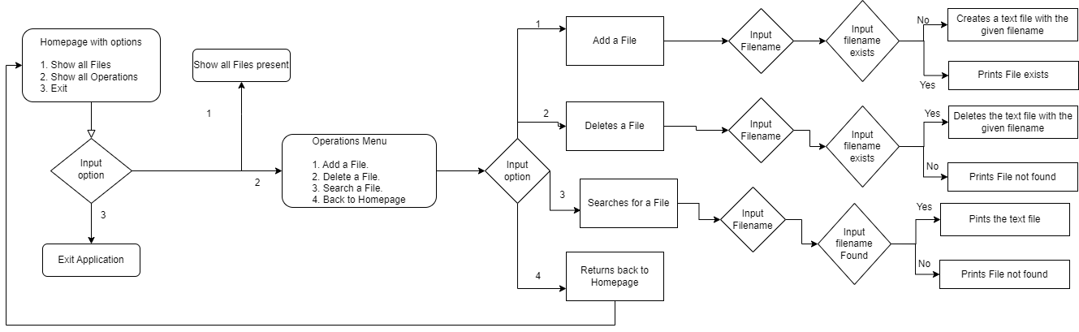

**Methods followed in the application**

1. Add a file to the existing directory list.
   1. Used In-built class “File” and its function to create a file.
2. Delete a File
   1. Used In-built class “File” and its functions to delete a file.
3. Search for file
   1. Used In-build class “File” and its function to check to its existence.

**Java Concepts Used in the project**

1. Classes and Objects.
2. Switch case.
3. File Handling.
4. Exception Handling.

**Conclusion**

This product makes things easy for user to add, delete or search a file in the root directory simply by selecting a few options and compared to any traditional command prompts where a user needs to remember a command to do any of the above operations, Our application does it just by simply selecting an option.