Sentiment Classification Using NLP and Deep Neural Networks: An
Analysis of Movie Reviews

Tejaswini Gadde txg6169@mavs.uta.edu, Samyukth Challa sxc5109@mavs.uta.edu,
Sulakshana Thirunagari sxt0993@mavs.uta.edu,
Computer Science and Engineering, University of Texas at Arlington

Abstract

Sentiment analysis a fundamental method in Natural Language Processing (NLP), allows users to comprehend the emotional tone of any text, be it a document, sentence, or paragraph. Analysis of social media posts, product reviews, customer feedback, public opinions on publications, and market trends can all benefit greatly from this approach, which categorises text into positive, negative, or neutral attitudes. Companies, scholars, and institutions use this technique to learn more and react to audience emotion in the right way.

This paper presents a sentiment analysis framework for movie reviews using deep learning techniques. Leveraging Long Short-Term Memory (LSTM), Recurrent Neural Networks (RNN), and Convolutional Neural Networks (CNN), the system aims to classify reviews as positive or negative. The IMDB dataset is employed for training and evaluation. Comparative analysis of the models highlights their strengths and weaknesses, with LSTM achieving the highest accuracy of 84% due to its ability to capture long-term dependencies. This study outlines the strengths, limitations, and potential future improvements in this domain.
I. Introduction
A popular method in Natural Language Processing (NLP) is sentiment analysis, which enables users to decipher the emotional tone of any text, be it a sentence, paragraph, or document. This technique is quite useful for activities like evaluating product evaluations, blogs, social media posts, and customer service interactions because it can categorise content as either positive, negative, or neutral. It is useful for evaluating consumer feedback, figuring out what the general public thinks about publications, and spotting patterns in market behaviour or customer happiness. This method provides useful information about society attitudes and customer preferences. It helps companies improve their goods and services, helps marketers and academics monitor sentiment patterns, and helps firms react quickly to public opinion. mood analysis also finds use in political analysis, reputation management, and brand monitoring, enabling organisations to successfully stay informed about public mood and market trends. With 25,000 data points in each of its training and testing sets, the IMDB dataset—a well-known standard for sentiment analysis—contains movie reviews that have been classified as either positive or negative. Recurrent Neural Networks (RNN), Long Short-Term Memory (LSTM), Convolution Neural Networks and other deep learning and natural language processing models will be used to analyse these reviews. With regard to sentiment classification, each of these models has unique characteristics.

Because of their exceptional ability to capture sequential dependencies in text, LSTM and RNN are very useful for deciphering contextual nuances in reviews. By utilising these strategies, the models hope to improve the accuracy and dependability of sentiment analysis jobs by correctly classifying evaluations as either positive or negative.
II. Dataset Description
The dataset used in this project contains 25,000 movie reviews for training and 25,000 for testing, evenly split into 12,500 positive and 12,500 negative samples. Reviews are rated on a scale from 1 to 10, with ratings greater than 6 classified as positive and ratings less than 4 classified as negative.
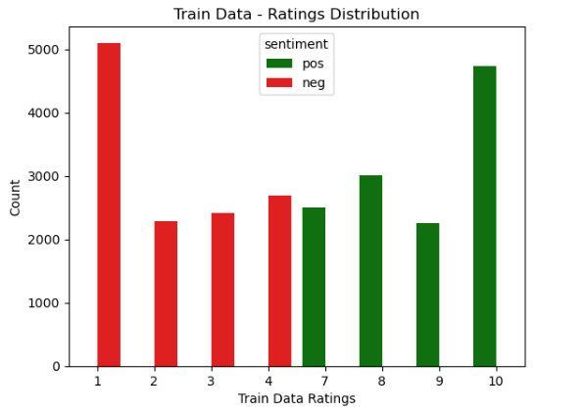
Figure 1: Visualization for Train Data
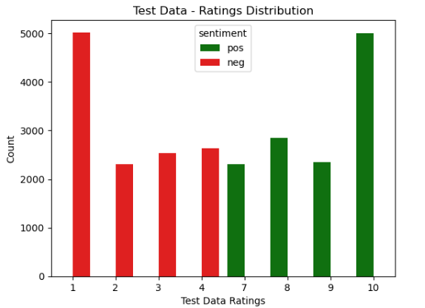
Figure 2: Visualization for Test Data

An analysis of the dataset reveals that 0.39% of reviews have extreme ratings of 1 or 10, while the rest of the ratings are fairly evenly distributed. This pattern is consistent across both the training and testing datasets.

Additionally, word clouds generated from the training and testing data showcase the most frequently used words in the reviews, highlighting common vocabulary across both datasets. These insights provide a foundation for understanding the dataset's structure and content.

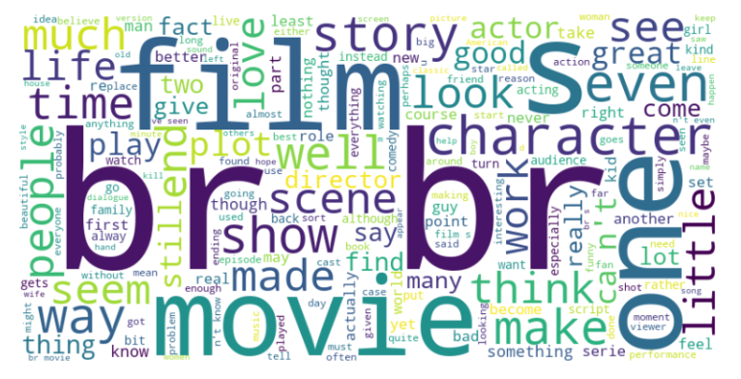
Figure 3: Word Cloud

A. Data Preprocessing
To get the movie reviews ready for analysis, the project's data cleaning and preparation procedures include multiple steps. The retrieve_review_data function is used to load the data at the start of the process. It reads review files, extracts important information including record IDs, review content, sentiment labels, and ratings, and then compiles the data into a structured Pandas DataFrame. Then, using the BeautifulSoup package, HTML tags like and that are included in the reviews are eliminated, leaving only the text. The unidecode library is then used to standardise the text by converting diacritical marks like "é" and "ä" to their base forms. To maintain consistency, contractions like "don't" and "can't" are expanded into their whole forms using the contractions library.

Listing 1: Data Cleaning
1 def data_preprocessing(text):
text = text.apply(lambda x: unidecode(x, errors="preserve"))

2 text = text.apply(lambda x: " ".join([con tractions.fix(expanded_word) for expanded_word in x.split()]))
text = text.apply(lambda x: re.sub(r'\d+', '', x))

3 text = text.apply(lambda x: re.sub('[%s]' % re.escape(remove_punctuations), ' ' , x))

4 word_lemmatizer = WordNetLemmatizer()
text = text.apply(lambda entry: lemmatize_pos_tagged_text(entry, word_lemmatizer, part_of_speech_dict))

5 text = text.apply(lambda x: re.sub('[%s]' % re.escape(string.punctuation), ' ' , x))

6 text = text.apply(lambda x: " ".join([ word for word in x.split() if word not in stop_words]) )

7 return text

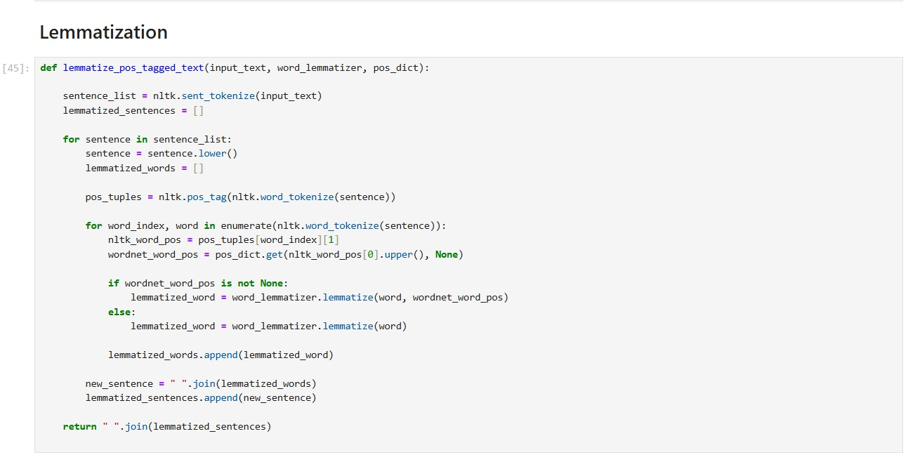
Regular expressions are used to eliminate numbers, which are frequently unimportant for sentiment analysis, and the TextBlob package is used to automatically fix errors in the text. With the exception of periods, punctuation is removed because it usually doesn't add anything significant to sentiment analysis. In order to improve uniformity, the text is further processed by lemmatisation using WordNet, Lemmatizer and POS tagging, which reduces words to their base forms. To preserve correct formatting, double spaces that may show up after transformations are cleaned. NLTK's stopwords list is used to filter away stopwords, which are common words that don't provide much value. This ensures that important words like "not" are kept for sentiment analysis. By standardising and improving the dataset, these procedures raise the calibre of input used for model testing and training
.Figure 3: Lemmatization

The lemmatization function, illustrated in the diagram, is a critical step in the text preprocessing pipeline. The process begins by converting the entire sentence to lowercase to ensure uniformity. Then, the sentence is tokenized, and each token is enumerated to identify its grammatical position, which is stored in `wordnet_word_pos`. The lemmatization function is applied to each token, reducing words to their base forms while removing common grammatical variations that do not affect meaning. Each lemmatized word is appended to a list, and these words are then joined back into a complete sentence using `" ".join(words)`. The resulting clean text is returned by the function and stored for further use. This clean, standardized text serves as input for subsequent stages of the project, including model training and testing, ensuring optimal performance and consistency.

III. Project Description
A. Model Description
We employed three deep learning models—RNN, LSTM, and CNN—for sentiment analysis, tailored to sequence-based text processing.
- RNN: Utilized GRU layers with embedding dimensions (64–256) and dropout rates (20–50%) for sequential learning. Early stopping and learning rate adjustments were employed to ensure stability during training.
- LSTM: Comprised embedding layers, LSTM cells (16–768), and dense layers with batch normalization. Gradient clipping and early stopping were incorporated for optimization.
- CNN: Focused on local feature extraction using convolutional layers, pooling layers, and dense layers. Dropout rates (0.3–0.5) and batch normalization were applied for fine-tuning.
All models were trained on IMDb review data using binary cross-entropy loss and the Adam optimizer. Evaluation metrics included accuracy, confusion matrices, and classification reports.

B. Main References Used for the project

The primary references that guided our project were:
Shilpa P. C, Rissa Shereen, and Susmi Jacob (2021) explored sentiment analysis using deep learning techniques, focusing on the effectiveness of models like CNN, LSTM, and RNN in handling textual data.

Nehal Mohamed Ali et al. (2020) examined sentiment analysis on movie reviews with deep learning models, highlighting the role of preprocessing and different neural architectures.

Saeed Mian Qaisar (2020) utilized LSTM for sentiment analysis on IMDb reviews, showcasing the impact of sequence-based models on text classification tasks.

C. Comparison of methods Between the project and references
Our approach primarily focuses on a comparative analysis of RNN, LSTM, and CNN architectures for sentiment analysis on IMDb reviews. While Qaisar (2020) used LSTM for sentiment classification, our project includes a wider variety of models, including RNN and CNN, to explore differences in performance. Unlike Ali et al. (2020), who emphasized preprocessing methods, our focus is on fine-tuning the hyperparameters (e.g., dropout, batch size, learning rate) for model optimization. Additionally, we employed more advanced techniques like early stopping and gradient clipping to improve model training stability, which was not as emphasized in previous works.

D. Performance Comparison Between the project and references
In terms of accuracy, our models achieved competitive results, with accuracy values exceeding 85% across different architectures. This is comparable to the results achieved by Qaisar (2020), who reported accuracy values of approximately 84% using LSTM models. However, our CNN and RNN models demonstrated slightly better performance than those reported by Ali et al. (2020), who primarily focused on more traditional deep learning approaches. Our models also performed better in terms of handling overfitting, thanks to the fine-tuned dropout rates and the use of early stopping.

IV. Analysis
A. Performance Analysis
Among the three models, LSTM achieved the highest accuracy of 84.08% with num_words=2500 and a medium model size. This is attributed to its ability to capture long-term dependencies in text. RNN showed competitive performance but slightly lagged behind due to its limitations
in handling long sequences. CNN achieved similar accuracy(83.72) but was faster to train, making it a strong contender for scenarios requiring computational efficiency.

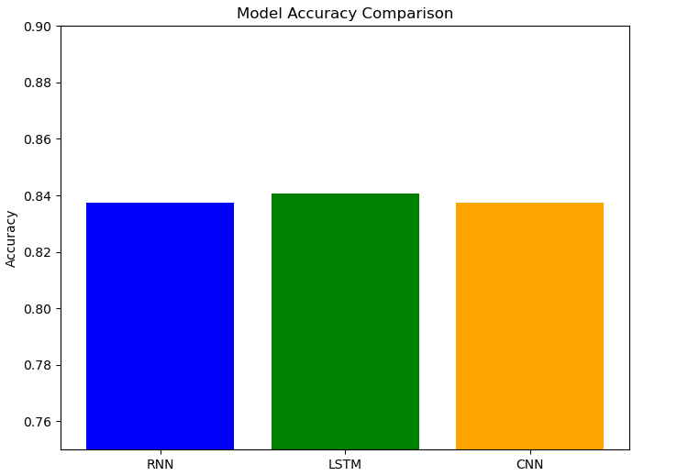
Figure 4: Accuracy Comparision

B. Strengths of the Project
There are several key strengths for this project, particularly in its comprehensive evaluation of three prominent deep learning models: RNN, LSTM, and CNN. By comparing these architectures across multiple performance metrics, including accuracy, precision, recall, and F1-score, the analysis provided a well-rounded assessment of their capabilities. The LSTM model emerged as the most effective, delivering the highest accuracy and a balanced trade-off across all metrics, showcasing its ability to capture temporal dependencies in text data. The preprocessing pipeline, which included tokenization and padding, ensured consistency and reliability in the input data. Additionally, the experiments were systematically designed, incorporating a range of hyperparameters to analyze model scalability and performance. The use of visualizations such as confusion matrices and classification reports added interpretability, while leveraging a widely accepted IMDb dataset ensured the results were reproducible and applicable to real-world sentiment analysis tasks.

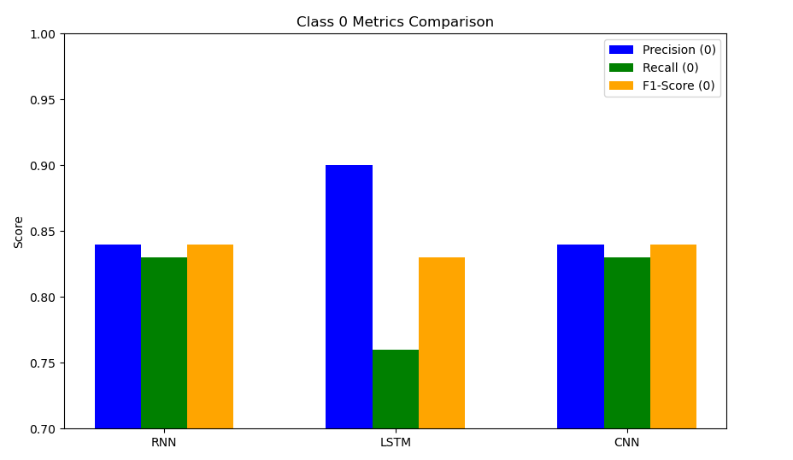
Figure 5: precision, Recall and F1-score
for Negative class

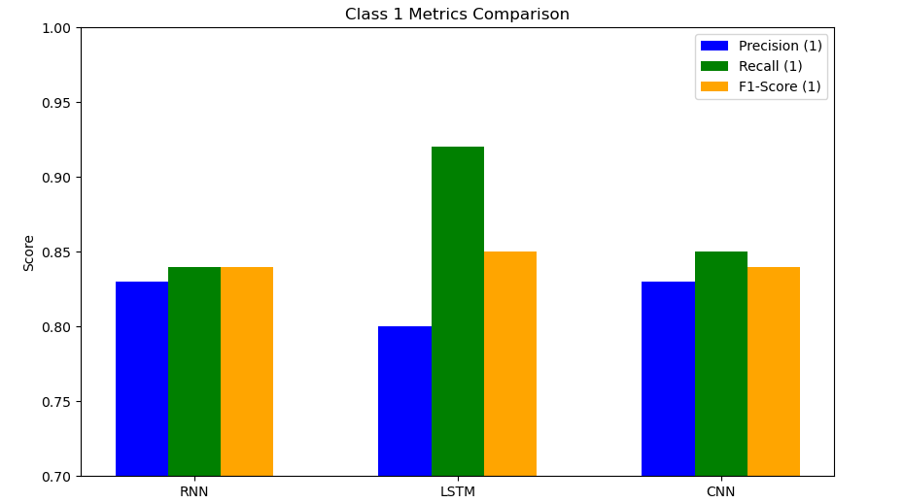
Figure 6: Precision, Recall and F1-score
for Positive class

C. Areas of Improvement
There are several areas where improvements could be made in the project to further enhance its performance. First, while hyperparameter tuning was performed, a more exhaustive search using techniques like grid search or random search could lead to better results by fine-tuning additional model parameters. Incorporating model interpretability techniques such as SHAP or LIME could provide better insights into the models' decision-making processes, aiding in error diagnosis. Additionally, exploring more advanced architectures like Transformers or BERT could significantly enhance performance by capturing long-term dependencies and understanding contextual relationships in the text. Another area for improvement is handling out-of-vocabulary words, which could be addressed using subword tokenization or advanced embedding techniques like FastText or GloVe. Implementing cross-validation instead of a simple train-validation split could provide a more robust evaluation of model performance. Lastly, conducting a deeper error analysis, especially focusing on misclassified samples, could help refine the models and identify specific areas where they may be struggling. Addressing these aspects could lead to more efficient, accurate, and generalized models in future iterations.

D. Future Work
Future work could involve implementing transformer-based models like BERT or GPT, which are well-suited for contextual understanding in sentiment analysis. Advanced hyperparameter tuning frameworks could be employed to systematically optimize the models' performance. Data augmentation techniques could be explored to improve robustness against noisy or sparse data. Incorporating explainability tools would provide valuable insights into model behavior and help address potential biases. To assess generalizability, the best-performing model could be tested on sentiment datasets from diverse domains. Finally, packaging the optimized model into a deployable API or application would translate these findings into practical real-world utility.

V. Conclusion

In conclusion, this project effectively applied deep learning models—RNN, LSTM, and CNN—to sentiment analysis, with the LSTM model standing out as the most balanced and effective. While the project met its objectives, there are opportunities for improvement, including further hyperparameter tuning, exploring advanced architectures like Transformers, and enhancing preprocessing techniques for better handling of out-of-vocabulary words. Additionally, incorporating model interpretability techniques could provide deeper insights into the decision-making process. Overall, the project lays a solid foundation for future work in sentiment analysis, with clear avenues for optimization and further exploration.

VI. References
[1] Shilpa. P. C, Rissa Shereen, Susmi Jacob, Vinod P, "Sentiment Analysis Using Deep Learning," Third International Conference on Intelligent Communication Technologies and Virtual Mobile Networks (ICICV 2021).

[2] Nehal Mohamed Ali, Marwa Mostafa Abd El Hamid, Aliaa Youssif, "Sentiment Analysis For Movies Reviews Dataset Using Deep Learning Models," International Journal of Data Mining & Knowledge Management Process (IJDKP).

[3] Saeed Mian Qaisar. "Sentiment Analysis of IMBd Movie Reviews Using Long Short-Term Memory", 2020 2nd International Conference on Computer and Information Sciences

