MARK HOSPITALS
HOSPITAL MANAGEMENT SYSTEM
PROJECT REPORT
A role-oriented dashboard for hospital operations
SUBMISSION DETAILS | INFORMATION
Course | 24CS810 - Modern Front-End Frameworks and SPA Development
Student Name | A. Tejaswini
Registration Number | 241FA04730
Section | 09
Faculty | ________________________________

MARK Hospitals HMS
Prepared with reference to the supplied project-report format

1. Project Overview
The MARK Hospitals Hospital Management System (HMS) is a browser-based demonstration dashboard for common hospital workflows. It presents a single interface with role-oriented screens for administration, clinical care, reception, pharmacy, finance, and patients. The current workspace combines a React/Vite application shell with a standalone HTML dashboard containing the interface, sample records, and client-side interactions.

Aim
To develop a user-friendly hospital management dashboard that demonstrates how patient information, appointments, staff views, pharmacy operations, billing, and reports can be organized in one web application.

Objectives
? Provide a dashboard view of hospital activity and operational summaries.
? Demonstrate patient registration, admission, and patient-list workflows.
? Support appointment booking and appointment status displays.
? Present role-specific navigation and screens for six hospital roles.
? Show pharmacy inventory, prescriptions, billing, finance, lab, and reporting views.
? Provide a maintainable starting point for future API, database, and authentication integration.

Project Scope
This version is a front-end demonstration using in-memory sample data. It is suitable for academic demonstration and interface prototyping, not for clinical use or storage of real patient information.

2. Software and Hardware Requirements
Category | Requirement
Operating system | Windows 10/11 (or another OS supported by Node.js)
Runtime | Node.js 18 or newer; npm
Frontend | React 19, React DOM 19, JavaScript, HTML5, CSS3
Build / development server | Vite 6 with the Vite React plugin
Code editor | Visual Studio Code or another JavaScript editor
Browser | A current version of Chrome, Edge, Firefox, or equivalent
Storage / backend | No backend or database is included; dashboard records are in-memory demo data
Hardware | A standard desktop or laptop capable of running a modern browser and Node.js

Run the Project
? Install dependencies with npm install.
? Start the development server with npm run dev.
? Open the local address printed by Vite in a browser.
? Create a production build with npm run build.
The Continue button enters the demonstration dashboard as Administrator; it does not authenticate a real hospital account.

3. Project Structure
hms/
|-- index.html
|-- package.json
|-- README.md
|-- public/
| `-- hospital-dashboard.html
|-- src/
| |-- App.jsx
| |-- main.jsx
| `-- styles.css
|-- node_modules/ (installed dependencies)
`-- dist/ (generated by npm run build)
The source files are intentionally compact in the current version. The hospital UI and its demo data are in public/hospital-dashboard.html; the React application mounts that page in an iframe. node_modules and dist are generated folders and should not be edited as source files.

Technology and Architecture
? index.html provides the root element and loads the React entry point.
? src/main.jsx mounts the React application and imports the outer app styles.
? src/App.jsx embeds /hospital-dashboard.html and presents a fallback if the frame fails to load.
? src/styles.css controls the full-screen dashboard host and iframe layout.
? public/hospital-dashboard.html contains the visual interface, embedded CSS, role navigation, sample data, and browser-side event handlers.
? Vite serves the development app and bundles the React shell for production.

Data Flow
Browser -> Vite-served React entry point -> App component -> hospital-dashboard.html -> client-side demo data and DOM updates. Form actions update JavaScript arrays in the current page session. There is no REST API, server-side validation, database, or durable save operation in the present implementation.

4. Functional Modules
Role / Area | Representative screens and functions
Administrator | Dashboard; patient management; doctors and staff; appointments; billing and finance; pharmacy; reports.
Doctor | Doctor dashboard, patient list, appointments, prescriptions, and lab results.
Patient | Personal dashboard, appointment history, lab reports, and bills.
Receptionist | Reception dashboard, appointments, patient registration, and patient list.
Pharmacist | Pharmacy dashboard, inventory, prescriptions, and supplier orders.
Finance | Finance dashboard, invoices, revenue reports, and insurance claims.
Shared interface | Sidebar navigation, status labels, tables, dialogs, notifications, and live date/time display.

Main Demonstration Workflows
? Patient admission: enter the required name and diagnosis fields, then add a patient record to the in-memory data collection.
? Appointment booking: provide a patient name and date, choose appointment details, and append a scheduled appointment.
? Role navigation: open the dashboard sections available to the selected demonstration role.
? Pharmacy and finance review: inspect sample stock, prescription, invoice, revenue, and claim data.

5. Implementation Excerpts
React host component (src/App.jsx):
return (
<main className="dashboard-host">
<iframe
className="dashboard-frame"
src="/hospital-dashboard.html"
title="MARK Hospitals management dashboard"
onError={() => setLoadError(true)}
/>
</main>
);
Patient admission validation and demo-record creation (public/hospital-dashboard.html):
function admitPatient() {
const fname = document.getElementById('ap-fname').value.trim();
const lname = document.getElementById('ap-lname').value.trim();
const diag = document.getElementById('ap-diag').value.trim();
if (!fname || !lname || !diag) {
toast('Please fill in required fields');
return;
}
DB._patientCounter++;
DB.patients.push({ id, fname, lname, diag, admitted: today() });
refreshCurrentPage();
}
The excerpt is abbreviated for the report. The live function also reads the other admission fields, assigns an ID and display values, closes and clears the dialog, and shows a confirmation message.

6. Verification and Limitations
Verification performed for this report: the Vite production build was run from the project root. Manual feature checks should also confirm that the dashboard loads, navigation switches views, required-field validation appears, patient admission and appointment forms update their tables, and the layout remains usable at narrow viewport widths.

Known Limitations
? The application is a demo, not a production hospital information system.
? The dashboard currently opens in Administrator demo mode; there is no real login, identity verification, or role authorization.
? Records are in browser memory and are lost when the page is reloaded; no API or database is configured.
? Sample data and interface actions do not represent validated medical records, clinical decision support, or production billing.
? No production-grade audit trail, access controls, backup, encryption, or privacy safeguards are implemented.
Privacy and safety: do not enter real patient information or use this demonstration to make clinical or financial decisions.

Future Enhancements
? Separate UI modules into reusable React components and add automated tests.
? Add a validated backend API with persistent database storage and role-based authorization.
? Use secure authentication, audit logging, backups, and appropriate privacy controls before handling sensitive records.
? Add real workflows for appointments, prescriptions, inventory updates, billing, and report exports with server-side validation.

Conclusion
MARK Hospitals HMS demonstrates a broad hospital operations interface and role-oriented workflows using React, Vite, and browser-side JavaScript. The project is a useful academic front-end prototype. Persistent data, secure identity management, and clinical-grade safeguards should be implemented and independently validated before any real-world use.
Prepared by A. Tejaswini | Registration No. 241FA04730 | Section 09

7. HMS Interface Screenshot Gallery
The following screenshots show the generated MARK Hospitals HMS interface. Screens are grouped by dashboard role. The displayed records are sample demonstration data.

Administrator
Dashboard
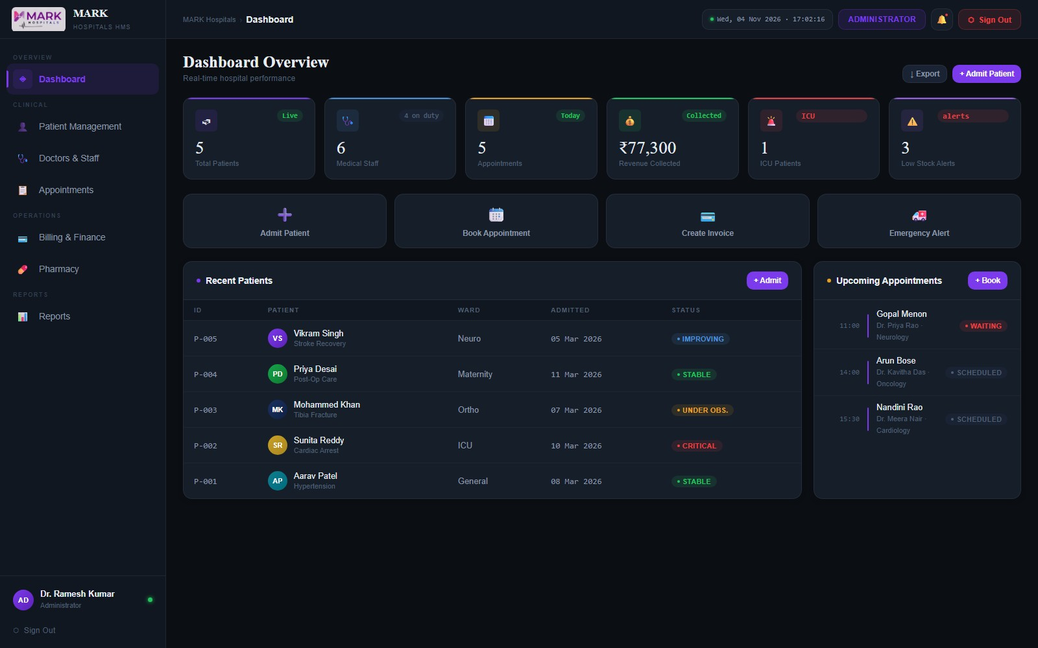

Patient Management
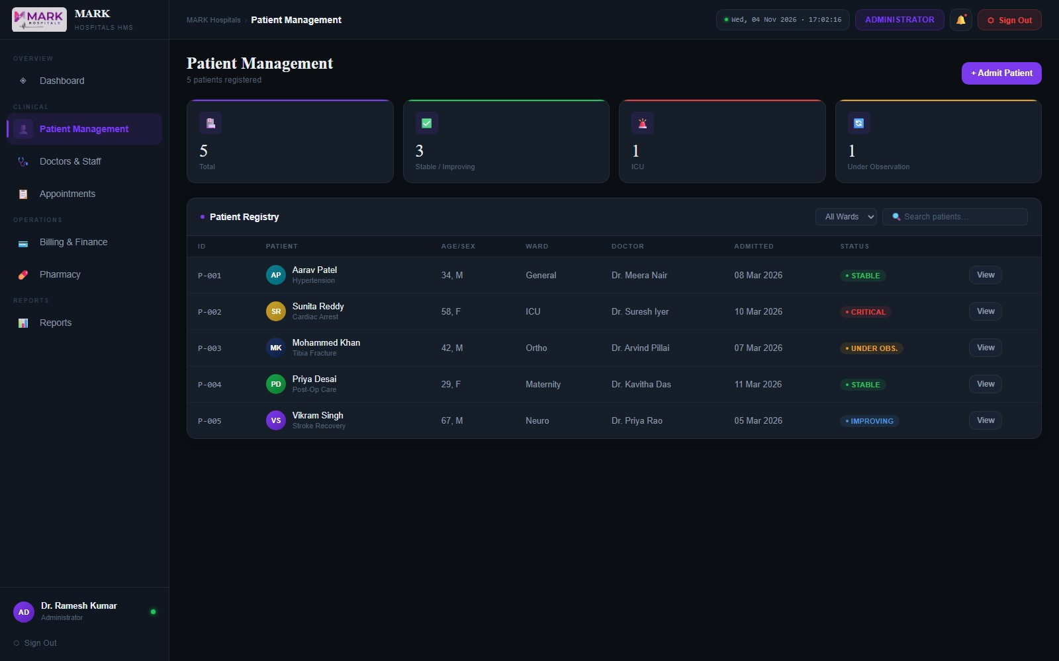

Doctors & Staff
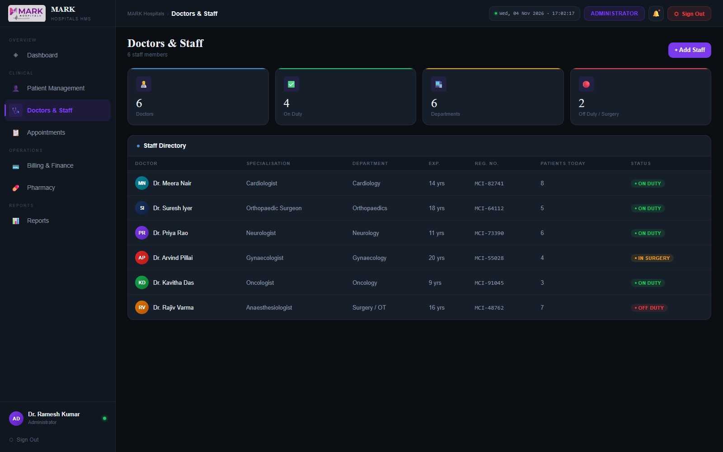

Appointments
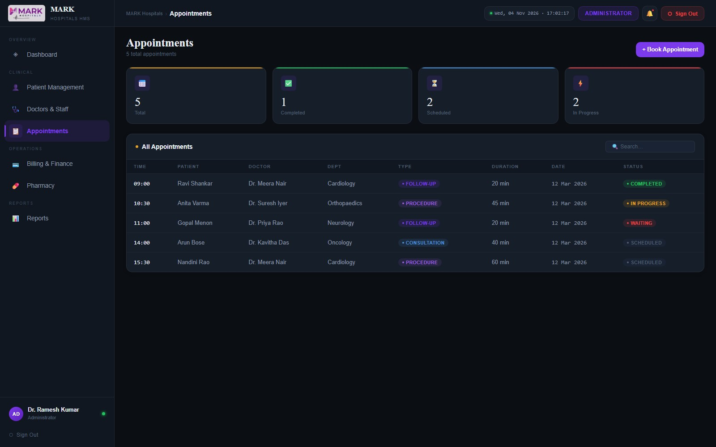

Billing & Finance
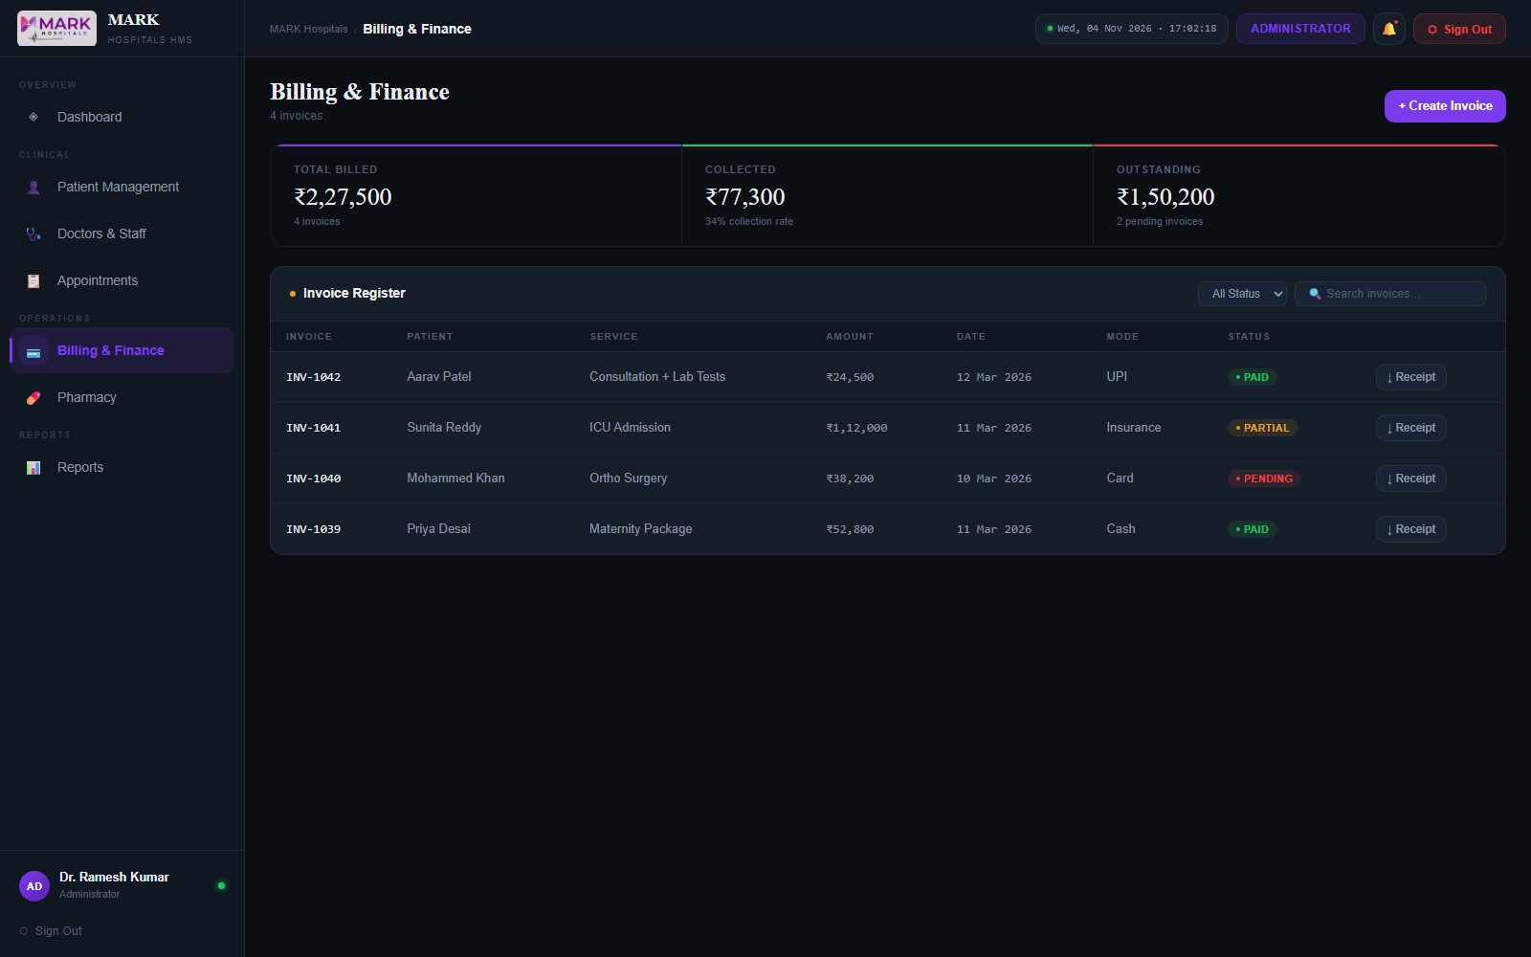

Pharmacy
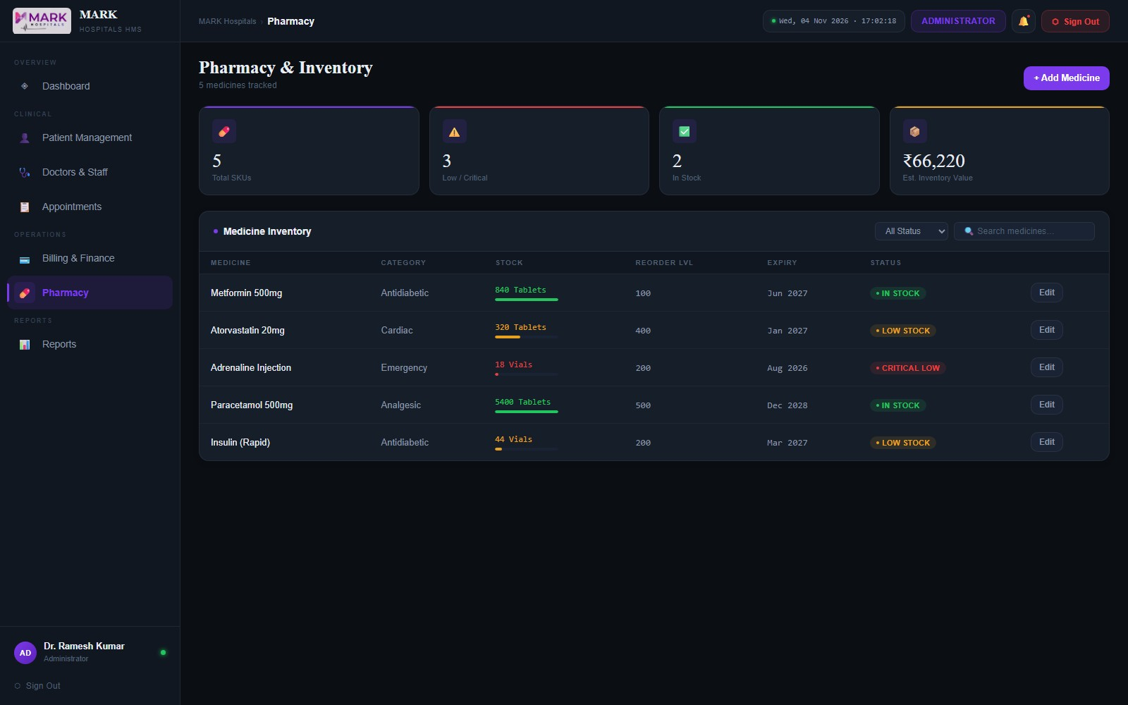

Reports
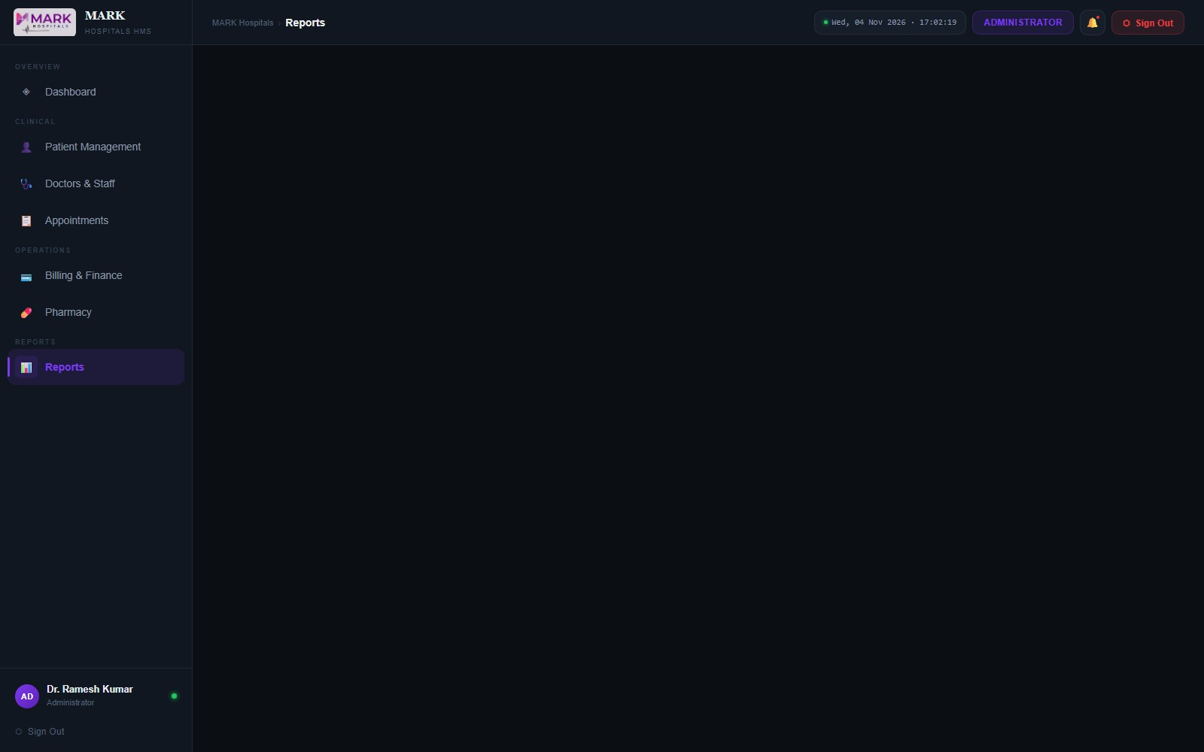

Doctor
My Dashboard
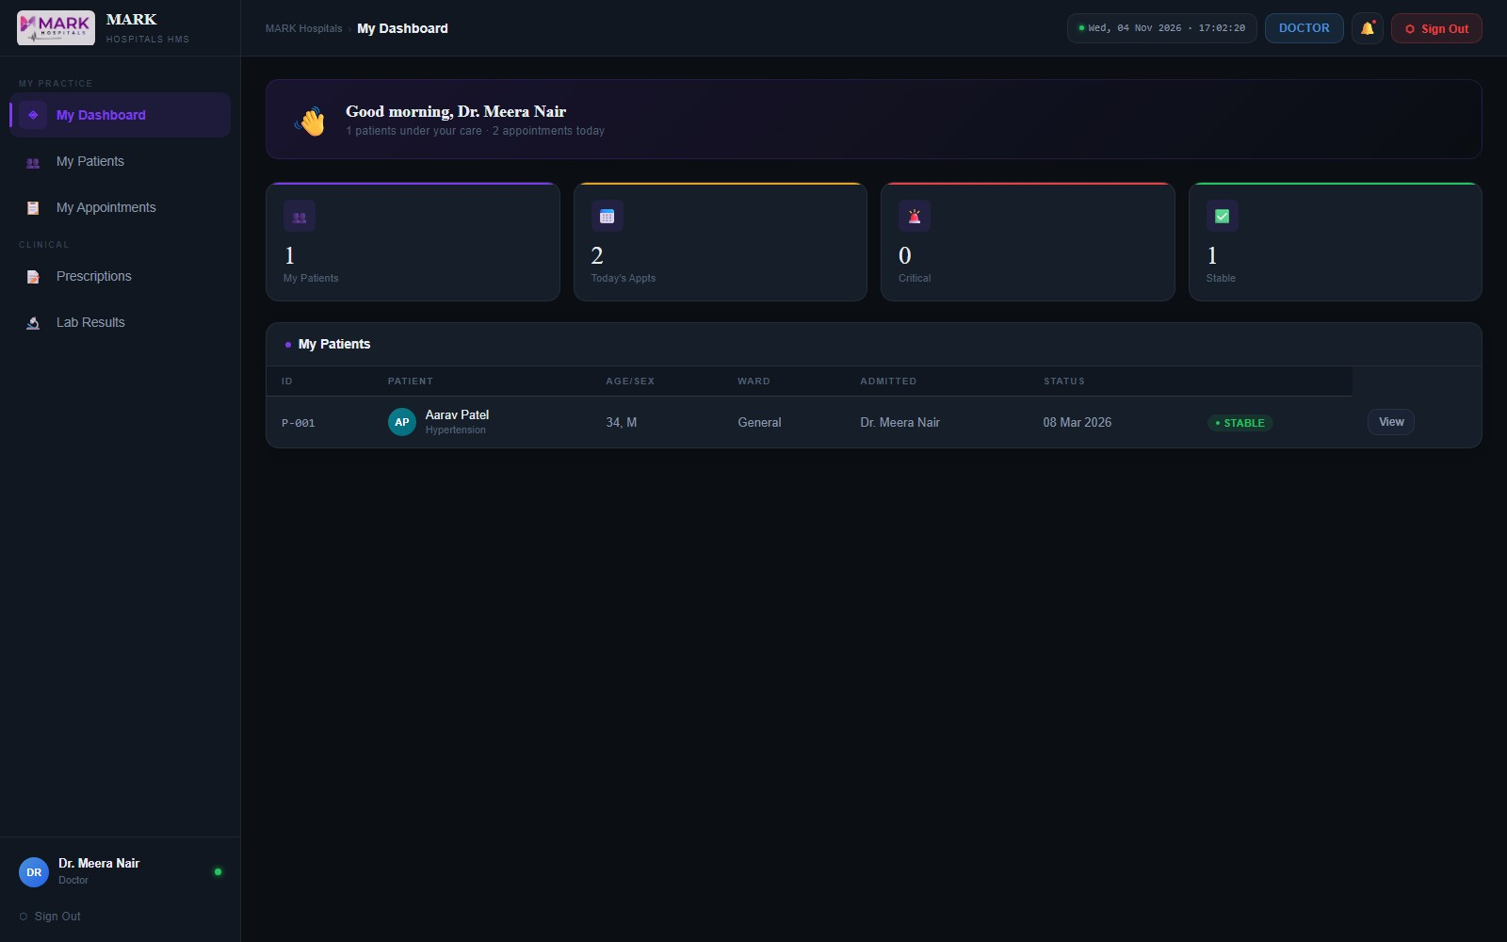

My Patients
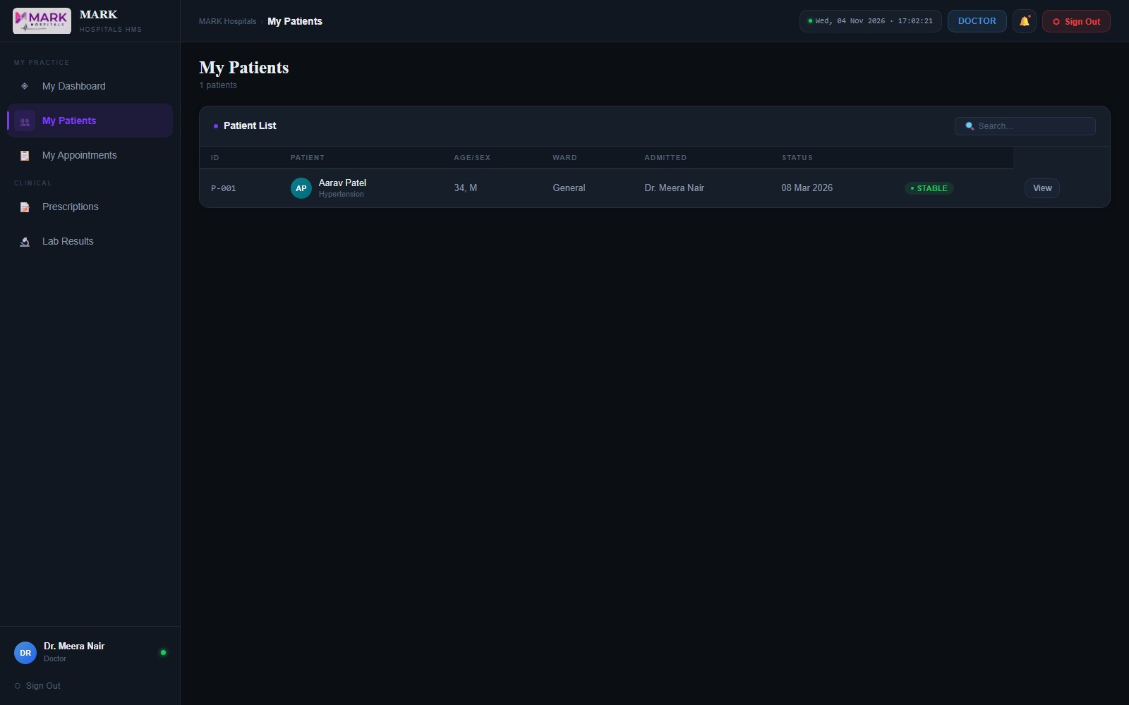

My Appointments
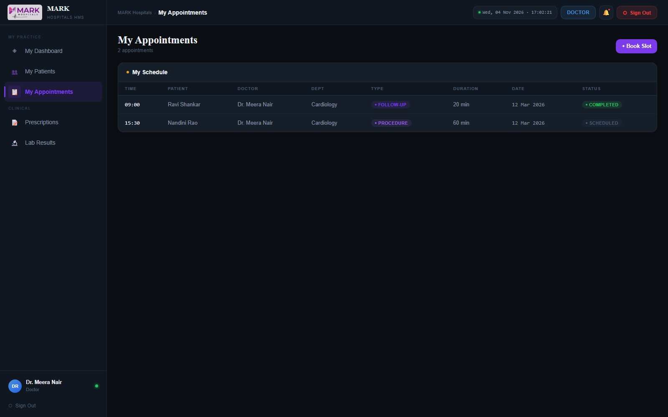

Prescriptions
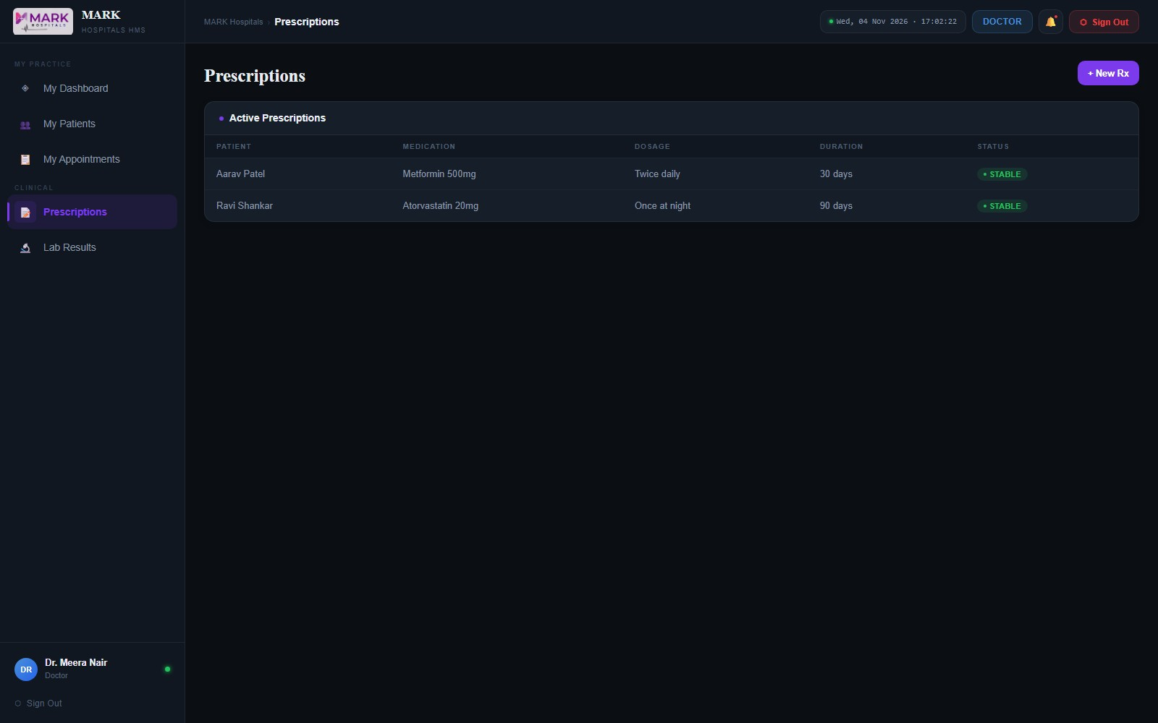

Lab Results
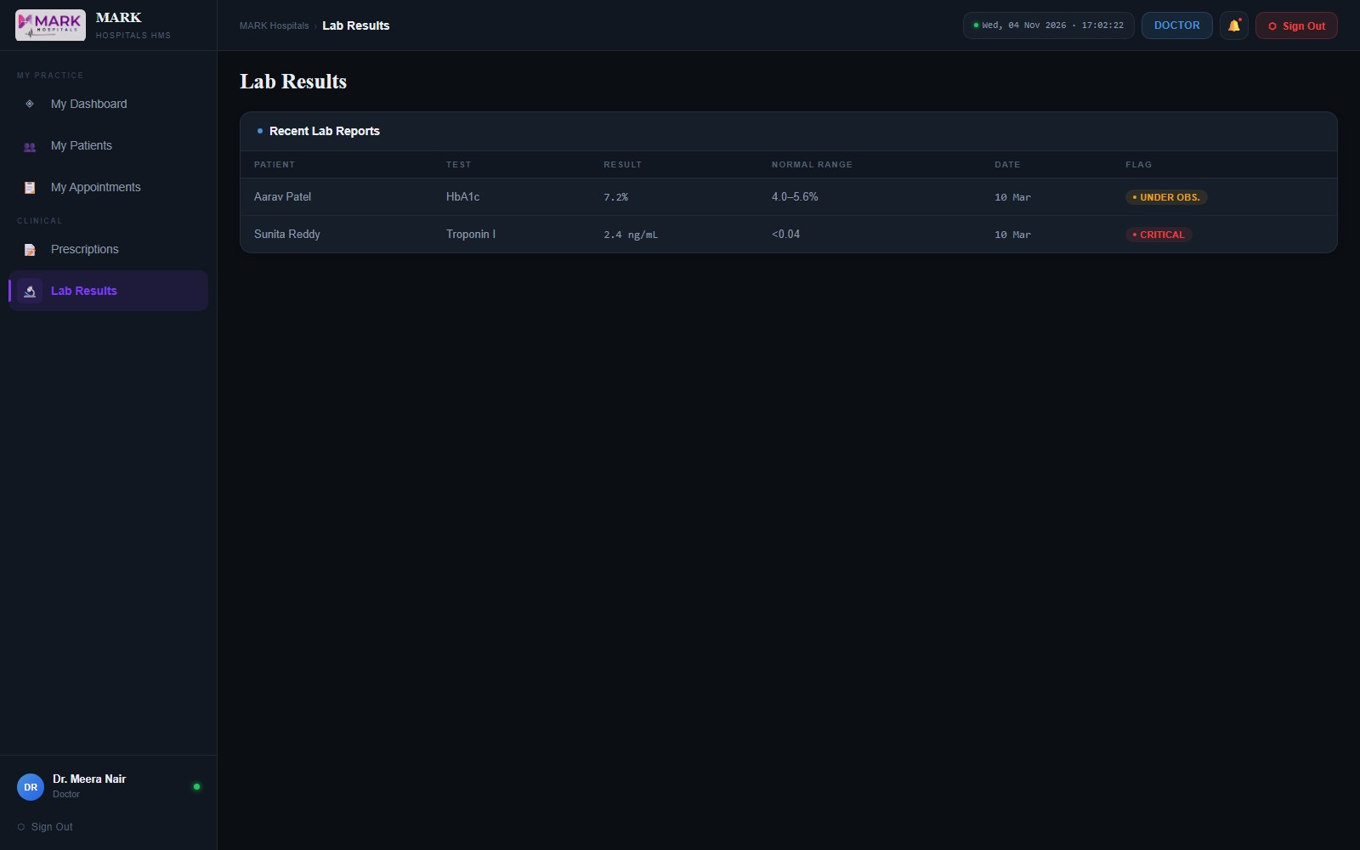

Patient
My Dashboard
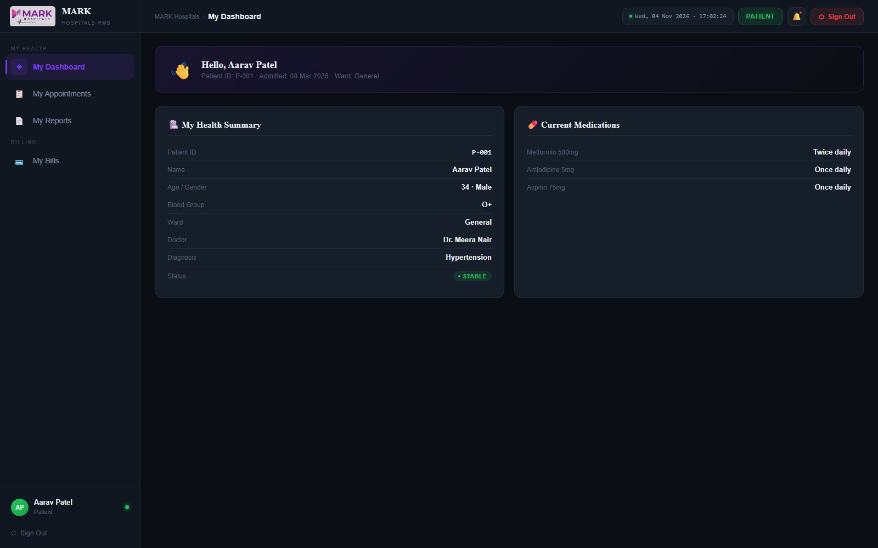

My Appointments
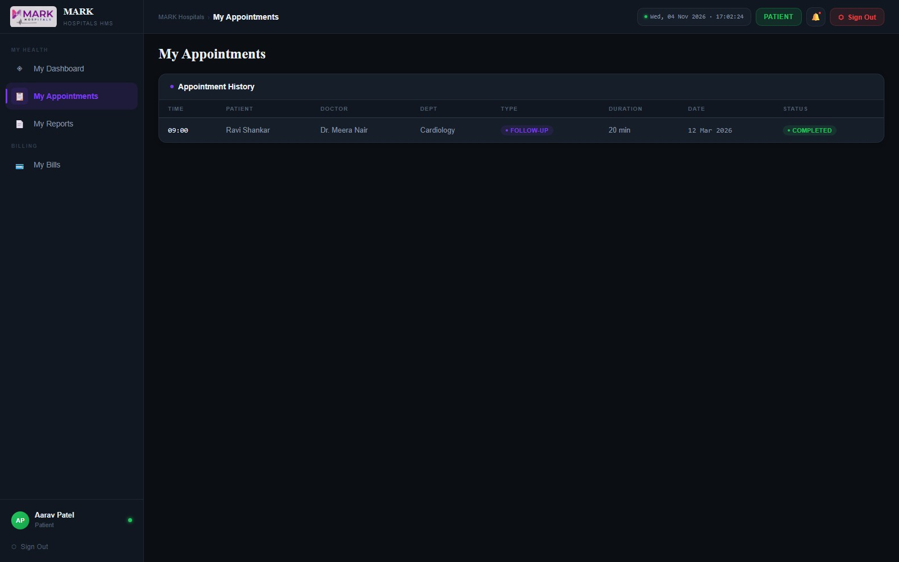

My Reports
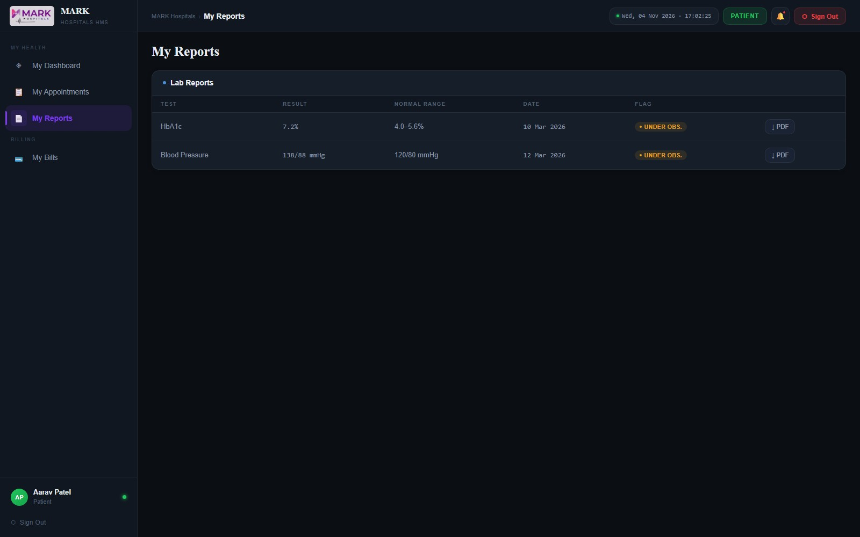

My Bills
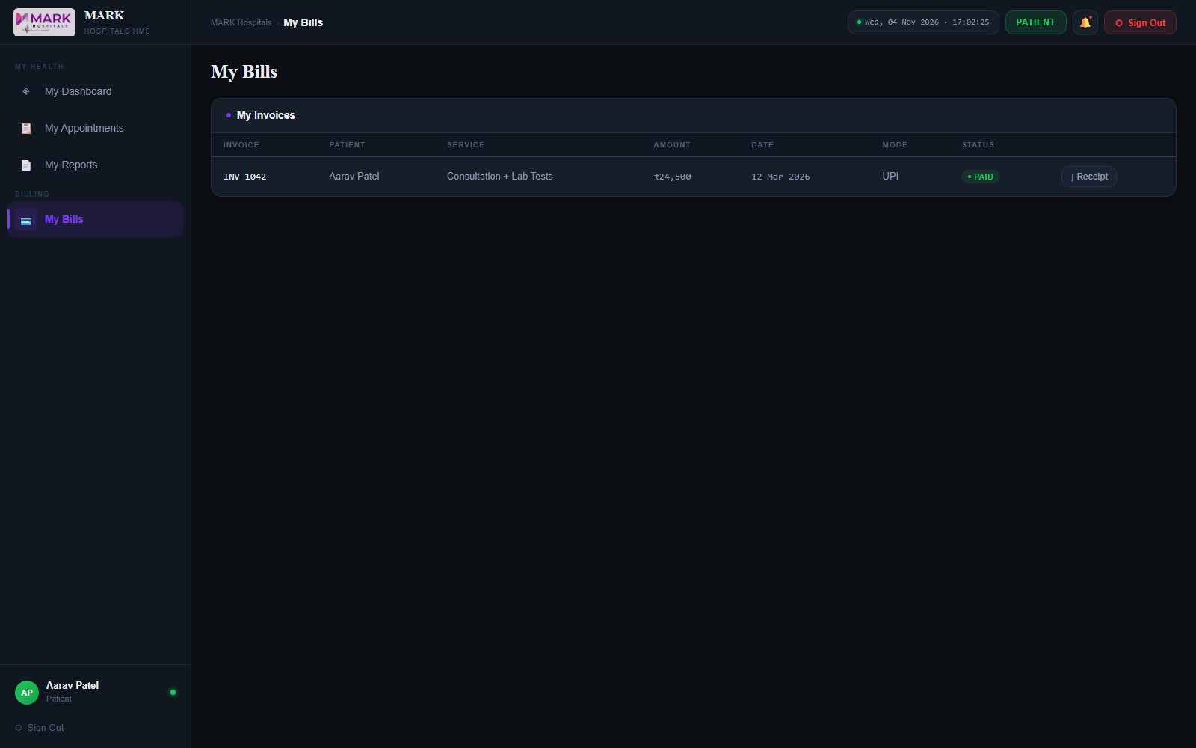

Receptionist
Dashboard
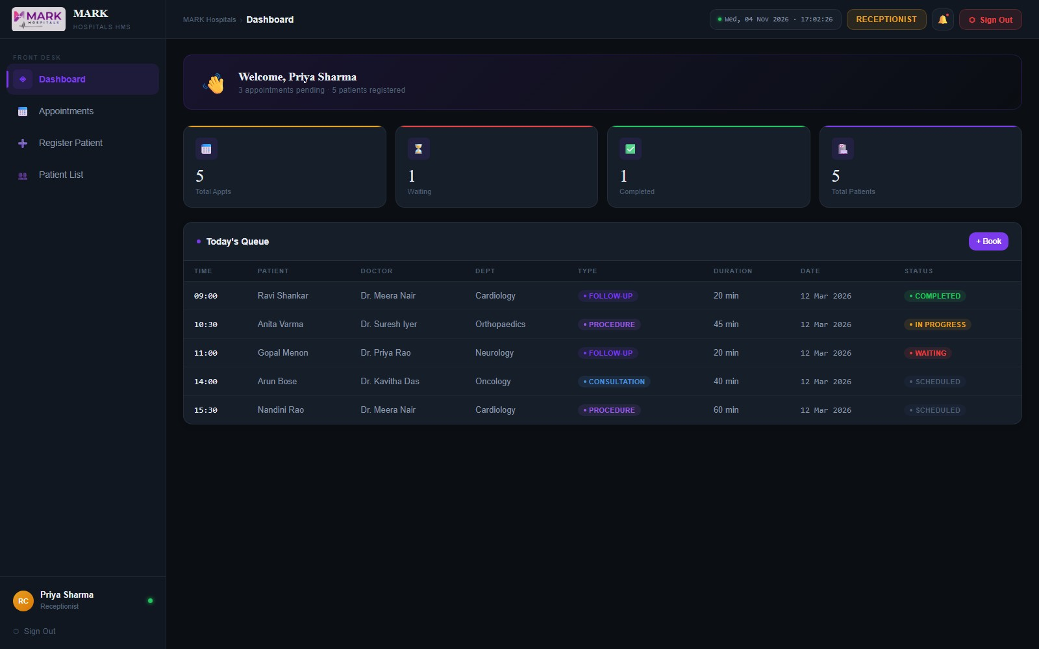

Appointments
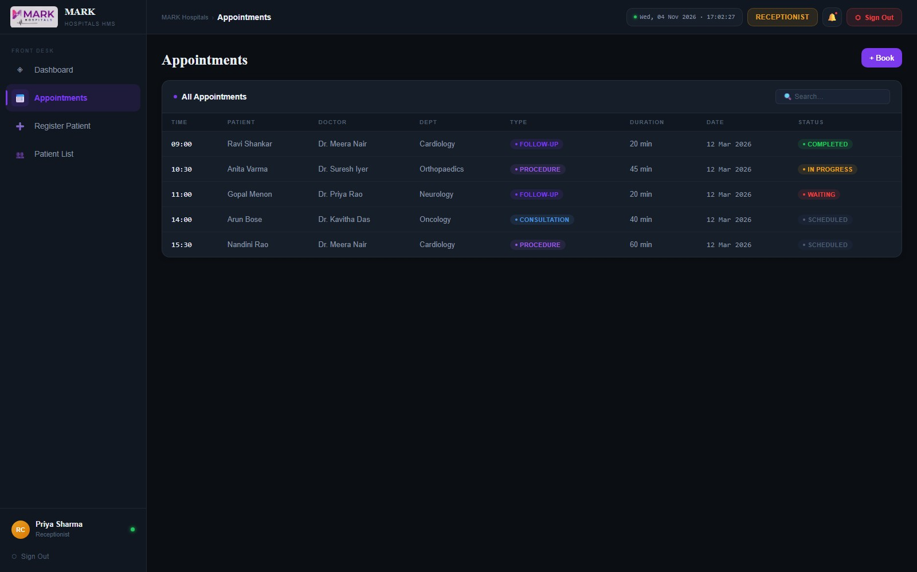

Register Patient
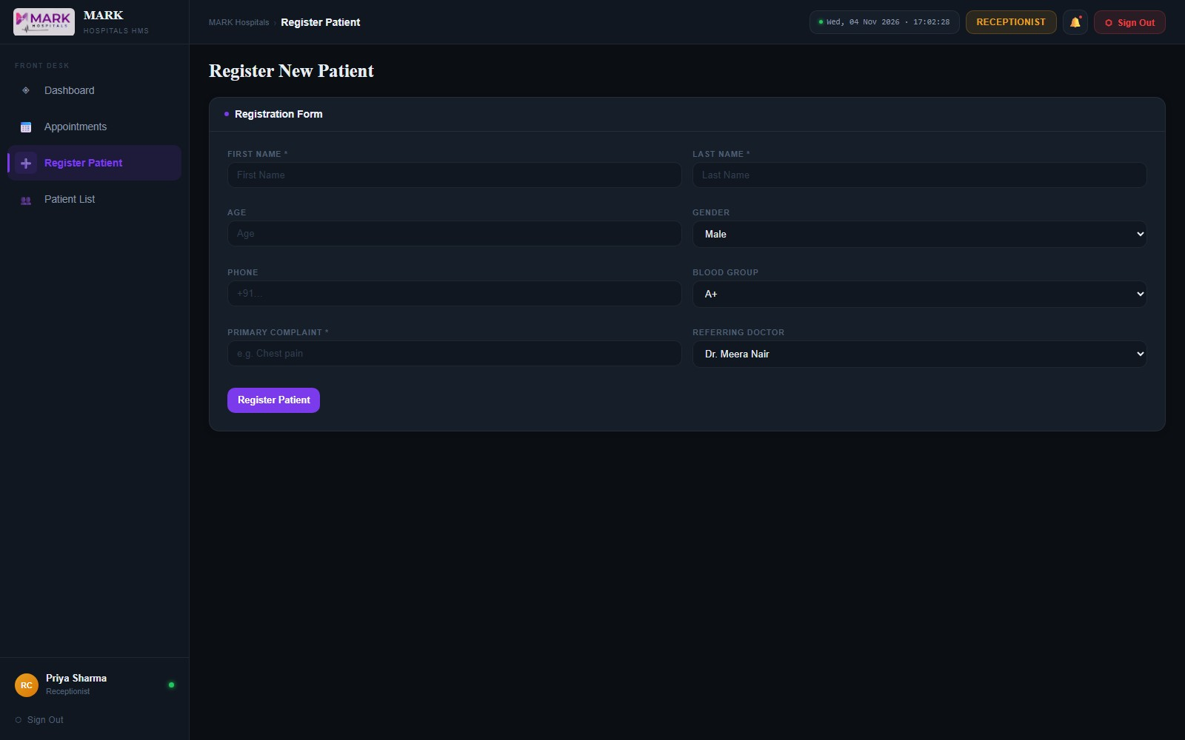

Patient List
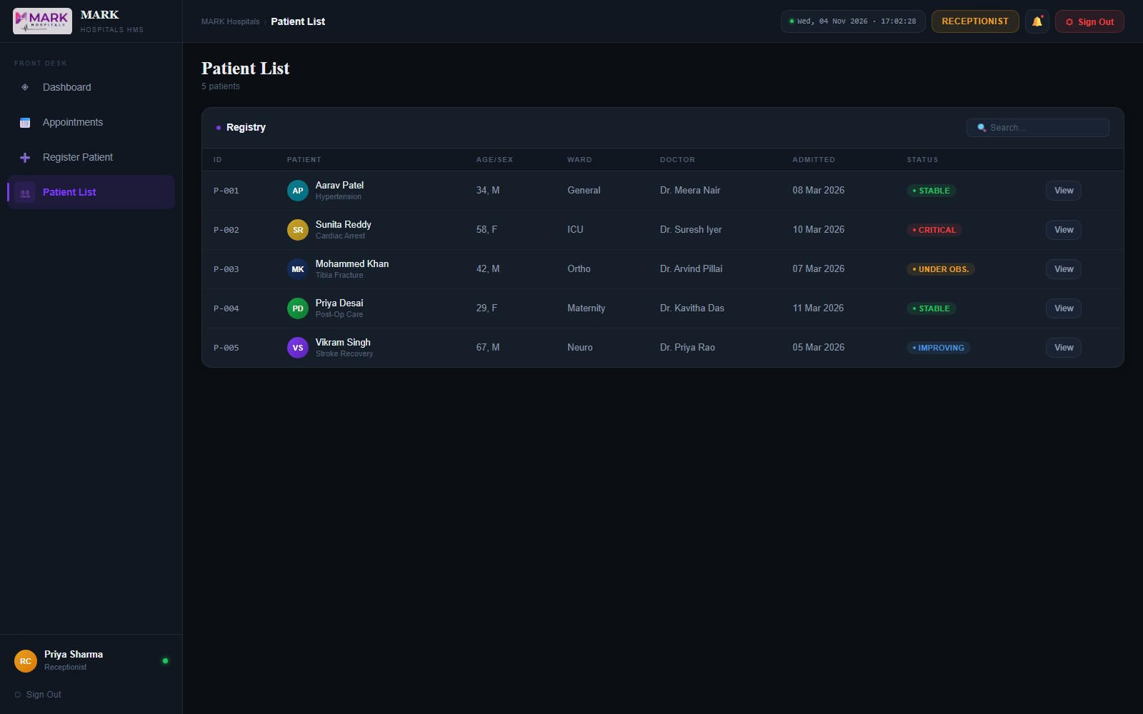

Pharmacist
Dashboard
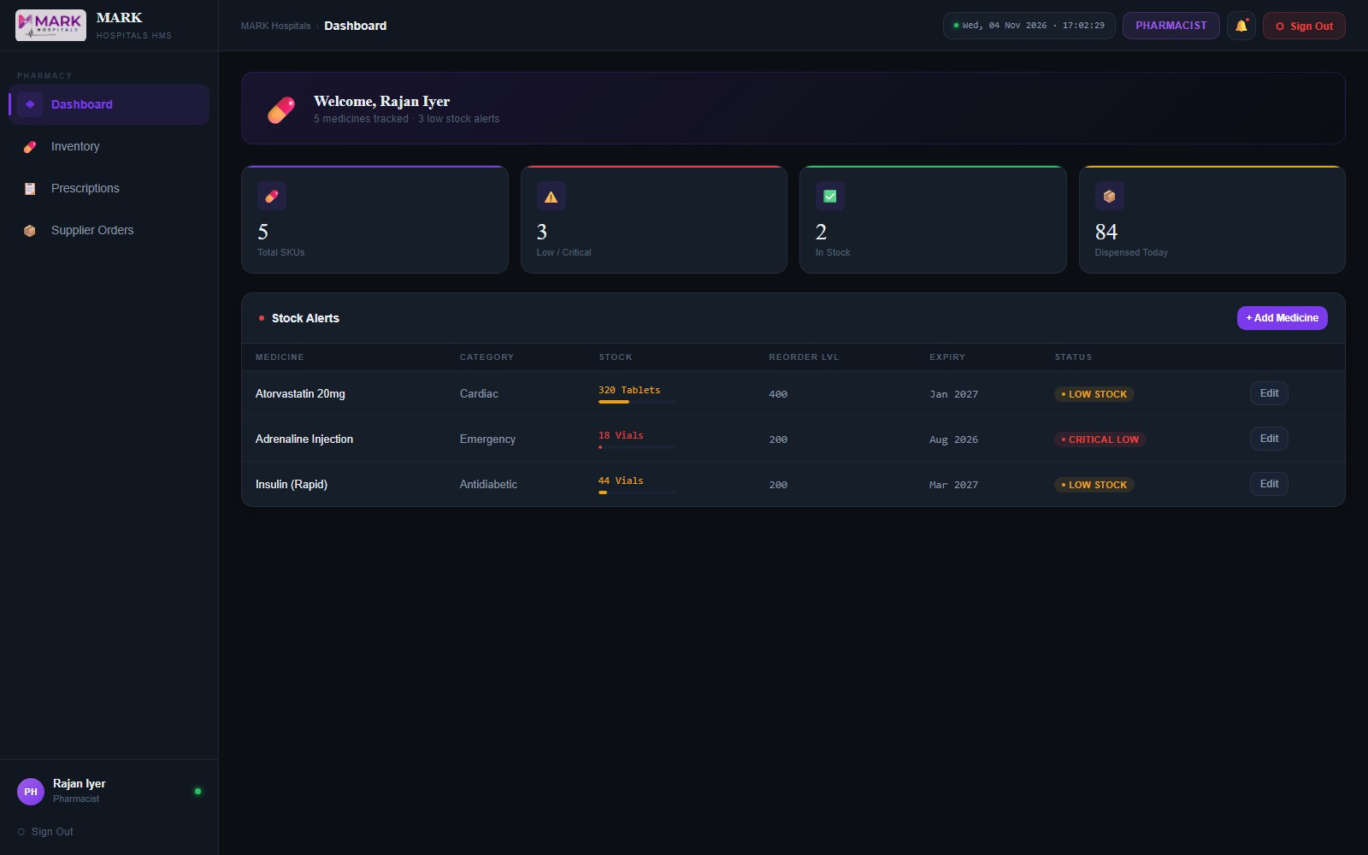

Inventory
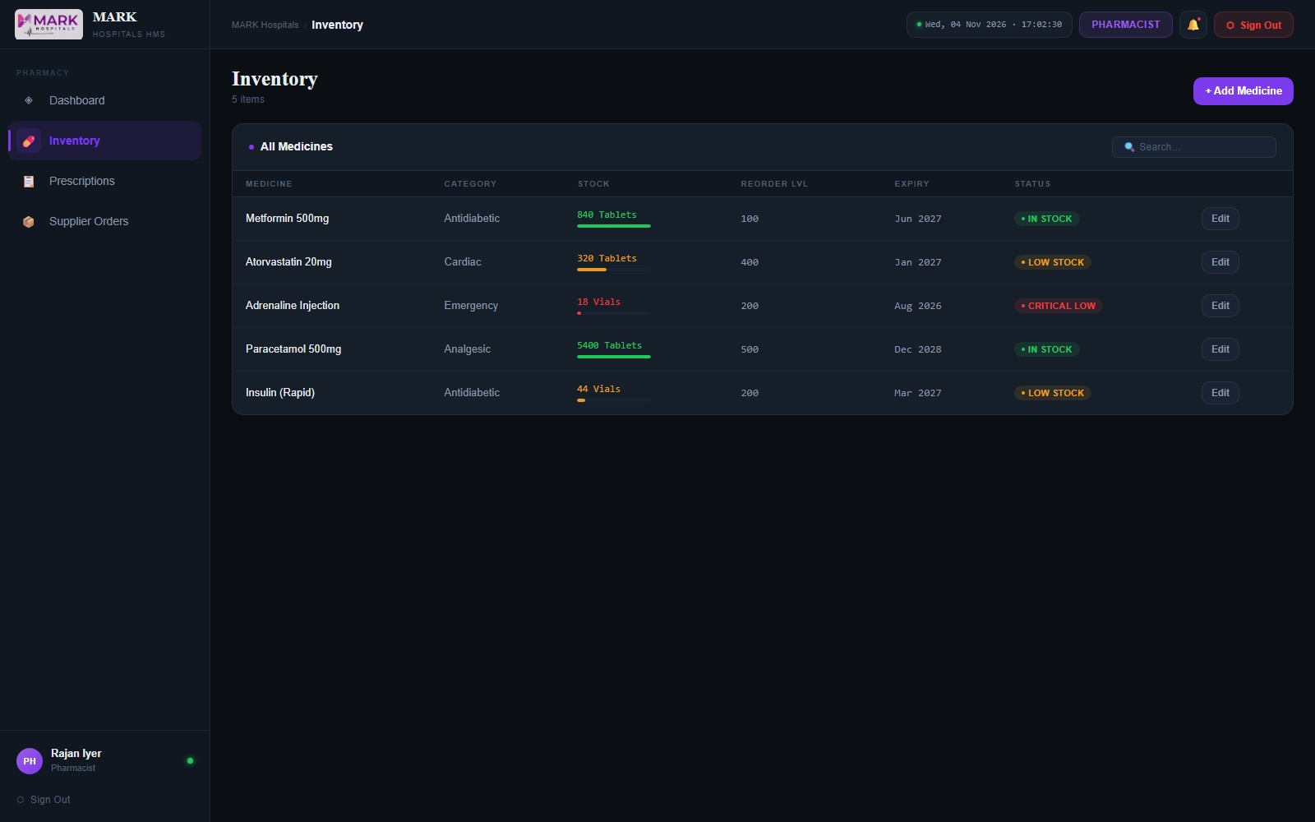

Prescriptions
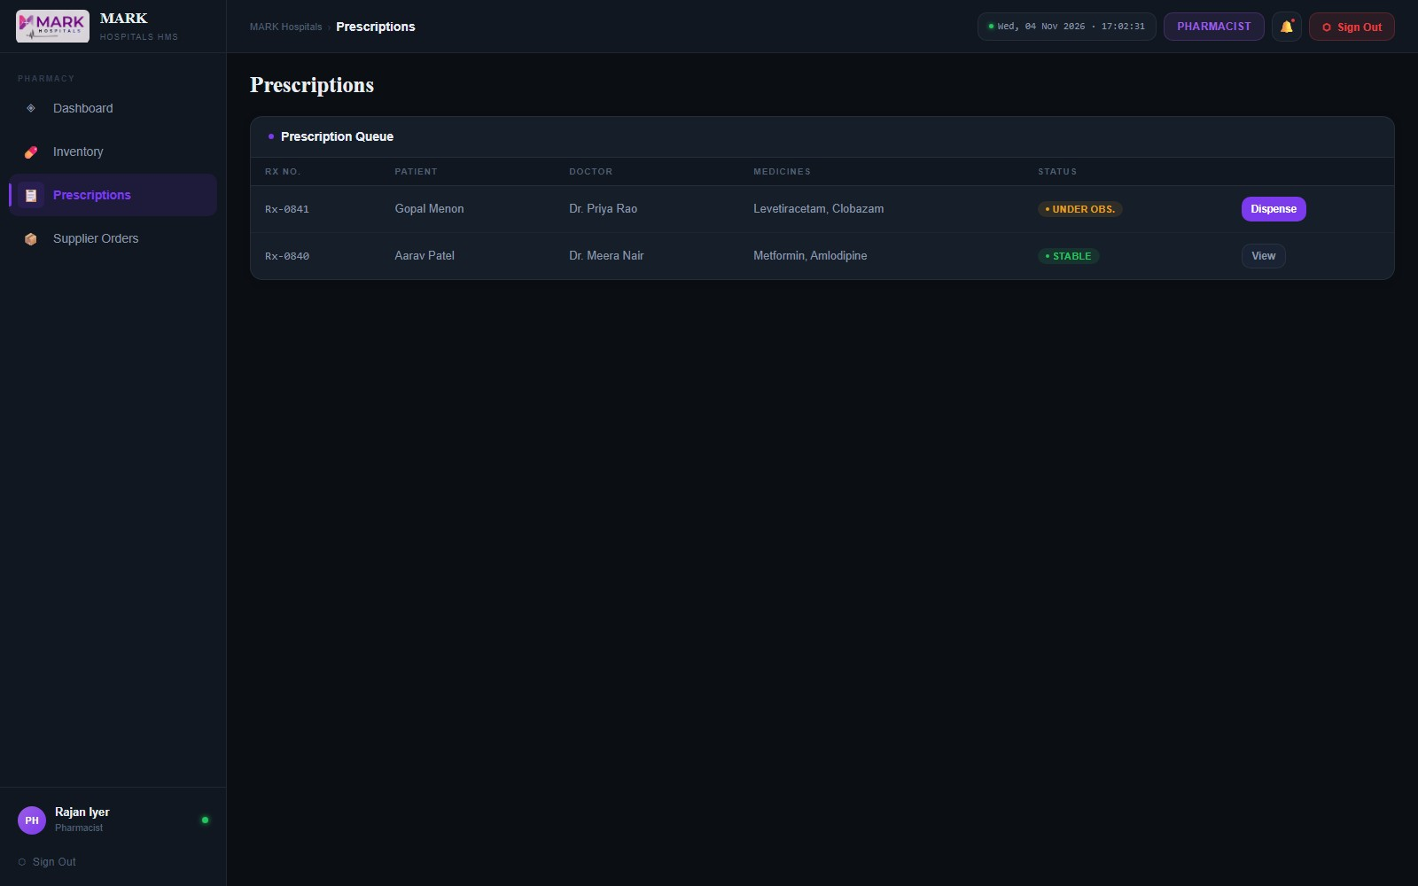

Supplier Orders
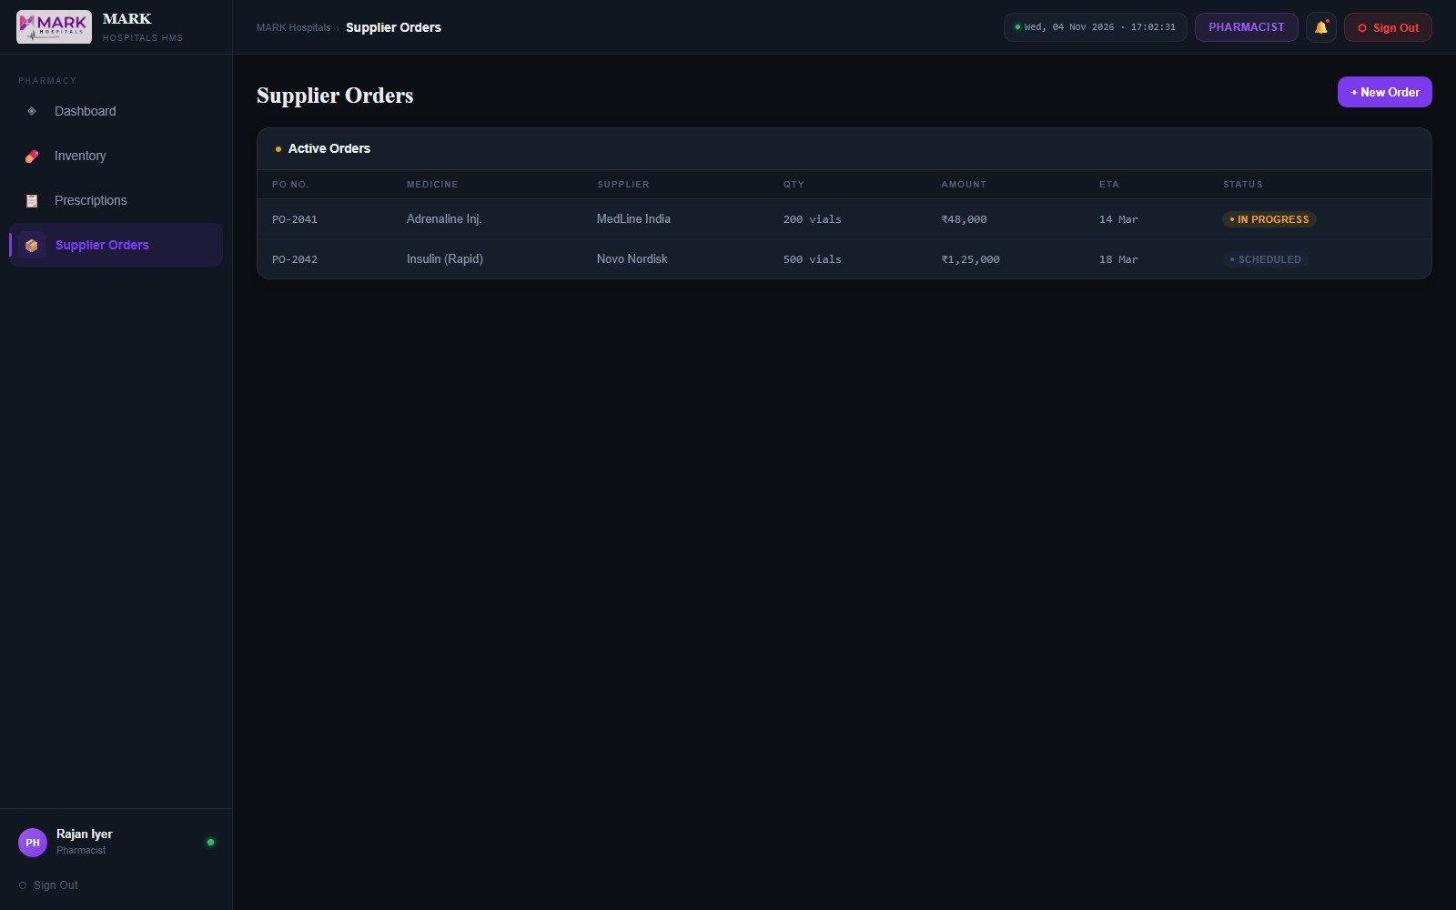

Finance
Dashboard
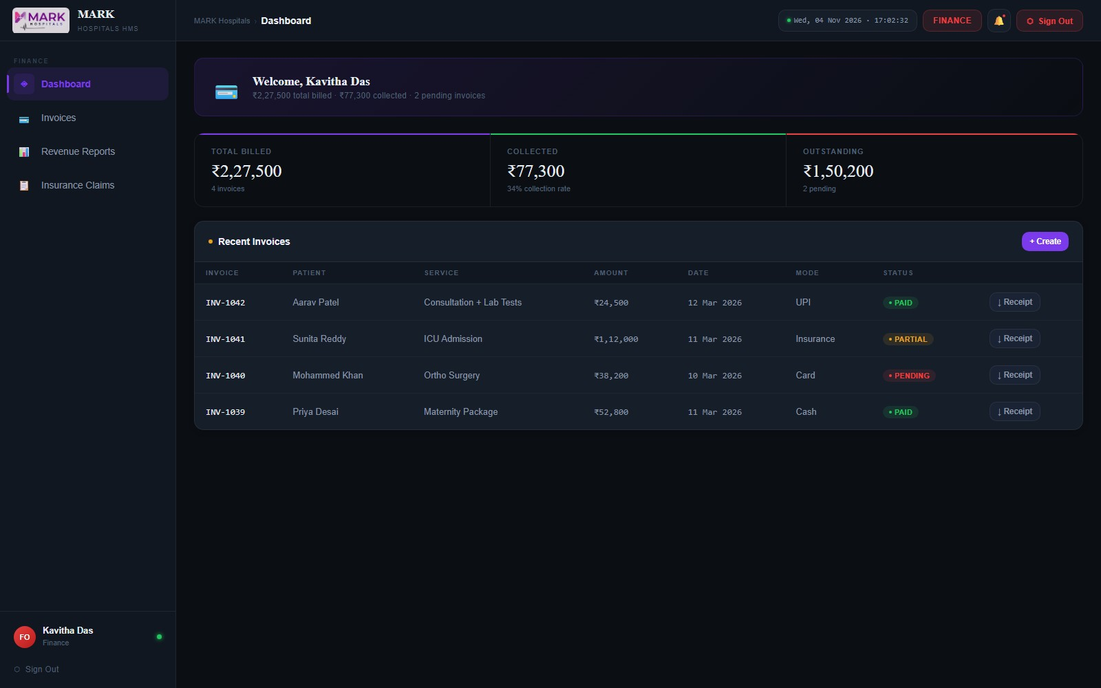

Invoices
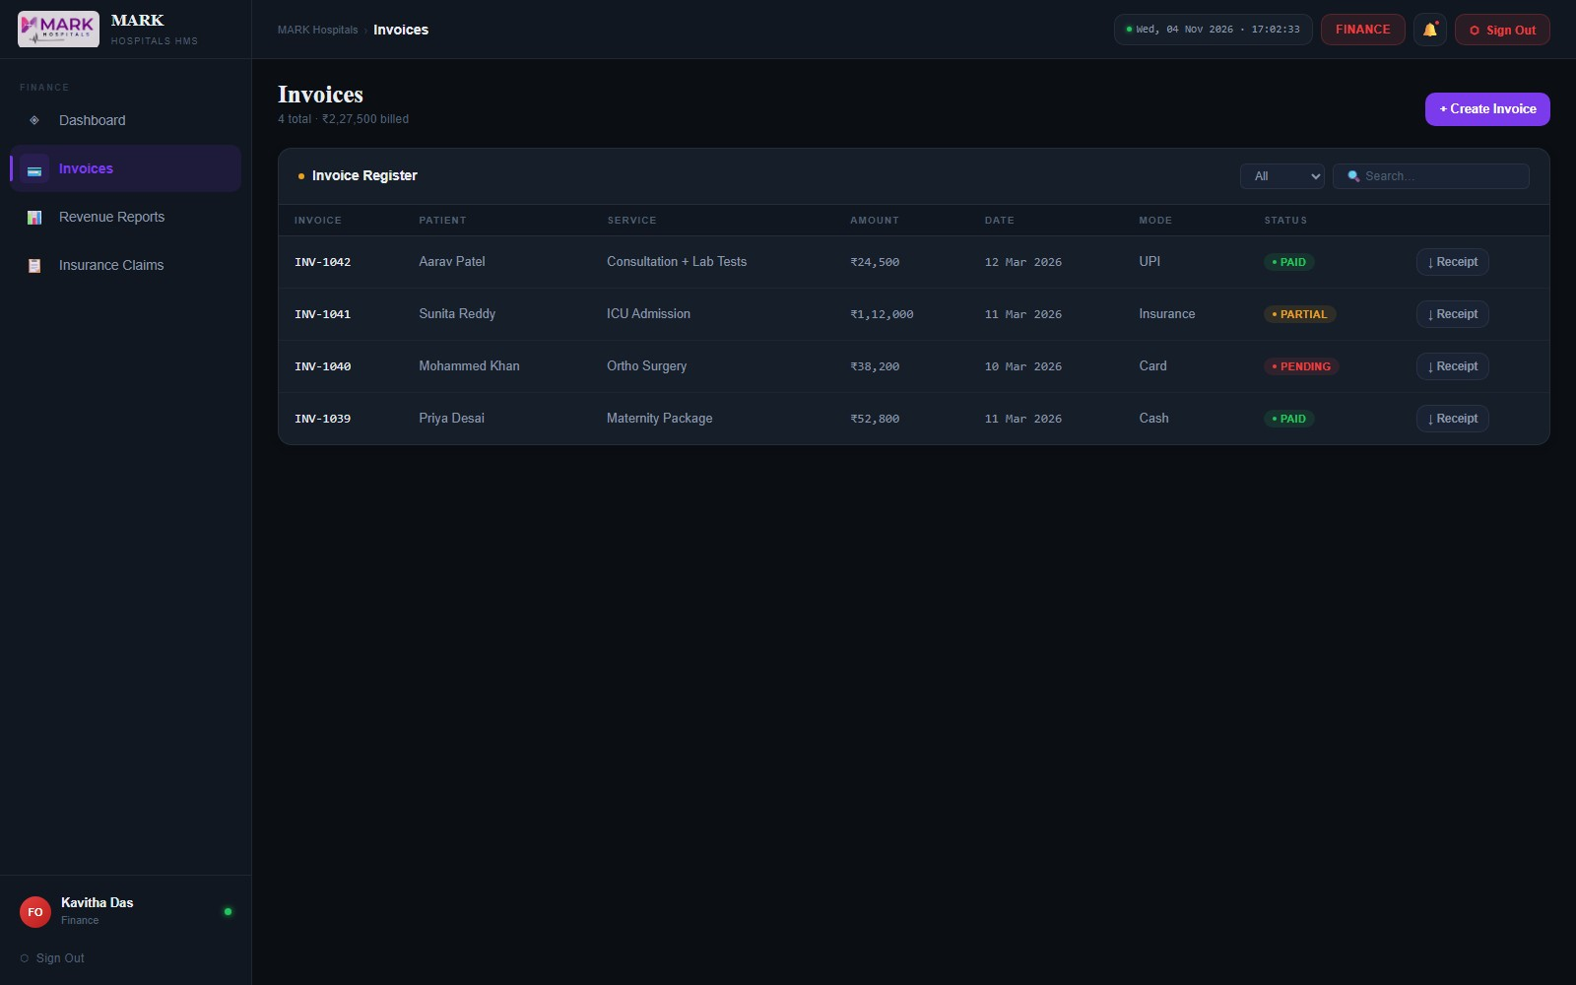

Revenue Reports
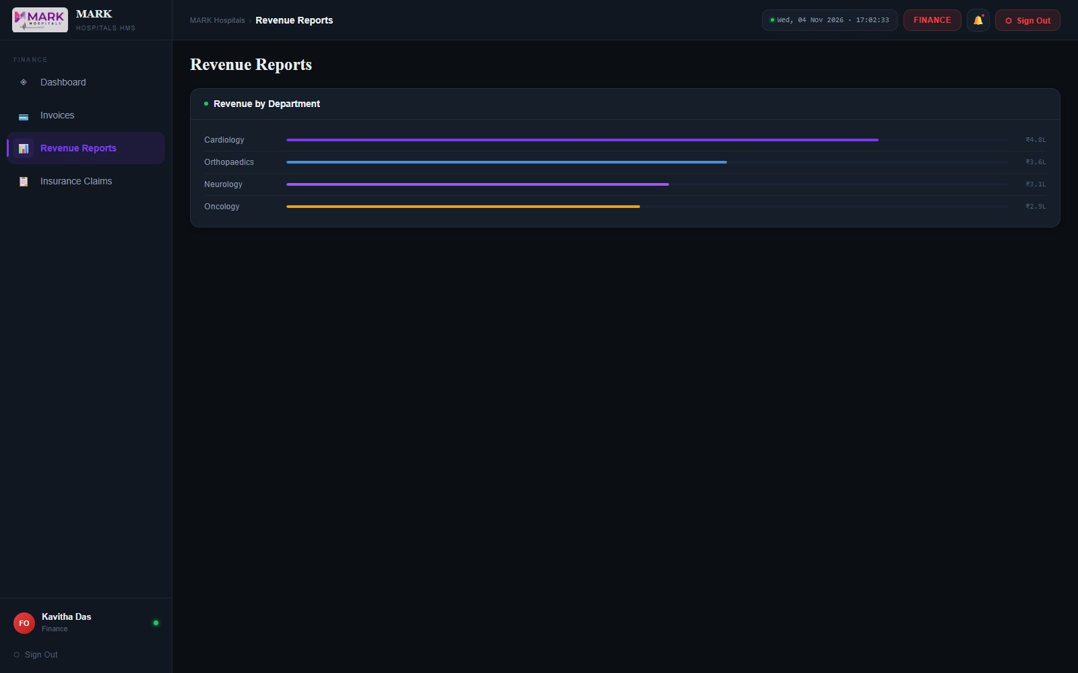

Insurance Claims


