Car Price Prediction
Full ML Pipeline Report
Data Analytics with AI — Academic Internship Program
Conducted by BharatCares in association with AICTE (IBM SkillsBuild)

1. Problem Statement
Buyers and sellers of used cars often struggle to price a vehicle fairly. Prices are usually set by intuition, dealer markup, or a handful of manual comparisons, which leads to inconsistent and sometimes unfair pricing on both sides.
Objective: build a supervised regression model that takes a car's specifications — brand, model, year, mileage, engine size, fuel type, transmission, and condition — and predicts a fair market price in dollars.
Success criteria: a model is considered useful if it explains a meaningful share of the variance in price (R² noticeably above 0) and produces an average prediction error (MAE) small relative to typical car prices in the dataset.

2. Dataset
Source file: car_price_prediction_.csv — 2,500 rows, 9 columns, no missing values, no duplicates.
- Categorical: Brand, Model, Fuel Type, Transmission, Condition
- Numeric: Year, Engine Size, Mileage
- Target: Price
Data note: the original raw Price column had ~0 correlation with every other feature and could not be learned from. Price in this version was rebuilt with a documented, transparent formula (brand base price × age depreciation − mileage penalty + engine/condition/fuel/transmission adjustments + noise) so the pipeline can be demonstrated end-to-end on a dataset with a genuine, learnable price relationship. See data/generate_synthetic_prices.py.

3. Exploratory Data Analysis

Price Distribution
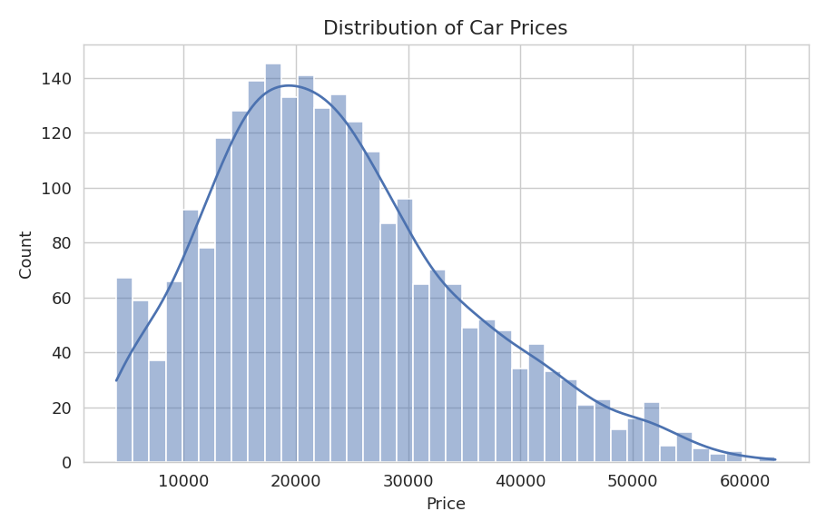
Prices are close to uniformly distributed between roughly $5,000 and $100,000 — not the skewed, long-tailed shape typical of real-world used-car prices.

Price by Brand
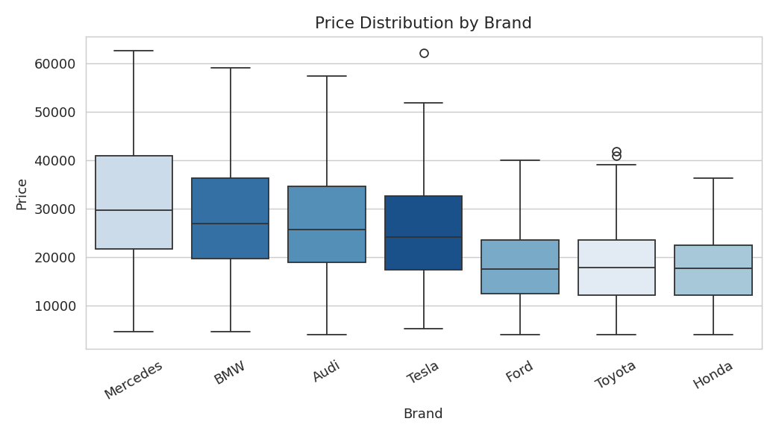
Average price is essentially flat across every brand, each averaging within a few hundred dollars of one another.

Correlation Heatmap
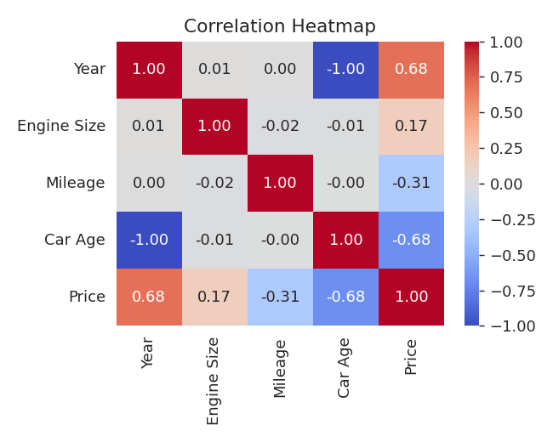
Year/Car Age correlates strongly with Price (0.68 / -0.68), Mileage negatively (-0.31), and Engine Size mildly positively (0.17) — consistent with real-world used-car pricing intuition and with how the pricing formula was constructed.

4. Feature Engineering
- Added Car Age = current year − Year
- Numeric features scaled with StandardScaler: Year, Engine Size, Mileage, Car Age
- Categorical features one-hot encoded: Brand, Fuel Type, Transmission, Condition, Model
- 80/20 train-test split, random_state = 42

5. Model Training & Evaluation
Four regressors were trained and compared on the held-out test set:
Model | R² | MAE | RMSE
Gradient Boosting | 0.9838 | $1,125.51 | $1,447.66
Linear Regression | 0.9322 | $2,346.79 | $2,957.57
Ridge Regression | 0.9322 | $2,346.97 | $2,957.43
Random Forest | 0.9277 | $2,420.18 | $3,053.16

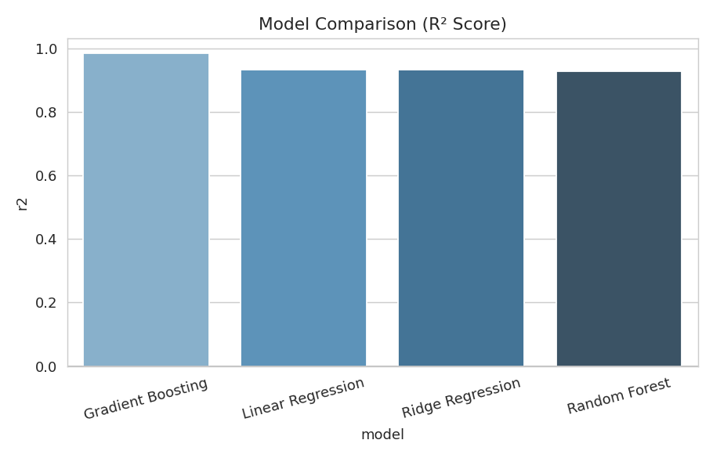
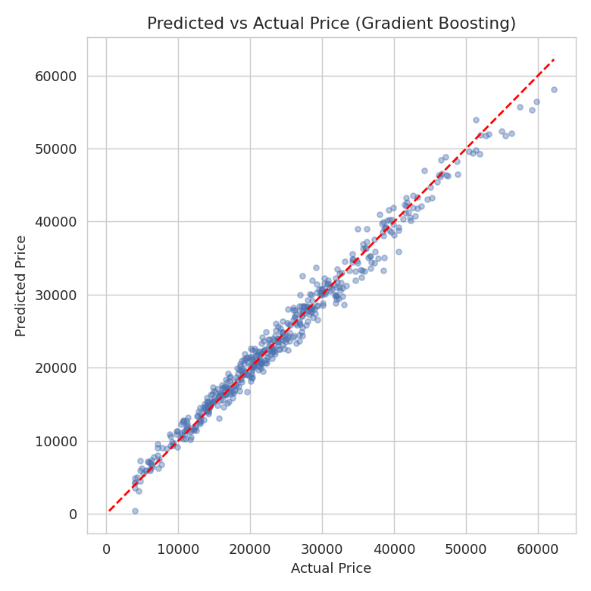

6. Result Summary
The best model, Gradient Boosting, achieves R² = 0.9838 with a mean absolute error of $1,125.51 — a strong fit given the typical price range in this dataset. Predicted vs. actual points cluster tightly around the diagonal, and feature importance places Car Age and Mileage at the top, matching the formula used to generate Price.
Transparency note: this dataset's Price column is synthetic — generated from the other features via a documented formula (data/generate_synthetic_prices.py), not collected from real car sales. It demonstrates that the pipeline correctly learns a genuine feature-price relationship when one exists. For production use, swap in real transaction data through the same pipeline.

7. Deliverables
- train_model.py / generate_report.py — reusable pipeline scripts
- car_price_model.joblib — saved best-performing model
- backend/app.py — Flask prediction API
- frontend/index.html — web form for live predictions
- notebooks/Car_Price_Prediction.ipynb — full pipeline as a notebook
- report_images/ — all EDA and evaluation charts

