EduVault – A Comprehensive Student Information Management System

Submitted by: [Your Name]

Roll Number: [Your Roll Number]

Department: [Your Department]

Institution: [Your College Name]

Date: [Submission Date]

# Abstract

EduVault is an innovative, web-based solution created to revolutionize the management of student data within educational institutions...

# Table of Contents

- Title Page

- Abstract

- Table of Contents

- Introduction

- Background

- Purpose

- Scope

- Objectives

- System Overview

- Technologies Used

- System Architecture

- MVC Paradigm

- Directory Structure

- Module Descriptions

- Authentication Module

- Student Management Module

- Attendance Module

- Certificate Module

- Admin Dashboard

- Database Design

- Tables and Relationships

- Implementation Details

- Server Setup

- Routing and Controllers

- Middleware and Views

- Testing and Validation

- Unit Testing

- Integration Testing

- User Acceptance Testing (UAT)

- Challenges Faced

- Future Enhancements

- Conclusion

- References

- Appendices

- Screenshots

- Code Snippets

- Database Schema Diagram

# Introduction

# Background

Managing student data using traditional, manual methods often leads to errors...

# Purpose

The primary goal of EduVault is to develop a centralized and automated system..

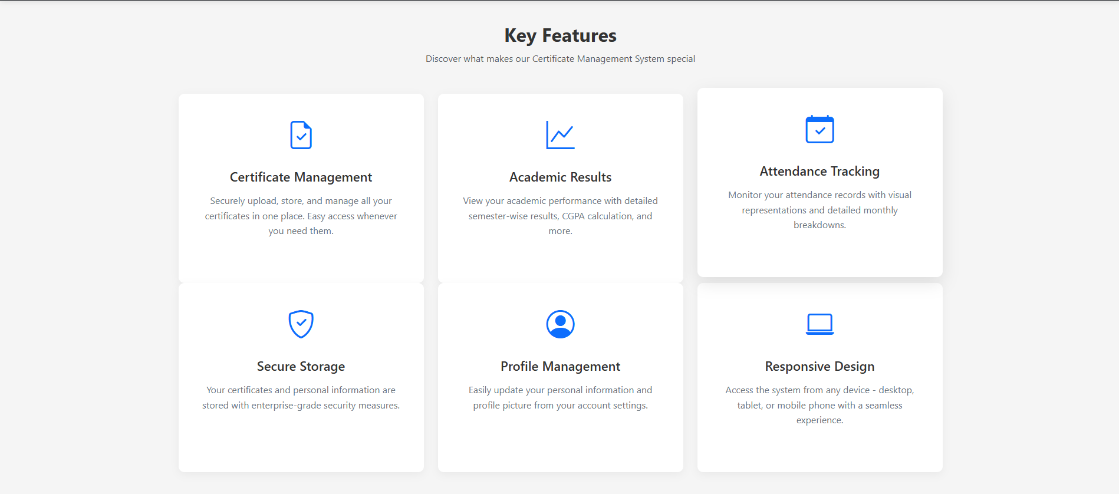

# Scope

- Student Registration: ...

- Academic Record Management: ...

- Attendance Tracking: ...

- Certificate Management: ...

# Objectives

- Enhanced Security: ...

- Efficient Data Handling: ...

- Database Efficiency: ...

- User-Friendly Interface: ...

- Real-Time Data Accessibility: ...

# System Overview

EduVault is architectured as a modern web application...

# Technologies Used

- Frontend:

- HTML & CSS

- JavaScript

- Backend:

- Node.js

- Express.js

- Database:

- MySQL

- Templating Engine:

- EJS

- Version Control:

- Git and GitHub

- Package Management:

- npm

# System Architecture

EduVault follows the Model-View-Controller (MVC) paradigm...

# Directory Structure

- controllers/

- models/

- routes/

- views/

- public/

- config/

# Module Descriptions

# Authentication Module

- Functionality: Manages user login and registration...

# Student Management Module

- Functionality: Facilitates CRUD operations for student records...

# Attendance Module

- Functionality: Records daily attendance data for every student...

# Certificate Module

- Functionality: Automates certificate generation...

# Admin Dashboard

- Functionality: Offers a comprehensive overview of system statistics...

# Database Design

# Tables and Relationships

| Table Name | Key Attributes | Relationship |

|------------|----------------|--------------|

| users | user_id (PK), username, password...

# Implementation Details

- Server Setup

- Middleware Configuration

- Routing and Controllers

- Middleware and Views

# Testing and Validation

- Unit Testing

- Integration Testing

- User Acceptance Testing (UAT)

# Challenges Faced

- Database Connectivity

- Session Management

- Dynamic Content Rendering

# Future Enhancements

- Role-Based Access Control (RBAC)

- Email Notifications

- Data Analytics

- Mobile Responsiveness

- Integration with Other Tools

# Conclusion

EduVault has been successfully developed to address the increasing demands...

# References

- Node.js Documentation

- Express.js Guide

- MySQL Reference Manual

- EJS Templating Documentation

# Appendices

# Screenshots

- Login Page

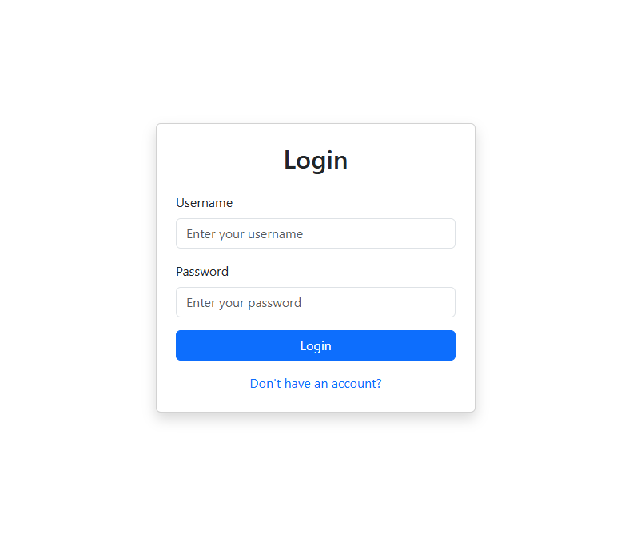

- Dashboard

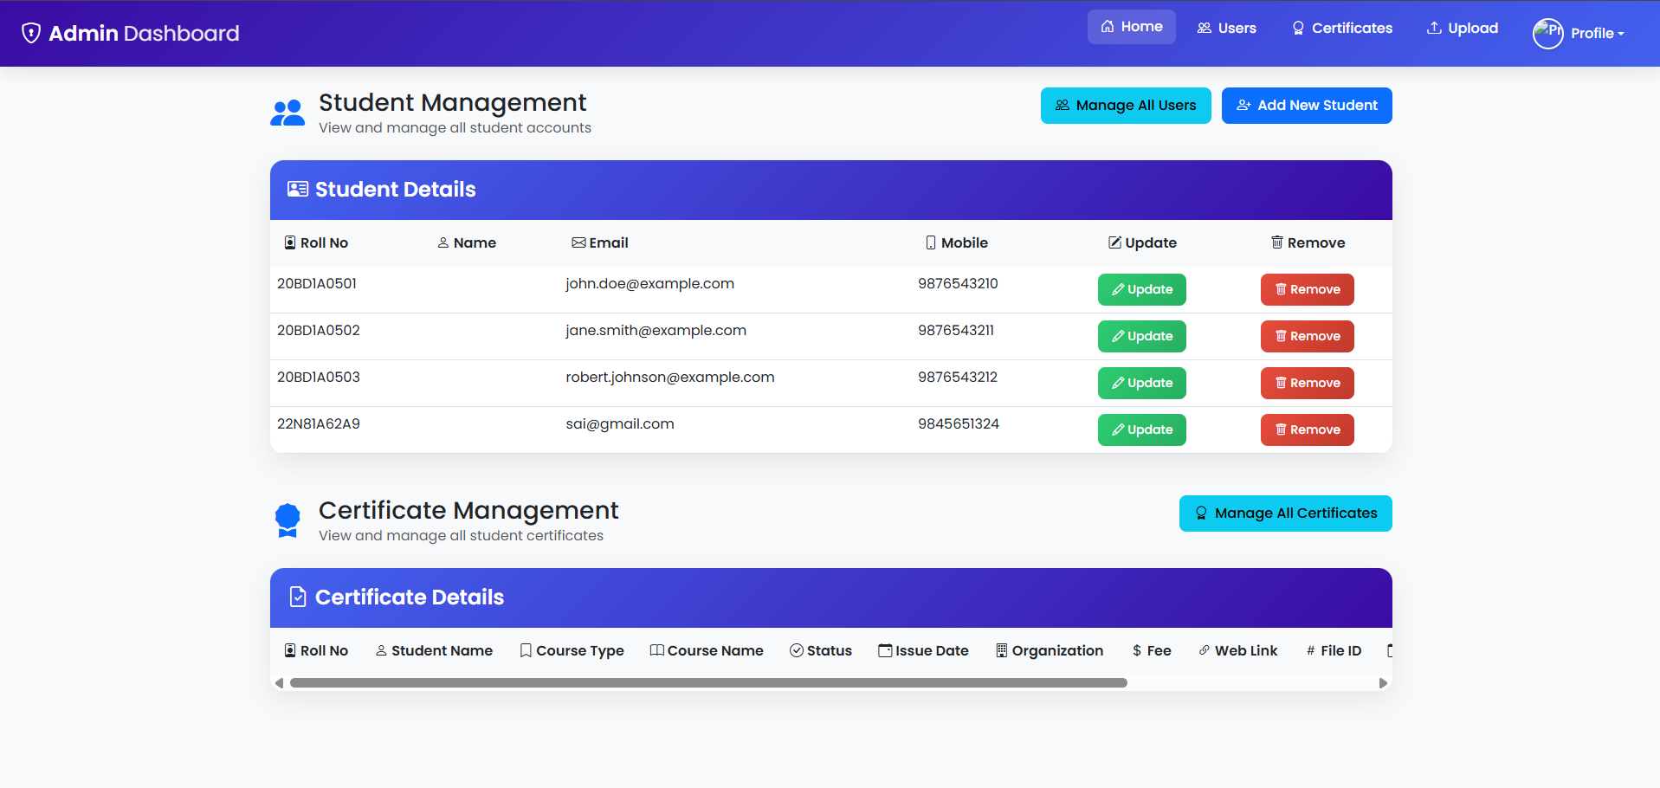

- Student Management Interface

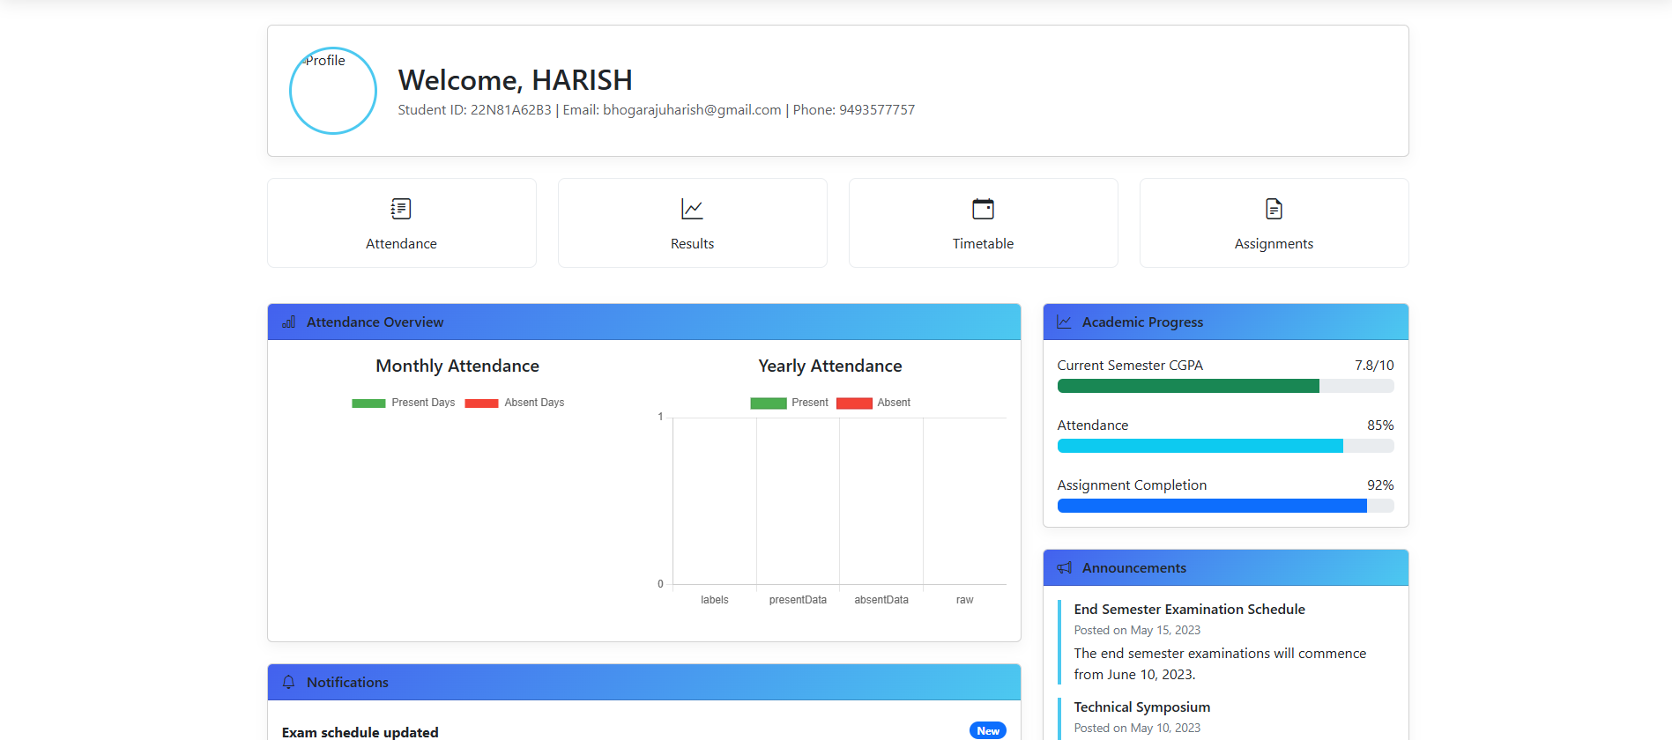

- Certificate Generation Page

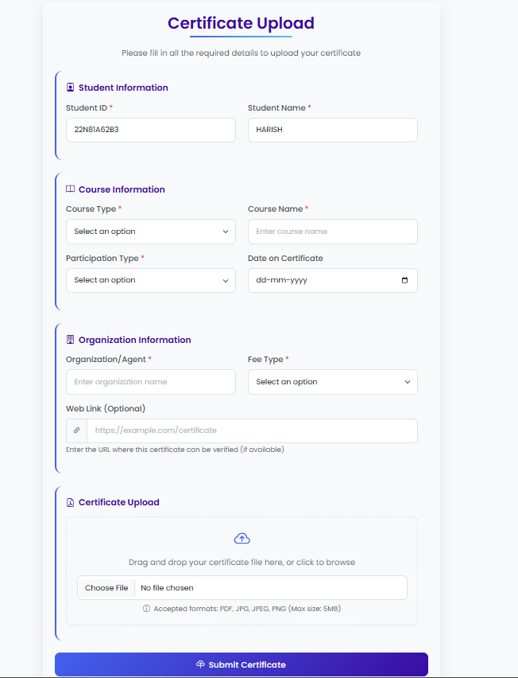

# Code Snippets

- Sample Controller Functions

- EJS Template Examples

# Database Schema Diagram

A visual representation of the database schema...

