InClass 14: Firebase Cloud Messaging in Flutter
Name: Tejaswini Kolliboni
Panther # - 003037935

Environment and Setup
Device / OS: Android emulator
Notification permission: authorized (recorded once, shown in the app)
Firebase project: madinclass14-fcm; Android app com.yourname.cloud_courier
Packages: firebase_core 4.15.2, firebase_messaging 16.7.1 (Firebase Installation ID flow from 17.x not used)

Valid Payload Used
Sent from Firebase Console as a notification with two custom data keys (string values):
{
"notification": {
"title": "New promotion",
"body": "Switch the screen to the promo asset"
},
"data": { "asset": "promo", "action": "update_ui" }
}

T4 variant: same message with the asset key omitted.

Test Results
Test | Expected handler / result | Observed result | Status | Evidence
T1 Foreground | onMessage; UI switches to promo | onMessage; title "New promotion", orange promo image, "OK: applied asset promo"; receipts 2 | Pass | Figure 1
T2 Background tap | onMessageOpenedApp after tapping tray notification; UI promo | Notification appeared in shade; after tap, onMessageOpenedApp, receipts 3, new message ID | Pass | Figures 2, 3
T3 Cold-start tap | getInitialMessage after swiping app away and tapping notification | getInitialMessage; receipts reset to 1 (fresh launch); new message ID | Pass | Figure 4
T4 Invalid payload | Diagnostic shown; previous title/image preserved; no crash | onMessage; red card "Rejected: required key asset is missing"; title and promo image unchanged; receipts 2 | Pass | Figure 5

Reflection
1. Setup and payload
I ran flutterfire configure --platforms=android so the generated options matched one target, then awaited Firebase.initializeApp before registering the background handler and calling runApp. The data keys action (must equal update_ui) and asset (default or promo) select an allow-listed bundled image; everything else is rejected.
2. Lifecycle and evidence
T1 used onMessage, T2 onMessageOpenedApp, and T3 getInitialMessage; unique message IDs and the on-screen handler name show each was a fresh event. onMessage fires on receipt, while the other two fire only on a tap. onBackgroundMessage runs in a separate isolate, so it cannot touch widget state and only logs. Delivery is not authorization: FCM delivering a payload does not make its contents trustworthy, so the app validates before acting. Assumption: a notification-plus-data payload lets Android show the tray notification when backgrounded; data-only messages behave differently.
3. Validation and next step
In T4 I omitted asset; the app showed a diagnostic and kept the previous title and image, with no crash. This guard stops untrusted data from building an invalid asset path. The alternative, interpolating the value into a path, is simpler but fails at runtime on unknown values; the allow-list trades flexibility for safety. Limits: one emulator and one payload cannot generalize to real devices or OEM battery policies. Next, add an event ID; success means sending one ID twice raises the receipt count but applies content once.

Limitations and Assistance
Results come from one Android emulator and one payload shape.
AI assistance: I configured Firebase, ran the app, performed all four tests, and captured the evidence myself. FCM tokens are redacted in all screenshots. The Readme and Document have been rephrased by Claude.

Evidence
Screenshots from the Android emulator. Each app screen shows the last handler, receipt count, message ID, and diagnostic. Message IDs differ between tests, confirming each was a fresh event.
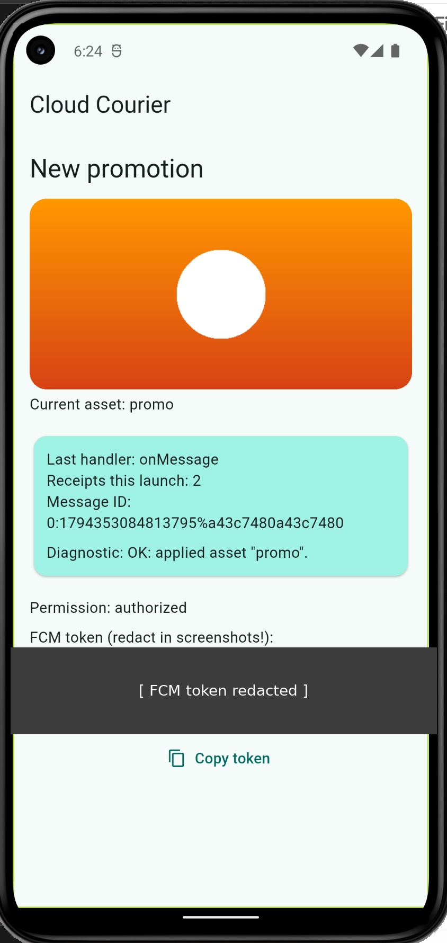  Figure 1. T1 foreground: onMessage | 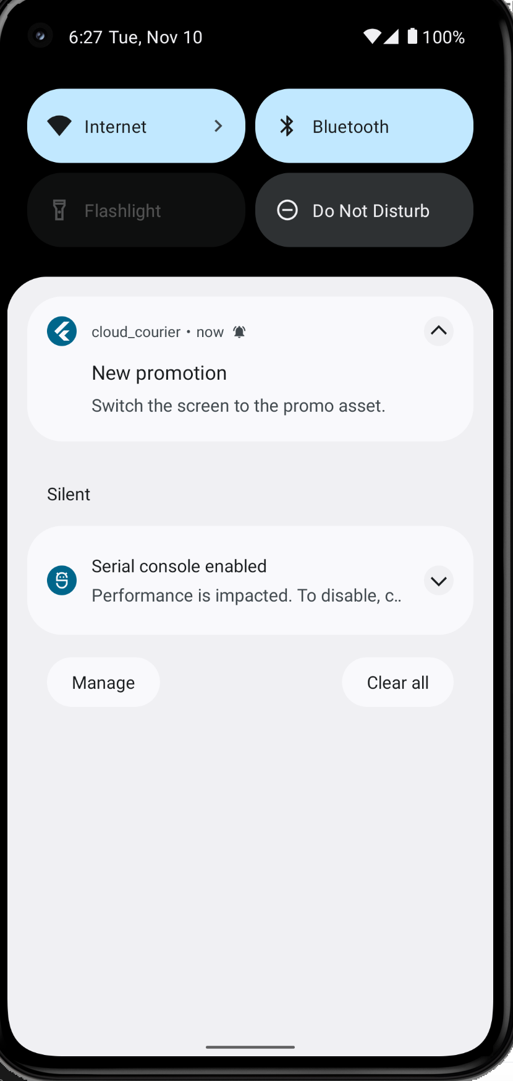  Figure 2. T2 background: notification in shade | 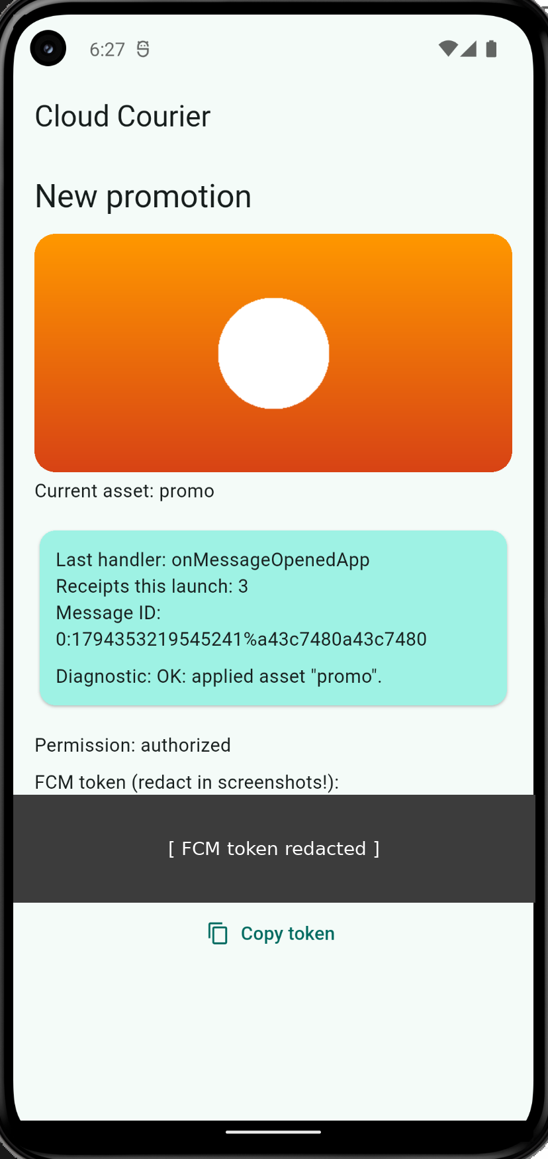  Figure 3. T2 after tap: onMessageOpenedApp
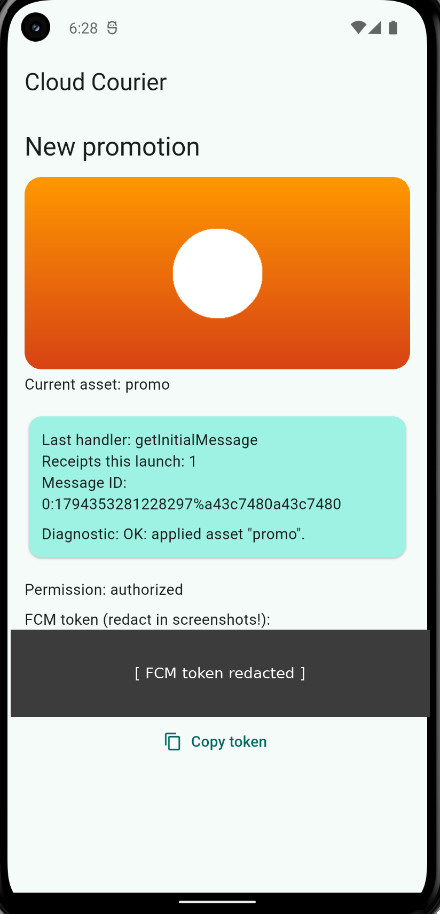  Figure 4. T3 cold start: getInitialMessage | 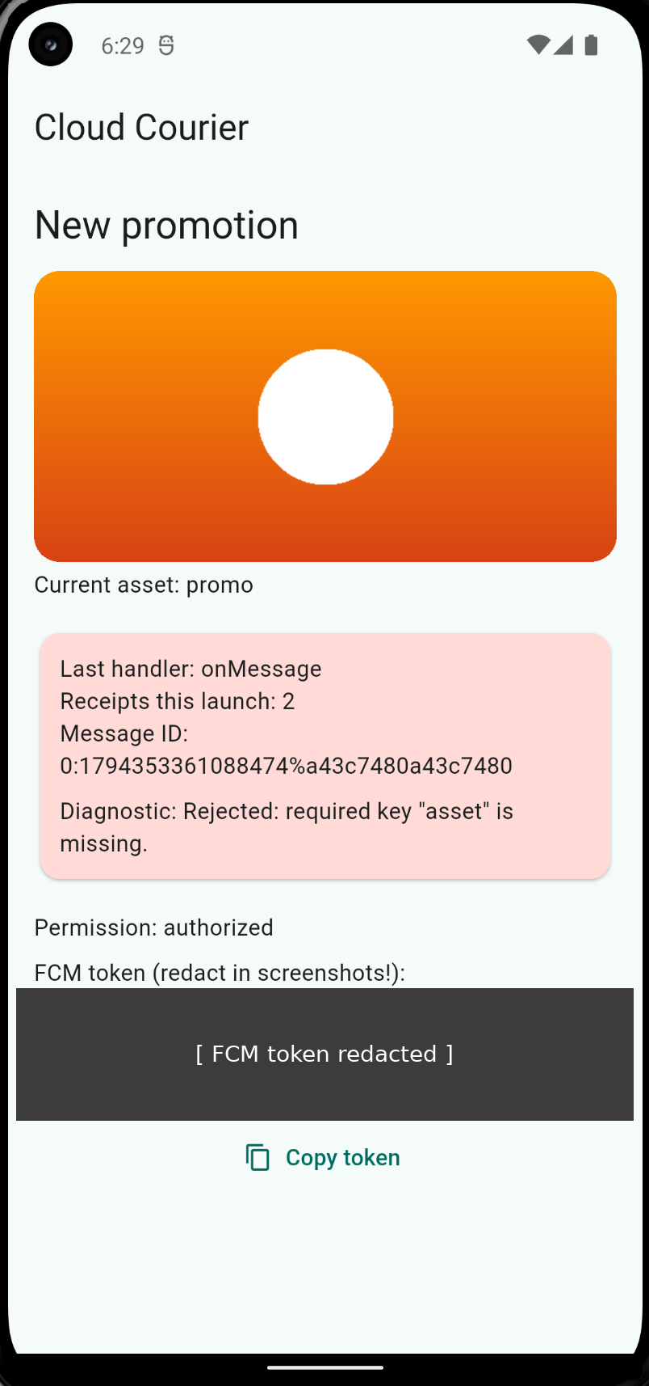  Figure 5. T4 invalid payload: rejected, UI preserved

