**A**

**PROJECT REPORT**

**ON**

**Online Cab Booking management system**

**SUBMITTED TO**



**SAVITRIBAI PHULE PUNE UNIVERSITY**

(Formerly University of Pune)

**FOR THE PARTIAL FULFILLMENT OF PROJECT WORK REQUIRED**

**FOR THE COURSE B.Sc. (COMPUTER SCIENCE)**

**SUBMITTED BY**

**Mr. LANKE ABHISHEK SOMNATH**

**Mr. GAIDHANI HRUSHIKESH DATTATRAY**

**UNDER GUIDANCE OF**

**PROF. WAGH T.B**

**DEPARTMENT OF COMPUTER SCIENCE**

**VISHWALATA ARTS COMMERCE SCIENCE COLLEGE BHATGOAN , YEOLA ,**

**NASHIK**

SAVITRIBAI PHULE PUNE UNIVERSITY(SPPU)



**CERTIFICATE**

**VISHWALATA ARTS COMMERCE SCIENCE COLLEGE BHATGOAN , YEOLA , NASHIK**

SAVITRIBAI PHULE PUNE UNIVERSITY(SPPU)

This is to certify that **Mr.** …………………………….. (**Seat No** .……………) of **T.Y.B.S.c. (Computer Science)** have/has successfully completed project on …………………………. as partial fulfillment of curriculum for **T.Y.B.S.c. (Computer Science)** **Semester-VI** during academic **year 2023-2024**.

**Project Guide Head,**

**Dept. of Computer Science**

**Internal Examiner External Examiner**

**DECLARATION**

I undersigned hereby declares that, the project titled "**ONLINE CAB BOOKING MANAGEMENT SYSTEM**” is executed as per the course requirement of **Three Year** full time **BCS(COMPUTER SCIENCE)** program of **Savitribai Phule Pune University**. This report has not submitted by me or any other person to any other University or Institution for a **degree or diploma course**. This is my own and original work.

**Place : Yeola** **Name: Lanke Abhishek Somnath**

**Date : / /**

**Signature of Candidate**

**ACKNOWLEDGEMENT**

I extend my deepest appreciation to my esteemed guide, **Proff. Mayur Pansare** for providing me with the possibility to complete this project with the right guidance and advice.

Special gratitude I give to my respected head of the division **Proff. Wagh.T.B (HOD)** for allowing me to use the facilities available and also help me to coordinate my project

Furthermore, I would also like to acknowledge with much appreciation the crucial role of faculty members on this occasion.

Last but not least, I would like to thank friends who help me to assemble the parts and gave a suggestion about the project.

INDEX

|  |  |  |
| --- | --- | --- |
| Sr.No | **Topic** | Page  no. |
| **1.** | **ABSTRACT** |  |
| **2.1** | **INTRODUCTION** |  |
| **2.2** | **PROBLEM STATEMENT** |  |
| **2.3** | **OBJEVTIVES** |  |
| **2.4** | **PURPOSE** |  |
| **2.5** | **SCOPE** |  |
| **3.** | **SYSTEM SPECIFICATION** |  |
| **3.1** | **HARDWARE REQUIREMENTS** |  |
| **3.2** | **SOFTWARE REQUIREMENTS** |  |
| **3.3** | **APACHE** |  |
| **3.4** | **PHP** |  |
| **3.5** | **MYSQL** |  |
| **4** | **SYSTEM DESIGN** |  |
| **4.1** | **ER DIAGRAM** |  |
| **4.2** | **MAIN DIAGRAM** |  |
| **4.3** | **DIAGRAM** |  |
| **4.3.1** | **ADMIN AND USE CASE** |  |
| **4.3.2** | **USER AND USE CASE** |  |
| **5.** | **STATE CHART DIAGRAM** |  |
| **5.1** | **USER** |  |
| **5.2** | **REGISTRATION** |  |
| **6.** | **ACTIVITY DIAGRAM** |  |
| **6.1** | **ADMIN** |  |
| **6.2** | **USER** |  |
| **7.** | **SEQUENCE DIAGRAM** |  |
| **8.** | **DATA MODEL** |  |
| **9.** | **HOME PAGE SCREENSHOTS** |  |
| **10.** | **ADMIN PAGE SCREENSHOTS** |  |
| **11.** | **USER PAGE SCREENSHORTS** |  |

**1.ABSTRACT**

The main aim of online cab booking is providing faster booking. It helps customer for their various purposes and to book in a convenient date and time for the journey. It also provide various type of vehicle like mini, auto, prime SUV etc as per the requirements of customer. here the customer can see the history of his or her journey, book cab, search cab. it is user-friendly. the online cab booking is growing as the internet emerages as the best technology which provide fast and efficient access of any information.

**2.1.INTRODUCTION**

In today’s era, everyone wants convenience and comfort in daily life activities but everywhere, it is not possible. Travelling is also a major part of day-to-day activities and in same case also, people wants same comfort assistance in whole journey. taking this statement, we came to the solution that will provide the comfort as well as secure journey provided.

Now a days everything is online and people are constantly looking for things online be to purchasing something or getting touch with someone. It is an online portal through which customer can view available cabs, register the cab, view profile and book cabs, the main purpose of online cab booking system is that will help you get quick cab at your Place. Cab booking service is a major transport service provided by the various transport operators in a particular City. mostly people use cab service for their Daily transportation need.

Online cab booking system is a web-based platform that allows your customers to book their cabs in online from the comfort of their own home or office.

The system after carefully analyses has been identified to be presented with the following models.

**User: -**

* User can access his or her respective account by supplying a username and password along with other required details.
* After successfully login the user can access the option
* The user can see available cabs and book the cab.
* The user can also put complaints and suggestions.

**Admin: -**

* With valid username and password admin can enter the system.
* Admin goes enter all the data in the system.
* Admin also put the discount and the new offers.
* Admin has the privilege to update database table.
* Admin also retrieve the complaint and suggestion put by the customer.

**2.2 PROBLEM STATEMENT**

The problem statement of online cab booking project is to develop an online process of Cab Booking Service. Present system is manual and it is time consuming as well as non standardized in terms of returns. Currently, customers need to make a manual call in order to rent / reserve preferred vehicle. The software of Online Cab Booking System will check their file to see which vehicle is available for rental. The objective of online cab booking project is to automate vehicle rental and reservation. So customers do not need to call & spend unnecessary time in order to reserve preferred vehicle..

**2.3 OBJEVTIVES**

* + Online system can provide improved accessibility for getting information.
  + This system helps the user to save their valuable time.
  + It is user friendly.
  + The system makes the overall project management much easier and flexible.
  + It can be accessed over the Internet.

* + This can give the good security for user information because data is not in client machine.
  + Authentication is provided for this application only registered users can access.

**2.4 PURPOSE:-**

In this purpose where actually providing the functionalities on which;

Online cab booking it automatically send the request to the driver, and the driver accept the user request, process of the cab booking initiate and send notification to user about driver like; driver details, phone number, vehicle number, etc.

In this project admin control everything like add driver, delete driver, show booking list and feedback list etc.

**2.5 SCOPE:-**

The driven by convenience technological advancements, and increased reliance on on-demand transportation services.

As urbanization and digital connectivity expand, the demand for efficient and accessible transportation solutions is likely to contribute to the sustained grouth of online cab booking platform.

**2.6 Limitation’s :-**

(1) User will require the computer to run the software

**3. SYSTEM SPECIFICATION**

**3.1 HARDWARE REQUIREMENTS**

* 64-bit operating system, x64-based processor
* 16 GB Ram
* 512 GB ROM
* Hard disk

**3.2 SOFTWARE REQUIREMENTS**

* Operating System : Windows-10
* Web-Technology: PHP
* Front-End: HTML,CSS,JAVASCRIPT
* Back-End: PHP, Myphpadmin
* Web Server: Apache SERVER.

**3.3 APACHE**

The Apache HTTP Server Project is an effort to develop and maintain an open-source HTTP server for modern operating systems including UNIX and Windows. The goal of this project is to provide a secure, efficient and extensible server that provides HTTP services in sync with the current HTTP standards.

The Apache HTTP Server ("httpd") was launched in 1995 and it has been the most popular web server on the Internet since April 1996. It has celebrated its 20th birthday as a project in February 2015.

**3.4 PHP**

* PHP stands for PHP: Hypertext Preprocessor.
* PHP scripts are executed on the server.
* PHP supports many databases (MYSQL, Informix, Oracle, Sybase, Solid, Generic ODBC, etc.).
* PHP is an open source software.
* PHP is free to download and use

**3.5 MYSQL**

* MYSQL is a database server
* MYSQL is ideal for both small and large

Applications

* MYSQL supports standard SQL
* MYSQL compiles on a number of platforms
* MYSQL is free to download and use
* How to access MySQL:
* <http://localhost/phpmyadmin>

**4.SYSTEM DESIGN**

**4.1 ER DIAGRAM :-**

**ADMIN**

**LOGIN TO**

**SYSTEM**

**FORGOT**

**PASSWORD**

**CHECK**

**CREDENTI**

**ALS**

MANAGE

**MODULES**

**CHECK**

**ROLES OF**

**ACCESS**

**SEND**

**EMAIL**

**TO USER**

**MANAGE SYSTEM ADMINS**

**MANAGE ROLES OF**

**USER**

**MANAGE USER PERMISSION**

**MANAGE REPORT**

**MANAGE PAYMENY DETAILS**

**MANAGE BOOKING DETAILS**

**MANAGE CUSTOMER DETAILS**

**MANAGE CAR DETAILS**

**4.2 MAIN DIAGRAM :-**

**BOOKING**

**MANAGEMENT**

**CUSTOMER**

**MANAGEMENT**

**Payment**

**management**

**SYSTEM USER**

**MANAGEMENT**

**CAR**

**MANAGEMENT**

**LOGIN**

**MANAGEMENT**

**FEEDBACK**

**MANAGEMENT**

**4.3 DIAGRAMS**

**4.3.1 ADMIN :-**

**DB**

**ADMIN**

**Id & Password**

**InValid Id & Password**

**USE CASE**

**ADMIN :-**

**Admin**

**4.3.2 USER :-**

**USE CASE :-**

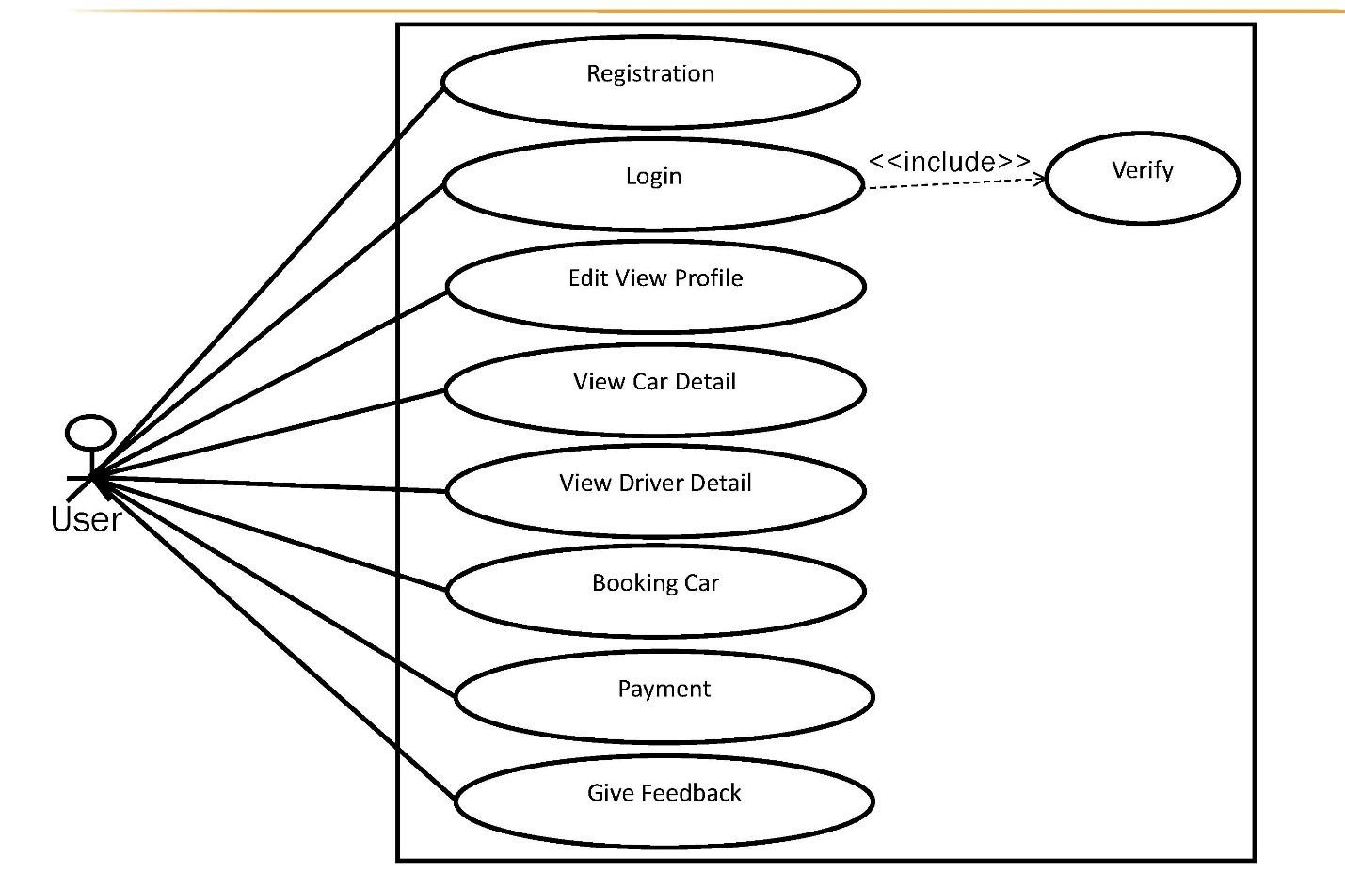

**5. STATE CHART DIAGRAM :-**

**5.1 LOGIN :-**

**Figure**

**3.7**

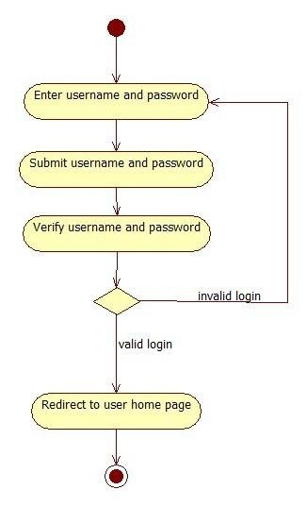

**5.2 REGISTRATION :-**

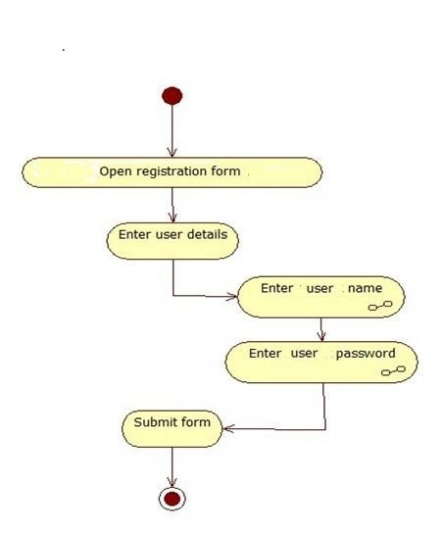

**6. ACTIVITY DIAGRAM**

**6.1.ADMIN :-**

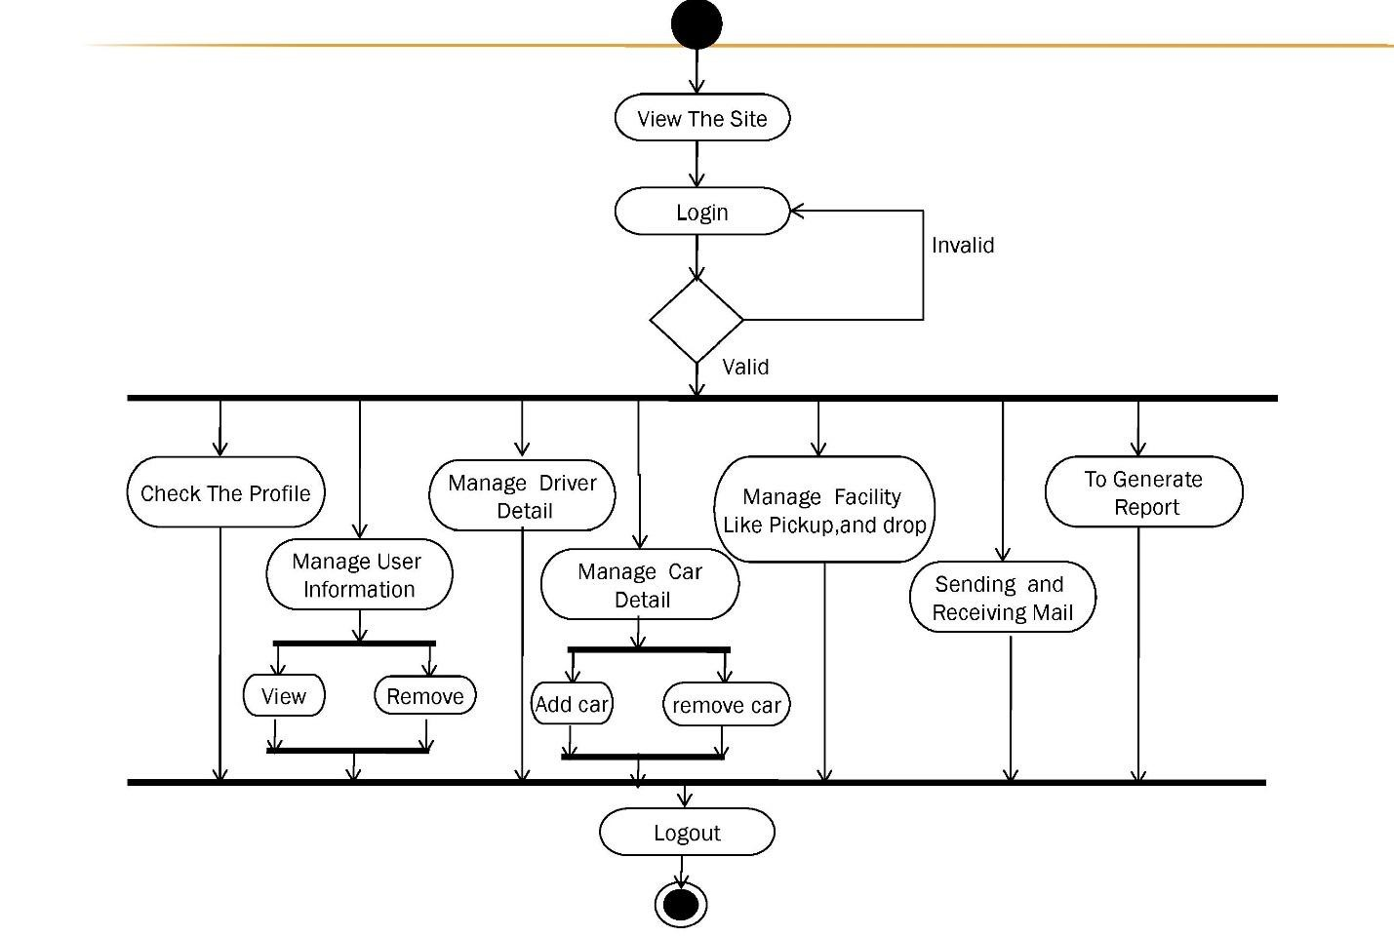

**6.2.USER :-**

Yes

New user

No

No

Valid

Yes

**View the site**

**Register**

**Login**

**Edit profile**

**Search cabs**

**nearby**

**Give feedback**

**Payment**

**View driver**

**details**

**Book cab**

**Mini**

**Prime**

**Micro**

**Logout**

**7. SEQUENCE DIAGRAM :-**

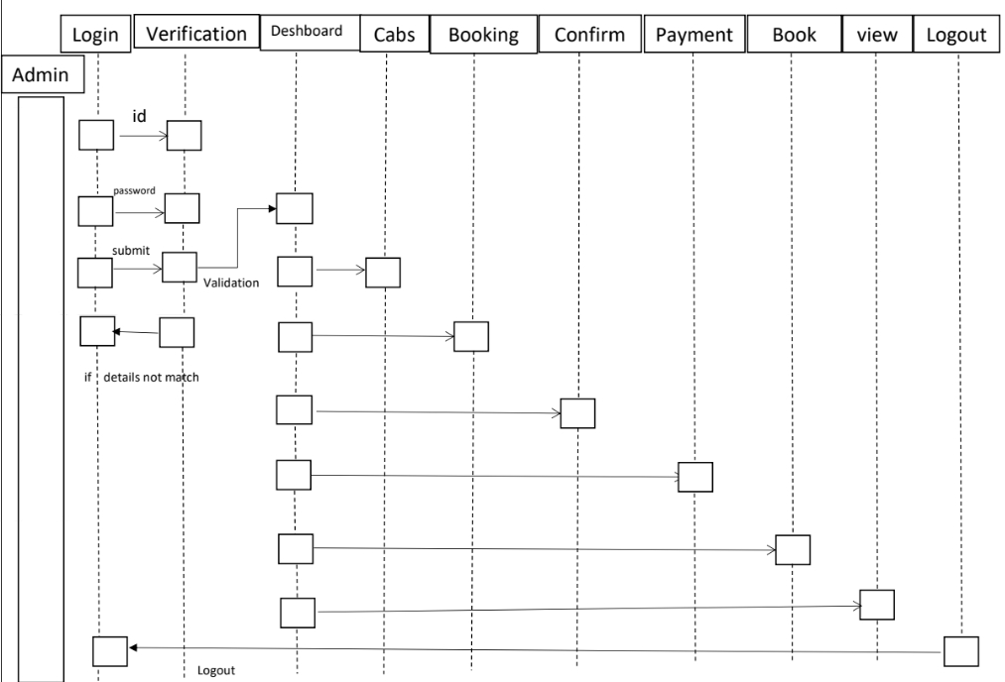

**8. DATA MODEL :-**

**8.1 ADMIN :-**

|  |  |  |  |  |
| --- | --- | --- | --- | --- |
| **Field Name** | **Field Size** | **Data Type** | **Key** | **Descrition** |
| ID | 20 | Integer | Primary Key | Id of admin member |
| Name | 200 | Varchar | - | Name of admin |
| Email | 200 | Varchar | - | Email of the admin |
| password | 200 | Varchar | - | Password od admin |

**8.2 FEEDBACK :-**

|  |  |  |  |  |
| --- | --- | --- | --- | --- |
| **Field Name** | **Field Size** | **Data Type** | **Key** | **Descrition** |
| ID | 20 | Integer | Primary Key | Id of Feedback |
| Name | 200 | Varchar | - | Name of User |
| content | - | Longtext | - | Feedback |
| Status | 200 | Varchar | - | Status of Feedback |

**8.3 USER :-**

|  |  |  |  |  |
| --- | --- | --- | --- | --- |
| **Field Name** | **Field Size** | **Data Type** | **Key** | **Descrition** |
| Id | 20 | Integer | Primary Key | Id of User |
| First Name | 200 | varchar | - | Name of User |
| Last Name | 200 | varchar | - | Email of User |
| Phone | 200 | varchar | - | Phone No of User |
| Address | 200 | varchar | - | Address of User |
| category | 200 | varchar | - | category |
| Email | 200 | varchar | - | Email of User |
| Password | 200 | varchar | - | Password of User |
| Car Type | 200 | varchar | - | Car type of User |
| Car register No | 200 | varchar | - | Car register No of User |
| Car Book Date | 200 | varchar |  | Car Book Date |
| Car Book Status | 200 | varchar |  | Car Book Status |

**8.4 VEHICLE :-**

|  |  |  |  |  |
| --- | --- | --- | --- | --- |
| **Field Name** | **Field Size** | **Data Type** | **Key** | **Descrition** |
| Id | 20 | Integer | Primary Key | Id of vehicle |
| Name | 200 | varchar | - | Name of vehicle |
| Reg No | 200 | varchar | - | Vehicle Register Number |
| Password | 200 | varchar | - | Set Password |
| Driver | 200 | varchar | - | Driver Name |
| Category | 200 | varchar | - | Vehicle Category |
| Picture | 200 | varchar | - | Picture of Vehicle |
| Status | 200 | varchar | - | Status Check |

**8.5 RESET PASSWORD :-**

|  |  |  |  |  |
| --- | --- | --- | --- | --- |
| **Field Name** | **Field Size** | **Data Type** | **Key** | **Descrition** |
| Id | 20 | Integer | - | Id of User |
| Email | 200 | varchar | - | Email Id |

**9. HOME PAGE SCREENSHOTS :-**